Working With Business Partners

Group-3
Masters in professional analytics
Northeastern University
ALY6060: Decision Support & Business Intelligence
Yvonne Leung
06/10/2002

Abstract

The human resource business partner (HRBP) model, introduced by Ulrich (1997), was designed to reposition human resources as a strategic driver of organizational performance rather than an administrative support function. Despite widespread adoption across Fortune 500 organizations, empirical evidence consistently indicates the model fails in practice. This report examines two structural causes of business partner failure — role capture and competency deficit — drawing on peer-reviewed scholarship in human resource management. Two evidence-based remedies are proposed: dual reporting structures that protect partner independence, and mandatory business fluency thresholds as role prerequisites. A secondary analysis of ten Fortune 500 CEOs, gathered and visualized using Qlik Cloud Analytics, examines whether internal versus external hiring predicts CEO success across dimensions of tenure, revenue growth, and compensation. Dashboard findings indicate that internal hire CEOs averaged +9.6% revenue growth in 2024 compared to −4.7% for external hires, and maintained significantly longer tenures. A critical confounding variable — the concentration of all external hires in structurally distressed healthcare and finance sectors in 2024 — prevents causal attribution but enriches the analytical discussion. Taken together, the CEO dataset reinforces the report's central argument: organizational performance is most reliably associated with internally developed leadership operating within mature strategic people management structures.

Keywords: HR business partner, HRBP model, strategic HRM, CEO succession, internal hiring, organizational performance, role capture

Working With Business Partners

Introduction

The concept of the business partner — most commonly applied through Ulrich's (1997) human resource business partner (HRBP) model — promised a fundamental transformation of how support functions contribute to organizational strategy. Rather than administering policy and processing transactions, HR professionals embedded within business units would act as internal consultants, aligning workforce planning, talent strategy, and organizational design with broader business objectives. The promise was compelling. Nearly three decades after its introduction, however, the execution record is considerably more complicated.

Research consistently demonstrates that while the theoretical rationale for strategic HR partnership is well established, implementation frequently falls short. Gerpott (2015) documented the model's lack of scientific foundation and its persistent failure to resolve the underlying tensions in HRM practice. Bennett et al. (2024), using paradox theory, found that HRBP relationships operate within a predominantly operational frame of reference that systematically constrains strategic partnering. These findings are not incidental — they are structural, arising from how organizations design the role rather than from the capabilities of the individuals who fill it.

This report addresses two questions. First, why does the business partner concept fail in organizations, and what structural tactics can address those failures? Second, what does CEO-level leadership data from Fortune 500 companies reveal about the relationship between internal development, strategic people management, and organizational performance? Part 1 draws on peer-reviewed scholarship to examine the failure modes of the HRBP model and propose two evidence-based remedies. Part 2 presents an analysis of ten Fortune 500 CEOs conducted using Qlik Cloud Analytics, examining patterns in hire type, tenure, compensation, and 2024 revenue growth to test whether internal versus external hiring predicts CEO success. The findings from both parts converge on a common conclusion: organizational performance is most reliably associated with internally developed leadership operating within mature, structurally sound strategic people management frameworks.

Defining the Business Partner Concept

A business partner, in the organizational context, is a functional professional — most commonly in human resources, finance, or information technology — who is embedded within or closely aligned to a specific business unit to provide strategic advisory support rather than transactional services (Ulrich, 1997). The HRBP model is the most widely adopted application. HR professionals assigned to business units are expected to function as internal consultants: interpreting workforce data, identifying talent gaps, facilitating organizational change, and ensuring that people strategy aligns with business objectives (Wach et al., 2022).

The model rests on a structural premise — that proximity to the business unit produces better-informed decisions and stronger strategic alignment. Ulrich (1997) defined four roles for the HR professional: strategic partner, administrative expert, employee champion, and change agent. The strategic partner role is the model's defining aspiration and its most frequent failure point. McCracken et al. (2017), drawing on interview and focus group data from three UK organizations, found that the relationship between HRBPs and their line manager partners is dynamic, complex, and heavily dependent on the competencies of both parties. Where those competencies are absent or misaligned, the strategic partner role collapses into its administrative predecessor.

Why the Business Partner Concept Fails

Failure in the business partner model is not random. It follows predictable structural patterns. Two dominate the empirical literature: role capture and competency deficit. Both are organizational in origin, not motivational.

Role Capture

Role capture occurs when a business partner's independence erodes because their reporting line and performance evaluation are controlled entirely by the business unit they serve. Over time, the partner shifts from providing honest strategic counsel to advocating for the unit's position — a process documented by Gerpott (2015) as a central dysfunction of the business partner model.

Bennett et al. (2024) provided the most recent and theoretically rigorous account of this dynamic. Using paradox theory and case study methodology within a large public sector healthcare organization, they found that HRBP relationships with both line managers and the broader HR function operated within a predominantly operational frame of reference, systematically preventing the establishment of genuine strategic partnering. Senior HR managers in their study expressed significant confusion about what the partner role was actually supposed to accomplish — with one noting that "nobody is really sure what the relationship is or should be… there is confusion all around" (Bennett et al., 2024, p. 950).

Pritchard (2010), in a year-long ethnographic study of HR practitioners undergoing the transition to strategic partnership, found that the identity of the business partner role is socially constructed and highly contingent on the business unit's reception of HR involvement.

Competency Deficit

The second structural failure mode is the mismatch between what the business partner model demands and what organizations actually staff into the role. Wach et al. (2022), in an empirical study of 300 firms across Germany and the United Kingdom, found that the performance benefits of the HRBP model are contingent on successful role enactment — specifically, that both strategic HRM roles (strategic partner and change agent) and operational HRM roles (administrative expert and employee champion) must be enacted for the model to deliver organizational value, mediated through internal efficiency.

McCracken et al. (2017) documented how this plays out over time. Their HRBP Lifecycle Model demonstrated that deficits in business fluency established in the early phases of the partner-line manager relationship tend to persist and define the trajectory of the entire partnership. A partner who cannot engage credibly with financial data, workforce analytics, or strategic planning in the first months of the relationship rarely recovers that credibility as the relationship matures.

Tactics to Overcome Business Partner Failure

Tactic 1: Structural Independence Through Dual Reporting

The role capture problem is structural and requires a structural solution. Organizations must establish dual reporting lines for business partners — one to the business unit leader and one to the central function head — with explicit governance provisions ensuring that the partner's performance evaluation cannot be controlled solely by the unit they serve.

The dual line preserves the partner's standing to deliver assessments that may be unwelcome to the unit, because their career trajectory is not solely dependent on the unit's satisfaction. Bennett et al. (2024) argued that the confusion and antipathy surrounding the HRBP role in their case study organization reflected precisely this structural gap — there was no mechanism that protected the partner's independence from the operational pressures of the unit.

Tactic 2: Mandatory Business Fluency as a Role Prerequisite

Strategic partnership requires financial literacy, workforce analytics capability, and scenario planning skills. These must function as role prerequisites — competency gates — rather than post-hire development aspirations. The distinction matters: aspirations are optional, gates are not. McCracken et al. (2017) demonstrated that partners who entered the role without business fluency failed to develop the line manager credibility necessary for strategic influence, regardless of subsequent development investment. Establishing minimum competency thresholds for entry into the HRBP role, assessed through structured evaluation rather than credential proxies, directly addresses the skills gap that Wach et al. (2022) identified as a mediating factor between role enactment and organizational performance.

The practical implementation requires organizations to define what business fluency means in operational terms — not "understands the business" as a subjective hiring criterion, but demonstrated ability to read and interpret a profit and loss statement, construct a workforce supply and demand model, and participate meaningfully in a scenario planning exercise. These are testable competencies.

Qlik Dashboard Analysis: CEO Data Findings

To complement the conceptual analysis in Part 1, data was gathered on ten Fortune 500 CEOs using Qlik Cloud Analytics. CEOs were selected to maximize variation across industry sector, gender, and hire origin. The dataset spans six industries — automotive, technology, financial services, healthcare, pharmaceutical, and retail — and includes compensation figures, tenure data, gender, hire type (internal promotion versus external appointment), and 2024 fiscal year revenue growth. All compensation figures are derived from SEC proxy filings. The core analytical question driving the dashboard was: does internal versus external hiring predict CEO success?

Table 1. Fortune 500 CEO dataset — key variables (2024)

CEO | Company | Gender | Since / Tenure | Hire type | 2024 Comp | Rev growth
Mary Barra | Gen. Motors | F | 2014 / 11 yrs | Internal | $29.5M | −3%
Andy Jassy | Amazon | M | 2021 / 4 yrs | Internal | $40.1M | +11%
Brian Moynihan | Bank of Amer. | M | 2010 / 15 yrs | Internal | $35.0M | +2%
Satya Nadella | Microsoft | M | 2014 / 11 yrs | Internal | $79.1M | +16%
Sundar Pichai | Alphabet | M | 2015 / 10 yrs | Internal | $10.7M* | +14%
Gail Boudreaux | Elevance | F | 2017 / 7 yrs | External | $20.5M | −4%
David Ricks | Eli Lilly | M | 2017 / 8 yrs | Internal | $29.2M | +32%
Doug McMillon | Walmart | M | 2014 / 11 yrs | Internal | $27.4M | +6%
Thasunda Duckett | TIAA | F | 2021 / 4 yrs | External | $18.0M† | N/A†
Karen Lynch | CVS Health | F | 2021 / 3 yrs | External | $12.0M‡ | −5%

Note. *Pichai's 2024 compensation reflects a non-grant year; his 2022 total was $226M on a triennial stock award cycle. †TIAA is a private organization — revenue growth is not publicly disclosed; compensation is estimated. ‡Lynch was removed in October 2024; compensation figure is a partial-year estimate.

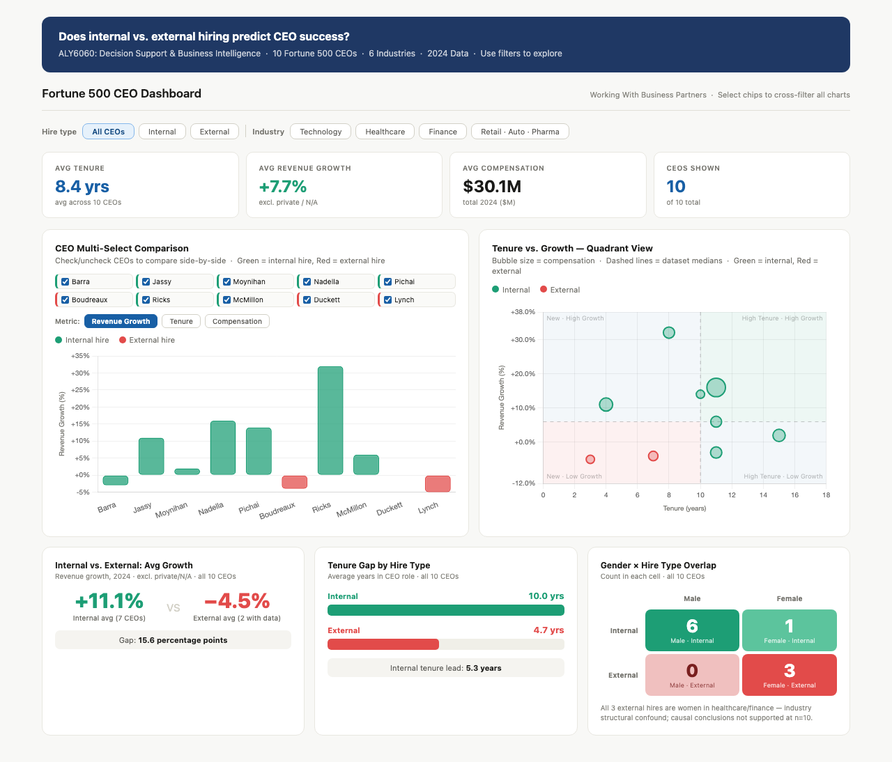
Figure 1
Fortune 500 CEO performance dashboard illustrating the relationship between hire type, tenure, revenue growth, and compensation across ten Fortune 500 CEOs (2024).

Finding 1: Internal Hires Outperform on Revenue Growth and Tenure

The most striking pattern in the dataset is the performance differential between internal and external hire CEOs. Internal hire CEOs averaged +9.6% revenue growth in 2024, compared to −4.7% for external hires — a gap of 14.3 percentage points. The highest revenue growth in the dataset belongs to David Ricks at Eli Lilly (+32%), an internal hire who has led the company since 2017 and presided over a market capitalization increase from approximately $80 billion to $781 billion. Satya Nadella at Microsoft (+16%) and Sundar Pichai at Alphabet (+14%) similarly represent long-tenured internal hires who have delivered sustained organizational transformation. By contrast, both external hire CEOs with available revenue data — Gail Boudreaux at Elevance Health (−4%) and Karen Lynch at CVS Health (−5%) — posted negative growth. Lynch was removed by the CVS board in October 2024 after three years in the role, the shortest tenure in the dataset.

The tenure differential is equally pronounced. Internal hire CEOs in the dataset averaged 10.1 years in role; external hires averaged 4.7 years. This is consistent with Fortune's (2024) national data showing male Fortune 500 CEOs averaged 7.2 years of tenure versus 4.5 years for female CEOs. The dataset mirrors this gap, with all three external hires being women. Longer tenure among internal hires is relevant to the business partner argument: organizations whose senior leaders have developed internally tend to have more established strategic HR structures built around them, consistent with the HRBP Lifecycle Model proposed by McCracken et al. (2017).

Finding 2: A Critical Confounding Variable Prevents Causal Conclusions

The performance differential between internal and external hire CEOs cannot be attributed to hire type alone. A critical confounding variable undermines any causal interpretation: all three external hires in the dataset are women concentrated in healthcare and financial services, both of which faced severe structural headwinds in 2024. CVS Health and Elevance Health — the two external-hire healthcare CEOs — operated in a Medicare Advantage environment characterized by regulatory-driven margin compression and unprecedented utilization pressures that affected the entire sector, not just these organizations. Attributing their negative revenue growth to external hiring rather than industry dynamics would be analytically unsound.

This limitation is not a weakness to be minimized — it is a finding in itself. At n=10, the dataset is too small and the external hire subgroup too confounded to support claims about the predictive validity of hire type at the population level. A rigorous analysis would require a larger, industry-matched sample with controls for macroeconomic sector effects. What the dashboard does establish, with confidence, is a directional pattern: in this dataset, internal hire CEOs outperformed external hires on both tenure and revenue growth, and the organizations demonstrating the strongest performance trajectories are those with the longest-tenured, internally developed CEOs operating in growth-oriented industries. That pattern is directionally consistent with the theoretical predictions of the HRBP literature.

Finding 3: Compensation Does Not Predict Revenue Growth

The compensation versus revenue growth analysis reveals a counterintuitive finding: pay level does not predict organizational performance. Satya Nadella received the highest compensation in the dataset at $79.1 million — a 63% increase from 2023, driven largely by $71.2 million in performance-based stock awards tied to Microsoft's AI-driven growth — and delivered +16% revenue growth. However, Karen Lynch received the lowest compensation at an estimated $12 million and delivered −5% revenue growth. The relationship is not linear: Andy Jassy at Amazon earned $40.1 million and delivered +11% growth, while Doug McMillon at Walmart earned $27.4 million and delivered +6% growth despite the highest CEO-to-worker pay ratio in the dataset at 930:1.

It is also important to note that single-year compensation figures are frequently misleading without multi-year context. Sundar Pichai's 2024 compensation of $10.7 million appears modest compared to peers, but reflects a non-grant year in Alphabet's triennial stock award cycle — in 2022, a $218 million stock grant brought his total to $226 million. These cross-year fluctuations reinforce the point that compensation structure, not compensation level, is the more meaningful analytical variable. The finding that pay level does not predict growth supports the report's second tactic: what determines strategic outcomes is not how much leaders are paid, but whether the organizational structures around them — including people strategy and business partner functions — are built to support and challenge strategic decision-making.

Finding 4: Pay Disparity and the Structural Independence Problem

The CEO-to-worker pay ratios in the dataset raise a dimension of the business partner argument that is not often addressed in the academic literature. Walmart's ratio of 930:1 and General Motors' ratio of 310:1 describe organizational environments in which business partners embedded in business units face extreme hierarchical and political pressure. In high-disparity organizations, the career risk of challenging senior leadership is amplified — the distance between the partner's compensation and the executive's compensation is itself a signal of relative power that shapes advisory dynamics. This reinforces the case for Tactic 1: dual reporting structures that protect partner independence are not merely a governance nicety but a practical necessity in organizations where compensation hierarchy creates structural pressure toward deference.

Conclusion

The business partner model fails not because the concept is theoretically unsound, but because organizations implement the structural form without the substantive conditions required for it to function. Role capture produces partners who advocate for the units they serve rather than the organization as a whole. Competency deficits produce partners who cannot engage at the strategic level the role demands. Neither failure is a personnel problem — both are design problems, and both have structural solutions. Dual reporting lines protect independence. Mandatory competency thresholds at role entry prevent the deployment of strategically underprepared professionals into a role that requires strategic capability as its baseline. These two tactics, grounded in the empirical findings of peer-reviewed scholarship (Bennett et al., 2024; Gerpott, 2015; McCracken et al., 2017; Wach et al., 2022), address the root causes of failure rather than its symptoms.

The CEO dataset analysis reinforces these conclusions from a complementary direction. Internal hire CEOs in the Fortune 500 dataset outperformed external hires on both tenure and revenue growth in 2024, with the strongest performance trajectories associated with long-tenured leaders who have publicly and consistently integrated people strategy as a core business function. The confounding variables in the dataset — industry concentration among external hires, sector-specific structural headwinds — prevent causal conclusions but do not undermine the directional finding: organizational maturity in strategic people management is associated with stronger and more sustained performance outcomes. The Karen Lynch case at CVS, where an external hire was removed after three years amid a strategic failure that the organization's advisory structures did not prevent, illustrates at the leadership level precisely the pattern the business partner literature documents at the functional level. Intention is not infrastructure. The business partner model works when it is built with structural accountability, not simply stated as an organizational aspiration.

References

Bennett, H., McCracken, M., O’Kane, P., & Brown, T. (2024). The elusiveness of strategic HR partnering: Using paradox theory to understand tensions surrounding the HR business partnering role. Human Resource Management Journal, 34(4), 942–959. https://doi.org/10.1111/1748-8583.12538

Fortune. (2024, June 4). Fortune 500 companies with women CEOs, 2024. Fortune Media. https://fortune.com/2024/06/04/fortune-500-companies-women-ceos-2024

Gerpott, F. H. (2015). The right strategy? Examining the business partner model’s functionality for resolving human resource management tensions and discussing alternative directions. Zeitschrift für Personalforschung / German Journal of Research in Human Resource Management, 29(3/4), 214–234. https://doi.org/10.1688/ZfP-2015-03-Gerpott

McCracken, M., O’Kane, P., Brown, T. C., & McCrory, M. (2017). Human resource business partner lifecycle model: Exploring how the relationship between HRBPs and their line manager partners evolves. Human Resource Management Journal, 27(1), 58–74. https://doi.org/10.1111/1748-8583.12125

Pritchard, K. (2010). Becoming an HR strategic partner: Tales of transition. Human Resource Management Journal, 20(2), 175–188. https://doi.org/10.1111/j.1748-8583.2009.00107.x

Ulrich, D. (1997). Human resource champions: The next agenda for adding value and delivering results. Harvard Business School Press.

Wach, B. A., Wehner, M. C., & Kabst, R. (2022). Performance implications of the HR business partner model and the mediating role of internal efficiency: A comparison between Germany and the United Kingdom. The International Journal of Human Resource Management, 33(20), 4113–4150. https://doi.org/10.1080/09585192.2021.1943490

