Implementing Embedded Analytics: Industry 4.0 and the Future of Quality
Management Analytics in Manufacturing

Ritik shah
Northeastern University
ALY6060: Decision Support and Business Intelligence
Yvonne Leung

06/17/2026

Introduction

The manufacturing sector stands at a pivotal inflection point. The convergence of cyber-physical systems, artificial intelligence, cloud computing, and real-time data analytics—collectively described as Industry 4.0—is fundamentally reshaping how organizations measure, manage, and improve performance. Where previous industrial paradigms focused on automating physical processes, Industry 4.0 demands the automation of intelligence itself: systems that not only execute but sense, analyze, and adapt without human intervention.

This report examines the research conducted by Sanchez-Marquez et al. (2020) as a case study for understanding how data analytics is currently being used to diagnose quality management systems (QMS) in a multinational manufacturing environment. The study developed a multi-phase statistical methodology using principal component analysis (PCA), simple linear regression (SLR), and time series analysis to identify and quantify relationships between internal KPIs and external customer satisfaction metrics within a balanced scorecard (BSC) framework.

This report addresses three central questions: (1) How will Industry 4.0 characteristics affect the company described in this case study? (2) What is the company currently doing to prepare for the future, and how should Industry 4.0 transform its analytics approach and decision-making? (3) What BI tool recommendations would improve its implementation of data analytics-driven decision-making? The analysis draws on Sanchez-Marquez et al. (2020) as the primary case source, supported by Duan and Xu (2021) and Escobar et al. (2021) as the principal theoretical frameworks for understanding Industry 4.0 and Quality 4.0 respectively.

Industry 4.0: Characteristics and Their Impact on the Case Study Company

Duan and Xu (2021) define Industry 4.0 as a fourth industrial revolution that enables decentralized, on-demand manufacturing through cyber-physical systems (CPS), cloud computing, the Internet of Things (IoT), digital twins, and advanced data analytics. These technologies bridge the physical and digital worlds, enabling systems to automatically configure facilities, dynamically adjust production parameters, and minimize human intervention. The implications for a multinational manufacturing company like the one described in Sanchez-Marquez et al. (2020) are both immediate and structural.

The most impactful characteristic is the shift from periodic, batch-based KPI monitoring to continuous, real-time analytics. The case study company currently aggregates KPI data monthly to construct its balanced scorecard, using this data retroactively to identify quality failures and initiate improvement strategies. This approach, while statistically rigorous and analytically sound, operates on a lag that Industry 4.0 architectures are designed to eliminate. With IoT-enabled sensor networks embedded across every production stage—online inspection, end-of-line audit, final product audit—defect data could be captured, analyzed, and acted upon within the same production cycle in which the defect occurs, rather than weeks or months later.

The second most critical characteristic is the integration of machine learning and predictive analytics into quality management. Escobar et al. (2021) identify the emergence of Quality 4.0 as a direct response to this shift, describing it as the application of big data, artificial intelligence, and advanced analytical methods to manufacturing quality in ways that extend far beyond traditional statistical process control. The regression models developed by Sanchez-Marquez et al. (2020)—particularly the relationship between First Time Through (FTT) and warranty repairs at zero months in service (R1000 0MIS), with a predictive R² of 76.86%—represent a strong statistical foundation. However, these are static models estimated on historical data at fixed intervals. Under Industry 4.0, such models would be replaced or supplemented by continuously retrained machine learning models that update coefficient estimates as new production data flows in, enabling dynamic rather than retrospective prediction.

The third significant characteristic is the concept of the digital twin—a virtual, real-time replica of a physical production system. For the company in the case study, a digital twin of the quality management system would allow simulation of how changes in internal KPIs (such as FTT or D1000) propagate to external customer satisfaction metrics, enabling scenario-based strategic planning without the cost and delay of physical experimentation. This directly addresses the limitation Sanchez-Marquez et al. (2020) themselves note: that their methodology is constrained by sample size and the monthly frequency of KPI data collection.

Cloud computing and interconnected global facilities represent a fourth critical dimension. The company operates multiple production facilities worldwide, each with its own balanced scorecard. Currently, conclusions from the case study are generalized as recommendations to be implemented globally. Under an Industry 4.0 architecture, data from all facilities would feed a centralized cloud-based analytics platform, enabling cross-facility benchmarking, anomaly detection, and the identification of systemic quality patterns that no single-facility study could surface.

Current Preparation and How Industry 4.0 Should Transform Approach and Decision-Making

Sanchez-Marquez et al. (2020) demonstrate that the company is actively investing in data-driven quality management. Their methodology moves the company's BSC from a descriptive scorekeeping tool to a genuinely analytical instrument capable of identifying causal relationships between operational inputs and customer outcomes. The study's most significant finding—that a 2% improvement in FTT generates an approximate reduction of 0.4 warranty repairs per 1,000 units—translates directly into a quantified management lever. The executive board's decision to implement FTT as a global strategic KPI and simplify the BSC by eliminating R1000 3MIS (given its near-perfect correlation with R1000 1MIS) demonstrates genuine organizational responsiveness to data-driven insights.

However, the current approach reflects what Duan and Xu (2021) describe as the Industry 3.0 paradigm: digitalization within fixed physical locations, using routine automation and periodic analysis. The transition to Industry 4.0 requires a fundamentally different data architecture. The company's analytics are currently executed using Minitab, Stata, and Excel on manually compiled monthly KPI exports. This approach is labor-intensive, introduces human error at the data preparation stage, and limits analytical frequency to whatever the manual process can sustain.

Under an Industry 4.0-aligned approach, the quality management pipeline should be restructured around three layers. The first is an automated data ingestion layer, where IoT sensors, computer vision systems, and automated inspection equipment feed defect and throughput data directly into a cloud data warehouse in real time, eliminating manual data compilation entirely. The second is a continuous analytics layer, where statistical models and machine learning algorithms run on incoming data streams, flagging anomalies, updating predictive models, and generating alerts when KPIs deviate from their expected ranges. The third is a decision support layer: an interactive BI dashboard that surfaces model outputs, trends, and recommendations to quality managers and executives in a format that requires no statistical expertise to interpret.

The feedback loop identified by Sanchez-Marquez et al. (2020)—that it takes approximately three months for customer warranty claims at 0MIS to feed back into product audit calibrations—is a prime candidate for acceleration through Industry 4.0 methods. With real-time customer complaint data integrated directly into the analytics platform, the lag between customer feedback and production adjustment could be compressed from three months to days. This would transform quality feedback from a retrospective diagnosis into a proactive control signal, precisely the shift from performance measurement to performance management that Sanchez-Marquez et al. (2020) identify as the ultimate goal of the methodology.

Recommendations for BI Tool Implementation

Based on the case study findings and the Industry 4.0 frameworks reviewed, three specific recommendations are offered for improving the company's BI implementation.

First, the company should migrate from desktop statistical tools to a cloud-based analytics platform with embedded machine learning capabilities. Tools such as Microsoft Azure Machine Learning, AWS SageMaker, or Google Vertex AI provide the infrastructure for continuous model training and deployment that a static Minitab/Excel workflow cannot. The regression models developed by Sanchez-Marquez et al. (2020) can be operationalized as continuously updating prediction engines rather than periodically re-estimated statistical models. This directly addresses the study's own limitation of small sample sizes: with real-time data flowing continuously, sample size constraints become a historical artifact rather than an ongoing research limitation.

Second, the company should implement a dedicated BI dashboard layer—using tools such as Power BI, Tableau, or Qlik—that surfaces KPI relationships, predictive quality signals, and anomaly alerts in an operationally relevant format. Escobar et al. (2021) emphasize that the benchmark challenge in Quality 4.0 is not model accuracy in isolation, but the deployment of machine learning outputs in environments where they can realistically improve quality decisions made by production managers who are not data scientists. The statistical sophistication of the current methodology is genuinely valuable; the gap is between that sophistication and the accessibility of its outputs to the operational teams who must act on them. A well-designed dashboard closes that gap.

Third, the company should invest in data governance infrastructure before scaling the current analytics approach globally. The confidentiality constraint documented by Sanchez-Marquez et al. (2020)—that raw KPI data required normalization before the research team could work with it—suggests that data standards, definitions, and collection protocols vary across facilities. Consistent data governance is a prerequisite for the cross-facility benchmarking and global predictive modeling that Industry 4.0 architectures make possible. Without it, data from different production facilities cannot be reliably combined, and the generalizability of any analytical finding remains limited to the facility in which it was produced.

Conclusion

The case study by Sanchez-Marquez et al. (2020) represents a methodologically rigorous and practically impactful application of data analytics to quality management in a manufacturing environment. It establishes a clear causal relationship between internal process KPIs and external customer outcomes, demonstrates the value of BSC simplification based on empirical evidence, and provides a replicable multi-phase framework for practitioners. These are genuine contributions to the field.

At the same time, the study reflects a pre-Industry 4.0 analytical architecture: periodic, manually compiled, and executed in desktop statistical software. The Industry 4.0 characteristics that will most profoundly affect this company—real-time IoT data streams, cloud-based analytics, machine learning, and digital twins—do not invalidate the analytical logic of the current approach. They accelerate it, scale it, and make it continuous rather than episodic. The company's next strategic step is not to replace what works, but to build an infrastructure that removes the bottlenecks currently preventing that approach from operating at the speed and scale that competitive manufacturing demands.

The three BI recommendations offered—cloud-based ML platforms, operationalized dashboards, and data governance infrastructure—are sequenced deliberately. Data governance enables platform migration; platform migration enables dashboard deployment; dashboard deployment translates analytical rigor into operational impact. Executed in that order, they represent a credible roadmap from the company's current state to a genuinely Industry 4.0-aligned quality analytics capability.

Data Visualization

The dashboard below visualizes four key analytical findings from Sanchez-Marquez et al. (2020). Chart 1 displays the regression relationship between FTT and warranty repairs at 0MIS (R²-pred = 76.86%), confirming FTT as the primary predictive KPI. Chart 2 demonstrates the near-perfect correlation (ρ > 0.90) between R1000 1MIS and R1000 3MIS, supporting the recommendation to eliminate R1000 3MIS from the balanced scorecard. Chart 3 illustrates the three-month quality feedback lag between warranty rates and product audit alerts (PA TGW B), a structural constraint that Industry 4.0 real-time data pipelines are positioned to compress significantly. Chart 4 presents an Industry 4.0 readiness assessment comparing the company's current analytical capability against a full Industry 4.0 target state, scored across six dimensions, and reveals that predictive modeling is the company's strongest current capability while real-time data ingestion, automated alerting, and cross-facility benchmarking represent the most significant gaps.

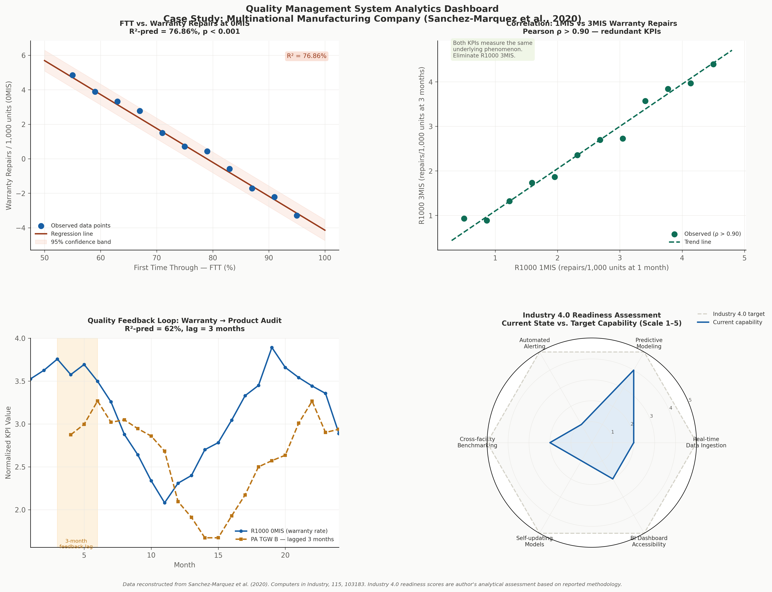
Figure 1. Quality Management System Analytics Dashboard. Data reconstructed from Sanchez-Marquez et al. (2020). Computers in Industry, 115, Article 103183. Industry 4.0 readiness scores represent the author's analytical assessment based on the reported methodology.

References

Duan, L., & Xu, L. D. (2021). Data analytics in Industry 4.0: A survey. Information Systems Frontiers, 24(6), 1–17. https://doi.org/10.1007/s10796-021-10190-0

Escobar, C. A., McGovern, M. E., & Morales-Menendez, R. (2021). Quality 4.0: A review of big data challenges in manufacturing. Journal of Intelligent Manufacturing, 32(8), 2319–2334. https://doi.org/10.1007/s10845-021-01765-4

Sanchez-Marquez, R., Albarracín Guillem, J. M., Vicens-Salort, E., & Jabaloyes Vivas, J. (2020). Diagnosis of quality management systems using data analytics: A case study in the manufacturing sector. Computers in Industry, 115, Article 103183. https://doi.org/10.1016/j.compind.2019.103183

