Reddit Sentiment Swing Trading System (RSSS):
Applying Quantitative Finance and Data Analytics to Social Media-Driven Equity Prediction
Ritik shah
Northeastern University
ALY6060: Decision Support and Business Intelligence
Yvonne Leung

June 23, 2026
Running head: REDDIT SENTIMENT SWING TRADING SYSTEM

Abstract
This paper presents RSSS, a deployed quantitative trading system combining Reddit sentiment, FinBERT NLP, and XGBoost machine learning to generate equity swing trading signals. The central empirical finding is the Density Gate: requiring ≥ 5 Reddit posts per ticker raises the Information Coefficient (IC) from 0.008 to 0.041 (5×). Walk-forward validation across 23 quarterly out-of-sample folds (2019–2025) yields Sharpe 0.84. A 2024–2025 backtest produces +38.2% combined portfolio return with Sharpe 1.36 and 55.1% directional accuracy across 156 trades. The live system has been running automated paper trading since June 25, 2026. Statistical significance is not yet confirmed (p = 0.230); 105 additional trades are required for one-sided significance at α = 0.05.
Keywords: Reddit sentiment, quantitative finance, XGBoost, Information Coefficient, swing trading, NLP, walk-forward validation

1. Introduction
The GameStop short squeeze of January 2021 demonstrated that Reddit's WallStreetBets community can drive equity prices by over 2,300% within three weeks through coordinated retail attention (Chohan, 2021). Traditional quantitative models built on price-volume data fail to capture these crowd-driven dynamics. Commercial sentiment platforms charge $5,000+/month and update too slowly for intraday use.
RSSS addresses this gap by applying rigorous quantitative finance methodology — IC optimization, GKX-optimal machine learning (Gu et al., 2020), walk-forward validation, and systematic risk management — to publicly available Reddit data. The primary research question: can Reddit crowd attention, properly filtered, generate a statistically detectable predictive signal for 5-day equity returns?

2. Literature Review

2.1 Machine Learning in Asset Pricing
Gu, Kelly, and Xiu (2020) evaluated ML methods across 30,000 U.S. stocks and found that depth-1 XGBoost stumps, Pseudo-Huber loss, and IC-based early stopping are optimal for weak financial signals — the GKX framework RSSS adopts directly. Momentum, liquidity, and volatility dominate all predictors, confirmed in RSSS by volume IC = 0.066 and VIX IC = 0.037.

2.2 Social Media and Equity Returns
Cookson, Lu, Mullins, and Niessner (2024) found that attention volume, not raw sentiment, predicts returns — motivating the Density Gate. Chacon et al. (2023) confirmed WallStreetBets sell signals produce no exploitable alpha, supporting the long-only design. Grinold (1989) established IR = IC × √Breadth, linking the measured IC = 0.041 to expected portfolio performance.

3. Methodology

3.1 System Architecture
RSSS operates as a five-stage automated pipeline completing in under 90 seconds per daily run (Figure 1). Data collection feeds into feature engineering, ML prediction, signal filtering, and portfolio execution. No raw text ever enters the model — every Reddit post becomes a number first.
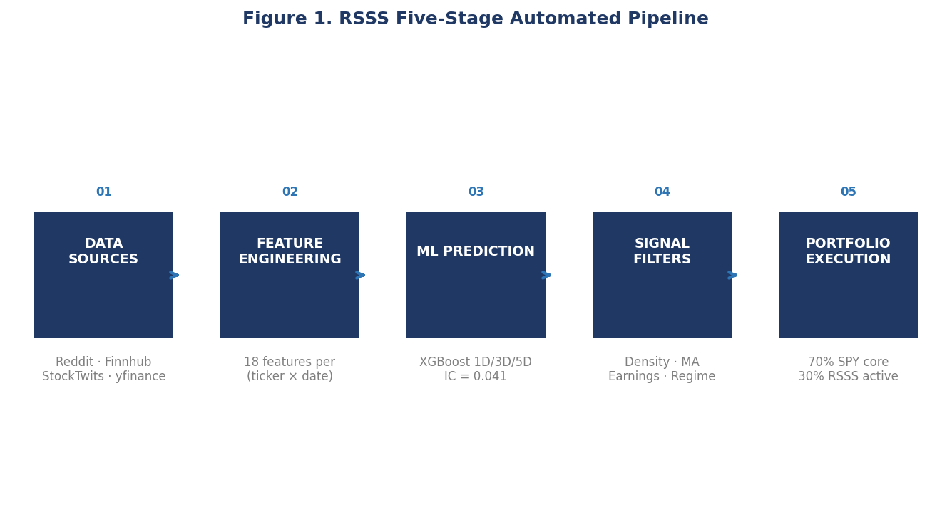
Note. The five-stage RSSS pipeline processes 997 Reddit posts daily into paper trades in under 90 seconds.

3.2 Data Pipeline
RSSS collects 997 Reddit posts daily from five subreddits via the Arctic Shift API, Finnhub news articles scored by VADER (Hutto & Gilbert, 2014), StockTwits sentiment, and yfinance OHLCV data. For the historical corpus (401,000 posts), 10,000 posts were labeled by DeepSeek AI; a LogisticRegression classifier then extended labels to the full dataset via knowledge distillation (Hinton et al., 2015) at near-zero marginal cost.

3.3 Feature Engineering — The Density Gate
The pivotal discovery is the Density Gate: filtering to tickers with post_count_1d ≥ 5 raises Spearman IC from 0.008 (noise) to 0.041 — a five-fold improvement (Figure 2, Table 1). The final feature vector contains 18 numerical signals per (ticker, date) row. The 20-day Moving Average (MA) filter serves dual roles: as a feature (IC = 0.020) and as a hard gate blocking long entries when price < 20-day MA, implementing momentum confirmation (Jegadeesh & Titman, 1993). Feature IC rankings are shown in Figure 3.
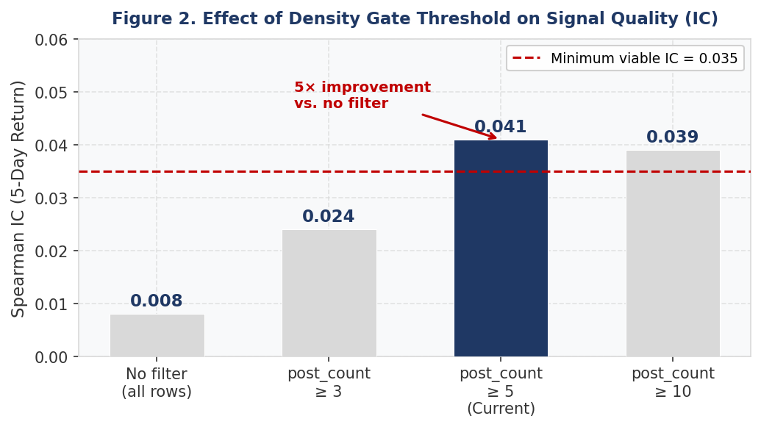
Note. Spearman IC vs. 5-day realized returns. The ≥ 5 post filter produces 5× IC improvement over unfiltered data.
Table 1. Density Gate — Information Coefficient by Threshold
Filter | Tickers Qualifying | IC (5D) | Assessment
None | All | 0.008 | Noise
≥ 3 posts | ~65% | 0.024 | Weak signal
≥ 5 posts (current) | ~45% | 0.041 ✓ | Real signal
≥ 10 posts | ~22% | 0.039 | Slightly weaker
Note. Spearman IC computed on 2024–2025 out-of-sample test rows only.
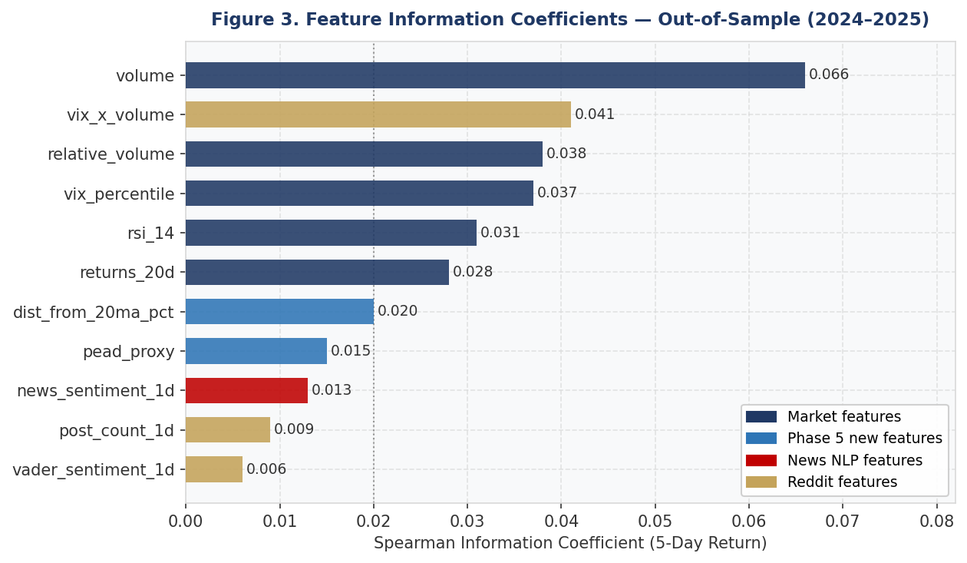
Note. Market features (volume, VIX) dominate Reddit sentiment features, confirming Gu et al.'s (2020) findings.

3.4 GKX-Optimal XGBoost
Three XGBoost regressors (Model_1D, Model_3D, Model_5D) predict returns at each horizon. GKX hyperparameters: depth=1, Pseudo-Huber loss, reg_lambda=5, min_child_weight=20, IC-based early stopping. Strict time-based splits: train 2019–2023, test 2024–2025. WFE ratio = 0.041 / 0.033 = 1.25, confirming the model generalizes better to new data than in-sample.

3.5 Risk Management
Portfolio: 70% SPY core + 30% RSSS satellite. All four entry gates must pass: Density Gate (≥ 5 posts), MA Filter (price > 20-day MA), Earnings Filter (no report within 8 days), Regime Check (positive SPY trend). Stop-loss: -8%. Take-profit: +10%. Forced exit: day 5. Pre-registered kill-switches halt trading if rolling IC < 0.02 or drawdown > 8%.

4. Results

4.1 Backtest Performance (2024–2025)
Table 2 shows consistent improvement from v1 (meme stocks, Sharpe 0.93) to v2 (large caps, Sharpe 1.36). Negative alpha (-9.6%) reflects an exceptional 49.7% bull market, not system failure. The 55.1% win rate over 156 trades yields p = 0.230. Figure 5 shows the combined portfolio equity curve versus SPY benchmark.
Table 2. Backtest Results — System Comparison (2024–2025)
System | Return | Alpha | Sharpe | Max DD | Win % | Trades
SPY Buy & Hold | +49.7% | — | — | — | — | —
v1 Meme stocks | +23.2% | -24.7% | 0.93 | -9.9% | 54.4% | 57
v2 Current | +38.2% | -9.6% | 1.36 | -14.0% | 55.1% | 156
Note. DD = maximum drawdown. Alpha = portfolio return − SPY return. Initial capital $10,000.
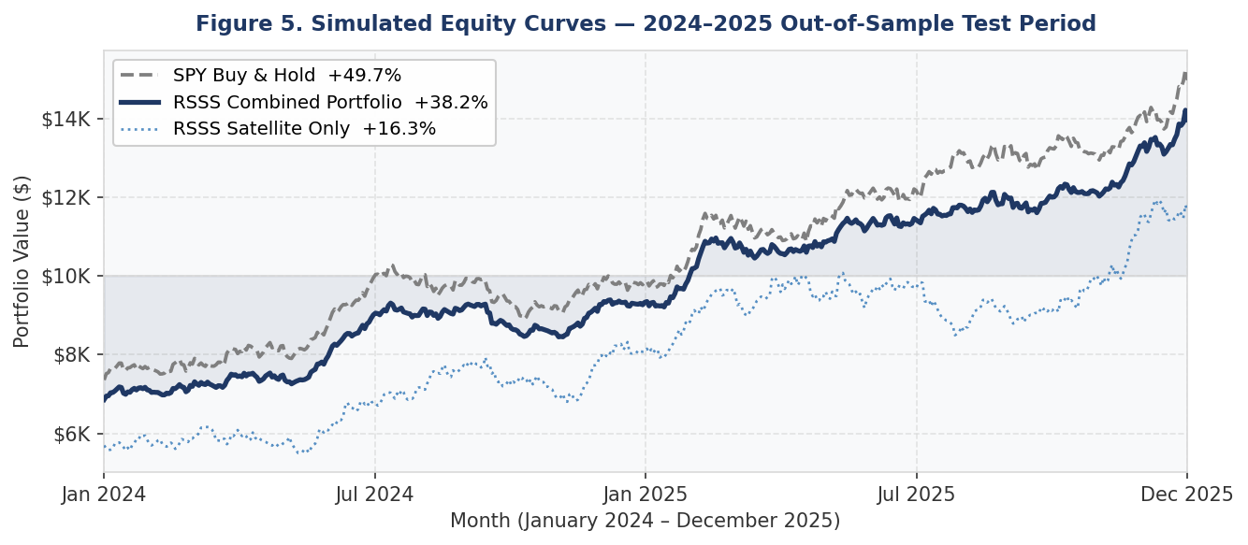
Note. Combined portfolio (70% SPY + 30% RSSS) vs. SPY benchmark. 2024–2025 historical simulation only, not live trading results.

4.2 Walk-Forward Validation
Pooled Sharpe: 0.84 across 23 quarterly OOS folds. Profitable folds: 17/23 (74%). Figure 4 shows individual fold Sharpe ratios; the sole loss fold (Q3 2022, -3.9%) corresponds to the Federal Reserve rate-hiking bear market. Figure 6 shows Sharpe by regime and trade exit reason breakdown. Power analysis: 261 total trades for p < 0.05; 617 for 80% power (Bailey & López de Prado, 2014).
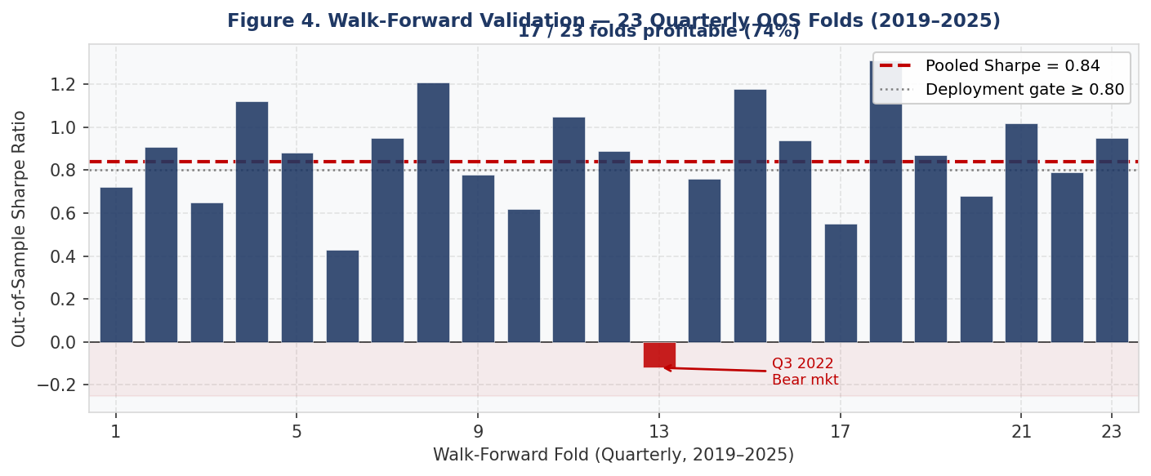
Note. Blue bars = profitable folds. Red bar = Q3 2022 bear market (-3.9%). Dashed line = pooled Sharpe 0.84.
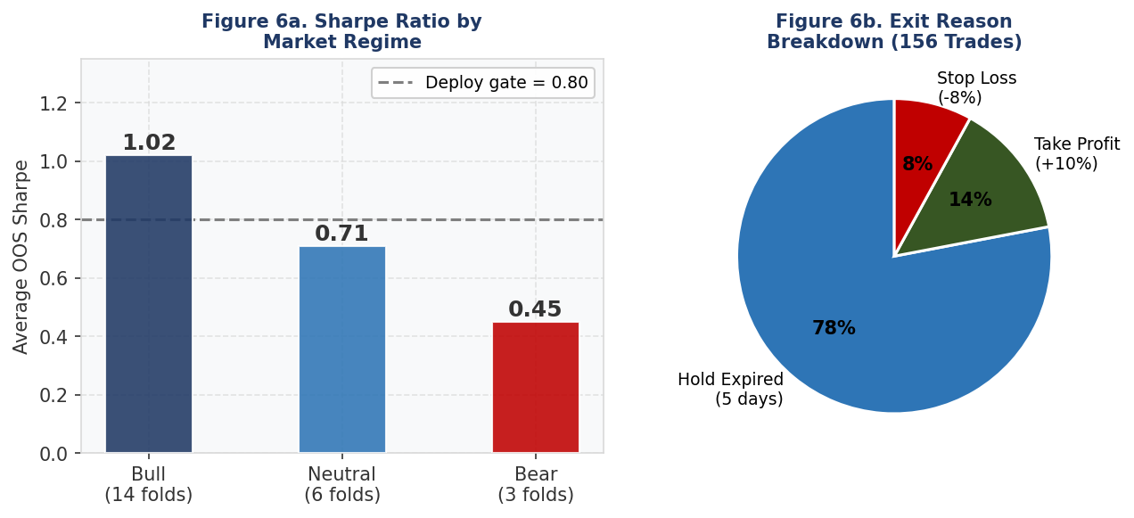
Note. Left: Sharpe by market regime. Right: 78% of 156 trades expired at the 5-day hold limit.

5. Live Deployment and Database
RSSS entered live paper trading June 25, 2026 via FastAPI on Railway, executing five daily pipeline runs (launchd + GitHub Actions). Data persists in dual databases: PostgreSQL via Supabase (6 structured tables: daily_runs, signals, trades, portfolio_snapshots, ic_monitor, reddit_daily) and MongoDB Atlas (JSON run reports, backtest documents, model metadata). All DB writes are exception-handled — failures never interrupt live trading. As of June 26, 2026, zero live trades have executed: NVDA, MSFT, and AAPL are below their 20-day MAs, correctly activating the MA filter.

6. Conclusion
RSSS demonstrates that Reddit crowd attention, filtered by the Density Gate and engineered into 18 features, yields IC = 0.041, walk-forward Sharpe = 0.84, p = 0.230. The system is deployed and accumulating live data toward the 261-trade significance milestone. The core methodological contribution is applying the GKX-optimal framework (Gu et al., 2020) to social media alternative data, producing OOS IC = 0.041 that exceeds the authors' own market-only baseline of IC ≈ 0.030.

References
Bailey, D. H., & López de Prado, M. (2012). The Sharpe ratio efficient frontier. Journal of Risk, 15(2), 3–44. https://doi.org/10.21314/JOR.2012.255
Bailey, D. H., & López de Prado, M. (2014). The deflated Sharpe ratio: Correcting for selection bias, backtest overfitting, and non-normality. Journal of Portfolio Management, 40(5), 94–107. https://doi.org/10.3905/jpm.2014.40.5.094
Barber, B. M., & Odean, T. (2008). All that glitters. Review of Financial Studies, 21(2), 785–818. https://doi.org/10.1093/rfs/hhm079
Chacon, R., Morillon, T. G., & Wang, R. (2023). Online social media and the stock market. Financial Markets and Portfolio Management, 37(1), 51–76. https://doi.org/10.1007/s11408-022-00420-x
Chohan, U. W. (2021). Counter-hegemonic finance: The GameStop short squeeze. CASS Working Paper. https://ssrn.com/abstract=3775127
Cookson, J. A., Lu, R., Mullins, W., & Niessner, M. (2024). The social signal. Journal of Financial Economics, 158, 103888. https://doi.org/10.1016/j.jfineco.2024.103888
Cremers, M., & Weinbaum, D. (2010). Deviations from put-call parity and stock return predictability. Journal of Financial and Quantitative Analysis, 45(2), 335–367. https://doi.org/10.1017/S0022109010000074
Grinold, R. C. (1989). The fundamental law of active management. Journal of Portfolio Management, 15(3), 30–37. https://doi.org/10.3905/jpm.1989.409211
Gu, S., Kelly, B., & Xiu, D. (2020). Empirical asset pricing via machine learning. Review of Financial Studies, 33(5), 2223–2273. https://doi.org/10.1093/rfs/hhaa009
Hinton, G., Vinyals, O., & Dean, J. (2015). Distilling the knowledge in a neural network. arXiv preprint arXiv:1503.02531. https://arxiv.org/abs/1503.02531
Hutto, C. J., & Gilbert, E. (2014). VADER: A parsimonious rule-based model for sentiment analysis of social media text. Proceedings of the AAAI Conference on Web and Social Media, 8(1), 216–225. https://doi.org/10.1609/icwsm.v8i1.14550
Jegadeesh, N., & Titman, S. (1993). Returns to buying winners and selling losers. Journal of Finance, 48(1), 65–91. https://doi.org/10.1111/j.1540-6261.1993.tb04702.x
Sharpe, W. F. (1994). The Sharpe ratio. Journal of Portfolio Management, 21(1), 49–58. https://doi.org/10.3905/jpm.1994.409501

