PROJECT REPORT

Auto Dialler for LPG gas leakage Notification

**Group Members:**

K Vishnu Bhargav (AM.EN.U4EAC21040)

L Ritish Rishi (AM.EN.U4EAC21043)

Ashrith Vardhan (AM.EN.U4EAC21075)

Sriram Sameer (AM.EN.U4EAC21087)

**Objective:**

The objective of this project is to develop an auto-dialler system using ARM7TDMI microcontroller that detects LPG gas leaks and automatically notifies the relevant authorities or individuals for prompt action. This system will be continuously able to monitor the gas levels, detect aby potential leaks, and initiate an automated message to the pre-configured contacts for immediate attention and necessary measure.

**Software’s used:**

* Keil uVision4
* Proteus 8 professional

**Block diagram:**

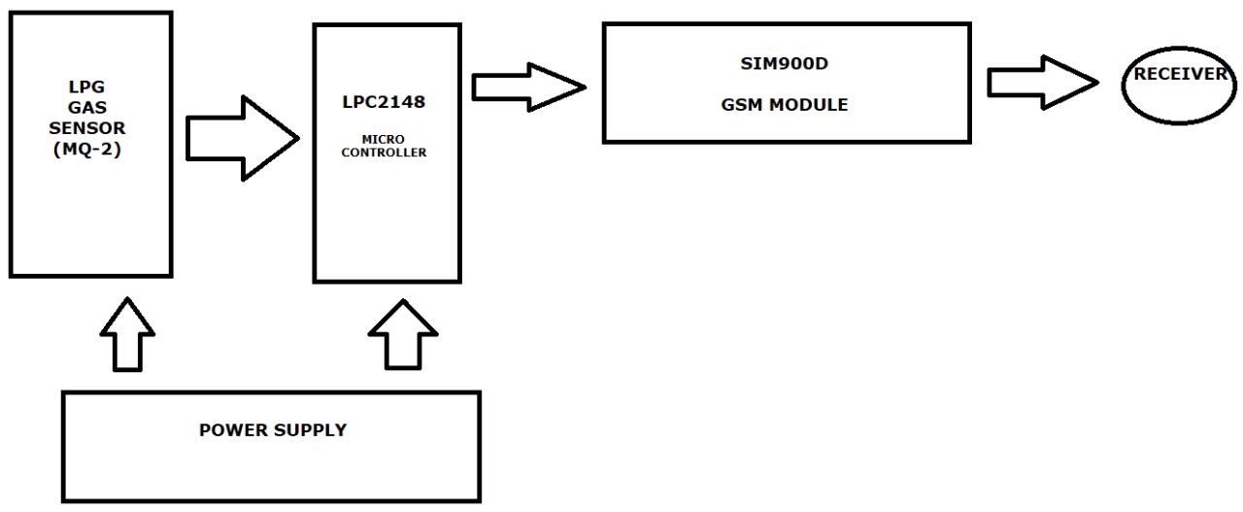

**Project description:**

Creating an auto-diallers for LPG gas leakage notification requires combining hardware and software components. Given below is a general description of how you can approach building such a system,

**Hardware Components:**

* **Gas Leakage Sensor:** Gas sensors (also known as gas detectors) are electronic devices that detect and identify different types of gasses. They are commonly used to detect toxic or explosive gasses and measure gas concentration. Here we used MQ-2 sensor which detects LPG gas.
* **Microcontroller:** A microcontroller (MCU for microcontroller unit, also MC, UC, or μC) is a small computer on a single VLSI integrated circuit (IC) chip. Here we used LPC2148.
* **GSM Module:** GSM module is used to establish a cellular connection and enable communication for sending notifications through phone calls or SMS messages. Here we used SIM900 gsm module.
* **Power Supply:** Here we gave a power supply of 3.3 V to the microcontroller and to the sensor.

**Working:**

An auto dialler for LPG gas leakage notification using the ARM7TDMI microcontroller involves several components and steps. Here's a high-level overview of how such a project could work:

1. Gas Leakage Detection: The project begins with the gas leakage detection mechanism. This typically involves using gas sensors, such as MQ-series gas sensors, to detect the presence of LPG gas in the environment. When a significant gas leakage is detected, the gas sensor sends a signal to the microcontroller.

2. ARM7TDMI Microcontroller: The ARM7TDMI microcontroller serves as the brain of the project. It receives signals from the gas sensor and processes them to trigger the necessary actions. The microcontroller should be programmed with appropriate firmware to handle the gas leakage notification process.

3. Phone Interface: To initiate an automated phone call for gas leakage notification, the ARM7TDMI microcontroller needs a phone interface. This can be achieved using a GSM module or a compatible cellular communication module. The module allows the microcontroller to communicate with the telephone network.

4. Programming Logic: The microcontroller's firmware should include the necessary programming logic to handle the gas leakage event. This logic typically involves the following steps:

a. Gas Leakage Detection: The microcontroller continuously monitors the gas sensor for any gas leakage events.

b. Triggering the Phone Call: When a gas leakage event is detected, the microcontroller activates the phone interface module to make an automated phone call.

c. Dialling the Phone Number: The microcontroller is programmed with the phone number(s) of the desired recipient(s). It dials the number using appropriate AT commands or APIs provided by the cellular module.

d. Message: After the call is connected, the microcontroller can send a message informing the recipient about the gas leakage. This message can include instructions on what actions to take, such as evacuating the premises and contacting emergency services.

e. Hang up or Repeat: Once the voice message is played, the microcontroller can either hang up the call or repeat the message multiple times to ensure the recipient receives the notification.

5. Power Supply: The project requires a suitable power supply to provide power to the gas sensors, microcontroller, and phone interface module. This can be achieved using a regulated power supply or a battery-powered setup, depending on the specific requirements and constraints.

6. Testing and Integration: After developing the hardware and programming the microcontroller, thorough testing and integration with the gas leakage detection system should be performed to ensure proper functionality and reliability.

It's worth noting that this overview provides a general idea of how an auto dialer for LPG gas leakage notification using the ARM7TDMI microcontroller could work. The actual implementation may vary depending on specific hardware components, programming language, development tools, and additional features required for the project.

**CODE: Functions program (UART):**

#include<LPC214x.h>

void Uart0Init()

{

PINSEL0=0x01;

U0LCR=0x83;

U0DLM=0x00;

U0DLL=97;

U0LCR=0x03;

}

unsigned char UART0_PutChar(unsigned char Ch)

{

while(!(U0LSR & 0x20));

U0THR=Ch;

return Ch;

}

void UART0_PutS(unsigned char *Ch)

{

while(*Ch)

UART0_PutChar(*Ch++);

}

void delay(int time)

{

unsigned int i,j;

for (i=0;i<time;i++)

for (j=0;j<5000; j++);

}

void call()

{

Uart0Init();

UART0_PutS("ATE0\r\n"); //disable echo

delay(1000);

UART0_PutS("ATD4762620555;\r\n"); //dial nearest karunagapally’s firestation number

delay(10000);

UART0_PutS("ATH0\r"); //hang call

delay(1000);

UART0_PutS("AT+CMGF=1\r\n"); //to select text mode

delay(1000);

UART0_PutS("AT+CMGS=\"4762620555\"\r\n");

delay(1000);

UART0_PutS("Alert there is a lpg leakage in this house of specified address\r"); //send message

delay(1000);

UART0_PutChar(0x1A);

}

**Main Program:**

#include<lpc214x.h>

#define bit(x) (1<<x)

#define delay for(i=0;i<25000;i++);

#define GAS (IO1PIN & (1<<24))

unsigned int i;

void lcd_int(void);

void dat(unsigned char);

void cmd(unsigned char);

void string(unsigned char *);

void main()

{

IO0DIR =0XFFF;

IO1DIR = 0x0;

lcd_int();

cmd(0x80);

while(1) {

if(GAS) {

call();

}

delay;

delay;

cmd(0x01);

}

}

void lcd_int()

{

cmd(0x38);

cmd(0x0c);

cmd(0x06);

cmd(0x01);

cmd(0x80);

}

void cmd(unsigned char a)

{

IO0PIN&=0x00;

IO0PIN|=(a<<0);

IO0CLR|=bit(8); //rs=0

IO0CLR|=bit(9); //rw=0

IO0SET|=bit(10); //en=1

delay;

IO0CLR|=bit(10); //en=0

}

void dat(unsigned char b)

{

IO0PIN&=0x00;

IO0PIN|=(b<<0);

IO0SET|=bit(8); //rs=1

IO0CLR|=bit(9); //rw=0

IO0SET|=bit(10); //en=1

delay;

IO0CLR|=bit(10); //en=0

}

void string(unsigned char *p)

{

while(*p!='\0') {

dat(*p++);

}

}

Although we have some functions which are not necessary in the circuit but if we remove the functions, the code isn’t working.

**Proteus Circuit Diagram:**

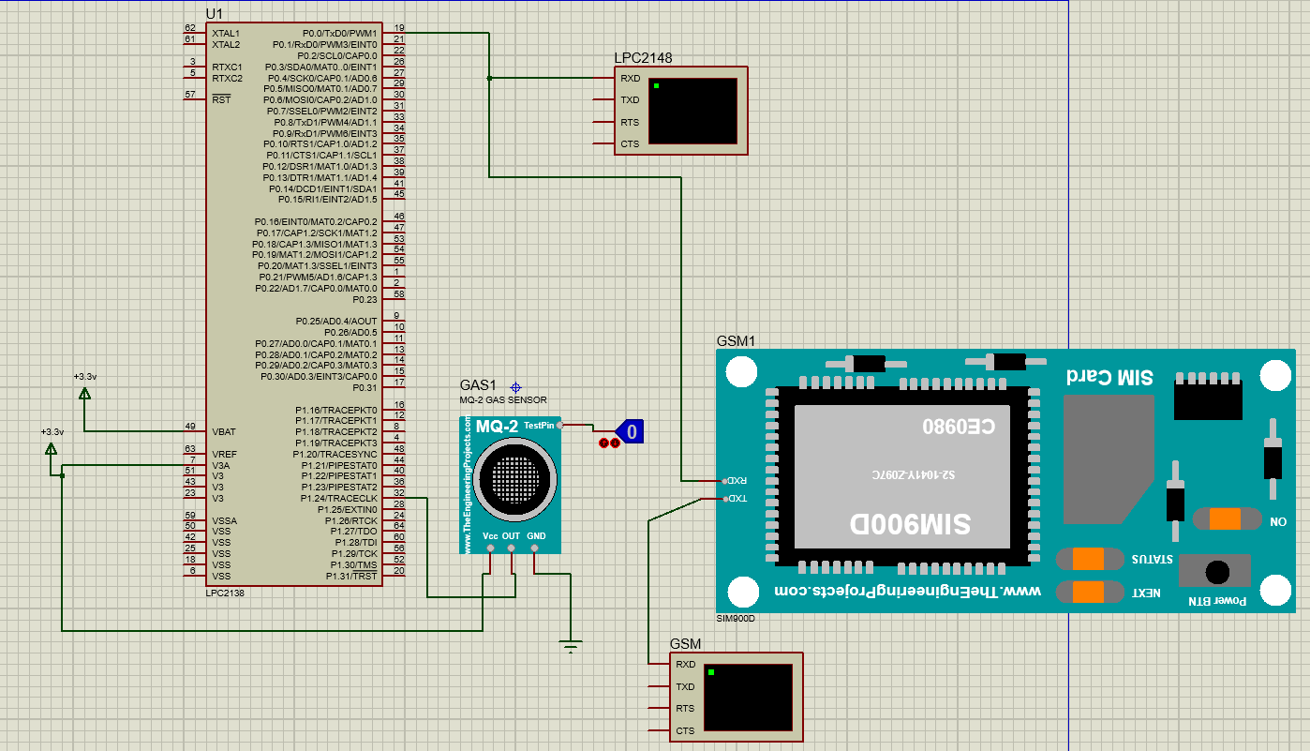

**Output:**

**When LPG gas sensor is off (logic state=0),**

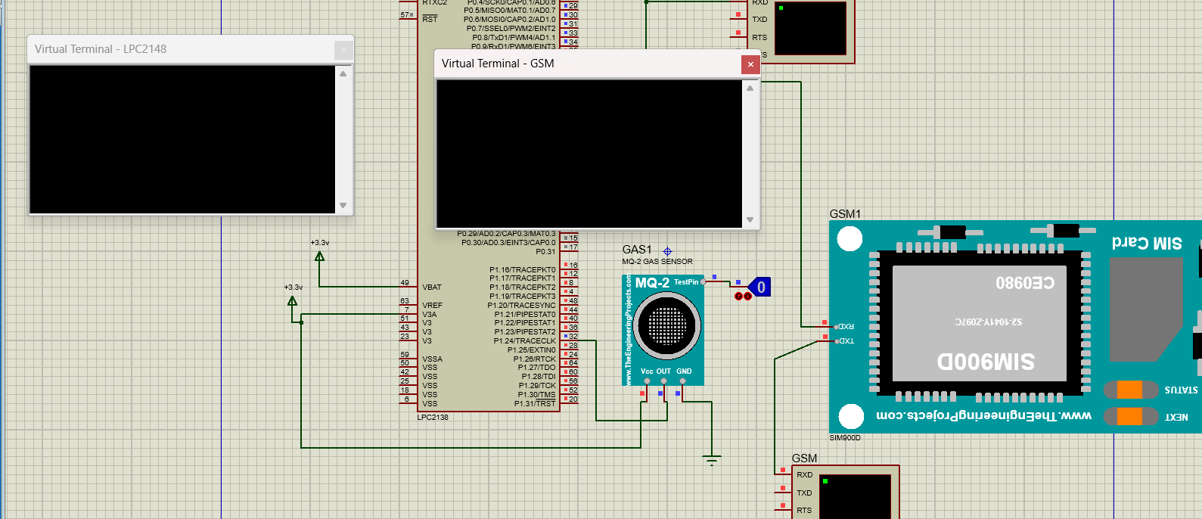

**When there is LPG gas sensor is on (logic state = 1),**

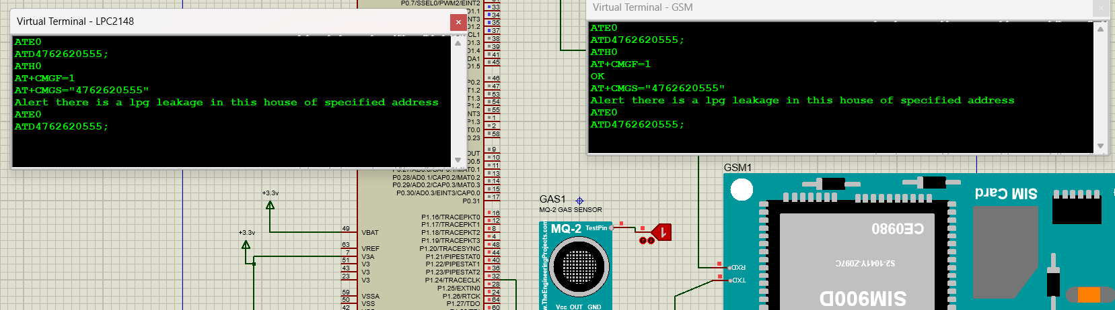

**Inference:**

Designing an auto dialler for LPG gas leakage notification using the ARM7TDMI microcontroller involves several components and steps. Here's an inference for the project:

1. Hardware Requirements:

- ARM7TDMI microcontroller: It is a 32-bit RISC microcontroller that offers sufficient processing power for this application.

- LPG Gas Sensor: A sensor capable of detecting LPG gas leakage.

- GSM Module: To enable communication and sending notifications via SMS or phone calls.

- Power Supply: A stable power source for the microcontroller and other components.

- Other supporting components: Resistors, capacitors, connectors, etc., as per the design requirements.

2. Software Requirements:

- Development Environment: Install the necessary software tools such as Keil uvision4, Proteus simulator, or similar for ARM7TDMI development.

- Programming Language: Use C or assembly language to write the firmware for the microcontroller.

- GSM Communication Library: Utilize libraries or APIs provided by the GSM module manufacturer to facilitate communication.

3. System Design:

- Connect the LPG gas sensor to the microcontroller to detect gas leakage.

- Interface the GSM module with the microcontroller for sending notifications.

- Implement necessary signal conditioning and interfacing circuits for proper integration.

- Design the firmware to continuously monitor the gas sensor for leakage.

- If gas leakage is detected, trigger the GSM module to send SMS or make phone calls to the specified numbers.

4. Firmware Development:

- Configure the necessary I/O pins and peripherals of the ARM7TDMI microcontroller.

- Implement interrupt routines or periodic polling to check the gas sensor's status.

- Write code to handle gas leakage events, including activating the GSM module.

- Develop functions to establish communication with the GSM module and send notifications.

- Implement error handling and recovery mechanisms in case of communication failures or sensor issues.

5. Testing and Deployment:

- Debug and test the firmware on the ARM7TDMI microcontroller to ensure correct functionality.

- Perform thorough testing with simulated gas leakage scenarios to verify the system's response.

- Deploy the auto dialer system in the desired location, ensuring proper connections and power supply.

- Conduct real-world testing to validate the system's performance and reliability.

Remember, the above steps provide a general inference for designing an auto dialler for LPG gas leakage notification using the ARM7TDMI microcontroller. Actual implementation may require additional considerations based on your specific requirements and the availability of components and tools.

******