1. IAM settings are region specific or NOT

A. IAM setting are universal (Global) i.e., IAM doesn’t require region selection.

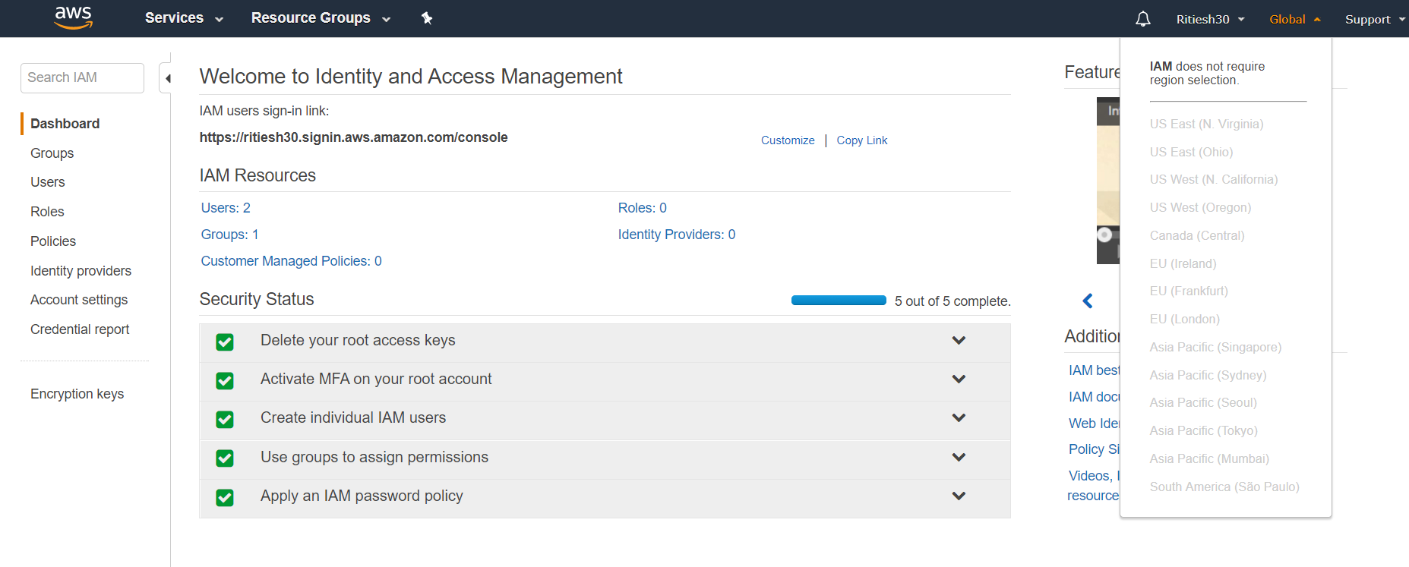

2. By default users have no permissions when first added

A. No, IAMUserChangePassword Permission is available to the user when the user has been created.

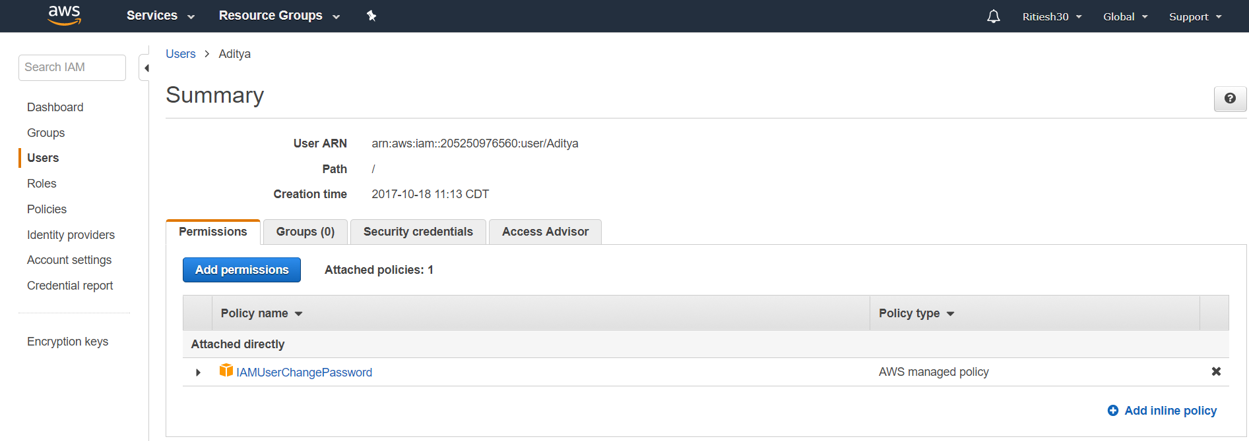

3. Active Directory Federation (AD) Can authenticate to AWS with AD using SAML

A. Yes, AWS can be authenticated with AD using SAML.

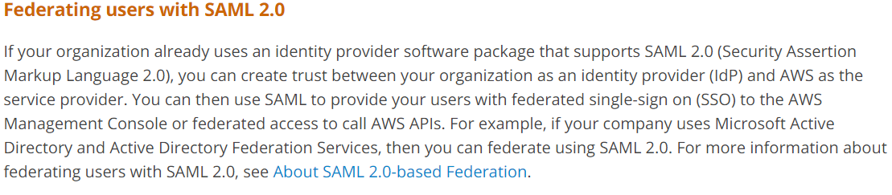

4. Web Identity Federation to AWS via Facebook or any other social sites

A. When you sign in with Facebook, it will trigger an event and you will receive an object that contains the access token. With the temporary token generated you can access AWS.

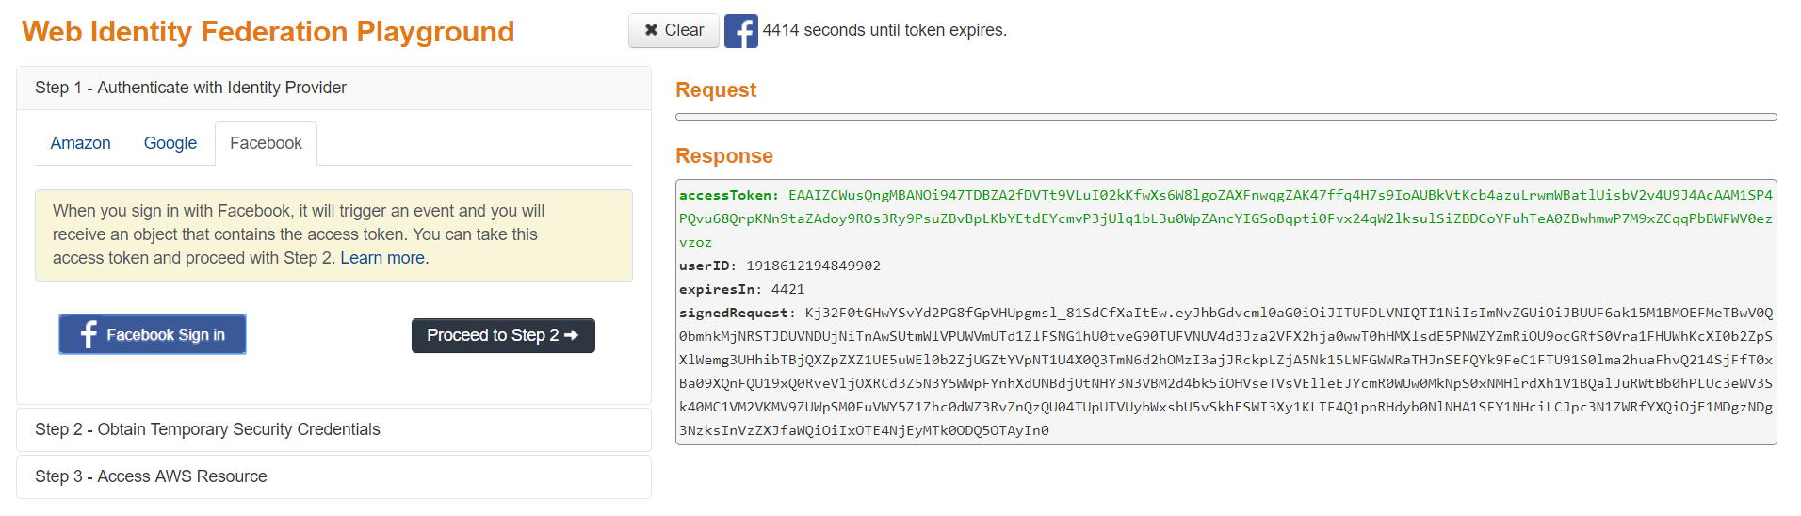

5. AssumeRoleWithWebIdentity API call used to obtain temporary security credentials when authenticating using Web Identity Federation?

A. By making an AssumeRoleWithWebIdentity call, we receive an temporary token to access AWS.