M.B.M. Engineering College, Faculty of Engineering

Department of Computer Science and Engineering

Jai Narain Vyas University, Jodhpur, Rajasthan



Usage Manual for the Minor Project On

**“Algorithm Visualizer”**

**Visualize Sorting Algorithms**

Made By Ritisha Gupta(19UITE9027) and Harsh Gupta (19UITE9010)

**Submitted by:**

Lakshita Sharma(19UITE9025)

Shreya Suroliya (19UITE9029)

Table of Contents

|  |  |  |
| --- | --- | --- |
| **Sr. No.** | **TOPIC** | **Pg. No.** |
| 1 | Introduction | 3 |
| 2 | Hardware Requirements | 3 |
| 3 | Software Requirements | 4 |
| 4 | Proposed Work | 4 |
| 5 | Navigation And Screenshots | 5 |
| 6 | Result | 7 |
|  |  |  |

1. INTRODUCTION

From the beginning of one's engineering as an Information Technology / Computer Science graduate, we always found it difficult or tricky to understand how these different Sorting algorithms work. We always get confused among them and are unable to visualize in order to understand them. To cope up with this problem, this team has come up with a solution to help to understand and visualize some sorting algorithms in a very interactive and beautiful way.

**Home Page**

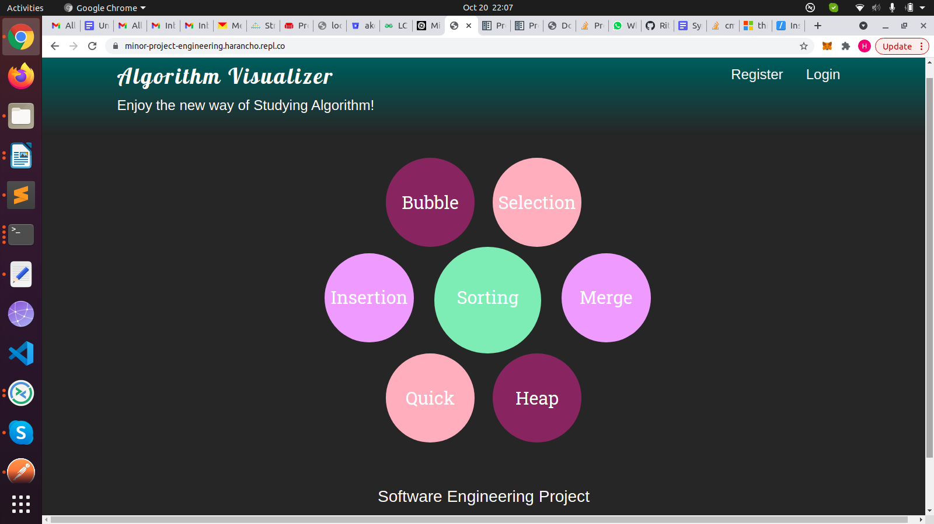

1. HARDWARE REQUIREMENTS

The most common set of requirements defined by any operating system or software application is the physical computer resources, known as Hardware. For current project Hardware Requirements are:

**Processor**: Intel core i5 + versions

**RAM**: minimum 4GB

**Hard Disk**: minimum 256GB

1. SOFTWARE REQUIREMENTS

Software requirements deal with defining software resource requirements and prerequisites that need to be installed on a computer to provide optimal functioning of an application.

For current project Software Requirements are:

**Operating System:** Windows 7 / Windows 10 / Linux / Mac

**Front End:** HTML, CSS, Bootstrap, JavaScript

**Back End:** Python (Flask Framework)

**Development Environments/Tools:** Replit Server for Hosting and real-time collaboration for development.

1. PROPOSED WORK

For a user to use this application , they first have to visit their website’s home page and click on the Register Button to register themselves. Without registering you are not allowed to use this application. After registering you will automatically get navigated to the login page where you have to enter your Login Credentials and then you will reach the visualization Page of the application.

**NOTE : Token based authentication is used in the app to prevent hackers from accessing the app without logging inn. If you try to access the URL of the visualization page directly , you will see a message of “Access Forbidden”.**

Ones you are on the Visualization page , you can see an input bar where you can enter the digits which you want to sort after selecting the suitable algorithm from the navigation bar. As soon as you click on submit button, you will see the bar-graphs are generated representing the numbers you just entered. Then you can click on start and the algorithm will start running and the screenshots of intermediate stages are placed below for illustration. You can reset the algo whenever you like and re-enter digits to sort them.

1. NAVIGATION AND SCREENSHOTS

When you enter the digits in the input Bar and click on submit, the bar graph appears similar to this.

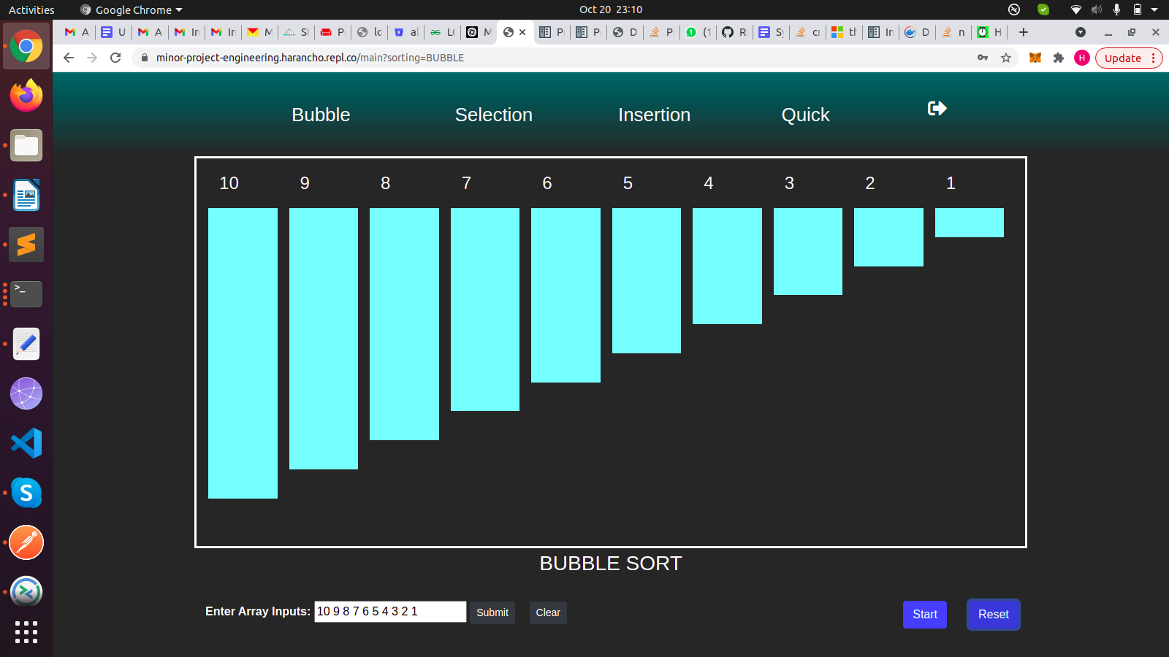

Intermediate image showing the sorted elements by “BLUE” color, the current element which is getting sorted by “RED” color and the rest by “CYAN” color. Bubble sort is being used in tis case.

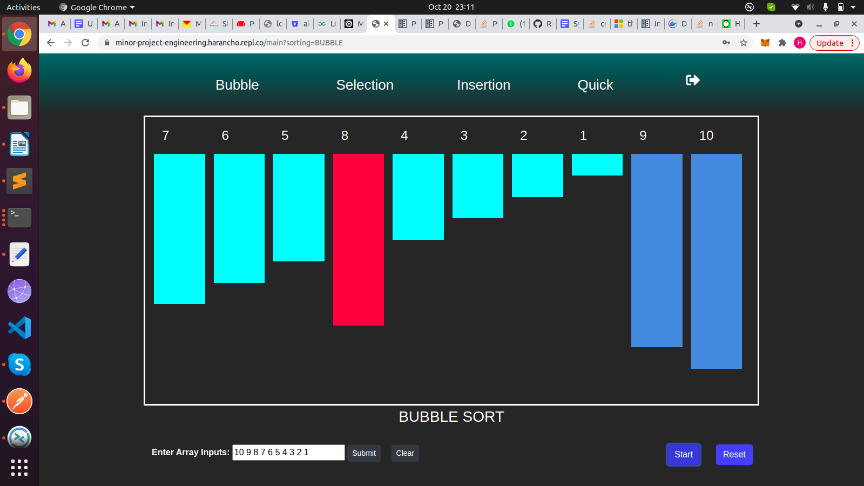

Finally Sorted Elements

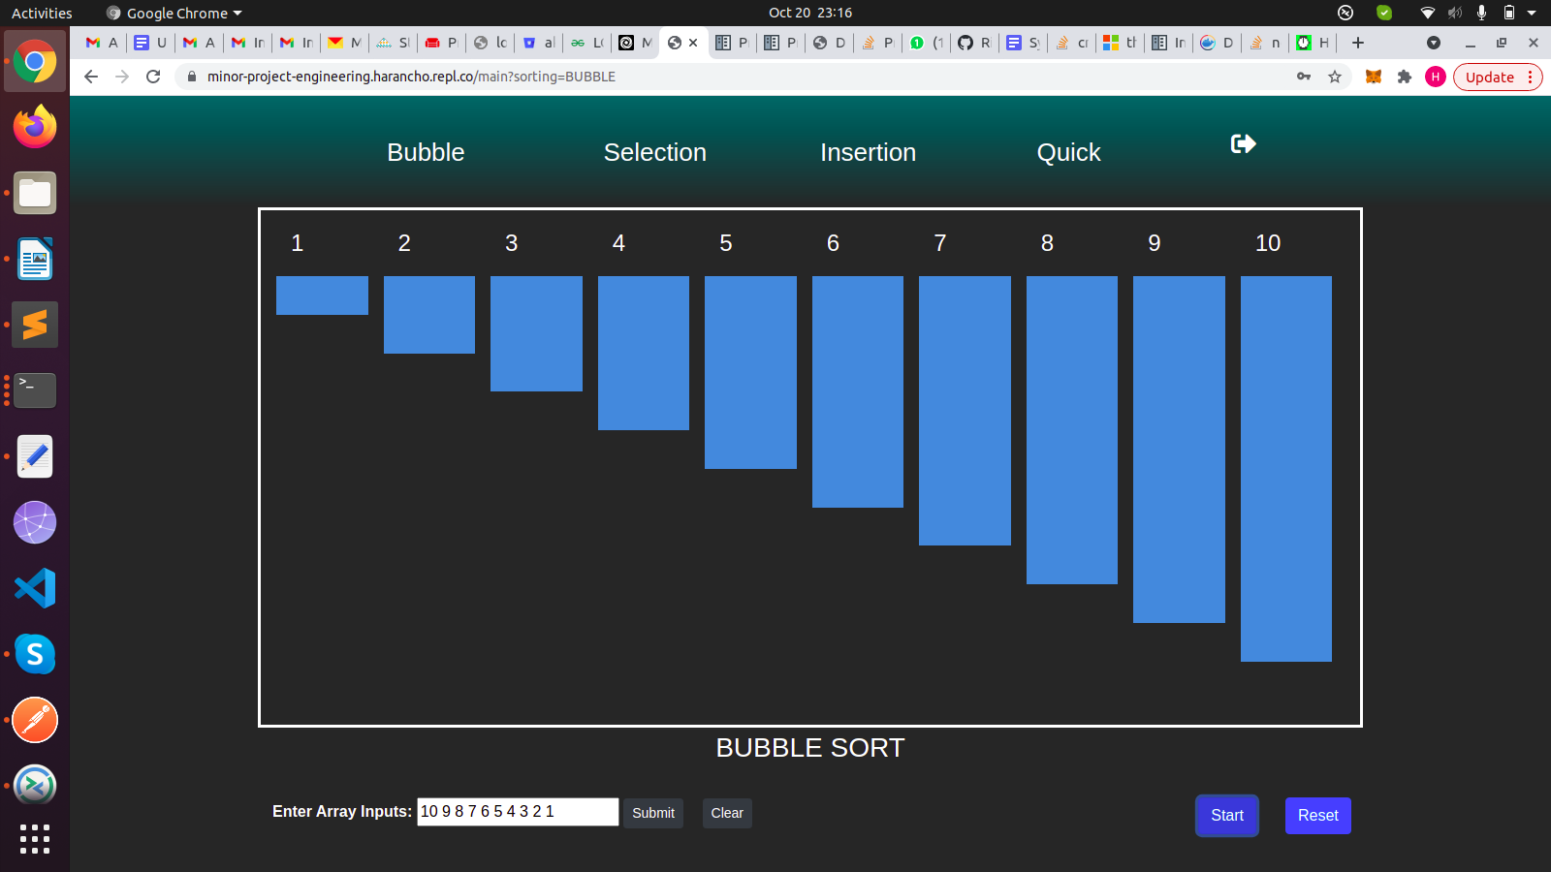

1. RESULTS

**Goals of proposed system:**

1. The application is easy to operate.
2. The working in the organization is well planned and organized.
3. The level of accuracy in the proposed system is higher.
4. The reliability of the proposed system is high due to proper storage of information.
5. Provide quick and efficient retrieval of information.

**Expected outcomes:**

1. Application is efficient to keep sort digits using multiple algorithms.
2. Proper arrangements and database of user passwords and token management is done.
3. Really easy for users to visualize the algorithm with the help of various color contrasts depicting various stages of the algorithm.
4. The application is useful for Beginners and Intermediate students who want to learn the algorithms.