**An Independent Project Report**

**Submitted in partial fulfilment**

**Of the regulations governing**

**The award of the**

**BIT (Hons.) Computing, 2020**

**Online Doctor Appointment System**

**RITISH SHAHI**

**100205773**

**9**

**Institute of Computer Science and Digital Innovation**

**UCSI**

**University**

**[**

**Jan, 2020**

**]**



Online Doctor Appointment System

A system for managing appointments and smoothly checking in patients to view consultants upon arrival

### Table of Contents

Acknowledgement

Abstract

Authorship Declaration

Chapter 1: Introduction

1.1 Background

1.2 Problem Statement

1.3 Aim

1.4 Objectives

1.5 Justification

1.6 Scope

1.7 Structure of the report

Chapter 2: Approaches and Deliverables

2.1 Approaches

2.2 Deliverables

2.3 Major Milestones

Chapter 3: Constrains and Assumptions

3.1 Constraints

3.2 Assumptions

Chapter 4: Synthesis

Chapter 5: Major Risks

Chapter 6: External Bodies Involved

Chapter 7: Project Plan

Chapter 8: References

### Table of Figures

Figure 1: Patients Use Case Diagram .............................................................................................

Figure 2: Administration Use Case Diagram ..................................................................................

Figure 3: Doctor Use Case Diagram ...............................................................................................

**Acknowledgement**

**Abstract**

**Authorship Declaration**

# Chapter 1: Introduction

## 1.1 Background

Everyone wants to be healthy since it is one of our fundamental needs as humans. People don't often risk their health therefore, they choose to work with those who have more credentials and expertise. Everybody has once gone to the hospital. Humans are susceptible to disease, and the majority of the time we seek expert assistance to treat the illness. However, the entire process is frequently highly chaotic. By choosing an appointment based on their preferences, the online doctor appointment system saves consumers' time. Doctor listings, patient profiles, patient databases, appointment scheduling, and management are some of the system's key features.

In today's world, technology has replaced certain human labor and has become a crucial tool for issue solving. As a result, everything has grown easier for us. This has a significant impact on the development of Online Doctor Appointment System Doctors, which is critical in the medical industry today. Doctors save savior and they should not be too far away from individuals in need of medical attention. Doctors should make their services accessible and available to their patients, since more and more people require medical treatment. This system was created so that clients could choose their preferred appointment time and medical professionals as per their requirement. The required system is designed for the patient that contains a login screen. Before login onto the system, the patient must first register. After logging in, the patient may choose a hospital and examine its details. The patient can choose a doctor from a list of doctors and examine the doctor's information. The patient can schedule an appointment on his or her favorite day and time. The patient can see the hospital's location. Furthermore, the patient can contact the hospital and the doctor via phone or by sending an email to the doctor.

Patients may schedule a doctor's appointment online at any time from the convenience of their homes using a computer, laptop, or mobile device. This web-based application solves the problem of maintaining and scheduling appointments in accordance with the preferences or needs of the user. The task of manually assigning appointments for the users in accordance with their availability can occasionally become quite laborious for the compounder or doctor themselves. As a result, this project provides a useful solution that allows customers to browse the many booking slots that are available and choose the ideal day and time. The reserved place will be highlighted in yellow and unavailable to others for the designated period of time. Customers can cancel their reservations at any moment using this method. The system also has an AI recommendation tool, which will suggest to users or customers the best hospital or doctor based on symptoms or diseases that have been identified. This system has connected doctors and patients on a single platform, allowing patients to be more flexible. They can sign up and look for a doctor's office depending on the position. The list of physicians will be made public and patients will be able to acquire by picking any time, with the admin required to confirm the booking. Every aspect of it is digitized and performed quickly, saving time. This provides a simple approach to provide a fast response to individuals who require the services of a medical professional. This system intends to deliver a user-friendly, error-free, dependable, and quick management system, as well as a feature that allows clients to view a list of physicians in their region. It also tries to reduce the amount of manual effort required to manage physicians, appointments, and patients.

Requirements and Basic Working of System

First thing first, anyone trying to access the features of the system should be registered to the system. For the doctor panel, doctor must register themselves to the system. The doctor can log in after successfully registering by providing a username and password. The doctor may see the booking requests made by users, and if the doctor approves the requests, the status will be displayed to the users as booking confirmed. Doctors can also see the feedback left by users. Similarly for the users to book a doctor, users must first register and log in. The search results will show a list of doctors who match the user's criteria, and he can select one and send a request. The request will be sent to the admin who will then pass it to the doctor. If the doctor is available, they will give the admin a confirmation request, after which the admin will update the booking request and inform the users that it has been confirmed. Also, the AI recommendation feature will recommend the list of doctors to the user being base on their diagnosed and symptoms.

## 1.2 Problem Statement

The primary issue with the online doctor appointment system is even when there are openings, it might be challenging to secure an appointment quickly. User may also need to have an account with a medical provider or an ID to make an online appointment booking. This may strict the new user if don’t have proper verification ID. This will lead to inadequate service to any user who fails to verify or in need of quick service. In addition, the previous appointment system was meant to reduce the specialist's inactive time, however current appointment system planning is dependent on specific factors including both the patient and the doctor. As a result, there is a requirement for developing a coordinated medical services system that can deal with all medical care data and provide an exceptionally long-lasting collaborating correspondence between the system segment and system consumers. The goal of this investigation is to identify and assess the present system for monitoring understanding data and medical care data.

The problem statements and project solution are shown in the following sections in the following ways:

* Writing down the patient's credentials in the journal is not only a time-consuming task, but it also has a higher risk of mistake. Making modifications to the details will likewise be a time-consuming task. Aside from that, digitalized material is easier to find and more secure. In this manner, user records will be maintained in a structured way.
* Users will also no longer have to contact the doctor's office repeatedly to find out about his or her schedule, as they will be able to check it thorough this system.
* Users will be alerted in advance about cancellations through the application utilizing various channels, such as SMS/Emails. In a similar manner, users can change their appointments in an emergency.
* Furthermore, if the person in charge of the appointment calendar must be changed for whatever reason, the new staff will be able to catch up quickly. This program also assists in reserving a bed on the road in the event of an accident or other essential situation.
* Internet access is required. Online booking might not be for the users if they excursions and activities are conducted in isolated locations without access to the Internet. They'll need dependable Internet access to verify your reservations and add any online bookings.

Numerous elements, such as fluctuating arrival and service time, patient and provider preferences, available information technology and the level of experience of the scheduling staff have an impact on appointment system success.

## 1.3 Aim

The main aim of this project is to offer a user-friendly, error-free, dependable, and quick doctor appointment system in addition to a feature that allows users to view a list of doctors in that specific location with AI recommendation feature.

## 1.4 Objectives

* To develop a web-based doctor appointment system.
* To reduce the amount of manual effort required to manage appointments, patients, and doctors.
* To decrease patient's waiting time with the aid of this system.
* To provide user the option to choose the appointment time that best suits them.
* To display slots that are booked and available, in an efficient graphical user interface.
* To study existing doctor appointment system.
* To provide service at all the time to required users.
* To manage all the required information related to doctor and appointment.
* To provide all the required details about the doctors and hospitals to the user.
* To develop a user-friendly Doctor Appointment System.

## 1.5 Justification

Firstly, online doctor appointment system provides value because customers can book anywhere, they have internet, rather than depending on staff availability to set their appointment up. This system is being implemented to improve user experience. Accessing this system is pretty simple. Establishing real-time connection while utilizing cutting-edge technologies. So, the user does not need to reload or refresh to view the update. Anybody, anywhere may readily access the system. Any user may simply utilize this system since it is very basic and user-friendly.

The application's primary aim is to offer a platform from which the user may choose a doctor who specializes in a certain specialty and make an appointment online. The program lists all of the doctors in a certain department together with information about their training, specialization, and availability. The suggested system will justify all of the course requirements since it will include sufficient documentation that will explain why the system is needed and what real-world problem it attempts to solve. By the end of the semester term, a functioning prototype with the essential documentation would have been developed validating the course requirements. Aside from meeting course requirements, the suggested system will also be capable of solving a real-world problem.

## 1.6 Scope

In existing practice of appointment system not only is writing down the patient's credentials in the logbook a time-consuming operation, but it also carries a larger chance of error. Making changes to the details will also be a time-consuming job.

The proposed web based online doctor appointment system holds the capacity to overcome the challenges that exists in current appointment system. The user will have no trouble using this system to handle all of the capabilities. Doctors will also use the system to monitor the patient's condition and provide further counseling. The goal of this system is to give dependable service in a short amount of time while increasing the number of patients who can be handled effortlessly.

The given are the scope of the system:

* In its original iteration, the system would be web-based. As a result, it is not suitable for desktop or mobile apps but may be visited through browsers.
* To make better use of resources by boosting productivity through automation.
* The system creates numerous forms of data that may be utilized for a variety of purposes.
* Recommend the doctor being based on symptoms or disease and provide location of the doctor.
* Have an appealing user interface.
* Reduce the time between appointments.
* Because the system is only available on the internet, it does not support offline interaction.
* The system meets user requirement and will be fully functional.

## 1.7 Structure of the report

# Chapter 2: Approaches and Deliverables

## 2.1 Approaches

Agile

The Agile SDLC methodology aims to accelerate change and get ahead of inefficient procedures. It replaces the command-and-control paradigm of Waterfall development with a strategy that anticipates and embraces change. Agile is a Software Development Lifecycle (SDLC) methodology that has gained a lot of traction in the IT sector. This strategy results in continuous release cycles, with each one including minor, incremental modifications from the last version. The product is examined after each iteration. The Agile methodology enables business stakeholders to provide input throughout the development process and assists teams in identifying and resolving minor project issues before they grow into more serious difficulties. Many teams use an agile framework known as Scrum to assist structure more complicated development projects as part of their adoption of this technique.

So for the best of development of the required system I believe that agile methodology of SDLC will provide the best frame work for fully developing this system.

Microsoft Visual Studio

The Visual Studio IDE (Integrated Development Environment) is a programming environment that allows developers to write and edit code. Its user interface is used to edit, debug, and build code in software development. Visual Studio comes with a code editor that supports IntelliSense and code refactoring. Both a source-level debugger and a machine-level debugger may be used with the integrated debugger. A code profiler, designer for creating GUI apps, web designer, class designer, and database schema designer are further built-in tools. It can generate both native code and managed code.

As per the requirements for developing this web-based doctor appointment system, Visual studio is one of the best software and provides accurate framework and required tools.

Also, for the programming language we have used Html, CSS, JavaScript and Python.

## 2.2 Deliverables

Since deliverables is overall progress of development of a project or system. This progress can be divided into certain stages, each stages having its own specific task. a. Planning

At this very first stage, project leaders analyze the project terms. This comprises assessing labor and material expenses, developing a timeline with target targets, and establishing the project's teams and leadership structure. Planning should explicitly identify the scope and goal of the project. It charts the route and prepares the team to produce the program efficiently. It also establishes limits to protect the project from growing or deviating from its intended objective.

1. Define requirements

Defining requirements is part of the planning process to identify what the application is meant to perform and its requirements. This stage entails gathering all of the precise details necessary for a new system as well as determining the initial prototype concepts. This comprises all of the software, hardware, and network specs for the system developers want to create. This will protect them from overdrawing cash or resources when operating in the same location as other development teams.

1. Design and Prototyping

Before moving on to the primary development stage, the design stage is required. The specifics of the entire application will first be outlined by the developers. A step in the design process that includes prototyping. A prototype is comparable to one of the early software versions created using the iterative software development approach. A fundamental concept of the application's appearance and functionality is shown.

1. Software development

During the development phase, programmers actually write code and create the application in accordance with the prior design documentation and detailed requirements.

The design document's specifications are followed while creating product program code. Using various tools including compilers, debuggers, and interpreters, developers will adhere to any code standards established by the firm.

1. Testing and deployment

Before making an application accessible to consumers, testing is essential. It is important to examine how well the application's various components interact with one another in order to minimize processing delays and hangs. The testing step assists in minimizing the amount of problems and glitches users’ experience.

Users can access the application during the deployment phase. The full software design will be completed after testing. Developer work will be used to launch and integrate various modules or designs into the main source code.

|  |  |
| --- | --- |
| **Phases** | **Deliverables** |
| Planning and Define Requirements | Business requirements report  A high-level strategy document and a conceptual system design plan |
| Design | Use Case, Activity diagram, sequence diagram, ER diagram |
| Development | Source code |
| Testing and deployment | Unit testing, User Acceptance Test |

# Chapter 3: Constrains and Assumptions

# Chapter 4: Synthesis

Use case Diagram of Online Doctor Appointment System

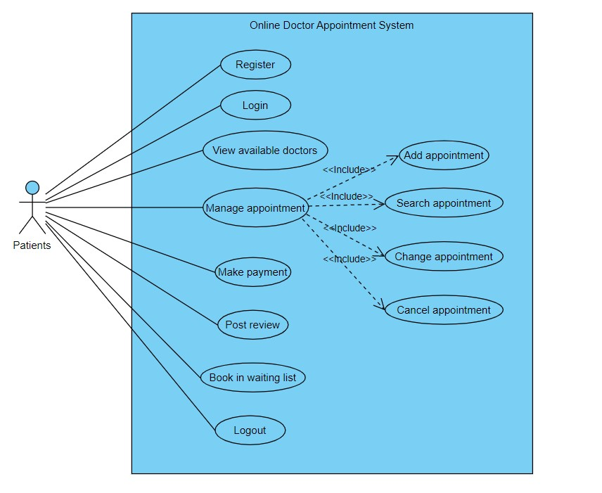

#### Figure 1: Patients Use Case Diagram

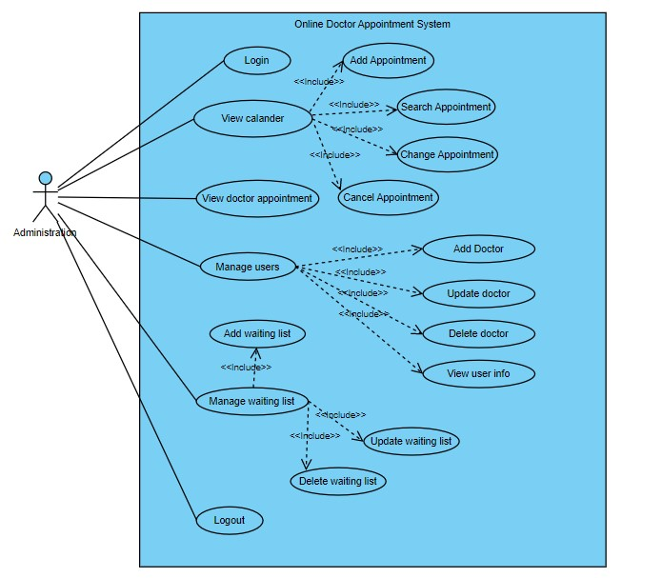

#### Figure 2: Administration Use Case Diagram

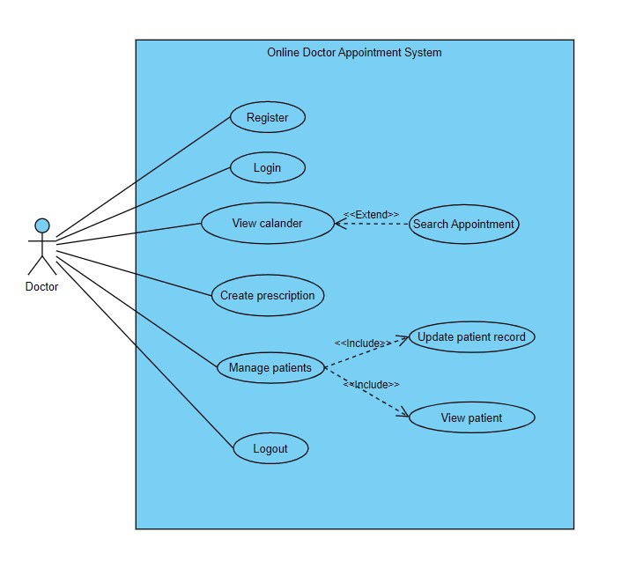

*Figure 3: Doctor Use Case Diagram*