SC6113 Group Project Report — Integration Testing, Deployment & Final Integration (Member E)
Project: Freelancer Milestone Payment DApp
Repository: GitHub Rito520/SC6113 Branch: D-integration (baseline commit a0bcad1)
Report date: 2026-10-15 Author: Member E (responsible for integration testing, system testing, deployment and final integration)
Team split: Member A — requirements & functional specification; Member B — smart contracts; Member C — backend API & on-chain receipt verification; Member D — frontend & wallet integration; Member E (author) — integration testing, system testing, deployment and final integration.

Part 1 System Architecture

1.1 Architecture Diagram
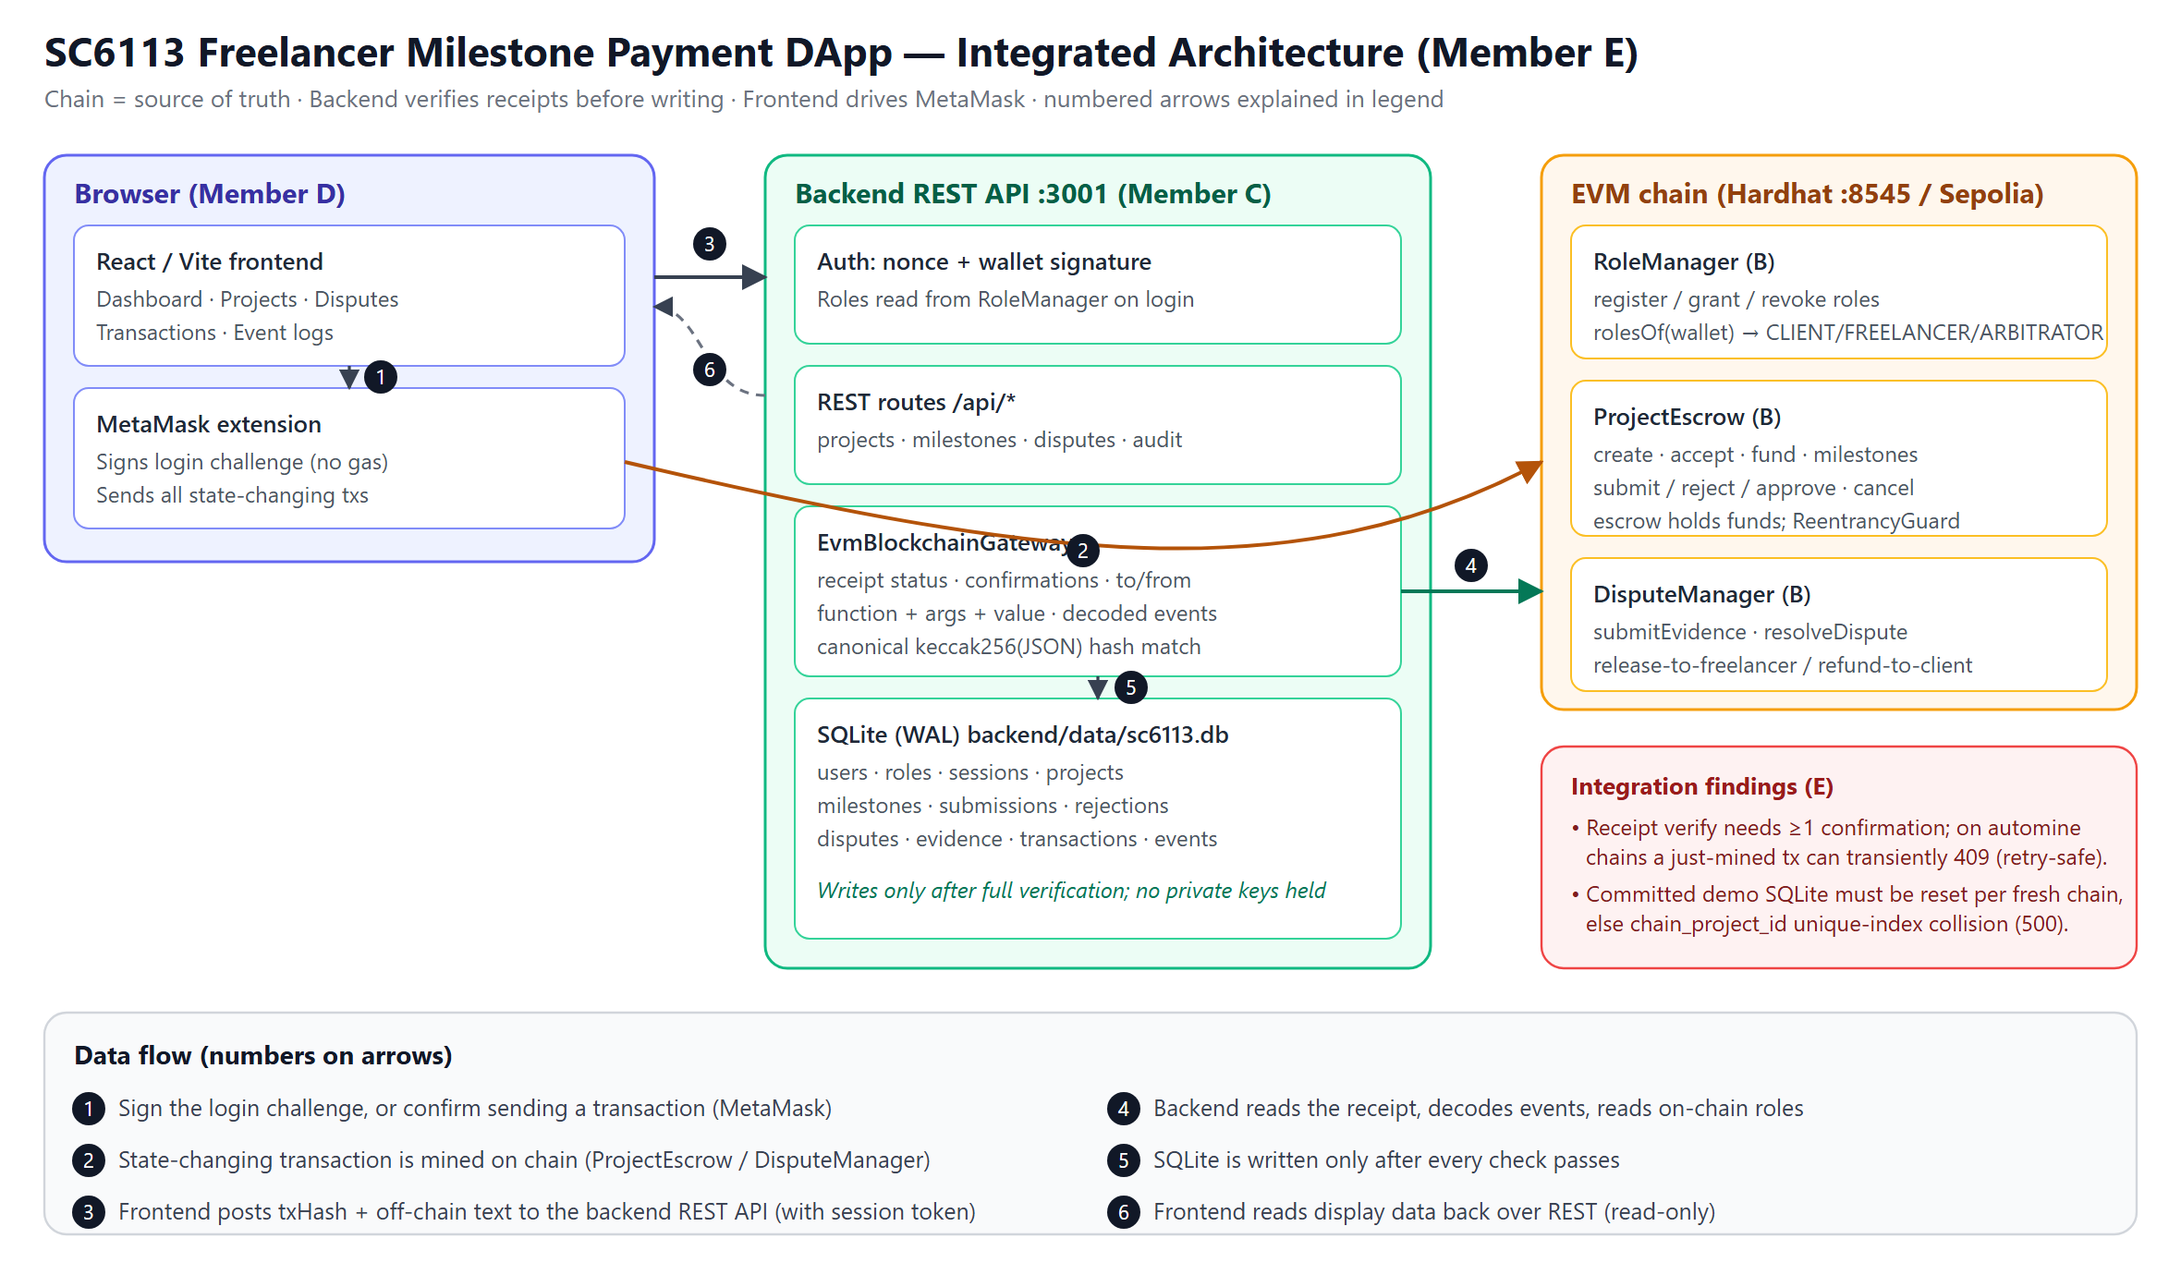
SC6113 system architecture
The numbered arrows 1–6 follow the "Data flow" legend at the bottom of the diagram; the red box at the bottom right marks the integration-test findings (see Part 2, §2.4, E-01).

1.2 Components & Responsibilities

Component | Stack | Responsibility
Frontend (D) | React + TypeScript + Vite + wagmi/viem | Workspaces for the three roles; MetaMask connection; builds the canonical JSON locally and computes its hash; sends on-chain transactions; submits the transaction receipt plus the off-chain payload to the backend for recording
Backend (C) | Node.js + TypeScript + Express + SQLite (node:sqlite) | SIWE-style signature auth with on-chain role checks; REST API; verifies every transaction against its on-chain receipt (sender, target contract, function arguments, value, confirmations); writes to the database only after verification passes; audit tables (transactions / events / evidence / disputes)
Smart contracts (B) | Solidity 0.8.24 + Hardhat | RoleManager (on-chain role registration), ProjectEscrow (escrow & milestone-payment state machine), DisputeManager (dispute resolution & refunds); 32 unit tests
Local blockchain | Hardhat Network (chainId 31337) | Demo & test environment; instant mining

1.3 Core Data Flow (one typical operation)
- The user fills in a web form → the frontend assembles the canonical JSON and computes its keccak256 hash;
- The user signs via MetaMask and the transaction is sent to the on-chain contract;
- The frontend submits "transaction hash + off-chain payload" to the backend REST API;
- The backend fetches the on-chain receipt and verifies sender wallet, target contract, function arguments, value and confirmations;
- Only after verification passes does it write to SQLite (transaction table, event table, project/milestone/dispute state);
- The frontend reads backend data to render the UI and audit pages.
This "on-chain first, verify, then persist" design guarantees that every database record is backed by a corresponding on-chain transaction.

1.4 Roles & Permissions
The three roles (Client / Freelancer / Arbitrator) must each be registered in the on-chain RoleManager before they can log in (the backend checks on-chain roles at login). The permission matrix is enforced twice — by contract requireRole and by backend requireRoles: e.g. only a Client can create and fund a project, only a Freelancer can submit a milestone, only an Arbitrator can resolve a dispute. Unauthorized actions revert at the contract level and return 403 at the backend level.

Part 2 Test Report
Test environment: Windows 11 / Node v22.14.0 / pnpm 12.11.2 / Hardhat local chain (chainId 31337)
Test script: backend/e2e/e2e-integration.mjs (written by Member E; machine-readable results in backend/e2e/e2e-results.json)

2.1 Summary of Results

Level | Result
B — contract unit tests | 32/32 passed
C — backend API tests | 2/2 passed
C — backend real-receipt integration test (RUN_EVM_INTEGRATION=true) | 1/1 passed
D — frontend production build | Success (194 modules, no type errors)
E — end-to-end integration tests (real chain + real backend, 17 cases) | 17/17 passed

On the local Hardhat + SQLite + MetaMask-compatible flow the system is functionally correct, permission-correct, and receipt verification works. Five issues were found (§2.4): one frontend defect (E-04) was fixed by E and re-tested to green, one is recommended to fix before deployment (E-01), and the rest are environment-operation items and a documentation gap — none blocks the local demo.

2.2 Baseline Tests
cd contracts; npm test # 32 passing
cd ..\backend; pnpm typecheck; pnpm test # 2 pass (+1 skipped integration test)
$env:RUN_EVM_INTEGRATION='true'; pnpm test # 3 pass (incl. real-receipt integration test)
cd ..\frontend; npm run build # ✓ built

The real-receipt integration test reads RoleManager.rolesOf and checks the acceptProject receipt for sender wallet / target contract / function arguments / ProjectAccepted event — all pass, proving the contract-to-backend connection holds on a real chain.

2.3 End-to-End Integration Tests (17 cases, all passed)
Method: the test script replicates exactly how the frontend calls the system — same contract functions, same canonical hash keccak256(JSON.stringify(…)), same REST request bodies — and verifies the full "MetaMask transaction → receipt verification → SQLite record" chain under CHAIN_MODE=evm. Permission negative cases use staticCall simulation (zero gas, zero on-chain side effects).

Case | Coverage | Result
ENV-01 | Backend health=evm, RPC chainId=31337 | PASS
AUTH-01 | All three roles log in via nonce+signature; /api/me returns correct on-chain roles | PASS
AUTH-02 | Unregistered wallet rejected at nonce stage (403) | PASS
AUTH-03 | Tampered signature rejected (401) | PASS
A-01 | Client creates project on-chain → backend verifies receipt and persists (2 milestones, 0.01 ETH) | PASS
A-02 | Non-mined hash rejected (409 TRANSACTION_NOT_MINED) | PASS
A-03 | Freelancer accepts → Client funds → ACTIVE; on-chain escrow balance = 0.01 ETH | PASS
A-04 | Unauthorized actions (freelancer funds / freelancer creates / client starts milestone) all rejected | PASS
A-05 | Milestone 1: start → submit → approve, status APPROVED | PASS
A-06 | Milestone 2: submit → approve, project COMPLETED, escrow drained to zero, freelancer balance increased | PASS
A-07 | Audit tables: ≥8 transaction records + 5 event types persisted correctly | PASS
NEG-01 | On-chain hash ≠ REST payload hash → 422 rejection, nothing written to DB | PASS
B-01 | Dispute project: create → accept → fund | PASS
B-02 | submit → reject → resubmit → freelancer raiseDispute, project DISPUTED | PASS
B-03 | Dispute listing, evidence submission, non-party operations rejected | PASS
B-04 | Non-arbitrator gets 403; arbitrator resolve → RESOLVED, project back to ACTIVE | PASS
C-01 | Cancel a not-yet-started project → CANCELLED, on-chain state consistent | PASS

Coverage notes — covered: full payment happy path, reject-resubmit, dispute-evidence-resolution, cancel-refund, negative cases for roles/signatures/hashes, audit and event persistence. Not covered: the 7-day silent-period self-claim claimAfterReview and pause administration paths (require time travel; covered by contract unit tests); real-browser MetaMask pop-up interaction (covered by the demo presentation; step-by-step guide in E-DEMO-GUIDE.md).

2.4 Findings
E-01 (fix recommended before deployment) Timing window in backend confirmation check. EvmBlockchainGateway.verifyAction computes confirmations with a default-polling (~4 s) provider; under Hardhat instant mining, a receipt submitted immediately after mining returns 409 INSUFFICIENT_CONFIRMATIONS, and succeeds on retry 2–4 s later. Because verification failure happens before any DB write, retrying is safe with no duplicate records (triggered 18 times in this run; all retries succeeded). Recommendation: use receipt.waitForConfirmations or a short wait before deciding.
E-02 (environment operation) The demo database must be reset with every new chain. Projects in an old SQLite file occupy the (chain_id, chain_project_id) unique index and collide with project IDs on a restarted chain, causing 500 on project creation. The reset procedure (stop backend → move backend/data/sc6113.db* away → restart) is verified; see Part 3, §3.2.
E-03 (documentation gap) The .env.example files referenced by the README do not exist in the repo. Following the README's copy command fails. backend/.env was recreated from config.ts defaults; committing .env.example is recommended.
E-04 (frontend defect, fixed) Wrong event field name breaks dispute resolution and evidence submission.** In `frontend/src/services/api/index.ts`, `chainDisputeId` is rebuilt from the `DisputeRaised` event by reading `args.milestoneIndex`, while the contract's event parameter is named `index` — the match always fails, `chainDisputeId` stays empty, and the Disputes page calls `resolveDispute`/`submitEvidence` with id=0, which reverts. Fixed by changing the field to `args.index`; the full dispute flow (including arbitrator RESOLVED) was re-tested and passes. **This fix must be committed with the branch.
E-05 (minor frontend defect, fix recommended) First load after a full page refresh on the project detail page returns 401. When /projects/:id is loaded via a hard refresh, the page's data-loading effect runs before the session provider restores the token (React child effects run before parent effects), so the first request is sent without a token → 401; a second navigation recovers. In-SPA click navigation is unaffected. Recommendation: defer detail-page loading until the session is ready.
Design notes (not defects): GET /api/disputes does not return chainDisputeId; the frontend and this test script both parse it from the DisputeRaised event/receipt (consistent with D's implementation). When receipt verification rejects a record, the on-chain and database states intentionally diverge (the chain event happened; the DB does not record it), converging via subsequent business actions.

2.5 Reproduction
# Terminal 1: contracts → npm run node
# Terminal 2: contracts → $env:SEED_DEMO='true'; npm run deploy:localhost
# Terminal 3: backend → pnpm start (requires .env first, see E-03)
# Terminal 4: backend → node e2e/e2e-integration.mjs

Part 3 Deployment Guide

3.1 Final Runtime Environment (local demo)

Service | Address | Status
Hardhat local chain | http://127.0.0.1:8546 (chainId 31337) | Running
Backend REST API | http://localhost:3001 (CHAIN_MODE=evm) | Running
Frontend (Vite) | http://localhost:5173 | Running

Contract addresses (deterministic first deployment on localhost): RoleManager 0x5FbDB2315678afecb367f032d93F642f64180aa3, ProjectEscrow 0xe7f1725E7734CE288F8367e1Bb143E90bb3F0512, DisputeManager 0x9fE46736679d2D9a65F0992F2272dE9f3c7fa6e0.
Demo roles (local testing only — never use with real funds): Hardhat accounts #1 = Client, #2 = Freelancer, #3 = Arbitrator (roles registered on-chain automatically when deploying with SEED_DEMO=true).

3.2 Reproducing the Local Environment from Scratch (four terminals)
Prerequisites: Node.js ≥ 22, npm, pnpm (npm i -g pnpm), MetaMask extension.
# Terminal 1: local chain
cd D-integration\contracts
npm ci
npm run node

# Terminal 2: deploy + seed roles (must redo after every chain restart)
cd D-integration\contracts
$env:SEED_DEMO='true'
npm run deploy:localhost # generates deployments/localhost.json and abi/

# Terminal 3: backend
cd D-integration\backend
pnpm install
# The repo lacks .env.example (see E-03); create backend\.env manually:
# CHAIN_MODE=evm
# PORT=3001
# FRONTEND_ORIGIN=http://localhost:5173
# RPC_URL=http://127.0.0.1:8546
# CHAIN_ID=31337
# CHAIN_CONFIRMATIONS=0
# ROLE_MANAGER_ADDRESS / PROJECT_ESCROW_ADDRESS / DISPUTE_MANAGER_ADDRESS
# (from deployments/localhost.json; identical to §3.1 for the first deployment)
pnpm start # prefer start (no watch) for demos; watch restarts interrupt long flows

# Terminal 4: frontend
cd D-integration\frontend
npm ci
npm run dev # frontend reads the committed localhost.json; no .env needed

Verify: http://localhost:3001/health returns {"status":"ok","chainMode":"evm"}; open http://localhost:5173 in a browser.
MetaMask setup: add a network (RPC http://127.0.0.1:8546, Chain ID 31337, symbol ETH) and switch to it; import the #1/#2/#3 private keys printed by Hardhat on startup. If MetaMask shows nonce issues after a chain restart: clear activity data for the network (Settings → Advanced → Clear activity tab data) and reconnect.
Port note: the repo and README originally defaulted to 8545; because port 8545 on the demo machine is occupied by another tool (Ganache), the project now uses 8546 everywhere (contracts/package.json, hardhat.config.js, backend/.env, MetaMask network config). On other machines keep all four places consistent.
Reset procedure (for clean demo data): stop backend and chain → restart npm run node → redeploy with SEED_DEMO → confirm localhost.json and .env addresses match → move backend/data/sc6113.db* away (rename; do not delete) → start the backend. The old database must be reset with every new chain, otherwise the E-02 unique-index conflict occurs.

3.3 Sepolia Testnet Deployment Plan (optional)
hardhat.config.js already includes a sepolia network (reads env vars SEPOLIA_RPC_URL, PRIVATE_KEY):
- Prepare: a public RPC (Alchemy/Infura free tier is fine), a dedicated deployer wallet private key, some SepoliaETH (from a faucet), optionally an Etherscan API key for contract verification.
- Deploy:
cd contracts
$env:SEPOLIA_RPC_URL='https://…'; $env:PRIVATE_KEY='0x…' # never commit
npx hardhat run scripts/deploy.js --network sepolia # without SEED_DEMO

Roles are then registered by the real demo wallets themselves via registerAsClient/registerAsFreelancer; the arbitrator role is granted by the deployer via grantRole.
- Configure: write the three new contract addresses into backend/.env (RPC_URL → public RPC, CHAIN_ID=11155111, CHAIN_CONFIRMATIONS ≥ 2 recommended); update the frontend address configuration; set FRONTEND_ORIGIN to the frontend's public domain.
- Backend hosting: single-node SQLite suits demos only; multi-instance deployments need a hosted database plus formal migrations; restrict CORS to the frontend domain.
- Frontend hosting: static hosting of the npm run build output on Vercel/Netlify/GitHub Pages.
- Acceptance: /health shows evm with the correct chainId; run create→fund→submit→approve with test wallets; contracts and events visible on Etherscan.
Note: .env, private keys and deployments/localhost.json must never be committed; a Sepolia deployment record may be saved separately as deployments/sepolia.json and committed (it is a formal deployment record, unlike localhost artifacts).

3.4 Commit Rules (following the repo .gitignore)
Commit: source code, tests, lockfiles, ABIs, deployment scripts, docs, .env.example (recommended), this report.
Do not commit: real .env, node_modules, dist, artifacts/cache, backend/data/*.db*, localhost deployment artifacts and demo receipts, logs and private keys.

Appendix Deliverables Checklist (Member E)

Deliverable | File
Architecture diagram (vector / bitmap) | docs/E-architecture.svg, docs/E-architecture.png
Test report | Part 2 of this report (standalone: E-TEST-REPORT.md)
Deployment guide | Part 3 of this report (standalone: E-DEPLOYMENT.md)
End-to-end integration test script | backend/e2e/e2e-integration.mjs (+ e2e-results.json)
Demo operation guide (with 17 UI screenshots) | E-DEMO-GUIDE.md, docs/shots/
This report | E-FINAL-REPORT.md (Chinese), E-FINAL-REPORT-EN.md (English)

