Smart Contract Design, Security and Testing
SC6113 Group Project – Freelancer Milestone Payment DApp – Section by Member B (Smart Contract Lead)

Smart Contract Design, Security and Testing

1. Overview
The on-chain layer implements the trust-sensitive part of the Freelancer Milestone Payment DApp: the escrow, the milestone payment rules and the dispute decision. Following the hybrid design in the requirements (§17.4), only financial state and critical events live on-chain. Titles, descriptions, rejection reasons, dispute explanations and files are kept by the backend, and only their bytes32 hash is recorded on-chain so later tampering can be detected (§13–14, SR-07).
The logic is split into three Solidity 0.8.24 contracts built on OpenZeppelin Contracts 5.4.0 (Figure 1). Payments use native test ETH, as in the requirements’ example (§5.2).
Contract | Responsibility | Holds ETH?
RoleManager | Single source of truth for roles (OpenZeppelin AccessControl): Admin, Client, Freelancer, Arbitrator | No
ProjectEscrow | Projects, milestones, the ETH escrow, approval / rejection / resubmission, payment release | Yes
DisputeManager | Dispute records, evidence log, the Arbitrator’s binary decision | No
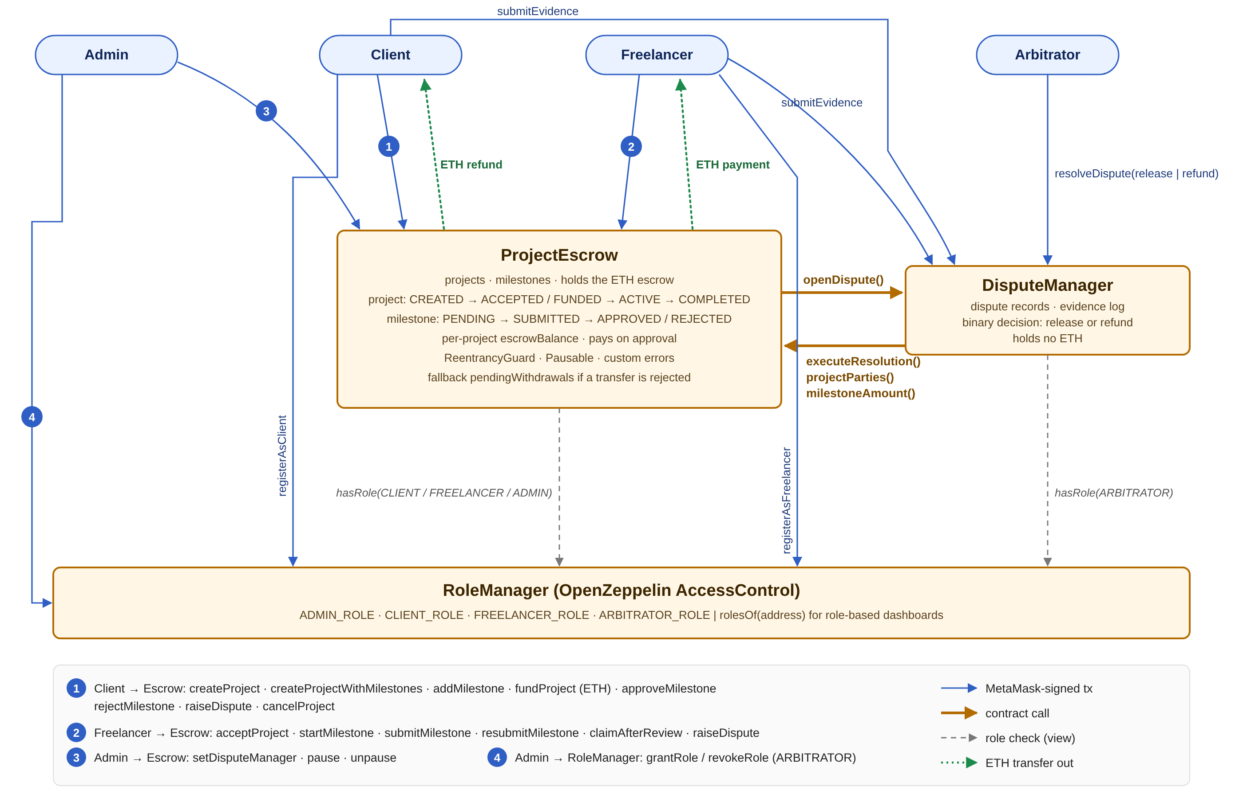
Figure 1 – Smart contract interaction diagram
Figure 1. Smart contract interaction diagram. Blue arrows are MetaMask-signed user transactions, orange arrows are contract-to-contract calls, grey dashed arrows are role checks, green dotted arrows are ETH paid out.

1.1 How the contracts interact
- ProjectEscrow → DisputeManager. raiseDispute freezes the milestone and calls openDispute, which records the dispute and the amount at stake.
- DisputeManager → ProjectEscrow. When the Arbitrator decides, resolveDispute calls back executeResolution, which only the DisputeManager address may call. The DisputeManager also reads projectParties (to stop a party from deciding their own case) and milestoneAmount.
- Both → RoleManager. Every restricted function checks RoleManager.hasRole(...), so revoking a role in one place takes effect in both contracts in the same block.
The DisputeManager needs the escrow’s address in its constructor, and the escrow needs the DisputeManager’s address, so the escrow has a one-time setDisputeManager. It reverts if called again, so the link cannot later be redirected to a malicious contract.

2. Roles and access control
The brief requires at least three roles; the requirements define Client, Freelancer and Arbitrator (§4), and the contracts add an Admin to authorise Arbitrators.
Role | How obtained | What it can do on-chain
Client | registerAsClient() from their own wallet | Create projects and milestones, fund, cancel before work starts, approve or reject submissions, raise disputes
Freelancer | registerAsFreelancer() | Accept assigned projects, start, submit and resubmit milestones, claim after the review period, raise disputes
Arbitrator | Granted by the Admin only | Resolve open disputes by releasing to the Freelancer or refunding the Client. Cannot withdraw funds (§4.3)
Admin | Deployer wallet | Grant or revoke roles, connect the DisputeManager once, pause and unpause new activity
Role membership alone is not enough. The contracts also check ownership of each project:
- Only the project’s own Client may fund, approve or reject (BR-01, BR-08). Holding CLIENT_ROLE does not let one client touch another client’s project.
- Only the assigned Freelancer may accept or submit (BR-04, BR-06), and the assigned wallet must hold FREELANCER_ROLE.
- A Client cannot assign themselves as Freelancer.
- An Arbitrator must hold ARBITRATOR_ROLE when deciding and cannot be the Client or Freelancer of that project (BR-12, SR-03). An Arbitrator wallet cannot register as Client or Freelancer.

3. Transaction logic

3.1 Transaction types
The brief requires at least ten blockchain transaction types. The contracts provide 19 state-changing transactions. Scenario A and Scenario B from the requirements (§20) were run end-to-end on the local network: 18 transactions, logged with hashes in deployments/localhost-demo-transactions.json.
# | Transaction | Contract | Caller | Gas (avg)
1 | registerAsClient | RoleManager | any wallet | 50,029
2 | registerAsFreelancer | RoleManager | any wallet | 50,052
3 | grantRole / revokeRole (Arbitrator) | RoleManager | Admin | 51,485 / 29,543
4 | createProject | ProjectEscrow | Client | 84,614
5 | createProjectWithMilestones | ProjectEscrow | Client | 173,214
6 | addMilestone | ProjectEscrow | Client | 74,775
7 | acceptProject | ProjectEscrow | Freelancer | 35,371
8 | fundProject (payable) | ProjectEscrow | Client | 39,712
9 | cancelProject | ProjectEscrow | Client | 42,922
10 | startMilestone | ProjectEscrow | Freelancer | 33,161
11 | submitMilestone | ProjectEscrow | Freelancer | 34,440
12 | approveMilestone (pays Freelancer) | ProjectEscrow | Client | 60,651
13 | rejectMilestone | ProjectEscrow | Client | 32,041
14 | resubmitMilestone | ProjectEscrow | Freelancer | 34,389
15 | claimAfterReview | ProjectEscrow | Freelancer | 54,292
16 | raiseDispute | ProjectEscrow → DisputeManager | Client / Freelancer | 116,478
17 | submitEvidence | DisputeManager | Client / Freelancer | 34,062
18 | resolveDispute | DisputeManager → ProjectEscrow | Arbitrator | 105,577
19 | pause / unpause / setDisputeManager / withdraw | ProjectEscrow | Admin / fallback | 33,220 / 33,201 / 50,921 / –
Average gas from hardhat-gas-reporter across the test suite (reports/gas-report.txt).

3.2 Project and milestone state machines
Projects and milestones follow exactly the states in the requirements (§7, §8), shown in Figures 2 and 3. Every function first checks the current state and reverts with InvalidProjectStatus or InvalidMilestoneStatus otherwise (SR-05). This rules out paying a milestone twice (BR-09, SR-04), moving a finished milestone back (BR-15), or adding milestones after the terms are agreed (BR-14).
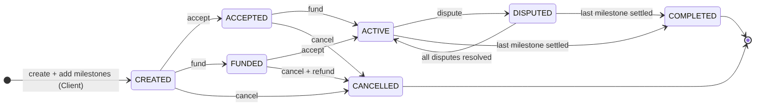
Figure 2 – Project state machine
Figure 2. Project states. The normal path is CREATED → ACCEPTED → ACTIVE (accept, then fund). Funding first is also accepted and waits in FUNDED until the Freelancer accepts; either way a project becomes ACTIVE only when it is both accepted and fully funded (BR-05).
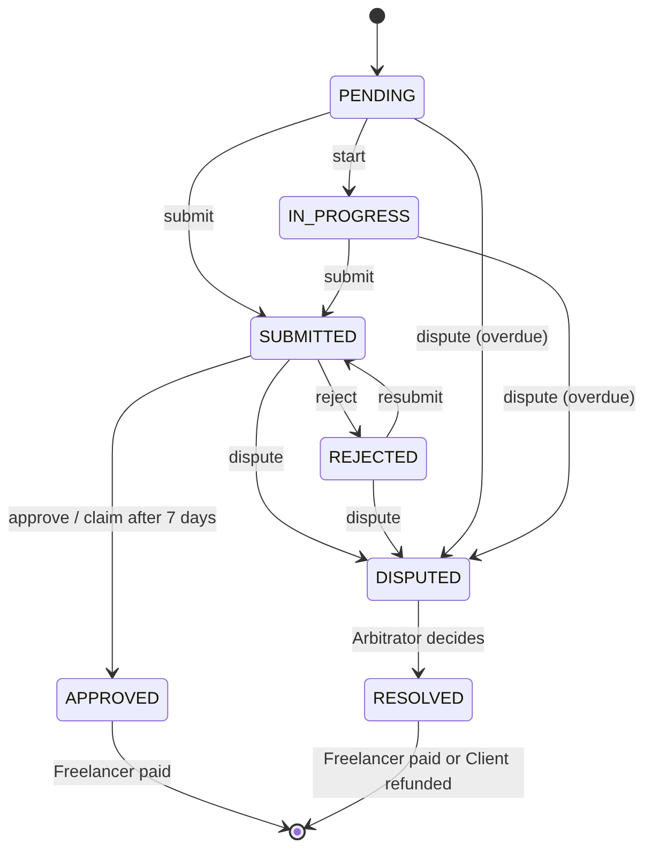
Figure 3 – Milestone state machine
Figure 3. Milestone states. A rejection never refunds the Client (§5.3): the Freelancer resubmits or disputes.
Key rules enforced in code:
- Full funding (BR-03, §5.2). Milestone amounts must add up exactly to the project total before the project can be accepted or funded, and fundProject requires msg.value to equal the total.
- Exact payment (BR-10). Approval transfers exactly the milestone’s predefined amount.
- Funds frozen during a dispute (BR-11). A disputed milestone cannot be approved, resubmitted or cancelled until the Arbitrator decides. Other milestones of the same project continue normally; the project shows DISPUTED while at least one dispute is open.
- No cancellation once work starts (BR-13). cancelProject works only in CREATED, ACCEPTED or FUNDED, and refunds any deposit.

3.3 Decisions where the requirements are silent
Situation | Decision in the contracts
Client never reviews a submission | After 7 days (REVIEW_PERIOD) the Freelancer can call claimAfterReview and is paid. This stops a Client from locking funds by staying silent
Freelancer misses a milestone’s due date without submitting | The Client may raise a dispute on that milestone, and the Arbitrator decides
Who authorises Arbitrators | The Admin (deployer) wallet
Platform fee | None

3.4 Dispute flow
Figure 4 shows Scenario B. The decision is binary, as the requirements specify (§5.4): the whole milestone amount goes to the Freelancer or back to the Client. The DisputeManager holds no ETH and has no transfer function, so an Arbitrator can choose only between the two parties and can never move funds anywhere else.
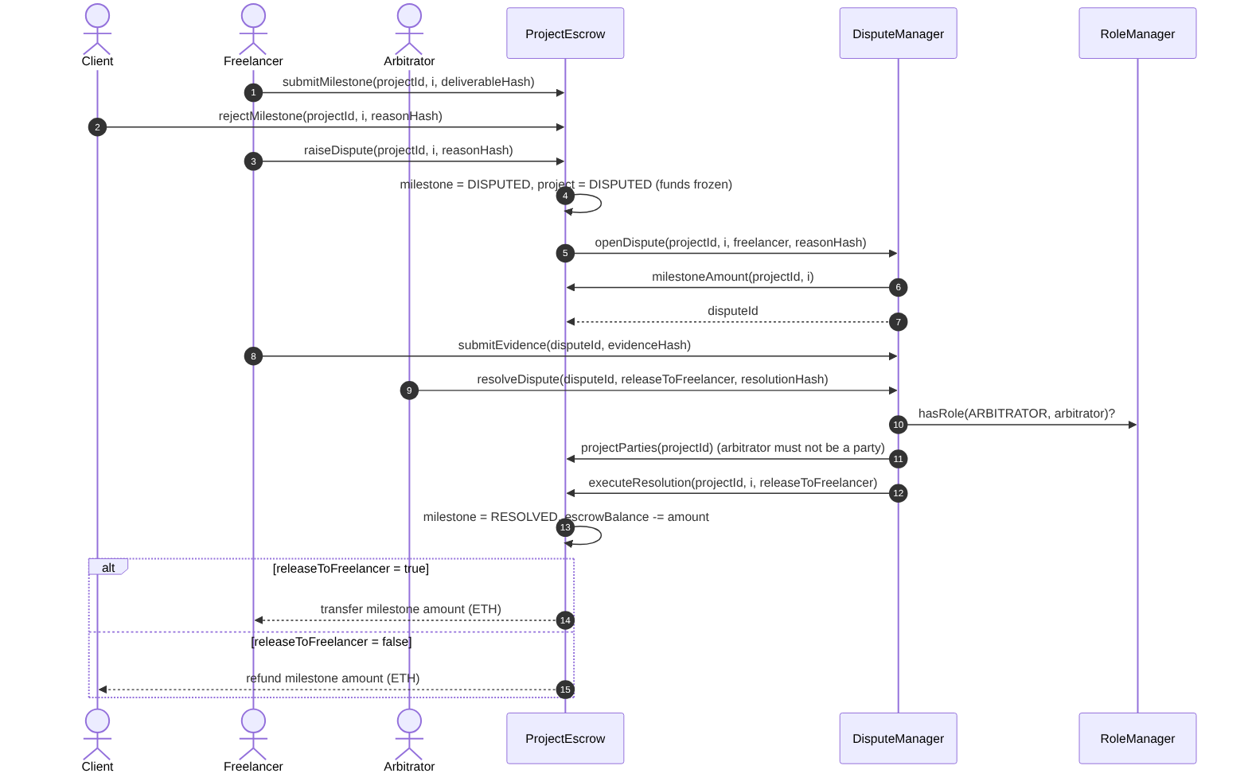
Figure 4 – Dispute resolution sequence
Figure 4. Dispute resolution sequence (Scenario B).

4. Security design
Threat | Control in the contracts | Test evidence
Re-entrancy (SWC-107) | nonReentrant on every function that sends ETH; checks-effects-interactions: state, escrow balance and completion are updated before the transfer | A malicious freelancer wallet re-enters approveMilestone while being paid; the call fails with ReentrancyGuardReentrantCall and the other milestone is untouched
A recipient that rejects ETH blocks the workflow | Payment is pushed automatically (FR-10). If the transfer fails, the amount is credited to pendingWithdrawals and the recipient calls withdraw() later, so the project still completes | Test with a wallet contract that reverts on receive
Unauthorised actions (SR-01, SR-02, SR-03) | Central RoleManager; per-project ownership checks; executeResolution callable only by DisputeManager; openDispute only by the escrow | Negative tests for outsiders, the wrong party and revoked roles on every restricted function
Duplicate payment (BR-09, SR-04, NFR-02) | Milestone status changes to APPROVED or RESOLVED before paying; no path leads back | Double-approve, re-submit and re-dispute tests after payment
Paying more than was deposited (SR-06) | Per-project escrowBalance; _release reverts with InsufficientEscrow if it would go negative | Invariant test: escrow balance = sum of unsettled milestones after mixed approve and dispute flows
Arbitrator abuse | Arbitrator only picks release or refund; cannot be a party; cannot register as Client/Freelancer; must still hold the role when deciding | Party-as-arbitrator and revoked-arbitrator tests
Admin abuse | The Admin cannot move escrowed ETH, approve milestones or decide disputes; the DisputeManager link can be set only once | Wiring-once test
Emergency (bug discovered) | Pausable blocks new projects, milestones, acceptance and funding. Approvals, disputes, cancellation and withdrawal stay open so funds are never trapped | Pause test
Integer overflow (SWC-101) | Solidity ≥ 0.8 checked arithmetic; unchecked only where bounds are proven (counters, ≤ 20 milestones) | –
Unbounded loops (SWC-128) | At most 20 milestones per project | Over-limit test
Timestamp dependence (SWC-116) | Only day-scale due dates and the 7-day review period, where seconds of drift do not matter | Time-travel tests
Sensitive data on-chain (SR-07) | Only hashes of descriptions, reasons and files are recorded, in events | –
Meaningful errors (SR-08, NFR-06) | Custom errors with context, e.g. IncorrectDeposit(sent, required), InvalidMilestoneStatus(current), ReviewPeriodActive(claimableAt) | Every negative test checks the exact error
Known limitations, for the evaluation section:
- The Admin is a single wallet. In production the Admin role should be a multisig (e.g. Safe).
- Arbitration is centralised to Admin-authorised arbitrators. Human judgement is still required, as the requirements note (§19.3).
- Native ETH is volatile (§19.7). The escrow could be switched to a stablecoin such as USDC for real payments.
- Contracts are not upgradeable, so users can verify the exact code holding their funds. Fixes would be deployed as a new version, with pause used to stop new projects on the old one.
- No external audit has been done. Static analysis with Slither is a recommended next step.

5. Gas optimisation
Gas is paid by the Client and Freelancer on every action, so gas efficiency matters (§19.5). Measured with scripts/gas-bench.js (Hardhat network, optimizer 200 runs):
Technique | Before | After | Saving
Packing the Project struct into 3 storage slots (uint40 timestamps, uint8 counters, uint96 amounts next to addresses) instead of 9 | 203,405 | 88,781 | 56.4 %
Storing document hashes in events instead of contract storage | 44,205 | 23,434 | 47.0 %
Custom errors instead of require strings (per failed call; also smaller bytecode) | 5,669 | 5,586 | 1.5 %
Manual unchecked { ++i; } loop increment vs i++ | 26,190 | 26,188 | 0.0 %
Other techniques used: the Milestone struct fits one slot (amount + due date + submission time + status); the Dispute struct fits three; contract references are immutable and role identifiers constant; milestone arrays are passed as calldata; createProjectWithMilestones creates a project with three milestones for 192,747 gas instead of 291,827 for createProject plus three addMilestone calls in the demo run (34 % less).
The loop result is a deliberate negative finding. Since Solidity 0.8.22 the compiler already removes the overflow check from simple loop counters, so the manual unchecked increment no longer saves anything on this compiler.
Deployment of all three contracts plus wiring costs 4.15 M gas: about 0.0083 ETH at 2 gwei. A complete three-milestone project (create with milestones, accept, fund, three submissions and three approvals) costs about 0.54 M gas across both parties, about 0.0011 ETH at 2 gwei. On an Ethereum L2 the same flow would cost cents.

6. Testing
Tests use Mocha/Chai with Hardhat Network helpers (fixtures and time travel) in test/Escrow.test.js. Test names carry the requirement IDs they verify, so the results map directly to the success indicators in §18.
Area | Tests | Requirements covered
RoleManager | 3 | FR-02, SR-01: self-registration, admin-only arbitrators, revocation takes effect at once
Project setup | 7 | FR-03–FR-07, BR-01–BR-05, BR-13, BR-14: milestone totals, both funding orders, deposit amount, cancellation rules, input validation
Milestone workflow | 7 | FR-08–FR-12, BR-06–BR-10, BR-15, SR-02, SR-04, SR-05: Scenario A, exact payment, pay-once, reject and resubmit, review timeout
Disputes | 10 | FR-13, FR-14, BR-11, BR-12, SR-03: Scenario B, frozen funds, release and refund, evidence, overdue disputes, unauthorised resolvers, party-as-arbitrator
Security & admin | 5 | SR-06, NFR-02: rejected transfer fallback, re-entrancy attack, escrow balance invariant, pause, one-time wiring
Total | 32 | 32 passing
Coverage (npx hardhat coverage, test helpers excluded): 100 % statements, 100 % functions, 100 % lines, 81.5 % branches. The uncovered branches are defensive checks that ordinary use cannot reach, such as the uint96 total-overflow guard and the InsufficientEscrow check, which the accounting makes impossible to trigger.
Mapping to the success indicators: SI-02 (payment accuracy) and SI-03 (no duplicate payment) are asserted by balance checks in every payment test; SI-04 (access control) by the negative tests; SI-05 (traceability) by event assertions; SI-01 and SI-06 by the Scenario A and B tests and the 18-transaction demo run.

7. Deployment
The contracts are deployed on a Hardhat local network (chain ID 31337) with scripts/deploy.js. The script deploys, wires and records every address, transaction hash, block, gas figure and constructor argument in deployments/localhost.json, and exports ABIs to deployments/abi/ for the backend and frontend.
Contract | Address (local, chain 31337) | Deploy gas
RoleManager | 0x5FbDB2315678afecb367f032d93F642f64180aa3 | 587,311
ProjectEscrow | 0xe7f1725E7734CE288F8367e1Bb143E90bb3F0512 | 2,714,228
DisputeManager | 0x9fE46736679d2D9a65F0992F2272dE9f3c7fa6e0 | 801,651
The same script deploys to the Sepolia public testnet with --network sepolia once SEPOLIA_RPC_URL and PRIVATE_KEY are set. The public addresses and Etherscan verification links are recorded in docs/DEPLOYMENT.md.

