# Two images of the same scene at two different time instants have been captured by a surveillance camera as illustrated in Figure. Write a MATLAB code to perform change detection.

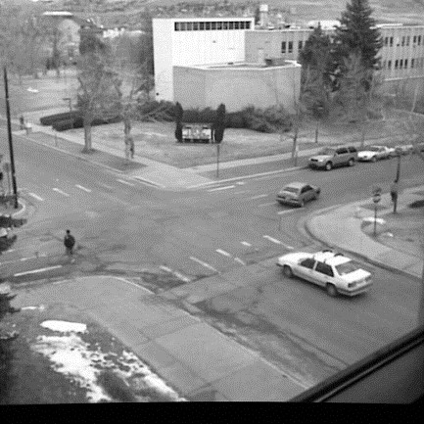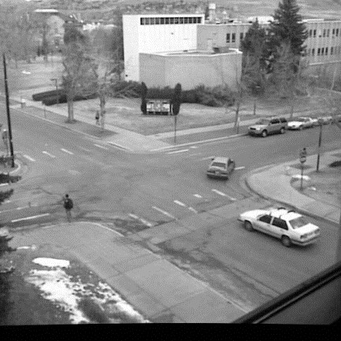

## (a)Explain what methodology/ steps you have adapted, with neat flow diagram and display your results**.**

# **Code:**

clc

clear all

close all

[I1,map1] = imread('fig31.tif',1);

i1 = im2double(I1);

[I2,map2] = imread('fig32.tif',1);

i2 = im2double(I2);

figure(1)

subplot(2,1,1);

imshow(I1,map1);

subplot(2,1,2);

imshow(I2,map2);

D = imabsdiff(i1,i2);

figure(2)

imshow(D)

# **Output:**



# Methodology:

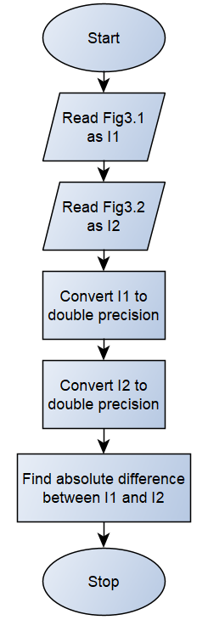

# Result:

1. Simplest algorithm to find the change in two images is find the absolute difference between them.
2. The image in t=0 time comes as a more gray pixel when compared to the image in t=t time in the resultant image.
3. Thus by looking at each object’s transition from gray to white pixel we can detect the change in position for that object.