# Problem Statement:

Aim:

Perform segmentation of the original image as illustrated in Figure 1 to obtain the segmented region as illustrated in Figure 2.

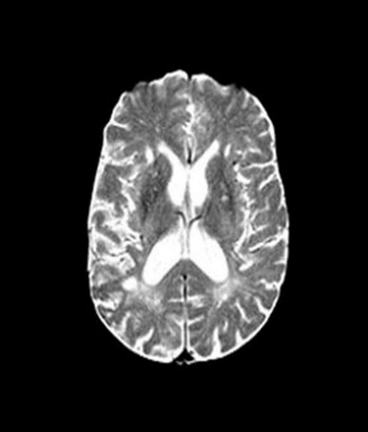

**Figure1**  **Figure 2**

# Procedure:

* Read the given image using **imread** command.
* Create a **mask** of size similar to the given image with false value.
* True the values in the region near to the output area which needs to be obtained.
* Create a **gray scale differentiate weight** with the threshold value of 15.
* Using this weight and the mask apply **imsegfmm** command to do segmentation with fast march method.
* Display the required image.

# MATLAB Code:

clc;

clear all;

close all;

I=imread('Fig4_1.jpg');

mask = false(size(I));

mask(472,557)=true;

mask(594,595)=true;

mask(454,480)=true;

W =graydiffweight(I, mask, 'GrayDifferenceCutoff',15);

thresh = 0.005;

[BW, D] = imsegfmm(W, mask, thresh);

figure

imshow(BW)

title('Required Image');

# Output:

# Conclusion:

1. This we can see with thresholding of 0.005 order we can obtain the required image.
2. The corpus callosum part of the brain is segregated.