A certain inspection application gathers black & white images of parts as they travel along a conveyor belt. It is necessary to sort the parts into two categories: parts with holes and parts without holes. An example of an image that might be taken by the inspection camera is shown in Figure 5. Propose a method to identify and locate the objects of each category in the image so that they can be picked up by a robotic system and placed in different bins. Assume that the imaging system knows where each image pixel is located on the conveyor belt at every point in time. Provide an annotated flow chart of the algorithm you propose. Write Matlab code to simulate your proposed algorithm.



# Procedure:

1. Read the png image
2. Convert RGB to binary.
3. Detect the boundaries in the image.
4. Find all the voids inside the detected boundaries.
5. The selected boundary coordinates are recorded and stored in a double array.
6. The coordinates are plotted onto the original image using hold on function with red line.
7. The detected boundary images are now plotted onto a new image and displayed.

# Flowchart:

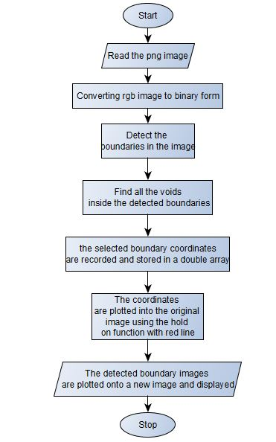

# Code:

clc

clear all

close all

I = imread('Fig.5.png');

imshow(I);

BW = im2bw(I);

figure(1)

imshow(BW);

hold on

[B,L,N,A] = bwboundaries(BW);

for k=1:N

if (nnz(A(:,k)) > 0)

b = B{k};

plot(b(:,2),b(:,1),'r','LineWidth',2);

c = cat(2,b(:,1),b(:,2));

end

end

# Output:

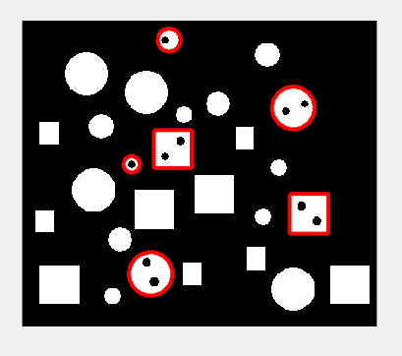

# Conclusion:

1. The objects with voids inside were detected.