**You can automate your workflows in three easy steps:**

1. Create a credentials .json file.
2. Create a batch file to run the workflow.
3. Use Task Scheduler to run the workflow on a regular basis.

Here we are building a script for local workflow . If your workflow is connected to extrernal data source like SQL,MongoDB and saved your workflow on your machine.

**1.Create Credentials file using name cred.json**

When you create an workflow using external data source and saved hyper file on your machine then we don’t need to enter Output Connection. Keep it blank.

Here I used localhost SQL database.

**Points to remember**

* We can ip address on hostname. Just simple ip address, Don’t include http or https.
* You can ignore port fields if your using default port address.
* If you don’t have password for connection then give blank in password field.

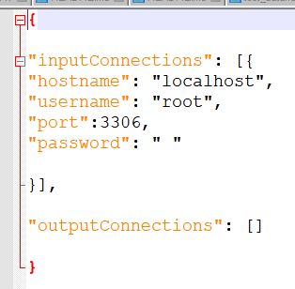

Now, save it as .json .

**2. Create batch file.**

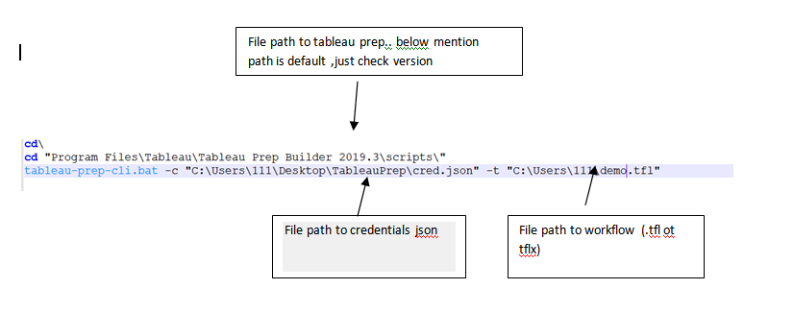

Before you go to third step, check your workflow status by running this batch script by doubling on it or entering above commands on cmd one by one (line by line). On successful running , you will get below message.

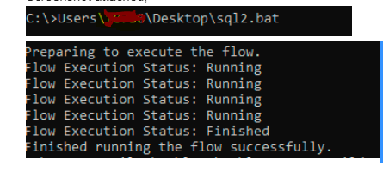

3.Create Task scheduler to run batch file regularly.

Open a task scheduler in windows and create basic task. Give name to your. Next, select duration to run a workflow. Then select a program (Browse to the batch file ). Here you can add argument to create logs. Hit on next , ensure all settings. Site back, relax and see magic