**You can automate your workflows in three easy steps:**

1. Create a credentials .json file.
2. Create a batch file to run the workflow.
3. Use Task Scheduler to run the workflow on a regular basis.

When you creat a workflow using

**1.Create Credentials file using name cred.json**

When you create a workflow using external data source and upload that workflow on tableau online or tableau server then you need to enter credentials for both input and output connection.

**Points to remember**

* We can ip address on hostname. Just simple ip address, Don’t include http or https.
* You can ignore port fields if your using default port address.
* If you don’t have password for connection then give blank in password field.
* If you don’t have a site on tableau server then keep this field blank.
* If you are using tableau online then you need to compulsory enter site namem in “ContentUrl” field. You will get your tableau online site name in url.
* Don’t include black slash at end tableau online or server url.
* If you have configured separate port for tableau server then you must include port filed in outputConnection.



{

"inputConnections": [{

"hostname": "localhost",

"username": "root",

"port":3306,

"password": " "

}],

"outputConnections": [

{

"serverUrl":"https://10ay.online.tableau.com",

"contentUrl":"tableauonlinedemositeforpartners", // contentUrl:””, for tableau server.

"username":"abcsdf ",

"password":"jfhjkfflsd" }}

Now, save it as .json .

2. Create batch file.

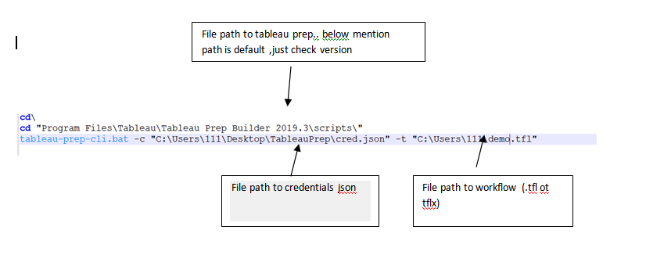

Before you go to third step, check your workflow status by running this batch script by doubling on it or entering above commands on cmd one by one (line by line). On successful running , you will get below message.

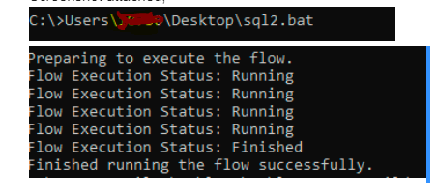

3.Create Task scheduler to run batch file regularly.

Open a task scheduler in windows and create basic task. Give name to your. Next, select duration to run a workflow. Then select a program (Browse to the batch file ). Here you can add argument to create logs. Hit on next , ensure all settings. Site back, relax and magic