**You can automate your workflows in three easy steps:**

1. Create a credentials .json file.
2. Create a batch file to run the workflow.
3. Use Task Scheduler to run the workflow on a regular basis.

Here we are building a script for local workflow.

Note: Please remove <> contain.

**1.Create Credentials file using name cred.json**

If you don’t have external data source connection to you tableau prep workflow then you need not need to create json file.

You can directly go with second step.

**2. Create batch file.**

File path to tableau prep.. below mention path is default ,just check version

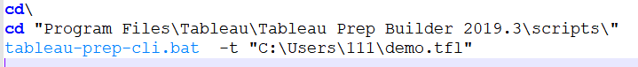

File path to workflow (.tfl ot tflx)

Before you go to third step, check your workflow status by running this batch script by double clicking on it or entering above commands on cmd one by one(line by line). On successful running , you will get below message. Run cmd with administrator.

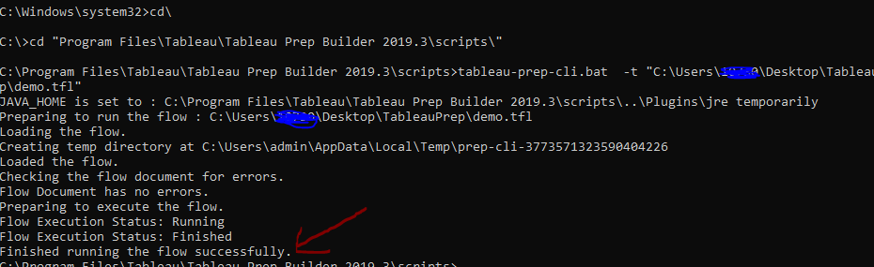

**3.Create Task scheduler to run batch file regularly.**

Open a task scheduler in windows and create basic task. Give name to task scheduler .

Next, select duration to run a workflow. Then select a program (Browse to the batch file ). Here you can add argument to create logs. Hit on next , ensure all settings. Site back, relax and see magic