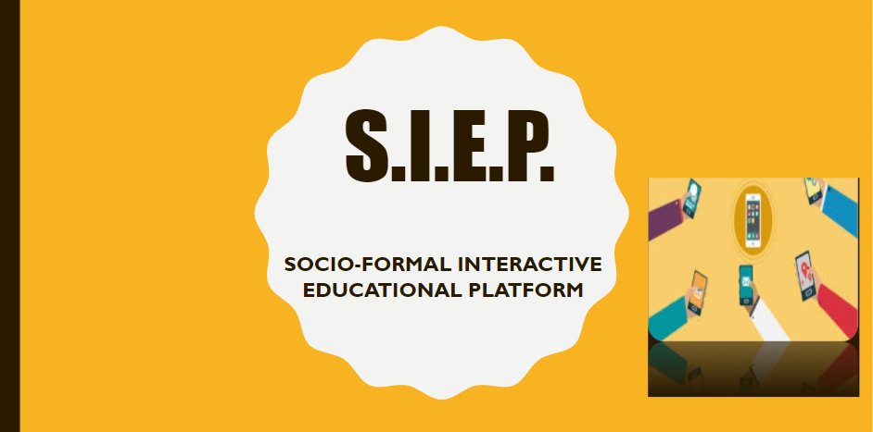

# **Abstract**

The world has been making tremendous technological growth for the last few decades, but most educational institutions in India use the ancient paperwork methods to do most of the work.

Currently students have no access to Teachers outside the institutions. For even small things like checking the marks of the previous tests, the students have to physically reach out to teachers and for various other purposes like checking the attendance student have to physically reach out to various teachers for respective subject as we currently don’t have a centralized attendance system where overall attendance can be seen moreover online copies of notes are currently shared using apps like WhatsApp which ends up making a mess and it becomes extremely difficult to find those files or notes when needed the most and furthermore any other special activity/event organized in the institute remains confined to the mess of those WhatsApp group chat and no more than that which means the alerts for the activities are not properly received to the students and hence leading to the less participants in the activities and concluding to lowering the moral of activity organizers.

# **Introduction**

The world has been making exponential technological growth in recent times, but most educational institutions in India use the ancient paperwork methods to do most of the work.

Students have no access to Teachers outside the institutions. For even trivial things like checking the marks of the previous test, the students have to physically reach out to teachers.

The online copies of notes are currently shared using apps like WhatsApp which ends up making a mess and it becomes extremely difficult to find those files when needed the most.

**So, we propose a Social Media Type platform implemented in a formal manner providing ease of access to students and help them learn interactively by allowing them to reach out to teachers, seniors and juniors alike : SIEP**

SIEP provides different channels for different subjects where anyone in the channel can share notes of that particular subject. The channels could also be made Class or Section wise which will help the teacher maintain Attendance and Marks of the students.

There would be sub-channels where anyone could discuss their doubts with every teacher related to that subject.

To make this app into a social platform there would be a news feed on the home page of posts which could be made by anyone. Information and photos about various events going on in the institute could be posted there.

# **Related Work**

**SIEP** is a social media type platform implemented in a formal manner for providing ease of access to students and to help them learn interactively by allowing them to reach out to teachers, seniors and juniors alike SIEP also enables the students to easily access his/her academics records.

SIEP provides different channels for different subjects where anyone in the channel can share notes of that particular subject. These channels will help the teacher maintain Attendance and Marks of the students.

There would be sub-channels where anyone could discuss their doubts with every teacher related to that subject.

To make this app into a social platform there would be a news feed on the home page of posts which could be made by anyone. Information and photos about various events going on in the institute could be posted there.

The users could react, comment and share those posts like any other social media platforms.

The institute administration and Teachers would have Admin access and they will be able to control who has access to what. Teachers would also be able to appoint student-admins.

Using  this  system,  we  can  manage  all  information  of  all  aspects  of  a  college,  its  students,  faculties,  Departments, marks and other curricular activities. SIEP system provides the easiest way to  manage all functionalities of a college. This system facilitates institutes to maintain the functionality related to  college employees and their students.  Institutes  can  store  and  manage  all  data  of   the  various  departments  like  Administration,  Attendance,  Staff  details  etc.  using  this  system  user  can  retrieve  any  information  related  to  student, teacher and fees. Using this system teacher can check student attendance anytime. This system also  help  teacher  to announce  the  result.

So, SIEP will help boost interactive learning and provide an environment where learning can be more fun and easily available.

The “SIEP” is based on managing the records of an institute and  managing the records of all the students and Staff. The first activity is based on entering the  students and Staff as soon as their admission is done. A unique register number is given to that  particular for his identification. The system also maintains attendance details of a particular  student. At the end of each semester, the average percentage of classes attended by each  student is displayed. The system also manages in storing student’s marks separately for each  semester. At the end of each semester, the results can be displayed by calculating his/her  semester marks.   The second activity is based on managing the institute. The system keeps the record of the fee  payment done by each student. It also records the information and salary to be paid to each  staff members.   Admin has the authority to add details and new admin when needed. And he also has the right  to edit or delete those information to/from the list. All the information’s are being saved in the  database.

# **Approach**

1. **SIEP** aims to provide Subject-wise channels where one can share the study materials only for that subject so that it would be easier to search and access that document when needed.
2. Itaims to provide an interactive platform between students and teachers of respected subjects.
3. Itaims to provide an interactive platform among students of the respected section of class.
4. SIEP will let students check their academic performance & academic attendance quickly when needed.
5. SIEP will let students to get the knowledge of the upcoming event and updates of the academic at fingertips via notifications.
6. SIEP will let students to get the alerts of the exam dates and class tests via notifications so that preparation can be done accordingly to gain maximum marks as because of repetitive remainders students will surely wish to study before the plenty of days of exam .
7. Selected students can post the information about the  upcoming events or programs going to be held in college.
8. Students will get transparency of their attendance and internal marks/grades in the application.
9. Simple UI & Easily access all features of application.

# **Conclusion**

The “SIEP” is based on managing the records of an institute and  managing the records of all the students and Staff. The first activity is based on entering the  students and Staff as soon as their admission is done. A unique register number is given to that  particular for his identification. The system also maintains attendance details of a particular  student. At the end of each semester, the average percentage of classes attended by each  student is displayed. The system also manages in storing student’s marks separately for each  semester. At the end of each semester, the results can be displayed by calculating his/her  semester marks.   The second activity is based on managing the institute. The system keeps the record of the fee  payment done by each student. It also records the information and salary to be paid to each  staff members.   Admin has the authority to add details and new admin when needed. And he also has the right  to edit or delete those information to/from the list. All the information’s are being saved in the  database.

# **References**

1. **Firebase** - <https://firebase.google.com/docs>

Firebase is a platform developed by Google for creating mobile and web applications.

Firebase gives you the tools to develop high-quality apps, grow your user base, and earn more money. We cover the essentials so you can monetize your business and focus on your users.

1. **Android** - <https://developer.android.com/docs>

Android is a mobile operating system based on a modified version of the Linux kernel and other open source software, designed primarily for touchscreen mobile devices such as smartphones and tablets.

1. **Stack Overflow** - <https://stackoverflow.com>

Stack Overflow is a question and answer site for professional and enthusiast programmers. It is a privately held website, the flagship site of the Stack Exchange Network, created in 2008 by Jeff Atwood and Joel Spolsky. It features questions and answers on a wide range of topics in computer programming.