Table of Contents

How you define a ‘Simple digital system’? 1

What is register? 1

Structure of a CPU 1

What do you mean by ‘organization of a digital system’? 2

How to refer a register? 2

What is register Transfer? 3

Control Function 4

What is register Transfer Language? 4

What do you mean by register transfer level? 5

What is bus? 5

How register transfer is done by bus? 6

How to represent memory? 9

Memory read 10

Memory writes 11

Register Microoperation 11

Arithmetic Microoperations 11

Logical Microoperations 11

Shift Microoperations 11

Arithmetic Logic Shift Unit 11

# How you define a ‘Simple digital system’?

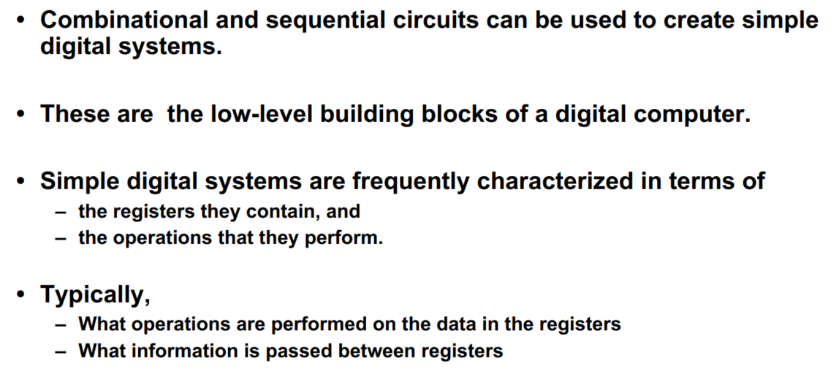

# What is register?

Registers are small memory units present in CPU.

# Structure of a CPU

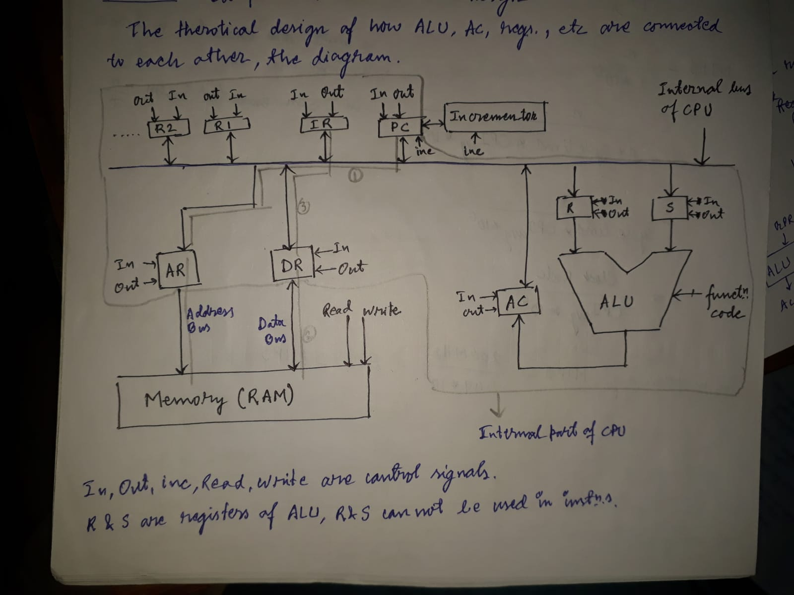

# What do you mean by ‘organization of a digital system’?

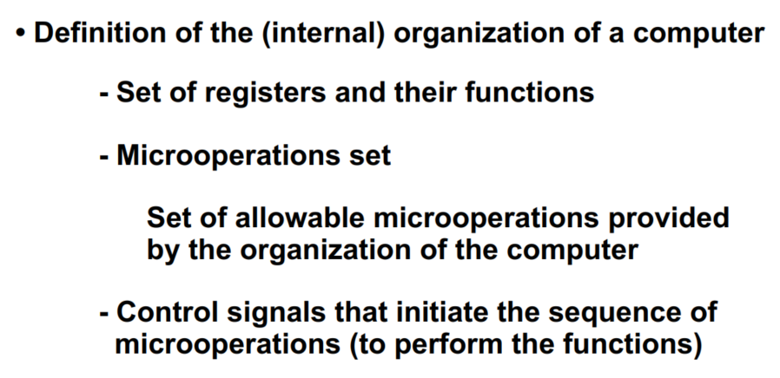

# How to refer a register?



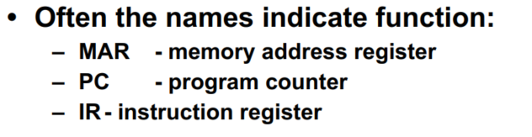

Program Counter stores till which instruction a program has executed.

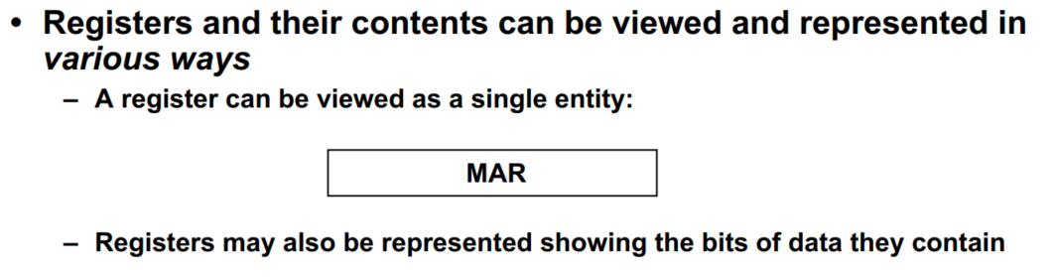

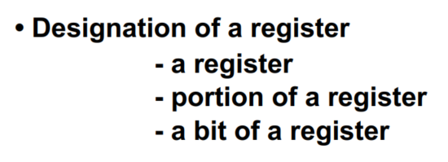

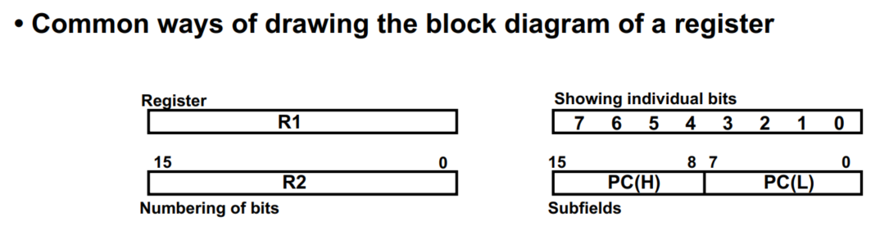

# What is register Transfer?



Example of register transfer

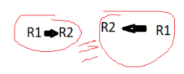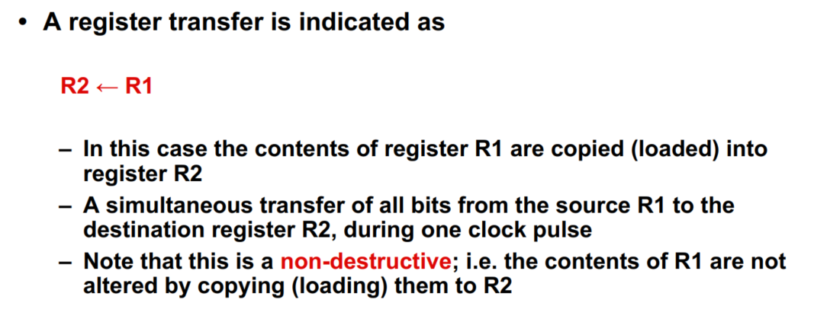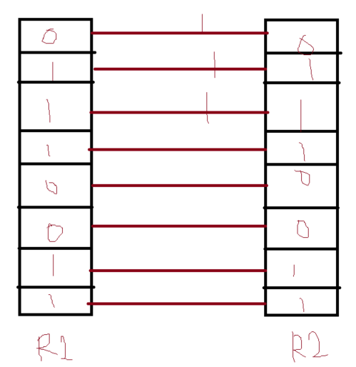

Another example of register transfer:

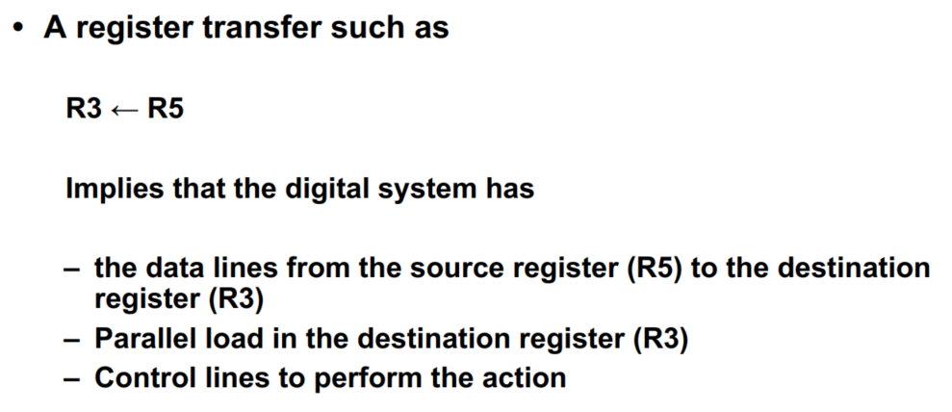



# Control Function



if(p==1) {

R2🡸R1

}

This is same as **P: R2🡸R1**



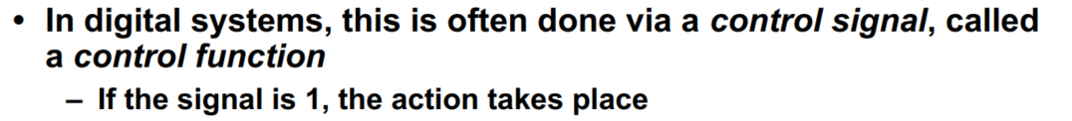

# What is register Transfer Language?

|  |  |
| --- | --- |
| A🡸B | Transfer content of register B into register A |
| AR🡸DR(AD) | Transfer content of AD portion of register DR into AR |
| A🡸Constant, eg: A🡸#5 | Transfer a binary constant into register A |
| ABUS🡸R1, R2🡸ABUS | Transfer content of R1 into **bus A**, and at the same time transfer content of **bus A** into R2 |
| AR | AR is Address Register |
| DR | DR is Data Register |
| M[R] | Memory word specified by register R |
| DR🡸M | Memory read operation: transfer content of memory word specified by AR into DR |
| M🡸DR | Memory write operation: transfers content of DR into memory word specified by AR |



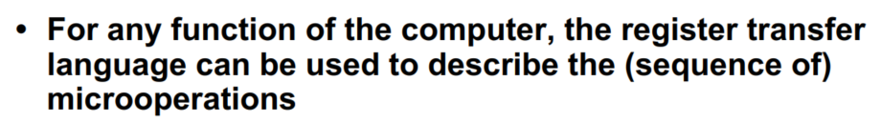

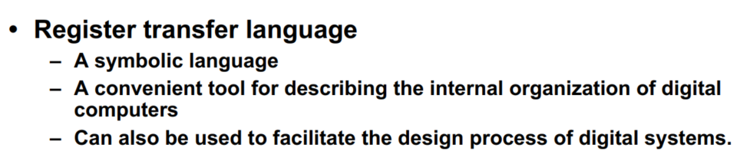

# What do you mean by register transfer level?

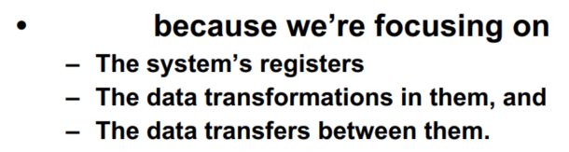

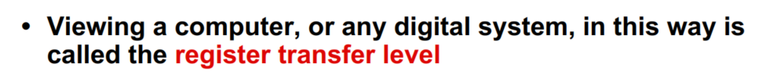

# What is bus?

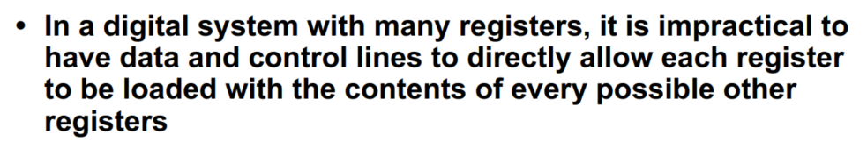



To connect n registers we need nC2 * 2 = n(n-1) lines

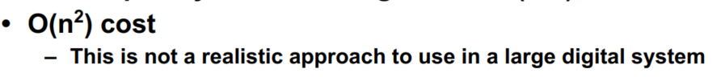

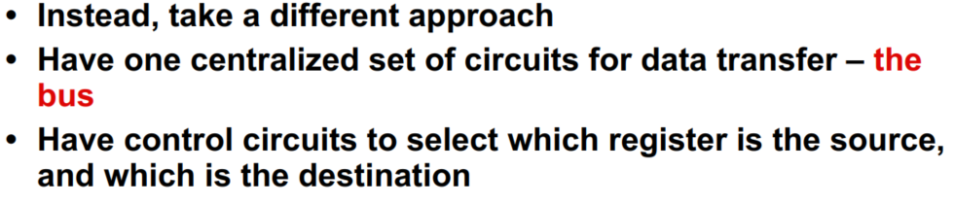

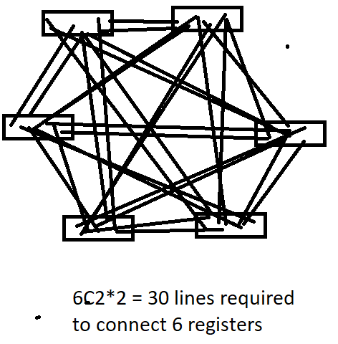

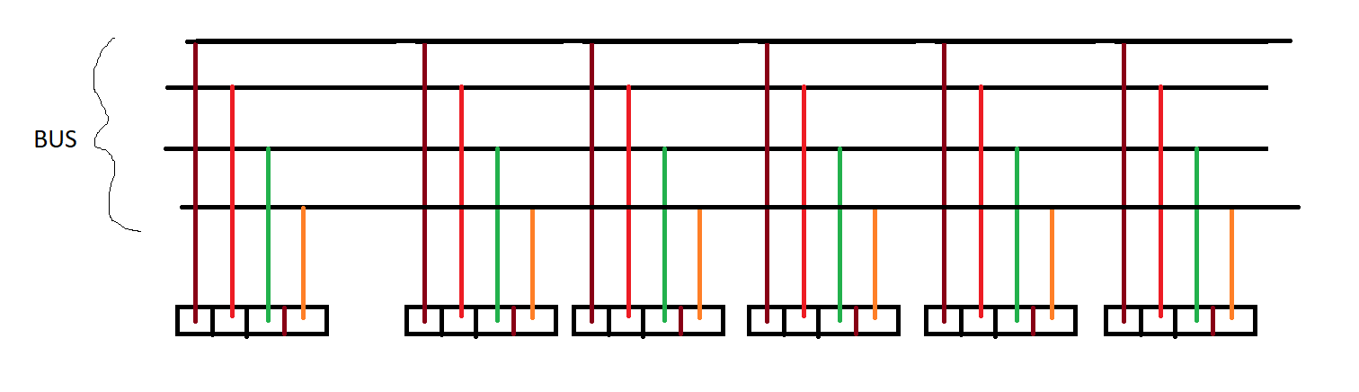

# How register transfer is done by bus?

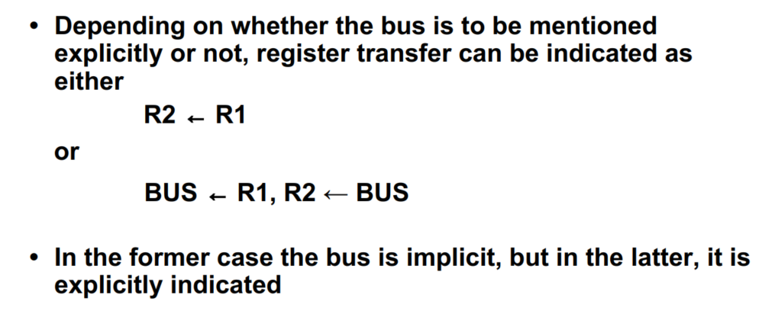

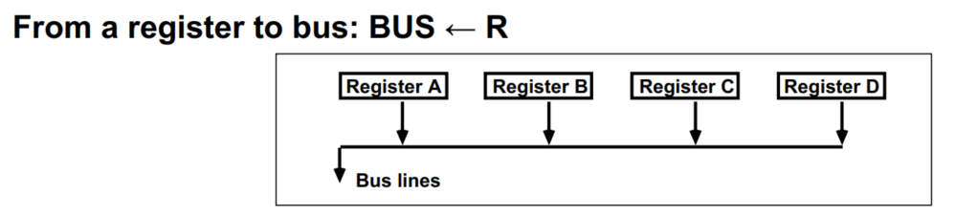

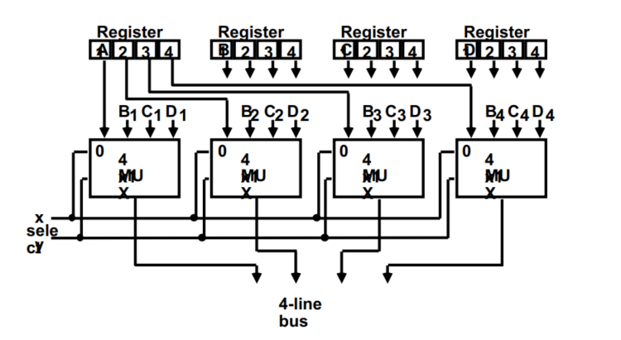

If (x,y)==(0,0) then A1, A2, A3, A4 will come out:

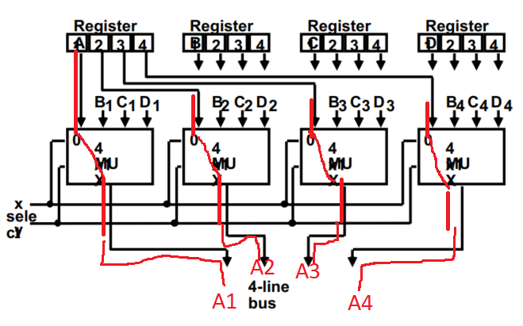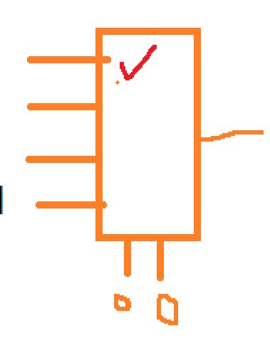

If (x,y)==(0,1) then B1, B2, B3, B4 will come out:

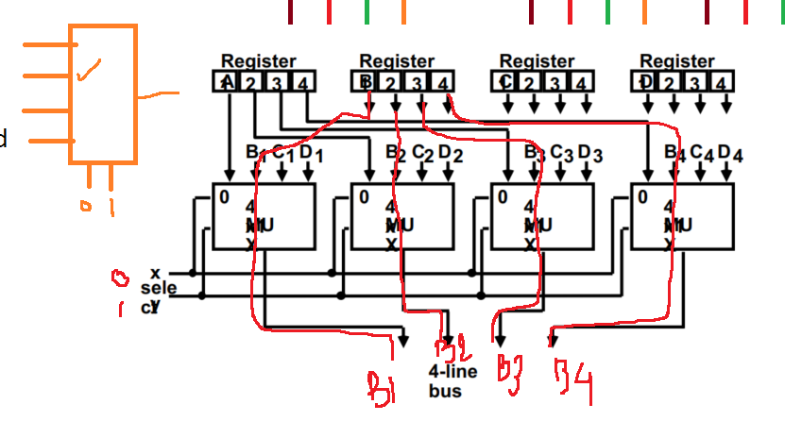

Draw the diagrams for C1, C2, C3, C4 to come out.

Draw the diagrams for D1, D2, D3, D4 to come out.

We have just seen Register to bus (Register🡺Bus) transfer. Now we’ll see Bus🡺Register Transfer:

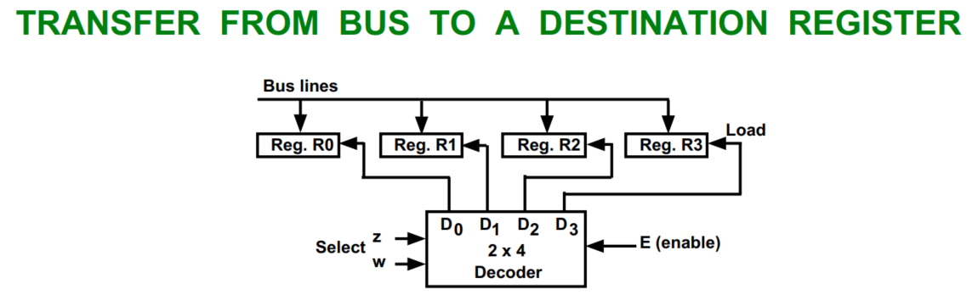

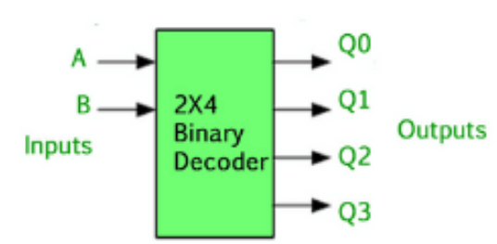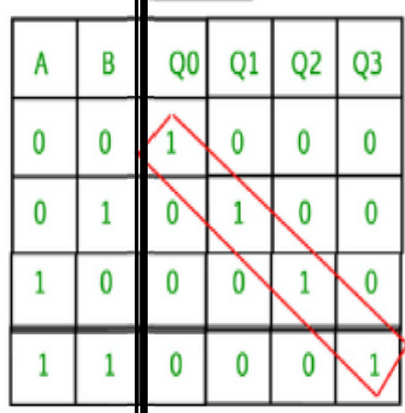

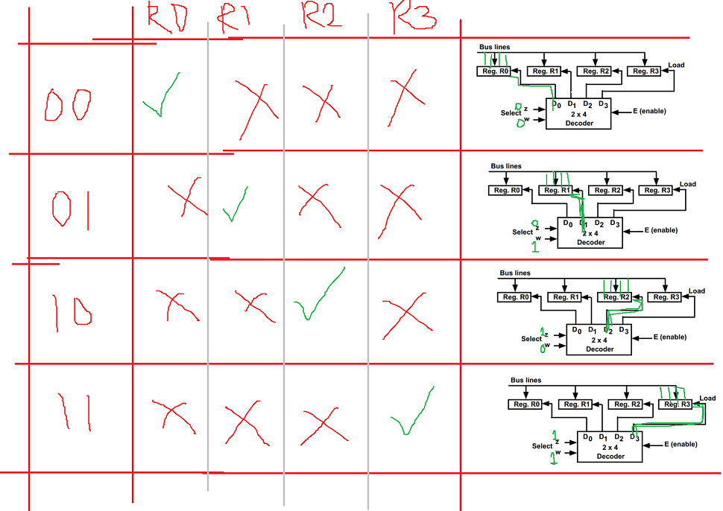

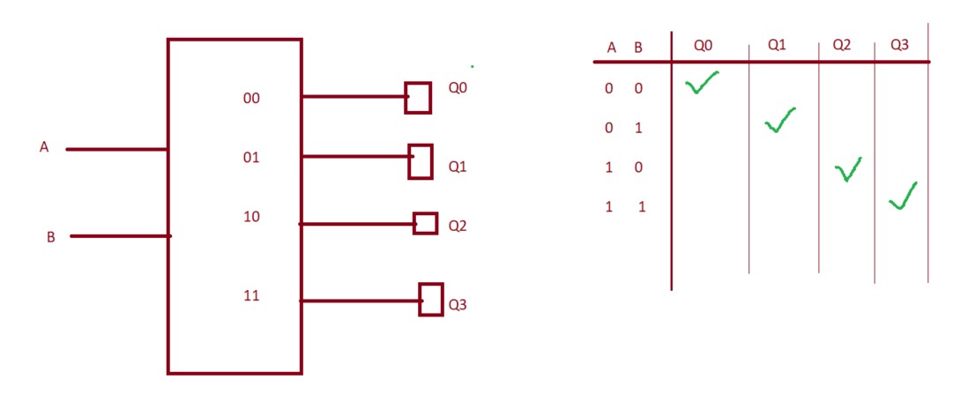

# How to represent memory?

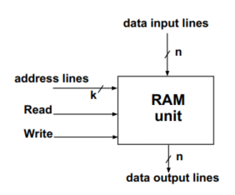

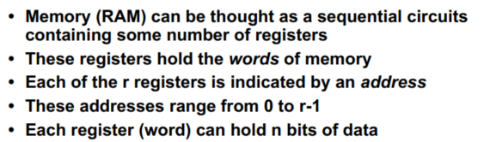

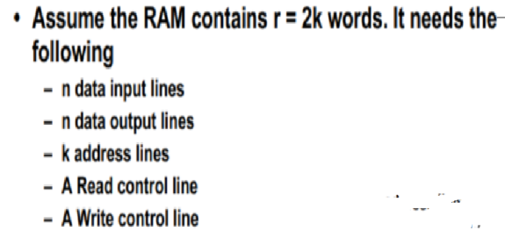

# Memory read

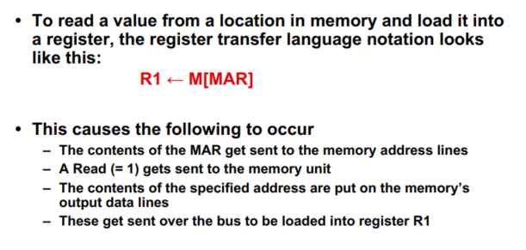

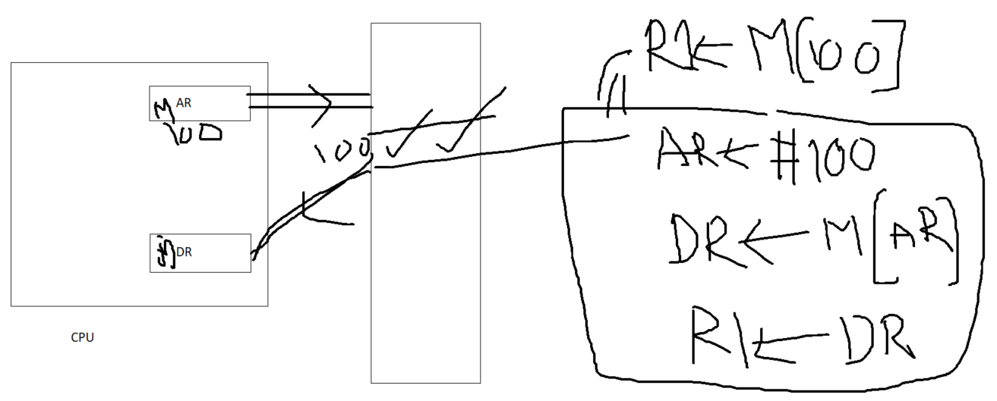

# Memory writes

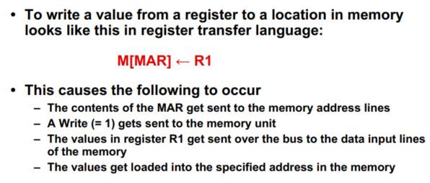

# Register Microoperation

# Arithmetic Microoperations

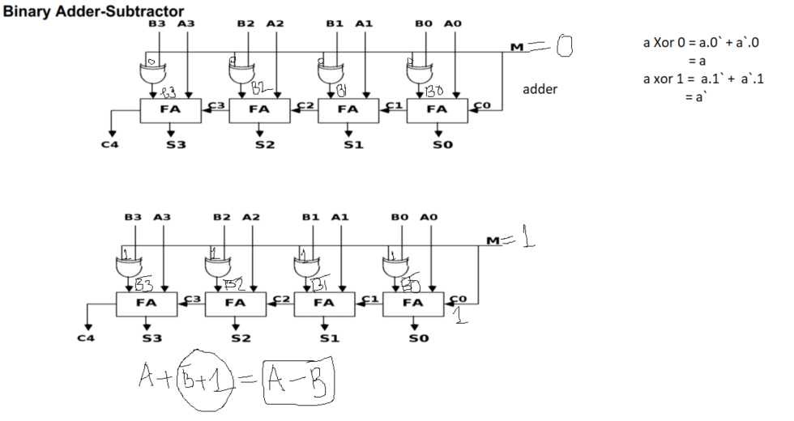

# Logical Microoperations

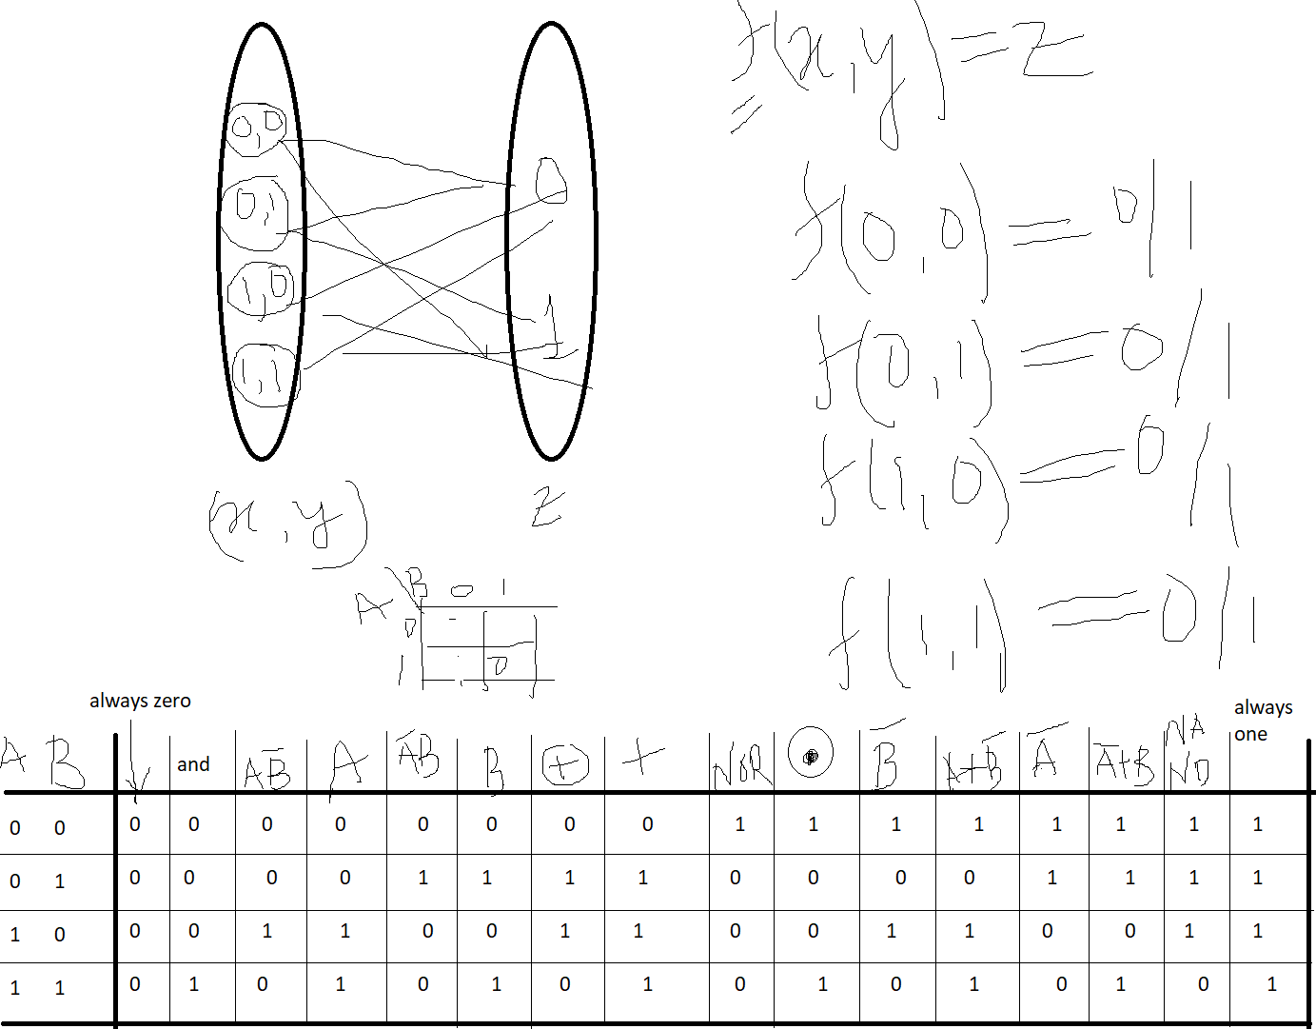

# Application of Logic Microoperations

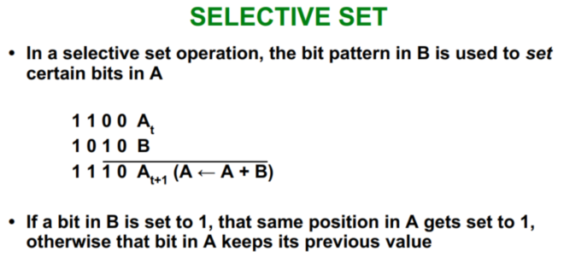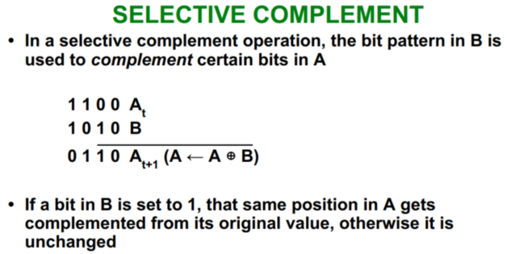

# Shift Microoperations

# Arithmetic Logic Shift Unit

