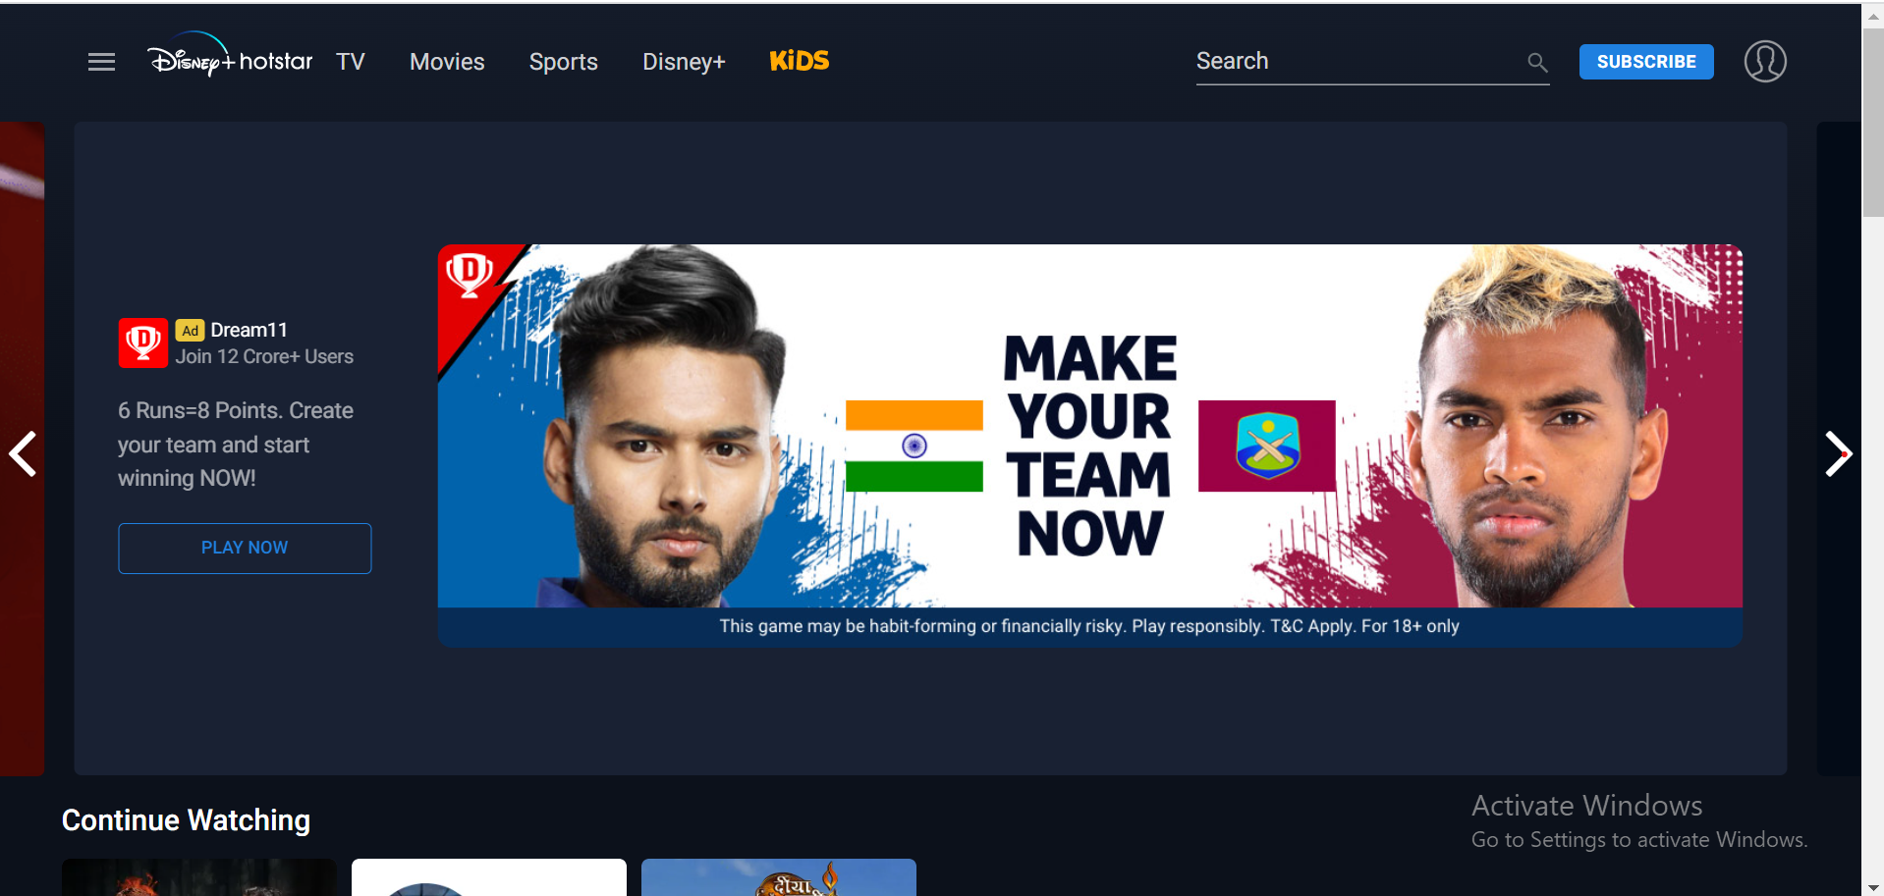

Project Name: Disney+Hotstar

***Rittwik Garai***

***Edureka presents***

**Overview**

Disney+Hotstar is an online video streaming platform owned by Novi Digital Entertainment Private Limited, a wholly owned subsidiary of Star India Private Limited. Disney+Hotstar currently offers over 100,000 hours of TV content and movies across 9 languages, and every major sport covered live. Highly evolved video streaming technology and a high attention to quality of experience across devices and platforms, make Disney+Hotstar the most complete video destination for Over The Top (OTT) video consumers.

**Goals**

1. Login Page
2. Subscription Page
3. Payment Page
4. Home Page
5. Streaming Page

**Technology Used:**

MERN stack is used in this project. MERN stands for MongoDB, Express, React, Node, after the four key technologies that make up the stack.

* MongoDB - document database
* Express(.js) - Node.js web framework
* React(.js) - a client-side JavaScript framework
* Node(.js) - the premier JavaScript web server

Express and Node make up the middle (application) tier. Express.js is a server-side web framework, and Node.js the popular and powerful JavaScript server platform. Regardless of which variant you choose, ME(RVA)N is the ideal approach to working with JavaScript and JSON, all the way through.

**History of Disney+Hotstar:**

**Disney+** is an American subscription video on-demand over-the-top streaming service owned and operated by the Media and Entertainment Distribution division of The Walt Disney Company. The service primarily distributes films and television series produced by The Walt Disney Studios and Walt Disney Television, with dedicated content hubs for the brands Disney, Pixar, Marvel, *Star Wars*, and National Geographic, as well as Star in some regions. Original films and television series are also distributed on Disney+.

1. **LOGIN:**

#PHONE NUMBER

#FACEBOOK/EMAIL ACCOUNT

1. **SUBSCRIPTION PAGE:**

#ALL CONTENT (SUPER, PREMIUM)

#WATCH ON TV OR LAPTOP (SUPER, PREMIUM)

#NO. OF DEVICES THAT CAN BE LOGGED IN (SUPER (2), PREMIUM (4))

#MAX VIDEO QUALITY (SUPER (FULL HD(1080P)), PREMIUM (4K(2160P))

1. **PAYMENT PAGE:**

#PAYMENT METHOD (CREDIT/DEBIT CARD, NETBANKING, PAYTM, BHIMUPI, GOOGLE PAY, PHONEPE)

1. **HOME PAGE:**

#FILTERS (TV, MOVIES, SPORTS, DISNEY+, KIDS)

#IMAGES OF SHOWS OR MOVIES (NAME, LANGUAGE, SEASON)

#ON HOVERING OVER THE IMAGES (OVERVIEW)

#CENTER OF THE PAGE (WATCHED OR WATCHING SHOWS OR MOVIES)

#LOWER HALF OF THE PAGES SHOWS (POPULAR SHOWS, LATEST & TRENDS, MOVIES RECOMMENDED, SHOWS RECOMMENDED FOR YOU, POPULAR MOVIES)

1. **STREAMING PAGE:**

#LOWER HALF OF THE PAGE (RELATED SHOWS OR MOVIES)

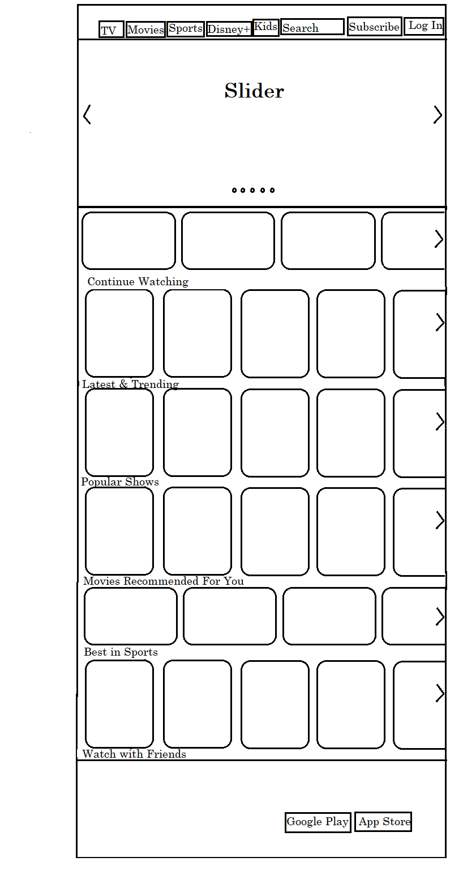

**LAYOUT OF HOMEPAGE**

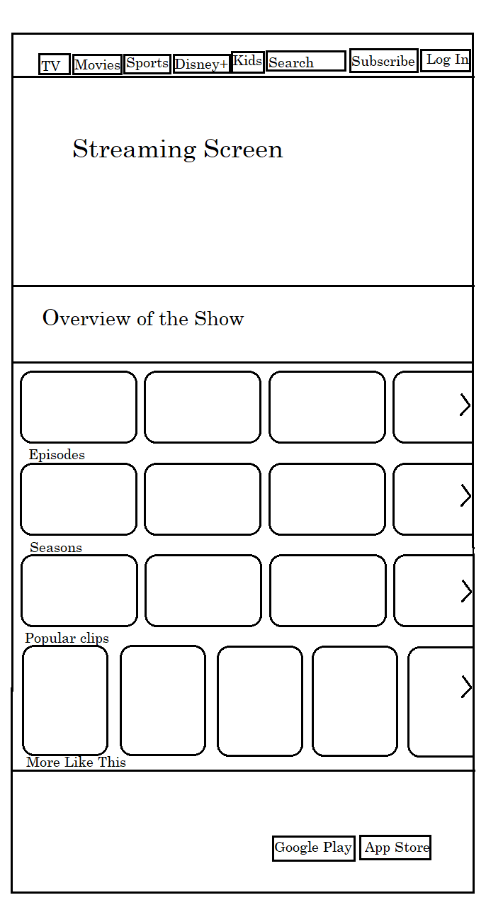

**Layout of Streaming Page**