CalendarMate – AI Productivity Assistant

Business Case:
The Problem:
ServionIQ’s PMs/TPMs and senior ICs are burdened by administrative overhead that limits their ability to focus on strategic work. They spend an estimated two hours per day on scheduling, meeting logistics, and email management. Manual coordination often results in calendar conflicts and double bookings. Daily work information is scattered across multiple tools, creating inefficiencies through constant context switching. As a result, meeting action items and follow-ups are inconsistently tracked, leading to execution gaps and reduced productivity.
Business Benefits:
Recovered billable/delivery capacity. In a professional service SaaS business, a PM/TPM's time is very crucial. Two hours/day recovered per person is the additional capacity that converts directly into higher utilization on client-billable project work, or into a PM/TPM being able to run a larger portfolio of projects without ServionIQ hiring another PM to cover the growth.
2. Fewer scheduling errors and their downstream cost. Double-bookings and missed conflicts aren't just annoying in a client-facing firm, they can cost trust or rework. Automated availability checking and conflict detection (the Scheduler Agent) reduces the rate of these errors directly, and reduces the "silent cost" of a PM manually re-checking 3–5 calendars before proposing a time.
3. Action items that don't get dropped: The problem statement explicitly calls out that "action items from meetings are discussed but rarely tracked systematically." Systematic follow-up generation closes a real delivery-quality gap: fewer commitments falling through the cracks means fewer client escalations, fewer disputes, and better internal accountability — all things that show up in client renewal and satisfaction.
4. Lower context-switching, better focus quality. Consolidating calendar, email, and meeting-prep into one morning briefing removes the daily 30–45 minute "figuring out my day" ritual and the constant tool-switching during the day.

Metrics to track:
 | Metric | Definition | Baseline | Target (post-rollout) | Data source
 | Daily operational time saved per user | Self-reported or estimated minutes/day no longer spent on manual scheduling, calendar cross-checking, and email triage | ~120 min/day (problem statement) | ≥50% reduction (≤60 min/day) | Pre/post time-use survey + CalendarMate usage/trace logs
 | Scheduling conflict rate | Double-bookings or missed-conflict incidents per user per week | Current manual baseline (to be measured in week 1 of pilot) | Meaningful downward trend within first month | Scheduler Agent trace logs (conflicts detected/flagged vs. conflicts that reach the calendar)
 | Meeting follow-up / action-item closure rate | % of meetings that produce a tracked recap + action-item list, and % of those action items marked complete within an agreed window (e.g. 5 business days) | Largely untracked today ("rarely tracked systematically") | ≥80% of meetings get a recap; track closure rate as a leading indicator, not a hard target in month one | Follow-Up Agent output logs + existing project-management/task data
 | Cost per user per day vs. value recovered | (LLM + API + infra cost per user per day) compared against recovered time valued at loaded PM/TPM cost | N/A (new cost line) | Positive ROI — cost per user per day should be a small fraction of the dollar value of time recovered | LLM/API billing + trace token-usage logs, cross-referenced with HR-provided lo

Design & Architecture:
Functionality mapping:
Daily Briefing(Core) - `briefing-agent.json`
Key nodes: `Get Today's Events` (Calendar), `Get Unread Emails` (Gmail), `Sync Point` merge, `Generate Daily Briefing` (agent)
Smart Scheduling(Core) - `scheduler-agent.json`
Key nodes: `Get Busy Times`, `Propose Slot` + structured parser, `Has Conflict?` / `Slot Found?` branches, `Create Event with Meet Link`
Email Summarization(Core) - `email-agent.json`
Key nodes: `Get Unread Emails` (filtered query), `Classify, Group & Write Digest
Meeting Follow-Up Generator (Extended) - `followup-agent.json`
Key nodes: `Extract Recap` + structured parser, `Attendees Known?` branch, `Email Recap to Attendees`
Tool selection rationale:
n8n (no-code/low-code): Native, pre-built OAuth2 nodes for Google Calendar and Gmail provide the ease of connection; the visual canvas also makes the IF/branch logic in the Scheduler and Follow-Up workflows easy to audit against the baseline test cases.
sub-workflows for each specialist, rather than one long single workflow: Each specialist becomes independently callable, independently testable against its own baseline rows and independently re-usable.

Agent design decisions:
One Orchestrator with tools, not a rigid switch/router node: Orchestrator decides which specialist(s) to call and in what order, and its system message explicitly instructs it to combine multiple tool outputs into one reply when a request spans more than one specialist.
Narrow, single-purpose system prompts per specialist: Each specialist's prompt only knows about its own slice of the problem. This keeps each grounding short and unambiguous and makes it easy to test each specialist in isolation against its own baseline.
Two-tier LLM reasoning inside Scheduler (Propose Slot → Conflict Resolver): Rather than asking one prompt to find a slot and reason about rescheduling priority, the workflow splits these into separate agent calls with separate schemas.
Orchestration pattern selection with justification:
Pattern implemented: Hierarchical delegation (Orchestrator decomposes → delegates to specialist(s) → aggregates results), not a pure Router.
Why not pure Router: A Router classifies a request into exactly one category and hands off entirely — it would break the moment a user asks something that spans two specialists. The Orchestrator's system message explicitly instructs it to call multiple tools in the right order and combine their outputs into one reply, which is decomposition-and-aggregation behavior, not single-label classification.
Why not Sequential Pipeline: Running Briefing → Scheduler → Email → Follow-Up on every single request regardless of intent would increase the number of LLM calls and Calendar/Gmail API calls needed for the common case of a single-intent question like "summarize my emails", with no benefit.
Why Hierarchical fits: The implementation matches the course's own definition almost exactly: the Orchestrator (a) decomposes the request implicitly by deciding which specialist(s) are relevant, (b) delegates via toolWorkflow calls with an LLM-extracted request parameter ($fromAI(...)) tailored to each specialist's needs, and (c) aggregates the returned text into a single, tool-name-free reply to the user. This is also the natural fit for n8n specifically — the platform's own "AI Agent + Tool sub-workflow" primitive is the hierarchical-delegation pattern; building a genuine Router would mean fighting the platform's idiom rather than using it.
Design Constraint:
The Orchestrator never touches Calendar/Gmail directly — every read or write happens inside a specialist's own sub-workflow, which returns a single text string back to the Orchestrator via n8n's `toolWorkflow` node. The Orchestrator can call more than one specialist per turn before composing its final reply.
Screenshots of Workflows:
1.Orchestrator Agent Workflow:
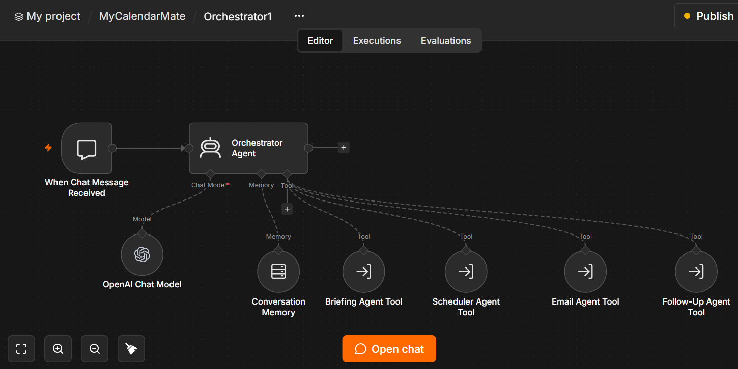
2. Briefing Agent Workflow:
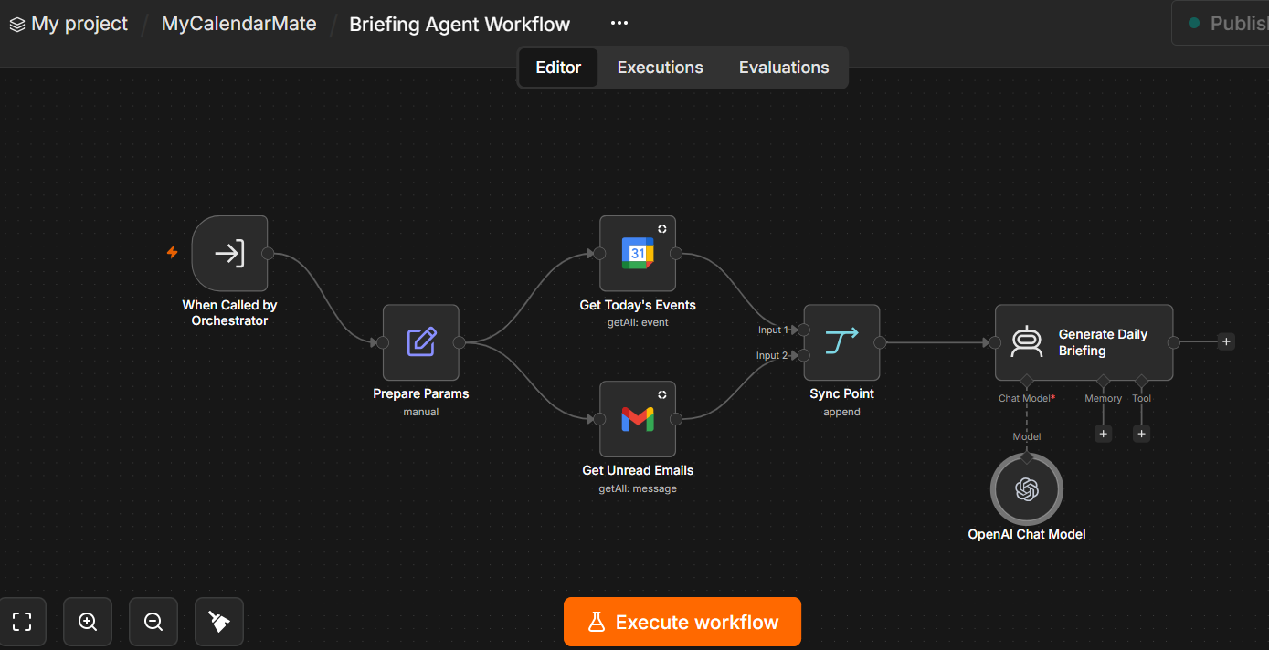

3. Scheduler Agent Workflow:
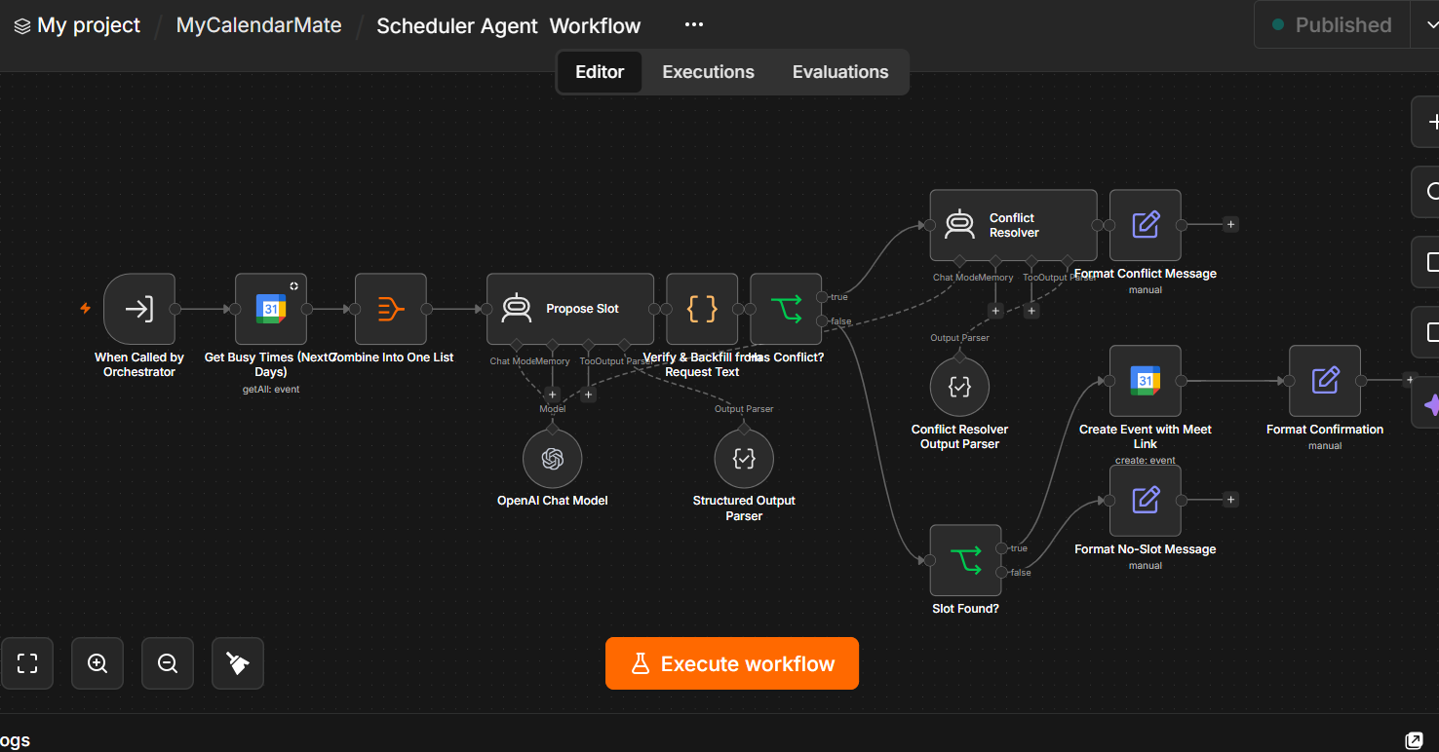

4. Email Agent Workflow:
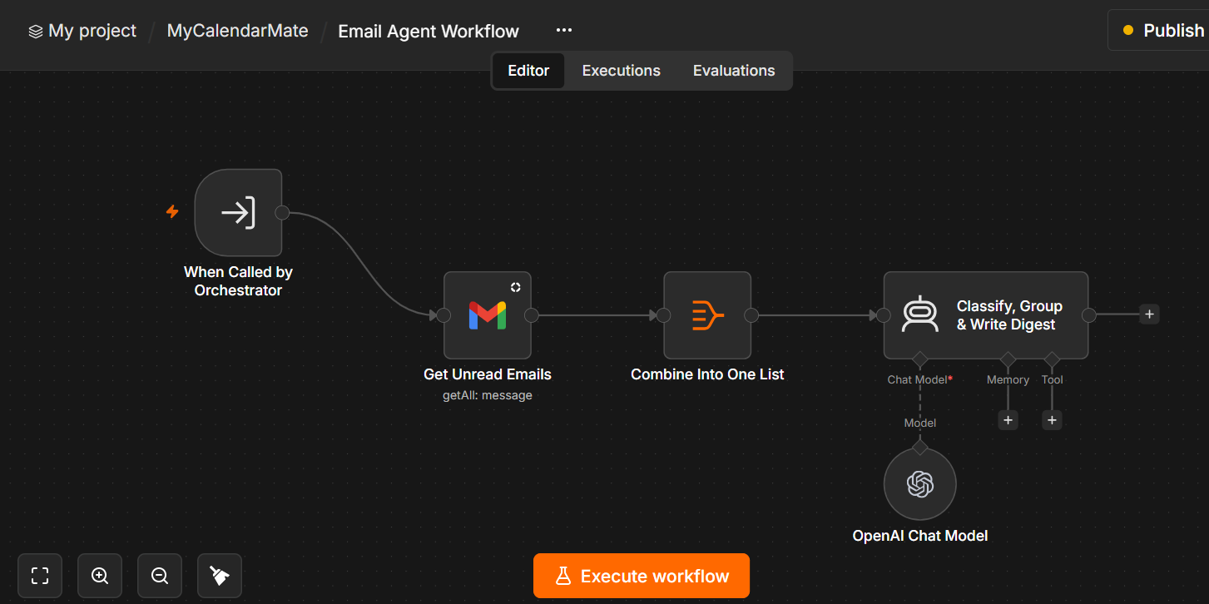

5. Follow-up Agent Workflow:
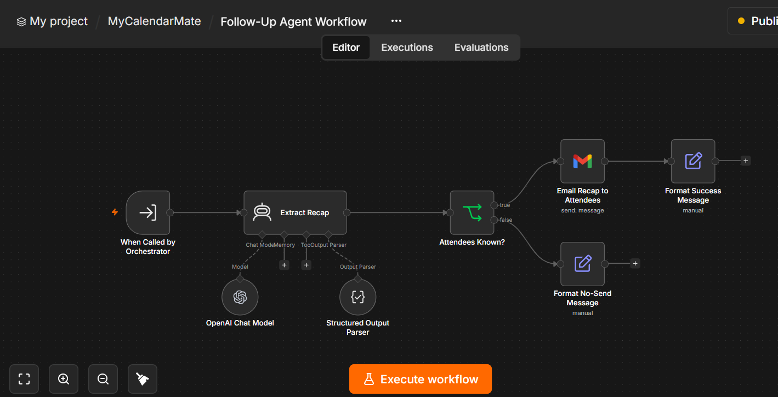

Screenshots of execution:
Implementation:
The CalendarMate AI productivity assistant is implemented with three core capabilities and one extended capability.
Next step: Observability integration.
Testing with baseline dataset:
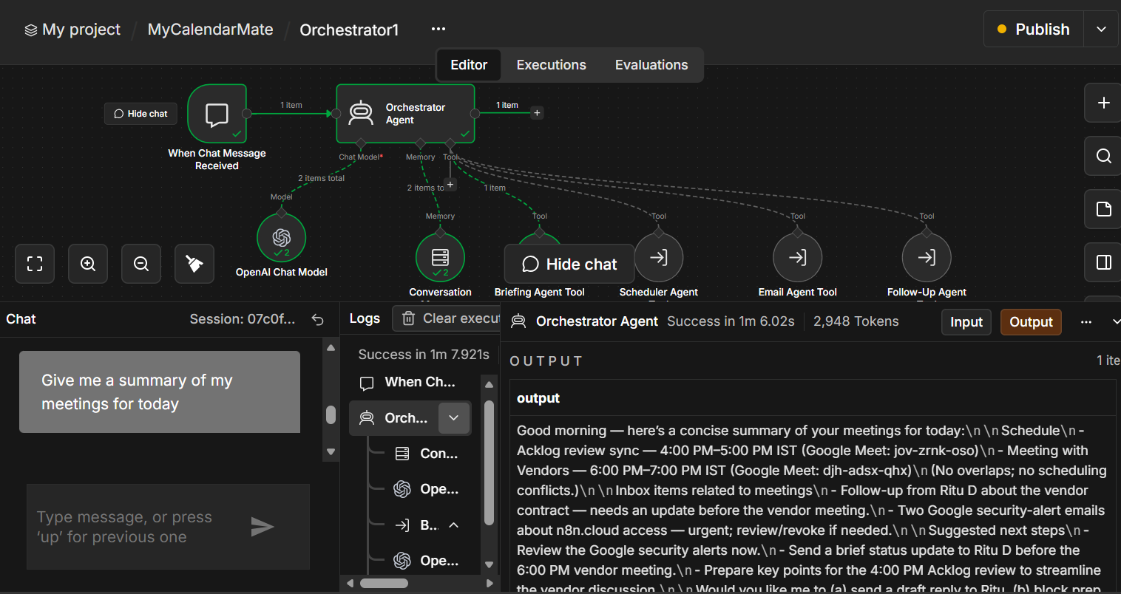

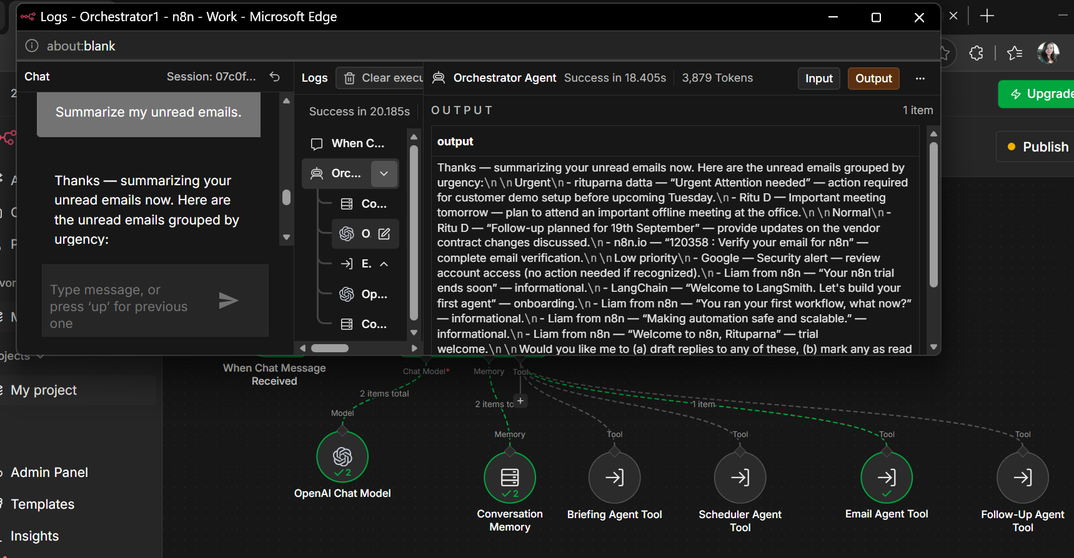
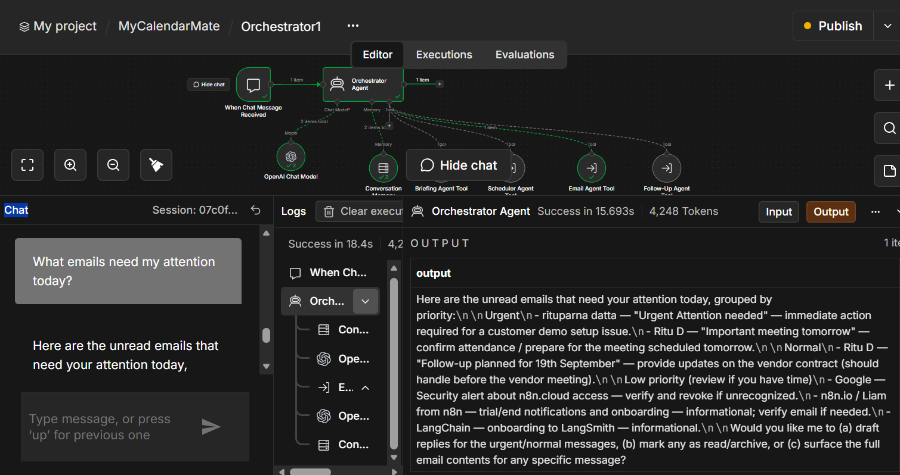
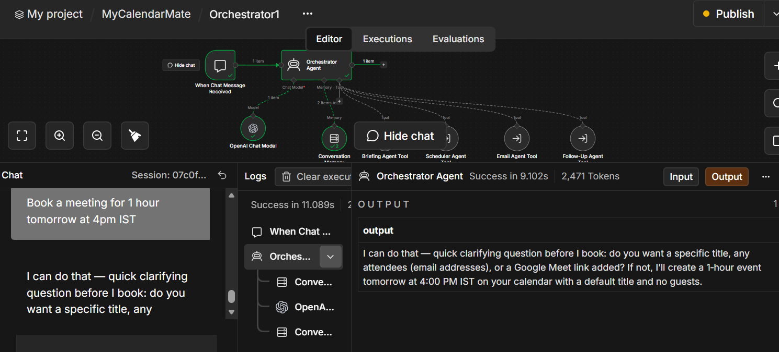
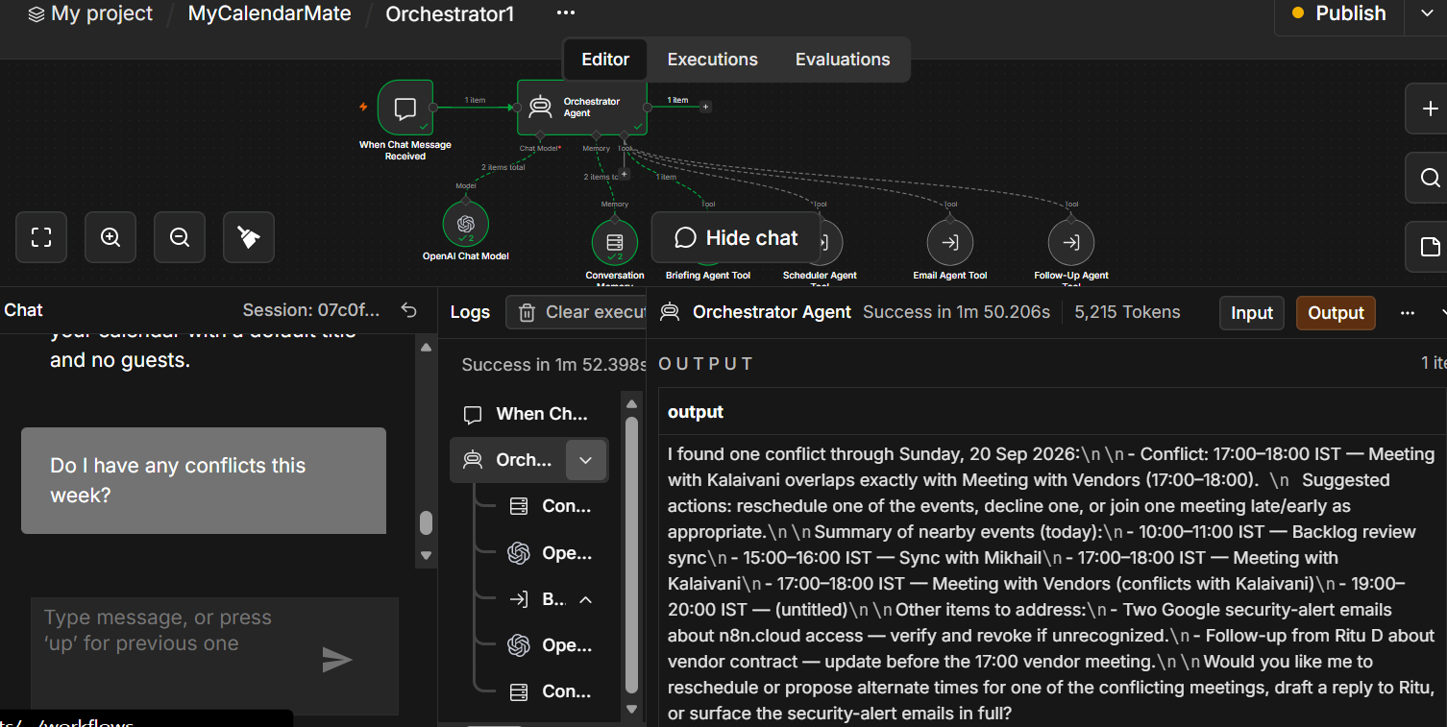

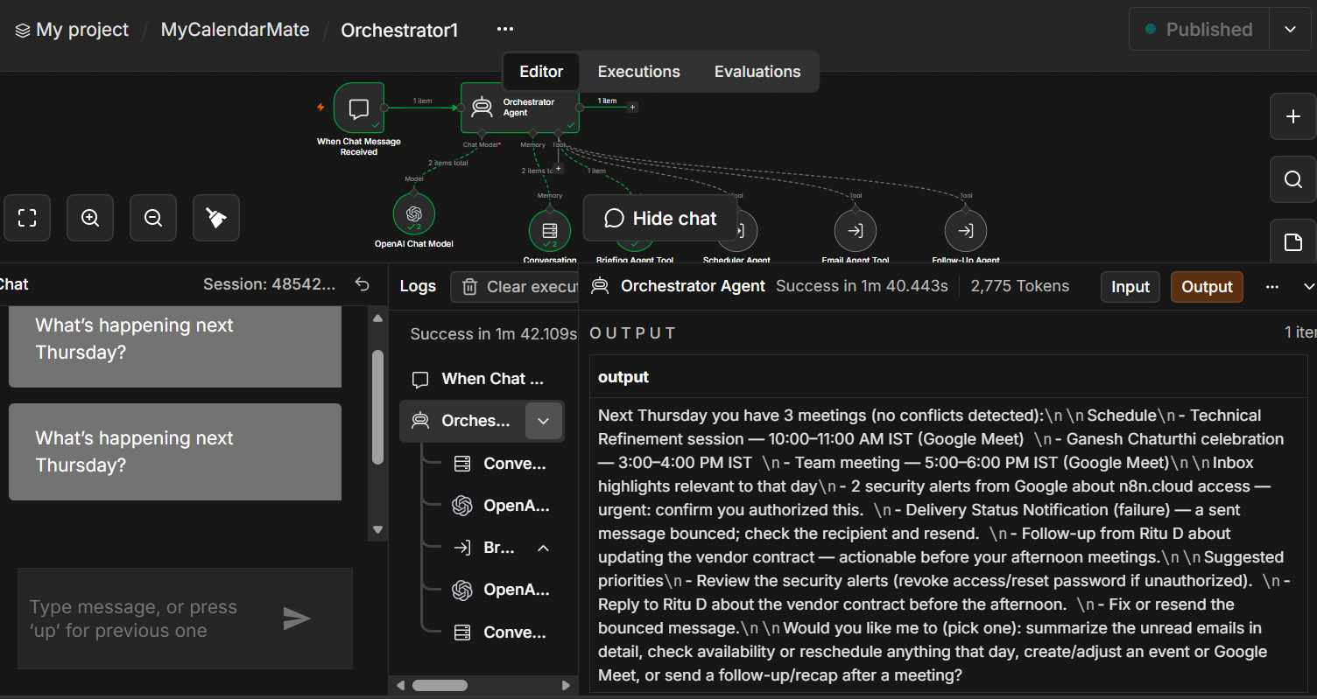

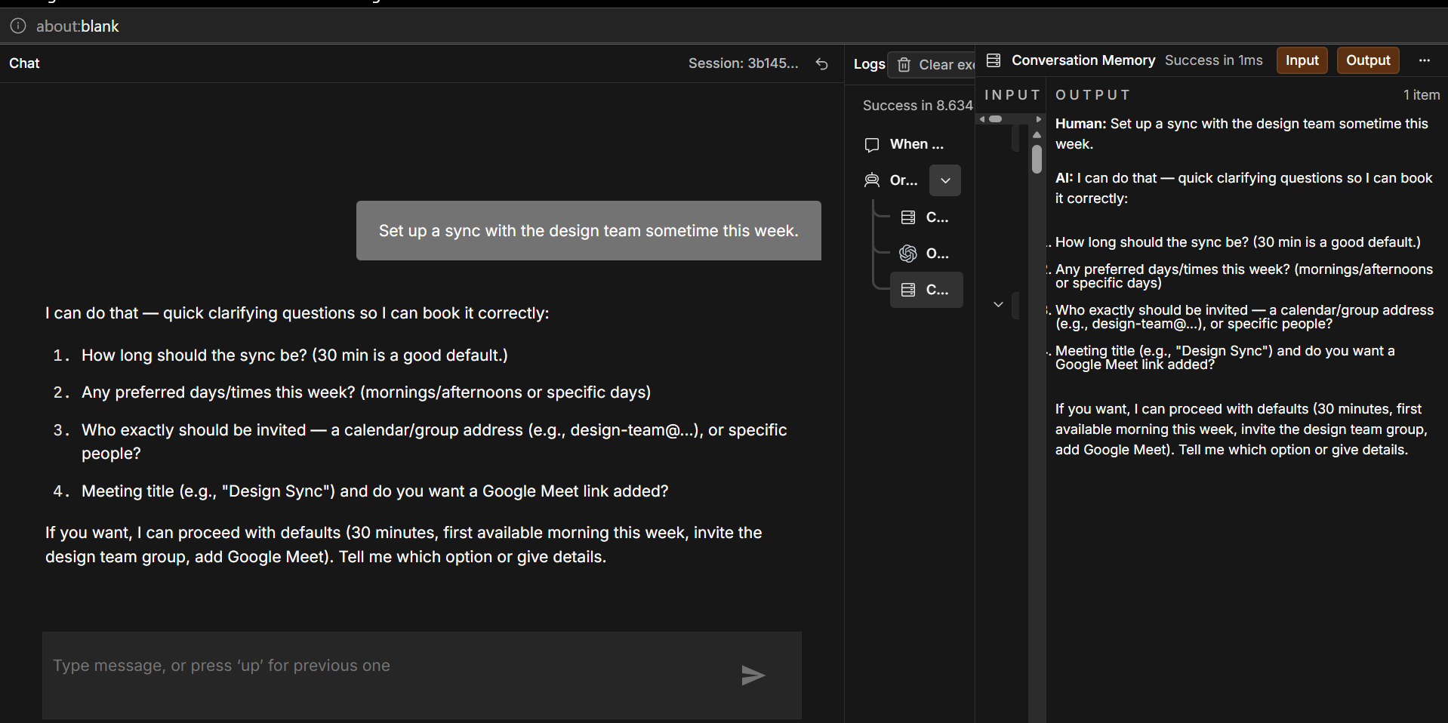
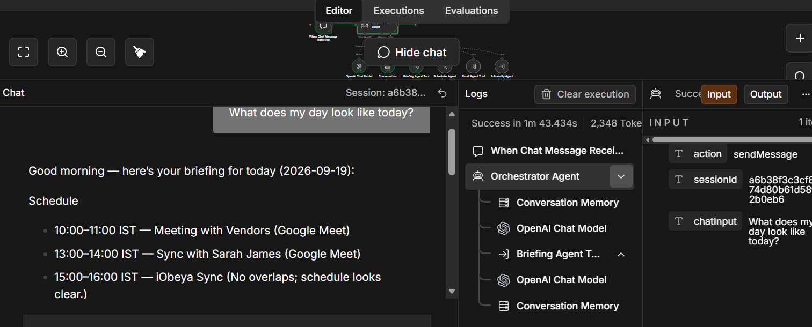
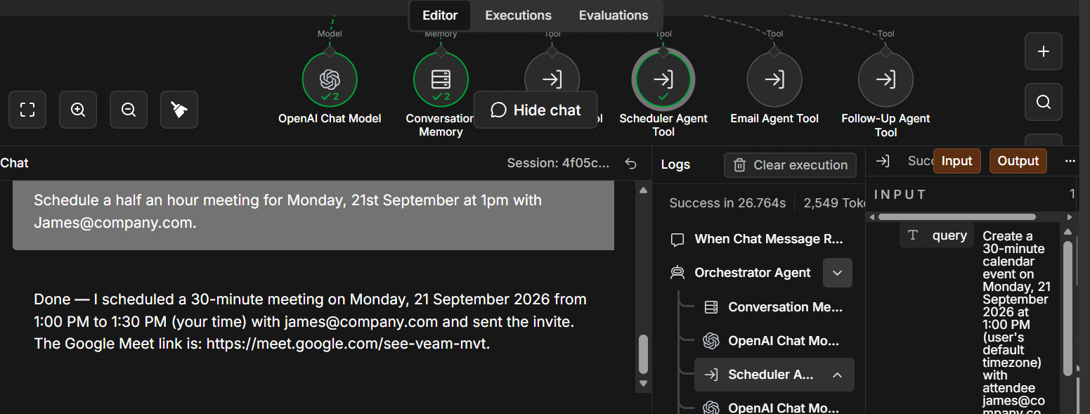

Cost and Evaluation Strategy:
Cost per user per day:
Model: All five workflows run **gpt-5-mini** end-to-end (Orchestrator + all four specialists), at OpenAI's published $0.25/$2.00 per million input/output tokens.
Call | Est. Input tokens | Est Output tokens | Cost/call | Calls/day | Cost/day
Orchestrator | 1500 | 250 | $0.00088 | 8 | $0.007
Briefing Agent | 4500 | 300 | $0.0017 | 1 | $0.002
Scheduler — Propose Slot | 6000 | 200 | $0.0019 | 3 | $0.006
Scheduler — Conflict Resolver (when triggered) | 3000 | 350 | $0.0015 | ~1 | $0.001
Email agent | 3000 | 350 | $0.0015 | 2 | $0.003
Follow-Up Agent | 1500 | 400 | $0.0012 | 2 | $0.002
LLM subtotal |  |  |  |  | ~ $0.02/user/day

Production metrics (3+):
Metric | Definition
Booking correctness rate | % of created calendar events whose title, time, duration, and attendee list all match what was actually requested
Multi-turn correction rate | % of scheduling requests that require at least one follow-up "that's not what I asked for, please fix it" exchange before landing correctly
Scheduler tool-call error rate | % of Scheduler invocations that return a structured-output parse error or execution failure rather than a usable result
Unclarified-ambiguous-request rate | % of scheduling requests with a missing or ambiguous element (no attendee, no exact time, "sometime this week") that got forwarded to Scheduler without any clarifying question

Program Charter:
Vision statement: Give every PM/TPM and senior IC an AI assistant that handles the coordination layer of their job — briefing, scheduling, inbox triage, and meeting follow-through, so that their working hours reflect their actual priorities. Success looks like the ~2 hours/day of operational overhead described in the original problem statement being reclaimed as billable/delivery capacity, without adding headcount. Beyond the internal productivity win, a working, well-evidenced CalendarMate deployment becomes a credible "we use this ourselves" reference story for ServionIQ's own customer-facing project management and workforce-planning product line.
North star: Reduce time spent on scheduling/email/logistics from ~2 hours/day toward a target of 30 minutes/day within two quarters of full rollout, with no increase in missed commitments or scheduling errors.
Scope:
- Core capabilities: Daily Briefing, Smart Scheduling, Email Summarization
- Extended capability: Meeting Follow-Up Generator (the capability selected for this build)
- The five-agent n8n implementation (Orchestrator + Briefing/Scheduler/Email/Follow-Up specialists) using Hierarchical delegation via tool-workflow calls
- Google Calendar and Gmail as the only integrated data sources
- Rollout to up to 50 PMs/TPMs across ServionIQ's practice team
Success Criteria:
Criteria | Target
Baseline test pass rate (T1–T12) | ≥90% test pass
Daily operational time reduced per user | ≥50% reduction from the ~120 min/day baseline
Weekly active usage | ≥70% of onboarded PMs/TPMs by end of pilot
Routing accuracy (Orchestrator → correct specialist) | ≥95%
Grounding / fabrication rate | No instances (0%)
Meeting follow-up coverage | ≥80% of meetings receive a tracked recap

Timeline:
Phase | Duration
Build & Fix (phase 0) | 2 weeks
Pilot (phase 1) | 1-2 weeks
Limited rollout (phase 2) | 2 weeks
Full rollout (phase 3) | Starts from week 5-6

Risks:
1. Single-vendor (OpenAI) dependency, an outage or rate limit affects the whole assistant.
2. Confidential meeting/email content sent to a third-party LLM API. Must be addressed in next phase.
Stakeholders:
1. CTO – Executive sponsor. Final approver on scope changes and rollout phase gates.
2. AI PM/TPM – Owns architecture, agent design, orchestration pattern, model/vendor choices, and day-to-day delivery decisions.
3. PMs/TPMs – Primary users.
4. IT/Security – Owns credential governance (OAuth2, API keys), data-processing agreement review with OpenAI, and the per-user authorization.
5. Finance Dept - Monitors cost-per-user-day against the business case estimate.
Decision making:
1. Scope changes – CTO and AI PM/TPM jointly.
2. Rollout decision – AI PM/TPM proposes based on the Success Criteria, CTO approves.
3. Model/vendor choices – AI PM/TPM decides based on baseline test evidence, informing CTO of the cost/reliability trade-off rather than seeking pre-approval for every model experiment.
4. Privacy/security – IT/Security, a security concern pauses progression regardless of where the program otherwise stands.
5. Day-to-day engineering decisions – AI PM/TPM and supporting engineers, no sponsor approval required.

Reflection & Next Steps
What the actual testing/tracing surfaced:
Live debugging of the Scheduler surfaced failure modes that reading the workflow JSON alone didn't predict:
1. gpt-5-mini repeatedly misclassified explicit-time requests as flexible searches, defaulting duration/title/attendees and booking an unrelated slot.
2. It also drifted on required JSON keys (attendeeEmails instead of the schema's attendees), crashing the output parser.
3. Scheduler was running its no-conflict flexible search against an empty request which needs to be re-verified in week one rather than assumed fixed.
2-week improvement plan:
Week 1:
a. Integrate with Langsmith/Lanfuse.
b. Root-cause the request: null issue properly: test in isolation. Re-run the dataset once request is confirmed non-null.
c. Fix Briefing's date-range parameters.
Week 2:
a. Decide and implement Scheduler's missing update-event capability (currently create-only.
b. Add multi-attendee free/busy checking (today only checks the organizer's own calendar).
c. Re-run the full 12-item baseline and decide, with real data, whether gpt-5-mini stays for Scheduler specifically or reverts to a stronger model there, independent of Briefing/Email/Follow-Up.

Privacy and security considerations:
- Meeting titles, attendee emails, and inbox content are sent to OpenAI on every call. This needs to be relooked at before roll-out to ensure client-confidential meeting data is not sent out.
- Never commit real OAuth2/API credentials into the exported workflow JSON
- Follow-Up auto-sends recap emails to LLM-extracted addresses. Extracted recipients to be cross-checked against a trusted directory before sending.
- There is currently no per-user authorization boundary tying a chat session to one PM/TPM's own calendar/inbox scope, a real gap at 50-user scale.

Rollout plan for 50 PMs/TPMs:
Phase 1 (Pilot - 3-5 users, 1-2 weeks): volunteers only, Scheduler use closely monitored given the issues observed during the implementation; Briefing/Email can be enabled more freely since they've shown fewer failures.
Phase 2 (~15 users, 2 weeks): expand across the different practice teams named in the company profile (consulting/legal/accounting/architecture/marketing), watching the routing-accuracy.
Phase 3 (remaining ~35 users): Roll-out to remaining PMs/TPMs. Weekly trace/cost review for the first 2 months. The reviews then can be planned on a monthly basis.

