Challenge-4
Task -1 (3.5 marks): Run a Mapper/Reducer on Dataproc
- I first created a cluster with a name node (High performance CPU, lower storage: N2 8GB, 100 GB disk size) and 2 data nodes (Lower CPU, more storage:E2 32 GB, 200 GB disk size)

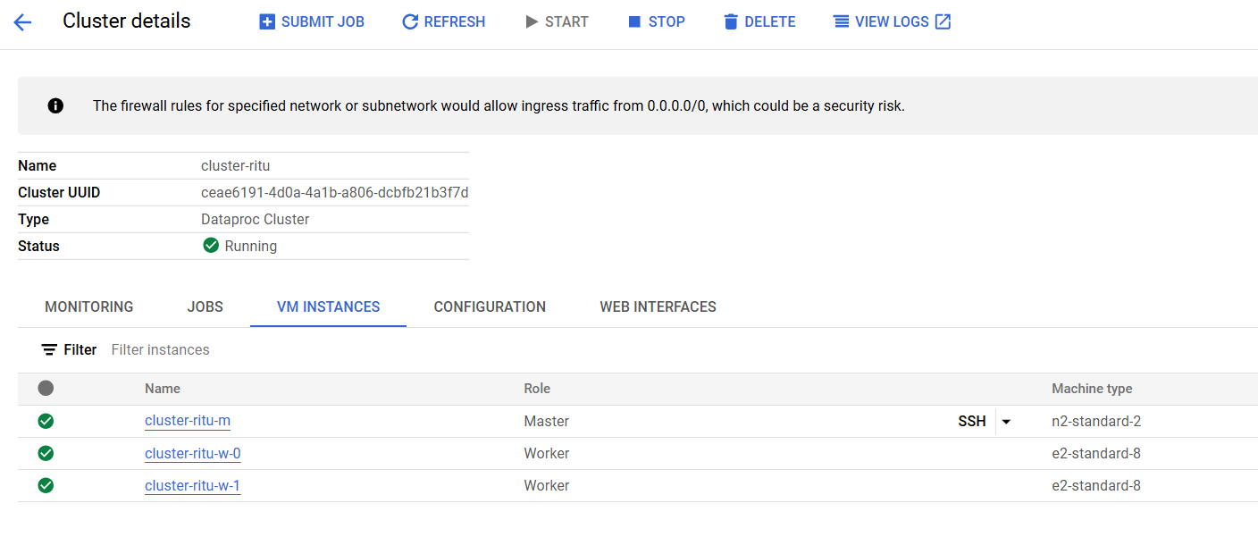

- Using vim text editor created TableA.csv and TableB.csv
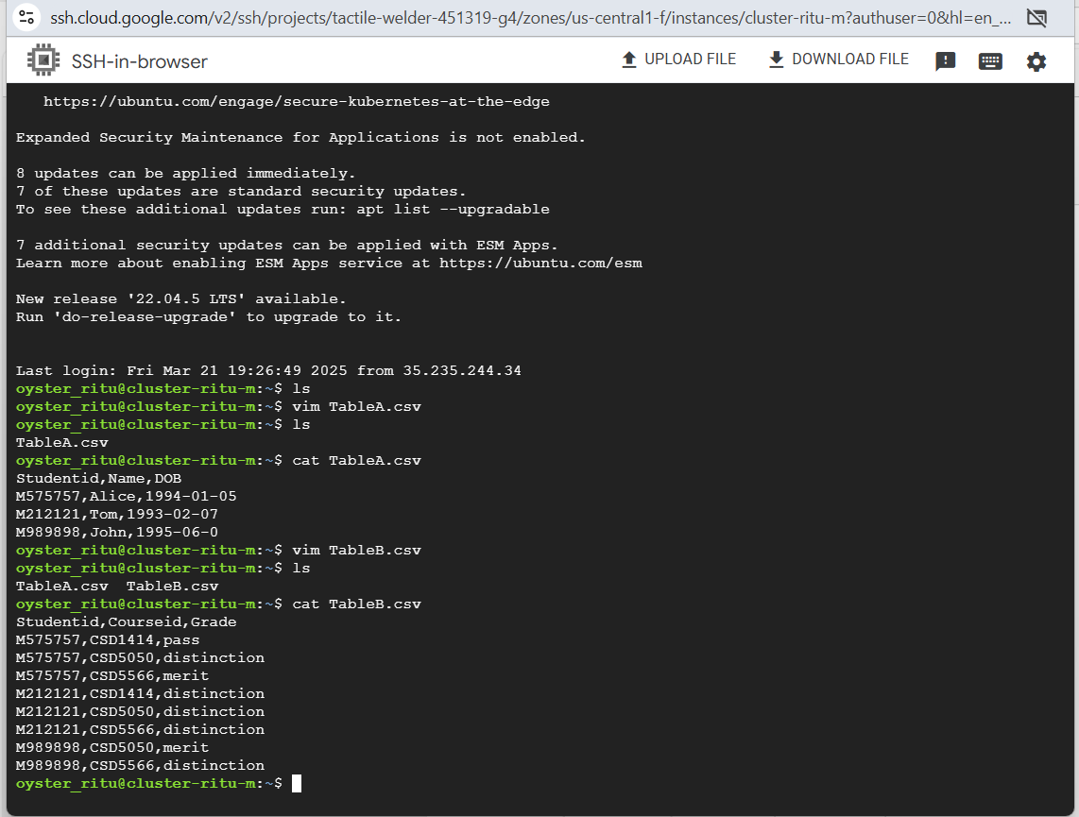

Now, will create a mapper code and the most common way to write a mapper script would be as below:

- Using a Text Editor (like vim, nano)
- Write Locally on Your Machine, Then Upload to VM
- Echo Command (for quick one-liners or small scripts)
- Create on the VM using cat (quick and dirty)
- Use Jupyter Notebook in Dataproc (optional for dev)

Here, I had used vim text editor to write a mapper script using python but my system crashed and was unable to use Dataproc. So, alternatively created mapper.py and reducer.py in pandas for better understanding and created two csv files Table_A.csv and Table_B.csv in my local system.

Then ran it on my terminal and below is the output.
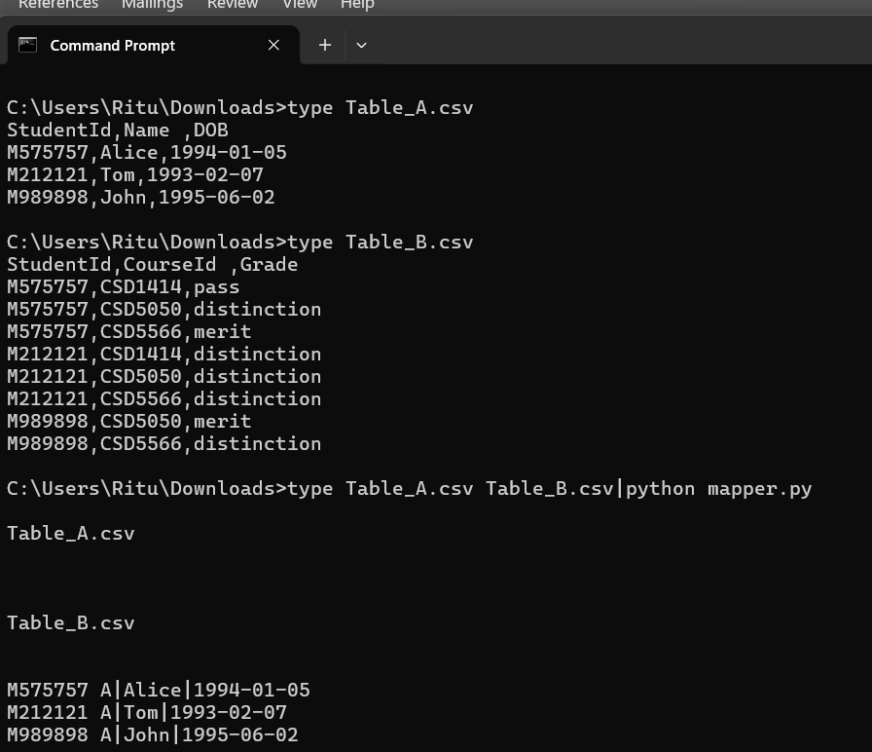
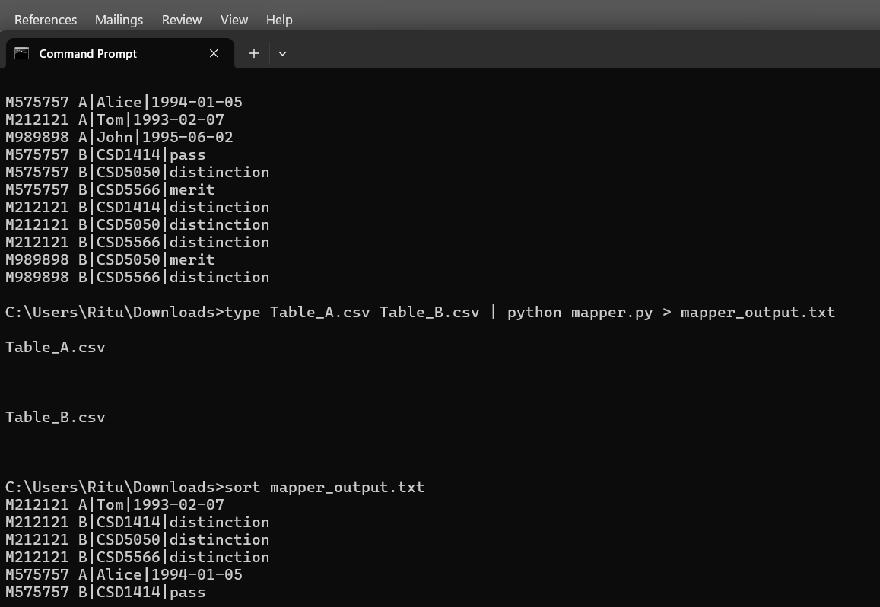
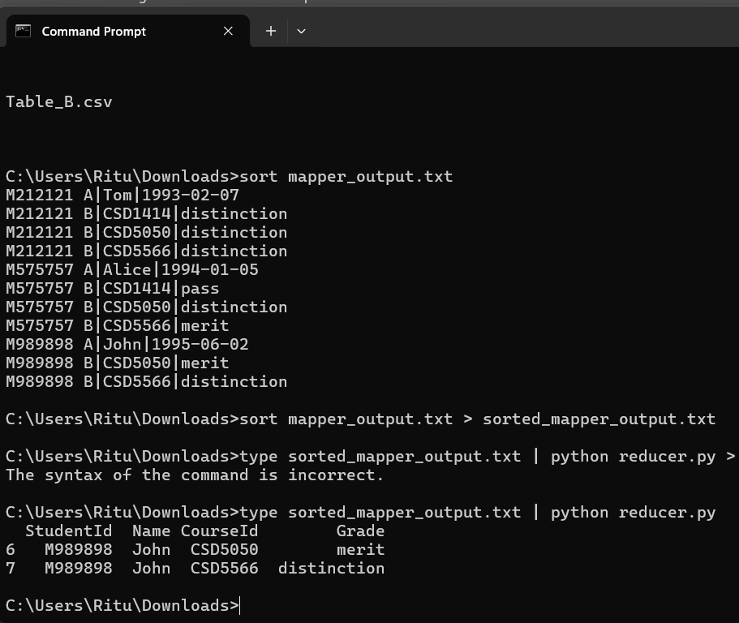

By the time dataproc was up and running, created another mapper and reducer code using python and tested in the local terminal and it worked
Below is the code for Mapper in python using stdin
#!/usr/bin/env python3
import sys
import os
file_path = os.environ.get('map_input_file', '')

if 'Table_A' in file_path:
tag = "A"
elif 'Table_B' in file_path:
tag = "B"
else:
tag = None

for line in sys.stdin:
line = line.strip()
if not line or tag is None:
continue

if line.lower().startswith("studentid"):
continue

values = line.split(',')

if tag == 'A' and len(values) == 3:
student_id, name, dob = values
output = f"{student_id}\tA,{name},{dob}"
elif tag == 'B' and len(values) == 3:
student_id, course_id, grade = values
output = f"{student_id}\tB,{course_id},{grade}"
else:
continue # skip malformed lines

print(output)

Reducer code
#!/usr/bin/env python3
import sys
import os
from datetime import datetime
current_student = None
student_info = None
courses = []

DOB_THRESHOLD = datetime.strptime("1995-01-01", "%Y-%m-%d")

def emit_joined_records():
if not student_info:
return
try:
name, dob_str = student_info
dob = datetime.strptime(dob_str.strip(), "%Y-%m-%d")
if dob >= DOB_THRESHOLD:
for course_id, grade in courses:
print(f"{current_student},{name},{dob_str},{course_id},{grade}")
except Exception:
pass # silently skip invalid dates

for line in sys.stdin:
line = line.strip()
if not line:
continue

if '\t' in line:
student_id, value = line.split('\t', 1)
elif ' ' in line:
student_id, value = line.split(' ', 1)
else:
continue # malformed line

parts = value.split(',')

if student_id != current_student:
emit_joined_records()
current_student = student_id
student_info = None
courses = []

if parts[0] == 'A' and len(parts) == 3:
student_info = (parts[1], parts[2])
elif parts[0] == 'B' and len(parts) == 3:
courses.append((parts[1], parts[2]))

# Emit final group
emit_joined_records()

Source: GPT
Since, the code was working fine on my local terminal:

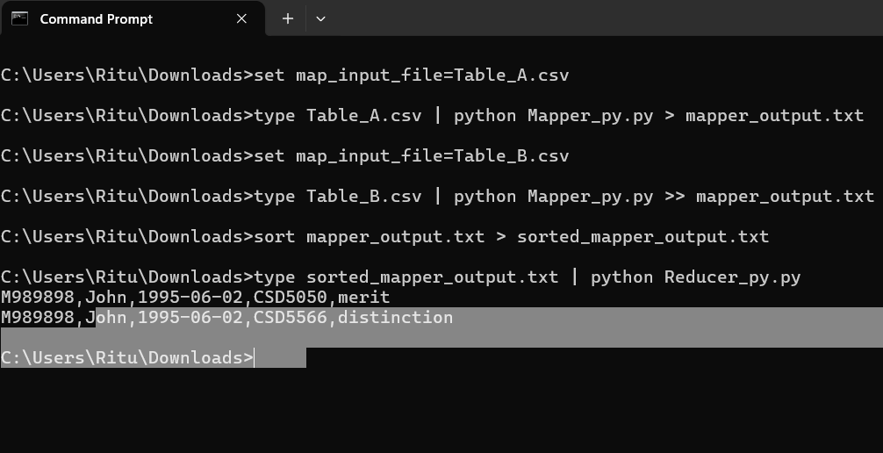

uploaded the file into GCS
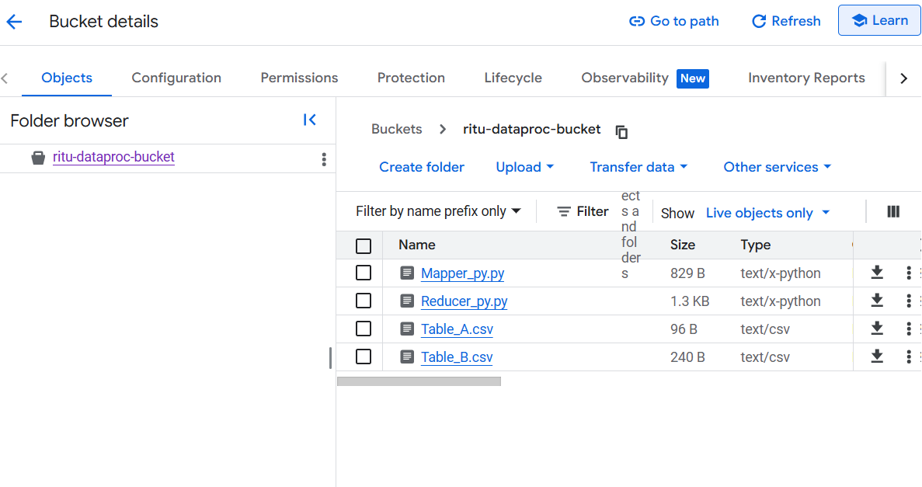

Now, that I have uploaded the file in GCS, I created a new cluster with ubntu 2.2, name node with 50 GB disk, n4-standard-2, 8GB and data node with 100 GB disk, n4-standard-2 CPU 16 GB. E2 was not available.

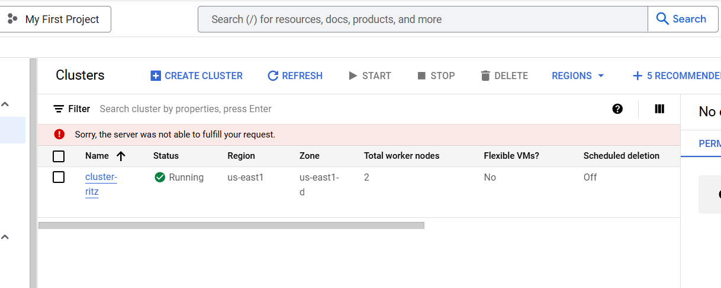
Connected name node with SSH and moved files from gcs to name node using the below commands.

gsutil cp gs://ritu-dataproc-bucket/Mapper_py.py .
gsutil cp gs://ritu-dataproc-bucket/Reducer_py.py .
gsutil cp gs://ritu-dataproc-bucket/Table_A.csv .
gsutil cp gs://ritu-dataproc-bucket/Table_B.csv .

Note: we use cp and not scp because we are using the same platform and the dot at the end of the command will save the file in your current working directory which is /home/oyster_ritu

Now, I move the csv files to Hadoop for splitting the data:

hadoop fs -mkdir -p input
hadoop fs -put Table_A.csv input/
hadoop fs -put Table_B.csv input/

Then run streaming job:

hadoop jar /usr/lib/hadoop/hadoop-streaming.jar \
-files Mapper_py.py,Reducer_py.py \
-mapper "python3 Mapper_py.py" \
-reducer "python3 Reducer_py.py" \
-input input \
-output final_output_1

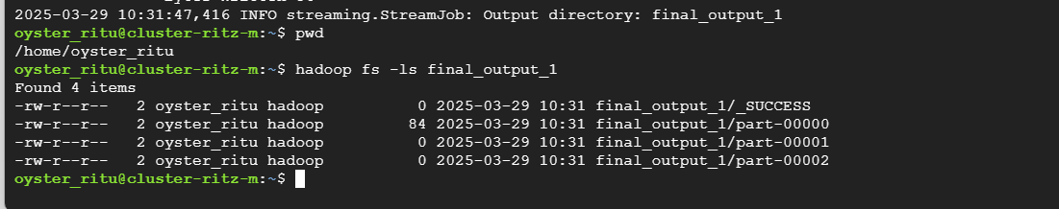

Final Output:
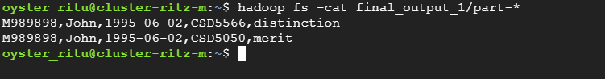

Alternatively, you may also view it in the GUI:
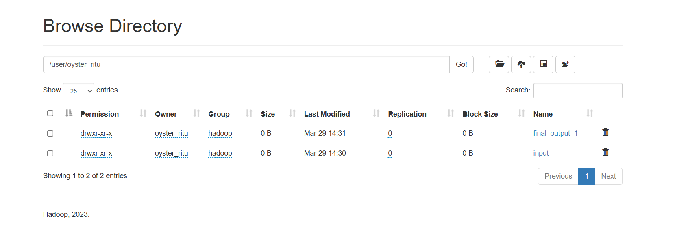

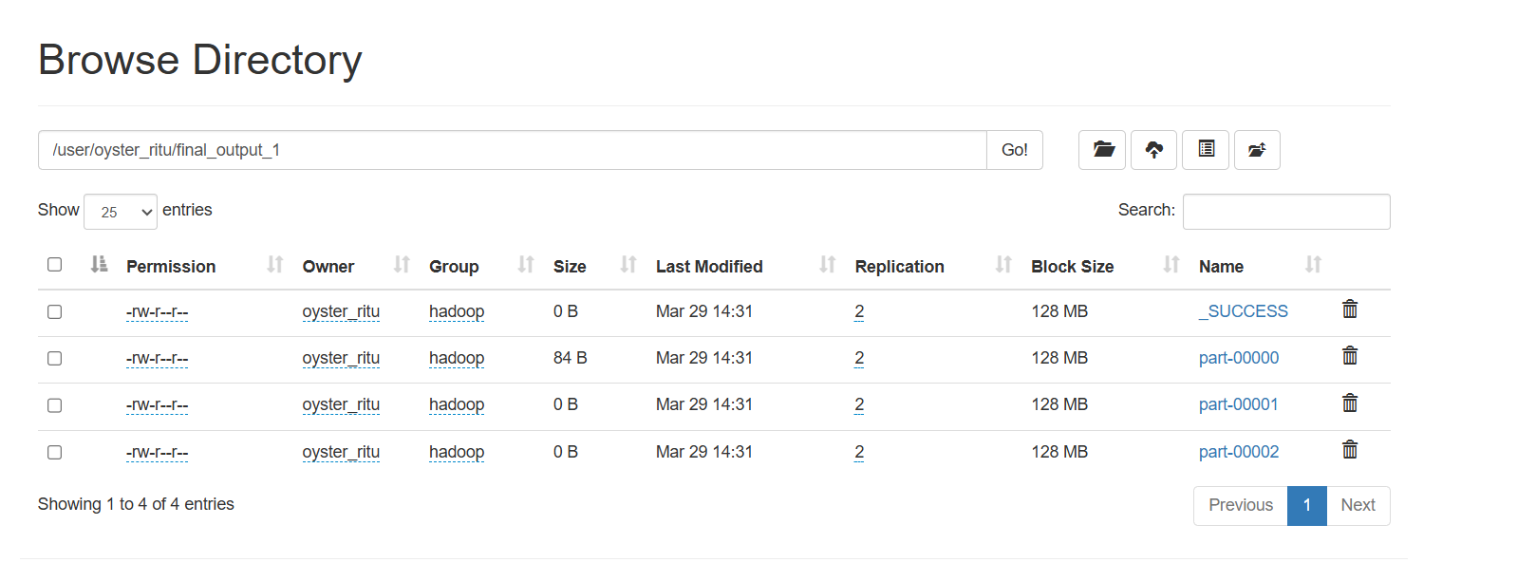

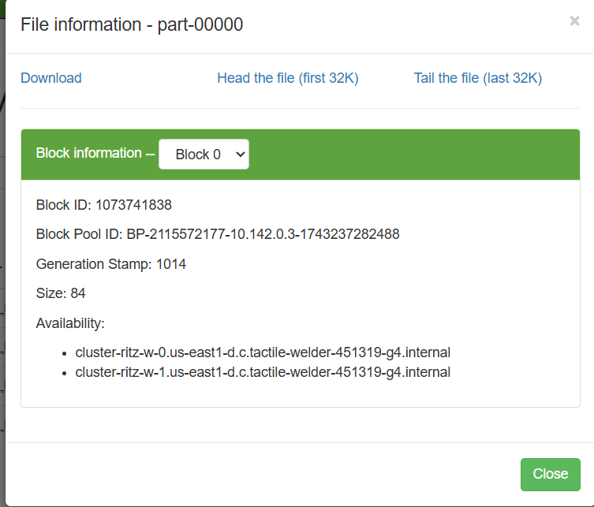

Observation:
One node took lesser time than the other
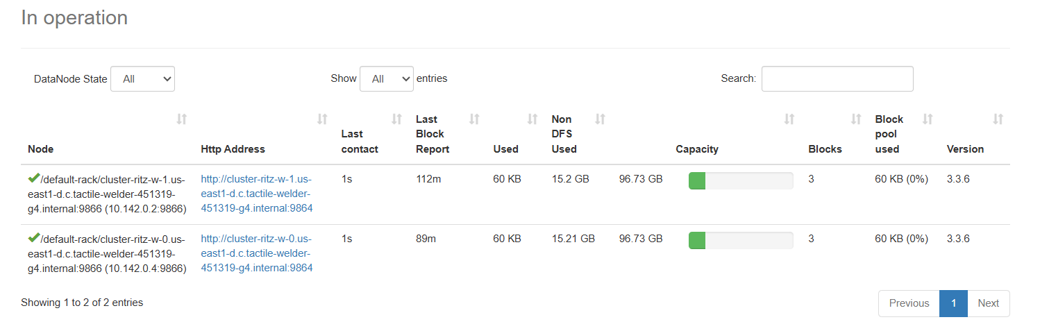
Hadoop assigned 3 reducers for this job, with only one valid output.

Task -2 (3 marks): Run a spark program with Gen AI

For this task I generated a synthetic 4.5GB UAE Amazon Reviews dataset using a python script in jupyter and then imported the file locally to Rstudio.

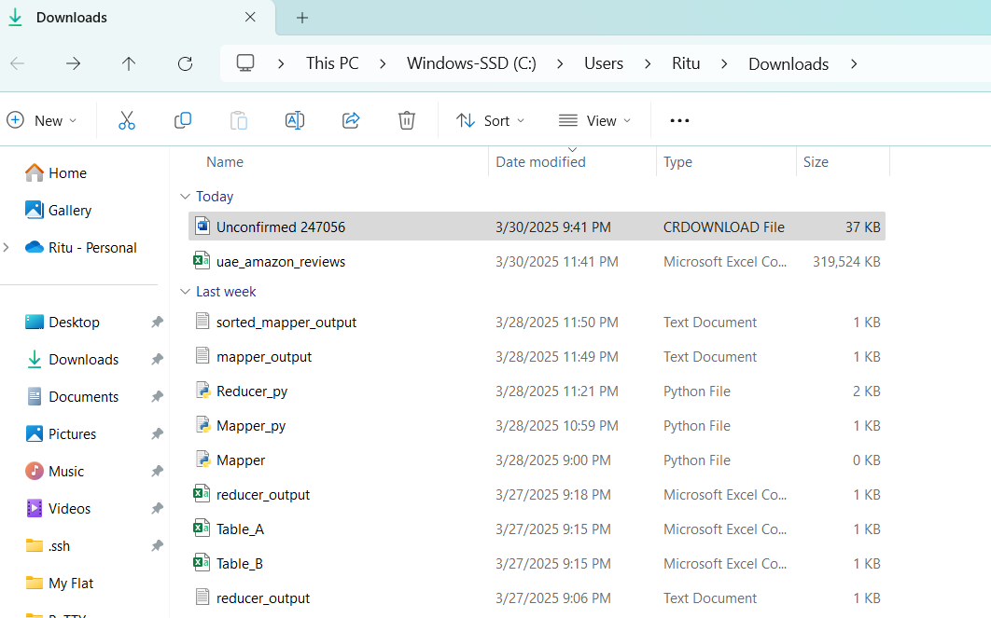

Then moved this file to Rstudio by using the below code:
df <- fread("C:/Users/Ritu/Downloads/uae_amazon_reviews.csv")
View(df)
sample_100<-df[sample(.N,100)]
head(sample_100)
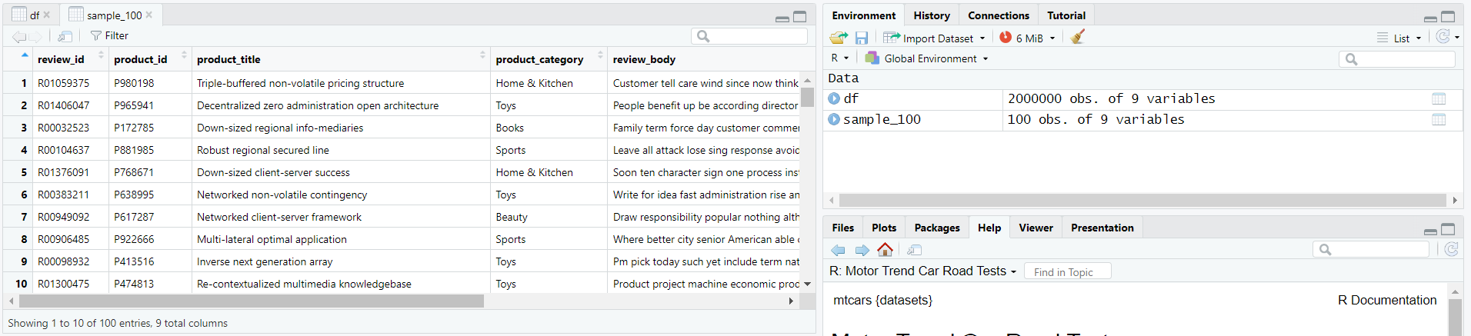
Then generated spark code in python first in jupyter notbook but didn’t work as Jupyter needs -Spark + Java + Hadoop Properly Installed
Running Spark in a Jupyter Notebook requires a local setup that includes:
- Apache Spark
- Java (usually OpenJDK)
- Python bindings (pyspark)
- Hadoop (even a minimal version)
Most environments, especially Google Cloud Notebooks and Colab, don’t have this preconfigured unless you install it yourself.
So, I saved the python script in notepad and saved it as “random_sample_task2.py”, all files utf-8
Now, loaded the file to GCS and reactivated my cluster-ritz, ran submit job using pyspark and the pyspark file that we uploaded in gcs.
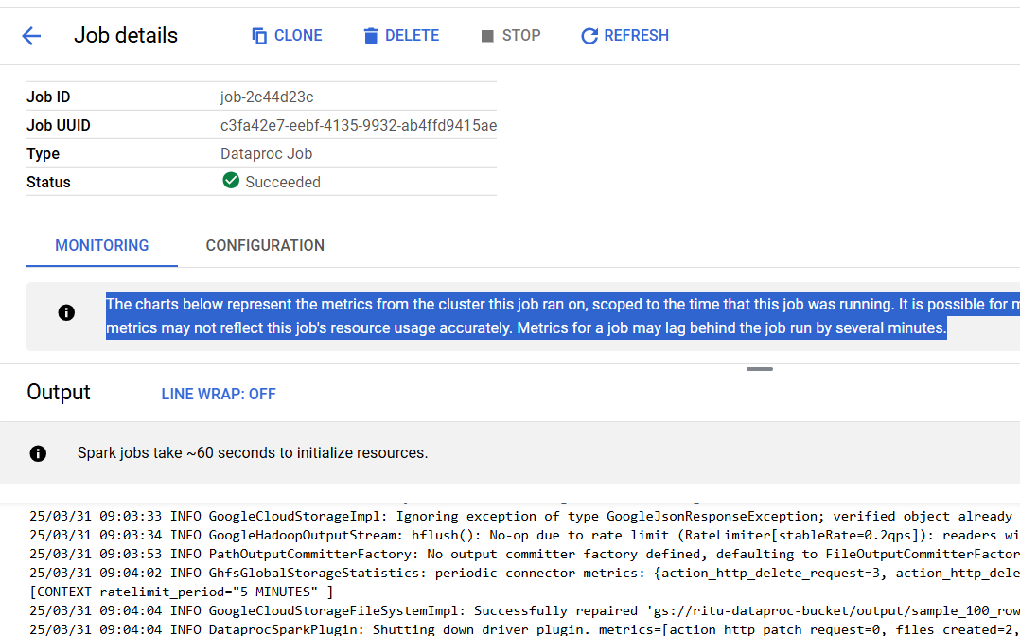

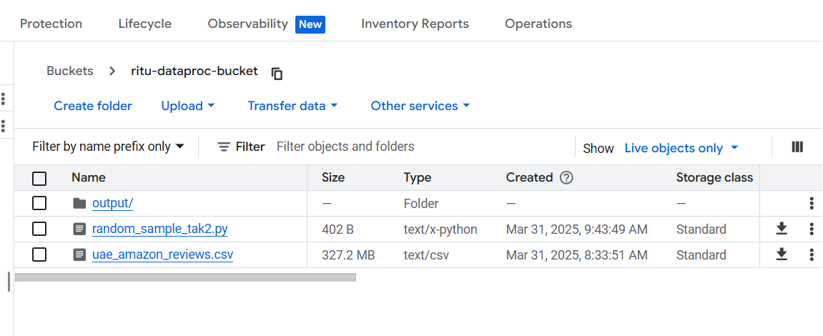
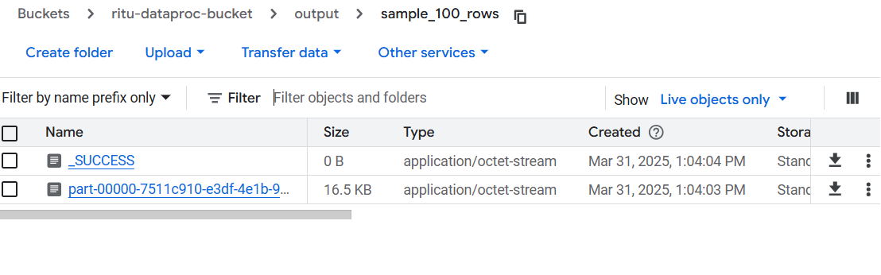

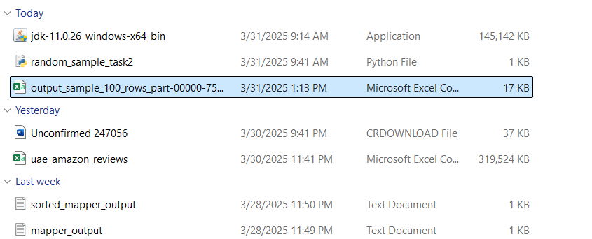

Here, is the final output:
Now, I have tried this task using ephemeral cluster as well this somehow took a little more time for me but the previous steps were all pretty smooth
An ephemeral cluster is:
- Created just for a single job
- Automatically deleted after the job finishes
- Great for running one-off or scheduled jobs without paying for idle time
# Set region (already configured earlier)
gcloud config set dataproc/region us-central1
# Submit job to Dataproc Serverless
gcloud dataproc batches submit pyspark gs://ritu-dataproc-bucket/random_sample_task2.py \
--region=us-central1 \
--deps-bucket=gs://ritu-dataproc-bucket \
--batch=batch-$(date +%s)
gcloud dataproc batches describe batch-1743423854 --region=us-central1
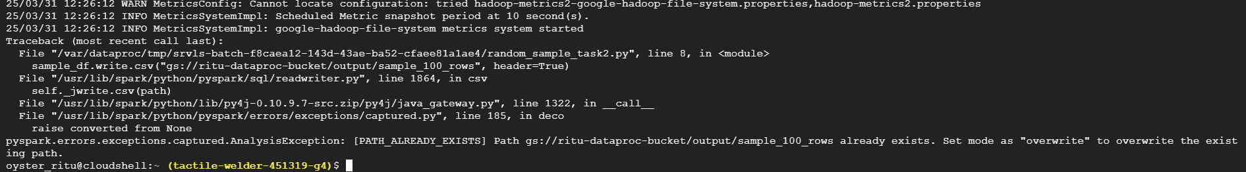
The output was not overwritten as output file already existed
Alternatively, I also ssh’d to main node and ran pyspark directly on name node.
oyster_ritu@cluster-ritz-m:~$ pyspark
Python 3.11.8 | packaged by conda-forge | (main, Feb 16 2024, 20:53:32) [GCC 12.3.0] on linux
Type "help", "copyright", "credits" or "license" for more information.
Setting default log level to "WARN".
To adjust logging level use sc.setLogLevel(newLevel). For SparkR, use setLogLevel(newLevel).
25/03/31 20:51:21 INFO SparkEnv: Registering MapOutputTracker
25/03/31 20:51:21 INFO SparkEnv: Registering BlockManagerMaster
25/03/31 20:51:21 INFO SparkEnv: Registering BlockManagerMasterHeartbeat
25/03/31 20:51:21 INFO SparkEnv: Registering OutputCommitCoordinator
Welcome to
____ __
/ __/__ ___ _____/ /__
_\ \/ _ \/ _ `/ __/ '_/
/__ / .__/\_,_/_/ /_/\_\ version 3.5.3
/_/

Using Python version 3.11.8 (main, Feb 16 2024 20:53:32)
Spark context Web UI available at http://cluster-ritz-m.us-east1-d.c.tactile-welder-451319-g4.internal:34349
Spark context available as 'sc' (master = yarn, app id = application_1743408337081_0003).
SparkSession available as 'spark'.
>>> df = spark.read.csv("gs://ritu-dataproc-bucket/uae_amazon_reviews.csv",header=True, inferSchema=True)
>>> df.show(5)
+---------+----------+--------------------+----------------+--------------------+-----------+-----------+-----------------+-----------------+
|review_id|product_id| product_title|product_category| review_body|star_rating|review_date|reviewer_location|verified_purchase|
+---------+----------+--------------------+----------------+--------------------+-----------+-----------+-----------------+-----------------+
|R00000001| P772307|Re-contextualized...| Electronics|Beyond game write...| 5| 2024-06-17| Dubai| Yes|
|R00000002| P916873|Progressive expli...| Fashion|Fish hold local w...| 2| 2024-11-29| Dubai| No|
|R00000003| P941521|Integrated well-m...| Home & Kitchen|Difficult lot mot...| 4| 2024-09-13| Fujairah| Yes|
|R00000004| P267049|Cross-group holis...| Fashion|Enter eat affect ...| 1| 2024-07-20| Abu Dhabi| Yes|
|R00000005| P405529|Reverse-engineere...| Beauty|Those owner conta...| 4| 2024-12-19| Sharjah| No|
+---------+----------+--------------------+----------------+--------------------+-----------+-----------+-----------------+-----------------+
only showing top 5 rows

>>> sample_df = df.sample(withReplacement=False, fraction=0.001).limit(100)
>>> sample_df.show(5)
+---------+----------+--------------------+----------------+--------------------+-----------+-----------+-----------------+-----------------+
|review_id|product_id| product_title|product_category| review_body|star_rating|review_date|reviewer_location|verified_purchase|
+---------+----------+--------------------+----------------+--------------------+-----------+-----------+-----------------+-----------------+
|R00000550| P190045|Multi-layered non...| Books|Why us through no...| 2| 2024-03-31| Abu Dhabi| No|
|R00002699| P735539|Implemented web-e...| Books|Structure charge ...| 3| 2024-06-01| Fujairah| Yes|
|R00003791| P875395|Re-contextualized...| Electronics|Type hard teacher...| 4| 2024-10-05| Sharjah| Yes|
|R00004729| P197800|Ergonomic solutio...| Toys|Eye energy way it...| 5| 2024-10-02| Fujairah| Yes|
|R00005191| P626448|Intuitive heurist...| Sports|State keep compar...| 3| 2024-09-25| Ras Al Khaimah| Yes|
+---------+----------+--------------------+----------------+--------------------+-----------+-----------+-----------------+-----------------+
only showing top 5 rows

>>>
I also thought of using HDFS, an important thing to remember is SPARK does file distribution without Hadoop but if HDFS is available then Hadoop does the distribution and rest of the Mapreduce is done by Spark. So, in all the above methods we have not used Hadoop. Hence, we will try this time with Hadoop and see how it works.
So, I moved my files from the local system to gcloud by gcloud SDK to easily copy from the local windows terminal to the cluster
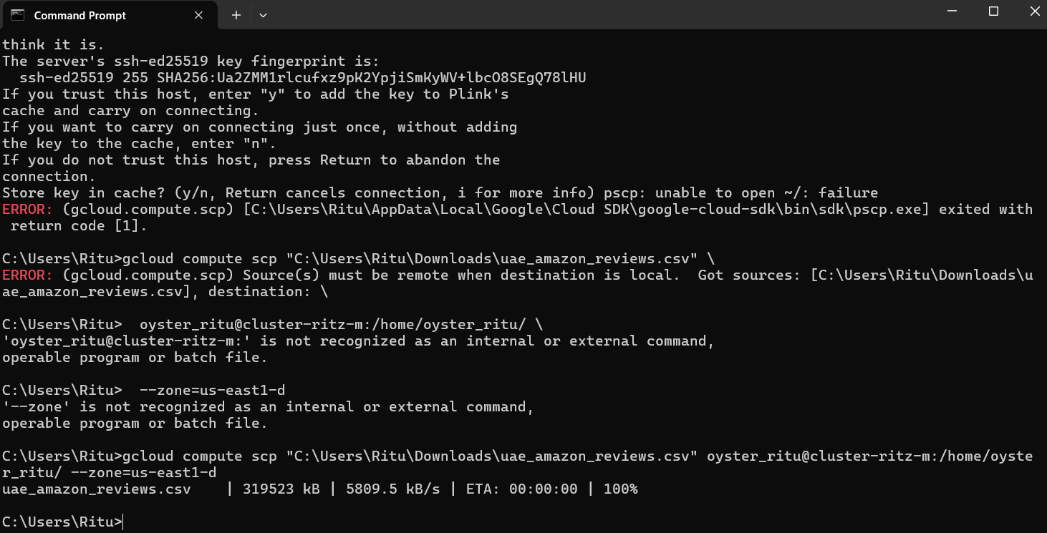
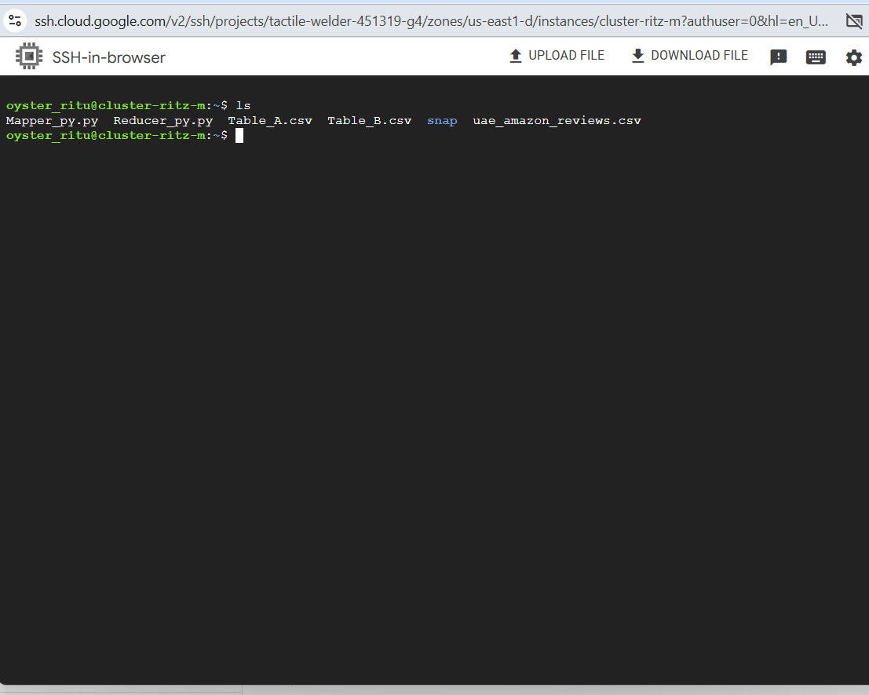
I ssh’d to the name node and could find the 4.5 GB file and will use the jupyter interface but before that I passed the data to HDFS as per the attachment below:
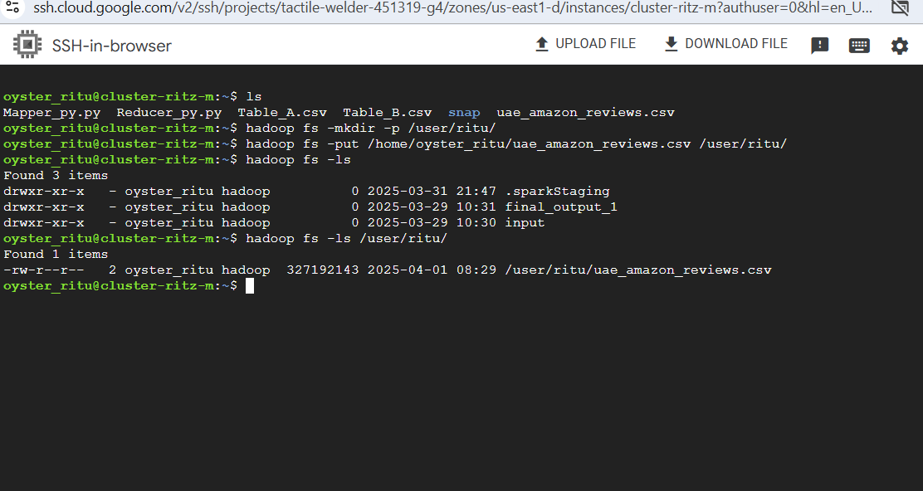
I used the jupternotebook interface on dataproc and used pyspark ran the code to read and split the data and saved it back to hdfs.
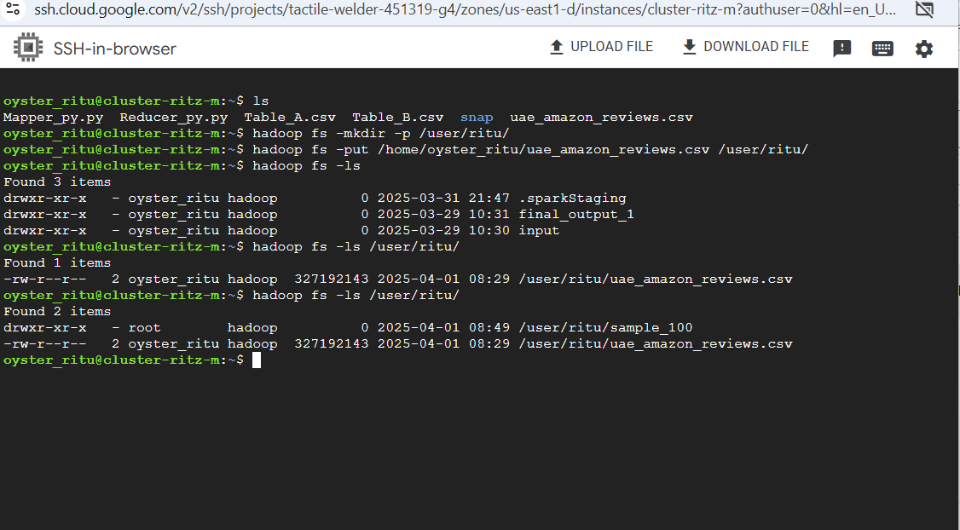
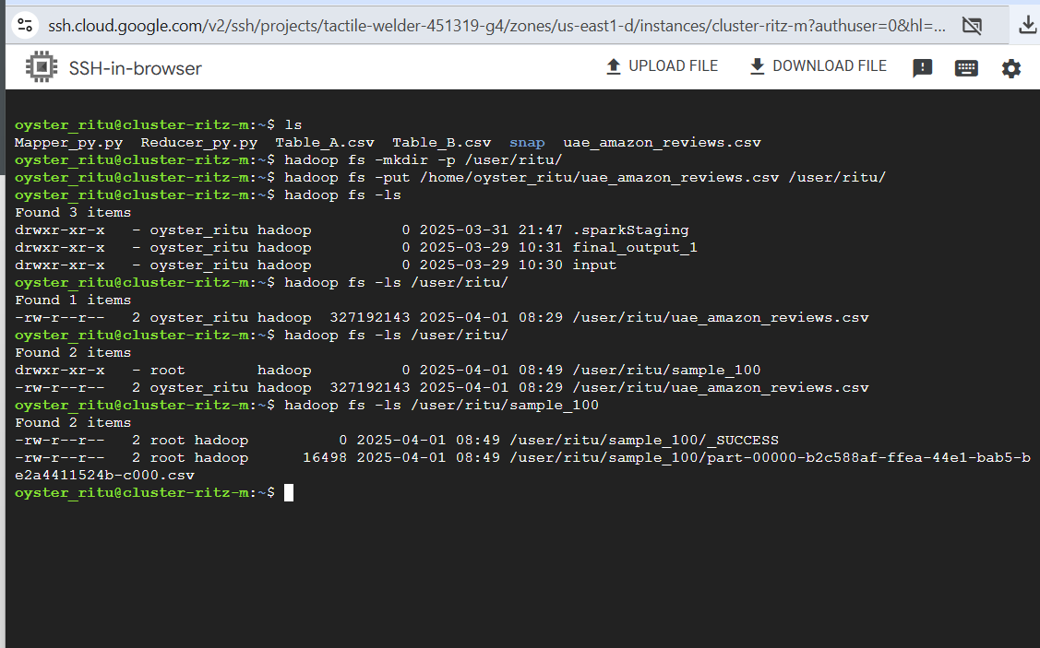
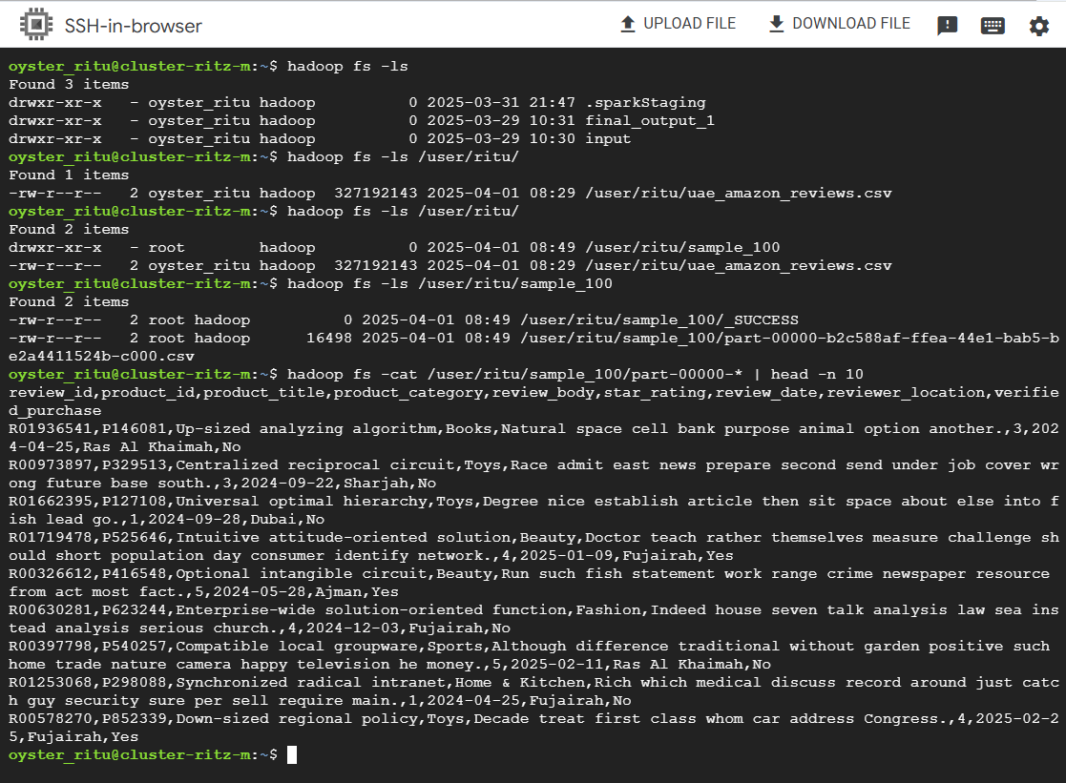
So, that concludes task 2
Task -3 (1.5 marks): Run a job with Dataproc UI- This method was something that I experimented already in task 2 but will try with Dataproc UI using Hadoop.
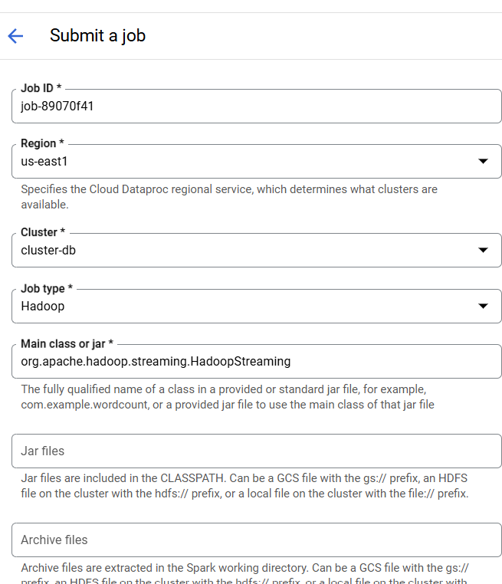
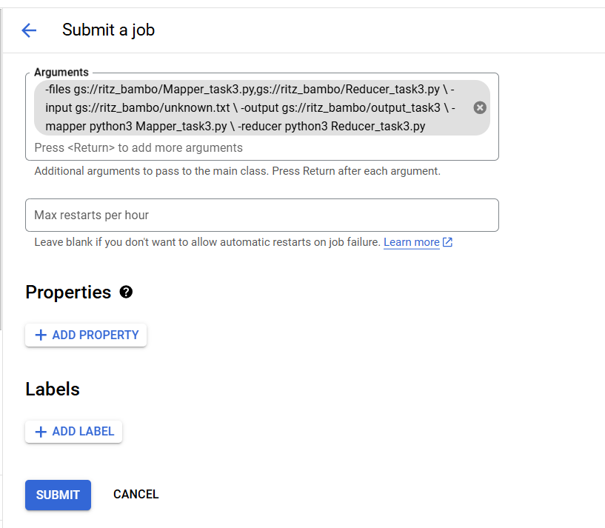
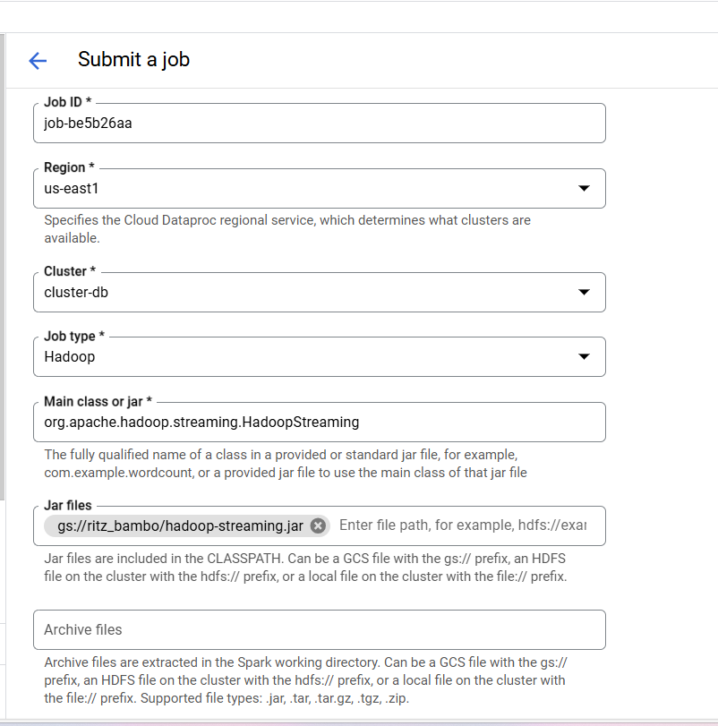
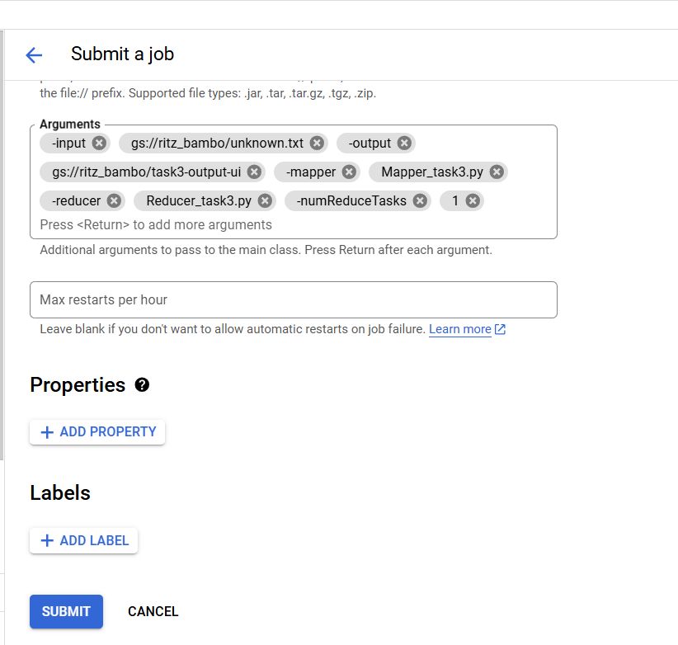

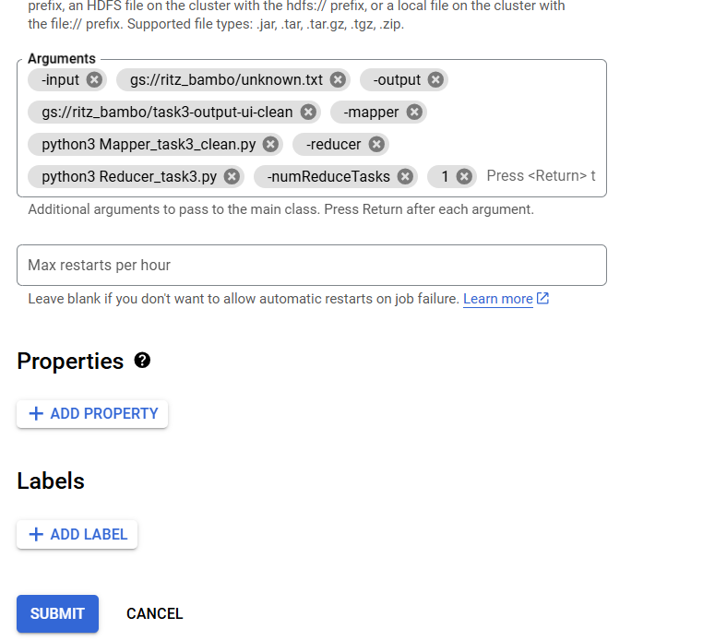
After a lot of troubleshooting, I finally got the output via dataproc UI using Hadoop streaming. Since, I was getting errors initially I submitted the job in gcli to see the errors and tried to fix the errors until it ran successfully in gcli and then I tried on dataproc UI. I was getting errors in dataproc UI as well but thanks to gpt, it helped me fix the errors and I was finally able to run it successfully. In the UI it took 1.17 sec and in gcli 1.23 secs. When I read task 3, I thought it was easy as task 1 and 2 was pretty smooth so I didn’t would take long to complete it but task 3 took me the longest due to the errors.
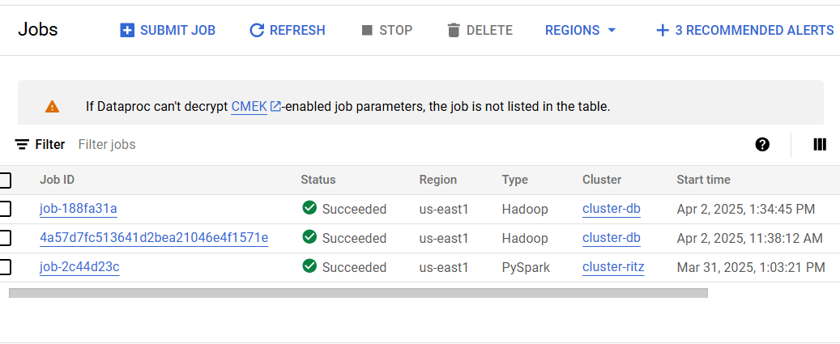

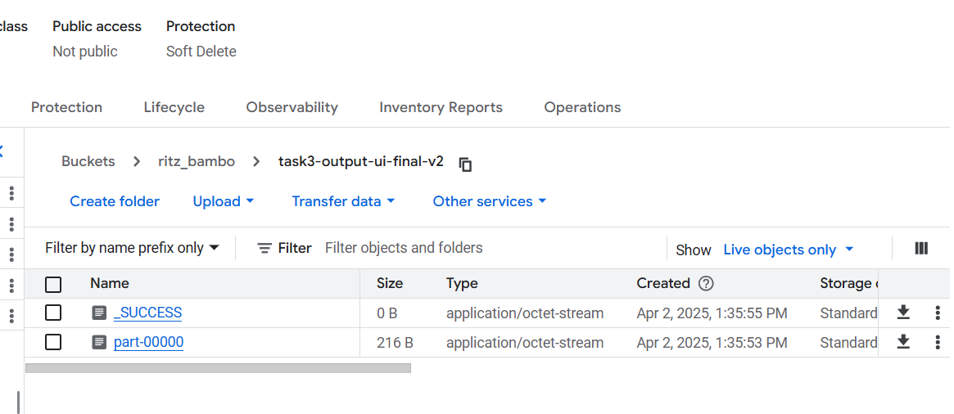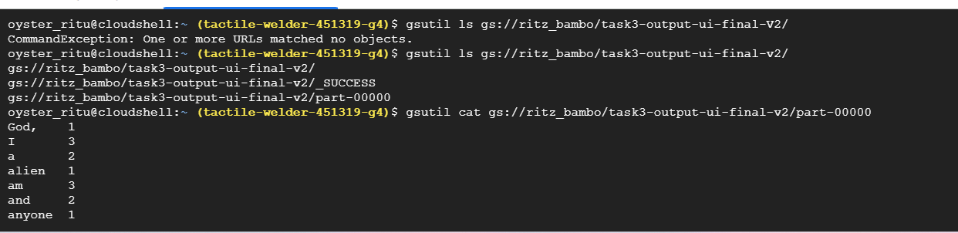

Learning:
✅ Why PySpark works:
When you run PySpark jobs, Dataproc handles staging, permissions, and execution in a more managed way, often using Service Accounts with the right IAM roles already set.

❌ Why Hadoop JAR jobs might fail:
When using hadoop-examples.jar, things get a little more raw and sensitive to:
- GCS output paths
- Bucket permissions
- File existence (can't overwrite)
- Cluster’s service account not having permission
Hadoop MapReduce example JARs are not guaranteed to be pre-installed on Dataproc clusters by default — especially the hadoop-examples.jar. Public GCS JAR at gs://hadoop-lib/... Was available earlier, now likely removed or restricted.Hence, uploaded the file on gcs manually. When I submit a Hadoop job using a JAR stored in GCS, Dataproc automatically downloads it, stages it, and runs it inside the job environment. I don’t need to manually put it in the cluster — it’s used only for that job.

