Kubernetes Management

Kubernetes with Minikube on Windows
- Verify Docker (docker version & docker ps)
- Install kubectl
- Install Minikube
- Start Kubernetes
- Verify cluster
- Deploy first application

kubectl is the command-line tool used to interact with Kubernetes.
- create deployments; inspect pods; expose services; scale applications

C:\first> curl.exe -LO "https://dl.k8s.io/release/v1.30.0/bin/windows/amd64/kubectl.exe"

Add kubectl to PATH
Open Start Search: Environment Variables Open Edit the system environment variables Click Environment Variables Under System Variables, select Path Click Edit Click New Add

C:\first\kubectl

Click OK and close (cmd also).

Verify on cmd: kubectl version --client

Install Minikube

C:\first\kubectl> curl.exe -LO https://github.com/kubernetes/minikube/releases/latest/download/minikube-installer.exe

C:\first\kubectl>minikube-installer.exe

After installation, close your CMD and open, then verify: minikube version

Start Kubernetes Cluster

start Kubernetes using Docker: minikube start --driver=docker

C:\first\kubectl> minikube start --driver=docker

It creates local Kubernetes cluster
use Docker as backend
configure kubectl
start Kubernetes components

Verify Kubernetes is Running

Check cluster info: kubectl cluster-info

Message: Kubernetes control plane is running

Check nodes: kubectl get nodes
Check Kubernetes System Pods: kubectl get pods -A

Deploy Your First Application (web-server) // first experiment

Deploy Nginx: kubectl create deployment my-nginx --image=nginx

Check Deployment: kubectl get deployments

Check Pods: kubectl get pods

Expose the Application

Expose it as a service: kubectl expose deployment my-nginx --type=NodePort --port=80

Check service: kubectl get services

Open Application in Browser

minikube service my-nginx

Scale Application

Scale to 3 pods: kubectl scale deployment my-nginx --replicas=3

Check: kubectl get pods

Useful Commands

View all resources: kubectl get all

View pods: kubectl get pods

View services: kubectl get services

View deployments: kubectl get deployments

View pod details: kubectl describe pod <pod-name>

View logs: kubectl logs <pod-name>

Stop cluster: minikube stop

Start again later: minikube start --driver=docker

Delete cluster: minikube delete

Deploying your website on Minikube //use for project

Create Dockerfile Folder should have website and Dockerfile (Refer to previous experiment to create Dockerfile)

C:\first\frontend>docker build -t myweb .

Verify your image: docker images

Run images: docker run -d -p 8080:80 myweb

Verify on browser: http://localhost:8080

Load Image into Minikube

C:\first\frontend> minikube image load myweb (Kubernetes can use your image) myweb is an image
// folder should have dockerfile and docker image
// in the same folder create two images deployment and service

Create Kubernetes Deployment

Create deployment.yaml file in the same folder

C:\first\frontend>notepad deployment.yaml

It creates Deployment and runs with 1 Pod. It uses your Docker image and exposes port 80 inside container.

apiVersion: apps/v1
kind: Deployment
metadata:
name: myweb
spec:
replicas: 1
selector:
matchLabels:
app: myweb
template:
metadata:
labels:
app: myweb
spec:
containers:
- name: myweb
image: myweb
imagePullPolicy: Never
ports:
- containerPort: 80

Deploy to Kubernetes

Apply deployment: kubectl apply -f deployment.yaml

Check deployment: kubectl get deployments

Check Pods: kubectl get pods

Here check your website Pod is running or not.

Expose Website Using Service

C:\first\frontend>notepad service.yaml

It exposes website outside Kubernetes and maps service to your website pod.

apiVersion: v1
kind: Service
metadata:
name: myweb-service
spec:
type: NodePort
selector:
app: myweb
ports:
- port: 80
targetPort: 80
nodePort: 30007

Apply: kubectl apply -f service.yaml

Check Service: kubectl get services

Access Website in Browser

C:\first\frontend>minikube service myweb-service // website available on kubernetes architecture
(Only loading image will not make website available for everyone, using services and deployment yml will make deply on kubernetes)

Verify information: kubectl get all

Scale Website

Run 3 replicas: kubectl scale deployment myweb --replicas=3

Check: kubectl get pods

Suppose if you updated the Website

Rebuild image: docker build -t mywebv2 .

Load into Minikube: minikube image load mywebv2

Note: First you deployed “myweb” then you have updated to “mywebv2”.

Rollback

Version 1 of your website is working, you deployed Version 2, then Version 2 has a problem. Instead of rebuilding everything, you simply tell Kubernetes: go back to the previous version.

Before rollback, check deployment history:

C:\first\frontend>kubectl rollout history deployment/myweb

Roll Back to Previous Version: kubectl rollout undo deployment/myweb

This tells Kubernetes to restore previous working deployment revision. Kubernetes will terminate broken pods and recreate pods using the older version.

Check rollout status: kubectl rollout status deployment/myweb

Check Pods: kubectl get pods

When rollback happens, Kubernetes: finds previous ReplicaSet scales down broken version scales up old stable version restores application.

This happens automatically.

To confirm rollback happened: kubectl describe deployment myweb

If you see previous image, then rollback had happened successfully.

You can also roll back to a specific version: kubectl rollout undo deployment/myweb --to-revision=1

Delete Website:

kubectl delete -f service.yaml

kubectl delete -f deployment.yaml

Complete information is available

https://minikube.sigs.k8s.io/docs/handbook/controls/

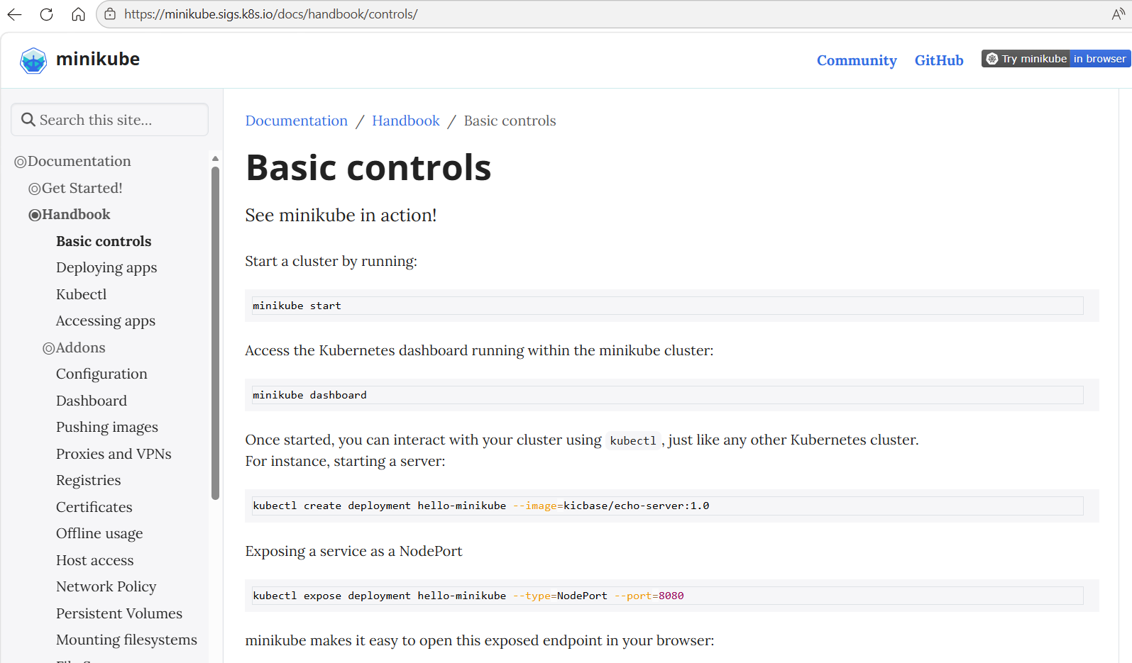

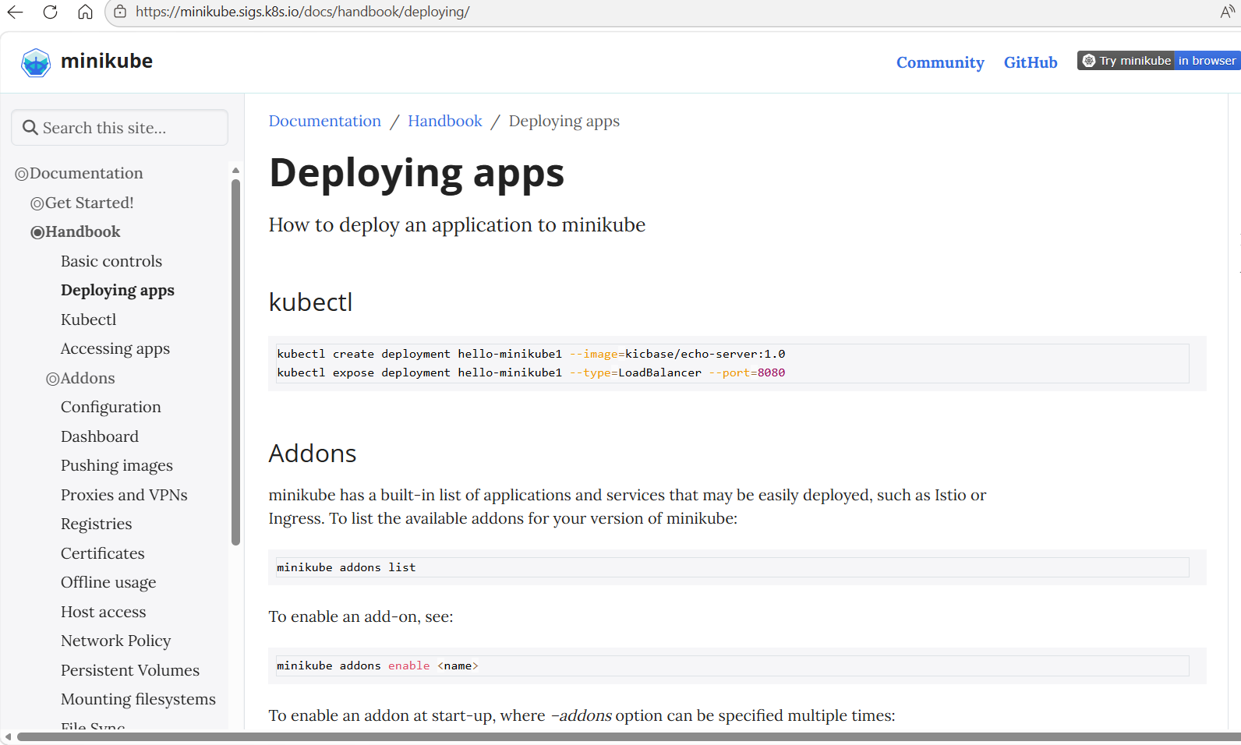

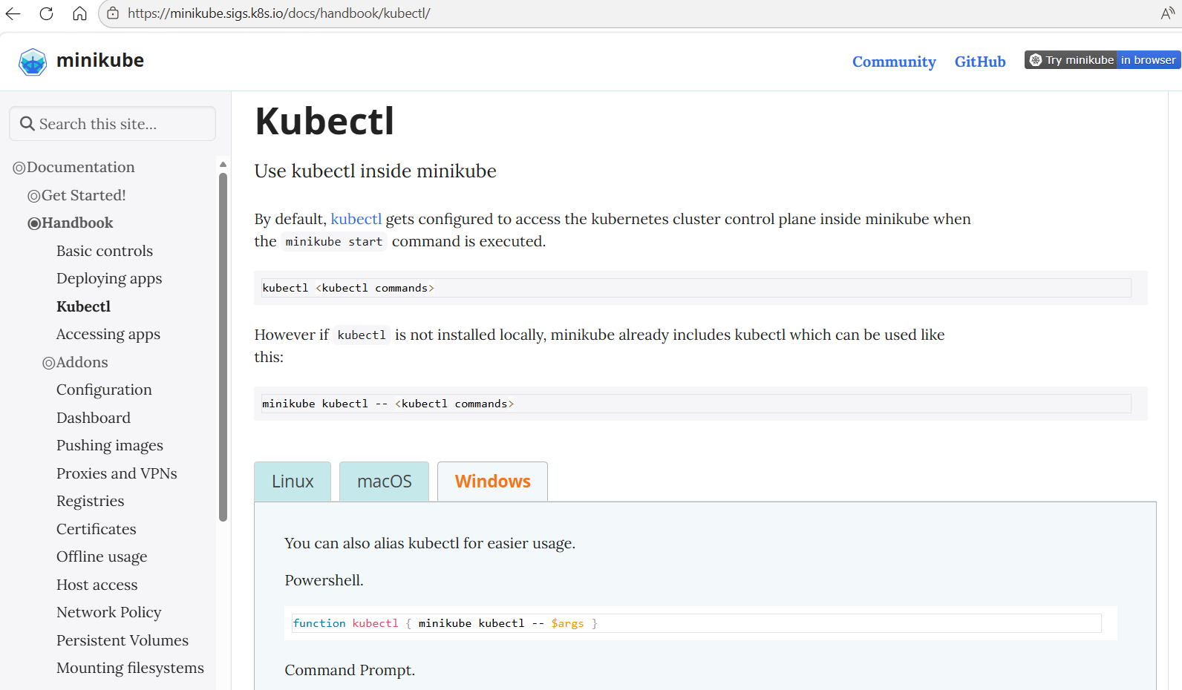

2nd Approach

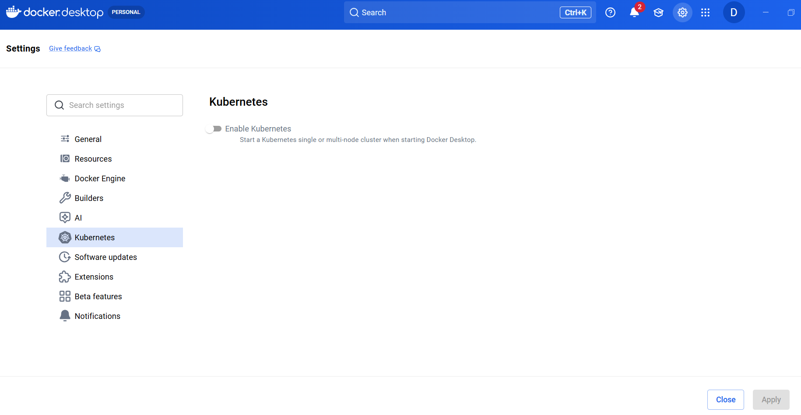

It download Kubernetes images, create a local Kubernetes cluster and configure networking. Then, install kubectl and start Kubernetes locally.

kubectl create deployment my-nginx --image=nginx

3rd Approach

kubeadm (Real Kubernetes setup)
single-node Kubernetes cluster:
- one machine
- one control plane
- same machine also runs workloads (pods)

In production, control plane and worker nodes are separate. In your setup, both run on the same machine.

Instructions:
Open CMD
- docker version // in cmd to verify the docker //
- docker ps // to check what is there running in docker //
- // install kubectl (works as a bridge between system and kubernetes //
//Create a new folder then run this cmd, don’t download directly Into drive //
curl.exe -LO https://dl.k8s.io/release/v1.30.0/bin/windows/amd64/kubectl.exe

- Add kubectl to PATH
Open Start Search: Environment Variables Open Edit the system environment variables Click Environment Variables Under System Variables, select Path Click Edit Click New Add

- Close cmd

- kubectl version –client // Open cmd again and check

- // Now open cloud tool folder and download the minikube
curl.exe -LO https://github.com/kubernetes/minikube/releases/latest/download/minikube-installer.exe
- minikube-installer.exe // Then run this cmd
- minikube version //to check the version
- minikube start --driver=docker // run this cmd in cloud tool folder, creates local local Kubernetes cluster
use Docker as backend
configure kubectl
start Kubernetes components

- kubectl cluster-info // to verify kubernetes is working
- kubectl get nodes // to verify the notes
- Kubectl get services // to expose the application to outside

