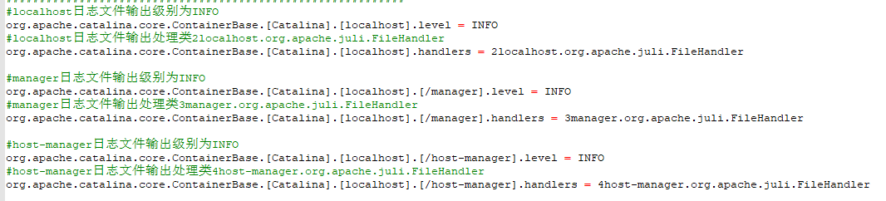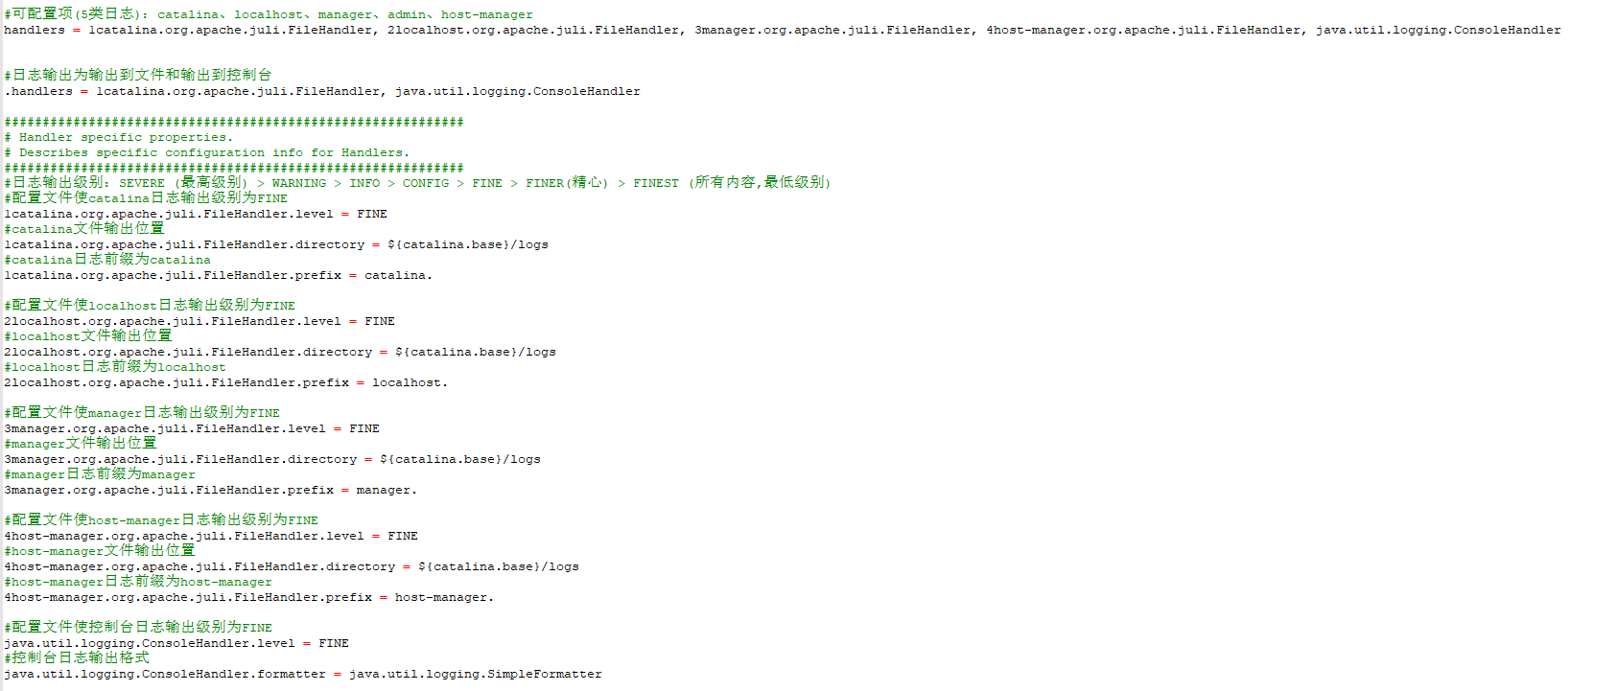Tomcat默认日志输出。

<https://www.cnblogs.com/operationhome/p/9680040.html>

各日志输出说明：

<https://www.cnblogs.com/qlqwjy/p/8036091.html>

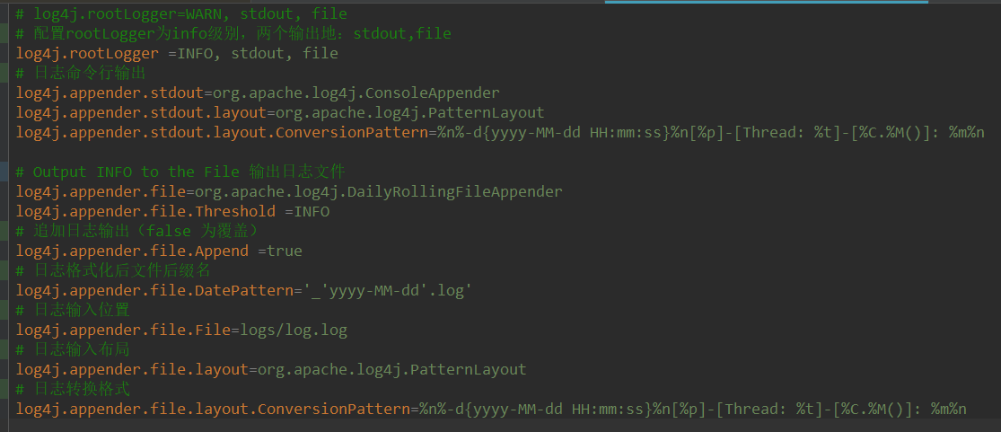

Bin/logs/... log4j日志输出文件

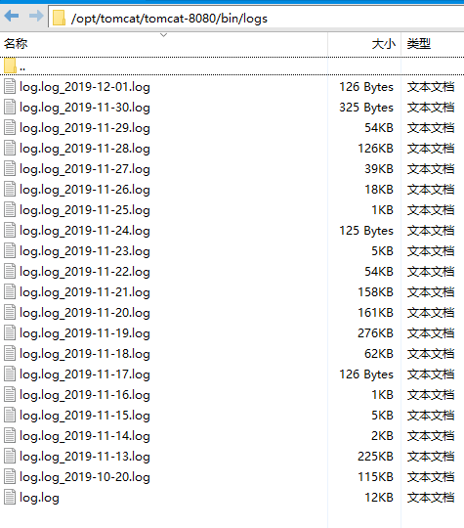

切割 catalina.out

下载

wget http://cronolog.org/download/cronolog-1.6.2.tar.gz

解压

tar xvf cronolog-1.6.2.tar.gz

./configure

make

make install

查看状态

which cronolog

一般情况下显示为：/usr/local/sbin/cronolog

修改tomcat启动脚本：vim catalina.sh

修改

if [ -z "$CATALINA_OUT" ] ; then

CATALINA_OUT="$CATALINA_BASE"/logs/catalina.out

fi

为：

if [ -z "$CATALINA_OUT" ] ; then

CATALINA_OUT="$CATALINA_BASE"/logs/catalina.$(date +%Y-%m-%d).out

fi

删除生成日志文件，注释掉：#touch "$CATALINA_OUT"

修改启动脚本参数：

org.apache.catalina.startup.Bootstrap "$@" start \

>> "$CATALINA_OUT" 2>&1 "&"

为：

org.apache.catalina.startup.Bootstrap "$@" start 2>&1 \

| /usr/local/sbin/cronolog "$CATALINA_OUT" >> /dev/null &

重启Tomcat