**6(1). Write program to interchange first and last elements in a list**

**Input: [12, 35, 9, 56, 24]**

**Output: [24, 35, 9, 56, 12]**

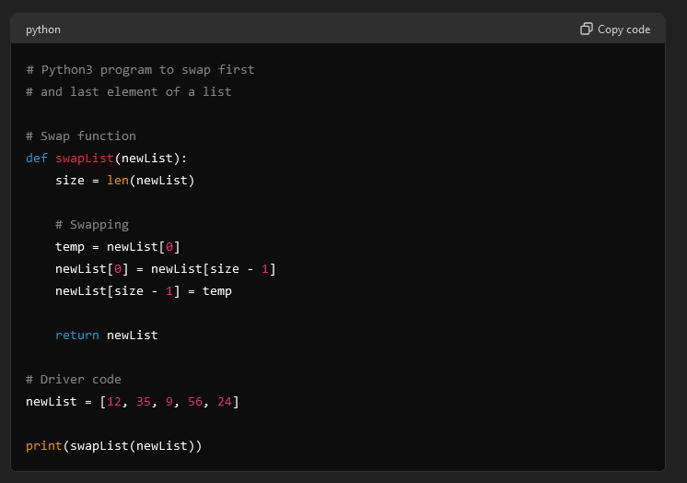

**OUTPUT:**

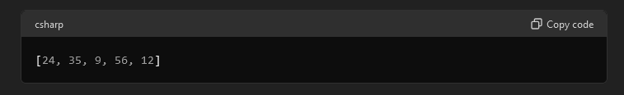

**7(2). Draw pattern:**

**12345**

**1234**

**123**

**12**

**1**

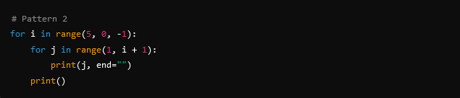

**OUTPUT:**

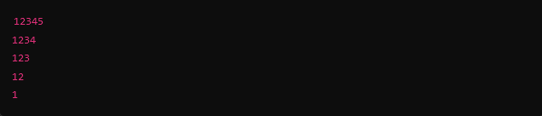

**8(3). Write program to find length of list**

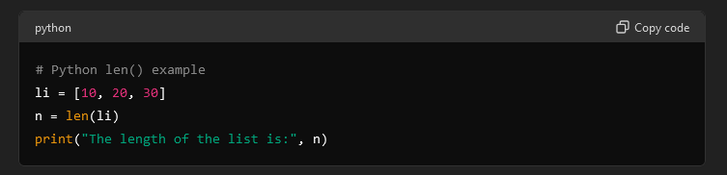

**OUTPUT:**

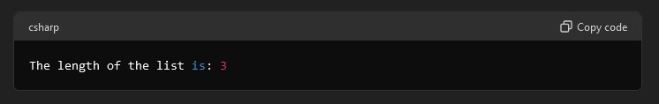

**9(4). Write program to check if element exists in list**

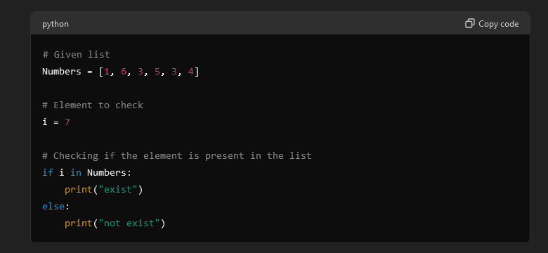

**OUTPUT:**

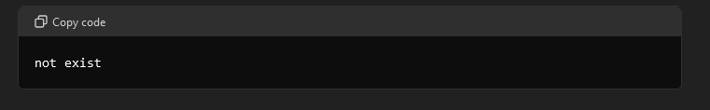

**10(5). Write program Reversing a List**

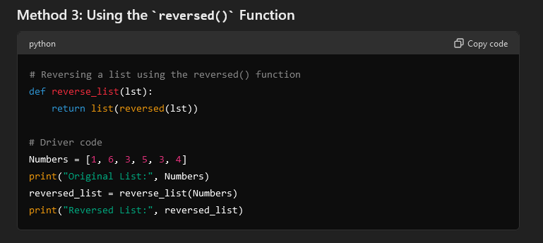

**OUTPUT:**

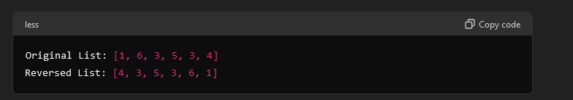

**11(6). Write program to create module calculator and perform**

**addition,subtraction,multiplication.division,percentage.**

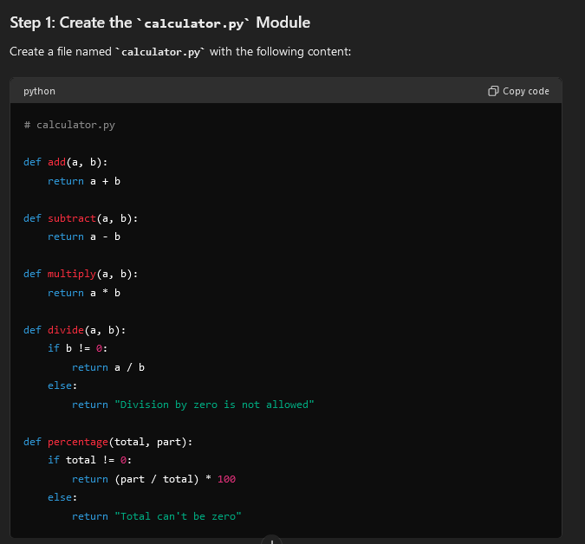

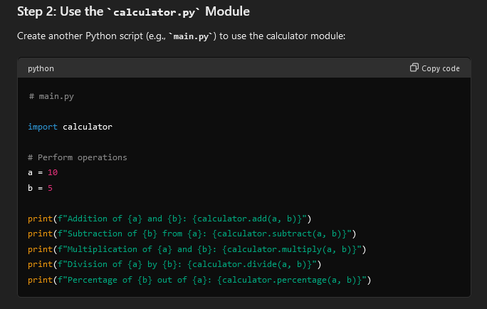

**OUTPUT:**

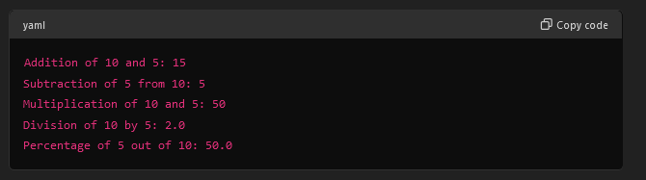

**12(7). Create file and perform to read() and write() function.**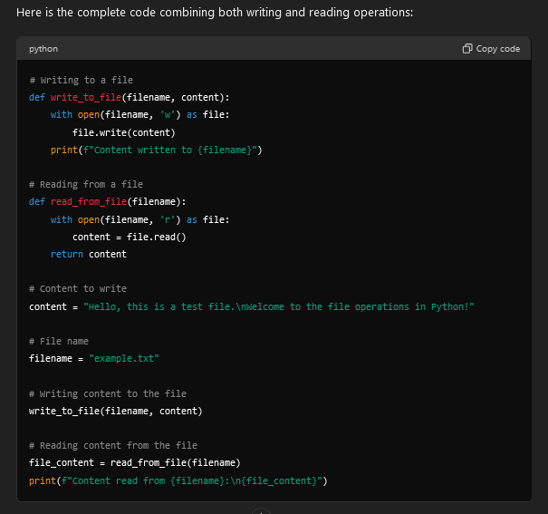

**OUTPUT:**

