**PHASE-4(PROJECT 1):**

**Quiz Web Application**

**Sprint Plan:** Number of Sprint-3, Duration-21days.

Sprint 1: Prepare a flow chart of the application and core concept, algorithm. Prepare separate git repository and update each and every work.

Sprint 2: Create wireframe for an application. work on admin portal and User page.

Sprint 3: Verify/Test application functionalities and Update it in git. Then create all documentation about the project.

**Flow of the Application:**

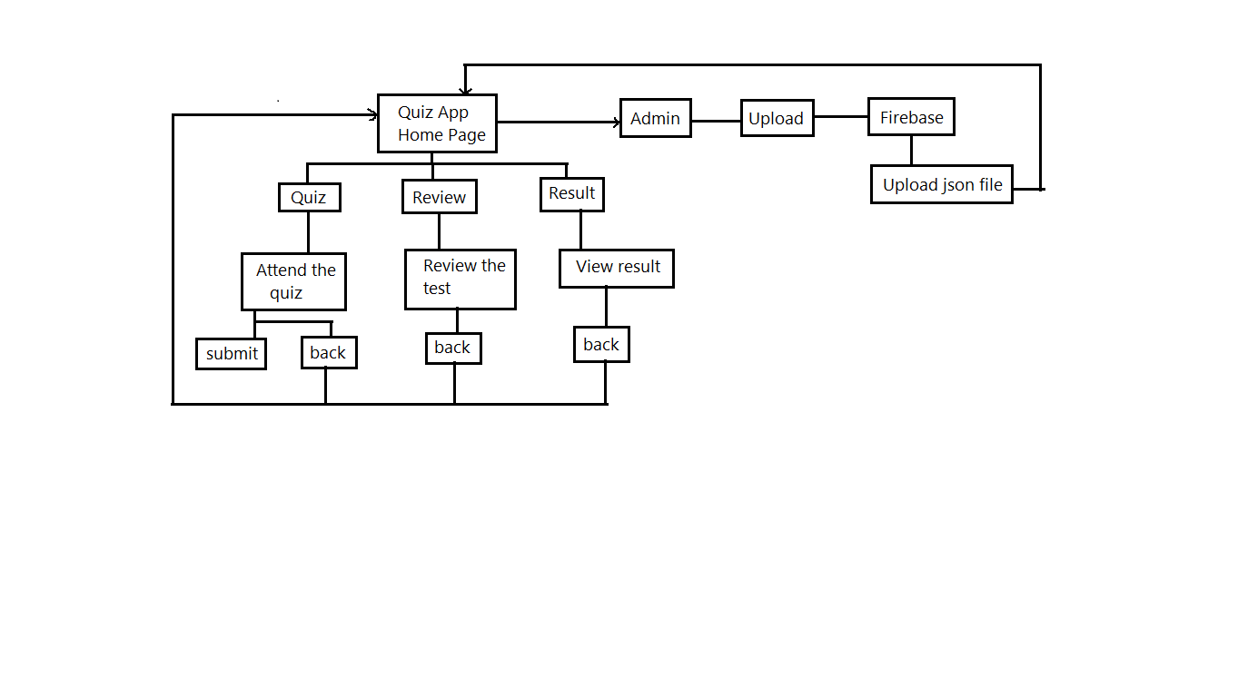

**Algorithm:**

1. Home page of the application have three options
2. The project is separated into two parts server side and client side
3. In server side we can able to upload the questions in json format
4. By adding /admin in home url will be redirect you to the admin page
5. In client side we can able to attend the quiz
6. And can able to review the questions and answer for the questions
7. In Result option we can able to see the score

**Login Credentials:**

**Firebase Login:**

Gmail – **Rajasekar.rs525@gmail.com**

Password – **9500400926**

**Instruction for work on Application:**

1. Open PowerShell or cmd
2. Move to the file location of the app (myapp1)
3. Now launch the application (by using this command ng serve)
4. Go to the browser and open the url - <http://localhost:4200/>
5. You can see the home page of the application now.
6. You can see three options Quiz, Review and Result.
7. In Quiz option you can able to attend the quiz and able to submit it.
8. In Review section you can see the answers for the questions
9. In result page your score will be displayed with dynamic quote
10. You can able to Upload json file in admin page
11. By adding /admin into the url will redirect to admin page
12. In admin page you have an option upload
13. By clicking upload button will redirect to firebase here you can upload json file by clicking three dot button.