**Arrhythmia Discrimination Using ECG**

**Bharat Bishu (B18EE010)**

**Pallav Sharma (B18EE032)**

**Raksham Tiwari (B18BB028)**

**Rituraj Kulshresth (B18CSE046)**

***Abstract***

ECG is a graphical record of the electrical activity of the heart and is one of the most important bio-signals used by cardiologists for diagnostic purposes and treatment. It is produced by analyzing the combination of electric impulse waveforms produced by different specialized cardiac tissues found in the heart. Using this signal it is possible to detect some of the heart’s abnormalities. An arrhythmia is such a problem with the rate or rhythm of the heartbeat. Due to the increase in the number of such cases and in order to fasten the detection of arrhythmias several computer software were developed. This project aims to take a patient’s ECG data as input, process it to detect the QRS complex and if the patient’s ECG is found to have large similarity to any of the signals in our database then subsequently detect the arrhythmia present in the signal.

**1. Introduction**

Cardiovascular diseases have been proved to be one of the deadliest diseases among the human beings with a very high mortality rate. After years of research and analysis on the cardiovascular abnormalities, it has been established that the diagnostic and monitoring of such abnormalities prevent them from getting any more serious and may even cure them. Arrhythmia is defined as any sort of abnormalities that takes place in the normal rhythm of heart. A lot of information about the heart can be taken out using the ECG. An ECG is a collection of multiple segments P complex, P-Q segment, Q -R-S complex, S-T segment, and the T complex. The process of identifying and classifying arrhythmias can be very troublesome for humans because in order to detect the abnormality it is necessary to analyze each heartbeat of the ECG record acquired which can extend up to hours. In addition, there is a possibility of human error during the ECG records analysis. A better way is to use computational techniques for [automatic classification](https://www.sciencedirect.com/topics/computer-science/automatic-classification) of the arrhythmias. This method ensures that no human error occurs and gives a very high percentage accuracy. Moreover, even a novice can load the data of a patient’s ECG and detect the abnormality, if any present. The detection of arrhythmia is an important task in clinical reasons which can initiate lifesaving operations. From early times several detection algorithms have been proposed. In this project we have used the MIT-BIH database in order to collect the dataset. Various tools of signal processing have been used viz band pass filter in order to remove high frequency and low frequency noises, Fourier transform in order to analyze the frequency domain of the signal and correlation to compare two ECG signals that have been preprocessed.

**2. ECG Analysis and Discrimination**

**2.1 Dataset**

The whole dataset for this project has been taken from MIT-BIH arrhythmia database. The database consists of 48, two channel recording. There are Annotations provided. These annotations are categorized in five different categories. Start and end of ventricular flutter and fibrillation constitute a specific category named “F”. Atrial, nodal and junctional escape beat are considered in category “E”. Ventricular premature beat and fibrillation beat, both produce irregular contraction of heart muscle and require medical emergency, so these have been kept in category “V”. Atrial, nodal and supraventricular premature beat shows irregular activity of atria and also conduction of impulses from the SA node to the AV node .Such beats are kept under category “A”. All remaining annotated beats like bundle branch block beats, fusion beats etc. that does not generate any serious situation, are kept under normal category and named “N”.

**2.2 Feature extraction**

Arrhythmic waves are clinically classified on the basis of heart beat namely bradycardia and tachycardia. Each signal is denoised by converting the signal to frequency domain. Then the frequency components greater than 5 Hz and less than 20 Hz are separated out and the rest of it is discarded. This will remove the noise due to heart motion muscle motion and heart rotation. The signal is brought back to time domain using inverse Fourier transform function. Now the local maximas are calculated using a windowed filter. Small values are removed and significant ones are stored. These local maximas are rerun through another windowed filter of a different window size so no smaller peaks are left.

From the above detected data of the local maximas we can detect the R peaks. The distance between two consecutive heartbeats is used in the classification. Then the filtered and denoised signal is cropped using the detected R peak in order to get a single PQRST complex. The Distances between R and P, and R and T peak, are constant for a normal heart beat. Using this data the signal is cropped to get a single complex. The above process has been used to create a database of the PQRST complex for various arrhythmias and a completely healthy heartbeat. All the PQRST complexes of the patient are separated. The time-series information which can be taken out includes Beats per minute (BPM), Inter-Beat Interval (IBI), mean distance of intervals between heartbeats, these are used to increase the accuracy of arrhythmia detection.

**2.3 Classification**

The extracted PQRST complexes are each compared (correlated) with the already present database of each type of arrhythmia and an N array is created which stores the correlation coefficient of each QRS complex of patient with the QRS complex of the arrhythmia present in database. The mean of all these values is the correlation factor of the patient’s ECG data and the particular type of arrhythmia. All the arrhythmia databases 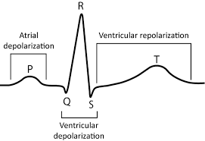are compared with the patient’s data one by one and the correlation coefficient is found. The maximum correlation coefficients among these is taken and the patient is reported to have that type of arrhythmia. If the correlation coefficient of the patient and the healthy heartbeat is maximum then the person is reported to be healthy.

Figure 1: PQRST Complex in Normal ECG 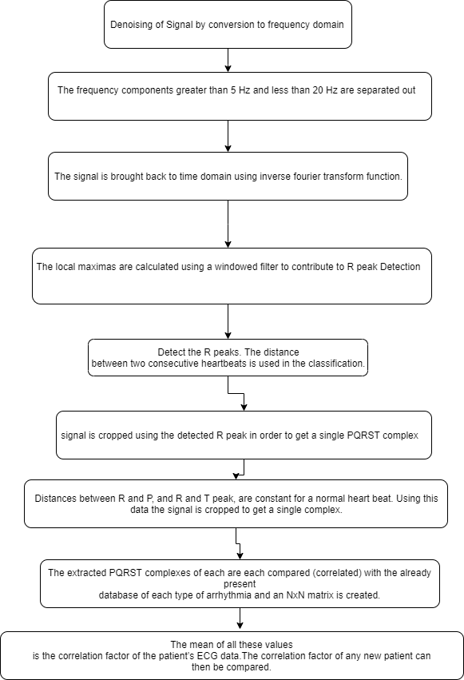

Figure 2: Block Diagram

**3. Results and Observation**

Using the above proposed algorithm we were able to get the data of one single PQRST complex of the patients and then compare it with a single PQRST complex of each type of arrhythmia signal present in the MIT-BIH database. The correlation coefficient of these PQRST complexes is taken. The maximum correlation coefficient that is obtained from these comparisons is reported as the arrhythmia present. If maximum correlation coefficient is found with the normal healthy heart beat then the person is reported as healthy.

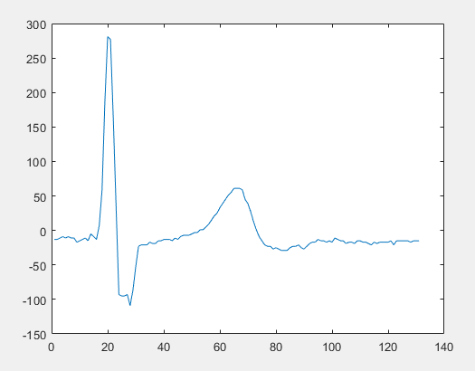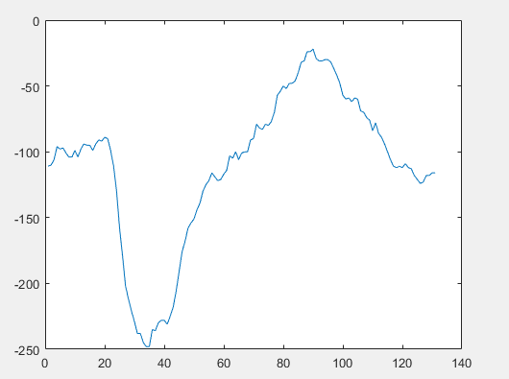

Figure 2: Supraventricular Arrhythmia Figure 3: Malignant Ventricular Ectopy

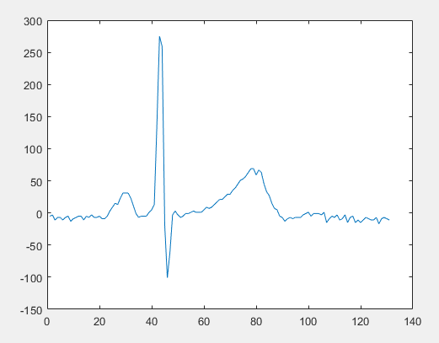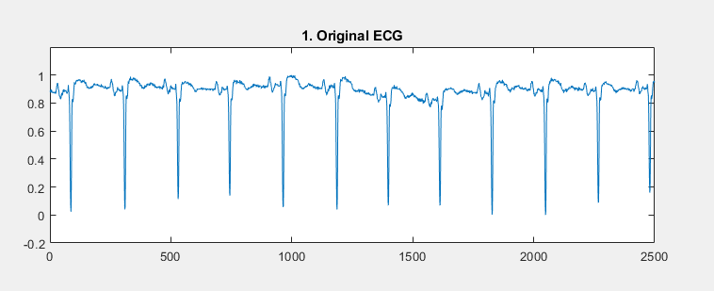

Figure 4: Normal ECG Figure 5: Atrial Fibrillation

The above given images are the PQRS Complexes detected to match the database of the Consecutive arrhythmias.

**4. Conclusions and Limitations**

We have developed a method for arrhythmia discrimination. This method is based on separating a single PQRST complex of the original arrhythmia signals and compare it with all the complexes created from the patient’s data, Moreover in order to increase the accuracy we calculated IBI and BPM to compare them with the standard data available.

Since our method is under development therefore there are many bugs and it has not been automated yet. The method employed above is very slow as the algorithm has not been optimized.

Comparing this algorithm to the research paper published by Chia-Hung Lin, we find that their process has more solid research behind and a proof of work. Our project is still under development and will require analysis of larger databases to get the final accuracy of the algorithm.

In the future, our goal is to integrate our project with larger databases and get the results live where input signal will be entered and the result will be given at the same time.

**References**

1. [Moody GB, Mark RG. The impact of the MIT-BIH Arrhythmia Database. IEEE Eng in Med and Biol 20(3):45-50 (May-June 2001). (PMID: 11446209)](http://ecg.mit.edu/george/publications/mitdb-embs-2001.pdf)
2. Goldberger AL, Amaral LAN, Glass L, Hausdorff JM, Ivanov PCh, Mark RG, Mietus JE, Moody GB, Peng C-K, Stanley HE. PhysioBank, PhysioToolkit, and PhysioNet: Components of a New Research Resource for Complex Physiologic Signals (2003). Circulation. 101(23):e215-e220

# Arrhythmia Database, Beth Israel Hospital, Feb. 24, 2005. Available: <https://physionet.org/content/mitdb/1.0.0/>

1. Matlab. (R2018b). [Online]. Available: <https://in.mathworks.com/>
2. [KGP Talkie](https://www.youtube.com/channel/UCTiWgVtEGSY4cuduJbMPblA), (Apr 18, 2016). Accessed: Nov. 21, 2019. [Online Video]. Available: <https://www.youtube.com/watch?v=1xGuCBakGIk>
3. [The Motivated Engineer](https://www.youtube.com/channel/UCFYYYN4YkDp85ol0e_XoU-w),, (Apr 22, 2014). Accessed: Nov. 21, 2019. [Online Video]. Available: <https://www.youtube.com/watch?v=ofDHz77hm1c>
4. [MedCram - Medical Lectures Explained CLEARLY](https://www.youtube.com/channel/UCG-iSMVtWbbwDDXgXXypARQ) (Jul 15, 2018). Accessed: Nov. 21, 2019. [Online Video]. Available: <https://www.youtube.com/watch?v=8ajWCLqz3VQ>
5. Pooja Bhardwaj, Rahul R Choudhary, Ravindra Dayama,“Analysis and Classification of Cardiac Arrhythmia using ECG Signals,” Ph.D. dissertation, Department of EI&CE, Govt. Engineering College Bikaner-334001, India, 2012.
6. Chia-Hung Lin,“Frequency-domain features for ECG beat discrimination using grey relational analysis-based classifier,”Department of Electrical Engineering, Kao-Yuan University, Lu-Chu Hsiang, Kaohsiung 821, Taiwan, 2007
7. Manish Sharma, Ru-San Tan , U. Rajendra Acharya,”Department of Electrical Engineering, Institute of Infrastructure Technology Research and Management, Ahmedabad, India, National Heart Centre Singapore, Singapore, Department of Electronics and Computer Engineering, Ngee Ann Polytechnic, Singapore, 599489, Singapore”, 2019

.