**LAB-5**

**Real-Time CPU Scheduling algorithms**

1. Write a C program to simulate Real-Time CPU Scheduling algorithms:

(a) Rate- Monotonic

(b) Earliest-deadline First.

#include <stdio.h>

#include <stdlib.h>

#include <math.h>

#include <stdbool.h>

#define MAX_PROCESS 10

typedef struct {

    int id;

    int burst_time;

    float priority;

} Task;

int num_of_process;

int execution_time[MAX_PROCESS], period[MAX_PROCESS], remain_time[MAX_PROCESS], deadline[MAX_PROCESS], remain_deadline[MAX_PROCESS];

void get_process_info(int selected_algo) {

    printf("Enter total number of processes (maximum %d):", MAX_PROCESS);

    scanf("%d", &num_of_process);

    if (num_of_process < 1) {

        exit(0);

    }

    for (int i = 0; i < num_of_process; i++) {

        printf("\nProcess %d:\n", i + 1);

        printf("==> Execution time: ");

        scanf("%d", &execution_time[i]);

        remain_time[i] = execution_time[i];

        if (selected_algo == 2) {

            printf("==> Deadline: ");

            scanf("%d", &deadline[i]);

        } else {

            printf("==> Period: ");

            scanf("%d", &period[i]);

        }

    }

}

int max(int a, int b, int c) {

    int max;

    if (a >= b && a >= c)

        max = a;

    else if (b >= a && b >= c)

        max = b;

    else

        max = c;

    return max;

}

int get_observation_time(int selected_algo)

{

    if (selected_algo == 1) {

        return max(period[0], period[1], period[2]);

    } else if (selected_algo == 2) {

        return max(deadline[0], deadline[1], deadline[2]);

    }

    return 0;

}

void print_schedule(int process_list[], int cycles) {

    printf("\nScheduling:\n\n");

    printf("Time: ");

    for (int i = 0; i < cycles; i++) {

        if (i < 10)

            printf("| 0%d ", i);

        else

            printf("| %d ", i);

    }

    printf("|\n");

    for (int i = 0; i < num_of_process; i++) {

        printf("P[%d]: ", i + 1);

        for (int j = 0; j < cycles; j++) {

            if (process_list[j] == i + 1)

                printf("|####");

            else

                printf("|    ");

        }

        printf("|\n");

    }

}

void rate_monotonic(int time) {

    int process_list[100] = {0}, min = 999, next_process = 0;

    float utilization = 0;

    for (int i = 0; i < num_of_process; i++) {

        utilization += (1.0 * execution_time[i]) / period[i];

    }

    int n = num_of_process;

    int m = (float)(n * (pow(2, 1.0 / n) - 1));

    if (utilization > m) {

        printf("\nGiven problem is not schedulable under the said scheduling algorithm.\n");

        return;

    }

    for (int i = 0; i < time; i++) {

        min = 1000;

        for (int j = 0; j < num_of_process; j++) {

            if (remain_time[j] > 0) {

                if (min > period[j]) {

                    min = period[j];

                    next_process = j;

                }

            }

        }

        if (remain_time[next_process] > 0) {

            process_list[i] = next_process + 1;

            remain_time[next_process] -= 1;

        }

        for (int k = 0; k < num_of_process; k++) {

            if ((i + 1) % period[k] == 0) {

                remain_time[k] = execution_time[k];

            }

        }

    }

    print_schedule(process_list, time);

}

void earliest_deadline_first(int time) {

    float utilization = 0;

    for (int i = 0; i < num_of_process; i++) {

        utilization += (1.0 * execution_time[i]) / deadline[i];

    }

    int n = num_of_process;

    int process[num_of_process];

    int max_deadline, current_process = 0, min_deadline, process_list[time];

    bool is_ready[num_of_process];

    for (int i = 0; i < num_of_process; i++) {

        is_ready[i] = true;

        process[i] = i + 1;

    }

    max_deadline = deadline[0];

    for (int i = 1; i < num_of_process; i++) {

        if (deadline[i] > max_deadline)

            max_deadline = deadline[i];

    }

    for (int i = 0; i < num_of_process; i++) {

        for (int j = i + 1; j < num_of_process; j++) {

            if (deadline[j] < deadline[i]) {

                int temp = execution_time[j];

                execution_time[j] = execution_time[i];

                execution_time[i] = temp;

                temp = deadline[j];

                deadline[j] = deadline[i];

                deadline[i] = temp;

                temp = process[j];

                process[j] = process[i];

                process[i] = temp;

            }

        }

    }

    for (int i = 0; i < num_of_process; i++) {

        remain_time[i] = execution_time[i];

        remain_deadline[i] = deadline[i];

    }

    for (int t = 0; t < time; t++) {

        if (current_process != -1) {

            --execution_time[current_process];

            process_list[t] = process[current_process];

        } else {

            process_list[t] = 0;

        }

        for (int i = 0; i < num_of_process; i++) {

            --deadline[i];

            if ((execution_time[i] == 0) && is_ready[i]) {

                deadline[i] += remain_deadline[i];

                is_ready[i] = false;

            }

            if ((deadline[i] <= remain_deadline[i]) && !is_ready[i]) {

                execution_time[i] = remain_time[i];

                is_ready[i] = true;

            }

        }

        min_deadline = max_deadline;

        current_process = -1;

        for (int i = 0; i < num_of_process; i++) {

            if ((deadline[i] <= min_deadline) && (execution_time[i] > 0)) {

                current_process = i;

                min_deadline = deadline[i];

            }

        }

    }

    print_schedule(process_list, time);

}

int main()

{

    int option;

    int observation_time;

    while (1) {

        printf("\n1. Rate Monotonic\n2. Earliest Deadline first\n3. Proportional Scheduling\n\nEnter your choice: ");

        scanf("%d", &option);

        switch (option) {

            case 1:

                get_process_info(option);

                observation_time = get_observation_time(option);

                rate_monotonic(observation_time);

                break;

            case 2:

                get_process_info(option);

                observation_time = get_observation_time(option);

                earliest_deadline_first(observation_time);

                break;

            case 3:

                exit(0);

            default:

                printf("\nInvalid Statement");

        }

    }

    return 0;

}

OUTPUT:

(a)Rate- Monotonic

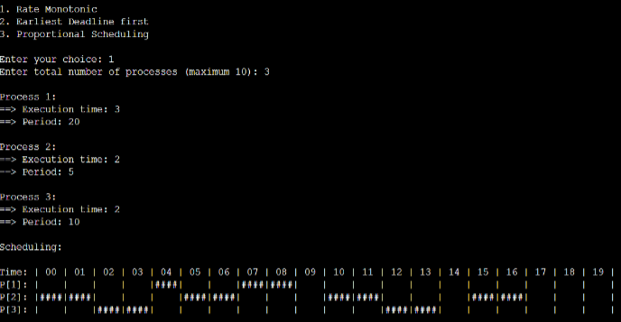

(b)Earliest-deadline First

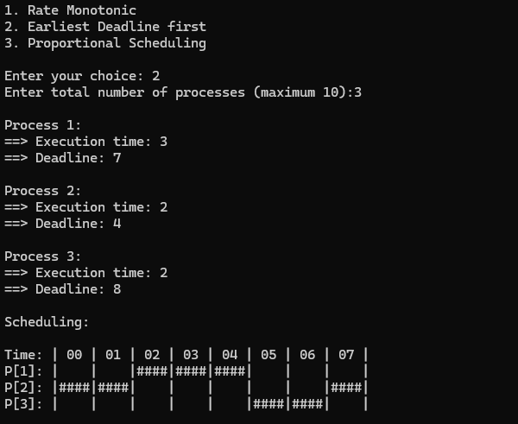

**Producer-Consumer problem**

1. Write a C program to simulate producer-consumer problem using semaphores.

#include <stdio.h>

#include <stdlib.h>

int mutex = 1, full = 0, empty = 3, x = 0;

void producer();

void consumer();

int wait(int);

int signal(int);

int main() {

    int n;

    printf("\n1. Producer\n2. Consumer\n3. Exit");

    while (1) {

        printf("\nEnter your choice: ");

        scanf("%d", &n);

        switch (n) {

            case 1:

                if ((mutex == 1) && (empty != 0)) {

                    producer();

                } else {

                    printf("Buffer is full!!");

                }

                break;

            case 2:

                if ((mutex == 1) && (full != 0)) {

                    consumer();

                } else {

                    printf("Buffer is empty!!");

                }

                break;

            case 3:

                exit(0);

                break;

            default:

                printf("Invalid choice! Please enter 1, 2, or 3.");

                break;

        }

    }

    return 0;

}

int wait(int s) {

    return --s;

}

int signal(int s) {

    return ++s;

}

void producer() {

    mutex = wait(mutex);

    full = signal(full);

    empty = wait(empty);

    x++;

    printf("\nProducer produces the item %d", x);

    mutex = signal(mutex);

}

void consumer() {

    mutex = wait(mutex);

    full = wait(full);

    empty = signal(empty);

    printf("\nConsumer consumes item %d", x);

    x--;

    mutex = signal(mutex);

}

OUTPUT:

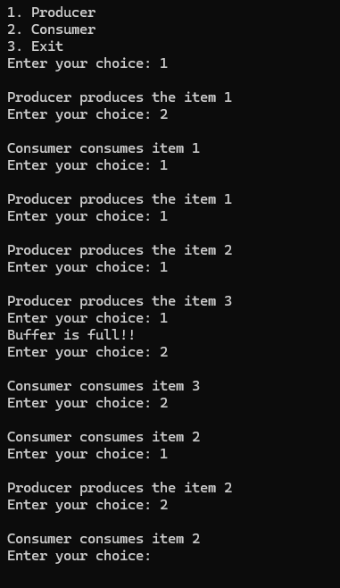

**Dining-Philosophers problem**

1. Write a C program to simulate the concept of Dining-Philosophers

problem.

#include <stdio.h>

#include <pthread.h>

#include <semaphore.h>

#include <unistd.h> // Include for sleep function

#define N 5

#define THINKING 2

#define HUNGRY 1

#define EATING 0

#define LEFT (i + 4) % N

#define RIGHT (i + 1) % N

int state[N];

int phil[N] = {0, 1, 2, 3, 4};

sem_t mutex;

sem_t S[N];

void test(int i) {

    if (state[i] == HUNGRY && state[LEFT] != EATING && state[RIGHT] != EATING) {

        state[i] = EATING;

        sleep(2);

        printf("Philosopher %d takes fork %d and %d\n", i + 1, LEFT + 1, i + 1);

        printf("Philosopher %d is Eating\n", i + 1);

        sem_post(&S[i]);

    }

}

void take_fork(int i) {

    sem_wait(&mutex);

    state[i] = HUNGRY;

    printf("Philosopher %d is Hungry\n", i + 1);

    test(i);

    sem_post(&mutex);

    sem_wait(&S[i]);

    sleep(1);

}

void put_fork(int i) {

    sem_wait(&mutex);

    state[i] = THINKING;

    printf("Philosopher %d putting fork %d and %d down\n", i + 1, LEFT + 1, i + 1);

    printf("Philosopher %d is thinking\n", i + 1);

    test(LEFT);

    test(RIGHT);

    sem_post(&mutex);

}

void* philosopher(void* num) {

    while (1) {

        int* i = num;

        sleep(1);

        take_fork(*i);

        sleep(0);

        put_fork(*i);

    }

}

int main() {

    int i;

    pthread_t thread_id[N];

    sem_init(&mutex, 0, 1);

    for (i = 0; i < N; i++)

        sem_init(&S[i], 0, 0);

    for (i = 0; i < N; i++) {

        pthread_create(&thread_id[i], NULL, philosopher, &phil[i]);

        printf("Philosopher %d is thinking\n", i + 1);

    }

    for (i = 0; i < N; i++) {

        pthread_join(thread_id[i], NULL);

    }

}

OUTPUT:

