VISVESVARAYA TECHNOLOGICAL UNIVERSITY
“JnanaSangama”,Belgaum-590014, Karnataka.



LAB REPORT
On
Operating Systems

Submitted by:
Ritu Sinha
(1BM23CS271)
In partial fulfillment for the award of the degree of
BACHELOR OF ENGINEERING
in
COMPUTER SCIENCE AND ENGINEERING



B.M.S. COLLEGE OF ENGINEERING
(Autonomous Institution under VTU)
BENGALURU - 560019
September2024-January2025

B.M. S. College of Engineering,
Bull Temple Road, Bangalore 560019
(Affiliated To Visvesvaraya Technological University, Belgaum) Department of Computer Science and Engineering



This is to certify that the Lab work entitled “OPERATING SYSTEMS” carried out by Ritu Sinha(1BM23CS271) who is bonafide student of B. M. S. College of Engineering. It is in partial fulfillment for the award of Bachelor of Engineering in Computer Science and Engineering of the Visvesvaraya Technological University, Belgaum during the year 2024-25. The Lab report has been approved as it satisfies the academic requirements in respect of Operating System Lab - (23CS4PCOPS) work prescribed for the said degree.

Prof. Sandhya A. Kulkarni Dr.Kavitha Sooda
Assistant Professor Professor and Head
Department of CSE Department of CSE
BMSCE, Bengaluru BMSCE, Bengaluru

Index Sheet

Sl. No. | Experiment Title | PageNo.
1 | LAB PROG-1  (FCFS) | 3-4
2 | LAB PROG-2  (SJF) | 5-7
3 | LAB PROG-3  (priority & round robin) | 8-12
4 | LAB PROG-4  (multilevel queue) | 13-15
5 | LAB PROG-5  (rate monotonic, earliest deadline first, dining & producer consumer) | 16-24
6 | LAB PROG-6  (deadlock detection and avoidance) | 25-28
7 | LAB PROG-7  (memory management) | 29-31
8 | LAB PROG-8  (page replacement algorithm) | 32-35

Lab program 1

Write a C program to simulate CPU scheduling algorithm with the following:
a) FCFS
#include <stdio.h>
void findwaitingtime(int bt[], int at[], int n, int wt[]) {
wt[0] = 0;
for (int i = 1; i < n; i++) {
wt[i] = bt[i - 1] + wt[i - 1] - at[i] + at[i - 1];
}
}
void findturnaroundtime(int bt[], int n, int wt[], int tat[]) {
tat[0] = wt[0];
for (int i = 1; i < n; i++) {
tat[i] = bt[i] + wt[i];
}
}
void findaveragetime(int bt[], int at[], int n) {
int wt[n], tat[n];
findwaitingtime(bt, at, n, wt);
findturnaroundtime(bt, n, wt, tat);
int totalwt = 0, totaltat = 0;
printf("Process\t burst time\t arrival time\t waiting time\t turnaround time\n");
for (int i = 0; i < n; i++) {
totalwt += wt[i];
totaltat += tat[i];
printf("%d\t\t%d\t\t%d\t\t%d\t\t%d\n", i + 1, bt[i], at[i], wt[i], tat[i]);
}
printf("Average Waiting Time = %.2f\n", (float)totalwt / n);
printf("Average Turnaround Time = %.2f\n", (float)totaltat / n);
}
int main() {
int n;
printf("Enter the number of processes:\n");
scanf("%d", &n);
int bt[n], at[n];
printf("Enter the burst time and arrival time of each process:\n");
for (int i = 0; i < n; i++) {
printf("Burst time for Process %d: ", i + 1);
scanf("%d", &bt[i]);
printf("Arrival time for Process %d: ", i + 1);
scanf("%d", &at[i]);
}
findaveragetime(bt, at, n);
return 0;
}

Output -

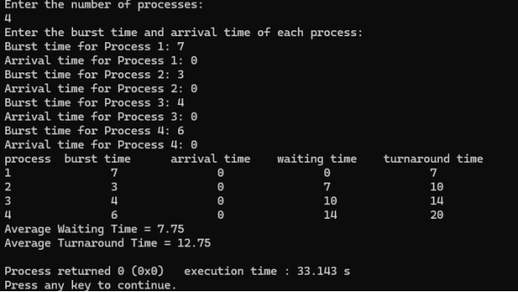
Lab program 2
Write a C program to simulate CPU scheduling algorithm with the following:
a) SJF

#include <stdio.h>
#include <limits.h>
struct Process {
int pid;
int arrival_time;
int burst_time;
int remaining_time;
int waiting_time;
int turnaround_time;
int completed;
};
void sortByBurstTime(struct Process p[], int n) {
for (int i = 0; i < n - 1; i++) {
for (int j = 0; j < n - i - 1; j++) {
if (p[j].burst_time > p[j + 1].burst_time) {
struct Process temp = p[j];
p[j] = p[j + 1];
p[j + 1] = temp;
}
}
}
}
void sjf_non_preemptive(struct Process p[], int n) {
sortByBurstTime(p, n);
p[0].waiting_time = 0;
for (int i = 1; i < n; i++) {
p[i].waiting_time = p[i - 1].waiting_time + p[i - 1].burst_time;
}
for (int i = 0; i < n; i++) {
p[i].turnaround_time = p[i].waiting_time + p[i].burst_time;
}
}
void sjf_preemptive(struct Process p[], int n) {
int completed = 0, time = 0, min_index;
while (completed != n) {
min_index = -1;
int min_time = INT_MAX;
for (int i = 0; i < n; i++) {
if (p[i].arrival_time <= time && p[i].remaining_time > 0 && p[i].remaining_time < min_time) {
min_time = p[i].remaining_time;
min_index = i;
}
}
if (min_index == -1) {
time++;
continue;
}
p[min_index].remaining_time--;
time++;
if (p[min_index].remaining_time == 0) {
p[min_index].completed = 1;
completed++;
p[min_index].turnaround_time = time - p[min_index].arrival_time;
p[min_index].waiting_time = p[min_index].turnaround_time - p[min_index].burst_time;
}
}
}

void displayProcesses(struct Process p[], int n) {
float total_wt = 0, total_tat = 0;
printf("Process\tArrival Time\tBurst Time\tWaiting Time\tTurnaround Time\n");
for (int i = 0; i < n; i++) {
printf("P%d\t\t%d\t\t%d\t\t%d\t\t%d\n", p[i].pid, p[i].arrival_time, p[i].burst_time, p[i].waiting_time, p[i].turnaround_time);
total_wt += p[i].waiting_time;
total_tat += p[i].turnaround_time;
}
printf("\nAverage Waiting Time: %.2f\n", total_wt / n);
printf("Average Turnaround Time: %.2f\n", total_tat / n);
}
int main() {
int n, choice;
printf("Enter number of processes: ");
scanf("%d", &n);
struct Process p[n];
for (int i = 0; i < n; i++) {
p[i].pid = i + 1;
printf("Enter Arrival Time and Burst Time for Process %d: ", i + 1);
scanf("%d %d", &p[i].arrival_time, &p[i].burst_time);
p[i].remaining_time = p[i].burst_time;
p[i].completed = 0;
}
printf("Choose Scheduling Algorithm:\n1. Non-Preemptive SJF\n2. Preemptive SJF (SRTF)\nEnter choice: ");
scanf("%d", &choice);
if (choice == 1)
{
sjf_non_preemptive(p, n);
} else if (choice == 2) {
sjf_preemptive(p, n);
}
else
{
printf("Invalid choice!\n");
return 1;
}
displayProcesses(p, n);
return 0;
}

Output:

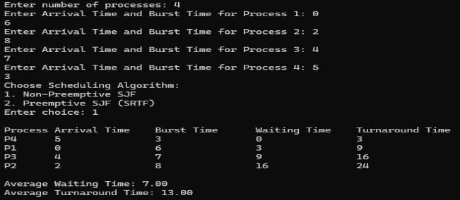

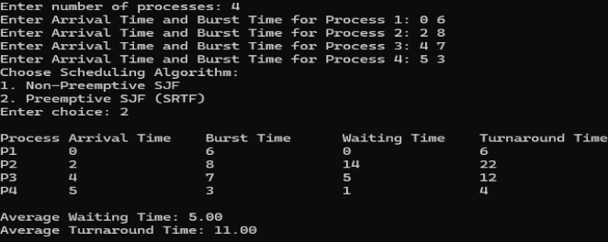

Lab program 3
Write a C program to simulate CPU scheduling algorithm with the following:
a) priority
b) round robin

#include <stdio.h>
#define MAX 100
typedef struct {
int pid;
int arrival;
int burst;
int priority;
int remaining;
int completion;
int waiting;
int turnaround;
} Process;
void calculateTimes(Process processes[], int n, int preemptive) {
int time = 0, completed = 0, min_index;
int is_completed[MAX] = {0};
while (completed != n) {
min_index = -1;
for (int i = 0; i < n; i++) {
if (processes[i].arrival <= time && !is_completed[i]) {
if (min_index == -1 ||
processes[i].priority < processes[min_index].priority ||
(processes[i].priority == processes[min_index].priority && processes[i].arrival < processes[min_index].arrival)) {
min_index = i;
}
}
}
if (min_index == -1) {
time++;
} else {
if (preemptive) {
processes[min_index].remaining--;
if (processes[min_index].remaining == 0) {
processes[min_index].completion = time + 1;
is_completed[min_index] = 1;
completed++;
}
} else {
time += processes[min_index].burst;
processes[min_index].completion = time;
is_completed[min_index] = 1;
completed++;
}
if (!preemptive)
processes[min_index].remaining = 0;
else
time++;
}
}
for (int i = 0; i < n; i++) {
processes[i].turnaround = processes[i].completion - processes[i].arrival;
processes[i].waiting = processes[i].turnaround - processes[i].burst;
}
}
void printResults(Process processes[], int n) {
printf("\nPID\tAT\tBT\tPriority\tCT\tTAT\tWT\n");
for (int i = 0; i < n; i++) {
printf("%d\t%d\t%d\t%d\t\t%d\t%d\t%d\n",
processes[i].pid, processes[i].arrival, processes[i].burst,
processes[i].priority, processes[i].completion,
processes[i].turnaround, processes[i].waiting);
}
}
int main() {
int n, choice;
Process processes[MAX];
printf("Enter the number of processes: ");
scanf("%d", &n);printf("Enter Process details (Arrival Time, Burst Time, Priority):\n");
for (int i = 0; i < n; i++) {
processes[i].pid = i + 1;
printf("Process %d: ", i + 1);
scanf("%d %d %d", &processes[i].arrival, &processes[i].burst, &processes[i].priority);
processes[i].remaining = processes[i].burst;
}
printf("\nChoose Scheduling Type:\n1. Preemptive Priority\n2. Non-Preemptive Priority\n");
scanf("%d", &choice);
if (choice == 1) {
printf("\nExecuting Preemptive Priority Scheduling...\n");
calculateTimes(processes, n, 1);
} else {
printf("\nExecuting Non-Preemptive Priority Scheduling...\n");
calculateTimes(processes, n, 0);
}
printResults(processes, n);
return 0;
}
Output:
(PREEMPTIVE PRIORITY)
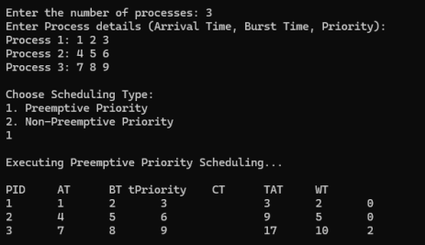
(NON- PREEMPTIVE PRIORITY)
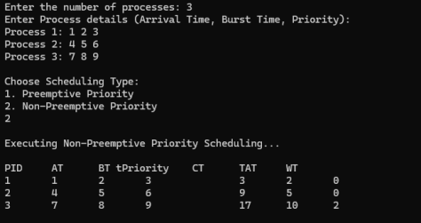

c) ROUND ROBIN

#include <stdio.h>
int main() {
int i, j, n, bu[10], wa[10], tat[10], t, ct[10], max;
float awt = 0, att = 0, temp = 0;
printf("Enter the number of processes: ");
scanf("%d", &n);
for (i = 0; i < n; i++) {
printf("\nEnter Burst Time for process %d: ", i + 1);
scanf("%d", &bu[i]);
ct[i] = bu[i];
}
printf("\nEnter the size of time: ");
scanf("%d", &t);
max = bu[0];
for (i = 1; i < n; i++) {
if (max < bu[i])
max = bu[i];
}
for (j = 0; j <= (max + t - 1) / t; j++) {
for (i = 0; i < n; i++) {
if (bu[i] != 0) {
if (bu[i] < t) {
tat[i] = temp + bu[i];
temp += bu[i];
bu[i] = 0;
} else {
bu[i] -= t;
temp += t;
}
}
}
}
for (i = 0; i < n; i++) {
wa[i] = tat[i] - ct[i];
att += tat[i];
awt += wa[i];
}
printf("\nThe Average Turnaround time is: %f", att / n);
printf("\nThe Average Waiting time is: %f", awt / n);
printf("\n\nPROCESS\t BURST TIME \t WAITING TIME \t TURNAROUND TIME\n");

for (i = 0; i < n; i++) {
printf("\t%d \t %d \t\t%d \t\t %d\n", i + 1, ct[i], wa[i], tat[i]);
}
return 0;
}
Output:

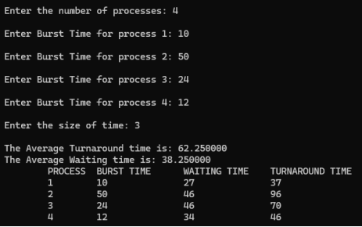
Lab program 4

Write a C program to simulate multilevel queue scheduling

#include <stdio.h>
#define MAX 100
typedef struct {
int pid, arrival, burst, completion, turnaround, waiting, remaining;
} Process;
void inputProcesses(Process sys[], int *sysCount, Process user[], int *userCount);
void fcfsScheduling(Process p[], int n, int startTime);
void roundRobinScheduling(Process p[], int n, int startTime, int timeQuantum);
void displayProcesses(Process p[], int n, const char *queueName);
int main() {
Process systemQueue[MAX], userQueue[MAX];
int sysCount = 0, userCount = 0, timeQuantum;
inputProcesses(systemQueue, &sysCount, userQueue, &userCount);
printf("Enter the time quantum for Round Robin: ");
scanf("%d", &timeQuantum);
fcfsScheduling(systemQueue, sysCount, 0);
roundRobinScheduling(userQueue, userCount, systemQueue[sysCount - 1].completion, timeQuantum);
displayProcesses(systemQueue, sysCount, "System Queue (FCFS)");
displayProcesses(userQueue, userCount, "User Queue (Round Robin)");
return 0;
}
void inputProcesses(Process sys[], int *sysCount, Process user[], int *userCount) {
int n, type;
printf("Enter the total number of processes: ");
scanf("%d", &n);
printf("\nEnter Process Details: (PID Arrival Burst Type[0=System, 1=User])\n");
for (int i = 0; i < n; i++) {
Process temp;
printf("Process %d: ", i + 1);
scanf("%d %d %d %d", &temp.pid, &temp.arrival, &temp.burst, &type);
temp.remaining = temp.burst;
if (type == 0) {
sys[*sysCount] = temp;
(*sysCount)++;
} else {
user[*userCount] = temp;
(*userCount)++;
}
}
}
void fcfsScheduling(Process p[], int n, int startTime) {
if (n == 0) return;
int time = startTime;
for (int i = 0; i < n; i++) {
if (time < p[i].arrival) {
time = p[i].arrival;
}
p[i].completion = time + p[i].burst;
p[i].turnaround = p[i].completion - p[i].arrival;
p[i].waiting = p[i].turnaround - p[i].burst;
time = p[i].completion;
}
}
void roundRobinScheduling(Process p[], int n, int startTime, int timeQuantum) {
if (n == 0) return;
int time = startTime, remainingProcesses = n;
while (remainingProcesses > 0) {
int allIdle = 1;
for (int i = 0; i < n; i++) {
if (p[i].remaining > 0 && p[i].arrival <= time) {
allIdle = 0;
if (p[i].remaining > timeQuantum) {
time += timeQuantum;
p[i].remaining -= timeQuantum;
} else {
time += p[i].remaining;
p[i].completion = time;
p[i].turnaround = p[i].completion - p[i].arrival;
p[i].waiting = p[i].turnaround - p[i].burst;
p[i].remaining = 0;
remainingProcesses--;
}
}
}
if (allIdle) time++;
}
}
void displayProcesses(Process p[], int n, const char *queueName) {
if (n == 0) {
printf("\nNo processes in %s.\n", queueName);
return;
}
printf("\n%s Execution Order:\n", queueName);
printf("PID Arrival Burst Completion Turnaround Waiting\n");
for (int i = 0; i < n; i++) {
printf("%3d %7d %6d %10d %10d %8d\n",
p[i].pid, p[i].arrival, p[i].burst,
p[i].completion, p[i].turnaround, p[i].waiting);
}
}

OUTPUT:
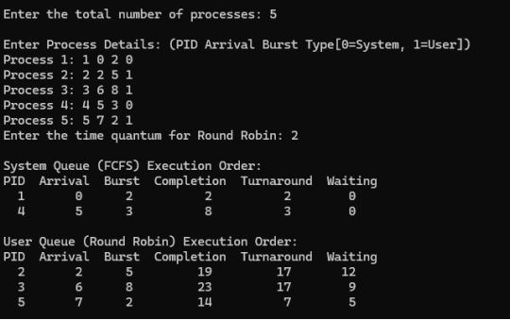

Lab program 5

Write a C program to simulate Real-Time CPU Scheduling algorithms:
(a) Rate- Monotonic
(b) Earliest-deadline First.

#include <stdio.h>
#include <stdlib.h>
#include <math.h>
#include <stdbool.h>

#define MAX_PROCESS 10

typedef struct {
int id;
int burst_time;
float priority;
} Task;

int num_of_process;
int execution_time[MAX_PROCESS], period[MAX_PROCESS], remain_time[MAX_PROCESS], deadline[MAX_PROCESS], remain_deadline[MAX_PROCESS];

void get_process_info(int selected_algo) {
printf("Enter total number of processes (maximum %d):", MAX_PROCESS);
scanf("%d", &num_of_process);
if (num_of_process < 1) {
exit(0);
}
for (int i = 0; i < num_of_process; i++) {
printf("\nProcess %d:\n", i + 1);
printf("==> Execution time: ");
scanf("%d", &execution_time[i]);
remain_time[i] = execution_time[i];
if (selected_algo == 2) {
printf("==> Deadline: ");
scanf("%d", &deadline[i]);
} else {
printf("==> Period: ");
scanf("%d", &period[i]);
}
}
}

int max(int a, int b, int c) {
int max;
if (a >= b && a >= c)
max = a;
else if (b >= a && b >= c)
max = b;
else
max = c;
return max;
}

int get_observation_time(int selected_algo)
{
if (selected_algo == 1) {
return max(period[0], period[1], period[2]);
} else if (selected_algo == 2) {
return max(deadline[0], deadline[1], deadline[2]);
}
return 0;
}
void print_schedule(int process_list[], int cycles) {
printf("\nScheduling:\n\n");
printf("Time: ");
for (int i = 0; i < cycles; i++) {
if (i < 10)
printf("| 0%d ", i);
else
printf("| %d ", i);
}
printf("|\n");
for (int i = 0; i < num_of_process; i++) {
printf("P[%d]: ", i + 1);
for (int j = 0; j < cycles; j++) {
if (process_list[j] == i + 1)
printf("|####");
else
printf("| ");
}
printf("|\n");
}
}

void rate_monotonic(int time) {
int process_list[100] = {0}, min = 999, next_process = 0;
float utilization = 0;
for (int i = 0; i < num_of_process; i++) {
utilization += (1.0 * execution_time[i]) / period[i];
}
int n = num_of_process;
int m = (float)(n * (pow(2, 1.0 / n) - 1));
if (utilization > m) {
printf("\nGiven problem is not schedulable under the said scheduling algorithm.\n");
return;
}
for (int i = 0; i < time; i++) {
min = 1000;
for (int j = 0; j < num_of_process; j++) {
if (remain_time[j] > 0) {
if (min > period[j]) {
min = period[j];
next_process = j;
}
}
}
if (remain_time[next_process] > 0) {
process_list[i] = next_process + 1;
remain_time[next_process] -= 1;
}
for (int k = 0; k < num_of_process; k++) {
if ((i + 1) % period[k] == 0) {
remain_time[k] = execution_time[k];
}
}
}
print_schedule(process_list, time);
}

void earliest_deadline_first(int time) {
float utilization = 0;
for (int i = 0; i < num_of_process; i++) {
utilization += (1.0 * execution_time[i]) / deadline[i];
}
int n = num_of_process;
int process[num_of_process];
int max_deadline, current_process = 0, min_deadline, process_list[time];
bool is_ready[num_of_process];
for (int i = 0; i < num_of_process; i++) {
is_ready[i] = true;
process[i] = i + 1;
}
max_deadline = deadline[0];
for (int i = 1; i < num_of_process; i++) {
if (deadline[i] > max_deadline)
max_deadline = deadline[i];
}

for (int i = 0; i < num_of_process; i++) {
for (int j = i + 1; j < num_of_process; j++) {
if (deadline[j] < deadline[i]) {
int temp = execution_time[j];
execution_time[j] = execution_time[i];
execution_time[i] = temp;
temp = deadline[j];
deadline[j] = deadline[i];
deadline[i] = temp;
temp = process[j];
process[j] = process[i];
process[i] = temp;
}
}
}
for (int i = 0; i < num_of_process; i++) {
remain_time[i] = execution_time[i];
remain_deadline[i] = deadline[i];
}
for (int t = 0; t < time; t++) {
if (current_process != -1) {
--execution_time[current_process];
process_list[t] = process[current_process];
} else {
process_list[t] = 0;
}
for (int i = 0; i < num_of_process; i++) {
--deadline[i];
if ((execution_time[i] == 0) && is_ready[i]) {
deadline[i] += remain_deadline[i];
is_ready[i] = false;
}
if ((deadline[i] <= remain_deadline[i]) && !is_ready[i]) {
execution_time[i] = remain_time[i];
is_ready[i] = true;
}
}
min_deadline = max_deadline;
current_process = -1;

for (int i = 0; i < num_of_process; i++) {
if ((deadline[i] <= min_deadline) && (execution_time[i] > 0)) {
current_process = i;
min_deadline = deadline[i];
}
}
}
print_schedule(process_list, time);
}

int main()
{
int option;
int observation_time;
while (1) {
printf("\n1. Rate Monotonic\n2. Earliest Deadline first\n3. Proportional Scheduling\n\nEnter your choice: ");
scanf("%d", &option);
switch (option) {
case 1:
get_process_info(option);
observation_time = get_observation_time(option);
rate_monotonic(observation_time);
break;
case 2:
get_process_info(option);
observation_time = get_observation_time(option);
earliest_deadline_first(observation_time);
break;
case 3:
exit(0);
default:
printf("\nInvalid Statement");
}
}
return 0;
}

OUTPUT:

Rate- Monotonic

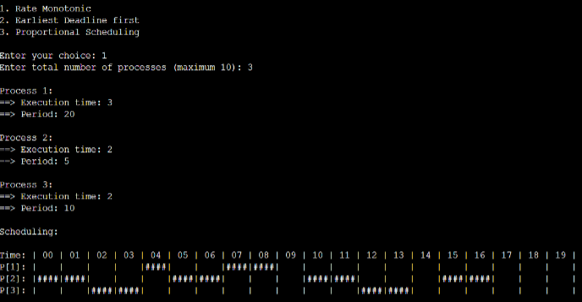

Earliest-deadline First

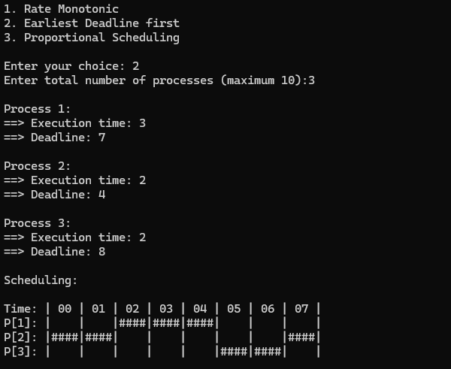

Write a C program to simulate the concept of Dining-Philosophers
problem.

#include <stdio.h>
#include <pthread.h>
#include <semaphore.h>
#include <unistd.h> // Include for sleep function

#define N 5
#define THINKING 2
#define HUNGRY 1
#define EATING 0
#define LEFT (i + 4) % N
#define RIGHT (i + 1) % N

int state[N];
int phil[N] = {0, 1, 2, 3, 4};
sem_t mutex;
sem_t S[N];

void test(int i) {
if (state[i] == HUNGRY && state[LEFT] != EATING && state[RIGHT] != EATING) {
state[i] = EATING;
sleep(2);
printf("Philosopher %d takes fork %d and %d\n", i + 1, LEFT + 1, i + 1);
printf("Philosopher %d is Eating\n", i + 1);
sem_post(&S[i]);
}
}

void take_fork(int i) {
sem_wait(&mutex);
state[i] = HUNGRY;
printf("Philosopher %d is Hungry\n", i + 1);
test(i);
sem_post(&mutex);
sem_wait(&S[i]);
sleep(1);
}

void put_fork(int i) {
sem_wait(&mutex);
state[i] = THINKING;
printf("Philosopher %d putting fork %d and %d down\n", i + 1, LEFT + 1, i + 1);
printf("Philosopher %d is thinking\n", i + 1);
test(LEFT);
test(RIGHT);
sem_post(&mutex);
}

void* philosopher(void* num) {
while (1) {
int* i = num;
sleep(1);
take_fork(*i);
sleep(0);
put_fork(*i);
}
}

int main() {
int i;
pthread_t thread_id[N];
sem_init(&mutex, 0, 1);
for (i = 0; i < N; i++)
sem_init(&S[i], 0, 0);
for (i = 0; i < N; i++) {
pthread_create(&thread_id[i], NULL, philosopher, &phil[i]);
printf("Philosopher %d is thinking\n", i + 1);
}
for (i = 0; i < N; i++) {
pthread_join(thread_id[i], NULL);
}
}

OUTPUT:

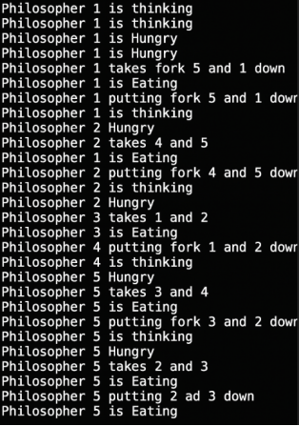

Write a C program to simulate producer-consumer problem using semaphores.

#include <stdio.h>
#include <stdlib.h>

int mutex = 1, full = 0, empty = 3, x = 0;

void producer();
void consumer();
int wait(int);
int signal(int);

int main() {
int n;
printf("\n1. Producer\n2. Consumer\n3. Exit");
while (1) {
printf("\nEnter your choice: ");
scanf("%d", &n);
switch (n) {
case 1:
if ((mutex == 1) && (empty != 0)) {
producer();
} else {
printf("Buffer is full!!");
}
break;
case 2:
if ((mutex == 1) && (full != 0)) {
consumer();
} else {
printf("Buffer is empty!!");
}
break;
case 3:
exit(0);
break;
default:
printf("Invalid choice! Please enter 1, 2, or 3.");
break;
}
}
return 0;
}

int wait(int s) {
return --s;
}

int signal(int s) {
return ++s;
}

void producer() {
mutex = wait(mutex);

full = signal(full);

empty = wait(empty);
x++;
printf("\nProducer produces the item %d", x);
mutex = signal(mutex);
}

void consumer() {
mutex = wait(mutex);
full = wait(full);
empty = signal(empty);
printf("\nConsumer consumes item %d", x);
x--;
mutex = signal(mutex);
}

OUTPUT:

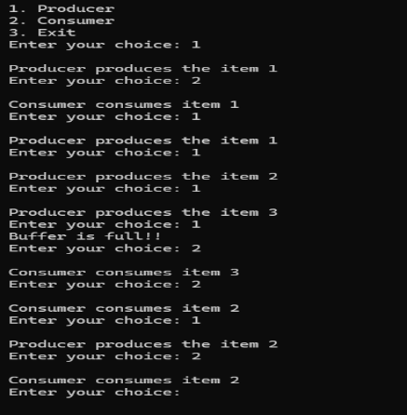

Lab program 6

Write a C program to simulate Bankers algorithm for the purpose of
deadlock avoidance.

#include <stdio.h>
int main() {
int n, m, i, j, k;
printf("Enter the number of processes: ");
scanf("%d", &n);
printf("Enter the number of resources: ");
scanf("%d", &m);
int allocation[n][m];
printf("Enter the Allocation Matrix:\n");
for (i = 0; i < n; i++) {
for (j = 0; j < m; j++) {
scanf("%d", &allocation[i][j]);
}
)
int max[n][m];
printf("Enter the MAX Matrix:\n");
for (i = 0; i < n; i++) {
for (j = 0; j < m; j++) {
scanf("%d", &max[i][j]);
}
}
int available[m];
printf("Enter the Available Resources:\n");
for (i = 0; i < m; i++) {
scanf("%d", &available[i]);
}
int f[n], ans[n], ind = 0;
for (k = 0; k < n; k++) {
f[k] = 0;
}
int need[n][m];
for (i = 0; i < n; i++) {
for (j = 0; j < m; j++) {
need[i][j] = max[i][j] - allocation[i][j];
}
}
int y = 0;
for (k = 0; k < n; k++) {
for (i = 0; i < n; i++) {
if (f[i] == 0) {
int flag = 0;
for (j = 0; j < m; j++) {
if (need[i][j] > available[j]) {
flag = 1;
break;
}

}

if (flag == 0) {
ans[ind++] = i;
for (y = 0; y < m; y++) {
available[y] += allocation[i][y];
}
f[i] = 1;
}
}
}
}
int flag = 1;
for (i = 0; i < n; i++) {
if (f[i] == 0) {
flag = 0;
printf("The following system is not safe\n");
break;
}
}
if (flag == 1) {
printf("Following is the SAFE Sequence\n");
for (i = 0; i < n - 1; i++) {
printf(" P%d ->", ans[i]);
}
printf(" P%d\n", ans[n - 1]);
}
return 0;
}

OUTPUT:

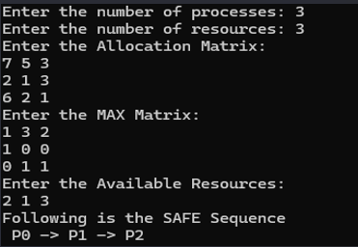

Write a C program to simulate deadlock detection.

#include <stdio.h>
static int mark[20];
int i, j, np, nr;
int main()
{
int alloc[10][10], request[10][10], avail[10], r[10], w[10];
printf("\nEnter the no of process: ");
scanf("%d", &np);
printf("\nEnter the no of resources: ");
scanf("%d", &nr);
for(i = 0; i < nr; i++)
{
printf("\nTotal Amount of the Resource R%d: ", i + 1);
scanf("%d", &r[i]);
}
printf("\nEnter the request matrix:");
for(i = 0; i < np; i++)
for(j = 0; j < nr; j++)
scanf("%d", &request[i][j]);
printf("\nEnter the allocation matrix:");
for(i = 0; i < np; i++)
for(j = 0; j < nr; j++)
scanf("%d", &alloc[i][j]);
for(j = 0; j < nr; j++)
{
avail[j] = r[j];
for(i = 0; i < np; i++)
{
avail[j] -= alloc[i][j];
}
}
for(i = 0; i < np; i++)
{
int count = 0;
for(j = 0; j < nr; j++)
{
if(alloc[i][j] == 0)
count++;
else
break;
}
if(count == nr)
mark[i] = 1;
}
for(j = 0; j < nr; j++)
w[j] = avail[j];
for(i = 0; i < np; i++)
{
int canbeprocessed = 0;
if(mark[i] != 1)
{

for(j = 0; j < nr; j++)
{
if(request[i][j] <= w[j])
canbeprocessed = 1;
else
{
canbeprocessed = 0;
break;
}
}
if(canbeprocessed)
{
mark[i] = 1;
for(j = 0; j < nr; j++)
w[j] += alloc[i][j];
}
}
}
int deadlock = 0;
for(i = 0; i < np; i++)
if(mark[i] != 1)
deadlock = 1;
if(deadlock)
printf("\n Deadlock detected");
else
printf("\n No Deadlock possible");
}

OUTPUT:

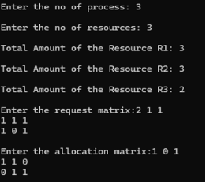
Lab program 7

Write a C program to simulate the following contiguous memory
allocation techniques:
(a) Worst-fit
(b) Best-fit
(c) First-fit

#include <stdio.h>
#define max 25

void firstFit(int b[], int nb, int f[], int nf);
void worstFit(int b[], int nb, int f[], int nf);
void bestFit(int b[], int nb, int f[], int nf);

int main() {
int b[max], f[max], nb, nf;
printf("Memory Management Schemes\n");
printf("\nEnter the number of blocks: ");
scanf("%d", &nb);
printf("Enter the number of files: ");
scanf("%d", &nf);
printf("\nEnter the size of the blocks:\n");
for (int i = 0; i < nb; i++) {
printf("Block %d: ", i + 1);
scanf("%d", &b[i]);
}
printf("\nEnter the size of the files:\n");
for (int i = 0; i < nf; i++) {
printf("File %d: ", i + 1);
scanf("%d", &f[i]);
}
printf("\nMemory Management Scheme - First Fit");
firstFit(b, nb, f, nf);
printf("\n\nMemory Management Scheme - Worst Fit");
worstFit(b, nb, f, nf);
printf("\n\nMemory Management Scheme - Best Fit");
bestFit(b, nb, f, nf);
return 0;
}
void firstFit(int b[], int nb, int f[], int nf) {
int bf[max] = {0}, ff[max], frag[max];
for (int i = 0; i < nf; i++) {
ff[i] = -1;
for (int j = 0; j < nb; j++) {
if (!bf[j] && b[j] >= f[i]) {
ff[i] = j;
frag[i] = b[j] - f[i];
bf[j] = 1;
break;
}
}
}
printf("\nFile_no:\tFile_size:\tBlock_no:\tBlock_size:\tFragment");
for (int i = 0; i < nf; i++) {
if (ff[i] != -1)
printf("\n%d\t\t%d\t\t%d\t\t%d\t\t%d", i+1, f[i], ff[i]+1, b[ff[i]], frag[i]);
else
printf("\n%d\t\t%d\t\tNot Allocated", i+1, f[i]);
}
}
void worstFit(int b[], int nb, int f[], int nf) {
int tempBlocks[max];
for (int i = 0; i < nb; i++) tempBlocks[i] = b[i]
int bf[max] = {0}, ff[max], frag[max];
for (int i = 0; i < nf; i++) {
int index = -1, maxDiff = -1;
for (int j = 0; j < nb; j++) {
if (!bf[j] && tempBlocks[j] >= f[i] && (tempBlocks[j] - f[i] > maxDiff)) {
index = j;
maxDiff = tempBlocks[j] - f[i];
}
}
if (index != -1) {
ff[i] = index;
frag[i] = tempBlocks[index] - f[i];
bf[index] = 1;
} else {
ff[i] = -1;
}
}
printf("\nFile_no:\tFile_size:\tBlock_no:\tBlock_size:\tFragment");
for (int i = 0; i < nf; i++) {
if (ff[i] != -1)
printf("\n%d\t\t%d\t\t%d\t\t%d\t\t%d", i+1, f[i], ff[i]+1, b[ff[i]], frag[i]);
else
printf("\n%d\t\t%d\t\tNot Allocated", i+1, f[i]);
}
}
void bestFit(int b[], int nb, int f[], int nf) {
int tempBlocks[max];
for (int i = 0; i < nb; i++) tempBlocks[i] = b[i];
int bf[max] = {0}, ff[max], frag[max];
for (int i = 0; i < nf; i++) {
int index = -1, minDiff = 100000;
for (int j = 0; j < nb; j++) {
if (!bf[j] && tempBlocks[j] >= f[i] && (tempBlocks[j] - f[i] < minDiff)) {
index = j;
minDiff = tempBlocks[j] - f[i];
}
}
if (index != -1) {
ff[i] = index;
frag[i] = tempBlocks[index] - f[i];
bf[index] = 1;
} else {
ff[i] = -1;
}
}
printf("\nFile_no:\tFile_size:\tBlock_no:\tBlock_size:\tFragment");
for (int i = 0; i < nf; i++) {
if (ff[i] != -1)
printf("\n%d\t\t%d\t\t%d\t\t%d\t\t%d", i+1, f[i], ff[i]+1, b[ff[i]], frag[i]);
else
printf("\n%d\t\t%d\t\tNot Allocated", i+1, f[i]);
}
}

OUTPUT:

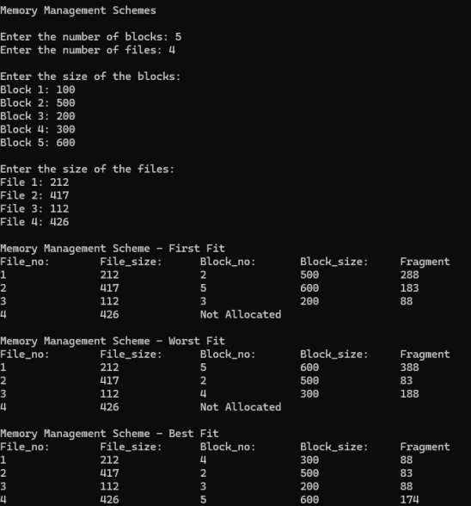

Lab program 8

Write a C program to simulate page replacement algorithms:
(a) FIFO
(b) LRU
(c) Optimal

#include <stdio.h>
int n, f, i, j, k;
int in[100];
int p[ 50];
int hit = 0;
int pgfaultcnt = 0;
void getData() {
printf("\nEnter length of page reference sequence: ");
scanf("%d", &n);
printf("Enter the page reference sequence: ");
for (i = 0; i < n; i++)
scanf("%d", &in[i]);
printf("Enter number of frames: ");
scanf("%d", &f);
}
void initialize() {
pgfaultcnt = 0;
for (i = 0; i < f; i++)
p[i] = -1;
}
int isHit(int data) {
hit = 0;
for (j = 0; j < f; j++) {
if (p[j] == data) {
hit = 1;
break;
}
}
return hit;
}
int getHitIndex(int data) {
for (k = 0; k < f; k++) {
if (p[k] == data)
return k;
}
return -1;
}
void dispPages() {
for (k = 0; k < f; k++) {
if (p[k] != -1)
printf(" %d", p[k]);
}
printf("\n");
}
void dispPgFaultCnt() {
printf("\nTotal number of page faults: %d\n", pgfaultcnt);
}
void fifo() {
initialize();
int index = 0;
for (i = 0; i < n; i++) {
printf("For %d: ", in[i]);
if (!isHit(in[i])) {
p[index] = in[i];
index = (index + 1) % f;
pgfaultcnt++;
dispPages();
} else {
printf("No page fault\n");
}
}
dispPgFaultCnt();
}
void optimal() {
initialize();
int near[50];
for (i = 0; i < n; i++) {
printf("For %d: ", in[i]);
if (!isHit(in[i])) {
for (j = 0; j < f; j++) {
int pg = p[j];
int found = 0;
for (k = i + 1; k < n; k++) {
if (pg == in[k]) {
near[j] = k;
found = 1;
break;
}
}
if (!found)
near[j] = 9999;
}
int max = -1, repindex = -1;
for (j = 0; j < f; j++) {
if (near[j] > max) {
max = near[j];
repindex = j;
}
}
p[repindex] = in[i];
pgfaultcnt++;
dispPages();
} else {
printf("No page fault\n");
}
}
dispPgFaultCnt();
}

void lru() {

initialize();
int least[50];
for (i = 0; i < n; i++) {
printf("For %d: ", in[i]);
if (!isHit(in[i])) {
for (j = 0; j < f; j++) {
int pg = p[j];
int found = 0;
for (k = i - 1; k >= 0; k--) {
if (pg == in[k]) {
least[j] = k;
found = 1;
break;
}
}
if (!found)
least[j] = -9999;
}
int min = 9999, repindex = -1;
for (j = 0; j < f; j++) {
if (least[j] < min) {
min = least[j];
repindex = j;
}
}
p[repindex] = in[i];
pgfaultcnt++;
dispPages();
} else {
printf("No page fault!\n");
}
}
dispPgFaultCnt();
}

int main() {
int choice;
while (1) {
printf("\nPage Replacement Algorithms\n");
printf("1. Enter data\n2. FIFO\n3. Optimal\n4. LRU\n5. Exit\nEnter your choice: ");
scanf("%d", &choice);
switch (choice) {
case 1: getData(); break;
case 2: fifo(); break;
case 3: optimal(); break;
case 4: lru(); break;
case 5: return 0;
default: printf("Invalid choice!\n"); break;
}
}
}

OUTPUT:
