CBSE Class 12 (2022): Attendance, Data Credibility & Risk Analysis
  - A reproducible Excel + Power Pivot analysis with integrity checks and coverage-weighted insights
Ritu Verma
Aspiring Data Analyst| Excel, SQL, Python| Reproducible Analytics

Executive Summary

Key Findings
- Overall appearance rate is high (~99.44), indicating strong system-level attendance.
- 99.96% of statistical weight comes from VALID_BASE row counts, making conclusions highly reliable.
- Anomalies affect only 0.14% of coverage, concentrated in a very small number of large-base cases.
- Structural zeros (22 cases) reflect institutional presence, not data errors.

Why this matters?
- Decisions based on this dataset are credibility safe.
- Risks are localized, not systemic.
- Over-reaction to small or perfect segments is avoided through base-aware modelling.

Dataset Overview

Scope
- Examination: CBSE Class 12
- Year: 2022
- Grain: Region x School Type
- Metrics: Registered, Appeared

What is not included?
- No student-level data
- No demographic or performance score
- No causality claims
This is a descriptive, integrity-aware operational analysis.

Methodology Overview

Workflow Architecture
- Raw Data (01_DATA_MODEL_raw_wide): untouched source
- Canonical Fact Table (02_FACT_APPEARANCE (VIEW)): all row-level logic
- Integrity Audit Log (03_DATA_QUALITY_LOG (VIEW)): validation & diagnostics
- Credibility & Coverage Analysis (04_CREDIBILITY)
- Anomalies & Risk Analysis (05_ANALYSIS)
- Volatility Analysis (06_VOLATILITY)
- Executive Dashboard (07_DASHBOARD)
- Assumptions & Thresholds (99_NOTES)

Design Principles
- Logic once, reuse everywhere
- Weight > Frequency
- Absence ≠ Failure
- Empty cells ≠ Missing data/error
- Thresholds must be documented

Data Integrity & Validation

Integrity Checks Implemented
- Missing value checks
- Rate validity checks
- Registered vs Appeared consistency
- Structural zero identification

Results
- 0 integrity failures
- 22 structural zeros (valid absence of school types)
- Integrity Score: 100%
Structural zeros are informational, not excluded as errors.
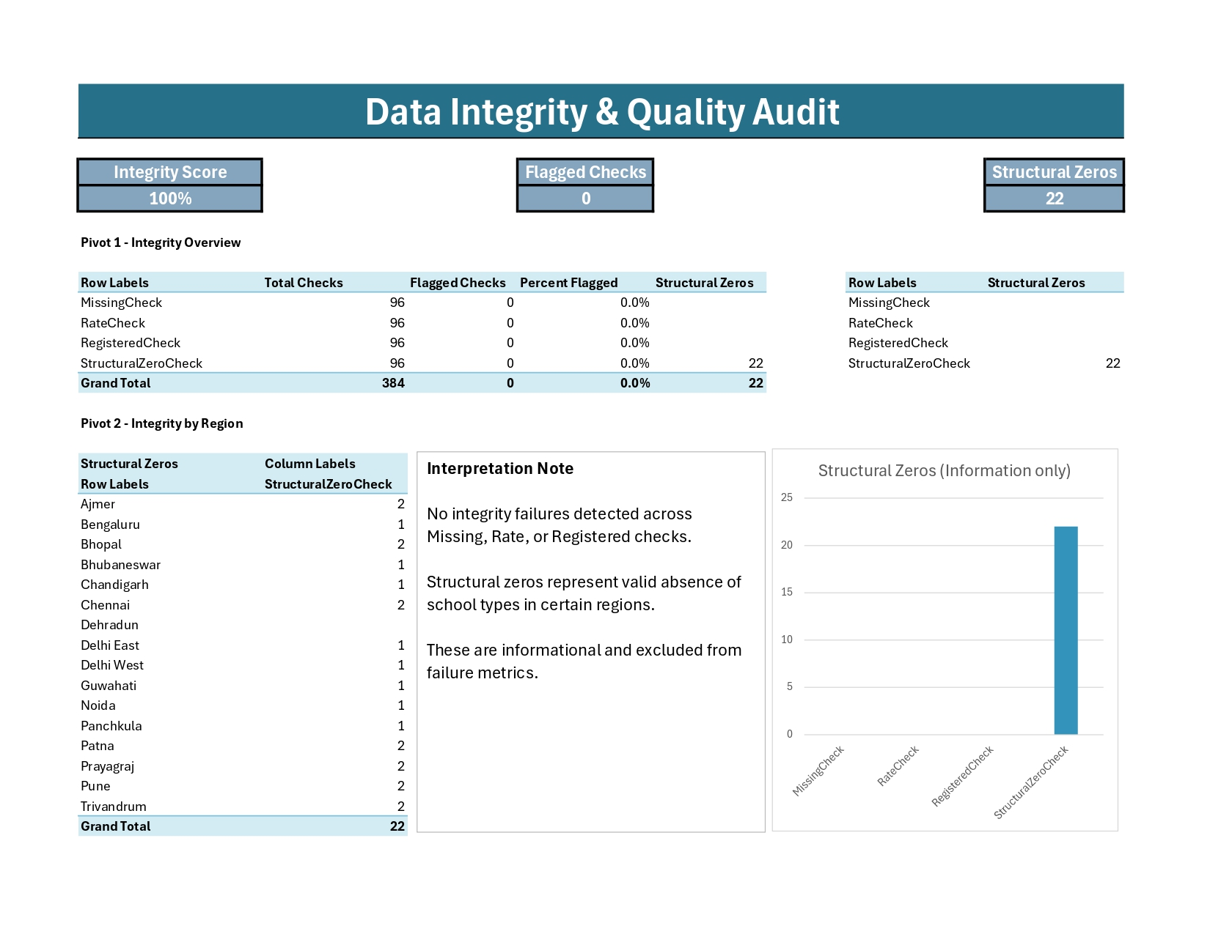

Base Stability & Credibility

Base Classification
- ABSENT_BASE: Registered = 0
- SMALL_BASE: Registered < 100
- VALID_BASE: Registered > 100

Coverage Impact
- VALID_BASE rows: 65 out of 96
- VALID_BASE coverage: 99.96%
- SMALL_BASE rows appear frequently but carry negligible weight (~0.04%)
Statistical conclusions are driven by stable denominations.

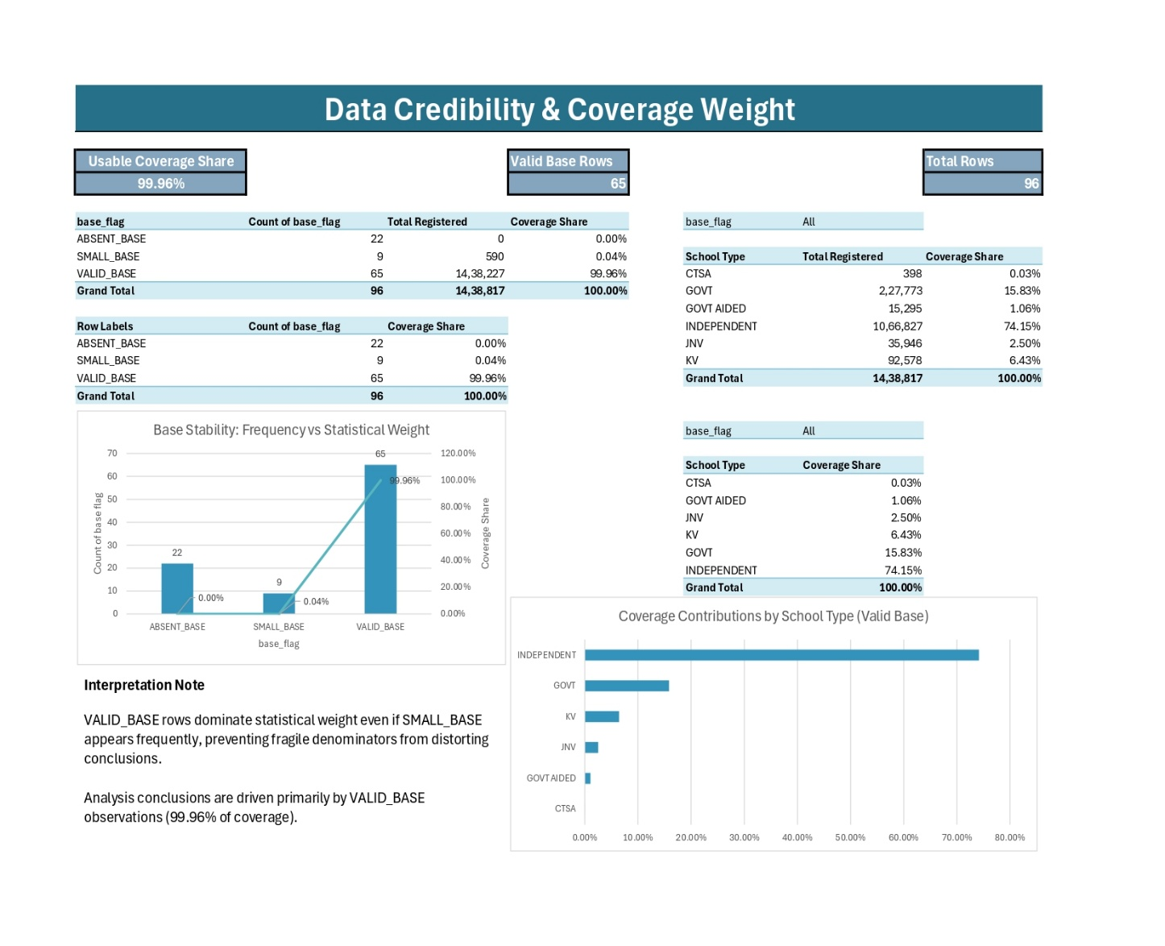

Threshold Justification (Why 100 and 0.98?)

SMALL_BASE = 100

Evidence:
- Median non-zero registrations ≈ 4000 (≈4067.5)
- Only 9 rows below 100
- Below-100 bases show disproportionate volatility

Decision:
100 balances stability and coverage without over-excluding data.

LOW_RATE = 0.98

Evidence:
- Appearance rates cluster tightly near 1.00
- Only 2 rows below 98%
- Below-98% lies in extreme lower tail

Decision:
0.98 isolates statistically uncommon behavior without flagging normal variation.

Anomalies & Risk Analysis

Anomaly Types
- NORMAL: Expected behavior
- LOW_RATE: Statistically uncommon under-attendance
- SUSPICIOUS_PERFECTION: Perfect rates on constrained bases
- ABSENT: Structural absence

Key Insights
- NORMAL dominates 99.86% coverage
- LOW_RATES affects only 0.11% coverage, but on large bases; deserves attention.
- Perfect attendance cases are rare and base-sensitive
- Seven small base “100%” cases: Bengaluru GOVT (70), Chandigarh GOVT AIDED (55), Dehradun GOVT AIDED (22), Delhi East JNV (81), Delhi West JNV (65), Panchkula CTSA (38), Trivandrum GOVT (82).
- ABSENT cases are excluded from evaluative conclusions
- Dehradun is uniquely complete (no structural absence)
- A large-base perfect case is normal, not suspicious. Example, Delhi West KV (2,872/2,872 = 100%) occurs on a valid base and is treated as NORMAL in the quality log.

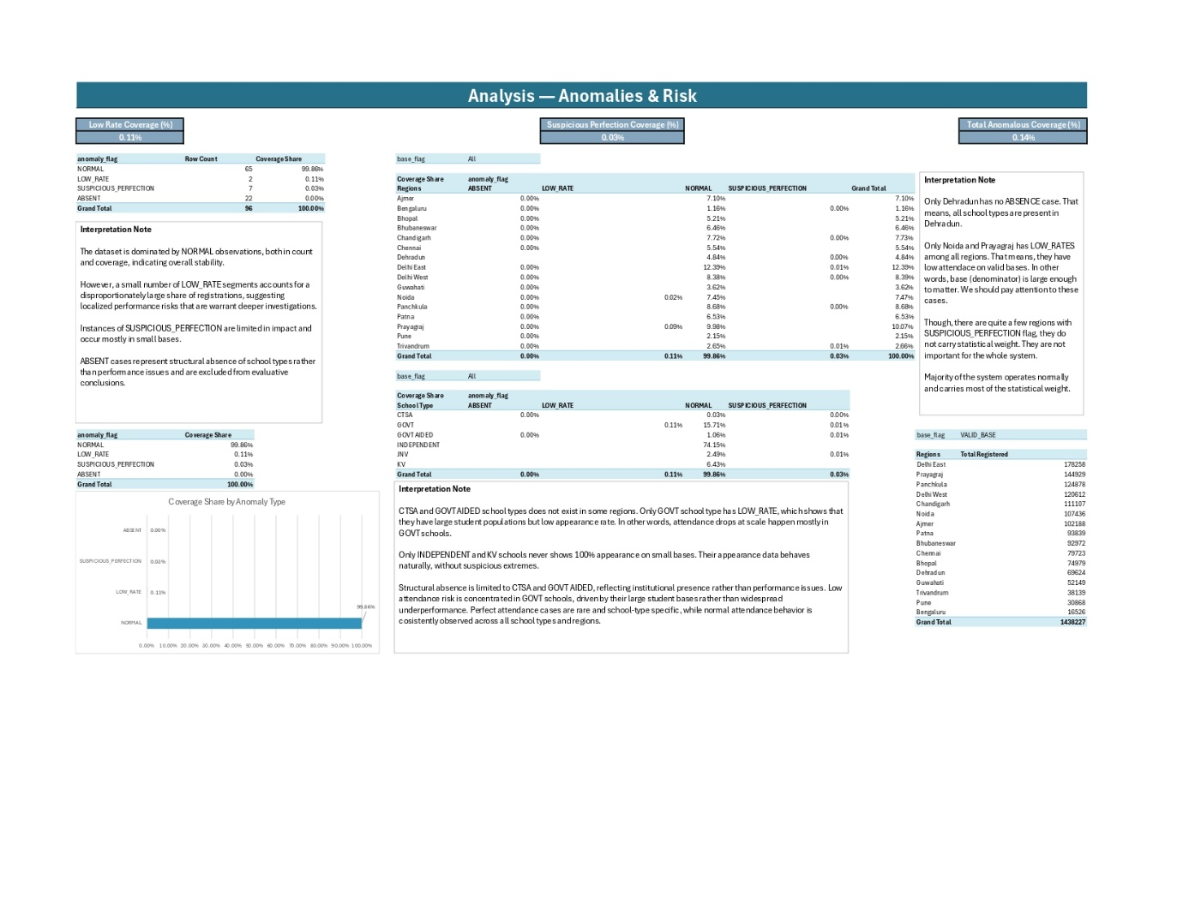

Regional & School-Type Patterns

Regional
- LOW_RATE concentrated in very few regions
- Majority of regions operate normally
- Top 3 regions by registrations: Delhi East (178,339), Prayagraj (144,929), Panchkula (124,916). These three alone accounts for 31.15% of total registrations—prime targets for performance programs.

School Type
- GOVT school dominate both volume and risk (coverage = 15.83%)
- Exactly 2 cases fall below 98% appearance threshold, both GOVT: Prayagraj and Noida. Together they represent 0.11% of total registrations—large base and high risk.
- INDEPENDENT schools dominate coverage (74.15%) but show stable behavior
- Changes in INDEPENDENT or large GOVT clusters will impact overall metrices most.
- CTSA & GOVT AIDED structural absences reflect institutional presence
Risk follows scale, not school type quality.

Volatility Analysis
- Appearance rates are consistently high across school types
- Volatility decreases as base size increases
- High performance + low volatility = operational stability
- Volatility by school type shows KV is the most stable (std dev ≈ 0.09%) and GOVT least stable (std dev ≈ 1.17%).

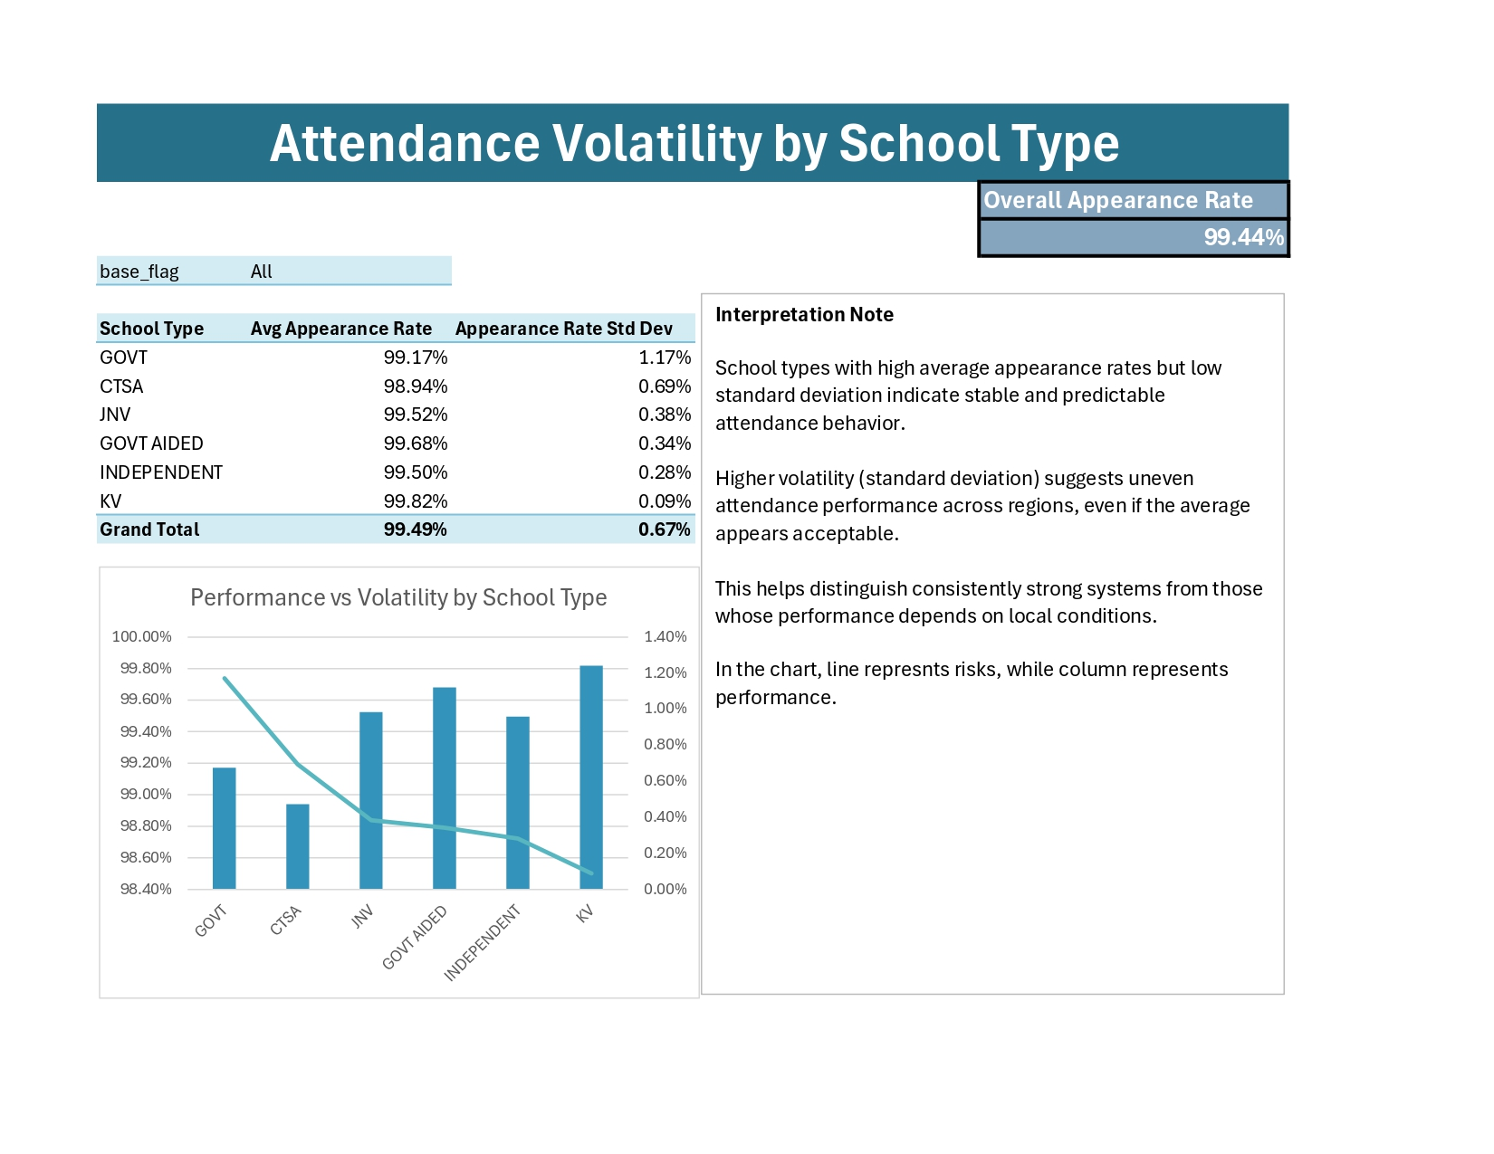

What Should Be Acted On

Focus Areas
- Large base LOW_RATE segments
- GOVT school operational scale risks

What NOT to over-react to
- Perfect attendance on small bases
- Structural zeros

Limitations & Boundaries
- No casual interference
- No student-level diagnostics
- Thresholds are context-specific
- Results apply to 2022 snapshot only

Reproducibility & Auditability
- All logic documented
- Thresholds justified
- Measures separated from data
- Workbook fully slicer-driven

