**CFD simulation of a car using openFoam**

Minor Project Report

Submitted in the partial fulfilment of

The Requirement for the Award of Degree

of

BACHELOR TECHNOLOGY

In Chemical Engineering

Submitted By:

Ritvik Shukla (20112059)

Under the guidance of

Supervisor: Dr Anurag Kumar Tiwari

Designation: Assistant Professor



**Department of Chemical Engineering**

**DR. B. R. AMBEDKAR NATIONAL INSTITUTE OF TECHNOLOGY**

**JALANDHAR, PUNJAB**

**MAY-2023**



**Dr B. R. Ambedkar National Institute of Technology, Jalandhar (PB)**

**(Department of Chemical Engineering)**

---------------------------------------------------------------------------------------------------------

**Candidate Declaration Certificate**

I hereby declare that the work which is being presented in the minor project report “CFD simulation of a car using openFoam” submitted towards the partial fulfilment of the requirements for the award of degree of bachelor of Technology in Chemical Engineering from Dr B. R. Ambedkar National Institute of Technology Jalandhar is an authentic record of our work carried out from July 2022 to April 2023 under the supervision of Dr Anurag Kumar Tiwari, Assistant Professor, Department of Chemical Engineering, NIT Jalandhar.

The matter embodied in this project has not been submitted by me for any other degree or diploma.

Place: NIT Jalandhar Date: 28/04/2023

Ritvik Shukla

(20112059)



**Dr B. R. Ambedkar National Institute of Technology, Jalandhar (PB)**

**(Department of Chemical Engineering)**

---------------------------------------------------------------------------------------------------------

**Certificate of Approval**

The undersigned certify that they have read and recommended to the Department of Chemical Engineering for acceptance, a project report entitled “CFD simulation of a car using openFoam” submitted by “Ritvik Shukla (20112059) in partial fulfilment for the degree of Bachelor of Engineering in Chemical Engineering.

Date: 28/04/2023

Supervisor: Dr Anurag Kumar Tiwari Dr Poonam Gera

(Assistant Professor) (Head of department)



**Dr B. R. Ambedkar National Institute of Technology, Jalandhar (PB)**

**(Department of Chemical Engineering)**

---------------------------------------------------------------------------------------------------------

**Certificate of Acknowledgement**

The satisfaction that accompanies the successful completion of any work would be incomplete unless we mention the names of the people who made it possible by giving constant guidance and encouragement.

I express my sincere gratitude and heartfelt thanks to Dr Anurag Kumar Tiwari, Assistant Professor, Department of Chemical Engineering, NIT Jalandhar for his constant support, guidance and encouragement. I am in debt to him fir having spared his valuable time in giving concrete suggestions and increasing my knowledge through fruitful discussions. His advice and timely guidance have helped this project reach consummation.

I am grateful to our Head of Department, Dr Poonam Gera for her kind support and permission to use the facility available in the institute which was indispensable in the completion of this work.

I am thankful to the entire faculty member and staff of the Department of Chemical Engineering for valuable advice and suggestions during this work.

I am also thankful to Miss Jaspinder Kaur, PhD, Department of Chemical Engineering, NIT Jalandhar for helping me in carrying out the simulations in the lab and also providing all the material support during the time of work.

Ritvik Shukla

(20112059)

**Table Of Content**

---------------------------------------------------------------------------------------------------------

Title Page………………………………………………………………………………………… 1

Certificate of Declaration………………………………………………………………… 2

Certificate of Approval……………………………………………………………………. 3

Acknowledgement………………………………………………………………………….. 4

|  |  |  |
| --- | --- | --- |
| S No. | Title | Page No. |
| 1 | Introduction | 6-7 |
| 2 | Literature Review | 8-10 |
| 3 | Methodology | 11-16 |
| 4 | Results and Discussions | 17-21 |
| 5 | Conclusion | 22 |
| 6 | References | 23 |

**Introduction**

Computational Fluid Dynamics (CFD) simulation has become a powerful tool for studying the aerodynamic performance of a car. CFD simulation allows the flow of air around a car to be simulated and analysed, providing detailed information about the air flow patterns, pressure distributions, and other important parameters.

To perform a CFD simulation of a car, the car geometry is first created in a 3D modelling software and then imported into a CFD simulation software, such as ANSYS or OpenFOAM. A mesh is generated around the car geometry, and the simulation is set up by defining the boundary conditions, including the velocity, pressure, and temperature of the air entering and leaving the simulation domain.

The simulation is then run by solving the governing equations of fluid dynamics using numerical methods. The resulting solution provides a detailed description of the airflow around the car, including the velocity, pressure, and turbulence levels at different points in the flow field.

CFD simulations of a car can be used to optimize the car's aerodynamic performance, such as reducing drag, improving downforce, or minimizing lift. The simulation results can also be used to evaluate the effectiveness of different design changes, such as the shape of the car body or the placement of aerodynamic features.

Overall, CFD simulation of a car is an important tool for car designers and engineers, allowing them to optimize the car's aerodynamic performance and improve its overall efficiency and performance. The use of CFD simulation can lead to significant improvements in fuel efficiency, speed, handling, and stability, making it a valuable tool for car manufacturers and racing teams alike.

**History of CFD | Computational Fluid Dynamics**

From antiquity to the present, humankind has been eager to explain their observations of fluid flow. So, how old is CFD? The field of CFD has one big disadvantage: it is extremely computationally expensive, and therefore progress could not be made until computing power made significant improvements in cost and performance. Until this happened, scientists and engineers focused primarily on improving mathematical models and numerical methods which would reduce computational costs.

The brief story of Computational Fluid Dynamics can be understood below:

* **Until 1910:** Improvements in mathematical models and numerical methods.
* **1910 – 1940:** Integration of models and methods to generate numerical solutions based on hand calculations.
* **1940 – 1950:** Transition to computer-based calculations with early computers (ENIAC). Solution for flow around a cylinder by Kawaguti with a mechanical desk calculator in 1938.
* **1950 – 1960:** Initial study using computers to model fluid flow based on the Navier-Stokes equations by Los Alamos National Lab, US. Evaluation of vorticity – stream function method. First implementation for 2D, transient, incompressible flow in the world.
* **1960 – 1970**: First scientific paper, “Calculation of potential flow about arbitrary bodies”, was published about computational analysis of 3D bodies by Hess and Smith in 1965. Generation of commercial codes. Contribution of various methods such as k-ε turbulence model, Arbitrary Lagrangian-Eulerian, and SIMPLE algorithm, which are all still broadly used.
* **1970 – 1980:** Codes generated by Boeing, NASA and some others have been unveiled and started to be used in several applications such as submarines, surface ships, automobiles, helicopters and aircraft .
* **1980 – 1990**: Improvement of accurate solutions of transonic flows in the three-dimensional case by Jameson et. al. Commercial codes have started to implement through both academia and industry.
* **1990 – Present:** Thorough developments in Informatics: worldwide usage of CFD virtually in every sector.

**Literature Review**

Vehicle Geometry: One of the key factors that influence the aerodynamic performance of a car is the vehicle's geometry. A number of studies have investigated the impact of different design parameters on the aerodynamic performance of a car using CFD simulations. For example**, Kim et al. (2019)** used CFD simulations to investigate the impact of front-end geometry on the aerodynamic performance of a sedan. They found that changes in the vehicle's front-end geometry had a significant impact on the vehicle's drag coefficient.

Similarly, **Sezer-Uzol et al. (2017)** used CFD simulations to investigate the impact of vehicle shape on drag and lift forces. They found that vehicle geometry had a significant impact on the aerodynamic performance of the vehicle, and that changes to the shape of the vehicle could result in significant improvements in performance.

Wheel Rotation: The rotation of a car's wheels can also have a significant impact on the flow of air around the vehicle. **Wang et al. (2018)** used CFD simulations to investigate the airflow around a passenger car with rotating wheels. They found that the presence of rotating wheels had a significant impact on the flow structure and the aerodynamic forces acting on the vehicle. The authors also found that the size and shape of the wheels could have a significant impact on the vehicle's aerodynamic performance.

CFD Validation: One important aspect of CFD simulations is the need to validate the results against experimental data. Several studies have investigated the accuracy of CFD simulations of car aerodynamics, often by comparing the results of CFD simulations to wind tunnel experiments. For example, in a study by **Bauduin et al. (2019),** the authors compared the results of CFD simulations to wind tunnel experiments for a simplified car model. They found that the CFD simulations were able to accurately predict the flow structure and the aerodynamic forces acting on the vehicle.

CFD Optimization: In addition to validating CFD simulations, several studies have also investigated the use of CFD simulations for optimization purposes. For example, in a study by **Cheng et al. (2017)**, the authors used CFD simulations to optimize the shape of a car's side mirror. They found that by using CFD simulations to optimize the mirror's shape, they were able to reduce drag and improve the vehicle's fuel efficiency.

In a study published in the **Journal of Wind Engineering and Industrial Aerodynamics**, researchers performed CFD simulations on a hatchback car model to investigate the effect of different design parameters on the aerodynamic performance. The study found that modifications to the front bumper and side mirrors can significantly reduce drag and improve the car's fuel efficiency.

Another study published in the **SAE International Journal of Passenger Cars - Mechanical Systems** used CFD simulations to evaluate the aerodynamic performance of a sedan car model at different speeds. The study found that the sedan's body shape was highly efficient in reducing drag and maintaining stability at high speeds.

A third study published in the Journal of Applied Sciences used CFD simulations to investigate the aerodynamic performance of a race car model. The study found that modifications to the rear wing and diffuser can significantly improve downforce and reduce drag, resulting in better cornering speeds and lap times.

A study published in the **International Journal of Automotive Technology** used CFD simulations to evaluate the aerodynamic performance of a passenger car model with a spoiler. The study found that the addition of the spoiler reduced the drag coefficient and improved the car's high-speed stability.

In a study published in the Proceedings of the **Institution of Mechanical Engineers**, researchers used CFD simulations to evaluate the aerodynamic performance of a Formula 1 race car model. The study found that the design of the car's front wing and underfloor components had a significant impact on its aerodynamic performance, and modifications to these components could improve lap times and overall performance.

Another study published in the Journal of Wind Engineering and Industrial Aerodynamics used CFD simulations to investigate the aerodynamic performance of a commercial vehicle model. The study found that the design of the vehicle's trailer had a significant impact on its aerodynamic performance and fuel efficiency, and modifications to the trailer's shape and side skirts could improve performance and reduce fuel consumption.

A study published in the Journal of Mechanical Science and Technology used CFD simulations to evaluate the aerodynamic performance of a bus model. The study found that the design of the bus's roof components and rear body shape had a significant impact on its aerodynamic performance, and modifications to these components could improve fuel efficiency and reduce noise levels.

In conclusion, CFD simulations are an important tool for the design and optimization of car aerodynamics. Numerous studies have investigated the impact of vehicle geometry, wheel rotation, yaw angle, and other factors on aerodynamic performance using CFD simulations. These studies have provided valuable insights into the complex flow physics of car aerodynamics and have demonstrated the potential for CFD simulations.

**Methodology**

**Problem Description**

This study focuses on the Drivaer Body model namely Fastback and only one underbody type which is smooth as shown in figure 1.

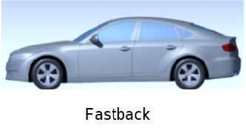 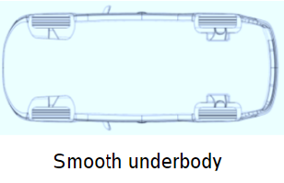

**Figure-1**

The model will be simulated using the open source CFD solver OpenFoam without the ground effect. The model is 2.5 scale down of the actual car model, Figure 2 shows the size of the model and the wind tunnel which will be replicated in our simulation.

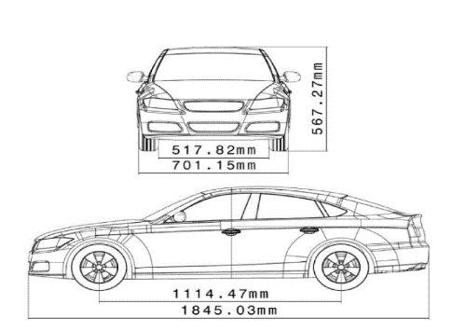 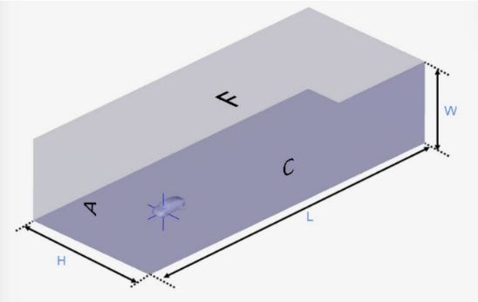

**Figure 2: Size of the model and wind tunnel**



Dimensions of the wind tunnel are:

* Length(L): 48m
* Width(W): 20m
* Height(H): 12m

We are going to calculate the Pressure Coefficient (Cp) and Drag Coefficient (Cd) and compare to the Previously known values.

The following conditions were set for the simulation:

* Air flow velocity in x-direction (v): 40m/s
* Density of air (ρ): 1.293kg/
* Reynolds Number (Re):

**Governing Equations**

To simulate the incompressible flow around our model, Navier-Stokes Equation will be used. The form of the equations depends on the assumptions made:

1. Continuity Equations:

For an incompressible flow:

**,**

Thus**,**

1. N-S Equation:

X-Direction component:

Y-Direction Component:

X-Direction Component:

* Some useful equation which will be used during the post processing of the data are:

1. , Drag Coefficient equation where;

= Velocity of air stream

= Drag Force, A = Projected area

1. , Pressure Coefficient equation where;

* **Mesh Generation**

Mesh generation is the creation of a volume net describing the vehicle and the domain. The key properties of the mesh is cell type, surface cell size, cell growth in the volume, refinement boxes in the volume, and domain size. Common for both the steady and unsteady simulation is the cell type and domain size. Hexahedral cells are used in both procedures for their robustness and ease of control when adjusting cell growth rates in the volume.

For the model we first used the blockMesh to generate and overall mesh for the car and the simulated control volume. This blockMeshing just creates an overview and not a very refined Mesh. The main job of the blockMesh is to set the boundaries inside the which all the calculations will take place.

After the generation of blockMesh we will use the snappyHexMesh to refine our meshing by splitting the blockMesh into millions of small hexagons. By doing this we are approaching towards the more accurate result. The more the number of cells in our mesh the more accurate the result.

But it’s not that easy to get a very well-defined refined mesh, as it requires a lot of Computational Power from the system in addition to the large amount of time required to refine the mesh.

We can see the difference between the blockMesh and snappyHexMesh in the Figure 3 and 4

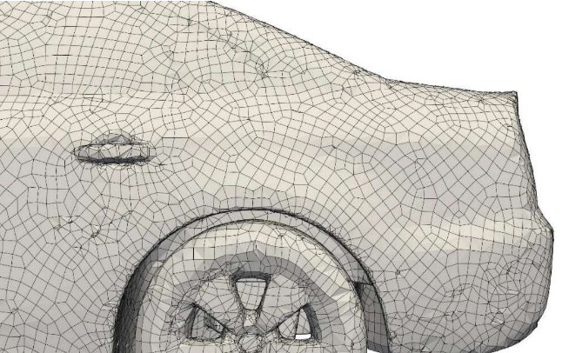

**Figure-3: model after blockMesh**

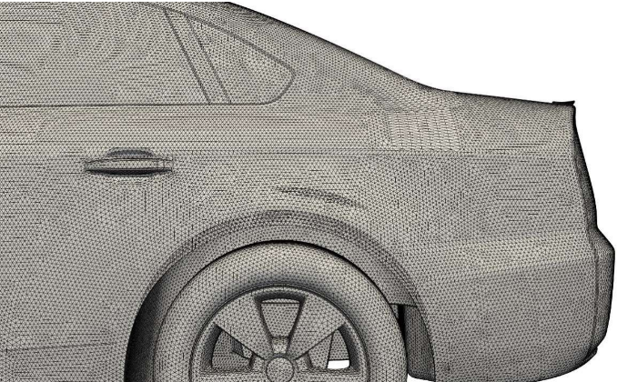

**Figure-4: Model after snappyHexMesh refinement**

**Solver**

After successfully generating the mesh for the system we will now use different solvers to simulate the model and conditions and get the desired results and outputs.

In this case we are going to use the potentialFoam and simpleFoam solver to solve for the model and also we are going to use the RANS turbulency model.

Before we move ahead let us discuss what is RANS turbulency model,

It is a numerical method to calculate the turbulent flow of a fluid (air in our case around the car), herein the flow quantities are decomposed into their time-averaged and fluctuating models.

potentialFoam is a potential flow solver which solves for the velocity potential (i.e. Phi) to calculate the volumetric face-flux field (i.e. phi) from which the velocity field (i.e. U) is obtained by reconstructing the flux.

SimpleFoam is a steady-state solver for incompressible, turbulent flow, using the SIMPLE (Semi-Implicit Method for Pressure Linked Equations) algorithm. In the newer releases it also includes an option to use the SIMPLEC (Semi-Implicit Method for Pressure Linked Equations Consistent) algorithm.

The solver will take the maximum amount of time during the whole simulation run. The approximate time for the simulation of the 45-50 minutes. After the running of simulation is done we will get the below flow pattern of the model following the RANS model (check Figure-5)

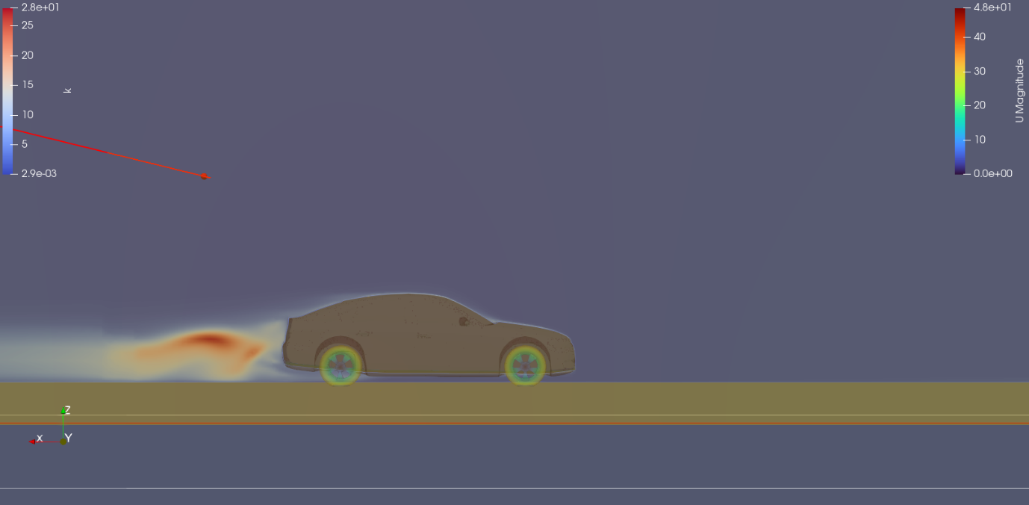

**Figure-5: Flow of air with the wake behind the car**

**Post Processing**

Now since we have completed our simulation it’s time to analyse the results and obtain the value for and .

In CFD the most important step is the post-processing, for doing this we will take the help of ParaView software. ParaView runs the simulation through an animated window and gives the simulation result in the form of animated colour videos. Let’s say if we talk about the wake of air behind the car in a 3D perspective then ParaView will give us the contour form of the air flow as shown in Figure-6.

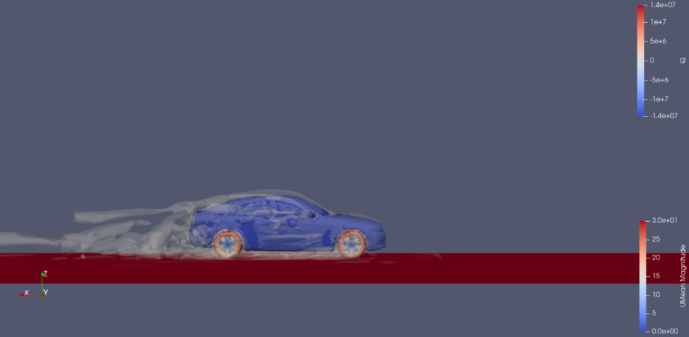

**Figure-6: Turbulent wake behind the car**

**Velocity Tracer in ParaView**

In the below figures we can see how ParaView helps in understanding the air tracer around the car at different values of y-coordinate of the system.

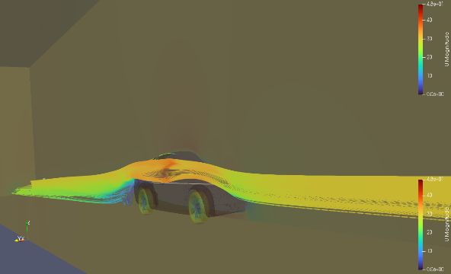 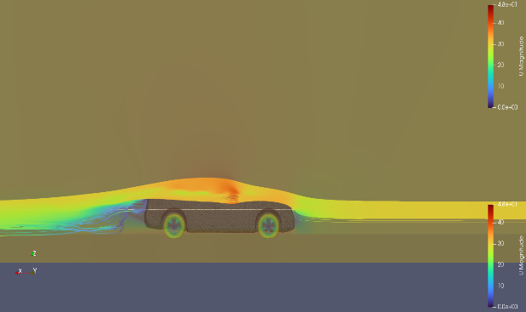

Figure-7: Velocity at y=0 Figure-8: Velocity at y=.2

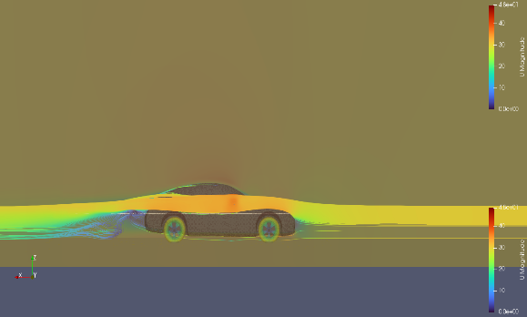 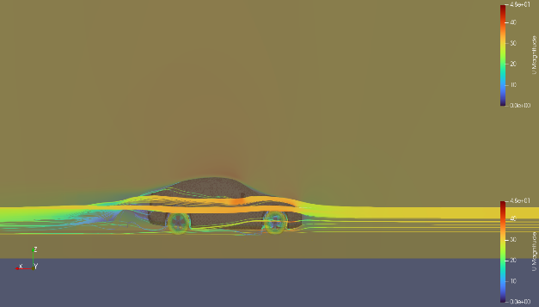

Figure-9: Velocity at y=.4 Figure-10: Velocity at y=.6

The above figures show how the velocity tracer i.e. how the air speed varies around the car for different regions or parts of the car.

The front Fenders, side mirrors and wheels also cause the air flow to split into different parts and also increase or decrease the air speed around that region of the car. By this we can analyse which part is producing excess drag in the car and causing the car to be less efficient.

**Results and Discussions**

**Analysing the pressure gradient of the model:**

We will now look at the pressure change along the surface of the car and calculate accordingly.

For the normal pressure of our model the result that we got for the surface of the car at y=.5 that is at the centre of our model is shown below:

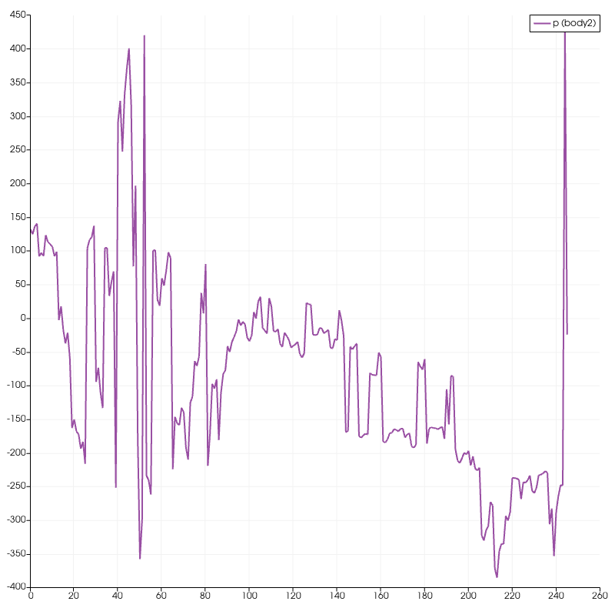

**Figure-11: Normal Pressure Curve of the car**

We can analyse that as we move ahead along the body of our car model the Normal Pressure keeps fluctuating for different parts of the car. At the front as the air strikes the front grill and the windshield normally therefore the pressure is observed to be max at the start and then keeps on dipping down until we reach the very end of the model.

In the end we are able to see a sudden spike in the pressure this is because of the High turbulent region which is formed at the end and also the emission coming out from the car, all these combined create a very high pressure zone at the back our model.

In the figure given below how the Normal Pressure varies along the whole body of the car with help of a heat map diagram of the car

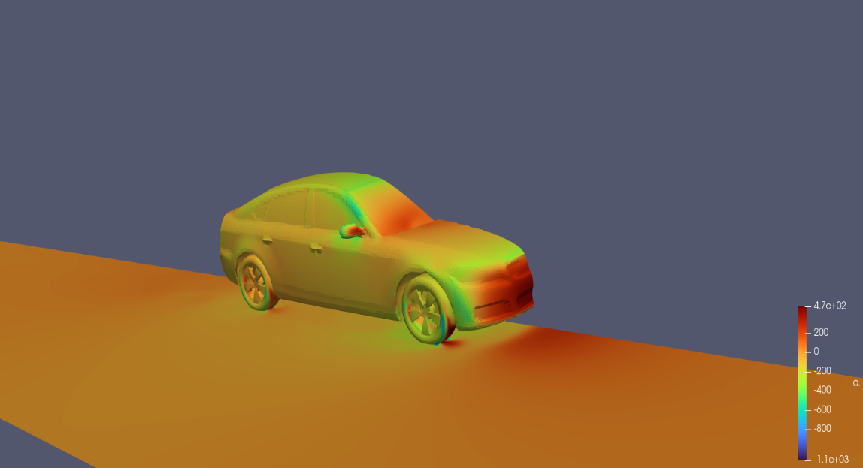

**Figure-12: Normal Pressure heat map**

Form the above graph we can calculate the by using the formula:

Here we will take to be the pressure at some infinite distance and it will be 0. The values of all other variables are already discussed above. After doing the calculations we will get the graph for as shown below:

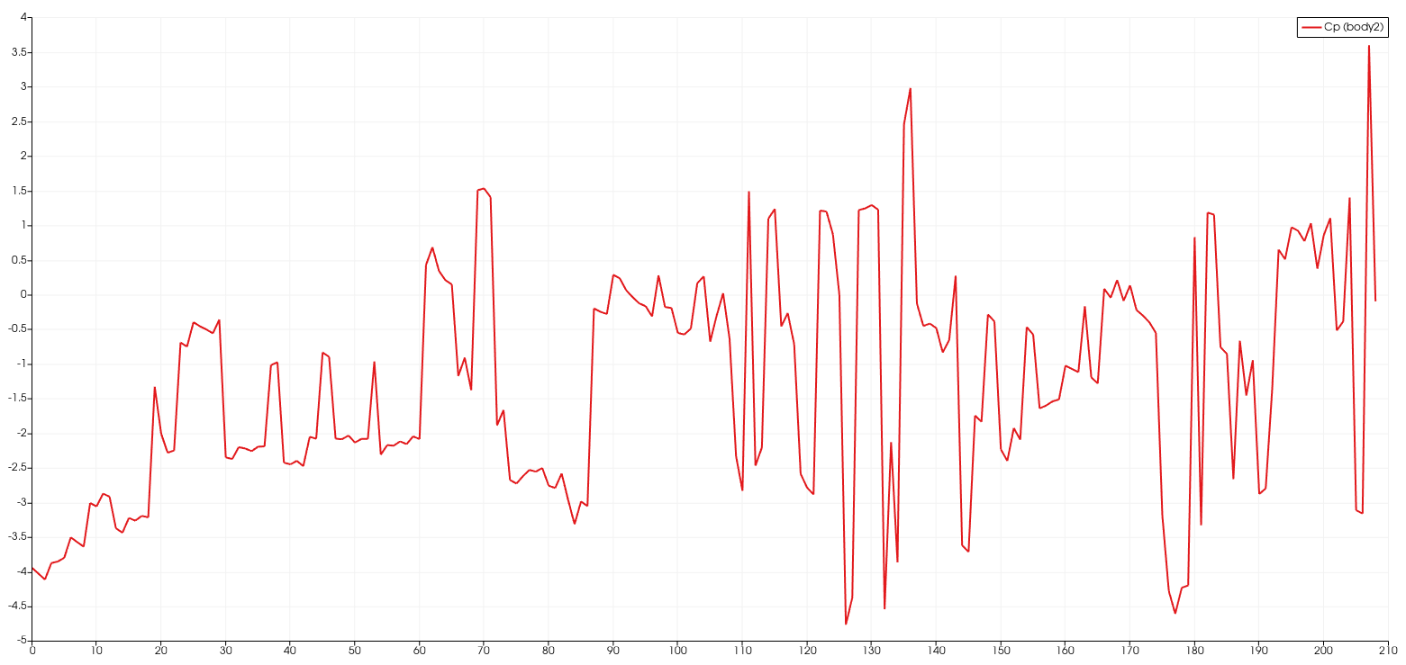

**Figure-13: values for the model**

**Analysing the Drag Coefficient for the model:**

Drag is one of the most important factors when it comes to designing a car let alone be any other moving object. Drag is a force that opposes the motion of an object through a fluid, such as air or water. It arises due to the interaction between the object and the fluid, and it can be caused by various factors, such as the shape, size, and speed of the object, as well as the properties of the fluid.

The drag coefficient is a dimensionless quantity that is used to characterize the amount of drag that a particular object experiences when moving through a fluid. It is a function of various factors, such as the object's shape, size, and speed, as well as the properties of the fluid, such as its viscosity and density.

The drag coefficient is defined as the ratio of the drag force on an object to the product of the fluid density, the object's reference area, and the square of the fluid velocity. In other words, it is the ratio of the drag force to the force that would be exerted on the object if it were moving through the fluid at a certain reference velocity.

When an object moves through a fluid, it causes the fluid to flow around it, creating areas of high and low pressure. The pressure difference creates a force that acts in the opposite direction to the object's motion, which is known as drag. As we have already calculated the pressure gradient across the surface of the model we now only have to calculate the force it will be exerting on the car.

For calculating the drag coefficient we are going to use the following equation:

Here first we have to calculate the projected area () of the car in the direction of the motion of our fluid (here in this case air). To calculate the projected we will use the given dimensions of the model as shown in figure below

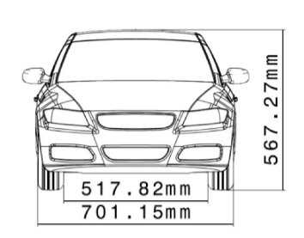

**Figure-14: Front dimensions of the model**

Therefore, the area of the car will be = .70115m X .56727m

= .3977

**Calculating :**

We will calculate the Drag Force by taking the Normal Component of the Air pressure at each and every point of the car in the Paraview as shown below:

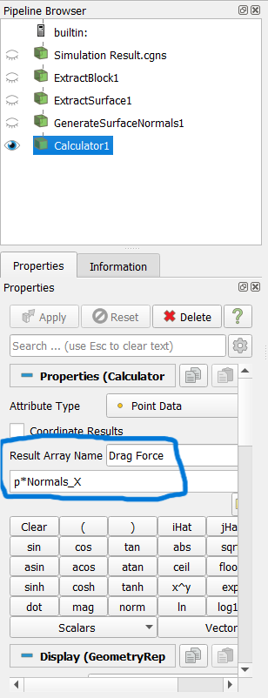

**Figure-15: Calculation of Fx**

When integrating the Drag Force for the whole body we get the value of Drag Force as = 119.972 N

Putting the values in the equation we get the value:

calculated = .291

experimental = .275

Error % =

= = 105.8181

Therefore, error in calculation = +5.8181%

The Error in our calculation tells us that the drag force experienced by our model will be approximately 5.8181% more than the actual real world design.

The calculated curve will come out to be something as shown below:

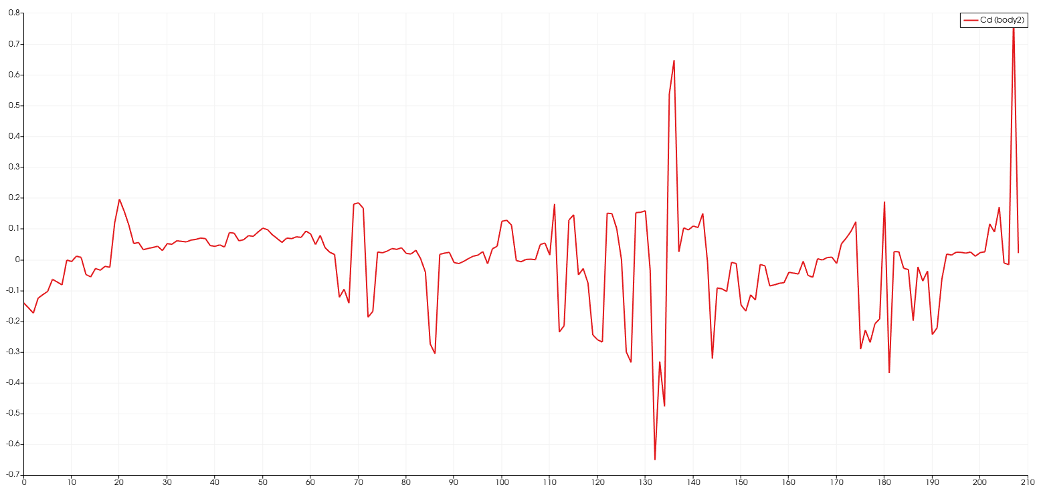

**Figure-16:**  Curve for the model

From the calculated values we can find out how the car model will behave when it is put on road and what all features it will show that is its performance, drag, efficiency etc.

**Conclusion**

In our model since our drag coefficient is more than the actual experimental value therefore, we can say the following:

* The car will be draggier and will require more energy to move forward.
* The car will be less efficient than the required model.
* The fuel consumption will be higher than we must have estimated because of more energy requirements.
* The handling of the car will be poorer and the overall performance of the car will be reduced.
* The high turbulent region at the end of the car will cause the exhaust emission to get dispersed into the air rather quick.
* The more energy consumption the car will leave a larger Carbon Footprint on the eco-system.
* Also, by looking at the pressure gradient we can tell that the design of the front bumpers and the bonnets should be very strong as they will come under a large amount of pressure.

There are huge flow separation / recirculation zones on the back-side of the models. In order to capture the flow features more accurately, we need to refine the grid in these zones. Since the flow features in these zones keep on changing with respect to time, current steady state simulations may not mimic the exact flow situation. Unsteady state flow simulations with region-wise refined grid and with more stringent convergence criterions may give more insights.

**References**

* <https://www.researchgate.net/publication/258841080_Numerical_Investigations_of_the_DrivAer_Car_Model_using_Opensource_CFD_Solver_OpenFOAM>
* <https://theansweris27.com/drivaer-fastback-vs-estate-back-aerodynamics/>
* <https://www.wevolver.com/article/how-simulation-is-used-in-automotive-design-to-decarbonize-the-industry>
* <https://resources.system-analysis.cadence.com/blog/msa2021-the-reynolds-averaged-navier-stokes-rans-equations-and-models>
* <https://www.epc.ed.tum.de/en/aer/research-groups/automotive/drivaer/>
* <https://cfdflowengineering.com/cfd-modelling-of-vehicle-aerodynamics/>
* <https://www.aerotak.dk/en/automotive>
* <https://www.simscale.com/docs/validation-cases/validation-case-drivaer-model/>
* <https://www.beta-cae.com/events/c6pdf/3B_2_Fotiadis.pdf>
* <https://www.researchgate.net/profile/Neil-Ashton-3/publication/276026640_Comparison_of_RANS_and_DES_Methods_for_the_DrivAer_Automotive_Body/links/5a19b91da6fdcc50adeae739/Comparison-of-RANS-and-DES-Methods-for-the-DrivAer-Automotive-Body.pdf>
* Heft, A.I.; Indinger, T.; Adams, N.A. Introduction of a new realistic generic car model for aerodynamic
* investigations. SAE Technol. Pap. 2012,
* <https://www.simscale.com/docs/simwiki/cfd-computational-fluid-dynamics/what-is-cfd-computational-fluid-dynamics/>
* <https://upcommons.upc.edu/bitstream/handle/2117/125379/drivaer-postprint.pdf;jsessionid=1F274E8545C1DD215282EDBA679C252C?sequence=1>
* <https://arxiv.org/ftp/arxiv/papers/2108/2108.05798.pdf>
* <https://cfdflowengineering.com/cfd-modelling-of-vehicle-aerodynamics/>
* <https://www.researchgate.net/publication/258841080_Numerical_Investigations_of_the_DrivAer_Car_Model_using_Opensource_CFD_Solver_OpenFOAM>
* <https://dspace.lib.cranfield.ac.uk/bitstream/handle/1826/12160/Complete_body_aerodynamic_study_of_three_vehicles-2017(1).pdf;jsessionid=F875ADB87E4D94A74DFD1DA2FCCA1B30?sequence=3>
* OpenFoam User Guide