|  |  |  |
| --- | --- | --- |
| **Guide Name** | | **Panel Head** |
|  | Dr. A. Arulmurugan | Dr. S, Godfrey Winster |
|  |  |  |
|  | **Faculty Advisor** | **Project Domain** |
|  | Dr. A. Arulmurugan | Research |
| M |  |  |
|  | **Student(s) Details: Name** | **Passport size photo(s)** |
|  | 1. Ritvik Kumar Singh 2. Tanya Singh |  |
|  |  |  |

**Registration Number(s)**

**1.** RA2011003010228

**2.** RA2011003010231

**Email ID(s)&Mobile Number(s)**

|  |  |
| --- | --- |
| [rs5051@srmist.edu.in](mailto:rs5051@srmist.edu.in) | [ts7307@srmist.edu.in](mailto:ts7307@srmist.edu.in) |
| 7651831179 | 9608373612 |

**Abstract Architecture Diagram**

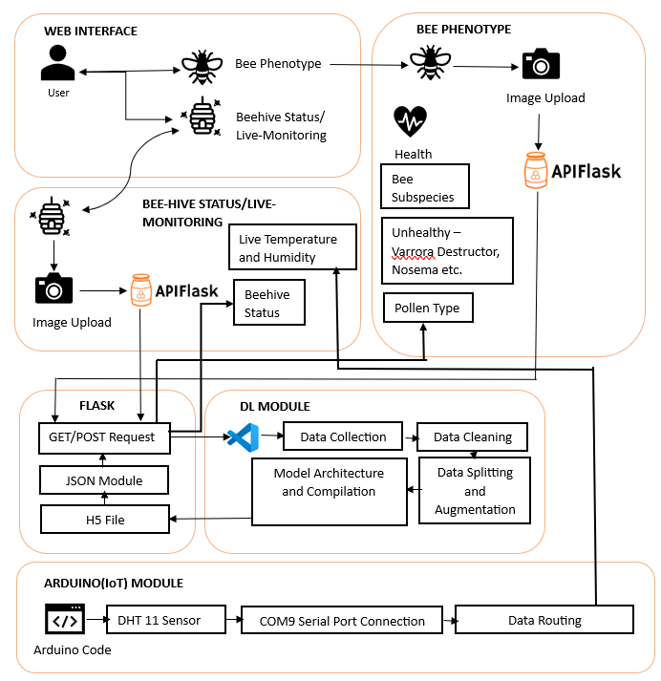

This project features image recognition technology for individual bee health, subspecies identification, and pollen type prediction along with beehive assessment with live monitoring and develop user-friendly interface with distinct webpages for bee and beehive analyses along with real time monitoring and real-time analysis and instant feedback through integration of deep learning .It empower beekeepers with tools for informed decision-making in hive management and contribute to bee conservation efforts, fostering biodiversity and meeting Sustainable Development Goals. Addressing the imminent threat of CCD to pollination services and agricultural ecosystems and enable beekeepers to monitor and manage the hive. Develop and compare various models for image recognition and analysis as well as temperature and humidity detection.

**Significance of the Project Conclusion**

This aim and significance of the project is to develop an innovative web-based platform addressing various bee parameters and performing analysis on beehive and employ image recognition analysis and deep learning using various models for precise predictions and is purposed to tackle the critical issue of Colony Collapse Disorder (CCD) in the Indian beekeeping sector and bring into spectrum, the Indian ecological flora and fauna and help in conservation of indigenous bee species for sustainability. Furthermore this project uses IoT in order to perform live time monitoring using Arduino and DHT sensors.

This project is a comprehensive bee health assessment project stands as a pioneering force in bee conservation, seamlessly integrating advanced technologies such as image analysis and IoT sensors, by providing beekeepers, researchers, and stakeholders with a powerful tool for individual bee health monitoring, beehive analysis, and real-time environmental data, and further aim to transform the landscape of sustainable beekeeping. With a commitment to data-driven decision-making, environmental stewardship, and global awareness, our project aspires to play a pivotal role in securing the well-being of bees, ensuring resilient ecosystems, and contributing to the future of sustainable agriculture.

**Conference/Journal Publication Details (Mandatory)**

Under Process