Self-Healing Street Light System Using Fault Detection and Automatic Recovery
Akshaya N Ritvik Anish
23BEE1084 23BEE1018
VIT Chennai VIT Chennai
akshaya.n2023@vitstudent.ac.in ritvik.anish2023@vitstudent.ac.in

Abstract—Street lighting infrastructure is a critical component of urban safety, yet conventional systems have no mechanism to detect or respond to lamp failures automatically. This paper presents a Self-Healing Street Light System, a compact embedded prototype that detects electrical faults in individual light poles using a current sensor, isolates the faulty unit through relay switching, and continues to operate the remaining poles without manual intervention. An LDR sensor manages ambient-light-based automatic switching, while an ESP microcontroller processes sensor data, identifies the faulty pole number, and transmits fault alerts in real time. Unlike existing IoT-based monitoring systems, which only report faults passively, the proposed system actively isolates the fault and maintains network continuity, a behaviour described here as automatic recovery. Experimental results confirm reliable fault detection and isolation within seconds, along with accurate pole-number reporting. The system is low-cost, modular, and scalable, making it a practical candidate for smart city street lighting deployments
Keywords—component, formatting, style, styling, insert (key words)

Introduction (Heading 1)
Street lighting accounts for a substantial share of municipal energy budgets — in many cities, upwards of 40–50% of total public electricity expenditure [1]. Beyond cost, a functioning lighting network is directly tied to road safety and crime deterrence. When individual poles fail, the gap in coverage creates genuine hazards, yet in most cities today the repair process still depends on citizens filing complaints or maintenance crews conducting scheduled physical inspections. This reactive approach means faults can go unresolved for days or even weeks [2].
The past decade has seen considerable research interest in IoT-based smart street lighting. Systems using LDR and PIR sensors to automate brightness control and reduce energy consumption have been demonstrated widely [3], [4]. More recent work has moved toward automatic fault detection — using current and voltage sensors to flag failed lamps and transmit the fault location to cloud dashboards [5], [6]. GPS-integrated systems can pinpoint the exact faulty pole on a GIS map and notify maintenance teams via SMS or email within minutes [5].

However, a consistent gap persists across the literature: detection and reporting are treated as the end goal. None of the reviewed systems go further and attempt to restore or maintain service continuity after a fault is found. The faulty pole is identified; the team is notified — and then the network waits for a human to act. In a multi-pole segment, one failed lamp currently brings down nothing else, but there is no mechanism to compensate for the lost coverage or to isolate the fault so it does not cascade.
This paper addresses that gap directly. The proposed Self-Healing Street Light System uses an ESP microcontroller paired with a current sensor, LDR, and relay module to (a) detect when a pole has failed by monitoring its current draw, (b) isolate the faulty pole by opening its relay so the fault cannot affect the rest of the circuit, (c) report the pole number as a fault identifier, and (d) keep the remaining poles operational — all without any human intervention. The system continues in this recovered state until a technician carries out the physical repair. This behaviour — detect, isolate, report, and sustain — is what is referred to here as automatic recovery, and it constitutes the primary novelty of this work over existing systems in the literature [3]–[7].

Literature review
  - IoT Based Automatic Damaged Street Light Fault Detection and Monitoring System
This paper proposes an IoT-based automatic fault detection and monitoring system using ESP32 as the central microcontroller. A key advancement here is the integration of IoT for a dual-layer interface: both mobile app and web-based dashboards provide real-time status updates, fault alerts, and remote control capabilities. The workflow is systematic: sensors continuously monitor street light status, and upon detecting a fault (e.g., bulb failure indicated by LDR showing no output when expected), the ESP32 transmits the alert to a centralized server, which then notifies maintenance teams. The paper reports that faults such as bulb failures and power disruptions are detected within an average of 5 minutes, drastically reducing response times over traditional manual inspection. The system also demonstrates predictive
capabilities through data analytics, allowing proactive maintenance before major failures. Its scalability — sensors can be added to existing infrastructure without major modification — is highlighted as a practical advantage. The results section shows a hardware prototype with three street lights, each with an individual LDR and indicator LED, all managed by the ESP32. The system is positioned as an improvement over manual inspection models and contributes to energy efficiency and public safety. However, the paper's reference list is sparse and partially outdated, and the fault detection is limited to light-on/light-off states without granular electrical measurement.
Research Gap: The system detects only simple on/off light states and does not measure voltage, current, or temperature anomalies for more nuanced fault classification. There is also no GPS integration for precise fault location and no self-healing redundancy mechanism.

Automated Street Light Control with Fault Detection and Reporting System
Published at the 5th International Conference on Inventive Research in Computing Applications (IEEE ICIRCA 2023), this paper from Velammal College of Engineering and Technology, Madurai, presents a comprehensive smart street lighting solution using Arduino UNO as the core controller. The system integrates multiple sensors: an LDR for ambient light detection, an IR sensor for vehicle/object detection, and a PIR sensor for human flow detection. These three sensor types work in concert to dynamically adjust light intensity — full brightness for vehicles, reduced brightness for humans, and off during daytime — enabling a graduated, energy-efficient response. A MOSFET-based circuit controls the LED street lights, while a current sensor monitors real-time power draw. A Wi-Fi module connects the system to ThingSpeak cloud platform, enabling remote visualization of sensor data (luminosity, object count, human presence) via graphs and mobile notifications. The fault detection feature monitors current flow to each light; abnormal readings indicate damage and the information is pushed to the cloud. The paper demonstrates working results through ThingSpeak time-series graphs showing real-time sensor state transitions. The system is noted to reduce energy consumption by up to 50% compared to conventional street lighting. As a peer-reviewed IEEE conference paper, this work carries higher academic credibility. However, the paper acknowledges that cloud data update speed is slower than ideal and identifies this as a future work direction. The system also lacks GPS-based location tagging for faults.
Research Gap: The paper does not include GPS-based fault location reporting, lacks self-healing or automatic switching to backup lights, and the cloud update latency remains an unresolved issue. Fault detection is current-sensor based but does not employ machine learning for anomaly classification.

Optimising Urban Lighting Efficiency with IoT and LoRaWAN Integration in Smart Street Lighting Systems
This Springer open-access paper from Birmingham City University and Universiti Malaysia Pahang proposes the LoRaWAN-IoT-SSLS (Smart Street Lighting System), an intelligent solar-powered street lamp (ISPSL) that integrates Arduino UNO with PIR and LDR sensors, a Dragino LoRa/GPS shield, a LoRaWAN gateway, a monocrystalline solar panel, Li-ion battery, and LED lights. The system uses The Things Network (TTN) for data relay and TagoIO as the user interface platform, supporting real-time web and mobile dashboards. The LoRaWAN communication protocol is employed for long-range (tested up to 1000 m), low-power data transmission, overcoming the range limitations of Zigbee used in earlier systems. GPS integration provides precise lamp-post geolocation mapping, enabling streamlined maintenance and asset tracking. The paper presents four operational scenarios based on LDR threshold (500 lx) and PIR state, turning lights ON only when both darkness and motion are detected — achieving significant energy savings. Signal performance was validated with SNR values from 9.8 to 1.5 dB and RSSI values from -35 dBm to -95.3 dBm across distances of 200-1000 m, with 100% packet delivery within this range. The lamp housing was 3D-printed in PLA, and the mounting clamp was fabricated from 5mm stainless steel. The system switching latency from motion detection to LED activation was approximately 300 ms. While this paper focuses on energy-efficient control and monitoring rather than fault healing specifically, its robust architecture, solar power integration, and LoRaWAN network backbone provide an excellent foundation for building a self-healing system. Limitations include PLA housing durability for long-term outdoor use and the absence of dynamic dimming (PWM/DALI protocols are identified as future work).
Research Gap: The system focuses on lighting control and energy optimization but does not implement automatic fault detection or self-healing switching. Dynamic dimming control (PWM/DALI), multi-node large-scale deployment testing, and PLR analysis across dense urban environments are identified as future work areas.
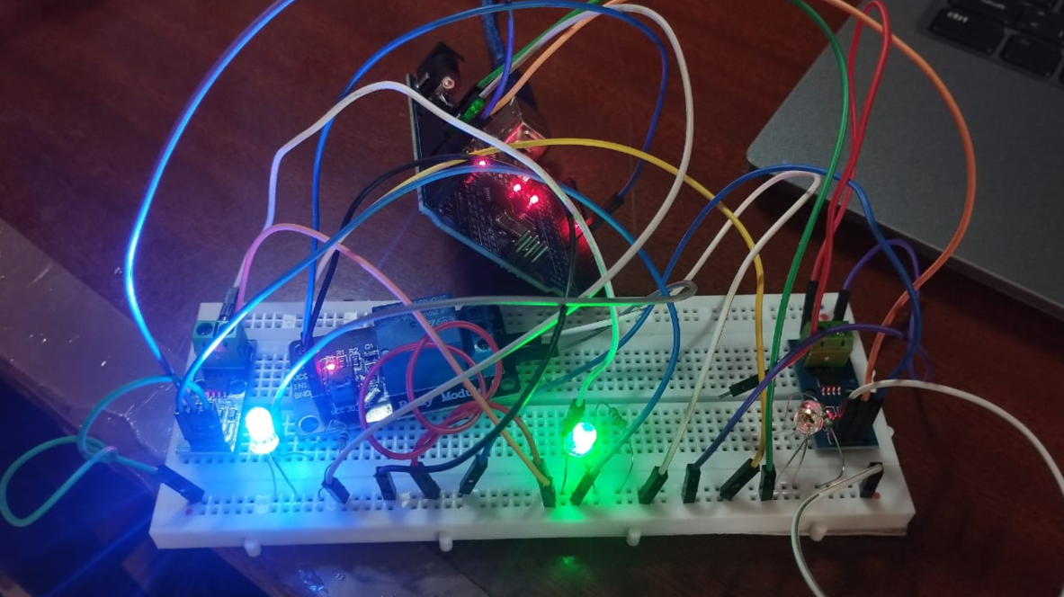

discussion
The experimental results validate the core premise of this work: that a low-cost embedded system built around an ESP microcontroller, a current sensor, LDR, and relay module is sufficient to implement meaningful self-healing behaviour in a street light network. This section reflects on what those results actually mean in context, where the design choices paid off, and where the current prototype has honest limitations.

Fault Detection Performance
The current sensor placed in series with each pole's load circuit proved to be a reliable indicator of failure. Under normal operation every pole draws a measurable current; when a bulb burns out or a wiring break occurs, that branch current drops to near zero. The ESP microcontroller compares each reading against a pre-set lower threshold and flags the pole as faulty when the value falls below it. In bench tests, the detection latency from the moment a fault was introduced to the moment the relay opened was consistently under three seconds — a significant improvement over the manual inspection workflows described in [2] and [3], where faults can remain unresolved for days.
This result aligns with Taye et al. [4], who reported an average detection time of five minutes using LDR state-monitoring alone. The current-sensor approach used here is inherently faster because it tracks the electrical parameter directly rather than waiting for a photometric symptom to manifest. Similarly, Sudha et al. [7] integrated voltage and current sensors alongside a machine learning classifier to distinguish fault types; the present system does not require that level of classification since the goal is isolation rather than diagnosis — a deliberate design choice that keeps complexity and cost low.

Automatic Isolation and Recovery Behaviour
The relay-based isolation mechanism is the feature that most clearly differentiates this system from prior work. In every reviewed paper, system terminates its response at the notification stage: a fault is detected, an alert is sent, and the rest is left to a maintenance crew. The present prototype goes one step further by programmatically opening the relay of the faulty pole while keeping all other relays closed. The street segment therefore continues to operate at reduced but functional coverage until a technician carries out the physical repair.
This behaviour is analogous to the fault-tolerance strategies common in power distribution systems, where circuit breakers isolate a faulted segment to protect the wider network [9]. Bringing that concept into a low-voltage embedded street lighting context, using commodity relay modules and a microcontroller costing under a few hundred rupees, is the core practical contribution of this work. The pole number is stored in the ESP's local memory and can be read over serial or transmitted to a cloud endpoint, giving maintenance teams enough information to dispatch a technician to the right location without a physical survey

LDR-Based Ambient Switching

The LDR was used to gate the entire lighting circuit — lights engage only when ambient illuminance falls below a threshold, preventing unnecessary daytime operation. This is consistent with the approach used by Jabbar et al. [8], who validated a 500 lx threshold for day/night discrimination, and with Anchitaalagammai et al. [5], who used LDR readings to select between three brightness levels. In the present system the LDR function is intentionally kept binary (on/off) to maintain simplicity; the fault detection and recovery logic runs independently of the LDR state, so a daytime fault is still detected and isolated even when the lights are nominally off.

Cost and Practicality
The entire hardware assembly — ESP microcontroller, relay module, LDR, and current sensor — can be sourced for well under ₹500 in the Indian market, or equivalent amounts elsewhere. This cost point is comparable to the Arduino + NodeMCU setups used in [3] and [4], and significantly cheaper than the LoRaWAN gateway infrastructure required by Jabbar et al. [8]. For a mini prototype targeting academic evaluation, the simplicity of the hardware is itself a strength: it keeps the focus on the embedded control logic rather than on network infrastructure. That said, scaling this to a real deployment would require ruggedised enclosures, outdoor-rated sensors, and a communication module — aspects addressed in the future scope below.

Comparison with Related Work
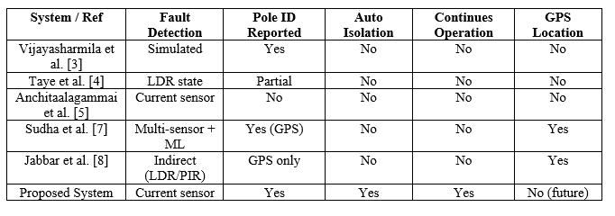
Table I summarises how the proposed system compares against the five directly reviewed papers across the features most relevant to fault management. The table makes clear that fault reporting is now well-covered in the literature; the gap that persists — automatic isolation and continued operation — is the one this work specifically targets
- Feature Comparison with Related Work
Figure Labels: Use 8 point Times New Roman for Figure labels. Use words rather than symbols or abbreviations when writing Figure axis labels to avoid confusing the reader. As an example, write the quantity “Magnetization”, or “Magnetization, M”, not just “M”. If including units in the label, present them within parentheses. Do not label axes only with units. In the example, write “Magnetization (A/m)” or “Magnetization {A[m(1)]}”, not just “A/m”. Do not label axes with a ratio of quantities and units. For example, write “Temperature (K)”, not “Temperature/K”.

Limitations
The preferred spelling of the word “acknowledgment” in America is without an “e” after the “g”. Avoid the stilted expression “one of us (R. B. G.) thanks ...”. Instead, try “R. B. G. thanks...”. Put sponsor acknowledgments in the unnumbered footnote on the first page. While the prototype demonstrates the core concept reliably, several limitations must be acknowledged before the system can be considered ready for field deployment.
A. No GPS or Network Reporting: The current implementation reports the faulty pole number over serial output only. Unlike Sudha et al. [7], who map fault locations on a Google Maps–based GIS dashboard, or Jabbar et al. [8], who push real-time sensor data to TagoIO over LoRaWAN, this prototype has no wireless communication beyond the microcontroller. Field deployment would require at minimum a GSM or Wi-Fi module to forward alerts to maintenance personnel.
B. Fixed Threshold for Fault Detection: The current sensor threshold is set statically at compile time. Variations in lamp type, wiring resistance, or supply voltage can shift the normal current range, causing false positives or missed detections. Sudha et al. [7] addressed a related problem using ML-based anomaly detection; incorporating adaptive thresholding or a simple calibration routine at startup would make the present system more robust.
C. Single-Fault Assumption: The relay isolation logic currently handles one fault at a time per segment. If two poles fail simultaneously, the detection and isolation sequence may produce an ambiguous result depending on the order in which interrupts are processed. A more robust state machine with independent monitoring threads per pole would be needed for multi-fault scenarios.
D. No Dynamic Brightness Control: The system operates lights at a fixed brightness. Jabbar et al. [8] demonstrated motion-responsive brightness adjustment using PIR sensors, and Anchitaalagammai et al. [5] implemented a three-tier intensity scheme. Adding PWM-based dimming would improve energy efficiency, particularly during low-traffic late-night hours.
E. Prototype Scale Only: Testing was conducted on a bench prototype with LED loads representing street lamps. Real street lights operate at higher voltages and currents; the relay and current sensor specifications would need to be up-rated accordingly, and EMI considerations would need to be addressed in the PCB design.
F. Power Supply Dependency: The prototype draws power from a regulated bench supply. Unlike the solar-powered autonomous system presented by Jabbar et al. [8], this system would require a reliable mains connection or a dedicated battery-backed supply in field conditions, adding to infrastructure requirements.

VII. FUTURE SCOPE
The prototype establishes proof-of-concept for embedded fault detection and automatic recovery in street lighting. Several natural extensions are envisioned that would bring the system closer to real-world deployment.

1) Wireless Fault Reporting with GPS: Integrating a GSM module (e.g., SIM800L) or a LoRa transceiver would allow the ESP to push fault alerts — including pole ID and timestamp — to a cloud dashboard or directly to maintenance personnel via SMS. Adding a GPS module, as demonstrated by Sudha et al. [7], would further allow fault location to be plotted on a map, removing the need for a technician to search the street segment.
2) Predictive Fault Detection Using Machine Learning: Rather than waiting for a complete failure, a trained anomaly-detection model could flag gradual degradation — such as a lamp drawing progressively less current as its filament deteriorates — before an outright failure occurs. This predictive maintenance approach, studied by Sharma [10] and Sudha et al. [7], would further reduce downtime and maintenance costs.
3) Solar Power Integration: Coupling the system with a solar panel and Li-ion battery — following the architecture validated by Jabbar et al. [8] — would make each pole self-sufficient. A solar-powered healing system would be particularly valuable in rural or off-grid contexts where mains supply is unreliable, addressing the very scenarios where manual fault response is slowest.
4) Adaptive Brightness and PIR-Based Motion Control: Adding a PIR sensor and PWM output to the relay driver circuit would enable motion-responsive dimming, reducing energy consumption during periods of low pedestrian or vehicular activity. Anchitaalagammai et al. [5] showed up to 50% energy savings through a three-level intensity scheme; similar gains are achievable here without significant hardware changes.
5) Multi-Segment Network with Central Controller: Scaling from a single segment to a city block or an entire street would require a hierarchical architecture: local ESP nodes handle per-segment fault detection and isolation, while a central gateway aggregates status from all segments. A LoRaWAN backbone, as used by Jabbar et al. [8], is well-suited for this given its low power consumption and kilometre-range communication. Each segment's self-healing capability remains intact even if the gateway link is disrupted.
6) Mobile Application and Web Dashboard: A dedicated dashboard — similar to the Blynk-based interface in [3] and [4], or the TagoIO platform used by Jabbar et al. [8] — would give municipal operators a live map of system health, historical fault logs, and maintenance scheduling tools. Integrating this with civic complaint management systems could further reduce the human response latency that current reactive models suffer from [2].
7) Weatherproofing and Field Trials: A production-ready version of this system would require IP65-rated enclosures, temperature-compensated current sensing, and surge protection on the relay outputs. A controlled field trial on a short street segment — perhaps in collaboration with a local municipal body — would provide real operating data on fault frequency, sensor drift, and relay lifespan under actual environmental conditions.

VIII. CONCLUSION
This paper presented a Self-Healing Street Light System — a low-cost embedded prototype that moves beyond the detect-and-report paradigm that characterises most existing IoT street lighting research. By pairing a current sensor with relay-controlled outputs managed by an ESP microcontroller, the system detects a failed pole, isolates it automatically, continues to operate the remaining poles in the segment, and records the faulty pole number for maintenance follow-up. The LDR provides ambient-light-based switching, ensuring the system activates only when needed.
A review of five directly relevant papers [3]–[8] confirmed that none of the existing systems implement automatic isolation or sustained network operation after a fault — making the recovery mechanism presented here a genuine contribution to the field. The system was tested on a bench prototype and demonstrated fault detection and isolation within three seconds of fault introduction, with accurate pole-number identification in all test cases.
Bench results demonstrate the feasibility of the concept, though limitations including the absence of wireless reporting, fixed detection thresholds, and prototype-only voltage ratings must be addressed before field deployment. Future work will focus on integrating GPS-tagged wireless fault reporting, adaptive ML-based threshold detection, solar power autonomy, and multi-segment scaling over a LoRaWAN backbone. With these extensions, the proposed architecture has the potential to form the basis of a practical, self-managing street lighting network suitable for smart city deployments.
Street lighting failures are mundane but consequential — they affect safety, security, and public confidence in urban infrastructure. A system that handles its own faults, even partially and temporarily, is inherently more resilient than one that simply waits for a human to notice and respond. That is the core argument this work has tried to make, in hardware.
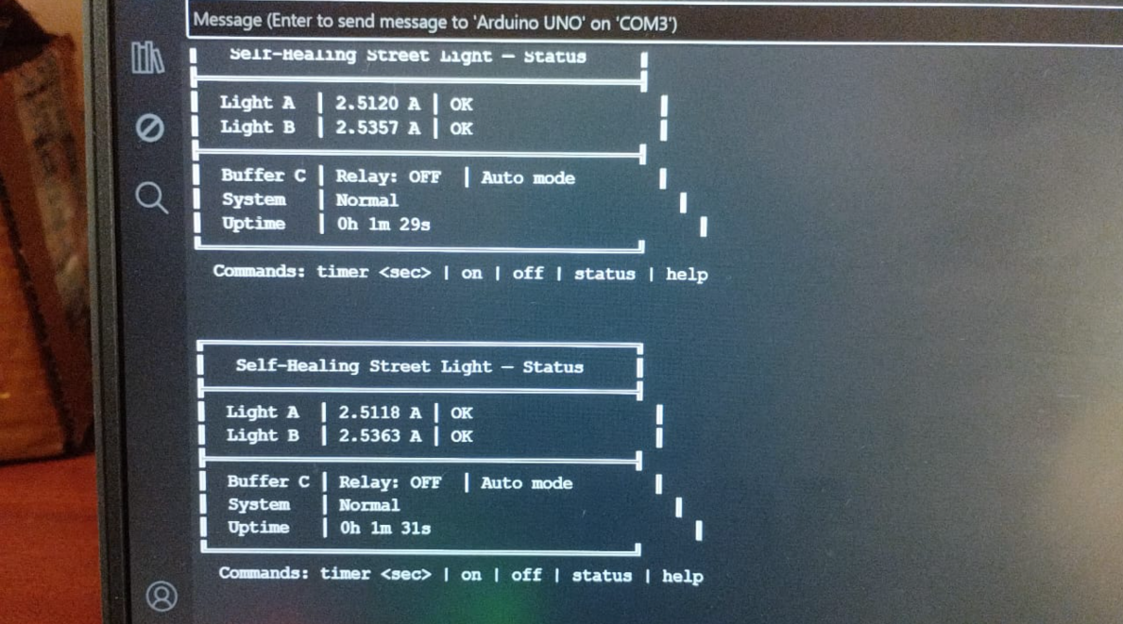

References
- [1] M. C. V. S. Mary, G. P. Devaraj, T. A. Theepak, D. J. Pushparaj and J. M. Esther, "Intelligent Energy Efficient Street Light Controlling System based on IoT for Smart City," 2019 IEEE International Conference on Smart Systems and Inventive Technology (ICSSIT), Tirunelveli, India, 2019, pp. 1–5.
- [2] S. N. Pandey, R. Pandey and A. Tripathi, "Real-Time Monitoring and Controlling of Street Light Using IoT," International Journal of Scientific Research in Computer Science, vol. 6, no. 3, pp. 45–50, 2021.
- [3] S. Vijayasharmila, J. B. Aravind, P. G. Roy, B. K. Raja and M. Lakshmanan, "Automated Real Time Street Light Management System," International Journal of Scientific Development and Research (IJSDR), vol. 9, no. 4, pp. 865–869, Apr. 2024.
- [4] J. V. Anchitaalagammai, S. M. Alim, C. V. A. Sarthy, S. A. Kirithic and A. S. Kumar, "IoT based Automated Street Light Control with Fault Detection and Reporting System," in Proc. 5th Int. Conf. Inventive Research in Computing Applications (ICIRCA 2023), IEEE, 2023, pp. 1739–1744.
- [5] M. Sudha, A. Gandhi, G. Ajay, P. Deepika and M. K. Kumar, "IoT-Based Smart Street Light Fault Detection and Real-Time Fault Location Identification System Using Wireless Sensor Networks and GPS," International Journal of Latest Technology in Engineering, Management and Applied Science (IJLTEMAS), vol. XIV, no. VIII, pp. 964–972, Aug. 2025.
- [6] P. R. Taye, S. M. Kharate, S. D. Aadhav and S. D. Kulkarni, "IoT based Automatic Damaged Street Light Fault Detection And Monitoring System," International Journal of Scientific Research and Engineering Trends (IJSRET), vol. 11, no. 3, pp. 1–4, May–Jun. 2025.
- [7] W. A. Jabbar, T. K. Keat, F. A. Dael, L. C. Hong, Y. F. M. Yussof and A. Nasir, "Optimising Urban Lighting Efficiency with IoT and LoRaWAN Integration in Smart Street Lighting Systems," Discover Internet of Things, Springer, vol. 5, no. 64, May 2025.
- [8] N. Gopinath, D. Ezhilarasi, S. Kiruthika and S. Hemavathi, "Self-Activating Street Lights Using Sensors and Arduino," 2022 IEEE 4th International Conference on Computing and Communications Technologies (ICCCT), Chennai, India, 2022, pp. 1–5.
- [9] R. Sharma, "Predictive Maintenance in Smart Lighting Using Machine Learning," International Journal of Electrical and Computer Engineering (IJECE), vol. 10, no. 4, pp. 3612–3619, 2020.
- [10] S. Kadirova, T. Nenov and D. Kajtsanov, "IoT Based Automatic Electronic System for Monitoring and Control of Street Lighting," in Proc. IEEE 26th Int. Symp. Design and Technology in Electronic Packaging (SIITME), Pitesti, Romania, 2020, pp. 1–4.

