Self-Healing Street Light System Using Fault Detection and Automatic Recovery

A PROJECT REPORT

Submitted in partial fulfillment of the requirements

For
BEEE213L-Embedded Systems Design

By
Akshaya N 23BEE1084
Ritvik Anish 23BEE1018

Under the guidance of
Sumathi. V,
Professor, SELECT


SCHOOL OF ELECTRICAL ENGINEERING
VIT CHENNAI
April 2026
Objective
1. Fault detection: A current sensor is used to detect a failed pole by monitoring the load current drop below a preset threshold
2. Automatic isolation: The faulty pole's relay is opened immediately after detection to prevent affecting the other poles.
3. Pole identification: The specific faulty pole is reported through the ESP and to the maintenance team.

Research Gap
The current IOT street lighting research handles energy efficiency and fault detection well. Systems in [3]-[8] use LDR, PIR, and current sensors to detect failures and push alerts to platforms like Blynk, ThinkSpeak and TagoIO. GPS-tagged fault maps are also demonstrated in [7] and [8]. But each system stops at notification. Once the alert is sent, the controller waits for the maintenance team to sort the issue.
This paper addresses the research gap in the following ways.
1. Relay isolation: The ESP opens the affected pole's relay electrically disconnecting the pole. This feature is absent in all the reviewed papers.
2. Recovery state: Remaining relays stay closed and the segment continues at reduced coverage.
3. Active post fault control: The ESP continues to monitor the healthy poles. The system is never idle between detection and repair.
4. Single board integration: As the whole system runs on one ESP with relay modules a current sensor, no secondary processor or cloud required.

Block Diagram

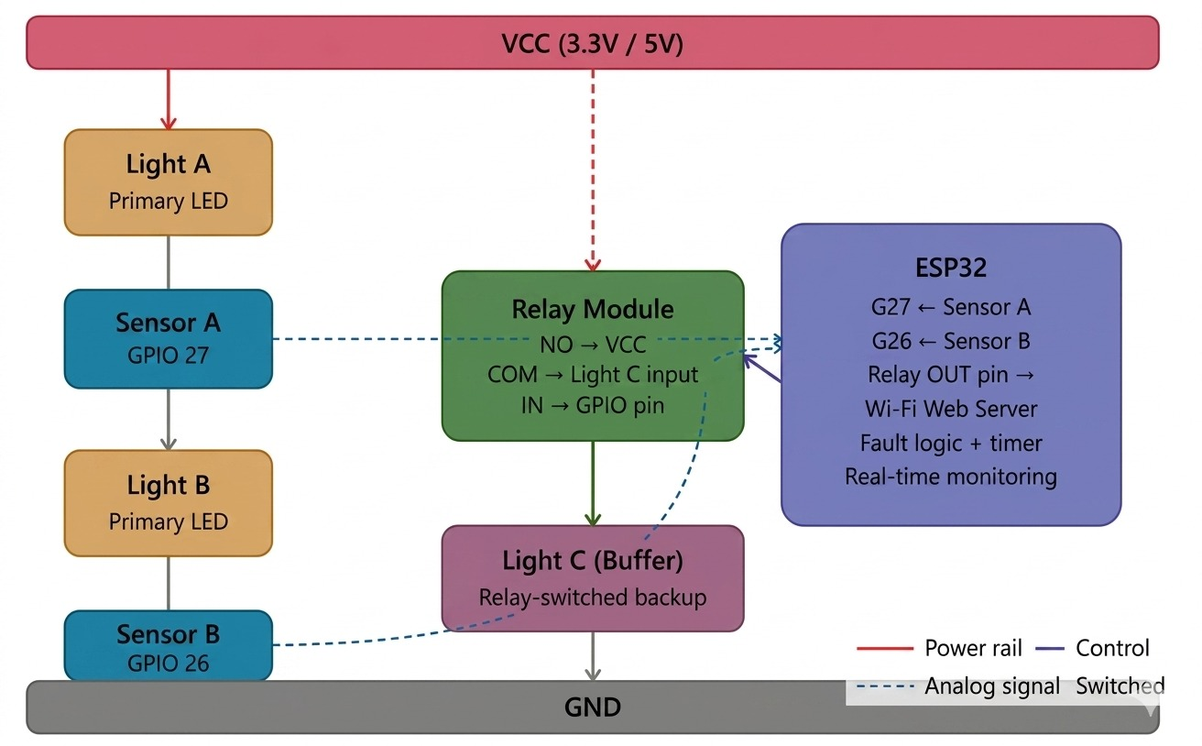
Fig.1: Block diagram of the proposed system
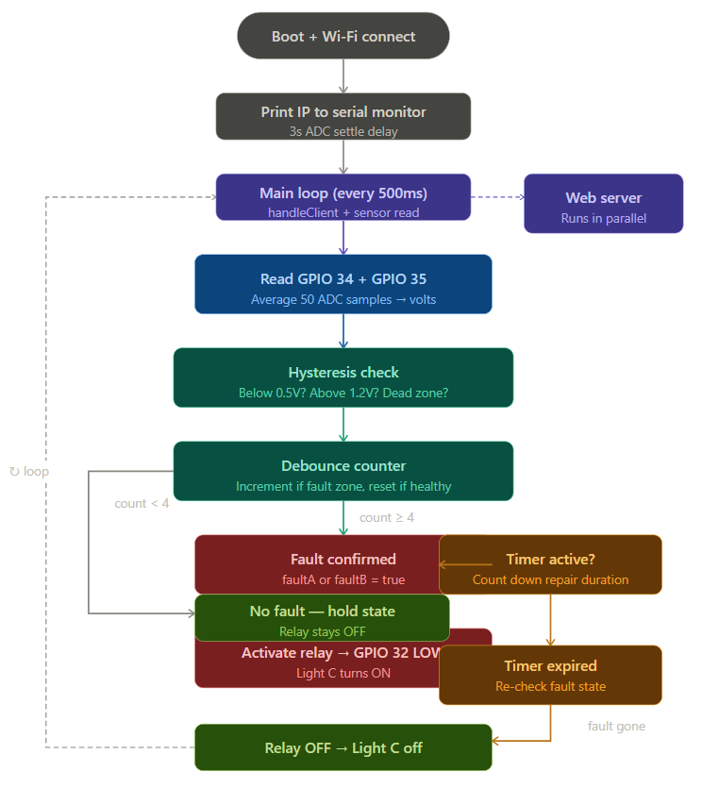
Fig.2: Block diagram of the proposed system

Circuit Diagram

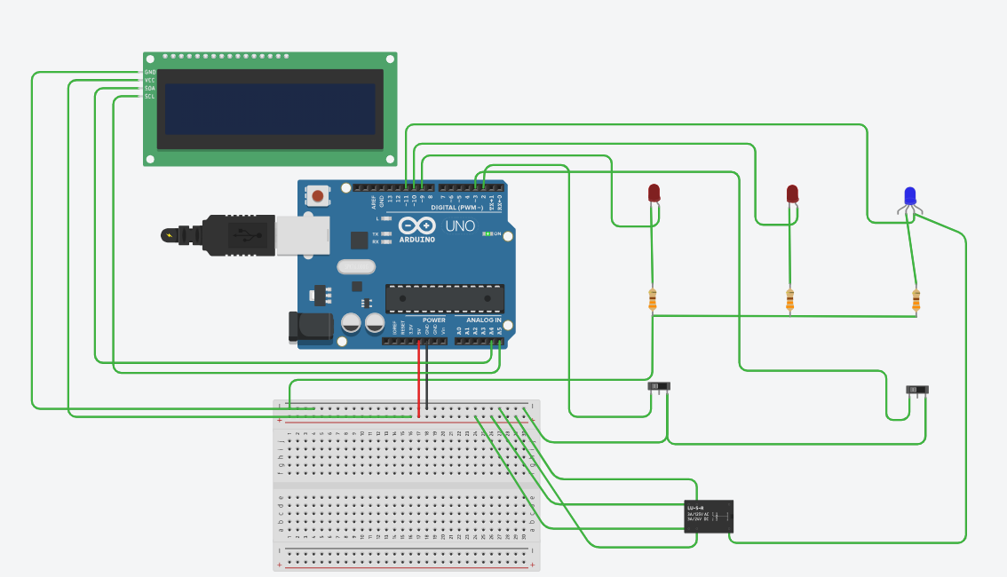
Fig.3: Circuit Diagram

Hardware Image

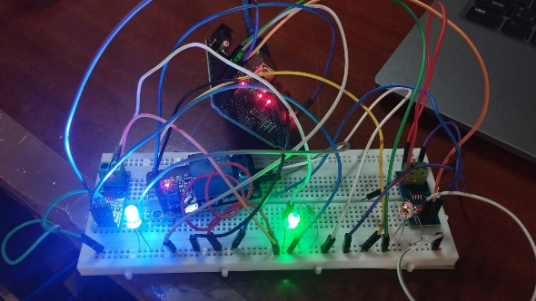
Fig.4: Hardware image of the proposed system

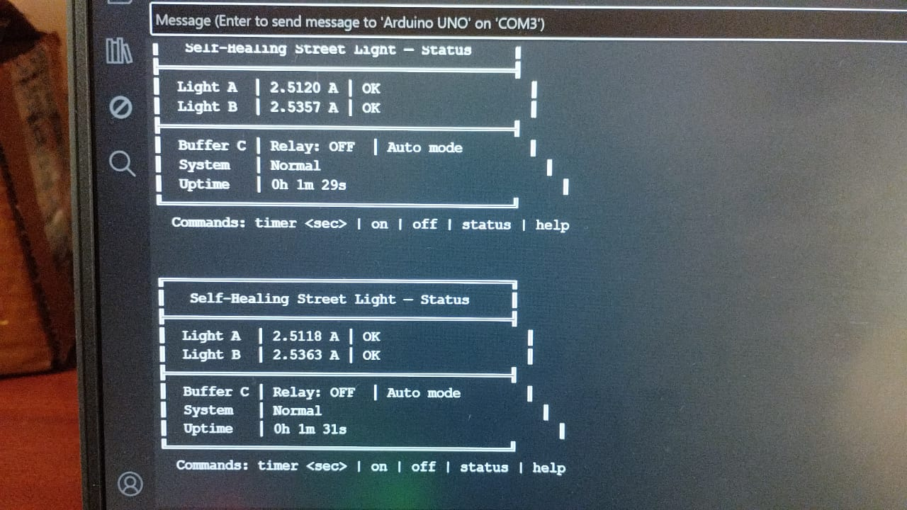
Fig.5: Serial Monitor Real-time Data

Results
The prototype was tested on a bench setup with two LED loads as poles each with its own relay channel. An ACS712 current sensor was connected in series per pole. The faults were introduced by connecting the load mid-operation. In the trails conducted, the relay opened exactly where the faults were introduced. Healthy poles operated without nay interruptions. All the objectives were met and was successfully implemented in the proposed system.

References
[1] C. Bhuvaneshwari, R. Rajeswari and C. Kalaiarasan, "Analysis of Solar Energy Based Street Light with Auto Tracking System," Int. J. Advanced Research in Electrical, Electronics and Instrumentation Engineering, vol. 2, no. 7, pp. 3217–3223, Jul. 2019.
[2] G. Praveen et al., "National Highway Street Light Faulty Detection & Monitoring System," JETIR, vol. 6, no. 4, pp. 421–426, Apr. 2019.
[3] S. Vijayasharmila et al., "Automated Real Time Street Light Management System," IJSDR, vol. 9, no. 4, pp. 865–869, Apr. 2024.
[4] P. R. Taye et al., "IoT Based Automatic Damaged Street Light Fault Detection and Monitoring System," IJSRET, vol. 11, no. 3, pp. 1–4, May–Jun. 2025.
[5] J. V. Anchitaalagammai et al., "IoT Based Automated Street Light Control with Fault Detection and Reporting System," in Proc. IEEE ICIRCA, Madurai, 2023, pp. 1739–1744.
[6] N. Gopinath et al., "Self-Activating Street Lights Using Sensors and Arduino," in Proc. IEEE ICCCT, Chennai, 2022, pp. 1–5.
[7] M. Sudha et al., "IoT-Based Smart Street Light Fault Detection and Real-Time Fault Location Identification Using WSN and GPS," IJLTEMAS, vol. XIV, no. VIII, pp. 964–972, Aug. 2025.
[8] W. A. Jabbar et al., "Optimising Urban Lighting Efficiency with IoT and LoRaWAN Integration in Smart Street Lighting Systems," Discover Internet of Things, Springer, vol. 5, art. 64, May 2025.
[9] A. von Jouanne and B. Banerjee, "Assessment of Voltage Unbalance," IEEE Trans. Power Delivery, vol. 16, no. 4, pp. 782–790, Oct. 2001.
[10] R. Sharma, "Predictive Maintenance in Smart Lighting Using Machine Learning," IJECE, vol. 10, no. 4, pp. 3612–3619, 2020.
[11] S. M. Sorif, D. Saha and P. Dutta, "Smart Street Light Management System with Automatic Brightness Adjustment Using Bolt IoT Platform," in Proc. IEEE IEMTRONICS, Toronto, 2021, pp. 1–5.
[12] M. Kumawat and A. Wadhwani, "Street Light Automation and Fault Monitoring System Using IoT," IJRTE, vol. 8, no. 3S, pp. 1–5, 2019.
[13] N. Gupta, A. Singh and R. Verma, "LoRa-Based Smart Street Light System for Real-Time Fault Detection," IEEE Sensors Journal, vol. 22, no. 8, pp. 7891–7899, Apr. 2022.
[14] S. Kadirova, T. Nenov and D. Kajtsanov, "IoT Based Automatic Electronic System for Monitoring and Control of Street Lighting," in Proc. IEEE SIITME, Pitesti, 2020, pp. 1–4.
[15] A. Nanduri et al., "IoT Based Automatic Damaged Street Light Fault Detection Management System," IJACSA, vol. 11, no. 8, 2020.

