Artificial Intelligence Based Noise Modulation Approaches for Modern Communication Systems
TEAM 9
Ritvik Anish (23BEE1018) Sanjh Yadav (23BEE1043) Sriram V (23BEE1110)

An Improved Ranking-Based Feature Enhancement Approach for Robust Speaker Recognition
The paper aims to address the critical issue of robustness degradation in automatic speaker recognition systems under noisy acoustic conditions. Specifically, it focuses on the challenge posed by additive noise, which non-linearly distorts feature sequences, thereby altering the relative positions of features that are crucial for effective feature warping. To overcome this, the study proposes an improved ranking-based feature enhancement method that leverages the robustness of ranking features—obtained by sorting feature sequences—to maintain the relative order of features even in noisy environments. The objectives include labelling frames as reliable or unreliable, estimating missing or corrupted ranking features via interpolation, and mapping these to warped features to improve recognition accuracy across diverse noise types.
Methodologically, the paper employs a combination of theoretical analysis and experimental validation. The approach involves extracting Mel-Frequency Cepstral Coefficients (MFCCs) as basic features, then applying a sliding window to generate ranking sequences by sorting the features. A mask estimation method based on local SNR classifies frames as reliable or unreliable. For unreliable frames, linear interpolation along the time axis estimates the ranking of the central frame, capitalizing on the higher autocorrelation and noise resilience of ranking sequences compared to raw features. The estimated ranking is then warped to match a standard normal distribution. The experiments utilize an open-set speaker recognition system based on Universal Background Model-Gaussian Mixture Model (UBM-GMM) trained on a speech database with artificially added noise from the NOISEX dataset (including babble, white, pink, factory2, and destroyer-engine noises). Performance metrics include recognition accuracy across varying signal-to-noise ratios (SNRs), comparing the proposed method with baseline MFCC, and feature warping, and missing data reconstruction methods.
Key findings demonstrate that the proposed ranking-based feature enhancement method consistently outperforms both the conventional feature warping and missing data methods across all tested noise types and SNR levels. The results indicate substantial improvements in recognition accuracy, with average gains ranging from approximately 3.6% to over 35% depending on the noise type and comparison baseline. The study highlights that the ranking sequence's higher autocorrelation and reduced sensitivity to abnormal or highly variable data underpin these gains. Furthermore, the method’s effectiveness is particularly notable in babble noise, attributed to its spectral characteristics allowing more reliable reconstruction. These outcomes contribute to existing knowledge by validating ranking features as a robust intermediary representation for feature enhancement in noisy speaker recognition contexts.
The research has significant practical implications for deploying speaker recognition systems in real-world noisy environments, such as telecommunication, security, and voice-controlled interfaces. By enhancing noise robustness through ranking-based feature processing, the system can achieve higher reliability and accuracy without extensive computational overhead. Additionally, the feature-based method’s compatibility with other techniques—such as model-based and score-based approaches—suggests potential for integration into more comprehensive noise-robust recognition frameworks. The approach also offers a pathway to improve recognition under non-stationary noise conditions, which are common in practical scenarios.
However, the study acknowledges limitations including the reliance on SNR-based mask estimation, which critically affects the classification of reliable and unreliable frames and thus the overall performance. The linear interpolation method, while computationally simple, may not optimally estimate missing rankings in highly non-stationary noise environments. Furthermore, the threshold selection for mask estimation lacks a universally optimal value, potentially limiting generalization. Future research directions include developing more sophisticated mask estimation techniques, exploring advanced interpolation or regression methods for ranking estimation, and extending evaluations to broader noise types and real-time applications. Investigations into adaptive threshold setting and integration with other robustness-enhancing technologies would also be valuable to further enhance system performance.
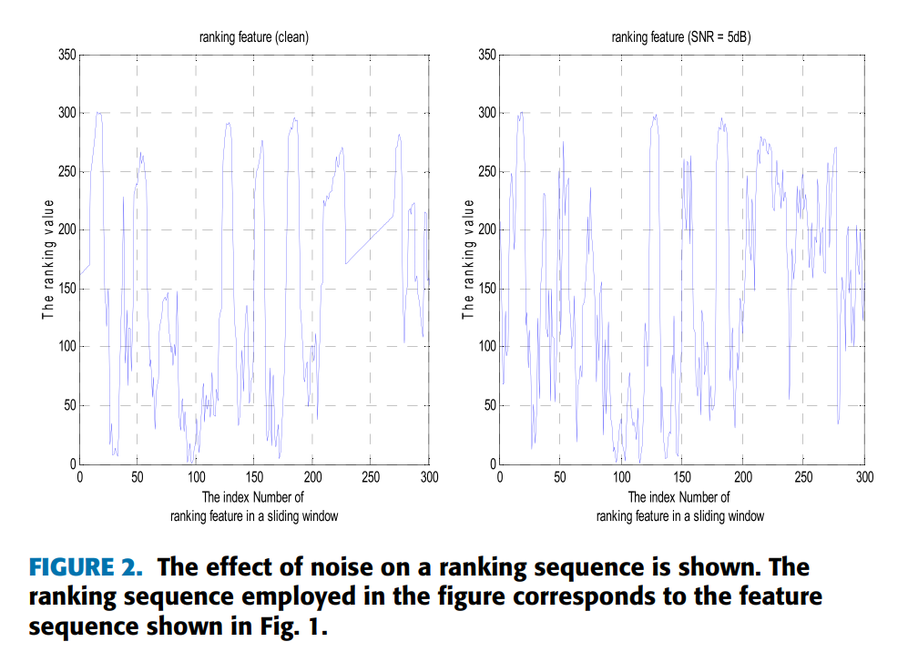

Phase Noise Effects on Phase-Modulated Coherent Optical OFDM

The paper addresses the issue of laser phase noise in phase-modulated coherent optical orthogonal frequency-division multiplexing (PM-OFDM) systems [1]. While PM-OFDM is advantageous for reducing the peak-to-average power ratio (PAPR) and thereby mitigating nonlinear degradations associated with conventional OFDM, it is highly susceptible to phase noise. This noise causes errors during the critical phase transformation process due to phase wrapping [1], [2]. To overcome this, the authors propose a mean-phase-compensation (MPC) method to prevent phase wrapping errors and derive closed-form expressions for phase noise spreading and signal-to-noise ratios (SNRs) using the Wiener phase noise model [1], [3].
The methodology combined theoretical derivation, simulation, and experimental validation. Using the Wiener phase noise model, the authors derived analytical expressions for noise distribution among OFDM subcarriers [3]. An arctangent-based demodulator was analyzed, and the MPC method was proposed, which calculates the mean phase offset of each Gaussian-distributed OFDM symbol in the time domain and rotates it to zero radians before phase transformation [4], [5]. The transmission experiment involved a 14.7 Gb/s PM-OFDM signal generated by an AWG at 25 GS/s [6]. The transmitter used an RF amplifier driving a 10-GHz phase modulator with either a 1-MHz DFB laser or a 10-kHz ECL [6], [7]. Tests were conducted over both back-to-back and 25-km SSMF links [6]. The receiver employed heterodyne detection with a balanced receiver and digitization at 50 GS/s for offline DSP [6], [8]. Simulations verified the theoretical expressions using a DFT length of 256 and a 1-MHz linewidth [9].
The findings highlight several important outcomes. Unlike conventional CO-OFDM, where phase noise is evenly distributed, PM-OFDM phase noise spreading is determined by the reciprocal of the square of the subcarrier frequency [1], [10]. Subcarriers close to DC are therefore more degraded than higher-frequency ones [11]. The MPC method successfully concentrated phase angles around zero radians, reducing phase wrapping probability [5], and allowed phase unwrapping to be skipped when the modulation index was small [5], [7]. SNR was improved by using larger modulation indices or discarding degraded low-frequency subcarriers [1], [12], [11]. Simulation results matched theoretical predictions within 0.02 dB [13]. Experimental validation with DFB lasers confirmed the theoretical noise distribution for low-frequency subcarriers [7].
The applications are significant for optical fiber transmissions where fiber nonlinearity is a bottleneck [14]. By enabling PM-OFDM with constant envelope and minimum PAPR, systems can operate more robustly against nonlinear responses from RF amplifiers or optical fibers compared to standard OFDM [14], [2]. The MPC method enhances the reliability of the arctangent-based demodulator, which is preferred for its lower complexity, making PM-OFDM a viable candidate for practical, cost-effective coherent optical communication systems [4], [5].
The study also identifies limitations. In experiments with the ECL laser after 25-km transmission, the noise floor at higher frequencies settled around –22 dBm, higher than theoretical predictions, suggesting other noise sources dominated [7]. Experimental SNR results were not discussed in detail due to low-pass filtering effects on subcarrier powers [7]. While MPC reduces the need for phase unwrapping, traditional unwrapping remains problematic in low-CNR regimes, indicating robustness under strong noise remains an area for future research [4].

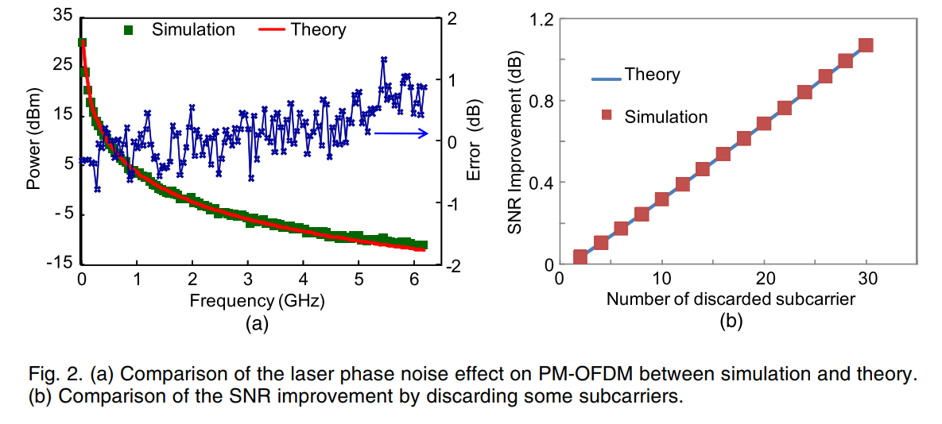

Pragmatic phase noise compensation for high-order coded modulations

The paper addresses the challenge of synchronization in phase noise-impaired communication systems that employ spectrally efficient, high-order modulations [1]. Signal distortion and information loss caused by oscillator instabilities are particularly detrimental in modern wireless and optical systems [2]. To overcome this, the authors propose a “pragmatic” iterative receiver design where demodulation and decoding are kept separate from Maximum A Posteriori (MAP) synchronization, rather than performing them jointly [1], [3]. The goal is to achieve performance levels close to ideal coherent detection and benchmark joint-receiver solutions while maintaining moderate computational complexity and compatibility with standard decoding blocks [1], [4].
The methodology involved developing an iterative receiver architecture validated through simulations using LDPC-coded QAM schemes [4], [5]. The system employed Multi-Level Coding (MLC) with Gray mapping, focusing on constellations from 16-QAM up to 1024-QAM [5], [6]. The channel was modeled with AWGN and phase noise described by the discrete-time Wiener model [7]. The receiver architecture separated detection from synchronization using an iterative loop: coarse pre-compensation with pilot symbols [5], [8], followed by iterative exchanges between a SISO demodulator/decoder and a phase estimation block [9], [10]. Two MAP-based estimation strategies were developed: Block Window (BW), which assumes constant phase noise over short windows [11], [12], and Phasor Linear Prediction (PLP), which extends BW with sliding triangular weights to smooth estimates [3], [13], [14]. Performance was evaluated using BER simulations against SNR for varying phase noise intensities and constellation sizes [15], with computational complexity compared to a benchmark joint MAP algorithm [16], [17].
The findings demonstrate near-optimal performance. The PLP strategy achieved results very close to the joint MAP receiver, with only about 0.1 dB degradation in challenging scenarios such as 1024-QAM under strong phase noise [18]. It significantly outperformed non-iterative schemes [19]. The receiver proved robust, maintaining synchronization even with phase noise standard deviation of 0.21° in dense constellations [18]. A window length was identified as a versatile compromise parameter across modulation sizes and noise intensities [20], [21]. Computational efficiency was notable: the proposed algorithms required less than 30% of the operations of joint MAP approaches for large constellations [17], [22].
The implications are significant for modern wireless and optical systems requiring high spectral efficiency with high-order modulations [3], [22]. By decoupling synchronization from decoding, the pragmatic design allows integration into existing systems using standard LDPC decoders without redesigning the entire receiver [1], [3]. Reduced computational complexity makes the approach feasible for real-time implementation in high-throughput modems [22]. The algorithms also require limited prior knowledge of phase noise statistics, making them adaptable to diverse oscillator types and complex noise models [3], [7].
The study acknowledges limitations. The derivation assumes bits within a symbol are a posteriori independent, which may be critical for uncoded bits unless proper interleaving is applied [23]. While efficient, the separate approach still incurs a minor performance loss of about 0.1 dB compared to fully joint MAP receivers [4]. Future research directions include applying the method to more complex or experimental phase noise models [7] and reducing pilot overhead by exploring blind or semi-blind adaptations to improve spectral efficiency [24]
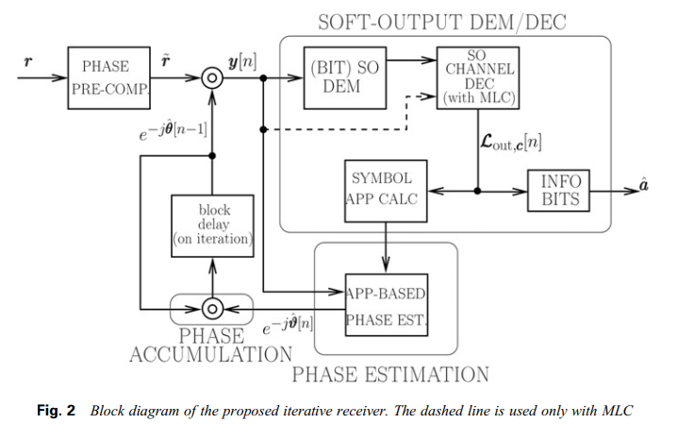

Joint Modulation Format/Bit-Rate Classification and Signal-to-Noise Ratio Estimation in Multipath Fading Channels Using Deep Machine Learning
The objective of this paper is to develop a unified and low-complexity technique for jointly classifying modulation format, bit-rate, and estimating signal-to-noise ratio (SNR) in multipath fading channels, which is a key requirement in cognitive radio and adaptive wireless communication systems. In practical wireless environments, signals are affected not only by additive white Gaussian noise but also by frequency-selective multipath fading, which severely degrades the performance of conventional automatic modulation classification (AMC) and SNR estimation methods. Most existing techniques address either modulation classification or SNR estimation separately and typically rely on high-speed, symbol-rate synchronous sampling and complex preprocessing. The primary objective of this work is therefore to enable accurate joint estimation of multiple signal parameters under realistic multipath conditions using low-speed asynchronous sampling and deep machine learning, thereby reducing implementation complexity while improving robustness.
The methodology proposed in this paper is based on deep neural networks applied to asynchronous delay-tap plots (ADTPs), which capture the statistical structure of received signals without requiring timing information. The received signal, distorted by multipath fading and noise, undergoes envelope detection followed by asynchronous delay-tap sampling to generate two-dimensional ADTPs. These ADTPs are converted into one-dimensional bin-count vectors and used as inputs to two deep neural networks. The first network (DNN-1) performs joint modulation format and bit-rate classification using a hierarchical architecture consisting of two stacked autoencoders followed by a softmax output layer. The second network (DNN-2) estimates SNR using a similar structure with a linear output layer. Both networks are trained using large labelled datasets generated from six signal types, including NRZ-2ASK, RZ-QPSK, and NRZ-16QAM at different bit-rates, over SNRs ranging from 0 to 30 dB and under three-path frequency-selective fading. Unsupervised pretraining of autoencoders is followed by supervised fine-tuning using backpropagation.
The results demonstrate that the proposed deep learning–based approach achieves excellent performance in multipath fading environments. Simulation results show a mean modulation format and bit-rate classification accuracy of 99.8%, with five out of six signal types achieving 100% classification accuracy. Even for the most challenging case, the classification accuracy remains above 98%. In addition, the proposed method achieves accurate non-data-aided SNR estimation over a wide range of 0–30 dB, with a mean estimation error of approximately 1 dB. These results confirm that ADTPs contain rich information related to modulation, bit-rate, and SNR, and that deep neural networks can effectively extract and exploit these features even under severe channel impairments. Importantly, the method requires only low-speed asynchronous sampling, significantly reducing system complexity compared to conventional approaches.
In conclusion, the paper establishes a powerful and practical deep machine learning framework for joint modulation format, bit-rate classification, and SNR estimation in frequency-selective multipath fading channels. By combining asynchronous delay-tap sampling with deep neural networks, the proposed approach overcomes the limitations of traditional AMC and SNR estimation techniques while maintaining low implementation complexity. Although the study is based on simulation results and considers a limited set of modulation formats, it provides strong evidence of the feasibility of low-cost, multiparameter estimation for cognitive radio systems. Future research directions include extending the framework to a wider range of modulation schemes, time-varying channels, and real-world experimental validation, as well as optimizing network architectures for real-time deployment.
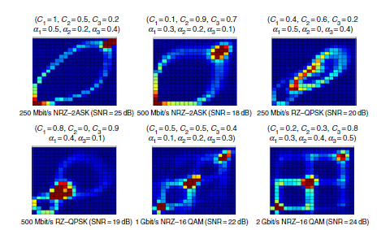

Modulation Scheme Recognition Using Convolutional Neural Network
The objective of this paper is to develop an effective and robust automatic modulation recognition method for non-cooperative communication systems by leveraging the powerful feature extraction capability of convolutional neural networks (CNNs). Modulation recognition plays a critical role in applications such as electronic warfare, spectrum monitoring, and cognitive radio, where prior information about transmitted signals is unavailable. Traditional modulation recognition techniques rely heavily on handcrafted features and expert knowledge, and their performance degrades significantly under low signal-to-noise ratio (SNR) conditions. With the recent success of deep learning in image classification, the paper aims to transform the modulation recognition problem into an image recognition task by using time–frequency representations of signals, thereby avoiding complex feature engineering and improving recognition accuracy, especially in noisy environments.
The methodology employed in this work is based on converting received communication signals into spectrogram images using short-time Fourier transform (STFT) and classifying them using a CNN architecture inspired by AlexNet. Four modulation schemes—AM, FM, FSK, and BPSK—are considered, and large datasets of spectrogram images are generated under additive white Gaussian noise conditions with SNRs ranging from −20 dB to 20 dB. Each spectrogram is resized to a normalized 64 × 64 grayscale image. The CNN model consists of multiple convolutional layers with 3 × 3 kernels, max-pooling layers for dimensionality reduction, local response normalization layers to mitigate overfitting, and fully connected layers followed by a softmax classifier. The model is trained using categorical cross-entropy loss. To optimize performance, different activation functions (ReLU, Sigmoid, Tanh, and Softplus) and optimization algorithms (gradient descent, RMSProp, and Adam) are systematically evaluated. The entire framework is implemented using TensorFlow.
The results demonstrate that the proposed CNN-based modulation recognition method achieves high recognition accuracy across a wide range of SNRs and outperforms conventional CNN-based approaches. Simulation results show that recognition accuracy approaches 100% when SNR is above 12 dB for all tested activation functions. Under low-SNR conditions, the Sigmoid activation function consistently provides superior performance, achieving nearly 10% higher accuracy than ReLU at −10 dB SNR. The model achieves over 80% recognition accuracy at −6 dB SNR and exceeds 90% accuracy once sufficient training iterations are completed. Comparisons among optimization algorithms reveal that Adam, RMSProp, and gradient descent yield comparable performance, indicating stable feature extraction capability. Overall, the proposed approach exhibits strong generalization ability and robustness under noisy conditions.
In conclusion, the paper establishes that convolutional neural networks combined with spectrogram-based signal representations provide an effective solution for automatic modulation scheme recognition. By converting modulation recognition into an image classification problem, the proposed method eliminates the need for manual feature extraction and achieves high accuracy even under low SNR conditions. Although the study focuses on four modulation schemes and simulation-based evaluation, it demonstrates the strong potential of CNN-based approaches for practical non-cooperative communication scenarios. Future research directions include extending the model to a wider range of modulation types, improving performance under extremely low SNR conditions, and validating the approach using real-world communication signals.
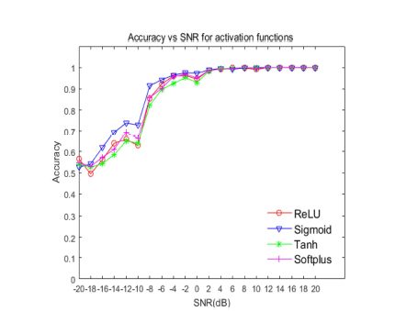

End-to-End Learning From Spectrum Data: A Deep Learning Approach for Wireless Signal Identification in Spectrum Monitoring Applications
The objective of this paper is to introduce and formalize an end-to-end deep learning framework for wireless signal identification in spectrum monitoring applications. With the rapid growth of heterogeneous wireless devices and the increasing scarcity of radio spectrum, effective spectrum monitoring has become essential for spectrum regulation, dynamic spectrum access, and interference management in 5G and future wireless networks. Traditional signal identification techniques rely heavily on handcrafted expert features such as cyclostationary statistics and multi-stage machine learning pipelines, which require significant domain expertise and are difficult to generalize across applications. The primary goal of the paper is to demonstrate that end-to-end learning using deep neural networks can automatically extract discriminative features directly from raw or lightly processed spectrum data, enabling accurate identification of modulation formats and wireless technologies without manual feature engineering.
The methodology adopted in this work is based on a data-driven deep learning framework using convolutional neural networks for spectrum monitoring tasks. Wireless signals are collected as complex baseband in-phase and quadrature (IQ) samples through standard receiver processing, including downconversion, filtering, and analog-to-digital conversion. Three different wireless data representations are considered to study their impact on classification performance: raw IQ time-domain samples, amplitude and phase representations, and frequency-domain representations obtained using fast Fourier transform. These representations are designed to have a unified dimensional structure to allow fair comparison using the same CNN architecture. A reference CNN model with two convolutional layers, dropout regularization, and a fully connected classification layer is implemented and trained using supervised learning. The framework is evaluated through two case studies: modulation recognition using eleven digital modulation schemes and wireless interference identification involving multiple technologies operating in unlicensed bands. Large labelled datasets are used for training and testing, and performance is evaluated across a wide range of signal-to-noise ratios.
The results presented in the paper demonstrate that end-to-end learning from spectrum data is highly effective for wireless signal identification tasks. Experimental evaluations show that classification accuracy strongly depends on the choice of data representation and the specific identification task. For modulation recognition, the amplitude-phase representation outperforms raw IQ and frequency-domain representations at medium to high SNR levels, achieving accuracy improvements of up to 2% and 12%, respectively. In contrast, for wireless interference identification, frequency-domain representations yield superior performance, outperforming IQ and amplitude-phase representations by up to 20%. The results confirm that deep learning models can automatically learn meaningful features from simple signal representations and achieve high classification accuracy without handcrafted features, even under noisy channel conditions.
In conclusion, the paper establishes end-to-end deep learning as a powerful and flexible approach for spectrum monitoring and wireless signal identification in next-generation networks. By eliminating manual feature extraction and unifying the learning pipeline, the proposed framework simplifies system design while improving adaptability across diverse spectrum monitoring applications. However, the study also highlights limitations such as the dependence on large labelled datasets, computational complexity during training, and sensitivity to channel impairments at low SNRs. Future research directions include developing more robust and lightweight models for real-time deployment, exploring semi-supervised and online learning techniques, extending the framework to wider bandwidths and real-world measurements, and integrating decision-making modules for autonomous spectrum management and regulation.
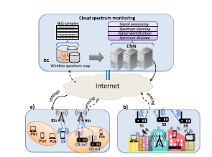

GPI-Based Secrecy Rate Maximization Beamforming Scheme for Wireless Transmission With AN-Aided Directional Modulation
The objective of this paper is to maximize the secrecy rate in directional modulation (DM) wireless networks by jointly optimizing the beamforming vector for confidential messages and the artificial noise (AN) projection matrix. In physical-layer security–oriented DM systems, confidential information is transmitted directionally toward an intended user while AN is injected to degrade eavesdroppers’ reception. However, conventional approaches such as null-space projection and leakage-based beamforming fail to achieve optimal secrecy performance, particularly in medium-to-high signal-to-noise ratio (SNR) regimes. The paper addresses this limitation by formulating secrecy rate maximization as a joint optimization problem and aims to design an efficient algorithm capable of significantly improving secrecy performance without relying on exhaustive search methods.
The methodology employed in this work is based on a general power iterative (GPI) algorithm combined with an alternatively iterative structure (AIS). A line-of-sight directional modulation system is considered, consisting of a multi-antenna transmitter, a single-antenna desired user, and a single-antenna eavesdropper. The secrecy rate expression is derived as the difference between the achievable rates of the desired user and the eavesdropper, resulting in a nonlinear and non-convex optimization problem. To handle this complexity, the joint optimization is decomposed into two subproblems: optimizing the AN projection matrix with a fixed beamforming vector using the GPI algorithm, and optimizing the beamforming vector with a fixed AN projection matrix using a generalized Rayleigh-Ritz approach. These two steps are executed alternately until convergence. To accelerate convergence, leakage-based solutions are adopted as initialization values instead of random initialization, significantly reducing the number of required iterations.
The results presented in the paper demonstrate that the proposed GPI-based AIS scheme achieves superior secrecy rate performance compared to conventional null-space projection and leakage-based beamforming methods. Simulation results show that the proposed method converges rapidly, requiring only four iterations when leakage-based initialization is used, compared to seven iterations with random initialization. In terms of secrecy rate versus SNR performance, the proposed scheme consistently outperforms the benchmark methods, with the secrecy rate gain increasing as SNR rises. For example, at higher SNR values, the proposed algorithm achieves approximately 10–20% secrecy rate improvement over leakage-based and null-space projection approaches. Bit-error-rate analysis further confirms that the method maintains reliable communication for the desired user while effectively suppressing information leakage toward the eavesdropper.
In conclusion, the paper establishes that the GPI-based secrecy rate maximization framework provides a powerful and effective solution for secure directional modulation systems. By jointly optimizing the confidential message beamforming vector and AN projection matrix through an alternatively iterative structure, the proposed scheme significantly enhances secrecy performance in medium and high SNR regions. Although the computational complexity is higher than that of conventional methods due to iterative processing, the use of efficient initialization substantially reduces convergence time. Future research directions include extending the proposed scheme to multi-user and multi-eavesdropper scenarios, reducing computational complexity, and applying the method to practical systems such as massive MIMO, millimeter-wave communications, UAV networks, and satellite communications.
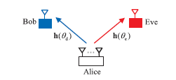
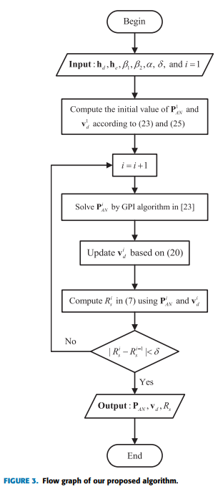

A Pulse Frequency Modulation Interpretation of VCOs Enabling VCO-ADC Architectures with Extended Noise Shaping
This paper addresses the limitations of conventional interpretations of voltage-controlled oscillator–based analog-to-digital converters (VCO-ADCs), which are typically modelled as first-order delta-sigma modulators. Such interpretations fail to fully capture the spectral characteristics and noise behaviour of VCO-based converters. The main objective of the study is to reinterpret VCO operation through a pulse frequency modulation (PFM) framework, enabling a deeper analytical understanding and the possibility of designing VCO-ADC architectures with extended and higher-order noise shaping.
The methodology is grounded in analytical modelling and signal theory. The authors establish an equivalence between VCO behaviour and pulse frequency modulation, showing that information is encoded in the timing of oscillator edges rather than amplitude. Using this PFM interpretation, the study derives mathematical expressions for modulation sidebands, quantization effects, and noise spectra. The paper further proposes open-loop VCO-ADC architectures using pulse shaping filters and sampling theory to achieve higher-order noise shaping, avoiding the stability issues associated with feedback-based designs. Behavioural simulations and theoretical analysis are used to validate the proposed architectures.
The results reveal that the PFM-based interpretation exposes previously unmodeled error components in VCO-ADCs and provides a systematic framework for extending noise shaping beyond first order. The study shows that higher-order noise shaping can be theoretically achieved and significantly improves signal-to-noise-and-distortion ratio (SNDR), especially for oversampled systems. This contributes to existing knowledge by offering a new design perspective for time-based ADCs, bridging the gap between frequency modulation theory and modern data converter design.
The proposed approach has strong implications for low-power, nanoscale CMOS ADCs, particularly in sensor interfaces, IoT devices, and mixed-signal systems where digital-friendly architectures are preferred. However, practical implementation of higher-order pulse shaping filters remains challenging due to circuit non-idealities and timing mismatches. Future research should focus on practical circuit realizations, calibration techniques, and hybrid architectures that balance theoretical noise shaping benefits with real-world implementation constraints.

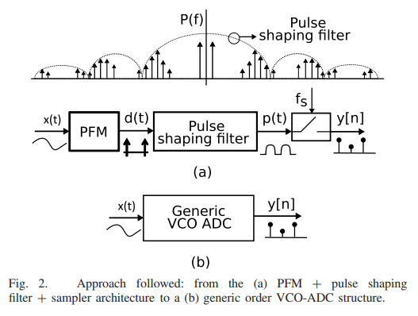
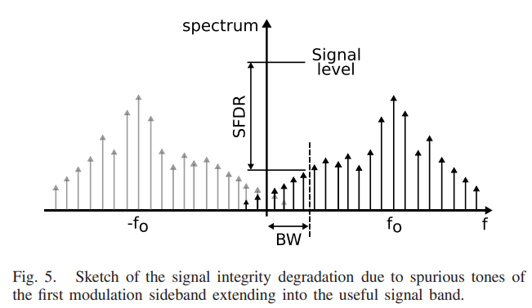

Effects of Multi-Level Format in MMF System Based on Mode-Field Matched Center-Launching Technique
The objective of this paper is to investigate the impact of multi-level modulation formats, particularly four-level pulse amplitude modulation (PAM4), on the performance of high-speed multimode fiber (MMF) transmission systems employing the mode-field matched center-launching technique. MMF is widely used in short-reach applications such as data center interconnections and local area networks; however, the demand for data rates exceeding 25 Gb/s has introduced severe challenges due to modal dispersion and mode coupling. Although the mode-field matched center-launching technique enables transmission by predominantly exciting the fundamental mode of MMF, imperfect coupling results in a small portion of optical power being carried by higher-order modes. The paper aims to evaluate how this residual high-order mode power affects system performance when spectrally efficient multi-level formats such as PAM4 are used, and to identify effective methods to mitigate the resulting performance degradation.
The methodology employed in this work is based on experimental evaluation of MMF transmission systems using both on-off keying (OOK) and PAM4 modulation formats. An optical transmitter comprising a 1.3-µm distributed feedback laser and a LiNbO₃ Mach–Zehnder modulator is used to generate 25.78-Gb/s OOK and PAM4 signals. The mode-field matched center-launching condition is realized by fusion-splicing single-mode-fiber-pigtailed transceivers directly to OM3-type MMF, with splicing parameters optimized to maximize coupling into the fundamental mode. The coupling efficiency is experimentally characterized using impulse response analysis, achieving approximately 94.5% fundamental-mode excitation. Bit-error-rate (BER) measurements are carried out after transmission over distances up to 12.2 km, with repeated measurements to capture BER fluctuations. Additional experiments are performed to quantify signal-to-interference beat noise by artificially controlling the signal-to-interference ratio, and the effect of replacing the single-mode-fiber-pigtailed receiver with a multimode-fiber-pigtailed receiver is investigated to suppress beat noise. High-speed sampling and offline BER estimation are used throughout the evaluation.
The results demonstrate that while OOK signals exhibit minimal power penalty and stable BER performance after 12.2 km of MMF transmission, PAM4 signals suffer from significant power penalties and severe BER fluctuations. These degradations are attributed to signal-to-interference beat noise generated when residual high-order mode components couple into the single-mode-fiber-pigtailed receiver and interfere with the fundamental-mode signal. Experimental measurements show that PAM4 is approximately 12 dB more sensitive to such beat noise than OOK. By replacing the single-mode-fiber-pigtailed receiver with a multimode-fiber-pigtailed receiver, the beat noise is effectively suppressed due to the orthogonality of modes in MMF. As a result, the power penalty for 25.78-Gb/s PAM4 transmission over 12.2 km is reduced from 3.9 dB to 0.9 dB at a BER of 5×10⁻⁵, and BER fluctuations are largely eliminated. The effectiveness of this approach is further validated by successfully demonstrating 56-Gb/s PAM4 transmission over 2.3 km of MMF with only about 1 dB penalty, without the use of electrical equalization.
In conclusion, the paper establishes that although multi-level modulation formats such as PAM4 enable higher spectral efficiency in MMF systems, they are highly sensitive to signal-to-interference beat noise caused by residual high-order mode coupling when using the mode-field matched center-launching technique. The study shows that this limitation can be effectively addressed by employing a multimode-fiber-pigtailed receiver, which suppresses beat noise through modal orthogonality. While the work is limited by receiver sensitivity constraints and the absence of electrical equalization, it demonstrates a practical and low-complexity solution for enabling high-speed (>50 Gb/s) MMF transmission. Future research directions include improving receiver sensitivity, extending transmission distance, and integrating advanced modulation formats for next-generation short-reach optical communication systems.
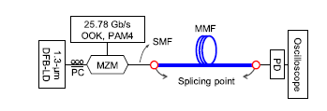

Simultaneous Determination of Modulation Types and Signal-to-Noise Ratios Using Feature-Based Approach

The paper presents a low-complexity technique for the simultaneous determination of modulation types and Signal-to-Noise Ratios (SNRs) in wireless communication systems [1]. Existing solutions typically estimate only one parameter—either modulation or SNR—or require complex hardware implementations such as dual sampling devices with adjusted tap-delays [2], [3]. To address these limitations, the authors propose a method that achieves high estimation accuracy while enabling cost-effective implementation by relying on a single low-speed asynchronous sampling device. This approach reduces both computational and hardware burdens on cognitive wireless receivers [1], [3].
The methodology combines statistical sampling, dimensionality reduction, and machine learning. The core technique involves generating Asynchronous Amplitude Histograms (AAHs) by sampling the received signal envelope at a rate much lower than the symbol rate [4]. This eliminates the need for synchronous timing information, with amplitude samples mapped into bins to create histograms that exhibit unique signatures for different modulation types and SNR levels [5], [6]. To reduce processing complexity, Principal Component Analysis (PCA) based on Singular Value Decomposition (SVD) is applied to extract the most significant features from the AAHs, compressing data dimensionality while preserving the statistical attributes required for recognition [1], [7], [8]. These features are then fed into a supervised learning system comprising a Support Vector Classifier (SVC), trained using a one-against-all approach with a cubic polynomial kernel to identify modulation formats [9], [10], and a Support Vector Regressor (SVR), employing a Gaussian-based SVR to predict SNR values [10]. The investigation simulated a three-path multipath fading channel with random delays and coefficients [11], evaluating performance across three modulation formats—2ASK, QPSK, and 16QAM—with SNR values ranging from 0 to 30 dB [11]. Validation was conducted using K-fold cross-validation (5-fold and 10-fold) on a dataset of 1860 samples to ensure robust performance metrics [12], [13].
The findings confirm the efficiency of the proposed technique. The approach achieved an average modulation recognition accuracy of 99.83% across tested signals, even in the presence of noise and multipath fading [1], [14]. It also demonstrated precise SNR estimation over a broad range (0–30 dB), with a very low average estimation error of 0.79 dB, outperforming a comparable Deep Neural Network (DNN) approach that had an error of 1 dB [15]. Feature selection analysis showed that using only the six most significant Principal Components yielded classification accuracies above 96% and SNR estimation errors around 1 dB, with marginal improvements beyond six features, confirming PCA’s effectiveness in reducing computational complexity [16], [17]. The study further verified that AAHs produce distinct peaks corresponding to constellation points—two peaks for 2ASK, one for QPSK, and three for 16QAM—which remain distinguishable under varying SNR conditions [6], [18].
The applications and implications of this research are highly relevant for cognitive radio and future wireless networks. By enabling receivers to autonomously and simultaneously determine modulation formats and SNRs, the technology supports adaptive communication functions such as dynamic link adaptation, power allocation, and demodulation without requiring prior transmitter knowledge [2], [5]. The ability to use a single low-speed sampler instead of high-speed synchronous samplers or complex delay-tap setups makes receiver hardware significantly more cost-effective and energy-efficient [3], [19]. Furthermore, the dimensionality reduction achieved through PCA allows faster processing, making the method suitable for real-time applications where computational resources are limited [20].
The study also identifies limitations and future research directions. A key limitation is the inability to distinguish between different M-PSK modulations types (excluding QPSK), since M-PSK signals distribute amplitudes equally in the complex plane, producing AAHs that resemble QPSK [21]. While validated on 2ASK, QPSK, and 16QAM, the authors suggest extending the technique to include formats such as 8QAM, 32QAM, and 64QAM, which exhibit unique histogram peaks [21]. Finally, although SVM was chosen for its flexibility with smaller datasets, future research could explore comparisons with other machine learning tools. The current SVM approach was found to be faster and comparable in accuracy to Deep Learning methods for this specific application [22]
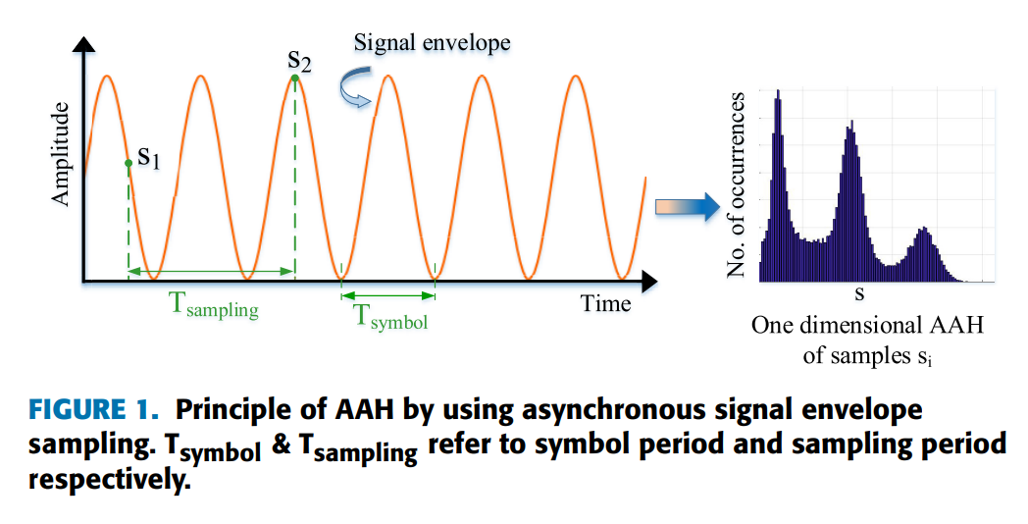

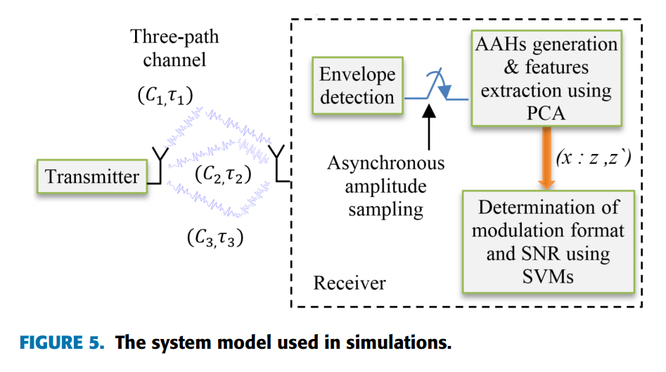

Spectral Efficient Spatial Modulation Techniques
The paper addresses a fundamental drawback inherent in existing Space Modulation Techniques (SMTs)—including Spatial Modulation (SM), Generalized Spatial Modulation (GSM), and Quadrature Spatial Modulation (QSM)—where achievable data rates increase only logarithmically with the number of transmit antennas [1], [2]. To overcome this bottleneck, the authors propose two novel schemes: Fully-Generalized Spatial Modulation (F-GSM) and Fully-Quadrature Spatial Modulation (F-QSM) [1], [3]. These techniques aim to establish a linear relationship between achievable data rates and the number of transmit antennas, thereby significantly enhancing spectral efficiency [3], [4]. In addition, the paper introduces a comprehensive mathematical framework for assessing the Average Bit Error Rate (ABER) of various SMTs, representing the first major attempt to generalize analytical analysis across these modulation families while also evaluating their computational complexity [1], [5].
The methodology combines theoretical derivation, system modeling, and numerical simulation to validate the proposed techniques. F-GSM and F-QSM are designed to utilize a variable number of transmit antennas for data embedding. Unlike conventional GSM, which uses a fixed number of active antennas, the proposed schemes vary the active antennas from a single antenna to multiple or all antennas depending on the input bit sequence [3], [4]. In F-QSM, the data symbol is decomposed into real and imaginary parts, which are transmitted via distinct antenna subsets selected by spatial bits [6]. A general analytical framework is derived using the union bounding technique to evaluate ABER performance [7], with a key contribution being the derivation of a generalized term that accounts for differences in data constellation symbols and antenna indices across SM, GSM, QSM, F-GSM, and F-QSM [8], [9]. Complexity analysis is performed by determining the Total Number of Real Operations (TNRO) required at Maximum-Likelihood (ML) decoders for each scheme [10], [11]. Extensive Monte Carlo simulations validate the analytical formulas under an uncorrelated Rayleigh fading channel with Additive White Gaussian Noise (AWGN) and perfect Channel State Information (CSI) at the receiver [12], [13]. Performance is evaluated under two scenarios: one maintaining the same modulation order across schemes, and another maintaining the same number of antennas while varying modulation orders to achieve identical spectral efficiency [13].
The findings demonstrate several significant outcomes regarding spectral efficiency and error performance. F-GSM and F-QSM successfully achieve a linear increase in data rates relative to the number of transmit antennas, contrasting with the logarithmic increase of conventional SMTs. For example, at a given configuration, F-QSM achieved a spectral efficiency of 32 bits per channel use (bpcu), whereas conventional QSM achieved only 10 bpcu [14]. In simulations where all schemes used the same number of transmit antennas and were adjusted for equal spectral efficiency, F-QSM and F-GSM significantly outperformed conventional methods. F-QSM provided approximately 6 dB gain over conventional SM and GSM, and 4 dB gain over QSM for 8 bpcu transmission [15]. This improvement is attributed to the ability of the proposed schemes to use lower modulation orders to achieve the same data rates [16]. The simulation results showed strong consistency with the derived analytical formulas, particularly at pragmatic Signal-to-Noise Ratio (SNR) values, validating the generalized mathematical framework [17], [18]. While F-GSM and F-QSM offer higher spectral efficiency, their computational complexity scales with the number of transmit antennas and is generally higher than SM and QSM, though comparable to conventional GSM [11], [18].
The applications and implications of this research are highly relevant for the development of 5G wireless networks, where high spectral and energy efficiency are critical [19], [20]. By breaking the logarithmic barrier of conventional SMTs, F-GSM and F-QSM position spatial modulation as viable competitors to high-rate MIMO techniques such as V-BLAST, making them suitable for applications requiring high throughput without the full hardware complexity of traditional MIMO [2], [7]. The schemes also retain the core advantages of Index Modulation, including reduced RF chain requirements compared to full MIMO systems, contributing to energy-efficient network design [19], [21]. Furthermore, the generalized mathematical framework enables system designers to analytically predict and compare the performance of different spatial modulation configurations without relying solely on time-consuming simulations [4].
The study acknowledges several limitations and areas for future research. Current performance analysis assumes uncorrelated Rayleigh fading channels and perfect CSI at the receiver [12], [13], whereas real-world channels are often correlated and CSI is imperfect. Future research should investigate the robustness of F-GSM and F-QSM under correlated fading and imperfect channel estimation. Computational complexity also increases with the number of transmit antennas [11], suggesting the need for low-complexity detection algorithms to reduce processing burdens at the receiver. Finally, while the paper addresses the theoretical reduction of RF chains, practical implementation of variable antenna activation—switching dynamically from one to all antennas—imposes hardware constraints [5]. Future work should therefore focus on hardware design and prototyping of these fully-generalized schemes to validate their feasibility in deployed systems.
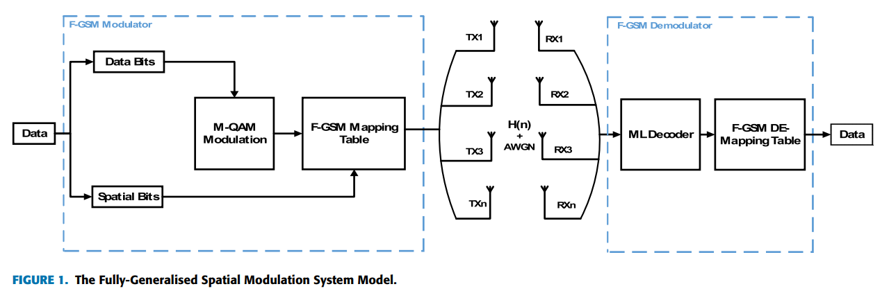

Modulation Options for OFDM-Based Waveforms: Classification, Comparison, and Future Directions
The objective of this paper is to provide a comprehensive classification and comparative analysis of different modulation options that can be integrated with orthogonal frequency division multiplexing (OFDM) to meet the diverse and stringent requirements of future wireless communication systems, particularly 5G and beyond. Although conventional OFDM has been widely adopted due to its high spectral efficiency and robustness to multipath fading, it faces several limitations such as high peak-to-average power ratio (PAPR), poor out-of-band emission (OOBE), and limited flexibility in supporting heterogeneous services. The paper aims to address these challenges by systematically categorizing existing and emerging OFDM-based modulation schemes based on signal-plane dimensionality and evaluating their suitability for applications such as enhanced mobile broadband (eMBB), ultra-reliable low-latency communications (URLLC), and massive machine-type communications (mMTC).
The methodology employed in this work is a structured survey and analytical comparison framework. The authors first classify OFDM modulation options into two main categories: two-dimensional (2-D) signal-plane schemes, which include conventional OFDM and differential modulation OFDM, and three-dimensional (3-D) signal-plane schemes, which exploit an additional dimension such as index, number, or shape. The 3-D category is further divided into index-based schemes (such as spatial modulation OFDM and OFDM with index modulation), number-based schemes (such as OFDM with subcarrier number modulation), and shape-based schemes (such as OFDM with pulse superposition modulation). Mathematical signal models are presented for each scheme, and their transmitter structures and signal representations are illustrated. A unified performance evaluation is then conducted using simulation-based comparisons under a multipath Rayleigh fading channel, focusing on key metrics including spectral efficiency, bit-error rate (BER), PAPR, power efficiency, OOBE, and computational complexity.
The results of the comparative analysis reveal that no single modulation option is universally optimal across all performance metrics. Conventional OFDM and differential OFDM offer simple transceiver structures but suffer from high PAPR and OOBE. Index-based schemes such as OFDM-IM and spatial modulation OFDM provide improved power efficiency and robustness to interference by exploiting sparse subcarrier or antenna activation. OFDM-SNM achieves higher throughput under certain conditions by encoding information in the number of active subcarriers, while OFDM-PSM improves spectral efficiency and reduces OOBE by exploiting pulse shape diversity. Simulation results demonstrate that OFDM-IM and OFDM-SNM achieve better BER performance than conventional OFDM at high SNR, while OFDM-PSM maintains similar BER with lower spectral leakage. The study also highlights the trade-offs between performance gains and increased receiver complexity, particularly for 3-D signal-plane schemes.
In conclusion, the paper establishes that advanced modulation options for OFDM provide valuable flexibility for addressing the diverse requirements of future wireless networks. By exploiting additional signal dimensions, these schemes can enhance spectral efficiency, power efficiency, and interference robustness beyond what is achievable with conventional OFDM. However, the study is limited to single-user scenarios with ideal synchronization and does not account for hardware impairments or large-scale multi-user deployments. Future research directions include developing adaptive modulation and resource allocation strategies, designing physical-layer security mechanisms tailored to index-based modulation, improving robustness against multi-access and narrowband interference, and devising efficient PAPR reduction techniques for advanced OFDM modulation schemes. Overall, the paper serves as a valuable reference for selecting and designing OFDM-based modulation techniques for next-generation wireless systems.
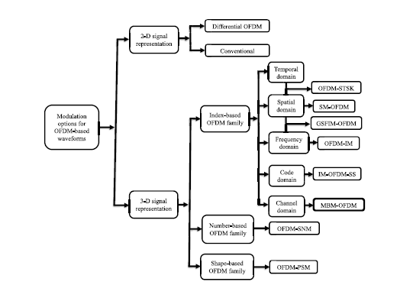

Improving the Signal-to-Noise Ratio of Time Domain Fiber Bragg Grating Sensor Based on Hybrid Simplex and Golay Coding Technique
The objective of this paper is to improve the signal-to-noise ratio (SNR) of time-domain multiplexed fiber Bragg grating (TDM-FBG) sensor systems used for distributed temperature and strain measurements. Although TDM-FBG sensors offer high spatial resolution and multiplexing capability, their performance is fundamentally limited by low reflected signal levels, fiber attenuation, and noise accumulation over long sensing distances. Increasing optical input power is not always feasible due to nonlinear scattering effects, while increasing pulse width degrades spatial resolution. The study aims to overcome these trade-offs by introducing a hybrid pulse coding strategy that simultaneously exploits the complementary autocorrelation property of Golay codes and the orthogonality of standard simplex codes to achieve higher SNR without compromising spatial resolution or measurement reliability.
The methodology employed in this work is based on the simultaneous encoding of interrogation pulses using a hybrid simplex–Golay (HSG) coding scheme in a TDM-FBG sensing architecture. Simplex codes derived from the Hadamard matrix are combined with unipolar Golay complementary codes through a Kronecker product to generate longer composite code sequences. The encoded optical pulses are generated using a narrow-linewidth continuous-wave laser, modulated by a Mach–Zehnder modulator driven by an arbitrary waveform generator, and amplified before being launched into a 16 km single-mode fiber containing two ultra-weak FBG sensors. The reflected signals are detected using a high-speed photodetector and decoded through a two-stage process involving Golay autocorrelation followed by Hadamard transform decoding. Experiments are conducted under two temperature conditions, 25 °C and 50 °C, using two coding patterns: Pattern A, where Golay code length is increased with fixed simplex length, and Pattern B, where simplex length is increased with fixed Golay length. Performance is evaluated in terms of decoded signal shape, noise reduction, SNR improvement ratio (SNIR), and measurement speed.
The results demonstrate that the proposed hybrid coding technique significantly enhances the SNR of TDM-FBG sensors while preserving accurate spatial localization of FBG reflections. Experimental observations show that decoded FBG signals maintain well-defined pulse shapes with negligible distortion under all coding configurations, confirming correct encoding and decoding. In Pattern A, increasing Golay code length from 4 to 64 bits reduces noise by a factor of four and yields an SNIR improvement of approximately 6.3 dB. In Pattern B, increasing simplex code length from 3 to 31 bits further reduces noise in accordance with theoretical predictions, contributing an additional SNIR improvement of about 4.1 dB. Overall, the hybrid coding approach achieves a total SNIR improvement of approximately 10.5 dB for sensors located 16 km from the interrogation unit, closely matching theoretical expectations. The results also show consistent performance under elevated temperature conditions, with slightly reduced absolute SNR due to wavelength detuning effects.
In conclusion, the paper establishes that hybrid simplex–Golay coding provides an effective and practical solution for enhancing the SNR of time-domain fiber Bragg grating sensor systems. By combining the strengths of two complementary coding techniques, the proposed method significantly improves noise suppression and sensing performance without increasing optical power or sacrificing spatial resolution. Although the hybrid approach introduces additional encoding, decoding, and acquisition time overhead, the achieved SNR gains greatly outweigh the complexity for long-range and high-sensitivity sensing applications. Future research directions include optimizing code length selection to balance measurement speed and performance, extending the approach to larger FBG arrays, and implementing real-time decoding strategies for deployment in structural health monitoring, environmental sensing, and industrial measurement systems.
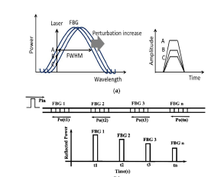

Advances in Acoustic Signal Processing Techniques for Enhanced Bowel Sound Analysis
This paper addresses the long-standing challenge of reliably analysing bowel sounds for clinical diagnosis, which has traditionally relied on subjective auscultation and qualitative interpretation. Bowel sounds are highly non-stationary, noise-contaminated, and difficult to interpret, limiting their diagnostic value in gastrointestinal assessment. The primary objective of this study is to systematically evaluate the advances in acoustic signal processing and machine learning techniques that enable meaningful extraction, enhancement, and interpretation of bowel sound information for clinical and research applications
The methodology adopted is a comprehensive literature review covering data acquisition hardware, signal pre-processing, noise reduction, feature extraction, and machine learning–based classification techniques. The paper examines time-domain, frequency-domain, and time–frequency approaches, including Fourier transforms, short-time Fourier transforms, wavelet transforms, adaptive filtering, and higher-order statistical methods. It further reviews the application of machine learning models such as artificial neural networks, radial basis function networks, Bayesian classifiers, and hybrid expert systems, along with experimental setups involving electronic stethoscopes, piezoelectric sensors, and multi-channel abdominal recording systems.
The key findings show that advanced acoustic signal processing combined with machine learning significantly improves bowel sound detection, denoising, and classification accuracy compared to traditional threshold-based methods. Wavelet-based denoising, kurtosis and fractal-dimension detectors, and adaptive filtering are found to be particularly effective in suppressing noise while preserving physiological signal characteristics. The study highlights that machine learning enables objective classification of bowel sound patterns and supports long-term, unsupervised monitoring, thereby advancing the state of the art in biomedical acoustic analysis.
The reviewed techniques have important implications for non-invasive gastrointestinal diagnostics, remote patient monitoring, and intelligent healthcare systems. However, the paper identifies limitations such as sensitivity to environmental noise, inter-subject variability, high computational complexity of advanced algorithms, and limited large-scale clinical validation. Future research directions include developing robust, low-complexity models for real-time deployment, integrating AI-driven feature learning, improving sound localization accuracy, and establishing standardized datasets to support reliable and scalable clinical adoption.
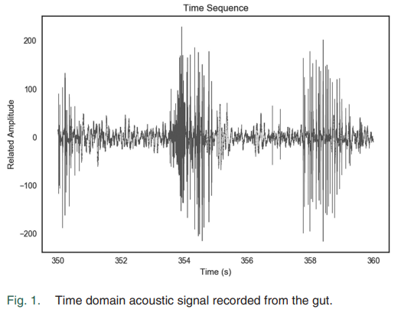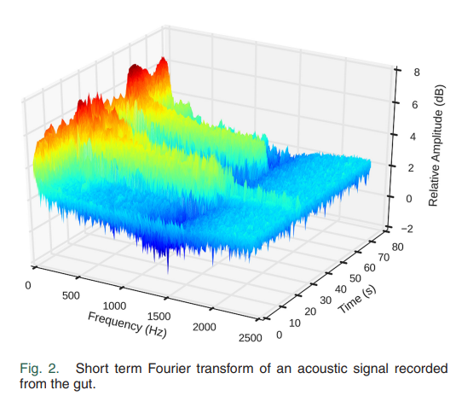
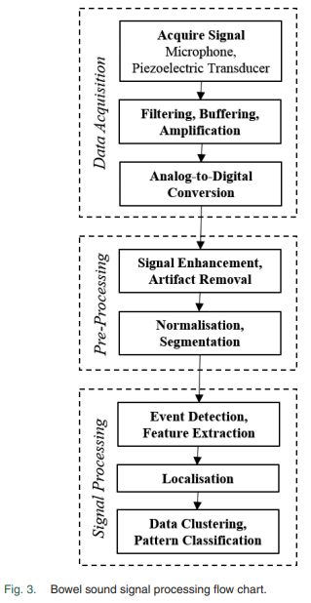

Symbiotic Radio: Cognitive Back scattering Communications for Future Wireless Networks
The paper introduces Symbiotic Radio (SR) as a novel spectrum- and energy-efficient wireless communication technology designed to address the scarcity of spectrum and the high energy consumption of active components in future networks such as 6G [1], [2]. SR aims to overcome the limitations of Cognitive Radio (CR), where secondary users are constrained by interference limits, and Ambient Backscatter Communications (AmBC), which suffer from weak links and unreliable non-coherent detection [3], [4]. The central goal is to establish a “mutualism” paradigm in which a secondary system shares not only the spectrum but also the power and infrastructure of a primary system, while providing beneficial multipath diversity in return [1], [5]. The authors also focus on three fundamental tasks: enhancing backscattering links, achieving reliable communication through joint decoding, and capturing signals using Reconfigurable Intelligent Surfaces (RIS) [1], [6].
The methodology employs a theoretical and analytical framework to define the principles of SR, incorporating system modeling, transceiver design analysis, and resource allocation formulations. The system model involves a Primary Transmitter (PTx), a Secondary Transmitter (STx), and receivers (PRx/SRx), where the STx transmits messages to the SRx by modulating and backscattering RF signals originating from the PTx [7], [8]. Transceiver design analysis explores detection schemes including Coherent Detectors such as Maximum Likelihood, Linear, and Successive Interference Cancellation, which jointly decode primary and secondary messages, as well as Semi-Blind Receivers using constellation learning and Blind Receivers for scenarios with limited channel knowledge [9], [10], [11]. Comparative analysis systematically contrasts SR with CR and AmBC in terms of spectrum access methods, hardware architecture, and interference management strategies [12], [13]. A resource allocation framework is formulated for SISO and MISO channels, deriving achievable rate expressions and constraints for transmit power and reflection efficiency to maximize weighted sum rates [14], [15], [16]. The methodology further extends to advanced configurations such as RIS-assisted SR (RSR) for passive beamforming and Full-Duplex SR (FDSR), where the PTx simultaneously transmits and receives backscattered signals [17], [18].
The findings highlight several outcomes that distinguish SR from existing paradigms. Unlike CR, where secondary transmission is treated as interference, SR demonstrates mutual benefits by creating multipath diversity that enhances primary system performance, with analytical results showing an SNR gain of approximately 3 dB in primary Bit Error Rate (BER) due to secondary transmission [19]. Reliability is improved compared to AmBC, as coherent detectors and joint decoding avoid the performance loss associated with non-coherent energy detection [19], [20]. Achievable rate analysis shows that the secondary rate scales with the logarithm of the number of receive antennas at high SNR regions [21]. The incorporation of an active load (negative resistance) at the STx allows the reflection coefficient to exceed unity, amplifying the incident signal and strengthening the backscattering link [22], [23]. Full-Duplex SR systems are shown to outperform half-duplex configurations, achieving significant data rates at short ranges, such as 5 Mbps at 1 meter in prototype references [18], [24].
The applications and implications of SR are highly relevant for 6G and IoT ecosystems, offering massive connectivity with minimal energy footprints. In e-health, SR can be applied to implantable and wearable sensors, enabling health monitors to operate without bulky batteries and with ultra-low heat generation, which is critical for patient safety [25], [26]. In smart homes, SR enables ubiquitous connectivity by backscattering existing WiFi signals, supporting intelligent automation with low power consumption [27]. For environmental monitoring, SR facilitates large-scale deployment of sensors by leveraging strong broadcast signals such as TV transmissions, providing a lower-cost and more pervasive alternative to active technologies like LoRa or NB-IoT [28]. By reusing the power and spectrum of primary signals, SR also reduces operational costs and energy demands of IoT networks, contributing to sustainable “green” communication standards [5], [29].
The study concludes by identifying several limitations and directions for future research. Channel estimation remains difficult due to the multiplicative nature of backscattering channels, and current schemes often involve high complexity, suggesting the need for low-complexity algorithms or joint estimation-detection approaches [30]. Existing performance metrics are limited to one-dimensional resources such as rate, and future work must develop multi-dimensional metrics that account for spectrum, energy, and infrastructure cost simultaneously [31]. Hardware constraints such as synchronization pose challenges, since accurate timing typically requires power-consuming oscillators, undermining the passive nature of SR; low-power synchronization circuits are therefore an open problem [32]. Scaling SR from single links to networks introduces complex user association and resource management issues, where Artificial Intelligence (AI) is suggested to manage dynamic resources in dense Symbiotic Radio Networks (SRNs) [33]. Finally, the symbiotic nature of SR creates security vulnerabilities, as disruption of the primary link directly affects the secondary link, highlighting the need for robust policies to ensure security and privacy in this coupled environment [34].
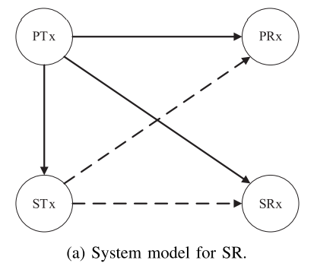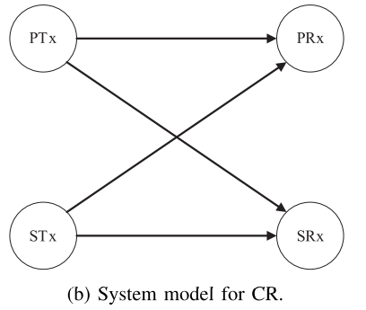

Artificial-Noise-Aided Energy-Efficient Secure Multibeam Wireless Communication Schemes Based on Frequency Diverse Array
This paper addresses the problem of ensuring secure wireless communication in multibeam transmission systems, where confidential information must be delivered to legitimate users while preventing interception by unauthorized receivers. Wireless communication systems inherently broadcast signals through open space, making them vulnerable to eavesdropping. Traditional techniques such as phased array antennas mainly control signal direction based on angle, which may still allow unintended receivers at different distances to intercept signals. To overcome this limitation, the paper proposes a secure transmission framework that combines Frequency Diverse Array (FDA) technology with artificial noise (AN). The objective is to improve physical layer security in multibeam directional modulation (MBDM) systems by ensuring that confidential signals are effectively received by legitimate users while being distorted or masked for potential eavesdroppers.
The study considers a wireless communication scenario consisting of a transmitter equipped with an array antenna, multiple legitimate users (LUs), and several passive eavesdroppers (Eves). Unlike conventional phased arrays, FDA antennas introduce small frequency offsets across array elements, producing beam patterns that depend on both angle and range. This property enables more precise signal focusing in space, making it harder for unintended receivers to access the transmitted information. The system also incorporates artificial noise, which is transmitted alongside the confidential signals to deliberately interfere with potential eavesdroppers while maintaining minimal impact on legitimate users. To achieve this, the authors jointly optimize three key components: the frequency offsets of the array elements, the precoding matrix used for beamforming, and the artificial noise projection matrix. These components are designed to maximize secure communication performance while maintaining energy efficiency.
Two different communication scenarios are investigated. In the first scenario, the transmitter is assumed to know the approximate locations of the eavesdroppers. In this case, the system minimizes the power of confidential signals received by eavesdroppers while ensuring that legitimate users receive sufficient signal strength. In the second scenario, the locations of eavesdroppers are unknown, which represents a more realistic environment. Here, the system allocates more transmission power to artificial noise so that potential eavesdroppers experience strong interference regardless of their location. In both cases, artificial noise is projected into a space that does not affect legitimate users but significantly reduces the signal quality at eavesdroppers.
To further enhance security performance, the authors optimize the frequency offsets of the antenna array using a modified Artificial Bee Colony (M-ABC) optimization algorithm. This algorithm improves the standard bee colony optimization method by incorporating ideas from particle swarm optimization and genetic algorithms, enabling more effective global search and avoiding premature convergence. Through this optimization process, the system maximizes the secrecy capacity, which represents the difference between the data rate achievable by legitimate users and that accessible to eavesdroppers.
Simulation results demonstrate that the proposed scheme successfully improves secure transmission performance. The results show that artificial noise can be distributed in such a way that legitimate users receive clear signals while eavesdroppers experience significantly degraded signal quality. The proposed optimization approach also enhances beam focusing in both angle and range dimensions, enabling efficient multibeam communication for multiple users simultaneously. Overall, the study demonstrates that combining FDA technology, artificial noise, and intelligent optimization algorithms provides an effective solution for achieving secure and energy-efficient wireless communication in multiuser environments.
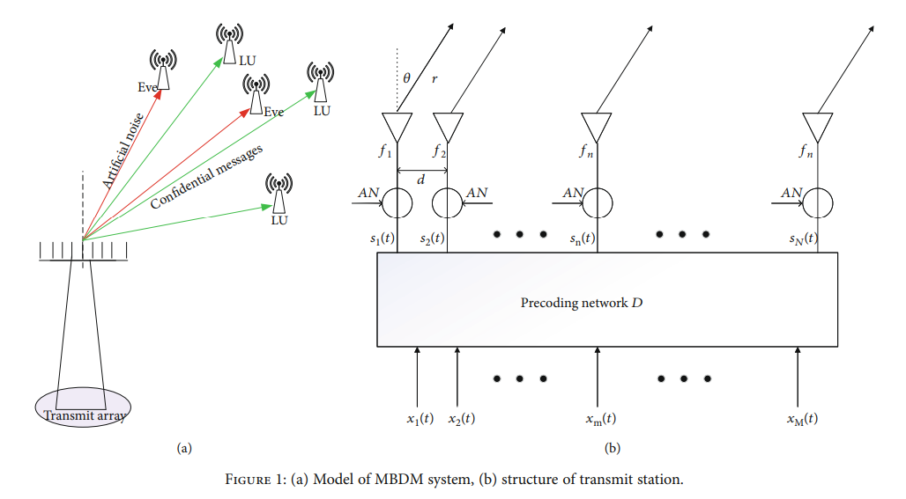

Robust Deep Radio Frequency Spectrum Learning for Future Wireless Communications Systems

The paper addresses the lack of robustness and generalization in Deep Learning (DL) models applied to wireless communication systems, particularly when there is a mismatch between training and testing data distributions with respect to Signal-to-Noise Ratio (SNR) [1], [2]. The study investigates “RF learning” across three practical scenarios: intended transmitter-receiver pairs, spectrum coexistence, and spectrum monitoring [3]. A central goal is to demonstrate that training with a fixed SNR is insufficient for practical deployment and to determine optimal training strategies—specifically regarding SNR selection and step size—to overcome the “distribution alignment problem” and ensure high accuracy in dynamic RF environments [2], [4].
The methodology employs an experimental “over-the-air” approach rather than relying solely on simulation. The testbed consisted of National Instruments USRP 2932 transceivers controlled via LabVIEW [5], with DL models implemented in Keras using TensorFlow [6]. Modulated signals (10 schemes including BPSK, QPSK, and 16QAM) were generated at a 2.4 GHz carrier frequency, and data were collected across varying SNRs (0–12 dB) by physically moving the USRP devices to capture real-world impairments [5], [7]. The authors compared CNN and LSTM architectures, ultimately selecting a 4-layer CNN (two convolutional and two dense layers) for its comparable accuracy and faster training [8], [6]. Three scenarios were evaluated: Automatic Modulation Classification (AMC) for intended transmitter-receiver pairs [9], coexistence classification in unlicensed spectrum (LTE-U, WiFi, Idle, or Both) [10], [11], and spectrum monitoring under varying SNRs [12]. Training strategies tested included models trained on single fixed SNRs versus multiple fixed SNRs with varying step sizes (0.5 dB, 1 dB, 2 dB) to analyze generalization [13-15].
The findings reveal several critical outcomes. Models trained on a single fixed SNR fail catastrophically when tested on different SNRs; for example, a model trained on 10 dB achieved 97.81% accuracy on 10 dB test data but dropped to 22.66% accuracy on 8 dB data [2], [3]. Using the Kolmogorov-Smirnov statistic, the authors confirmed that datasets with widely separated SNRs have different distributions, and successful generalization requires training data to cover the underlying distribution of the test environment [16], [17]. Step size granularity proved crucial: in spectrum monitoring, a fine step size (0.5 dB) generalized well to unseen intermediate SNRs (94.47% accuracy on 1.5 dB), while a coarse step size (2 dB) performed poorly (43.63% accuracy on 6 dB) [18], [19]. In AMC tasks, the model struggled to distinguish between 16QAM and 64QAM due to constellation overlap [20]. In coexistence scenarios, however, the model achieved very high accuracy (99.35%) when trained and tested on the same SNRs, outperforming AMC because of fewer, more distinguishable classes [21].
The applications and implications are significant for 5G and future wireless networks. For robust deployment, DL models must be trained on datasets containing a spectrum of SNRs with fine granularity rather than optimized for a single clean SNR [22], [23]. Accurate identification of interference and user types enables more efficient spectrum sharing and resource optimization [24], [9]. The techniques also support device fingerprinting and intrusion detection, allowing systems to distinguish authorized transmitters from malicious jammers in IoT environments [25], [26]. The CNN model demonstrated an inference latency of only 68 microseconds on a GPU, confirming its suitability for real-time edge computing applications [27].
The study acknowledges limitations and future research needs. While this work used over-the-air data, many existing studies rely on synthetic data, and future research should investigate how differences between synthetic and real-world RF data affect performance [28]. The paper also highlights adversarial robustness, noting that wireless signals naturally undergo perturbations similar to adversarial attacks, and future work should compare standard generalization with adversarially robust generalization [23]. Finally, current models struggle when test data distributions deviate significantly from training distributions, and future research should focus on developing models that can generalize to unseen distributions without exhaustive training across all possible SNR levels [29].
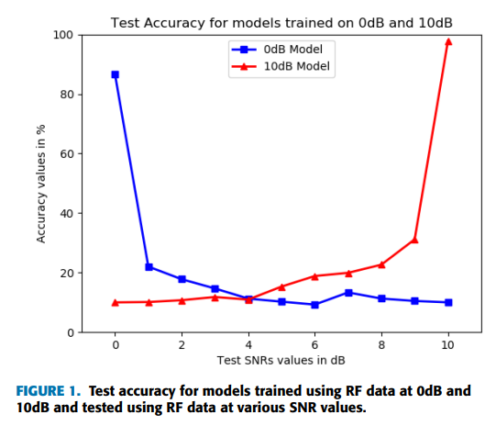

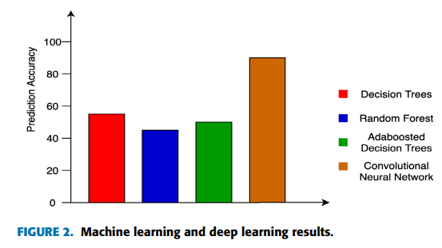

Nonlinear Noise Compensation in an Integration System of Fiber-Wireless Communication and Free Space Optical Communication
The paper addresses the issue of nonlinear signal distortion, specifically beating noise between subcarriers, in an integrated communication system that combines fiber-wireless (Fi-Wi) and Free Space Optical (FSO) technologies. The square-law detection of photoelectric components generates interference when using OFDM, reducing transmission performance. The authors aim to demonstrate that a nonlinear equalizer can effectively compensate for this distortion, thereby enhancing receiving sensitivity and reliability in a seamless system that merges the high bandwidth of millimeter-wave wireless with the security and interference immunity of FSO.
The methodology involved designing and experimentally validating a hybrid transmission link. The system architecture integrated three stages: 100 meters of SMF, 100 meters of FSO link, and 4 meters of wireless millimeter-wave link at 75 GHz. A 1-Gbaud 16QAM DMT-OFDM signal was generated using an AWG and modulated onto an optical signal via a Directly Modulated Laser. Millimeter-wave generation used a photon-assisted approach, coupling the data-carrying optical signal with a continuous light wave from an ECL, with the frequency difference producing the 75 GHz carrier. At the receiver, a photodetector converted optical to electrical signals, followed by envelope detection to downconvert to baseband. A digital oscilloscope (50 GSa/s, 16 GHz bandwidth) captured signals for offline processing. Compensation was achieved using a Volterra nonlinear equalizer based on the LMS algorithm, retaining first- and second-order terms to balance complexity and accuracy. Additional DSP techniques, including H-averaging and spread spectrum DFT processing, further optimized performance.
The findings confirm the feasibility of the integrated system. The 1-Gbaud 16QAM-DMT signal was successfully transmitted across the composite link with BER below the HD-FEC threshold. The Volterra nonlinear equalizer suppressed beating noise from the square-law detector, improving receiving sensitivity by 0.7 dB compared to the uncompensated system. Signal constellation analysis showed significantly better convergence with the equalizer, validating nonlinear noise reduction. The experiment confirmed that photon-assisted millimeter-wave technology can seamlessly combine with FSO systems, maintaining performance despite nonlinear effects of direct detection.
The applications are highly relevant for next-generation broadband and 5G/6G networks. Integrating FSO and millimeter-wave technologies offers robust solutions for emergency services, combining FSO’s security and EMI immunity with millimeter-wave’s obstacle penetration. The system supports high-capacity wireless transmission, making it suitable for last-mile access bottlenecks where fiber installation is impractical. The use of envelope detection with digital compensation provides a cost-effective alternative to complex coherent detection systems, enabling economically viable high-speed hybrid networks.
The study also identifies limitations and future directions. The Volterra equalizer involves a trade-off between accuracy and computational load, as higher-order terms were discarded to manage complexity. Future research could explore efficient algorithms or hardware accelerations to handle higher-order nonlinearities. Signal attenuation of high-frequency components due to frequency-selective fading requires advanced equalization or pre-distortion techniquee. Environmental robustness remains to be validated, as experiments were conducted under fixed distances; future work should test diverse atmospheric conditions and longer ranges.
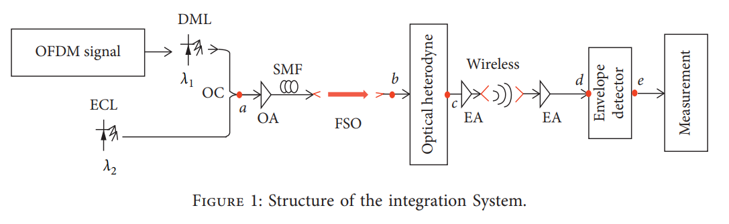

How Can Sound Generating Devices Support Coping With Tinnitus?
The objective of this paper is to understand how individuals with tinnitus perceive the role of sound generating devices in supporting their ability to cope with tinnitus, rather than focusing on whether these devices eliminate or suppress the tinnitus sound itself. Tinnitus is a subjective and often distressing condition that can significantly disrupt emotional well-being, sense of self, and daily functioning. Although sound therapy and sound generating devices are commonly prescribed in clinical audiology practice, existing quantitative research has produced inconsistent evidence regarding their effectiveness, and current outcome measures may fail to capture patient-perceived benefits. The paper therefore aims to explore, from the patient’s perspective, the underlying mechanisms through which sound generating devices contribute to coping, and to develop a theory grounded in lived experiences that explains why these devices may be helpful despite uncertain clinical efficacy.
The methodology employed in this study is a qualitative, interview-based design informed by grounded theory methodology. Ten adult patients from the UK National Health Service who had been issued sound generating devices by an audiology department participated in in-depth, semi-structured interviews. Participants were purposively sampled to provide contrast in age, gender, tinnitus duration, and life context, and interviews were conducted until thematic saturation was reached. The interviews explored participants’ emotional experiences of tinnitus, their interactions with sound generating devices, and how device use influenced their perception of tinnitus over time. All interviews were audio-recorded, transcribed verbatim, anonymized, and systematically analyzed using open coding, constant comparative analysis, and thematic categorization. Both researchers independently coded transcripts to enhance analytical rigor and credibility, and emerging concepts were refined iteratively to construct a data-driven theoretical framework.
The results reveal that sound generating devices support coping through three interconnected mechanisms rather than by directly masking or eliminating tinnitus. The first mechanism is validation, where the process of receiving a device and engaging in supportive clinical encounters helped participants feel that their tinnitus was acknowledged as a legitimate and serious condition. This validation reduced anxiety and restored a sense of legitimacy to an otherwise invisible condition. The second mechanism is escapism, where pleasant external sounds provided distraction from tinnitus, enabling participants to mentally disengage from distressing tinnitus awareness and evoke calming memories or imagery. The third mechanism is regaining control, as the physical presence of the device and the ability to adjust sound levels gave participants a tangible sense of agency over their tinnitus experience. These mechanisms collectively contributed to a higher-order process described as restoring embodiment, in which the disrupted relationship between the self and the body caused by tinnitus was gradually repaired, allowing tinnitus to become a manageable part of the individual’s lived experience rather than a dominant threat.
In conclusion, the paper establishes that sound generating devices assist individuals with tinnitus primarily by supporting psychological and emotional coping mechanisms rather than by removing the tinnitus percept. Through validation, escapism, and restoration of control, these devices help individuals regain a sense of embodiment and well-being. However, the study is limited by its small sample size, limited demographic diversity, and reliance on self-reported experiences. The findings nonetheless provide valuable insight into why sound therapy may be perceived as beneficial despite inconsistent quantitative evidence. Future research should explore these mechanisms across more diverse populations, integrate qualitative outcomes into clinical assessment tools, and investigate how sound therapy can be optimally combined with counseling and person-centered care approaches. This work highlights the importance of patient-centered perspectives in tinnitus management and suggests that outcome measures should extend beyond tinnitus loudness to include embodiment, control, and coping.
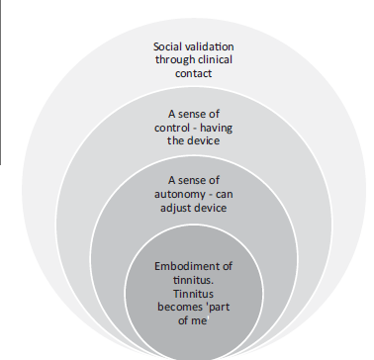

Automatic modulation classification of noise-like radar intrapulse signals using cascade classifier
The paper aims to address the critical challenge of automatic modulation classification (AMC) of noise-like intrapulse radar signals, particularly in environments where noise can be mistaken for radar signals. This problem is significant due to the increasing complexity and variety of radar modulation schemes, especially low probability of intercept (LPI) signals that exhibit noise-like characteristics, making their detection and classification in low signal-to-noise ratio (SNR) conditions highly challenging. Existing AMC methods often suffer from high computational complexity, sensitivity to noise types, or limited recognition accuracy for diverse modulation types. The study specifically targets the development of a robust, efficient, and accurate classification framework capable of distinguishing noise from radar signals and classifying multiple radar modulation schemes under various noise conditions and SNR levels.
To tackle these objectives, the authors propose a novel cascade classification system combining two machine learning models: a Support Vector Machine (SVM) and a Convolutional Neural Network (CNN). The methodology begins with extracting the main ridge slice feature (MSF) from the ambiguity function (AF) of intercepted signals. This feature effectively distinguishes noise from radar signals because noise AFs primarily exhibit a single main lobe, whereas radar signals display additional side lobes. The SVM, using a linear kernel, is trained on half of the symmetrical MSF to perform binary classification between noise and radar signals efficiently. Once a signal is identified as radar, its intermediate frequency (IF) is estimated using the Fast Fourier Transform (FFT), and the IF component is removed to extract complex envelope features representing the signal’s phase variations. These features are represented as two-dimensional texture-like images, preserving the phase change laws intrinsic to different modulation types. The CNN architecture, inspired by VT-CNN2 and tailored for this task, consists of two convolutional layers and two fully connected layers with ReLU activations and dropout regularization, designed to extract discriminative features from the complex envelope and perform multi-class classification among eleven radar modulation schemes. The training data are synthetically generated across a range of SNRs and noise types, and both models are implemented using Python with TensorFlow and scikit-learn libraries.
The key findings demonstrate that the proposed SVM-CNN cascade achieves superior classification performance compared to existing techniques. The combined approach attains an overall probability of successful recognition (PSR) of 98.52% at 20 dB SNR and maintains a PSR of 82.27% even at -2 dB SNR, illustrating robustness in low SNR scenarios. The SVM effectively filters out noise, reducing false alarms and computational overhead for the CNN, which then accurately classifies complex radar modulation schemes, including phase-coded and frequency-modulated signals with numerous sub codes. The CNN behaves akin to a bank of matched filters, learning to respond to specific phase patterns and invariant features across signal families, enabling it to generalize well despite parameter variations. The study also highlights the importance of precise IF estimation, as errors in IF removal significantly impact classification accuracy. Computational complexity analysis shows that the proposed method operates with time complexity O(N log N), which is more efficient than alternative methods relying on time-frequency images with O(N²) complexity, making it suitable for real-time or resource-constrained applications.
This research has important applications and implications in the fields of electronic reconnaissance, radar signal intelligence, and spectrum management. By reliably distinguishing radar signals from noise and classifying complex modulation types under diverse noise conditions, the proposed method enhances automatic identification and tracking of radar emitters, which is critical for defence and surveillance systems. Its robustness to noise and parameter variations improves the detection of LPI radars that are designed to evade interception, thereby strengthening electronic warfare capabilities. Furthermore, the computational efficiency and modular design of the cascade classifier make it feasible for real-time deployment in practical radar receivers and signal processing hardware. Beyond radar, the approach’s principles could be adapted to communication signal classification and cognitive radio systems, where automatic identification of signal types under noisy conditions is essential. The study also opens pathways for future work to refine IF estimation, incorporate additional noise models, and expand the classifier to new modulation schemes, thus broadening its operational scope and impact.
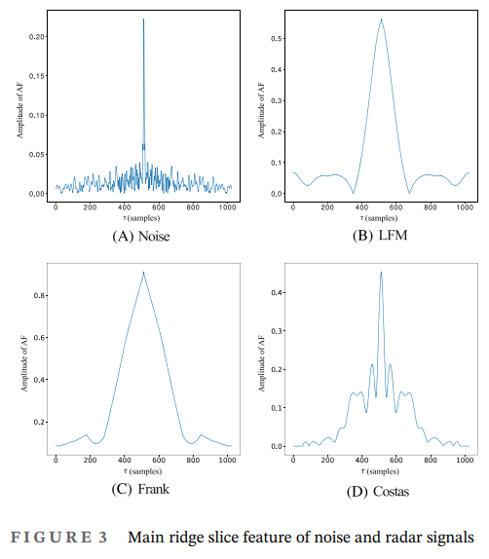

A machine learning approach for detecting wind farm noise amplitude modulation
This paper addresses the problem of reliably detecting amplitude modulation (AM) components in environmental and traffic noise, a phenomenon known to significantly increase human annoyance even when overall sound pressure levels remain unchanged. Conventional noise metrics based solely on energy averaging fail to capture these perceptually relevant temporal fluctuations, motivating the need for a robust and objective AM detection framework suitable for long-term noise monitoring.
The theoretical basis of the work lies in the psychoacoustic understanding of modulation depth and modulation frequency, where slow temporal envelope variations in broadband noise are known to correlate strongly with perceived annoyance. The authors build upon existing modulation spectrum analysis techniques, but identify limitations in sensitivity and consistency when applied to non-stationary real-world noise signals, particularly those dominated by road traffic.
Methodologically, the paper proposes an enhanced AM detection algorithm based on signal preprocessing, band-limited envelope extraction, and statistical thresholding of modulation indices. The noise signal is first filtered into relevant frequency bands to isolate perceptually dominant components, after which the temporal envelope is extracted using analytic signal techniques. A modulation depth metric is then computed and compared against adaptive thresholds derived from background noise statistics, allowing the algorithm to distinguish true AM events from random fluctuations. The method is validated using both synthetic test signals with known modulation characteristics and real traffic noise recordings collected under varied environmental conditions.
The results demonstrate that the proposed approach achieves significantly improved detection accuracy compared to earlier AM metrics, particularly in low signal-to-noise ratio scenarios and in the presence of overlapping noise sources. The algorithm shows strong robustness against false positives while maintaining high sensitivity to perceptually salient modulation patterns. These improvements make the method suitable for continuous environmental noise assessment and regulatory monitoring applications.
From an application perspective, the work is highly relevant to urban noise management, traffic noise assessment, and environmental acoustics regulation, where objective identification of annoying noise characteristics is increasingly required. The authors also note that the computational simplicity of the method allows for real-time or near-real-time deployment.
Despite its strengths, the study acknowledges limitations related to dependence on parameter tuning and the need for further validation across diverse climatic and traffic conditions. Future research directions include integrating perceptual weighting models and coupling AM detection with machine learning frameworks to improve adaptability across environments.
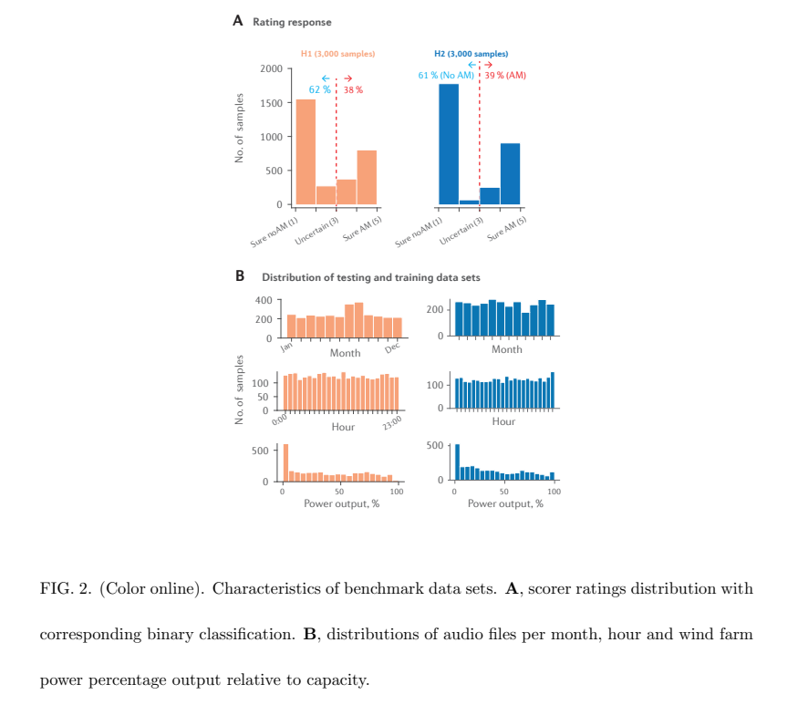

Deep Learning-Based Digital Signal Modulation Identification under Different Multipath Channels
The objective of this paper is to develop a robust digital signal modulation identification (DSMI) method that remains effective under varying multipath channel conditions, particularly for orthogonal frequency division multiplexing (OFDM) systems. Traditional deep learning–based DSMI methods typically assume additive white Gaussian noise (AWGN) or fixed multipath channels, leading to significant performance degradation when channel conditions change unless the model is retrained. This limitation restricts their practical applicability in real wireless environments where delay spread, path number, and channel coefficients vary dynamically. The primary goal of the study is therefore to design a DSMI framework that can accurately identify modulation types by learning intrinsic modulation features rather than channel-dependent distortions, thereby reducing retraining requirements and improving adaptability across diverse multipath scenarios.
The methodology adopted in this work consists of a two-stage framework combining signal processing–based channel compensation with a specialized deep learning classifier. In the preprocessing stage, the received OFDM signals undergo channel estimation and equalization to mitigate multipath effects. Both blind and pilot-based channel estimators are evaluated, including second-order statistics blind (SOSB) estimation, subspace blind (SB) estimation, least squares (LS), and minimum mean square error (MMSE) estimation, followed by zero-forcing (ZF) and MMSE equalization. In the classification stage, a novel deep learning architecture called RSN-MI is proposed, which is based on a modified deep residual shrinkage network. RSN-MI incorporates a dynamic soft-threshold update mechanism that adaptively suppresses noise-dominated features while preserving modulation-specific characteristics in the in-phase and quadrature (IQ) data. The framework is trained using OFDM signals with modulation types including BPSK, QPSK, 8PSK, 16QAM, 32QAM, and 64QAM. Extensive simulations and real-signal experiments are conducted using a software-defined radio platform to evaluate performance under dynamically varying multipath channel conditions.
The results demonstrate that the proposed RSN-MI–based DSMI framework significantly outperforms conventional modulation identification methods across a wide range of signal-to-noise ratios. With appropriate channel preprocessing, the proposed approach achieves identification accuracy close to 98% at an SNR of 10 dB and approaches 100% accuracy as SNR increases, even when channel parameters vary randomly. Comparative evaluations show that RSN-MI consistently outperforms traditional maximum likelihood–based methods, pattern recognition approaches using higher-order cumulants, and conventional convolutional neural network classifiers, particularly in low-SNR and highly dynamic multipath environments. Additionally, complexity analysis reveals that RSN-MI achieves superior performance with fewer parameters and lower computational overhead than standard CNN-based models, making it suitable for real-time deployment.
In conclusion, the paper establishes an effective and adaptable deep learning–based solution for digital signal modulation identification in realistic multipath wireless channels. By integrating robust signal preprocessing with a noise-aware deep learning classifier, the proposed method successfully isolates modulation features from channel-induced distortions, enabling reliable identification without extensive retraining. While the study is limited by its focus on single-user OFDM scenarios and controlled experimental environments, it provides a strong foundation for practical DSMI systems. Future research directions include extending the framework to fully non-cooperative communication scenarios, multi-user environments with mixed modulation schemes, and multi-modal learning approaches that combine time-domain, frequency-domain, and constellation-based features for further performance enhancement.
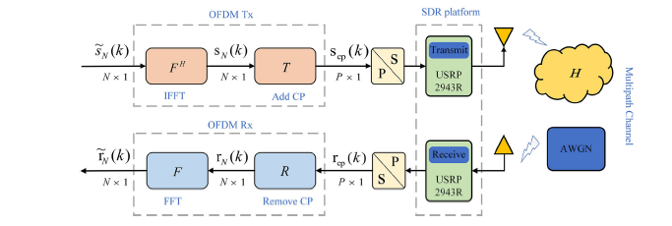

Automatic Recognition of Communication Signal Modulation Based on Multiple-Parallel Complex CNN
This paper addresses the challenge of recognizing complex-valued digital modulation signals in modern communication systems, where conventional real-valued neural networks fail to fully exploit the structure of complex baseband data. The study aims to improve modulation recognition accuracy by explicitly modelling the real and imaginary components of signals and by jointly extracting spatial and temporal features.
The theoretical basis lies in complex signal processing and deep learning, where modulation patterns exhibit distinct structures in the time-frequency domain. By mapping complex baseband signals into time-frequency images and processing them through parallel convolutional branches, the network can better preserve phase and amplitude information. Temporal dependencies are further captured using LSTM networks.
The methodology proposes a multi-parallel complex CNN architecture combined with CNN-LSTM feature fusion. Time-frequency analysis is first used to convert signals into image-like representations. Parallel CNN branches process real and imaginary components separately, and an LSTM module extracts temporal characteristics. Feature fusion and classification are then performed using a deep learning framework.
The results show that the proposed architecture achieves higher recognition accuracy than traditional CNN models, particularly in low-SNR conditions. The fusion of spatial and temporal features significantly enhances robustness and reduces misclassification among similar modulation schemes.
The work is relevant for software-defined radios, electronic countermeasures, and intelligent receivers, where accurate modulation recognition under noisy and dynamic conditions is essential.
Limitations include increased computational complexity and dependence on time-frequency pre-processing. Future work could focus on lightweight architectures, real-time hardware implementation, and end-to-end learning directly from raw I/Q samples.
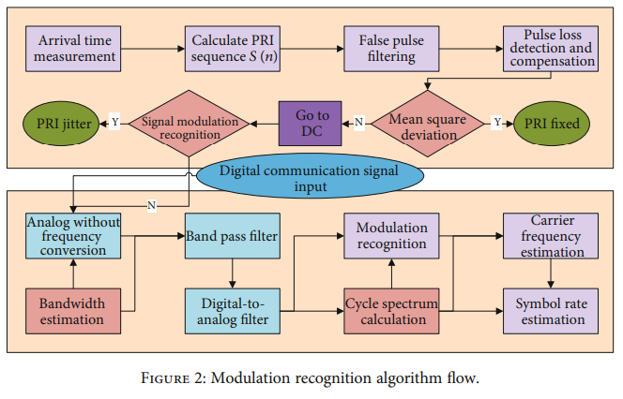

Enhancing the Efficacy of Noise Modulation for SBS Suppression in High Power, Narrow Linewidth Fiber Lasers by the Incorporation of Sinusoidal Modulation
The objective of this paper is to enhance the suppression of stimulated Brillouin scattering (SBS) in high-power, narrow-linewidth continuous-wave fiber lasers, which are critical for applications such as coherent beam combining, laser guide stars, nonlinear frequency conversion, and LIDAR systems. SBS is the lowest-threshold nonlinear effect in narrow-linewidth fiber lasers and manifests as high-peak-power backward-propagating pulses that can cause catastrophic damage to laser systems, thereby limiting power scalability. Although external phase modulation using filtered white noise is widely employed due to its simplicity and tunability, the resulting broadened laser spectrum exhibits a sharp central peak with slow spectral roll-off, leading to enhanced SBS seeding from reflections and reduced experimental SBS threshold compared to theoretical predictions. The primary objective of the study is therefore to improve SBS suppression without increasing system complexity or linewidth by introducing a dual-modulation approach that combines white noise modulation with sinusoidal modulation to achieve a more favorable spectral line-shape.
The methodology employed in this work is based on both numerical simulations and experimental validation using a fully polarization-maintaining, multi-stage fiber amplifier system. Initially, simulations are performed to analyze the evolution of the laser line-shape under the proposed dual modulation with sinusoid and noise (DMSN) scheme by modelling the phase modulator transfer function and synthesizing filtered noise waveforms. The RMS linewidth is used as a key metric to quantify spectral broadening and compare different modulation schemes, as it captures both central flatness and spectral roll-off characteristics. Experimentally, a 1064-nm distributed Bragg reflector seed laser with a narrow intrinsic linewidth is phase-modulated using cascaded filtered white noise and sinusoidal RF signals. The line-broadened seed is subsequently power-scaled through a three-stage polarization-maintaining Ytterbium-doped fiber master oscillator power amplifier (MOPA) architecture, consisting of a pre-amplifier, medium-power amplifier, and high-power amplifier. SBS onset is monitored using backward power measurements and high-speed photodetection, with the SBS threshold conservatively defined by the recurrence of backward pulses with peak powers around 10 W to ensure safe system operation.
The results demonstrate that the proposed dual modulation scheme significantly enhances SBS suppression compared to conventional noise-only modulation at similar RMS linewidths. At an RMS linewidth of approximately 7.3 GHz, the SBS-limited output power increases from 319 W with pure noise modulation to 751 W using DMSN, corresponding to an enhancement factor greater than 2.3. Further improvements are observed at higher linewidths, with output power scaling from 388 W to 879 W at around 9.4 GHz, and from 525 W to over 1029 W at approximately 10.4 GHz without encountering SBS-induced pulse formation. Spectral measurements confirm that DMSN produces a flatter-topped central spectrum with faster roll-off, significantly reducing overlap with the Brillouin gain spectrum and suppressing SBS seeding. The system achieves stable kilowatt-level operation, with power scaling ultimately limited by modal instability rather than SBS.
In conclusion, the paper establishes that incorporating sinusoidal modulation alongside white noise modulation provides a simple yet highly effective means of improving SBS suppression in high-power, narrow-linewidth fiber lasers. The proposed DMSN approach achieves more than a twofold increase in SBS-limited output power at the same linewidth, without requiring complex waveform generation hardware such as arbitrary waveform generators or pseudo-random binary sequence modulators. While the study is limited to experimental demonstrations within specific linewidth ranges and amplifier configurations, the results clearly indicate the potential of this technique for scalable, kilowatt-class laser systems. Future research directions include extending the approach to multi-kilowatt power levels, mitigating modal instability, optimizing modulation parameters for different fiber designs, and integrating anti-reflection strategies to further increase SBS thresholds.
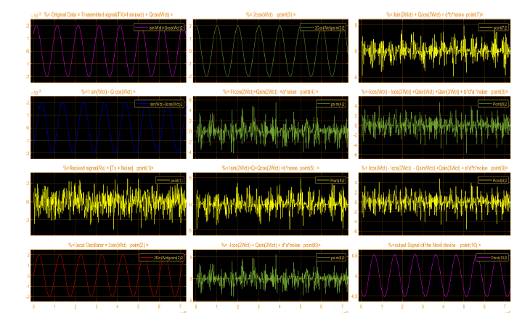

Noise Shaping Enhanced DMT Signal Transmission Utilizing Low-Resolution DAC
The objective of this paper is to address the performance degradation caused by quantization noise in discrete multitone (DMT) optical transmission systems employing low-resolution digital-to-analog converters (DACs), which are increasingly preferred for low-cost, energy-efficient short-reach optical interconnects. In high-speed intra-data-center interconnect (intra-DCI) systems, DMT modulation offers high spectral efficiency and robustness to chromatic dispersion but suffers from high peak-to-average power ratio, which exacerbates quantization noise when low-bit DACs are used. Conventional solutions such as delta-sigma modulation require very high oversampling rates, making them impractical. The primary objective of this study is therefore to investigate a practical noise shaping technique that redistributes quantization noise from the data subcarrier band to the null subcarrier band, thereby improving signal quality and enabling high-order DMT transmission with low-resolution DACs.
The methodology employed in this work combines theoretical analysis, numerical simulation, and experimental validation of a noise shaping enhanced DMT transmission system. The proposed noise shaping technique is implemented using a finite impulse response (FIR) feedback filter following the DAC, forming a noise transfer function that suppresses quantization noise within the signal band. The filter coefficients are derived analytically using pseudo-inverse matrix operations, and the tap length is optimized based on signal-to-quantization-noise ratio (SQNR) enhancement analysis. The system performance is analyzed by modelling both quantization noise and channel noise, and their combined impact on signal-to-noise ratio and bit error rate (BER). Simulations are conducted for 25-GHz DMT signals with QPSK, 16-QAM, 32-QAM, and 64-QAM modulation formats under different DAC resolutions. Experimental validation is performed in a 2-km single-mode fiber IM/DD optical interconnect using 4-bit, 5-bit, and 6-bit DACs, with BER performance measured against received optical power at the hard-decision forward error correction threshold.
The results demonstrate that the proposed noise shaping technique significantly improves the performance of low-resolution DAC-based DMT systems. Simulation results show that SQNR improvements of up to 8–9 dB can be achieved depending on DAC resolution, enabling lower-bit quantization systems to support higher-order modulation formats. Experimentally, the receiver sensitivity of a 4-bit 16-QAM DMT system is improved by approximately 4.3 dB, while a 5-bit 32-QAM DMT system achieves a sensitivity improvement of about 2.5 dB at the HD-FEC threshold. Notably, the performance of a 4-bit 16-QAM system with noise shaping matches that of an 8-bit system without noise shaping, confirming the effectiveness of quantization noise suppression. The experimental results closely align with simulation predictions, validating the theoretical noise analysis and system model.
In conclusion, the paper establishes that noise shaping is an effective and practical solution for mitigating quantization noise in DMT-based optical interconnects utilizing low-resolution DACs. By redistributing quantization noise outside the signal band, the proposed technique enables high-speed, high-order modulation transmission without increasing DAC resolution, thereby reducing system cost and power consumption. Although the study focuses on short-reach intra-DCI scenarios and specific modulation formats, the approach shows strong potential for future low-cost optical transport systems. Future research directions include extending the technique to longer transmission distances, optimizing filter design for adaptive modulation, and integrating noise shaping into real-time DSP architectures for next-generation 6G optical networks.
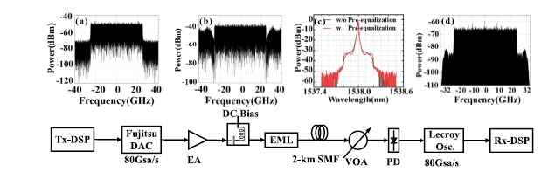

A Hybrid LSTM-ResNet Deep Neural Network for Noise Reduction and Classification of V-Band Receiver Signals
This paper addresses the challenge of mitigating noise and accurately classifying signals in V-band (millimeter-wave) receivers, where high path loss and hardware impairments significantly degrade signal quality. This problem is crucial for next-generation high-frequency communication systems used in 5G/6G backhaul and radar applications. The study aims to develop a deep learning-based framework that simultaneously performs noise reduction and signal classification.
The theoretical framework combines temporal sequence modelling and deep feature extraction. The proposed methodology integrates Long Short-Term Memory (LSTM) networks for temporal noise modelling with Residual Networks (ResNet) for hierarchical feature extraction. The hybrid architecture processes time-domain and frequency-domain representations of received signals. The model is trained using labelled datasets containing noisy and clean signal samples across different modulation formats.
Experimental results show that the hybrid LSTM-ResNet model significantly improves signal-to-noise ratio and classification accuracy compared to conventional filtering and standalone CNN approaches. The system demonstrates robustness under severe noise conditions, validating the effectiveness of temporal-spatial feature learning. The results contribute to the growing body of AI-assisted physical-layer signal processing research.
The proposed approach is applicable to millimeter-wave communication systems, radar signal processing, and intelligent receivers. Despite its effectiveness, the model suffers from high computational complexity and training data dependency. Future work could focus on model compression, online learning, and deployment on edge devices.
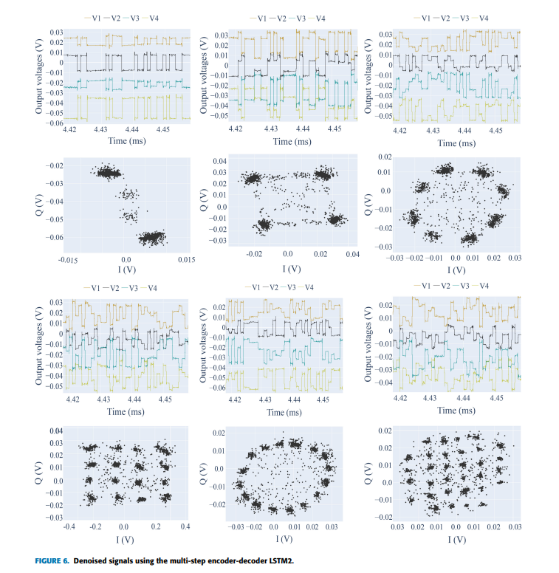

Deep Adversarial Reinforcement Learning With Noise Compensation by Autoencoder
The paper focuses on improving the robustness of deep reinforcement learning (DRL) systems when they operate in environments affected by noise or adversarial disturbances. In real-world applications such as autonomous driving, robotics, or game environments, input observations (often images from sensors) may be corrupted by random noise or deliberately manipulated adversarial perturbations. These disturbances can cause reinforcement learning agents to make incorrect decisions or choose unsafe actions. To address this issue, the study proposes a deep adversarial learning framework that enhances the internal representation of reinforcement learning models so that they remain reliable even when inputs are noisy or adversarial modified. The main objective is to develop a DRL architecture capable of maintaining stable policies and accurate decision-making despite perturbations in the observation space.
Methodologically, the research introduces two architectures that integrate reinforcement learning with Denoising techniques: Deep Q-Network with Autoencoder (DQAE) and an advanced version called Deep Q-W-Network with Autoencoder (DQWAE). Both architectures employ a shared encoder that extracts features from input images, while additional decoder networks perform different tasks. The Autoencoder component reconstructs clean images from noisy inputs, helping the network learn noise-resistant feature representations. In the advanced DQWAE architecture, an additional W-network predicts worst-case action outcomes, allowing the system to generate adversarial examples during training that encourage the agent to avoid harmful decisions. Adversarial noise is generated using a gradient-based method and applied to the training data so that the model learns to compensate for disturbances. Experiments were conducted using Atari 2600 game environments and a simulated autonomous driving task, where models were trained using stochastic gradient optimization and evaluated under both random noise and adversarial attacks.
The experimental results demonstrate that the proposed DQWAE model consistently achieves greater robustness than standard deep Q-networks and other baseline methods. In Atari game experiments, the model maintained higher scores when input images were affected by random noise, white-box attacks, and black-box attacks. In several games, such as Star Gunner and Chopper Command, the improvements were especially significant, indicating that the proposed method is particularly beneficial for complex decision-making environments. Furthermore, even in noiseless conditions, the DQWAE architecture often achieved better performance than baseline models, suggesting that the adversarial training strategy not only increases robustness but also accelerates learning by improving feature representation. Similar benefits were observed in the autonomous driving simulation, where the system was able to maintain stable driving behaviour and avoid pedestrians even when input images were disturbed.
The findings contribute to the development of more reliable reinforcement learning systems that can operate safely in real-world environments where sensor noise and unexpected disturbances are common. By combining adversarial training with a Denoising Autoencoder, the proposed framework improves the stability of internal representations within the neural network, enabling the agent to maintain effective control policies even under adversarial conditions. This approach is particularly relevant for applications such as autonomous vehicles, robotics, and other safety-critical systems where decision-making errors caused by corrupted inputs could have serious consequences. The method also demonstrates compatibility with existing deep reinforcement learning frameworks, making it feasible for integration into future robust AI systems.
Despite these promising results, the study also highlights several limitations. The proposed method was primarily tested in environments with discrete action spaces, meaning further research is required to adapt the approach to continuous control problems commonly found in robotics and real-world control systems. Additionally, most experiments were conducted in simulated environments, and the effectiveness of the method in real-world scenarios with highly complex sensor data remains to be explored. Future research directions include extending the approach to actor-critic and policy-gradient reinforcement learning methods, improving adversarial example generation strategies, and evaluating the system in large-scale real-world applications such as autonomous driving datasets and robotic platforms. These improvements could further enhance the robustness and adaptability of reinforcement learning systems operating in uncertain and dynamic environments.
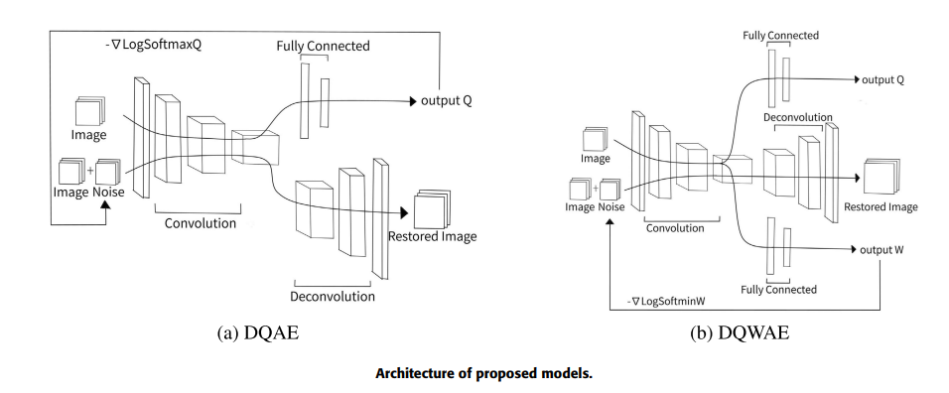

Noise Modulation-Based Reversible Data Hiding with McEliece Encryption
The objective of this paper is to design a highly secure and high-capacity reversible data hiding scheme in the encrypted domain (RDH-ED) that is resistant to quantum computing attacks. Existing RDH-ED techniques often rely on symmetric encryption or traditional public-key cryptosystems, which face challenges such as limited embedding capacity, dependency on image redundancy, key distribution complexity, and vulnerability to quantum algorithms like Shor’s and Grover’s. To address these limitations, the study aims to exploit the redundancy inherent in the McEliece public-key cryptosystem—a post-quantum cryptographic algorithm—to embed additional data without affecting encryption security or image reversibility. The goal is to achieve high embedding rates, perfect reversibility, and strong security while making the scheme applicable to any encrypted signal, not only images.
The methodology proposed in this work introduces a noise modulation-based reversible data hiding scheme called NM-RDHED. The authors first analyze the McEliece encryption process and mathematically prove that the random error vector added during encryption constitutes redundant space that can be safely exploited for data embedding. Based on the error-correction capability of McEliece coding, the random noise is divided into multiple sub-noises and classified according to their Hamming weights. A noise modulation principle is then defined, wherein encrypted additional data are mapped into structured load noise using probabilistic modulation tables. The scheme consists of three main stages: image scrambling and McEliece encryption by the content owner, noise modulation-based data embedding by the data hider through XOR addition of load noise to the ciphertext, and direct decryption with simultaneous data extraction by the receiver. Experimental validation is conducted using standard grayscale images and random binary sequences, with performance evaluated in terms of embedding rate, reversibility, computational complexity, data expansion, and security metrics such as entropy, NPCR, and UACI.
The results demonstrate that the proposed NM-RDHED scheme achieves significantly higher embedding rates than existing RDH-ED methods, with an average embedding rate of approximately 2.53 bits per pixel under suitable encryption parameters. The embedding capacity is shown to be independent of image content, unlike many traditional methods that rely on image smoothness. Experimental results confirm perfect reversibility, with reconstructed images achieving infinite PSNR and SSIM values equal to one, indicating lossless recovery. Security analysis reveals that the statistical properties of marked images closely resemble those of encrypted images, and differential attack evaluations yield NPCR and UACI values close to theoretical ideals. Additionally, entropy values approach the maximum, confirming strong randomness and resistance to cryptanalysis. The scheme also maintains manageable computational complexity and offers a favorable trade-off between embedding rate and data expansion.
In conclusion, the paper successfully demonstrates that redundancy within the McEliece encryption process can be effectively exploited for reversible data hiding in the encrypted domain. By integrating noise modulation with post-quantum cryptography, the proposed NM-RDHED scheme achieves high embedding capacity, perfect reversibility, and enhanced security against both classical and quantum attacks. While the method introduces side information that slightly affects embedding efficiency, careful parameter selection ensures an optimal balance. Future research directions include reducing side information overhead, further improving embedding efficiency, and extending the scheme to broader signal processing and real-time secure communication applications.
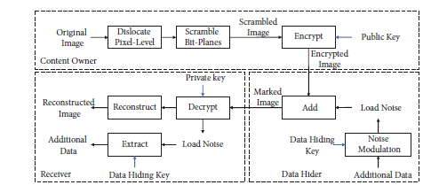

Blind Separation for Wireless Communication Convolutive Mixtures Based on Denoising IVA
The objective of this paper is to address the problem of blind source separation in wireless communication systems where received signals are affected by both convolutional mixing and noise. In practical wireless channels, transmitted signals arrive at the receiver through multiple propagation paths with different delays and attenuations, and are inevitably contaminated by noise. As a result, the observed signals form noisy convolutional mixtures, which significantly degrade the performance of traditional frequency-domain blind source separation techniques. Existing methods such as frequency-domain independent component analysis (FDICA) and conventional independent vector analysis (IVA) often suffer from poor robustness to noise, leading to unstable separation and high error rates. The primary goal of the study is therefore to enhance the noise robustness and separation accuracy of IVA-based algorithms by integrating an effective denoising mechanism, thereby improving the reliability of blind separation for digitally modulated wireless communication signals.
The methodology employed in this work is based on the development of a denoising-enhanced independent vector analysis algorithm, referred to as denoise-FastIVA. The proposed approach first applies wavelet threshold denoising to the noisy observation signals in the time domain to suppress additive white Gaussian noise while preserving useful signal components. Discrete wavelet transform using Haar wavelets is employed, and an unbiased risk estimation-based soft thresholding strategy is used to reconstruct denoised mixed signals. These denoised signals are then transformed into the frequency domain using short-time Fourier transform, converting the convolutional mixing model into an instantaneous mixing model at each frequency bin. FastIVA, which is a fast fixed-point optimization-based IVA algorithm, is subsequently applied to estimate the demixing matrices across frequency bins, thereby resolving the permutation ambiguity problem inherent in FDICA. Finally, inverse short-time Fourier transform is used to reconstruct the separated source signals in the time domain. The performance of the proposed algorithm is evaluated through extensive MATLAB simulations using linear frequency modulation (LFM), binary phase shift keying (BPSK), and binary frequency shift keying (2FSK) signals under varying signal-to-noise ratio conditions.
The results presented in the paper demonstrate that the denoise-FastIVA algorithm significantly outperforms traditional FDICA and standard FastIVA methods in separating noisy convolutional mixed signals. Simulation results show that, under moderate to high signal-to-noise ratios, the proposed method achieves correlation coefficients exceeding 94% between the separated signals and the original source signals, indicating strong separation accuracy. For example, the separation accuracy of LFM signals improves from approximately 88% to over 94%, BPSK signals from around 84% to above 97%, and 2FSK signals from about 81% to more than 95% after denoising is applied. Furthermore, bit error rate analysis reveals that the denoise-FastIVA method enables correct demodulation of BPSK and 2FSK baseband signals with minimal or zero errors when the signal-to-noise ratio exceeds 10 dB. Compared with conventional methods, the proposed algorithm exhibits superior robustness to noise across a wide range of signal-to-noise ratios, particularly in realistic wireless communication scenarios.
In conclusion, the paper establishes that integrating wavelet threshold denoising with fast independent vector analysis provides an effective solution for blind separation of noisy convolutional mixtures in wireless communication systems. The proposed denoise-FastIVA algorithm significantly enhances separation accuracy, noise immunity, and demodulation performance for multiple digitally modulated signals. However, the study also acknowledges certain limitations, including reduced performance under very low signal-to-noise ratio conditions and the exclusive use of wavelet-based denoising techniques. Future research directions include exploring alternative and adaptive denoising methods, improving separation performance under strong interference and low signal-to-noise environments, and extending the proposed framework to more complex and real-world wireless communication scenarios. 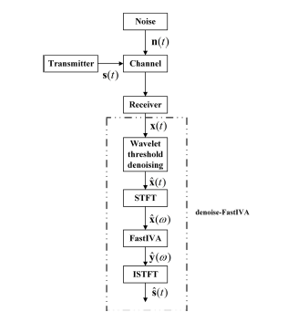

Intelligent identification technology for high‐order digital modulation signals under low signal‐to‐noise ratio conditions
The paper addresses the challenge of low recognition accuracy for high-order digital modulation signals, particularly in environments with low signal-to-noise ratios (SNR) [1], [2]. Feature extraction for complex signals is difficult under heavy noise, and existing methods often fail to differentiate signal characteristics in such conditions [1], [3]. By introducing an intelligent identification model, the authors aim to enhance adaptability to complex electromagnetic environments, thereby improving spectrum utilization and minimizing interference in applications such as IoT and 5G/6G networks [4].
The methodology was structured into three modules: time-frequency processing, image denoising, and image classification [5], [6]. Time-frequency processing used the Morlet wavelet transform to convert one-dimensional sequences into two-dimensional time-frequency images, enabling deep learning analysis [1], [7], [8]. For denoising, a GAN-based model was designed [6], [9]. The generator combined CNN and ResNet structures for multiscale feature extraction, residual denoising, and dimensionality reduction fusion [10], [11]. The discriminator was a CNN-based binary classifier trained with cross-entropy loss to minimize Jensen-Shannon divergence between real and generated distributions [12-14]. Classification employed a dual-model scheme based on an SNR threshold of 4 dB [15], [16]. Inception-ResNet-v2 was used for SNRs below 4 dB, while a lighter CNN was used for higher SNRs [15], [17]. The dataset was generated using USRP N210 systems over indoor wireless channels, covering eight modulation types (4ASK, 8ASK, 4FSK, 8FSK, QPSK, 8PSK, 128QAM, 256QAM) [18]. It comprised 48,000 training and 12,000 test samples, processed with MATLAB and Keras/TensorFlow on an NVIDIA RTX 2070 SUPER GPU [19], [20].
The findings demonstrate strong performance. The GAN-based denoising model effectively removed white noise while preserving frequency band distributions, producing clearer images [21]. Recognition accuracy reached 90% at 1 dB SNR and 92% at 2 dB [1], [22]. The integrated model (GAN + Inception-ResNet-v2) improved average accuracy by 5.1% in the low SNR range (–12 to 4 dB) compared to Inception-ResNet-v2 alone [23]. The proposed IF-GAN method outperformed state-of-the-art algorithms such as GoogLeNet, DenseNet-ResNet-LSTM, and SVM, achieving stable 100% accuracy at 8 dB earlier than competitors [24]. Testing time averaged 17.9 ms, acceptable for real communication scenarios [25].
The applications are highly relevant to modern communication systems facing spectrum scarcity and interference. Accurate identification of high-order modulation signals in noisy environments enables optimized spectrum allocation and reduced interference in 5G/6G networks, smart industries, and IoT [2], [4]. Transforming signals into time-frequency images and applying GAN-based denoising proved superior to traditional sequence analysis or standard image denoising methods [2], [26]. The study demonstrates that deep learning can robustly recognize electromagnetic environments, improving system generalization [27].
The study also notes limitations and future directions. The Inception-ResNet-v2 model used for low SNR conditions has over 54 million parameters, posing challenges for deployment on resource-constrained edge devices [28]. Future work should develop lightweight versions to reduce computational overhead. The current focus was on white noise removal [21]; real-world channels involve complex fading and multipath effects, requiring broader testing. The fixed 4 dB threshold [16] could be replaced with adaptive mechanisms that adjust dynamically based on real-time conditions.
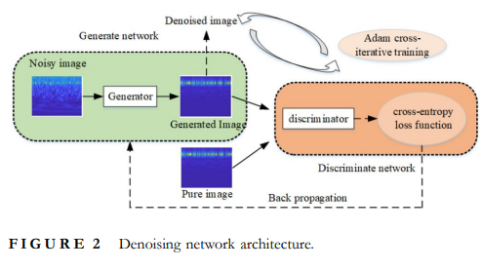

Phase Noise Effects on the Performance of High Order Digital Modulation Terahertz Communication System
The paper addresses the detrimental impact of phase noise on the performance of high-order digital modulation systems operating in the terahertz (THz) band (0.1–10 THz). At these high carrier frequencies, phase noise deterioration becomes severe, theoretically increasing by the multiplication factor when frequency multipliers are used, which significantly degrades the Bit Error Rate (BER) of communication systems [1-3]. The authors aim to verify the influence of near-end phase noise from local oscillator (LO) sources on system performance and to demonstrate how optimizing the Digital Phase-Locked Loop (DPLL) at the receiver can mitigate these effects, thereby improving signal stability and accuracy [1], [4].
The methodology combined theoretical modeling and experimental verification using a 16QAM digital modulation terahertz communication system (DMTCS) [1], [5]. The experimental transceiver setup included a 16QAM modulator/demodulator, THz up/down-converters, and a power amplifier chain. The THz carrier frequency was set to 140.4 GHz, generated by multiplying a 15.6 GHz reference signal from a Dielectric Resonator Oscillator (DRO) by a factor of 8 [5]. Phase noise was quantified using spectrum analyzers to measure intermediate frequency (IF) signals at both ends, employing a multi-line segment method to integrate the Phase Power Spectral Density (PPSD) for accurate RMS phase error estimation [6], [7]. Comparative experiments tested two LO sources: a DRO source with higher near-end phase noise, and a standard Agilent E8267D signal source with significantly lower near-end phase noise [8], [9]. Mitigation techniques focused on optimizing the receiver’s DPLL by increasing loop bandwidth (240 kHz to 1400 kHz) and loop order (second to third) to suppress phase noise and stabilize constellation diagrams [10], [11].
The findings highlight several key outcomes. The study discovered a large discrepancy between theoretical BER calculations and experimental results, revealing that near-end phase noise close to the carrier is the dominant factor affecting system performance [4]. Transmission quality varied drastically with LO source quality: the DRO source achieved only poor BER with fast-rotating constellations, while the Agilent source achieved stable constellations and superior BER [12]. DPLL optimization proved effective, as increasing loop bandwidth allowed better tracking and suppression of low-frequency phase noise, halting constellation rotation [13], [11]. The study also validated theoretical predictions that phase noise deteriorates significantly after transmission and frequency multiplication, as shown by degraded PPSD curves at the receiver compared to the transmitter [14], [15].
The applications are highly relevant for next-generation wireless communications, particularly 6G and THz networks demanding high data rates and spectral efficiency. As systems move toward THz frequencies to exploit large bandwidths, high-order modulations such as 16QAM are essential. This research provides guidelines for selecting LO sources that meet strict phase noise requirements to maintain link reliability [2], [3]. The findings also imply that while high-performance sources like the Agilent E8267D deliver superior results, cost-effective sources such as DROs may be viable if receiver algorithms like DPLL are properly optimized, impacting the cost-efficiency of commercial THz hardware deployment [16].
The study acknowledges limitations and future directions. Adjusting DPLL loop bandwidth involves a trade-off: while wider bandwidth suppresses phase noise, it also admits more in-band thermal noise, requiring careful optimization [13], [10]. Future research should focus on selecting appropriate transceiver front-end sources and precisely tuning DPLL parameters. The authors suggest developing algorithms to dynamically calculate optimal loop bandwidth by integrating phase noise characteristics, rather than relying on fixed references [10], [16]

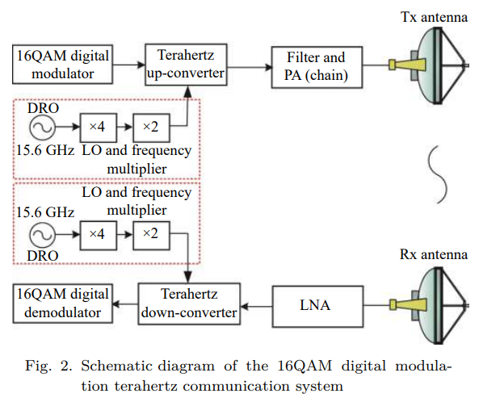

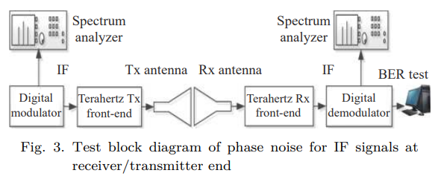

A Wideband Low-Power RF-to-BB Current-Reuse Receiver Using an Active Inductor and 1/f Noise-Cancellation for L-Band Applications
The paper aims to develop a low-power, wideband RF front-end specifically designed for L-Band applications (1–1.7 GHz), addressing the challenge of achieving high performance with minimal power consumption in CMOS technology. Its primary objective is to enable multi-standard receiver operation supporting high modulation bandwidths, such as GNSS and IoT applications, by improving the NF and bandwidth while maintaining low power usage.
The proposed methodology involves a quadrature RF-to-baseband current-reuse architecture incorporating a low-noise Trans-conductance amplifier (LNTA) with a common-gate topology, integrated active inductors, and a 1/f noise cancellation circuit. The design leverages current sharing among RF and baseband blocks, using active inductors to isolate RF signals, and employs on-chip LC-baluns to ensure wideband input matching. The fabricated prototype in a 130 nm CMOS process is experimentally characterized, confirming performance metrics such as input matching below –10 dB, a conversion gain of 41.5 dB, NF of 6.5 dB, and low power consumption of 1.66 mA.
The results demonstrate that the receiver achieves broad RF coverage (1–1.7 GHz), substantial IF bandwidth (~90 MHz), and improved NF, making it suitable for IoT, GNSS, and multi-standard wireless systems. This work offers a compact, cost-effective solution that extends the capabilities of CMOS-based receivers, enabling high-performance operation in larger CMOS nodes while reducing overall system complexity and cost. Future research directions include optimizing the active inductor for higher frequencies, validating full system integration, and further reducing power consumption for next-generation low-power wireless applications.
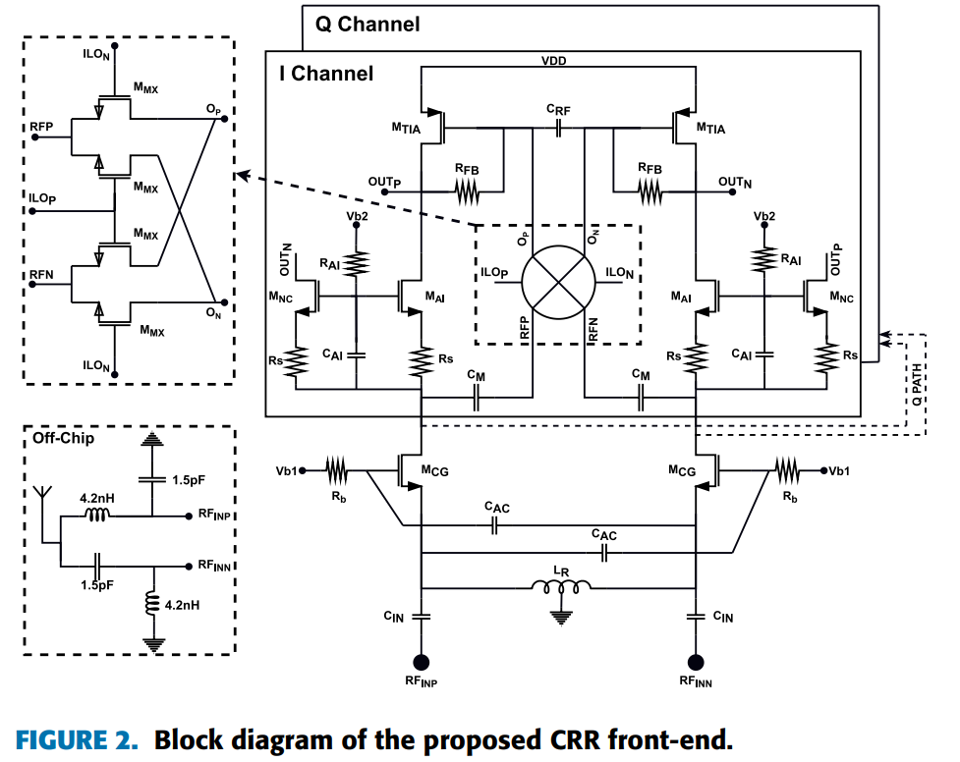
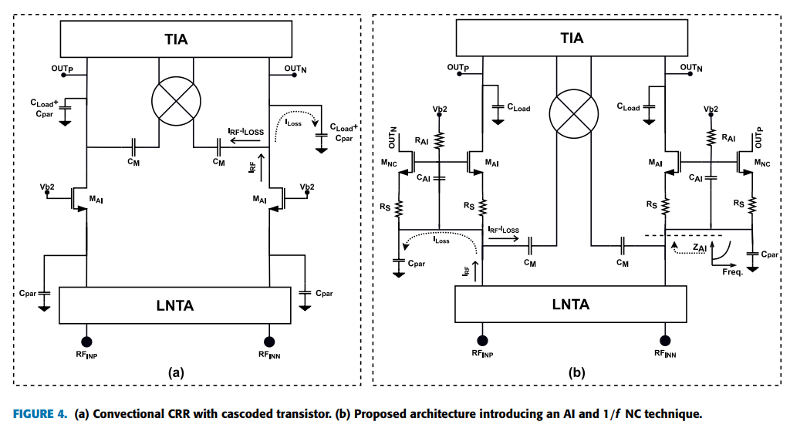

A Machine Learning Perspective on fNIRS Signal Quality Control Approaches
This paper examines the problem of ensuring reliable signal quality in functional Near-Infrared Spectroscopy (fNIRS) data, a neuroimaging technique used to measure brain activity by detecting changes in oxygenated and deoxygenated hemoglobin using near-infrared light. fNIRS has become increasingly popular in neuroscience research due to its non-invasive nature and ability to study brain activity in natural settings. However, one major challenge in fNIRS data analysis is signal quality control (SQC), as the collected signals are often affected by noise, poor sensor contact, or environmental interference. Traditionally, signal quality assessment relies on manual inspection or fixed thresholds applied to handcrafted signal quality indicators (SQIs), which can introduce subjectivity and inconsistent results. The main objective of the study is to investigate whether machine learning and deep learning methods can provide a more reliable and automated approach to evaluating fNIRS signal quality.
To explore this problem, the authors used a dataset consisting of 1,340 fNIRS signals collected from 67 participants during an experiment designed to measure brain responses to different social scenarios. From these recordings, 548 signal segments were manually labelled as either “good” or “bad” quality by four trained experts through visual inspection. These labelled signals served as a reference dataset for evaluating different signal quality control approaches. The study examined several commonly used SQIs, including Scalp Coupling (SC), Scalp Coupling Power (SCP), Coefficient of Variation (CV), Coefficient of Variation of Wavelengths (CVW), and Cardiac Power (CP), which attempt to quantify characteristics such as signal stability and physiological patterns. These indicators were statistically analyzed to determine their ability to distinguish between high- and low-quality signals.
The research then compared traditional SQI threshold methods with machine learning approaches. Two conventional machine learning models—Support Vector Machine (SVM) and Random Forest (RF)—were trained using the SQI features, while a Convolutional Neural Network (CNN) was trained directly on the raw signal data. Experimental results showed that threshold-based SQI methods were overly conservative and often rejected many usable signals, resulting in low sensitivity. Machine learning models significantly improved classification performance, and the deep learning CNN achieved the highest accuracy in identifying signal quality.
Overall, the study demonstrates that machine learning techniques offer a more objective and effective approach for automated fNIRS signal quality control. The results suggest that deep learning models can reduce reliance on subjective manual evaluation and simplify the signal processing pipeline by working directly with raw data. However, the authors note that a key challenge remains the lack of large reference datasets with consistent labels, which limits the development and validation of fully automated quality control systems. Future research is expected to focus on building standardized datasets and improving the interpretability of machine learning models for neuroimaging signal analysis.
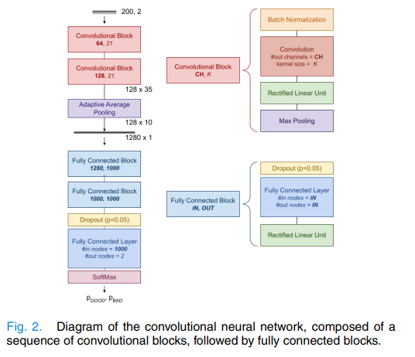

Monte Carlo Noise Reduction Algorithm Based on Deep Neural Network in Efficient Indoor Scene Rendering System
The paper addresses the high computational cost and time inefficiency of Monte Carlo (MC) path-tracking algorithms, which are widely used for realistic image synthesis but require extensive sampling to minimize variance and visual noise [1], [2]. The authors aim to develop a noise reduction algorithm based on deep neural networks (DNN) to enable efficient, real-time rendering of indoor scenes [1], [3]. A specific technical challenge is the gradient disappearance problem often encountered in deep convolutional neural networks, which the study seeks to solve by incorporating residual structures into the model [1], [4].
The methodology involved designing a deep learning framework using TensorFlow with GPU acceleration. The network architecture employed a CNN enhanced with 18 residual blocks (ResBlocks), allowing upstream features to flow to shallow layers and preventing gradient attenuation [4], [5]. Inputs included noisy pixel color values along with auxiliary features such as depth, perspective space normals, and albedo [6]. Training incorporated a Monte Carlo method for stochastic simulation of input samples and parameter adjustment, helping avoid local minima and optimize the loss function [7], [8]. A custom dataset was generated using the Tungsten renderer, producing about 20,000 data pieces from indoor videos with varying focal lengths and exposures, covering distributed effects like motion blur [9]. Training was conducted over 36 hours using the Adam optimizer (momentum 0.9) and L1-loss, with dynamic learning rate scheduling [10], [11]. Performance was benchmarked against NFOR, LBF, and KPCN using RelMSE and SSIM [11].
The findings demonstrate significant improvements in efficiency and quality. The proposed method achieved the highest structural similarity to ground truth, with an SSIM of 0.9993 and the lowest error rate (RelMSE of 3.228), outperforming state-of-the-art methods like NFOR and KPCN [12]. Qualitatively, the algorithm preserved more details in distant indirect light areas and produced superior global light effects, including softer shadows and better color mixing, compared to ordinary MC algorithms [13]. Real-time efficiency was validated, with single-frame processing time recorded at 26.2 ms, faster than the 29.6 ms required by ordinary MC rendering [3], [13]. The integration of residual blocks successfully addressed gradient disappearance, enabling effective deep network training [4].
The applications are highly relevant to industries requiring high-quality, physically based rendering, such as video games, animation, film special effects, and virtual reality [11], [14]. By enabling high-quality rendering with fewer samples, the technology makes real-time Monte Carlo ray tracing feasible, a task previously considered impractical due to hardware limitations [15]. It allows rapid generation of photo-realistic images for interactive previews and prototype designs, optimizing production workflows [11].
The study also notes limitations and future directions. The dataset and experiments were restricted to indoor scenes, leaving complex outdoor environments untested [3], [16]. Future research should focus on applying and validating the algorithm in outdoor scenarios to assess broader feasibility and applicability [16].
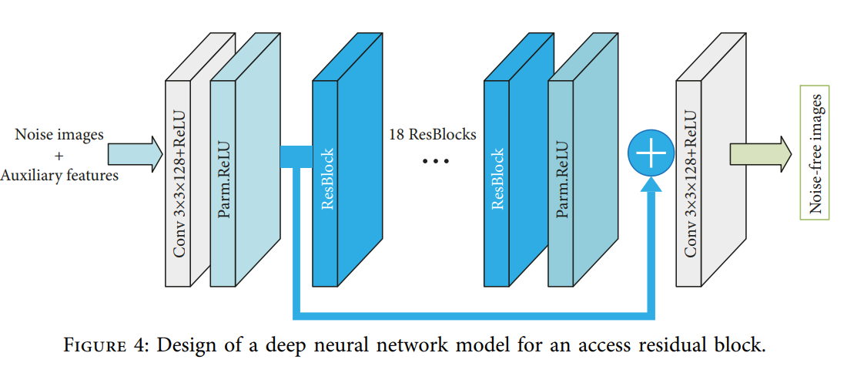

SEDENOSS: Separating and De-Noising Seismic Signals With Dual-Path Recurrent Neural Network Architecture
The paper addresses the challenge of analyzing seismic recordings that are obscured by significant noise or composed of overlapping signals, such as concurrent earthquakes or aftershock sequences [1], [2]. While source separation techniques like beamforming or independent component analysis are effective for multi-station arrays, there are few options available for separating signals recorded by single-station, one-component receivers [3], [4]. To solve this problem, the authors propose a Deep Learning approach using a Dual-Path Recurrent Neural Network (DPRNN) operating in the time domain, demonstrating that it can effectively denoise seismic data and separate two distinct earthquake signals that overlap in both time and frequency [3], [5].
The methodology adopts an end-to-end machine learning framework originally designed for speech separation and applies it to seismic waveforms [5], [6]. The DPRNN architecture consists of four modules: an Encoder to convert raw waveforms into N-dimensional representations, a Separator to split mixed signals, a Mask Estimation module to generate source masks, and a Decoder to reconstruct sequential outputs [7], [8]. The authors modified the original design by replacing activation functions with Mish to reduce gradient problems and using Softmax for masking strength [9], [10]. The model was trained on the STanford EArthquake Dataset (STEAD) [11], with preprocessing steps including removal of instrument responses, extraction of vertical channels, resampling to 30 samples per second, and normalization of traces based on the global maximum [11]. Training employed Utterance-level Permutation Invariant Training (PIT) to handle source assignment [12], with the Scale-Invariant Source to Distortion Ratio (SI-SDR) as the loss function [13]. Optimization used the Ranger optimizer [14], and data augmentation techniques such as random polarity changes, random gain, and random filtering were applied to improve generalization [15].
The findings demonstrate the efficacy of machine learning for single-station seismic analysis. The proposed model achieved state-of-the-art denoising, outperforming simple high-pass filters and surpassing the “DeepDenoiser” method in SI-SDR, SDR, and SNR metrics [16-18]. It successfully separated two distinct earthquake signals from a single mixed record, even when they overlapped in both time and frequency [19], [20]. Importantly, the network learned to separate sources without relying on traditional distinguishing features such as arrival times or frequency content, instead leveraging the statistical distribution of features in the N-dimensional vector space [21]. The model also proved resilient in noisy conditions, recovering signals at low SNRs, though performance degraded in extremely noisy samples [17], [22].
The applications and implications of this research are broad. Cleaner seismic records with more pronounced phases enable improved analysis of early aftershocks that are often obscured by main shocks [17], [23]. The method supports nuclear verification by separating acoustic energy from seismic ground coupling [23] and benefits ambient noise tomography by preserving noise portions while removing deterministic signals [24]. Automated monitoring systems could leverage the approach for low-cost seismometers in noisy environments and for automated phase picking [25], [26]. The authors also suggest potential applications in planetary science, such as analyzing marsquake data from the Mars2020 lander [25].
The study acknowledges several limitations and areas for future research. A major limitation is the loss of absolute amplitude due to waveform normalization and the scale-invariant SI-SDR loss function, making recovered signals unsuitable for magnitude estimation or moment tensor determination [11], [27]. The separated signals often contain residuals of other sources, indicating imperfect separation [25]. Comparisons with DeepDenoiser were constrained by differences in training data sampling rates (30 Hz vs. 100 Hz) [28]. Future work should focus on recovering absolute amplitudes, possibly by replacing the training objective or using time-frequency representations [29], [30]. The authors also propose exploring attention mechanisms, particularly Transformer architectures, to handle tightly overlapping signals and adapting the model to manage an unconstrained number of sources without retraining from scratch [30].

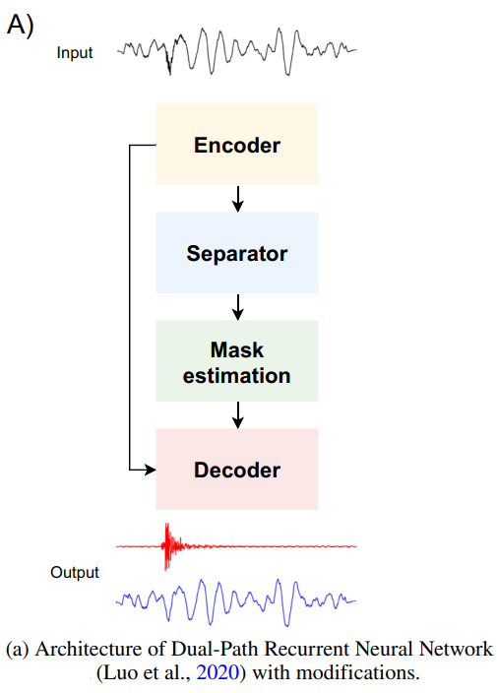
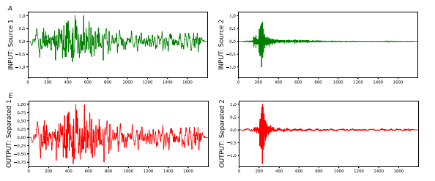

Defending AI-Based Automatic Modulation Recognition Models Against Adversarial Attacks

The objective of this paper is to investigate the security vulnerabilities of artificial intelligence–based automatic modulation recognition (AMR) models when subjected to adversarial attacks and to propose an effective mitigation strategy to enhance their robustness. Automatic modulation recognition plays a critical role in the signal processing chain of modern wireless communication systems by identifying modulation schemes without prior knowledge, thereby improving communication efficiency and adaptability. Although AI-based AMR models have demonstrated superior accuracy and efficiency compared to traditional feature-based or likelihood-based methods, their susceptibility to adversarial machine learning attacks raises serious security concerns for next-generation networks. The paper specifically aims to evaluate how adversarial attacks can degrade the performance of AI-based AMR models in both single-input single-output (SISO) and multiple-input multiple-output (MIMO) communication scenarios and to assess whether defensive distillation can effectively mitigate these threats.

The methodology employed in this study is based on simulation-driven analysis using a deep learning–based AMR framework. An LSTM-based neural network model is adopted to perform modulation recognition, as it is well suited for learning temporal dependencies in in-phase and quadrature signal components. Publicly available benchmark datasets are used, including the GNU Radio ML RML2016.10a dataset for the SISO scenario and a synthetically generated dataset for MIMO systems with different antenna configurations. Four widely used adversarial attack techniques—Fast Gradient Sign Method (FGSM), Basic Iterative Method (BIM), Momentum Iterative Method (MIM), and Projected Gradient Descent (PGD)—are applied to evaluate model vulnerability across varying attack strengths. To improve robustness, the paper employs defensive distillation as a mitigation technique, in which a distilled model is trained using softened probability outputs from the original model. Extensive simulations are conducted to compare attack success ratios for both undefended and defended AMR models under SISO and MIMO configurations.

The results presented in the paper demonstrate that AI-based AMR models are highly vulnerable to adversarial attacks, particularly iterative methods such as BIM, MIM, and PGD. In undefended SISO and MIMO scenarios, these attacks achieve very high attack success ratios, often approaching 100% at moderate to high attack strengths, leading to severe degradation in modulation classification accuracy. FGSM attacks are shown to be less effective compared to other methods due to their single-step nature. When defensive distillation is applied, a significant reduction in attack success ratios is observed for both SISO and MIMO models, especially at low to moderate attack strengths. The defended models exhibit improved robustness, although strong iterative attacks can still partially compromise performance at high attack power levels. The results also indicate that MIMO-based AMR models generally offer better resilience than SISO models due to spatial diversity and richer signal representations.

In conclusion, the paper highlights critical security risks associated with deploying AI-based automatic modulation recognition models in next-generation wireless communication systems. While AI-driven AMR offers substantial performance benefits, its vulnerability to adversarial attacks poses a serious challenge to reliable and secure communication. The study confirms that defensive distillation can significantly enhance model robustness and reduce the effectiveness of adversarial attacks, though it does not completely eliminate the threat. Limitations of the work include reliance on simulation-based evaluation and focus on a single mitigation technique. Future research directions include developing advanced adversarial attack detection mechanisms, exploring alternative and hybrid defense strategies, conducting real-world experimental validation, and designing inherently robust AI architectures for secure wireless communication systems.
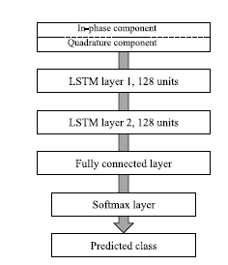

An AI-Assisted Smart Healthcare System Using 5G Communication
This paper investigates the convergence of artificial intelligence and 5G communication technologies in the design of next-generation smart healthcare systems. The primary problem addressed is the growing demand for real-time, reliable, and secure healthcare services capable of supporting remote monitoring, telemedicine, and data-intensive clinical decision-making.
The theoretical background spans multiple domains, including 5G network architecture, massive MIMO, edge computing, Internet of Things (IoT), and AI-driven data analytics. The authors emphasize that the ultra-low latency, high data rates, and massive device connectivity offered by 5G form a critical enabler for deploying AI models in time-sensitive healthcare applications.
Methodologically, the paper proposes a comprehensive architecture that integrates wearable medical sensors, IoT devices, edge computing nodes, and cloud-based AI systems interconnected through 5G networks. AI algorithms are employed for health data analysis, anomaly detection, predictive diagnostics, and intelligent resource management. The system also incorporates advanced security mechanisms to address privacy and data integrity concerns inherent in medical applications.
Simulation and performance evaluations are conducted using different network configurations and healthcare scenarios. The results indicate notable improvements in system efficiency, including approximately 25% performance enhancement and a 20% reduction in computational cost compared to conventional approaches. These gains are attributed to optimized AI-driven resource allocation and reduced latency through edge processing.
In terms of applications, the proposed system supports remote patient monitoring, emergency response, personalized healthcare, and large-scale health data analytics, aligning with Industry 4.0 objectives. The integration of AI with 5G enables faster clinical decision-making and improved quality of service, particularly in geographically remote or resource-constrained regions.
The paper also identifies key challenges, including ethical considerations, data privacy, model explainability, and infrastructure deployment costs. Future research directions highlighted by the authors include stronger AI security frameworks, enhanced explainability for clinical trust, and scalable real-world implementations across diverse healthcare ecosystems.
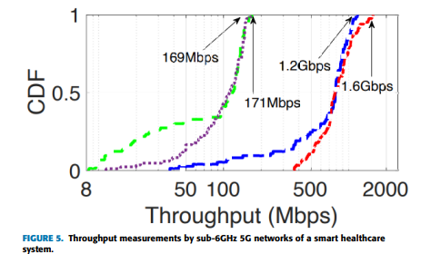

Artificial Intelligence applications in Noise Radar Technology
The paper addresses how Artificial Intelligence can be systematically integrated into Noise Radar Technology to overcome core limitations such as complex signal processing, high autocorrelation side lobes, antenna leakage, clutter, and dynamic-range constraints, while exploiting noise radar’s inherent advantages like low probability of intercept, robustness to jamming, and low mutual interference. It aims to survey recent AI-based methods across the radar chain—antenna design, waveform optimization, waveform interception/recognition, target detection and recognition, and clutter suppression—and map them specifically onto the needs and characteristics of noise radar systems. To do this, the authors build a structured framework that starts from the physics of noise radar and the main AI paradigms (machine learning, evolutionary computation, deep learning, reinforcement learning) and then describe how classical low-side lobe waveform algorithms, AI-driven waveform design (CNNs, VAEs, feed-forward NNs, genetic algorithms), and statistical randomness testing (e.g., NIST-type batteries) can be combined into a methodology for designing and validating pseudorandom continuous-wave UWB noise waveforms that preserve NRT advantages.
​Within this framework, the study finds that AI methods can be tightly linked to specific noise-radar bottlenecks, with evidence drawn from both conventional radar and early NRT-focused works. For waveform design, AI (CNNs, VAEs, GAs, and reinforcement learning) is shown conceptually to offer large speedups and better side lobe performance compared with traditional iterative optimizers, especially when formulated as multi-objective problems that jointly minimize Integrated Side lobe Level and Peak-to-Average Power Ratio while maintaining statistical randomness. For antenna design and leakage, the paper shows how machine-learning and evolutionary methods already used for phased-array/MIMO beam forming, antenna placement, and array optimization can be adapted to noise MIMO radar to keep beam patterns stable under statistical waveform variations and to learn leakage reconstruction for cancellation, while deep-learning-based classifiers and detectors developed for micro-Doppler, HRRP, and SAR in conventional radar are argued to be particularly promising for UWB noise radars in military surveillance, automotive sensing, and remote sensing, and AI-based clutter/interference suppression architectures (GANs, CNNs, RL-based spectrum management) can be transferred to mitigate the strong clutter and interference that degrade continuous-wave NRT.
​The authors emphasize that their contribution is a review and conceptual design roadmap rather than a full experimental demonstration, which limits the work to qualitative and comparative insights instead of unified quantitative benchmarks. They highlight several gaps and future directions: the lack of open, NRT-specific datasets and benchmarks for training and testing AI models; the difficulty of running deep models and advanced optimization under real-time, high-rate, and high-dynamic-range constraints of continuous UWB noise radar; and the present absence of fully implemented AI-based NRT waveform design, clutter suppression, and leakage mitigation chains beyond simulations and algorithmic proposals. Future research should, according to the paper, build shared datasets and realistic simulators, implement multi-objective GA or deep-learning waveform designers on practical hardware with integrated randomness testing, experimentally validate AI-based clutter and leakage suppression on real noise radar platforms, and further explore reinforcement-learning-driven cognitive NRT systems that continuously adapt waveform, beam forming, and processing strategies to the environment.

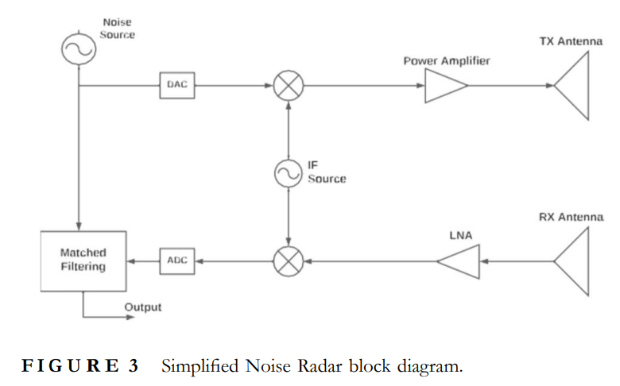

NEMO: Real-Time Noise and Exhaust Emissions Monitoring for Sustainable and Intelligent Transportation Systems
The paper addresses the environmental challenge posed by transportation noise and exhaust emissions, which significantly impact public health and contribute to climate change [1], [2]. Existing monitoring systems are often intrusive, limited to single-vehicle measurements, or incapable of assessing real-world driving conditions [3]. To overcome these limitations, the authors propose NEMO, a comprehensive real-time remote sensing system capable of identifying High Emitters (HEs) among both road vehicles and trains [1], [4]. By integrating NEMO into existing infrastructure, the study aims to provide a tool for enforcing Low Emission Zones (LEZs) and enabling intelligent decision-making for sustainable transportation [5], [6].
The methodology involved developing the Nautilus platform, a cloud-enabled software infrastructure to process data from remote sensing sites [7]. Hardware included microphone arrays for noise detection, multispectral cameras for ANPR, and exhaust sensors deployed on gantries and roadsides [1], [8], [9]. A beamforming algorithm combined with peak level correction was used to localize noise in dense traffic, subtracting interference from nearby vehicles [10-12]. AI-enabled classification employed a Sound Expectation Model (SEM) to predict expected noise based on speed and engine parameters, which was compared against measured levels to train a neural network classifier [13-15]. Communication was facilitated by a Classification Dialog System (CDS), enabling real-time alerts via I2V communication, SMS, and email [16-18]. Field testing was conducted in Rotterdam and Teesdorf, with controlled experiments in Austria validating detection accuracy under specific maneuvers [19], [20].
The findings demonstrate the feasibility and effectiveness of NEMO. In Rotterdam, the system classified 74% of vehicles as normal emitters, 19% as medium, and 7% as high emitters out of nearly 315,000 vehicles [21]. For trains, 16% were classified as high emitters based on noise levels exceeding 85 dB(A) at speeds of 90–100 km/h [22]. Tests at Teesdorf confirmed successful real-time communication of classification results to vehicle OBUs [20], [23]. Analytics revealed that 55.4% of high emitters were petrol vehicles, followed by 37.7% diesel [24]. The study highlights NEMO’s novelty compared to existing systems like Hydra, as it simultaneously tracks both noise and exhaust emissions across road and rail [25].
The applications are immediate for urban planning and environmental enforcement. NEMO enables automatic detection of non-compliant vehicles, supporting LEZ enforcement and variable tolling based on actual emissions [5], [26]. By identifying the small percentage of vehicles responsible for most pollution, cities can target enforcement to reduce noise and air pollution, improving public health [5], [27]. Real-time driver notifications encourage less aggressive driving, reducing emissions [28], [16]. The integration of sensors and cloud platforms demonstrates a scalable model for Intelligent Transportation Systems (ITS), where infrastructure actively communicates with vehicles to manage environmental impact [1], [29].
The study also identifies limitations and future directions. Current deployment is limited to specific European cities, with classification models requiring customization for local conditions [15]. Privacy concerns necessitate strict GDPR compliance, including immediate deletion of raw audio and video data after processing [30], [31]. Future research will expand NEMO to maritime applications, monitoring ships in port cities [32]. Technological upgrades include exploring 6G communication for reduced latency and adopting edge computing to move data processing closer to the network edge for improved efficiency [32].
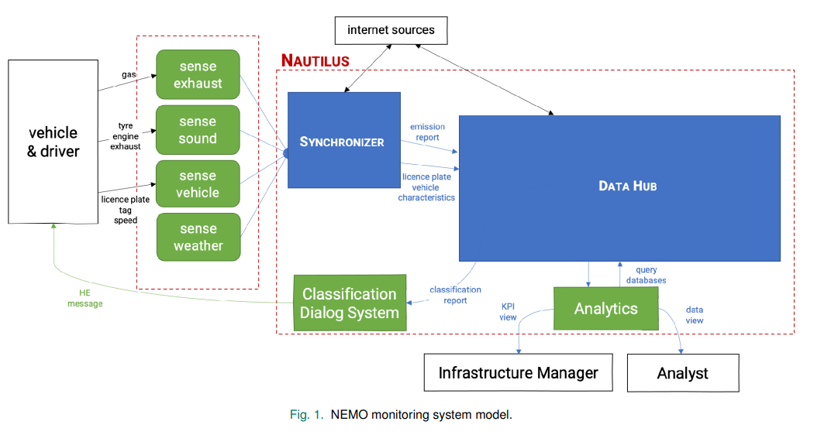

Semantic Noise and Conceptual Stagnation in Natural Language Processing

The paper critiques the prevailing tendency in Natural Language Processing (NLP) and Artificial Intelligence (AI) to treat semantic noise (SN) as an obstacle to be eliminated in favor of stabilizing and compressing linguistic representations. This tendency, the author argues, leads to “conceptual stagnation” and promotes a one-dimensional image of language, where meanings are treated as statistically given and static rather than dynamic and debatable. Instead of viewing SN as distortion, the study reframes it as a generative force essential for speculative inquiry, creativity, and the “plastic renewability” of language. Through this reframing, the paper challenges the standardization of solutions for the Winograd Schema Challenge (WSC), contending that such standardization relies on biased assumptions of “common sense” and ignores the dialogical nature of human communication.
The methodology is theoretical and philosophical, employing a transdisciplinary approach to deconstruct core concepts in NLP and Information Theory. The author conducts conceptual analysis and case studies of Winograd Schemas—sentences requiring pronoun disambiguation—to show how “common sense” resolutions often mask sociopolitical biases and ignore legitimate alternative interpretations. A theoretical critique of Information Theory revisits Shannon and Weaver’s foundational work, criticizing the separation of mathematical information from semantic meaning and the treatment of noise as merely an impediment. Philosophical integration draws on thinkers such as Simondon, Malaspina, and Derrida to explore the epistemological relationship between noise and pattern, treating noise as a concept that illuminates new domains precisely because of its lack of rigid definition. The study also includes etymological and metaphorical analysis, examining the origins of terms like “concept” and “example” and using theories of metaphor and analogy to show how cognition relies on the generative tension between likeness and difference, a process inherently involving semantic noise.
The findings challenge the current trajectory of NLP research. The author argues that semantic noise is generative, enabling concepts to evolve and allowing for probabilistic and possibilistic reasoning and alternative perspectives such as the “black swan.” Discarding semantic noise leads to closed systems incapable of accounting for the totality of human thought or the dynamic nature of dialogue. Analysis of Winograd Schemas reveals that attempts to automate “common sense reasoning” often encode one-dimensional sociopolitical opinions under the guise of neutrality, and that many schemas are theoretically unsolvable without context, requiring inference to the best explanation rather than unambiguous decoding. The research highlights metaphor as a cognitive core, showing that metaphoric operations—pairing two elements to express a third—are central to cognition and rely on semantic noise. Current NLP models, which favor indexical and statistical stability, struggle to capture this unfinished and expression-seeking nature of language. The paper also critiques large language models (LLMs), described as “stochastic parrots,” for mimicking coherence without engaging in dialogical negotiation of meaning, arguing that their reliance on statistical closure prevents them from recognizing that language thrives on semantic noise.
The implications are profound for the ethics, design, and deployment of AI and NLP technologies. The author warns that standardization of meaning in NLP tools risks homogenizing diversity and perpetuating “mass one-dimensional forgetting” of how language renders social agents. What is currently flagged as “error” or “noise” in AI outputs should be reconsidered as potential sites of meaning-making and creativity. Recognizing ambiguity as valuable could lead to more robust systems that acknowledge their limitations rather than presenting hallucinations as objective truthsThe findings suggest a need for an epistemic shift in NLP: instead of scaling data through brute force, researchers should design models that accommodate the dialogical and unstable nature of concepts. This involves moving away from the goal of noiseless communication and accepting interpretation as a generative, probabilistic process. The paper also suggests that acknowledging the analogical gap between human and artificial intelligence—viewing AI itself as a metaphor—can help society better understand the limitations of these tools and the biases inherent in concepts like “intelligence”.
The study concludes by identifying limitations in current approaches and directions for future research. It critiques the field’s over-reliance on scaling data without evolving conceptual models, noting that “the data grow but the conceptual model stays the same”. The lack of theoretical reflection within NLP literature leads to solutionism that ignores the complexity of natural language. Future research should pursue an epistemic shift, focusing on the nature of language itself rather than computer performance. Researchers are encouraged to explore how semantic noise can be integrated into models not as a flaw but as a feature that facilitates the plastic renewability of language. Bias should be treated not as a glitch to be removed but as a fundamental aspect of perception and collective meaning-making requiring dynamic individuation. Finally, the field must move beyond indexicality, exploring models that treat language not as a mirror of reality but as a socially distributed production of knowledge.

Noise Analysis and Modulation Optimization for Nonlinear Visible Light Communication System With Signal-Dependent Noise
The objective of this paper is to investigate the characteristics and impact of signal-dependent noise (SDN) in practical nonlinear visible light communication (VLC) systems and to design an optimized modulation scheme that minimizes performance degradation caused by such noise. In VLC systems employing light-emitting diodes (LEDs) and avalanche photodiodes (APDs), the received noise is composed of both signal-independent noise (SIDN) and SDN, where the latter increases with signal intensity due to shot noise and nonlinear device behavior. Existing modulation schemes are typically designed assuming additive white Gaussian noise and therefore fail to account for SDN, leading to severe symbol error rate (SER) degradation. The primary objective of the study is to experimentally analyze when SDN dominates in nonlinear VLC systems and to develop a modulation optimization strategy that improves reliability in both flat and inter-symbol interference (ISI) channels.
The methodology adopted in this work combines theoretical noise modelling, experimental validation, and modulation optimization. A comprehensive VLC system model is developed that incorporates LED nonlinearity, APD shot noise, amplifier noise, and quantization noise. The total noise variance is expressed as a function of transmitted signal strength, enabling the separation of SDN and SIDN components. To validate the model, three comparative experimental scenarios are conducted: a linear transmitter with a linear receiver, a nonlinear transmitter with a linear receiver, and a nonlinear transmitter with a nonlinear receiver. Measurements of noise variance versus incident optical power are performed using different APDs, bias-tee circuits, and amplifier configurations. Based on the experimental observations, a modulation optimization method for M-ary pulse amplitude modulation (M-PAM) is proposed. The optimized constellation is designed as a weighted combination of uniform and square-root modulation to account for the signal-dependent nature of noise. The optimal weights are obtained by minimizing SER under maximum likelihood detection. The impact of SDN on linear minimum mean square error (LMMSE) equalization is also analyzed through simulations in both flat and ISI channels.
The results demonstrate that the dominance of SDN strongly depends on system linearity. In highly linear VLC systems, noise variance increases monotonically with signal strength, confirming the significance of SDN, whereas in systems with strong nonlinear distortions, SIDN masks the effect of SDN. Experimental results show that conventional uniform modulation performs poorly under SDN, especially for higher modulation levels. The proposed optimized modulation significantly reduces SER compared to uniform modulation in flat channels. Simulation results further indicate that the root mean square error of LMMSE equalization increases with modulation order in the presence of SDN, highlighting the need for modulation-aware receiver design. In ISI channels, the optimized modulation consistently outperforms uniform modulation, confirming its robustness under practical VLC conditions.
In conclusion, the paper establishes that signal-dependent noise plays a crucial role in determining the performance of nonlinear VLC systems and must be explicitly considered in modulation and receiver design. By experimentally characterizing SDN and proposing an optimized modulation strategy, the study demonstrates substantial improvements in symbol error performance under both flat and dispersive channels. However, the analysis is limited to M-PAM modulation and indoor VLC scenarios with specific hardware configurations. Future research directions include extending the optimization framework to multi-dimensional constellations, incorporating adaptive modulation based on real-time noise estimation, and validating the approach in large-scale VLC deployments with mobility and varying illumination conditions.
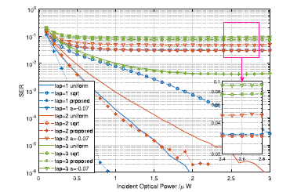

Pulse-Width Modulation Technique with Harmonic Injection in the Modulating Wave and Discontinuous Frequency Modulation for the Carrier Wave for Multilevel Inverters: An Application to the Reduction of Acoustic Noise in Induction Motors
The paper addresses the issue of acoustic noise and harmonic distortion in asynchronous motors fed by multilevel power inverters (MLI). The authors propose and validate a control strategy known as Harmonic Injection Pulse Width Modulation with Frequency Modulated Triangular Carrier (HIPWM FMTC), specifically adapted for cascaded H bridge inverters. The primary goal is to reduce acoustic noise by avoiding the coincidence of electrical harmonics with the machine’s mechanical natural frequencies and spatial harmonics. A secondary objective is to demonstrate that this method can reduce Total Harmonic Distortion (THD) at the inverter output compared to other established modulation strategies.
The methodology combined theoretical modeling, simulation, and experimental validation using a Cascaded H Bridge (CHB) inverter topology. The study employed a truncated version of HIPWM FMTC (HIPWM FMTCt), which modulates the instantaneous frequency of the triangular carrier wave based on the slope of the modulating sine wave with harmonic injection. Two control parameters—truncation level and amplitude modulation order—were used to modify the electrical spectrum without changing the number of pulses per period. The truncation parameter introduced discontinuities where the carrier frequency was forced to zero, blocking switching during specific intervals to concentrate pulses around the steepest slopes of the modulating wave.
Experimental validation was conducted on an AEG 1 kW, 4 pole asynchronous motor inside a semi anechoic chamber. The inverter hardware consisted of a GUASCH S.A. GPT IGBT power module with forced air cooling, controlled via National Instruments NI9154 hardware and LabVIEW. Acoustic noise was measured using a 01 dB METRAVIT Symphonie sound level meter with a G.R.A.S. microphone, while electrical harmonics were analyzed using a Chauvin Arnoux C.A 8336 power analyzer. The proposed strategy was benchmarked against amplitude shifted PWM (SPWM1), phase shifted PWM (SPWM2), and phase shifted PWM with harmonic injection (SPWM3).
The findings confirm the effectiveness of HIPWM FMTCt. Acoustic noise was reduced by up to 1 dB(A) compared to other techniques, with specific parameter adjustments yielding reductions of 2.6 dBA. The technique successfully shifted temporal harmonics to higher frequencies, avoiding overlap with mechanical resonances and thereby reducing vibration and noise. For central values of the truncation parameter, THD was lower than that of comparative techniques. Trade offs were identified: certain parameter values optimized noise reduction, others optimized THD, and higher values increased RMS voltage output.
The applications are directly relevant to industrial drives and renewable energy systems where multilevel inverters are widely used. The ability to tune modulation to avoid resonant frequencies improves acoustic comfort in environments sensitive to noise. The flexibility of adjusting software parameters allows a single hardware setup to be optimized for different objectives, offering adaptability for industrial applications. By leveraging cascaded H bridge topologies, the method supports efficient, high voltage drive systems with reduced filtering requirements.
The study also identifies limitations. At small truncation values, switching occurs outside the quasi linear range of the modulating signal, increasing THD. At high truncation values approaching unity, carrier frequency rises significantly, conflicting with IGBT dead time and maximum switching speed limits, leading to waveform degradation. Strict synchronization between modulating and carrier waves is required, with frequency modulation order constrained to integer values and specific multiples to avoid harmonics in three phase systems. Future research should focus on identifying optimal parameter values for each motor to balance noise and electrical performance, potentially automating the tuning process.

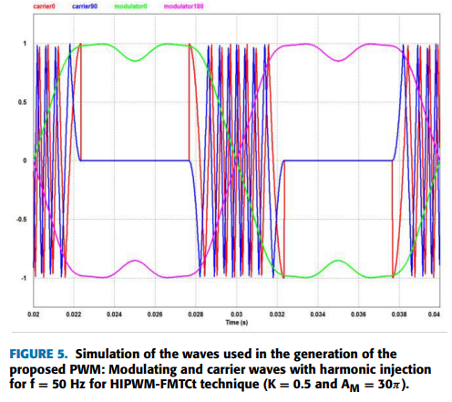
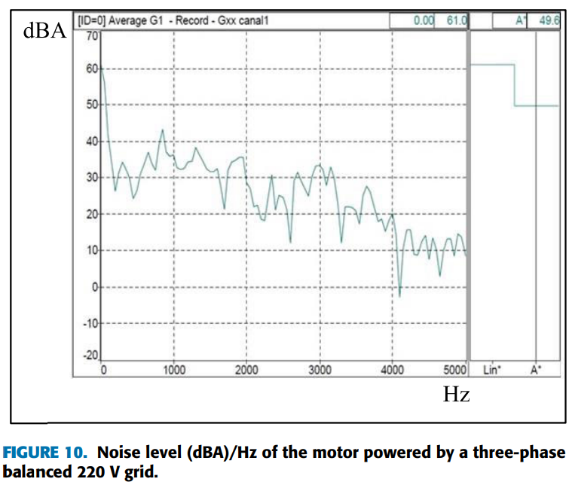

A Noise-Aware Deep Learning Model for Automatic Modulation Recognition in Radar Signals
This paper addresses the challenge of accurate automatic modulation recognition (AMR) in noisy and fading environments, particularly for radar and wireless communication systems. Traditional feature-based and likelihood-based modulation classification techniques suffer significant performance degradation under low signal-to-noise ratio (SNR), multipath fading, and Doppler effects. The primary objective of the study is to develop a noise-aware deep learning framework that can reliably identify modulation schemes even under severe noise and adversarial conditions, thereby improving robustness and reliability in practical communication and radar applications.
The proposed methodology converts received time-domain signals into two-dimensional time–frequency representations using the Choi–Williams transform, which effectively suppresses cross-term interference. A hybrid deep learning architecture combining auto encoders and convolutional neural networks (CNNs) is employed. The auto encoder performs noise suppression and feature enhancement, while the CNN extracts discriminative features for modulation classification. A custom dataset is created containing multiple radar modulation schemes corrupted by additive white Gaussian noise and Rayleigh fading with varying Doppler shifts, enabling the model to learn noise-invariant representations through supervised training.
The key findings demonstrate that the proposed noise-aware model achieves very high classification accuracy even at low SNR levels, outperforming conventional CNN-based and traditional modulation recognition approaches. The system maintains stable performance across different Doppler frequencies and fading conditions, confirming its robustness against channel impairments. These results contribute to existing knowledge by showing that explicit noise awareness combined with deep feature learning significantly improves modulation recognition reliability in challenging environments.
In terms of applications, the model is highly relevant for cognitive radio, electronic warfare, radar signal intelligence, and adaptive wireless receivers, where accurate identification of unknown signals is critical. However, the study is limited by high computational complexity and dependence on large labelled datasets, which may restrict real-time and edge deployment. Future research directions include model compression, transfer learning for unseen modulation types, and real-world hardware validation to improve scalability and practical applicability.
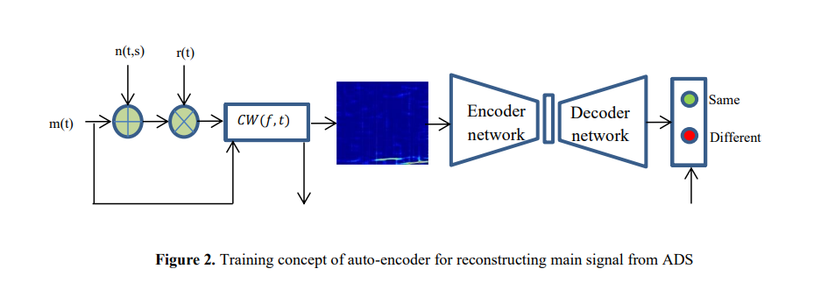
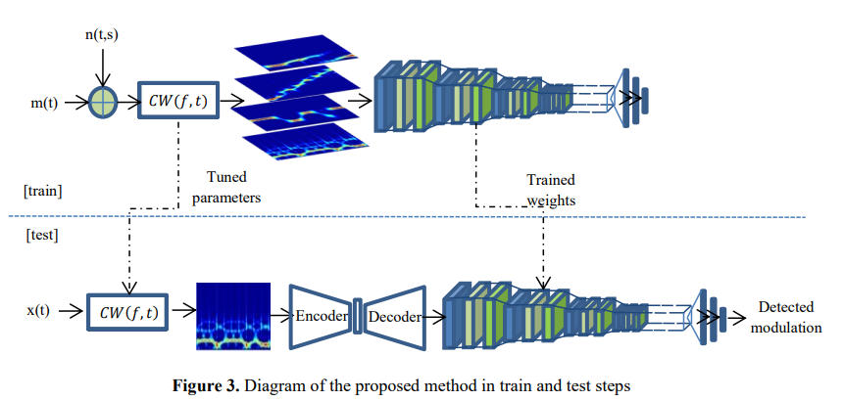

Recurrence Quantification Analysis of Crowd Sound Dynamics

The paper analyzes the emergent behaviors of large crowds by examining their global acoustic output through the lens of dynamical systems theory. It addresses the limitations of existing crowd analysis methods, which often rely on video data or individual tracking, and traditional acoustic analyses that assume that signals are stationary [1], [2]. Specifically, the authors demonstrate that Recurrence Quantification Analysis (RQA) can capture the nonlinear and non-stationary dynamics of crowd sounds [2]. The study has two goals: first, to provide a theory-driven description of crowd sound dynamics, testing the hypothesis that higher levels of social coordination such as chanting produce higher recurrence values than uncoordinated behaviors like noise [3], [4]; second, to employ a data-driven machine learning approach to determine whether RQA features can classify and predict categories of crowd behavior such as cheering, chanting, or distraction noise [3], [5].
The methodology involved a case study using audio data recorded from the student sections of two Brigham Young University (BYU) men’s basketball games [3], [6]. Raw audio recorded at 50 kHz was resampled to 5 kHz to filter out pitch information and focus on aggregate amplitude and rhythmic properties [7]. Data were manually labelled into categories including Angry Noise, Applause, Cheer, Distraction Noise, Positive Chant, and Negative Chant [6], [7]. For descriptive analysis, non-overlapping 5-second samples were examined using recurrence plots constructed with an embedding dimension of 5, a time delay of 5, and a fixed radius neighborhood of one standard deviation [8], [9]. Four metrics were calculated: Recurrence Rate, Determinism, Entropy, and Laminarity [10], [11]. Statistical analysis employed linear regression models with sum-to-zero contrasts and post hoc pairwise comparisons [12], [13]. For predictive modeling, all 19 RQA metrics were extracted using PyRQA [5], [14]. Sliding windows and bootstrapping were used to generate balanced training sets, with disjoint events reserved for testing to prevent over fitting [15], [16]. A Support Vector Machine (SVM) with an RBF kernel was trained to classify samples into both the original labelled categories and a consolidated set of three coordination modes: Chant, Cheer/Applause, and Distraction Noise [17], [18].
The findings confirm the relationship between acoustic recurrence and social coordination. Chanting behaviors exhibited the highest values across all RQA metrics, indicating that whole-crowd coordination produces stable and recurring acoustic patterns [19-21]. In descriptive analysis, chants were significantly different from other categories, though distinctions between Cheer/Applause and Distraction Noise were less clear, with Cheer and Applause often not significantly different from the grand average [21]. The SVM classifier, however, successfully distinguished between the three coordination modes, achieving accuracy above 0.8 for all classes [18], [22]. RQA features alone proved sufficient to classify unseen data, with strong distinction for Chant and Cheer categories, though some confusion persisted between Applause and Angry Noise [22], [23]. Distraction noise generally exhibited low stability and recurrence, visually resembling uncoordinated behavior in recurrence plots [24].
The implications are broad for studying collective human behavior and social coordination. The method allows researchers to study crowd dynamics in naturalistic, unscripted environments without invasive sensors or complex video tracking [25]. The findings extend the concept of joint action to large groups, showing that global acoustic signals can serve as proxies for emergent behavioral dynamics and coordinated group identity [25-27]. Applications include automated crowd monitoring where visual data may be incomplete [1], and multimodal analysis combining acoustic data with physiological and movement synchrony to provide a holistic view of group bonding [28].
The study acknowledges limitations and future directions. It was limited to two men’s collegiate basketball games, and factors such as attendance size, game type, and team performance likely introduce variability [29]. Overlap between Cheer/Applause and noise behaviors suggests that RQA may primarily detect two modes—Chant versus Non-Chant—rather than three distinct modes in some contexts [21], [30]. Future research should analyze broader datasets across different sports [29], investigate temporal dynamics of acoustic signals over the course of games [29], and integrate multimodal data to better understand synchronization [29]. Methodological expansion could combine RQA features with deep learning approaches such as CNNs to improve classification accuracy [25].
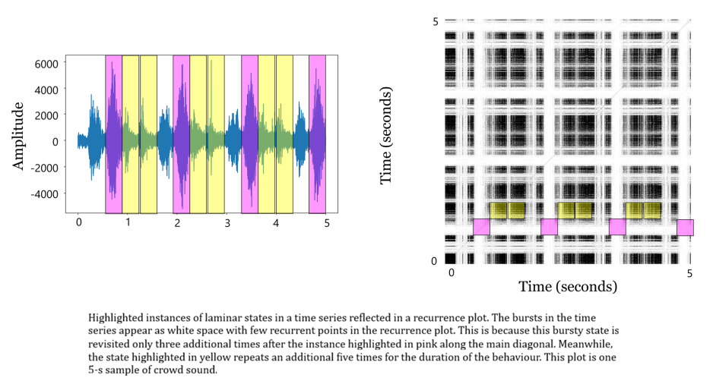

Autoencoder-Based Recommender System Exploiting Natural Noise Removal
This paper focuses on improving the performance of collaborative filtering–based recommender systems by addressing the issue of natural noise in user rating data. Recommender systems rely heavily on historical user ratings to predict preferences and suggest relevant items such as movies, products, or services. However, these ratings often contain inconsistencies that arise naturally from human behaviour rather than malicious attacks. Factors such as herd behaviour, anchoring bias, or momentary user preferences may cause users to give ratings that do not accurately reflect their true interests. These irregular ratings introduce what is known as natural noise, which can negatively affect recommendation accuracy. The primary objective of the study is to develop a recommender system that can automatically detect and remove such natural noise from rating data before generating recommendations, thereby improving prediction reliability and overall recommendation quality.
To address this challenge, the authors propose an Autoencoder-based recommendation framework that combines collaborative filtering with anomaly detection. Autoencoders are neural networks capable of learning compressed representations of data and reconstructing the original input from those representations. In the proposed method, the Autoencoder is first trained on users’ rating data to learn the relationships between users and items. During this process, the model reconstructs the observed ratings, and the difference between the original and reconstructed values—known as the reconstruction error—is used to identify potential anomalies. Ratings that produce unusually high reconstruction errors are considered natural noise. The algorithm follows a two-stage approach: in the first stage, the Autoencoder detects and removes noisy ratings based on these reconstruction errors; in the second stage, the model is retrained using the cleaned dataset to predict the ratings of items that users have not yet evaluated. The items with the highest predicted ratings are then recommended to users.
The effectiveness of the proposed system was evaluated using two widely used datasets: MovieLens 100K and MovieLens 1M, which contain user ratings for movies. The performance of the model was compared with conventional Autoencoder-based recommender systems and existing natural noise detection methods based on rating classification. Several evaluation metrics were used, including Root Mean Square Error (RMSE), Mean Absolute Error (MAE), and the F1-score, which measure prediction accuracy and recommendation quality. Experimental results show that the proposed method consistently improves recommendation performance by removing noisy ratings before prediction. In particular, the system achieved reductions in prediction error of up to about 5% compared to models without natural noise detection and about 4% compared to traditional rating classification-based noise detection methods. These results demonstrate that detecting natural noise using Autoencoder reconstruction errors is more effective than relying on manually defined rating categories.
The study highlights the importance of considering natural noise when designing recommender systems, as even genuine user data can contain inconsistencies that reduce prediction accuracy. By automatically identifying and filtering such noise, the proposed framework improves the reliability of collaborative filtering models and produces more accurate recommendations. However, the authors note that the method may face challenges in datasets with extremely high sparsity, where removing noisy ratings further reduces available data. Future research could focus on improving noise detection strategies, adapting the approach to more advanced Autoencoder architectures, and addressing the data sparsity problem to further enhance recommendation performance in large-scale real-world systems.
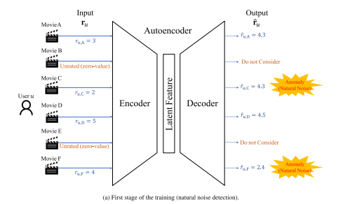

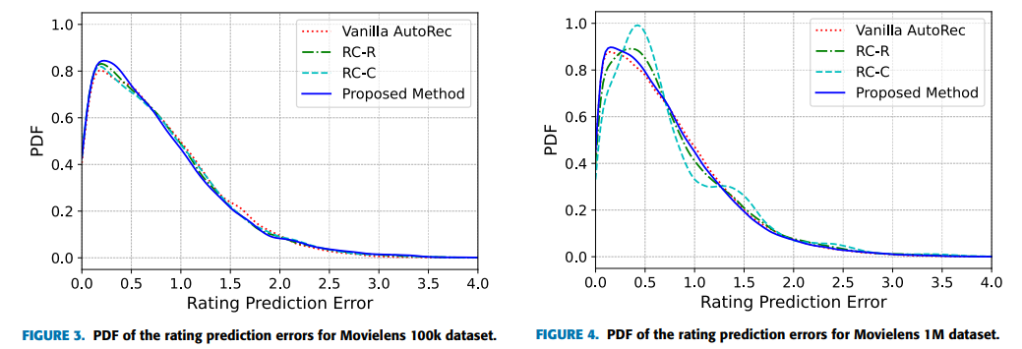

ChannelComp: A General Method for Computation by Communications
This paper addresses a fundamental limitation of over-the-air computation (Air Comp), namely its dependence on analog modulation, which is incompatible with most modern digital communication systems. The goal is to enable reliable and efficient computation over wireless channels using digital modulation schemes, thereby bridging the gap between communication and computation.
The theoretical foundation relies on the superposition property of wireless multiple-access channels, combined with optimization theory and digital modulation principles. Unlike traditional Air Comp, which aggregates analog amplitudes, the proposed approach reformulates computation as a modulation-aware optimization problem.
The methodology introduces ChannelComp, a general framework that supports both analog and digital modulations. A feasibility optimization problem is formulated to identify suitable constellations for computing arbitrary functions. Precoders are designed to adapt existing digital modulation schemes for function computation. Performance is evaluated through simulations across different functions and modulation types.
Key results show that ChannelComp significantly outperforms analog Air Comp, particularly for non-linear functions such as products, achieving more than 10 dB reduction in computation error. The approach demonstrates that digital modulation can be effectively exploited for over-the-air computation.
Applications include edge computing, federated learning, IoT data aggregation, and 6G networks, where joint communication-computation efficiency is critical.
Limitations include increased system complexity and the need for accurate channel state information. Future research may explore robustness under imperfect synchronization, practical hardware validation, and extension to multi-cell networks.
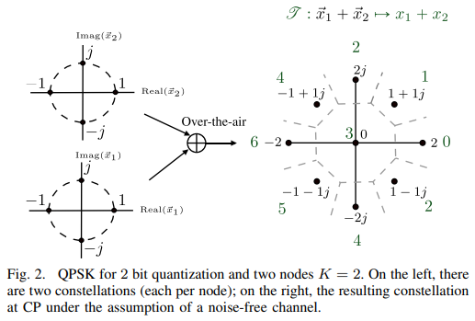

Optimizing multi‐user wireless networks through discrete Fourier transform‐based channel estimation with cascaded intelligent reflecting surfaces
The paper addresses the challenges of channel estimation in wireless networks equipped with cascaded Intelligent Reflecting Surfaces (IRS). Fading, path loss, and shadowing are prevalent in wireless environments and degrade estimation accuracy. Traditional methods such as Least Squares (LS), Linear Minimum Mean Square Error (LMMSE), and Maximal a Posteriori (MAP) often struggle with either accuracy or computational complexity in IRS systems. To overcome these limitations, the authors propose a novel Advanced Discrete Fourier Transform (ADFT) matrix scheme that efficiently manages common link configurations, reduces pilot overhead, and significantly minimizes the Normalized Mean Squared Error (NMSE) for multi user communications.
The methodology combined theoretical modelling and simulation. The system model was an uplink Multi Input Single Output (MISO) setup with a Base Station (BS), multiple users, and a cascaded IRS composed of passive reflecting elements. The channel model incorporated both direct BS User paths and reflected User IRS BS paths under quasi static block fading. The ADFT matrix scheme constructed the IRS reflection coefficient matrix during channel estimation, leveraging the structural advantages of the DFT to optimize reflection patterns and ensure maximal aperture utilization by activating all IRS elements in every time slot. To optimize phase shifts, the authors employed a penalty convex concave procedure and successive convex approximation to handle non convex unit modulus constraints. An iterative algorithm was designed to maximize received signal power and minimize NMSE. Simulations were conducted in a 20 m × 20 m indoor office scenario with 10 randomly distributed users. The BS had a uniform planar array of 10 antennas, and the IRS had 30 elements. The ADFT scheme was compared against LS, LMMSE, and MAP methods across varying SNRs (0–30 dB), pilot lengths (5–25), and BS distances (3–53 m).
The findings demonstrate the superiority of the proposed scheme. The ADFT matrix reduced NMSE by 66% at 20 dB SNR and 80% at 15 dB SNR compared to traditional methods. In comparative simulations, ADFT consistently outperformed LS, MAP, and LMMSE, showing a 75% decrease in NMSE as SNR increased. Increasing pilot length improved channel correlation, allowing ADFT to leverage prior knowledge more effectively, while LS and MAP performance remained stagnant. Even as BS distance increased, weakening the signal, ADFT maintained its lead, showing a 33% improvement in NMSE relative to other schemes.
The applications are highly relevant for next generation wireless networks (Beyond 5G and 6G), where IRS technology will play a critical role. IRS can extend coverage into dead zones and improve signal quality in complex indoor environments by intelligently reflecting signals around blockages. Since IRS elements are passive and require no RF chains or amplifiers, this method supports cost effective and energy efficient communication systems. Efficient handling of common link configurations makes the approach suitable for massive MISO setups, enabling better resource management and interference mitigation in dense user environments.
The study also identifies limitations and future directions. The algorithm assumes channel sparsity, which may not hold in all propagation environments. Phase shift optimization can become complex for large matrices, potentially impacting real time processing for very large IRS arrays. Hardware prototyping is needed to validate these findings in physical deployments. Synchronization issues in OFDM systems also require further exploration when integrating advanced signal processing techniques.

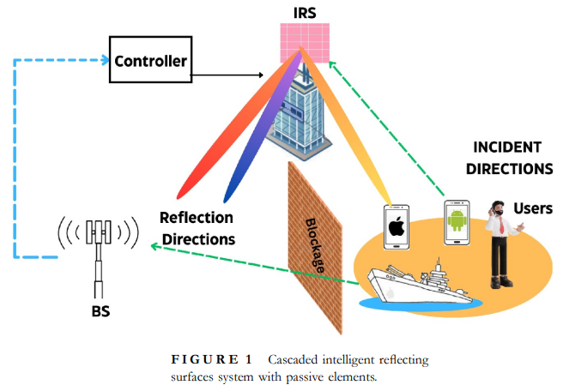

An Empirical Determination of Optimum Artificial Intelligence Algorithm: Detection Using Signal-to-Noise Ratio Approach
The paper addresses the specific problem of effectively evaluating and selecting artificial intelligence (AI) algorithms for malware detection using system calls, focusing on overcoming limitations of conventional metrics that prioritize accuracy alone and ignore other critical factors like precision and computational efficiency. This issue is significant because malware complexity is increasing, and a holistic performance metric is needed to guide algorithm choice in real-world, resource-constrained environments. The study aims to develop a robust, composite metric based on the signal-to-noise ratio (SNR) that integrates multiple performance measures—accuracy, precision, error rates, and model-building time—into a single, additive, and interpretable value to optimize AI algorithm selection processes.
The methodology involves the formulation and application of an SNR-based composite metric that combines key AI evaluation parameters: mean absolute error (MAE), root mean squared error (RMS), correctly classified instances (CCI), and time to build the model (TBM). The research uses the Attack-caused Windows System Calls Traces Dataset (AWSCTD), containing imbalanced malicious activity data across various system call lengths and malware classes. Eight commonly used AI algorithms (Bayes, Naïve Bayes, Logistic, ML Perceptron, J48, LMT, Random Forest, and Random Tree) were tested using the WEKA machine learning framework under default parameter settings. Each algorithm’s performance data—including classification accuracy, error metrics, and computational time—was extracted and transformed into SNR values following Taguchi’s approach, converting heterogeneous metrics into a decibel scale for additively. The study then conducts statistical analyses including ANOVA, correlation, and regression to validate the composite metric’s effectiveness in reflecting algorithm performance comprehensively.
Key findings reveal that the SNR composite metric successfully aggregates diverse performance indicators into a single measure that discriminates better among AI algorithms than accuracy alone. Results show that Bayes and Naïve Bayes perform poorly on accuracy despite fast model building, while Logistic, ML Perceptron, and LMT suffer from impractically long build times at higher system call lengths. J48, Random Forest, and Random Tree demonstrate superior balanced performance, with Random Tree emerging as the best overall algorithm due to its consistently high SNR values and minimal sensitivity to increased system call lengths, indicating robustness and efficiency. The analysis also finds that increasing system call lengths improves classification accuracy only up to about 100 calls, beyond which performance plateaus or declines. Validation tests confirm strong correlation and statistical significance between training and test data SNR values, supporting the metric’s robustness and practical relevance.
The main applications and implications of this research lie in providing a mathematically sound, holistic metric for AI algorithm evaluation that can be used in malware detection and other AI-based classification tasks where trade-offs between accuracy, precision, and computational cost are critical. The SNR-based metric facilitates more informed and objective decision-making in selecting AI models, especially in scenarios requiring real-time or resource-efficient solutions. Additionally, the approach can be adapted or extended to other domains of AI and machine learning that require aggregate performance assessment across multiple heterogeneous metrics.
Limitations include the focus on only eight relatively common AI algorithms, excluding many advanced or emerging techniques, which may limit the generalizability of the findings. Computational constraints restricted the evaluation of models on very large system call sequences, leading to incomplete analysis for longer sequences. Furthermore, the composite SNR metric, while additive and comprehensive, assumes equal weighting of included metrics and may oversimplify complex performance interactions. Future research directions suggested include incorporating additional relevant measures into the composite metric to enhance robustness, exploring the metric’s applicability to a broader range of AI algorithms and datasets, and leveraging more powerful computational resources to analyse larger datasets and extend model evaluations. Experimental validation and real-world deployment studies could further establish the metric’s effectiveness and practical utility.
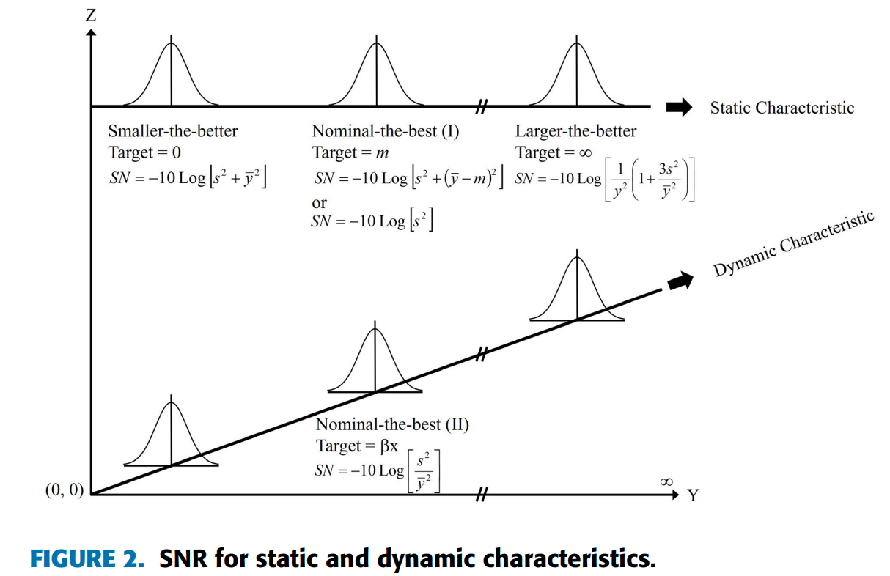

Convolutional Neural Network Algorithm and Application Method for Real-Time Beam Steering in RF System
The objective of this paper is to develop and demonstrate an artificial intelligence–based real-time beam steering system for radio-frequency (RF) applications using a convolutional neural network implemented on FPGA hardware. With the rapid growth of high-data-rate wireless communication systems, efficient spectrum utilization and fast target tracking have become critical requirements. Conventional digital beamforming approaches rely on large lookup tables and predefined phase data, which lead to high memory usage, limited scalability, and reduced adaptability, especially for large antenna arrays. The paper aims to overcome these limitations by introducing a CNN-based beamforming approach that can directly learn from received RF signals and dynamically control antenna phase shifters, enabling fast and accurate beam steering without the use of image sensors.
The methodology employed in this work involves the design and implementation of a hybrid analog–digital RF beamforming system integrated with artificial intelligence on an FPGA platform. A 5 × 5 antenna array is used at both the transmitter and receiver, where the transmitter emits a scanning beam and the receiver captures reflected signals from a target. The received analog signals are converted into digital form using an ADC and stored in FPGA memory. Instead of using FFT-based preprocessing, the authors propose a direct data-driven approach in which ADC output values are converted into a 35 × 35 input feature map for the CNN. The CNN architecture consists of three convolution layers and two pooling layers and is trained using supervised learning with labelled datasets representing target presence across 49 spatial classes. A two-stage beam scanning strategy is adopted, comprising a coarse scan with large phase steps to detect approximate target location, followed by a fine scan with smaller phase steps for precise localization. The trained CNN is implemented entirely on FPGA hardware, and its output is used to generate real-time control signals for the RF phase shifter.
The results presented in the paper demonstrate that the proposed CNN-based beam steering system achieves reliable real-time target detection and beam control with hardware implementation. FPGA-based simulations and experimental measurements show that the system achieves an accuracy of 88.33% in target detection across 60 test cases, which is considered high for real-time AI processing on hardware. The beam scanning process is completed in approximately 469 microseconds, confirming the suitability of the approach for fast RF applications. Experimental results further verify that the AI-generated control signals correctly adjust the phase shifter, producing the expected changes in beam direction during both coarse and fine scans. Compared to software-based and sensor-dependent beamforming systems, the proposed method demonstrates high speed, reduced latency, and efficient phase control directly from learned RF signal patterns.
In conclusion, the paper establishes that convolutional neural networks implemented on FPGA hardware can effectively enable real-time beam steering in RF systems by directly learning from digitized receiver data. The proposed approach reduces memory requirements, eliminates dependence on image sensors, and provides fast and adaptive beam control suitable for dynamic environments. However, the study also acknowledges limitations such as sensitivity to receiver signal quality, reliance on accurate ADC data, and the need for further optimization to improve accuracy and scalability. Future research directions include designing more FPGA-optimized CNN models, improving robustness under noisy or cluttered environments, extending the approach to larger antenna arrays, and transitioning the FPGA-based design to system-on-chip implementations for practical deployment.
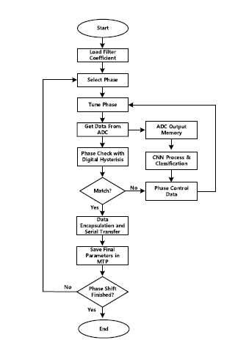

Real-Time Monte Carlo Denoising With Adaptive Fusion Network

The paper addresses the challenge of real-time Monte Carlo denoising for images rendered with extremely low samples per pixel (1 spp). Existing temporal accumulation (TA) techniques often suffer from performance degradation and ghosting artifacts in dynamic scenes characterized by rapid light source changes or low temporal consistency [1], [2]. To overcome these limitations, the authors propose a novel framework that leverages both the current 1 spp image, which captures immediate dynamic details, and the temporally accumulated TA-1 spp image, which provides higher effective sampling [3]. The ultimate goal is to achieve superior quantitative and qualitative restoration performance while maintaining the speed required for real-time applications, thereby breaking the traditional cost-performance trade-off [4], [5].
The methodology is based on a deep learning framework composed of three modules: multi-scale kernel prediction, filtering and fusion, and refinement [6]. Inputs include noisy 1 spp images, TA-1 spp images, and auxiliary features such as albedo, shading normal, and depth, which are pre-processed via albedo demodulation and tone-mapping to handle high dynamic ranges [7]. A lightweight auto encoder predicts per-pixel kernel maps, applying smaller kernels to down-sampled 1 spp images and larger kernels to TA-1 spp images to optimize receptive fields [8], [9]. The predicted kernels are applied to unfolded images via weighted sums [10], and a scale-compositor module fuses the filtered 1 spp and TA-1 spp images using a learned adaptive weight map, dynamically balancing contributions from current frames and accumulated history [11]. A residual learning module then refines the output, removing remaining noise and restoring fine details [12]. The model was trained and evaluated using the BMFR dataset for real-time performance and the Tungsten dataset for high-quality generalization [13], implemented in PyTorch on an NVidia RTX 2080Ti GPU with the Adam optimizer and Symmetric Mean Absolute Percentage Error (SMAPE) as the loss function [14].
The findings demonstrate significant advances in real-time rendering. The proposed method achieved a PSNR increase of 1.843 dB and a 39% reduction in run-time compared to the state-of-the-art WSKPN method on the BMFR dataset [4], [15]. In dynamic scenes with rapidly moving light sources, such as the “Sponza moving-light” scene, the method improved PSNR by up to 5.202 dB over SOTA, confirming that fusing 1 spp images preserves current pixel information that TA methods typically blur [15]. The system achieved real-time speed, processing at 239 FPS in HD resolution [16]. Ablation studies validated that the combined “Fusion w/ refine” approach consistently outperformed using either 1 spp or TA-1 spp images alone, providing stability in static scenes while maintaining responsiveness in dynamic ones [17], [18].
The applications are directly relevant to interactive computer graphics, particularly video games and film production, where Monte Carlo path tracing is the standard for realism but computationally expensive [19]. By effectively Denoising 1 spp images, the framework enables photo-realistic rendering within strict time budgets (e.g., 60+ FPS) without requiring massive hardware scaling [20], [21]. Its robustness to low temporal consistency makes it suitable for fast animation or dynamic lighting scenarios where TA methods produce artifacts [2], [4]. The lightweight design, with kernel prediction taking only 1.46 ms, ensures efficient resource usage and integration into pipelines without monopolizing GPU resources [22].
The study also acknowledges limitations. In highly consistent static scenes, incorporating noisy 1 spp images can introduce unnecessary variance, slightly degrading stability compared to pure accumulation [23]. The system depends on the quality of the external TA process, and poor TA performance can reduce overall effectiveness [23]. The degradation model used was based on artificial light sources, which may limit adaptability to complex natural lighting scenarios such as backlit or non-uniform environments [24]. Future research should focus on developing improved TA techniques integrated directly into the Denoising pipeline and exploring degradation models that simulate natural light distortions to enhance adaptability in real-world conditions [23], [25].
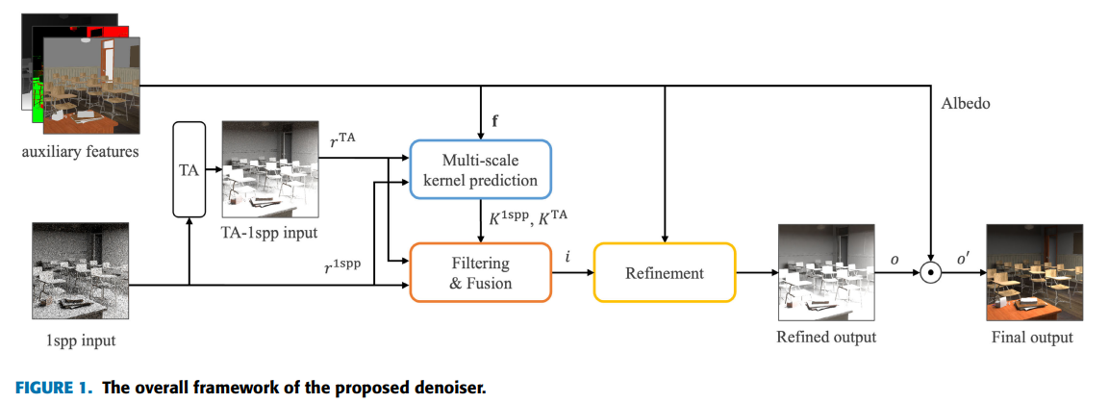

Asynchronous Wireless Signal Modulation Recognition Based on In-Phase Quadrature Histogram
The paper addresses the challenge of automatic modulation recognition for low-speed, asynchronously sampled wireless signals, where conventional likelihood-based and handcrafted feature methods lose accuracy at low SNR and often fail under carrier instability or asynchronous sampling. This issue is important because modern wireless and electromagnetic environments are dense, time-varying, and interference-limited, while practical receivers—especially low-cost or energy-constrained ones—cannot always rely on high-rate, synchronous sampling. To tackle this, the authors propose a framework that models asynchronously sampled I/Q signals, constructs a two-dimensional asynchronous in-phase–quadrature histogram (2D-IQH) to jointly capture amplitude and phase statistics, and applies a radial basis function neural network (RBFNN) to classify seven digital modulations (BPSK, QPSK, 8PSK, 4QAM, 16QAM, 32QAM, 64QAM).
Methodologically, the receiver is modelled as a standard RF front end with carrier demodulation, low-pass filtering, and an AWGN channel, where I/Q components are sampled at a rate much lower than the symbol rate and without symbol synchronization. These asynchronous samples are quantized along the I and Q axes and accumulated into an N×NN \times NN×N 2D-IQH matrix, which statistically represents the joint amplitude–phase distribution of the signal. This histogram is then vectored and fed into a three-layer RBFNN trained in a supervised manner, where Gaussian basis functions in the hidden layer enable nonlinear fitting between histogram features and modulation classes.
Simulation results demonstrate that the proposed 2D-IQH + RBFNN approach achieves strong robustness under low SNR and asynchronous sampling, outperforming classical machine-learning methods and CNN-based baselines. Average recognition accuracy exceeds 90% around 5 dB SNR and approaches 100% by 8–10 dB across all seven modulations, with particularly notable gains at low SNR compared to ELM, random forest, SVM, and CNN classifiers. These improvements are attributed to the joint amplitude–phase statistics captured by the 2D-IQH and the RBFNN’s ability to model nonlinear class boundaries effectively.
The authors note that the current study is limited to AWGN channels and simulation-based data, and does not yet account for multipath fading or real-world channel impairments. Future work is suggested in extending the framework to fading and time-varying channels, fusing 2D-IQH with additional statistical features, and integrating deeper neural networks (e.g., CNNs) to further enhance robustness and applicability in practical asynchronous wireless receivers.
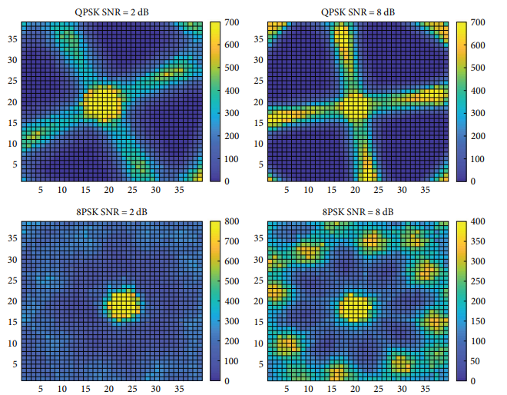
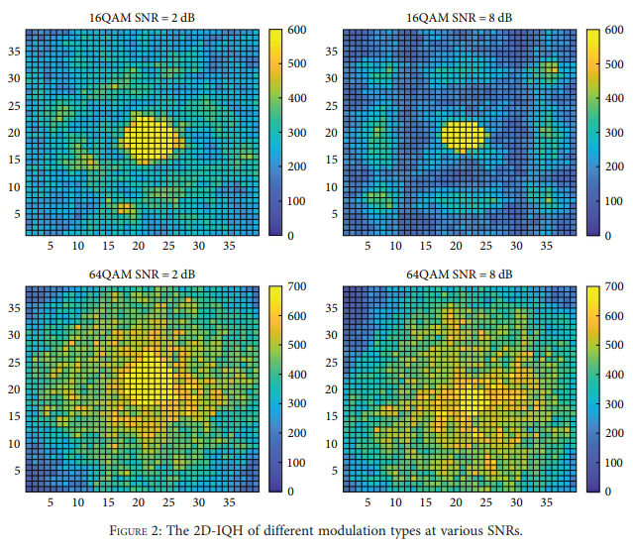

End-to-end learning of adaptive coded modulation schemes for resilient wireless communications
This paper investigates the limitations of conventional adaptive modulation and coding (AMC) schemes, which rely on predefined lookup tables and separately designed coding and modulation blocks. Such designs lack flexibility and struggle to adapt optimally to complex or rapidly changing channel conditions. The primary objective of the study is to develop an end-to-end deep learning framework that jointly learns adaptive coding and modulation strategies using a single unified neural network model
The methodology employs an auto encoder-based end-to-end learning architecture framed as a multi-task learning problem. A shared encoder–decoder network with branching outputs is designed to support multiple code rates within the same model. The system is trained using a custom procedure that alternates between transmitter–receiver joint training and receiver-only optimization. Performance is evaluated under additive white Gaussian noise and Rayleigh fading channels without retraining the model.
The findings show that the proposed approach achieves block error rate performance comparable to or better than conventional coding schemes, including maximum-likelihood decoding, across multiple code rates. Importantly, the model generalizes well to unseen channel conditions, demonstrating resilience without explicit channel modelling. This contributes to the field by proving that adaptive coded modulation can be learned directly from data in an end-to-end manner.
The proposed framework has strong implications for future intelligent and autonomous wireless systems, particularly in environments with unpredictable interference. However, the model is limited by training complexity and reliance on differentiable channel representations. Future work should explore reinforcement learning–based channel adaptation, scalability to longer code lengths, and real-time implementation feasibility.
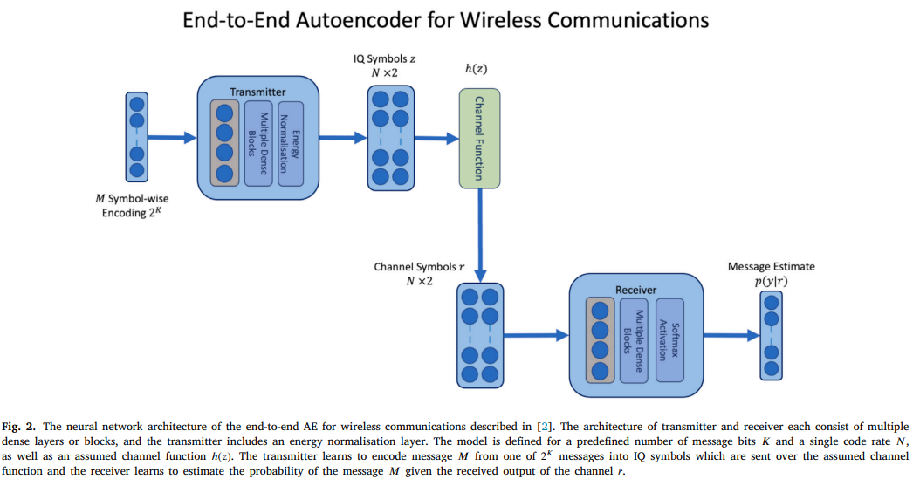

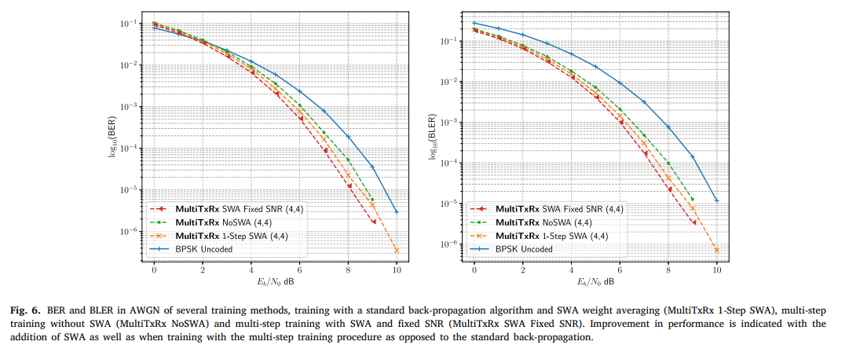

Low-Noise Frequency Synthesis and Terahertz Wireless Communication Driven by Compact Turnkey Kerr Combs
The objective of this paper is to overcome the fundamental phase-noise limitations that restrict high-frequency microwave and terahertz signal generation using conventional electronic and photonic technologies. As wireless communication systems advance toward terahertz frequencies to support ultra-high data rates, maintaining low phase noise becomes critical for achieving high signal-to-noise ratios and efficient modulation. Existing Kerr-comb-based photonic microwave sources offer compactness and high operating frequencies but typically suffer from elevated phase noise due to limited mode volume, pump laser noise, and thermorefractive noise. The primary goal of this study is to develop a compact, electrically driven, turnkey Kerr comb system capable of near quantum-limited low-noise frequency synthesis up to the terahertz range and to demonstrate its effectiveness in high-speed terahertz wireless communication without the need for complex carrier phase estimation.
The methodology employed in this work combines theoretical noise modelling, advanced resonator fabrication, and experimental system integration. A few-mode fiber Fabry–Perot resonator (FFPR) with an ultra-high quality factor of 6.0 × 10⁸ is designed and fabricated using precision polishing and multilayer dielectric coating techniques to reduce propagation and diffraction losses. The resonator is directly pumped by a distributed feedback (DFB) laser diode and stabilized using self-injection locking, significantly suppressing pump noise. The Kerr comb is generated within a compact package measuring 85 × 90 × 25 mm, enabling turnkey operation without dynamic tuning. Phase noise is characterized using phase noise analyzers, Allan deviation measurements, and direct beating and harmonic mixing techniques. For terahertz wireless communication experiments, selected comb lines are filtered, amplified, and converted to terahertz carriers using uni-traveling-carrier photodiodes. Coherent terahertz transmission experiments are performed over a combined 10-km fiber link and 4-m wireless link using QPSK, 16QAM, and 64QAM modulation formats at baud rates up to 40 GBd.
The results demonstrate that the proposed Kerr comb system achieves near quantum-limited phase noise performance across a wide frequency range from 10.1 GHz to 384 GHz. Measured phase noise reaches −133 dBc/Hz at 10.1 GHz and −95 dBc/Hz at 300 GHz at a 10-kHz offset, with noise floors approaching −160 dBc/Hz, surpassing conventional microwave electronics. The system exhibits excellent long-term stability, with Allan deviation below 4 × 10⁻¹⁰ at 1 s. In terahertz wireless communication experiments, the low phase noise enables high-order modulation without carrier phase estimation, achieving a record line rate of 240 Gbps using 64QAM at 40 GBd. Bit-error-rate measurements confirm reliable transmission meeting forward-error-correction thresholds, while comparisons with dual-laser systems highlight the significant performance and DSP complexity advantages of the Kerr-comb-based approach.
In conclusion, the paper establishes that compact, electrically driven Kerr combs based on high-Q few-mode fiber Fabry–Perot resonators provide a powerful solution for low-noise frequency synthesis and terahertz wireless communication. By achieving near quantum-limited phase noise and enabling carrier-phase-estimation-free high-order modulation, the proposed system significantly simplifies receiver DSP while supporting ultra-high data rates. Although further improvements in resonator fabrication and active feedback stabilization could enhance performance, this work represents a major step toward practical, field-deployable terahertz communication, radar, and sensing systems. Future research directions include increasing resonator Q, reducing power consumption, extending frequency coverage, and integrating the technology into large-scale terahertz networks and superchannel communication architectures.
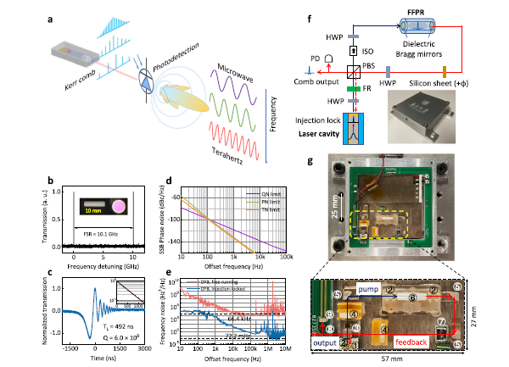

Multi-Channel Radio-Over-Fiber Communication Systems Through Modulation Instability Phenomenon
The objective of this paper is to enhance the performance and flexibility of multi-channel radio-over-fiber (RoF) communication systems for modern wireless applications by exploiting the modulation instability (MI) phenomenon in optical fibers. Although RoF technology offers large bandwidth, low loss, and cost-effective distribution of radio-frequency (RF) signals, its performance is constrained by limitations such as reduced modulation efficiency at high frequencies, increased half-wave voltage (Vπ) of Mach–Zehnder modulators (MZMs), beam squint in phased array antennas (PAAs), and reliance on external optical amplifiers. The primary goal of the study is to utilize MI-induced gain to improve modulation efficiency, enable frequency-selective amplification over multiple RF bands, reduce Vπ, and implement true-time-delay (TTD) beamforming, thereby achieving a high-performance and cost-efficient RoF architecture suitable for wideband wireless communication systems.
The methodology employed in this work combines analytical modelling, numerical simulations, and experimental validation of an MI-based RoF system. The MI phenomenon is analyzed using the nonlinear Schrödinger equation to derive expressions for MI gain as a function of fiber length, group velocity dispersion, nonlinear coefficient, and input optical power. Fibers operating in the anomalous dispersion regime with β₂ values of −20, −11.3, −3.2, and −2 ps²/km are selected to selectively amplify RF signals centered at 12, 16, 30, and 38 GHz, respectively. A Mach–Zehnder modulator is used to modulate RF signals onto an optical carrier, which then propagates through fibers experiencing MI to provide frequency-dependent gain. An MI-based switching control system selects the appropriate fiber according to the desired RF band. For beamforming, an integrated micro-ring resonator–based frequency comb source is combined with MI-enhanced fibers to realize TTD beam steering for PAAs. Numerical simulations are conducted using OptiSystem software, and experimental measurements are performed to evaluate MI gain, received power, bit-error rate (BER), signal-to-noise ratio (SNR), and beam steering performance over fiber lengths up to 45 km.
The results demonstrate that modulation instability significantly enhances the performance of multi-channel RoF systems across a wide frequency range. Experimental measurements show MI gains of approximately 18 dB over 30 km of fiber and up to 38.1 dB over 45 km, enabling substantial amplification without the use of external optical amplifiers. The effective half-wave voltage of the Mach–Zehnder modulator is reduced by more than 70 times, leading to improved modulation efficiency and reduced power requirements. The system maintains low BER for RF frequencies between 12 and 38 GHz over fiber lengths up to 45 km, confirming reliable long-distance transmission. The MI-based TTD beamforming approach successfully eliminates beam squint, maintaining a fixed beam direction across different frequencies, unlike conventional phase-shifting methods. Additionally, SNR performance improves with increasing fiber length due to MI-induced gain and reduced shot-noise impact, outperforming conventional RoF systems that rely on erbium-doped fiber amplifiers.
In conclusion, the paper establishes that incorporating modulation instability into radio-over-fiber systems provides an effective solution for multi-channel, wideband wireless communication. By enabling frequency-selective amplification, reducing Mach–Zehnder modulator Vπ, supporting true-time-delay beamforming, and eliminating the need for external optical amplifiers, the proposed MI-based RoF architecture achieves enhanced performance with reduced cost and system complexity. While the study is conducted under controlled experimental conditions and assumes ideal fiber characteristics, it demonstrates strong practical potential. Future research directions include optimizing fiber parameters for higher frequencies, extending the approach to larger phased array configurations, and validating the system in real-world 5G and beyond wireless deployment scenarios.
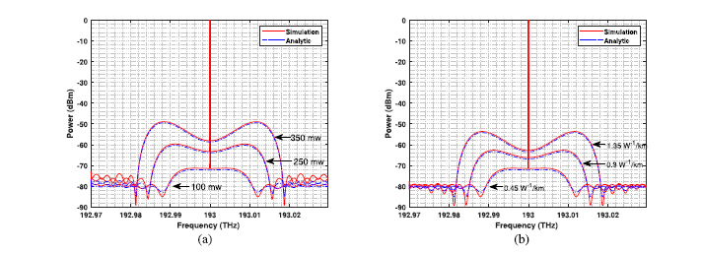

Towards explainability for AI‑based edge wireless signal automatic modulation classification

The paper addresses the “black box” nature of AI-based Automatic Modulation Classification (AMC) models, which currently lack sufficient explanation for their decision-making processes and therefore raise concerns about trust and accountability [1, 2]. High-performance deep learning models are often underutilized in sensitive fields such as military operations or industrial safety because failures cannot be easily diagnosed or distinguished from poor signal quality [3]. To solve this problem, the authors propose an interpretable AI-based AMC framework that maps classification results to specific wireless signal features using attribution scores, thereby enhancing transparency [1, 4]. In addition, the study aims to optimize these models for edge computing, enabling devices to train networks with lower energy consumption and higher accuracy by identifying which features contribute most to successful classification [1].
The methodology involves the design of an attribution-driven explainable AI (XAI) model that integrates three modules: attribution feature determination, wireless attributed feature conversion, and attribution-based model optimization [5]. Gradient-based attribution is employed through Integrated Gradients (IG), which addresses the gradient saturation problem by summing gradients along a path from a baseline (blank signal) to the input, assigning contribution scores to each sample [6, 7]. A novel wireless attributed feature conversion method is introduced to translate abstract neural network attribution scores into the wireless signal domain, using attention-based dynamic windows to extract “attributing signal segments”—the specific parts of a signal, such as phase shifts, that drive classification decisions [8, 9]. The experimental setup uses the RML2016.10a open-source radio dataset containing 11 modulation types, including QPSK, 8PSK, and QAM64 [10]. The framework is tested on Convolutional Neural Networks (CNN) and Long Short-Term Memory (LSTM) architectures, with raw IQ signals converted into Amplitude and Phase dimensions for visualization and analysis [11].
The findings demonstrate several important outcomes regarding interpretability in wireless signal classification. The model successfully visualizes specific signal features, such as phase changes in QPSK, that determine classification results, confirming that the network learns from meaningful signal segments rather than random noise [8, 12]. The study also reveals sample variability, showing that different signal samples of the same modulation type, such as QAM64, often rely on different attribution features for classification. This explains why some samples are misclassified while others are correctly identified [12, 13]. Furthermore, by feeding the extracted “attributing signal segments” back into the model, the system can weaken interfering signals and focus on the most relevant data, thereby improving learning accuracy [9, 12]. The proposed method also proves capable of exploring the internal classification mechanisms of non-transparent networks, bridging the gap between deep learning “black boxes” and understandable wireless communication concepts [1].
The applications and implications of this research are significant for the deployment of 6G intelligent systems and mobile edge computing [14, 15]. By providing explainability, the framework enables AI-based AMC to be applied in critical areas such as military operations and autonomous transportation, where users must understand the reasons behind a model’s success or failure [3, 14]. The findings also suggest that edge devices can use attribution data to share model weights more efficiently, reducing communication overhead and enabling training with lower energy consumption, which is crucial for resource-constrained IoT and mobile devices [1, 15]. Additionally, the approach supports debugging and diagnostics by allowing engineers to determine whether classification failures stem from the AI model’s structure or from poor input signal quality, thereby improving system troubleshooting [3].
Despite its contributions, the study acknowledges limitations and outlines future research directions. Previous explainability methods such as LIME or signal clustering are limited because they often rely on human experience or fail to explain latent features in time-series data, such as dominant frequencies, which this study sought to improve upon [16, 17]. The authors emphasize that the next critical step is the deployment of explainable deep learning networks on actual mobile edge devices [13]. Future work requires deeper exploration into validating the framework’s feasibility in real-world hardware environments to practically enhance communication performance and broaden application range [13].
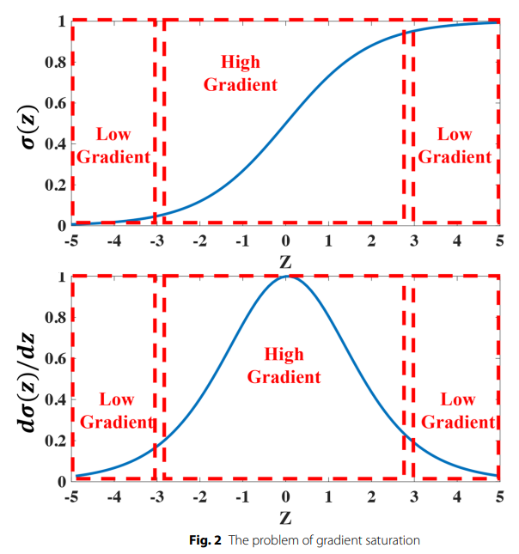

Comparative Assessment of Modulation Strategies in Modular Multilevel Converters
This paper investigates different modulation strategies used in Modular Multilevel Converters (MMCs) and focuses on improving the balance between efficiency, switching losses, and capacitor voltage stability. MMCs are widely used in high-power applications such as high-voltage direct current (HVDC) transmission, renewable energy systems, and large industrial drives. However, controlling MMCs presents several challenges, particularly maintaining balanced capacitor voltages while minimizing the number of switching operations and reducing current harmonic distortion. The study aims to evaluate several existing modulation techniques and proposes an improved sorting algorithm that reduces switching actions while preserving waveform quality and converter performance.
The research compares six modulation techniques: Nearest Level Control (NLC), Integral Modulation (IM), and Pulse Width Modulation (PWM) along with their improved versions NLC+, IM+, and PWM+, which incorporate the proposed sorting algorithm. Traditional sorting algorithms mainly focus on balancing capacitor voltages, but they can increase the number of switching events, leading to higher power losses. To address this, the authors introduce a modified sorting algorithm that considers both capacitor voltages and the previous switching states of submodules. By applying a penalty function during sorting, the algorithm reduces unnecessary switching actions while maintaining acceptable capacitor voltage balance. The techniques were evaluated using a three-phase MMC experimental test bench with four half-bridge submodules per arm.
Experimental results demonstrate that the proposed techniques significantly reduce the number of switching operations without degrading performance. In some cases, the improved algorithms reduced switching actions by more than 50% compared to conventional methods while maintaining similar current control accuracy and total harmonic distortion (THD). Among the modulation strategies, PWM and PWM+ achieved the lowest THD, while IM and IM+ provided a good compromise between low switching frequency and acceptable harmonic performance. The study also confirmed that the IM technique produces smoother output voltage due to its inherent error correction mechanism.
Although the improved techniques slightly increase the dispersion of capacitor voltages, the increase remains small and controllable through system parameters. Overall, the findings suggest that the proposed sorting algorithm can improve MMC efficiency by reducing switching losses while maintaining stable converter operation. These results provide valuable insights for optimizing modulation strategies in high-power converter systems used in modern energy and industrial applications.
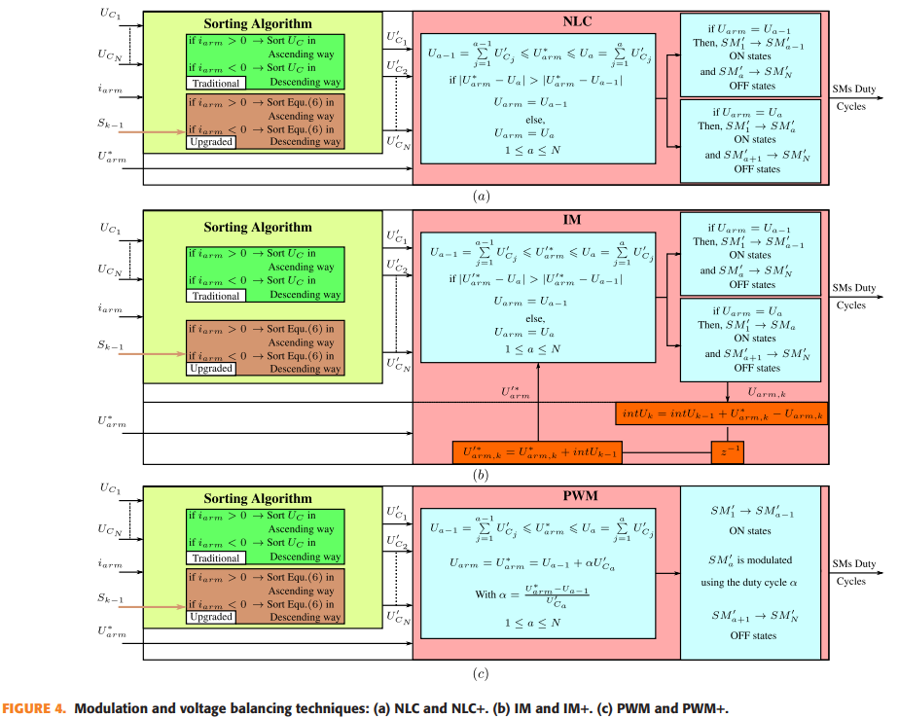

Development and verification of non-supervised smartphone-based methods for assessing pure tone thresholds and loudness perception
This paper addresses the growing need for accessible, cost-effective, and non-supervised hearing assessment tools, particularly for large-scale screening and remote healthcare applications. Conventional audiometric evaluations require specialized equipment, controlled environments, and professional supervision, which limit their scalability. The main objective of the study is to validate smartphone-based, self-administered methods for measuring pure-tone thresholds and loudness perception, and to assess whether these methods can achieve accuracy comparable to standardized laboratory-based audio logical tests

The methodology involves implementing pure-tone audiometry and categorical loudness scaling (CLS) on smartphones using a single-interval up-and-down procedure and adaptive loudness scaling techniques. The study compares three testing conditions with varying levels of supervision and evaluates both normal-hearing and hearing-impaired participants. Narrowband monaural and broadband binaural noise stimuli are used to examine spectral and binaural loudness summation, allowing the system to reduce sensitivity to calibration errors and environmental noise during unsupervised testing.

The results show that smartphone-based assessments exhibit no significant performance difference compared to laboratory-based measurements for both threshold and supra-threshold tests. The findings demonstrate that loudness perception measures are particularly robust against missing calibration and background noise, making them well suited for mobile platforms. This contributes to existing knowledge by confirming that non-supervised auditory testing can achieve clinical-grade reliability when appropriate perceptual measures are used.

The study has strong implications for remote audiology, mobile health applications, and large-scale hearing screening, especially in underserved or resource-limited regions. However, the work is limited by a relatively small participant pool and controlled experimental conditions. Future research should explore larger population studies, diverse acoustic environments, and integration with AI-based personalization to further improve robustness and diagnostic accuracy.

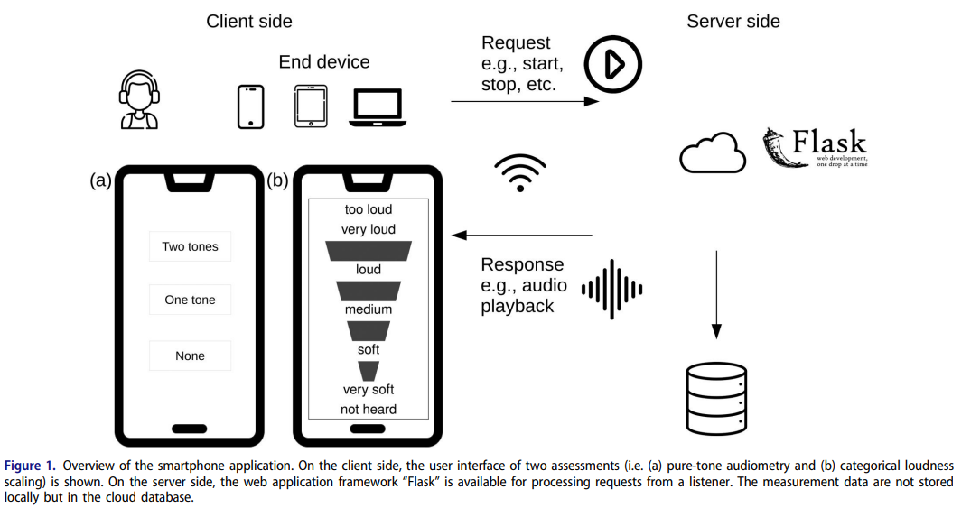

Directional Modulation with Artificial Noise in Time-Modulated Arrays
This paper addresses the problem of secure directional transmission in wireless systems, where signals must be intelligible only in desired spatial directions while remaining distorted elsewhere. Conventional directional modulation (DM) techniques using time-modulated arrays (TMAs) rely on complex and time-sensitive optimization algorithms, making them unsuitable for high-mobility and low-latency scenarios. The main objective of this study is to develop a simplified directional modulation scheme that ensures physical-layer security without requiring computationally intensive optimization procedures
The methodology proposes a novel DM-TMA architecture that simultaneously transmits the information signal using a sum radiation pattern and injects artificial noise using a difference radiation pattern. Unlike conventional approaches that depend on spectral aliasing and harmonic optimization, the proposed method uses deterministic time-modulated feeding networks and injects artificial noise only through a subset of antenna elements. This significantly reduces hardware complexity while maintaining spatial selectivity and security.
The results demonstrate that the proposed approach achieves competitive directional modulation performance while preserving time-modulated array efficiency. The artificial noise effectively distorts the signal in unintended directions, while the desired receiver experiences minimal degradation. The key contribution of this work lies in showing that secure directional modulation can be achieved without real-time optimization, making it suitable for dynamic wireless environments.
This technique is well suited for 5G/6G wireless systems, vehicular communications, secure broadcast links, and low-latency applications. However, the approach assumes ideal synchronization and precise array control, which may be challenging in practical deployments. Future research should explore robustness to hardware imperfections, multi-user extensions, and adaptive noise injection strategies under real-world channel conditions.
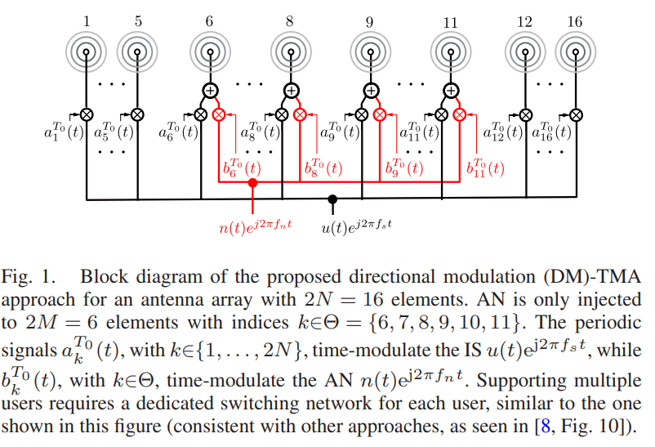

Overcoming laser phase noise for low-cost coherent optical communication
The paper addresses the challenge of laser phase noise in cost sensitive, short reach optical networks such as data center interconnects and fiber wireless access networks. Traditional solutions are limited because low cost Distributed Feedback (DFB) lasers, which typically have large linewidths in the MHz range, cannot support high order modulation formats due to severe phase fluctuations. To overcome this, the authors propose replacing expensive narrow linewidth External Cavity Lasers (ECLs) with affordable DFB lasers by developing a Residual Carrier Modulation (RCM) scheme. The goal is to enable precise carrier frequency and phase recovery without the spectral efficiency loss of time domain pilots or the DAC resolution penalties of RF pilot tones.
The methodology involved designing and experimentally validating a modulation and DSP framework. In RCM, the IQ modulator bias point is shifted slightly away from null, generating a residual optical carrier from the same laser source as the signal, which continuously tracks phase fluctuations. Dual band subcarrier multiplexing was used to reserve a narrow guard band around the carrier to prevent crosstalk. At the receiver, the residual carrier was extracted with a digital low pass filter and digitally beaten with the signal to cancel phase noise from both transmitter and LO lasers. Proof of concept experiments tested PS 256 QAM signals with a 3 MHz DFB laser and a 100 kHz ECL over an 80 km SSMF link. The setup used a 120 GSa/s AWG at the transmitter and a 256 GSa/s oscilloscope at the receiver. The methodology was extended to a 16 channel WDM system and an analog RoF fronthaul system using 512 QAM signals.
The findings highlight several record breaking outcomes. The study achieved a net 1.0 Tb/s single channel transmission using PS 256 QAM and a 3 MHz DFB laser, setting a record linewidth symbol duration product and demonstrating robustness against phase noise beyond previous limits. The RCM scheme improved bitrate by 41% compared to time domain pilot methods, enabling lasers with linewidths above 1 MHz to be used without constellation blurring. RCM performed comparably to RF pilot tones at moderate power but outperformed them at higher levels by avoiding DAC quantization penalties, maintaining higher SNR. In WDM, the system achieved 14.45 Tb/s aggregated capacity over 80 km. For RoF fronthaul, it supported over 2 Tb/s CPRI equivalent rates with BER well below error correction thresholds even at 512 QAM.
The applications are transformative for short reach optical networks. In data center interconnects, RCM enables low cost DFB lasers without sacrificing data rates, reducing transceiver costs amid AI driven traffic growth. In 5G/6G fronthaul, analog RoF with 512 QAM demonstrates high spectral efficiency and low latency for CU RU connections. The approach integrates self homodyne noise cancellation into standard intradyne architectures without complex optical path matching or remote LOs, simplifying hardware while maintaining performance.
The study also notes limitations and future directions. RCM requires a narrow guard band to isolate the residual carrier, introducing a minor spectral efficiency constraint. Performance is sensitive to CSPR and LPF bandwidth, which must be carefully tuned to avoid noise or phase loss. Future research could extend RCM beyond optical communications to precision measurement, CV QKD, FMCW Lidar, and sensing systems. Further work should also evaluate RCM in systems with lower resolution DACs to quantify its advantages over RF pilots in constrained hardware environments.
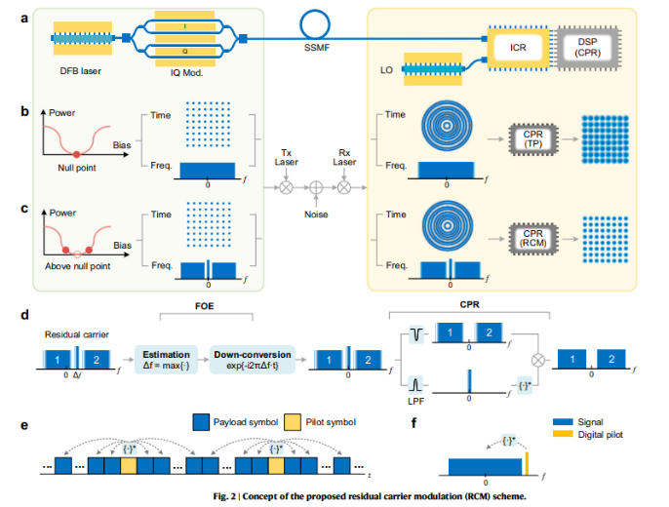

Device-compatible ultra-high-order quantum noise stream cipher based on delta-sigma modulator and optical chaos

This paper focuses on the challenge of achieving high-speed, physically secure communication that remains compatible with existing commercial communication systems. While quantum noise stream cipher (QNSC) schemes offer strong physical-layer security, their practical adoption is limited by high hardware complexity, synchronization difficulties, and inflexible noise control. The objective of this study is to develop a device-compatible, ultra-high-order QNSC system that enables secure transmission at very high data rates while overcoming these implementation barriers

The proposed methodology combines delta-sigma modulation (DSM) with optical chaos-based quantum noise masking. High-order encrypted QAM signals are converted into low-order digital signals using DSM, allowing transmission with standard DAC/ADC hardware. Broadband optical chaos introduces true randomness into the masking noise, while oversampling enables flexible control of noise shaping and security levels. The system is experimentally validated through coherent optical transmission over long-haul fibre links.

The key findings demonstrate 147.9-Gbps secure transmission of ultra-high-order QAM-QNSC signals over 75 km of optical fibre using commercially compatible devices. The results show that high security can be achieved without high-resolution converters or external clock channels, significantly improving system practicality. This work advances the field by proving that quantum noise–based physical-layer security can be integrated into real-world communication infrastructures.

The proposed scheme is highly relevant for future secure optical networks, data centers, and next-generation communication systems requiring both high speed and strong security. However, system complexity and sensitivity to optical component performance remain limitations. Future research should focus on further hardware integration, long-distance scalability, and adaptive security control to enable widespread deployment.

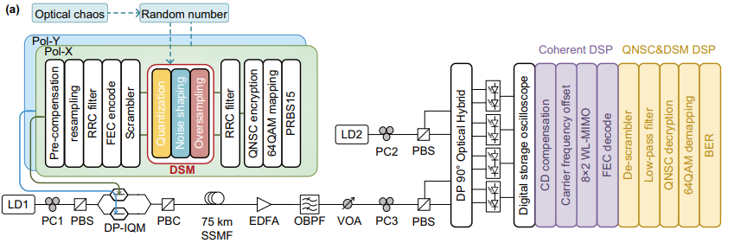
Fig. 4 Experimental setup. a PRBS15: pseudo-random binary sequence, QNSC: quantum noise stream cipher, RRC: root-raised-cosine filter, DSM: delta sigma modulator, FEC: forward error correction, Pol-X/Y: polarization X/Y, LD: laser diode, PC: polarization controller, PBS: polarization beam splitter, DPIQM: dual polarization I/Q modulator, PBC: polarization beam combiner, SSMF: standard single-mode fibre, EDFA: erbium-doped optical fibre amplifier, OBPF: optical band-pass filter, VOA: variable optical attenuator, CD compensation: chromatic dispersion compensation, WL-MIMO: widely-linear multiple input and multiple-output, BER: bit error ratio

Artificial Neural Network for Enhancing Signal-to-Noise Ratio and Contrast in Photothermal Optical Coherence Tomography

This paper focuses on improving the signal-to-noise ratio (SNR) and image contrast in Photothermal Optical Coherence Tomography (PT-OCT), an advanced biomedical imaging technique used to obtain detailed structural and molecular information from biological tissues. PT-OCT extends conventional Optical Coherence Tomography (OCT) by detecting molecular absorption through photothermal effects. However, one of the major limitations of PT-OCT is that detecting small phase fluctuations requires long signal acquisition times, which slows down imaging and limits its use in real-time clinical applications. To address this challenge, the authors propose using a machine learning approach based on an artificial neural network to estimate photothermal signals from short measurement traces, thereby improving image quality while significantly reducing acquisition time.
The proposed methodology involves training a neural network to predict the amplitude of photothermal phase modulation using only a short segment of the OCT phase signal. Conventionally, high-quality PT-OCT images require long signals consisting of many modulation cycles to suppress noise. In contrast, the neural network is trained using short signals as inputs while the corresponding long-signal reconstructions are used as ground-truth references. The network architecture consists of a fully connected structure with multiple hidden layers that learn patterns within the noisy phase signals. As illustrated in the system workflow, the model takes a short sequence of OCT phase data and predicts the photothermal signal amplitude that would normally require a much longer acquisition period. The training data were generated using specially designed phantom samples as well as biological tissue samples.
Experimental results demonstrate that the neural network significantly enhances both SNR and contrast in PT-OCT images. For example, when only a short signal segment containing two modulation cycles was used, the neural network produced signal amplitudes close to those obtained from conventional processing of much longer signals. Quantitative evaluation using metrics such as Mean Squared Error (MSE), Structural Similarity Index (SSIM), and Michelson contrast confirmed that the network reconstructions closely matched the ground-truth images. In many cases, the model reduced reconstruction error by nearly an order of magnitude compared to conventional short-signal processing. Furthermore, experiments on biological tissues—including adipose tissue, artificial plaques, and human aorta samples—showed that the network successfully suppressed noise and improved the visibility of absorbing regions within the tissue.
Overall, the study demonstrates that deep learning can effectively compensate for the limitations of traditional PT-OCT signal processing. By enabling accurate reconstruction from short signal traces, the proposed approach significantly increases imaging speed while maintaining high image quality. This advancement has important implications for translating PT-OCT into practical clinical applications, where fast acquisition and reliable signal detection are essential. The authors suggest that future research could integrate physics-informed machine learning models and explore additional strategies to further improve imaging performance and robustness across different biological tissues and experimental conditions
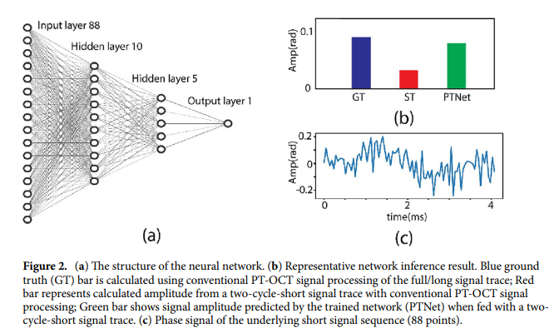

Deep Learning Prediction of Noise-Driven Nonlinear Instabilities in Fibre Optics
This paper explores how deep learning can be used to predict and analyze noise-driven nonlinear dynamics in optical fibre systems. In nonlinear optics, phenomena such as modulation instability arise from the interaction between coherent signals and random noise during fibre propagation, making their behaviour highly complex and difficult to model or control. Traditional numerical simulations of these processes are computationally expensive and often limited in capturing noise-driven effects. To address this challenge, the authors investigate whether artificial neural networks can learn these dynamics and accurately predict the evolution of optical signals under noisy conditions.
The proposed approach combines numerical simulations, experimental measurements, and machine learning models. Large datasets were generated by simulating nonlinear pulse propagation in optical fibres under various seeding conditions and noise realizations. A feed-forward neural network was then trained to perform two tasks: predicting the output optical spectrum from given input seed parameters, and inferring the hidden seed properties from observed output spectral correlations. The model processes statistical features of the output signals—such as average spectra and correlation maps—to learn relationships between the input conditions and the resulting nonlinear behaviour.
Results show that the neural network can successfully predict complex spectral features and retrieve seed parameters with high accuracy, even when the output signals are strongly affected by noise. In simulation experiments, prediction errors were typically below a few percent, demonstrating strong agreement with traditional physics-based models. Experimental validation using fibre-optic setups further confirmed that the network could capture key characteristics of noise-driven spectral broadening and modulation instability dynamics.
Overall, the study demonstrates that deep learning offers a powerful tool for understanding and controlling nonlinear optical systems. By reducing the need for extensive simulations and enabling rapid prediction of system behaviour, the proposed approach could support faster design and optimization of photonic devices and signal processing systems in optical communications and advanced photonic technologies.
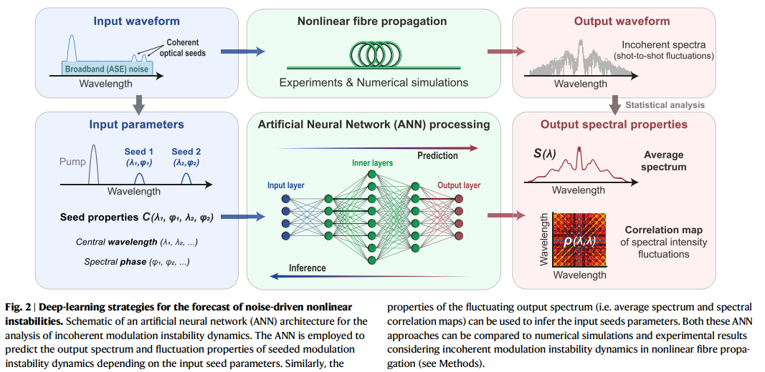

Automatic Modulation Recognition Using CNN Deep Learning Models
The paper addresses the problem of automatic modulation recognition (AMR) in wireless communication systems, focusing on improving classification accuracy under diverse modulation schemes and signal representations. This problem is critical because traditional feature-based or shallow machine-learning methods struggle under low signal-to-noise ratios (SNRs) and require manual feature engineering, which limits scalability and robustness in cognitive radio, spectrum monitoring, and electronic warfare applications. The goal of the study is to design and optimize deep learning models capable of learning discriminative modulation features directly from raw or image-based signal representations.

The theoretical foundation of the work is based on deep learning, particularly convolutional neural networks (CNNs), which are well suited for extracting hierarchical spatial patterns from structured data. In the context of AMR, CNNs learn modulation-specific structures either from I/Q sample vectors or from transformed image representations of signals, eliminating the need for handcrafted features. The study leverages supervised learning principles and statistical performance evaluation using ROC curves and classification metrics.

The methodology involves proposing two distinct CNN architectures, each trained on a different dataset. The first dataset, RadioML2016.10a, consists of complex baseband I/Q samples across eleven modulation classes, while the second dataset contains over 24,000 modulation images spanning eight digital modulation types. Extensive hyper parameter tuning is performed, including convolution kernel sizes, learning rates, and network depth. Model performance is evaluated using accuracy, confusion matrices, and ROC curves.

The key findings demonstrate that CNNs can achieve high modulation recognition performance when properly tuned. The image-based CNN achieves a testing accuracy exceeding 94%, while the I/Q-based CNN shows competitive performance despite the higher complexity of the dataset. The results confirm that deep learning can outperform many conventional AMR approaches and generalize across modulation families.

The research has direct applications in cognitive radio, spectrum surveillance, interference detection, and adaptive receivers, where fast and accurate modulation identification is essential. The implications extend to AI-driven communication systems capable of self-configuration in dynamic spectral environments.

However, the study is limited by its reliance on simulated datasets and idealized channel conditions. Future research directions include training with real-world over-the-air signals, improving robustness at very low SNRs, and exploring hybrid CNN-RNN architectures to capture temporal dependencies.

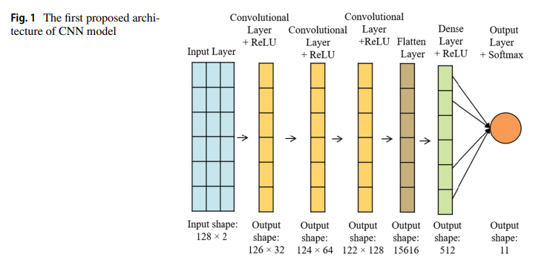

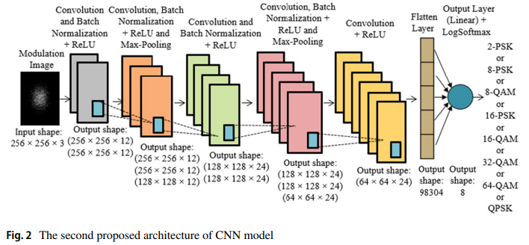

Machine Learning–Based Noise Characterization and Correction on Neutral Atoms NISQ Devices
The objective of this paper is to address the critical challenge of noise characterization and mitigation in neutral-atom-based noisy intermediate-scale quantum (NISQ) devices, which are emerging as a promising platform for near-term quantum computation. Neutral atom processors, such as those developed by Pasqal, allow flexible geometric arrangement of atoms and analog control via laser pulses, but their performance is significantly degraded by multiple noise sources including laser intensity fluctuations, finite temperature effects, imperfect measurements, and spatial inhomogeneities. Conventional quantum error correction techniques are impractical for NISQ systems due to their large qubit overhead. The primary objective of this study is therefore twofold: first, to accurately estimate dominant noise parameters using only measurements of the final quantum state without auxiliary qubits, and second, to mitigate the effects of such noise by learning corrective control strategies using machine learning, particularly reinforcement learning.
The methodology employed in this work combines supervised machine learning for noise characterization with reinforcement learning for noise correction, using both simulated and real data from neutral atom quantum processors. For noise estimation, the authors simulate noisy quantum dynamics using the Pasqal Pulser framework, modelling key noise parameters such as laser intensity fluctuation, laser waist, temperature, false-positive and false-negative measurement rates. Artificial neural networks (ANNs) are trained as regression models using occupation probabilities of the final quantum states as inputs. The study systematically investigates two scaling strategies: increasing the number of atoms in the quantum register and increasing the number of repeated measurements on smaller registers. Cross-validation is used to quantify prediction uncertainty. For noise mitigation, a reinforcement learning framework is designed in which an agent learns to apply a corrective laser pulse following a standard control pulse. The agent observes occupation probabilities as states, adjusts pulse parameters such as Rabi frequency and detuning as actions, and is rewarded based on how closely the corrected noisy evolution matches the ideal noiseless outcome, measured using metrics such as the Kullback–Leibler divergence.
The results show that machine learning models, particularly ANNs, are capable of effectively estimating noise parameters from simulated data, significantly outperforming linear regression baselines. The study finds that increasing the number of measurements on smaller systems yields more accurate noise estimates than simply increasing the number of atoms, which is advantageous given the difficulty of simulating large quantum systems. When applied to real data from Pasqal NISQ devices, the trained models exhibit low variance across multiple runs, indicating stable predictions, although discrepancies with vendor-estimated noise parameters are observed. These mismatches are attributed to limited real data availability and the prototype nature of the hardware. In the noise mitigation task, the reinforcement learning agent successfully learns corrective pulses that reduce the discrepancy between noisy and ideal quantum dynamics, achieving a clear reduction in the Kullback–Leibler divergence compared to uncorrected evolutions.
In conclusion, the paper demonstrates that machine learning provides a powerful and resource-efficient approach for both noise characterization and mitigation in neutral atom NISQ devices. By avoiding additional qubits and relying solely on final-state measurements, the proposed methods are well suited to near-term quantum hardware. However, the study is limited by the accuracy of the noise models used in simulation and the relatively small amount of real experimental data available for validation. Future research directions include training models with larger real-world datasets, incorporating temporal measurement statistics, extending the approach to more complex quantum gates and dynamics, and exploring quantum machine learning techniques for in-device noise characterization and correction. Overall, the work represents an important step toward practical noise-aware control of NISQ quantum processors.
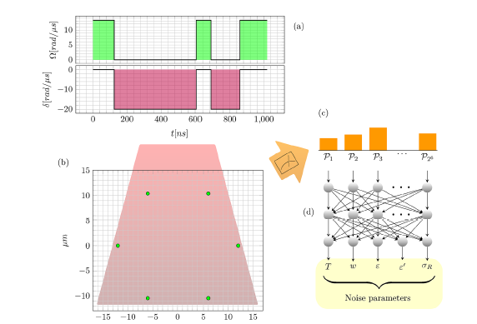

Modulation Classification for Overlapped Signals Using Deep Learning
The paper addresses the challenge of Modulation Recognition (MR) in scenarios involving completely overlapped multi-user (MU) signals, where transmissions from different users superpose in both time and frequency domains [1], [2]. Existing likelihood-based and feature-based methods often struggle with unknown signal parameters, such as transmitting power levels, or suffer from high computational complexity [3], [4]. To overcome these limitations, the authors propose a blind classification method—requiring no pilot transmission—that can identify modulation schemes of multiple users simultaneously, even under practical impairments like Carrier Frequency Offsets (CFO), noise variance, and timing offsets [1], [5].
The methodology employs a deep learning approach centered on a custom CNN. The system model simulates a satellite communication link where two users transmit signals using the same carrier frequency, symbol rate, and bandwidth, and a third user receives the superposed signal for classification [6], [7]. Before classification, a novel algorithm based on autocorrelation and Power Spectral Density (PSD) is used to blindly estimate symbol rate, enabling downsampling and extraction of “super-constellations” in the I/Q plane [1], [8]. Synthetic datasets were generated in MATLAB for a modulation pool of BPSK, QPSK, 8PSK, and 8QAM, resulting in a 20-class problem (16 multi-user combinations and 4 single-user classes) [1], [9]. Data variations included SNRs from 1–35 dB, power scaling factors, CFO, and timing offsets [10], [11]. The CNN architecture is lightweight, with ~107,686 parameters, processing low-resolution RGB images of super-constellations resized to a fixed dimension. It consists of three convolutional layers, max-pooling, layer normalization, and two fully connected layers [12], [13]. Training used categorical cross-entropy loss and mini-batch gradient descent on an NVIDIA Tesla T4 GPU [12], [14].
The findings highlight several advances. The proposed method achieved 90% average classification accuracy at 10 dB SNR, outperforming traditional methods [1]. For single-user classes, it reached 100% accuracy at SNRs as low as 3–7 dB [15]. Compared to cumulant-based methods, the CNN achieved 100% accuracy with only 1,000 symbols, whereas cumulant methods failed to reach 100% even with 8,000 symbols and higher SNRs [16]. The model proved robust against impairments, maintaining high accuracy with normalized CFO and timing offsets [5], [17]. The symbol rate estimator showed low NMSE, especially at high SNRs [18]. The CNN is computationally efficient, with ~100 times fewer parameters than AlexNet or VGG-16, making it suitable for real-time edge deployment [13], [19].
The applications are broad for modern and future wireless systems. In military and defense, the technology supports electronic warfare and SIGINT, enabling interception of hostile communications or generation of jamming signals [20], [21]. In Non-Orthogonal Multiple Access (NOMA), accurate modulation recognition facilitates successive interference cancellation [21], [22]. In Cognitive Radio and 5G/6G systems, the method supports spectrum allocation, interference management, and security enforcement by detecting unauthorized access or eavesdropping in multi-user environments [23], [2].
The study also identifies limitations and future directions. It focuses solely on classification, not full symbol decoding, which would require blind estimation of parameters like roll-off factor and noise variance [24]. Accuracy degrades significantly if CFO or timing offsets exceed certain thresholds unless retraining is performed with higher impairment data [17]. Performance also fluctuates with user power ratios, dropping when ratios cause constellation merging or dominance [25]. Future work should design complete receivers capable of blind parameter estimation for decoding, and explore more sophisticated deep learning models to further improve accuracy while keeping complexity manageable [19].
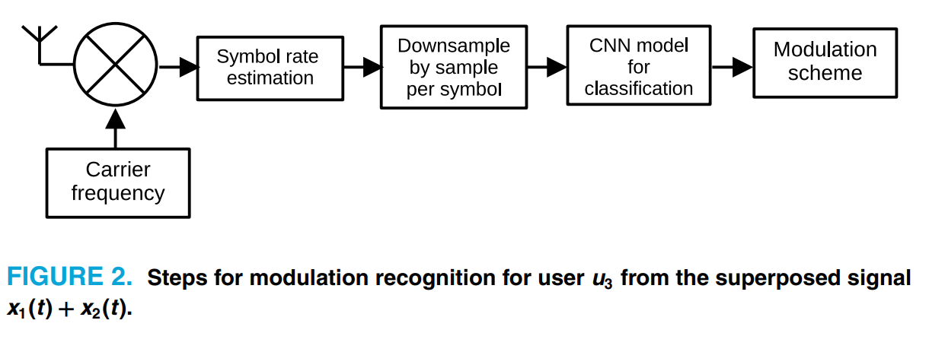
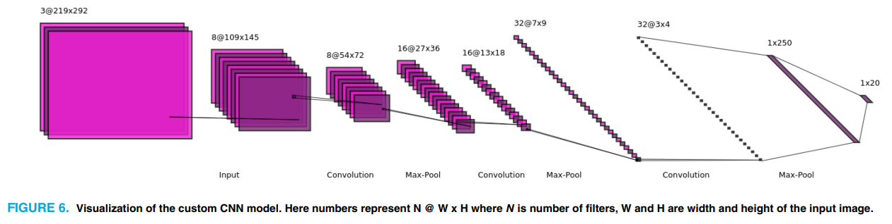

Radio Modulation Classification Optimization Using Combinatorial Deep Learning Technique
The paper focuses on improving automatic signal modulation classification (AMC) in wireless communications, particularly in environments with low Signal-to-Noise Ratio (SNR) where existing deep learning models often fail to classify signals accurately or require computationally expensive Denoising steps [1], [2]. The authors propose a “combinatorial” deep learning model that integrates different neural network architectures to maintain high accuracy at high SNRs while significantly boosting performance at low SNRs, thereby creating a robust system for dynamic spectrum allocation [1], [5]. The methodology employs a hybrid deep learning approach using the DeepSig RadioML2016.10a and RadioML2016.10b datasets [6].

The model adopts a dual-stream architecture: a ConvLSTM stream to extract spatial-spectral features and capture temporal dependencies [7], [8], and a Transformer-block stream that uses self-attention and positional encoding to capture long-range dependencies while enabling parallel processing [9], [8]. To address class imbalance and outliers, the authors introduce an adaptive weighted focal loss function, improving upon standard cross-entropy methods [1], [10]. Input data consists of raw In-Phase and Quadrature (I/Q) components (128-sample vectors) without prior denoising, supplemented by higher-order cumulant features [11-13]. The system was implemented in Keras on an Nvidia Tesla A100 GPU, with Adam optimization for the ConvLSTM stream and SGD for the Transformer stream [14-16]. The findings demonstrate significant advances in modulation classification. The proposed model achieved 66% classification accuracy for low SNR signals, a substantial improvement over existing methods.
At –16 dB SNR, it reached 62% accuracy, compared to less than 25% for models such as CLDNN+GRU or DenseNet+BLSTM [1], [17], [18].
At high SNRs, the model maintained strong performance, achieving 93.5% accuracy, confirming that noise robustness did not compromise clean-signal classification [1], [5]. The architecture is efficient, requiring only 1.7 million trainable parameters and 19.7 MB of memory, compared to over 5.4 million parameters and 61.4 MB for standard CNNs [19].

Simulation results confirmed robustness against noise, with the model able to classify raw signals without a separate denoising stage [5], [20]. The applications are highly relevant for Cognitive Radio (CR) networks and software-defined radio (SDR) systems [21]. Accurate classification in noisy environments enables dynamic spectrum access, improving spectrum management and interference detection [2], [21].
The model’s suitability for hardware accelerator chips allows modulation recognition to be offloaded from main processors, enhancing device efficiency [4], [22]. The inclusion of Transformer blocks supports parallel computation, improving training and inference times compared to sequential recurrent networks, making the model viable for real-time applications where latency is critical [9], [23].

The study also identifies limitations and future research directions. The model struggled to distinguish between 16QAM and 64QAM due to the subset relationship of constellation points and the short 128-sample observation window [24], [25]. The authors suggest that 128 samples may be insufficient for complex modulations, recommending larger datasets or longer sequences to improve resolution [25]. While parallelization improved efficiency, the model did not achieve the fastest prediction and training times compared to some other combined models, indicating a need for further architectural optimization to reduce latency [23].

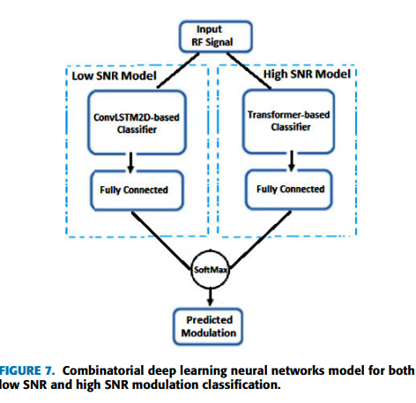
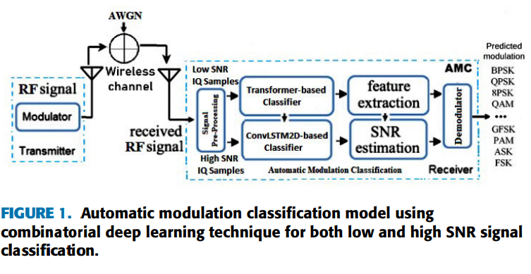

RFSoC Modulation Classification with Streaming CNN: Data Set Generation & Quantized-Aware Training

The paper addresses the challenge of deploying deep-learning-based automatic modulation classification (AMC) in real-time radio receivers, where most existing models rely on offline datasets and frame-based processing. This limitation is critical because practical RF systems require continuous data processing with deterministic latency. The main objective of the study is to bridge the gap between theoretical deep learning models and hardware deployment by demonstrating a streaming CNN that can be integrated directly after the ADC in an RFSoC-based receiver. Additionally, the paper aims to evaluate how quantized-aware training influences classification accuracy and hardware efficiency, enabling practical trade-offs between performance and resource usage.

To achieve these goals, the authors design a streaming CNN architecture implemented on the AMD Zynq Ultra Scale+ RFSoC 2x2 platform. A hardware-in-the-loop dataset, Deep RFSoC, is created by generating modulated signals in MATLAB, transmitting them through the RFSoC DAC, and recording them via the ADC to capture realistic transceiver impairments. The CNN follows a data-flow model that processes samples continuously without interruption, using GEMM-based convolution optimizations for efficient FPGA execution. Quantized-aware training is performed using the Brevitas framework, evaluating 16-bit, 8-bit, and 4-bit fixed-point weight precisions while keeping activations at 16-bit .

The results show that real-time AMC on RFSoC hardware is both feasible and effective. The 16-bit quantized model achieved the best performance, reaching about 76% accuracy at high SNR, only slightly below a floating-point baseline. The 8-bit and 4-bit models achieved approximately 70% and 63% accuracy, respectively, with the 4-bit model exhibiting early performance saturation. Resource analysis revealed that lower precision reduces LUT usage, but memory savings for 4-bit weights were limited due to byte-aligned storage constraints. Crucially, the streaming CNN classified live signals without dropping samples, confirming deterministic latency.

The proposed approach has important implications for 5G and 6G cognitive radio and PHY-layer intelligence, enabling deep learning models to operate directly on radio hardware in real time. The streaming architecture provides a practical path for integrating AI into spectrum sensing, modulation recognition, and potentially other PHY tasks. However, the study is limited by throughput constraints set by the decimated sample rate and by reduced accuracy at very low bit widths. Future work should focus on improving scheduling and parallelism, refining quantized-aware training for ultra-low precision models, and extending the streaming architecture to tasks such as channel estimation, synchronization, and decoding.
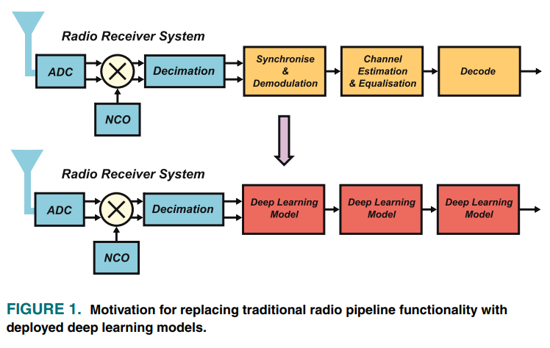
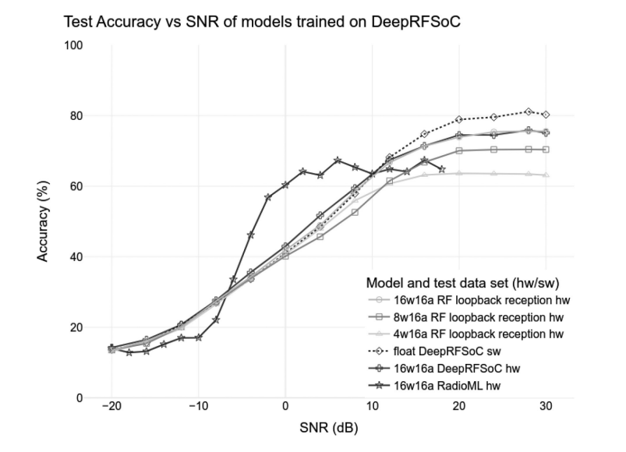

An Automated Framework for Traffic Noise Level Analysis Using Explainable Artificial Intelligence techniques
This paper focuses on the challenge of accurately analysing and predicting traffic noise levels while simultaneously addressing the lack of transparency in conventional machine learning models. While AI-based approaches have shown strong predictive performance in environmental noise modelling, their “black-box” nature limits trust, interpretability, and adoption in policy-driven applications.
The theoretical foundation of the study combines traffic noise propagation theory with supervised machine learning and explainable artificial intelligence (XAI) principles. The authors argue that noise prediction models must not only achieve low error rates but also provide interpretable insights into how traffic parameters such as vehicle count, speed, road geometry, and temporal patterns influence noise levels.
The proposed framework integrates automated data pre-processing, feature extraction, model training, and explainability analysis. Traffic and acoustic datasets are processed to remove inconsistencies and normalize features before being fed into machine learning models such as ensemble regressors and tree-based algorithms. To address interpretability, the framework employs XAI tools, including feature importance analysis and local explanation techniques, enabling both global and instance-level understanding of model decisions.
Experimental evaluation is carried out using real-world traffic noise datasets collected from urban road networks. The results show that the AI models achieve high prediction accuracy, outperforming traditional regression-based noise models. More importantly, the explain ability layer reveals clear causal relationships between traffic parameters and predicted noise levels, such as the dominant influence of heavy vehicle flow and speed variability during peak hours.
The study demonstrates that XAI significantly enhances model transparency without compromising performance, making the framework particularly suitable for urban planners, environmental engineers, and regulatory authorities. By enabling interpretable decision-making, the framework bridges the gap between advanced AI techniques and practical noise management policies.
Limitations of the work include dependency on data quality and the need for location-specific retraining to maintain accuracy across different urban settings. The authors suggest future extensions involving real-time sensor integration, transfer learning across cities, and coupling with psychoacoustic metrics to move beyond purely energy-based noise indicators.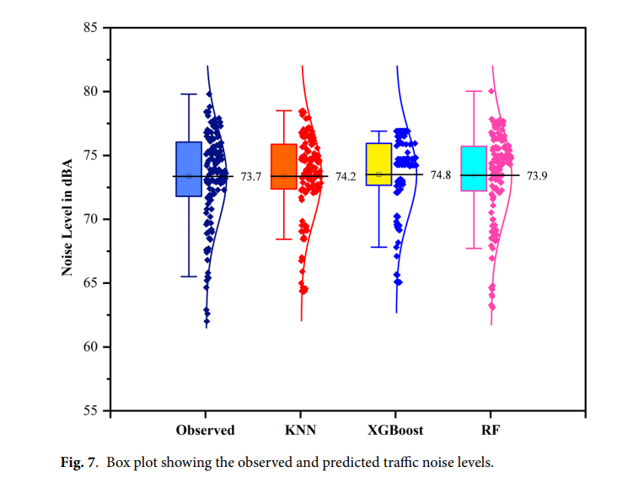

Assessment of Signal Strength in Intelligent Reflecting Surface-Aided Wireless Communication
The paper addresses the challenge of achieving high spectrum and energy efficiency in next-generation (6G) wireless networks through optimal design and deployment of Intelligent Reflecting Surfaces (IRS) that can dynamically reconfigure the wireless propagation environment. This problem is critical because the rapid growth of users and IoT devices demands higher data rates, lower latency, and reliable links for applications such as AR/VR and autonomous systems, while conventional wireless systems lack the ability to actively manipulate signal propagation in obstacle-rich or dense environments. To address this, the authors investigate how IRS performance depends on RLC circuit parameters—effective capacitance, bottom and top layer inductances, and resistance—and how system-level factors such as transmitted power, IRS size, AP–IRS distance, and bandwidth jointly affect received power, SNR, and data rate.
The theoretical framework is grounded in electromagnetic theory and wireless communications, modelling each IRS element as a lumped RLC circuit whose impedance determines the reflection coefficient and thus the phase and amplitude of reflected signals. IRS is treated as a programmable wireless environment that enables constructive interference at intended receivers through controlled phase and amplitude tuning. The system is modeled as an OFDM-based single-antenna AP communicating with multiple users via a large planar IRS array operating at 3.5 GHz. The received signal combines the uncontrollable direct channel with the controllable IRS-reflected channel, and achievable data rate is analyzed as a function of IRS configuration, transmit power, and noise.
Numerical results reveal clear component-level and system-level trade-offs. Increasing resistance reduces reflected signal amplitude due to higher losses, while capacitance and inductances exhibit strong frequency-dependent, non-monotonic effects on amplitude and phase. At the system level, received power and SNR decrease with increasing AP–IRS distance and bandwidth, but increase with higher transmit power and larger IRS size, while data rate generally improves with bandwidth and IRS dimensions. Among four compared optimization strategies, the proposed power-based IRS configuration method consistently achieves the highest data rates, significantly outperforming no-IRS and uniform-metal-surface cases and providing gains over best-pilot selection by maximizing constructive interference.
Overall, the study provides a comprehensive framework linking IRS RLC component design and system parameters to communication performance, establishing IRS as a key enabler for 6G networks. However, limitations remain, including reliance on lumped-circuit models for complex metasurfaces, frequency-dependent non-linear behaviour of components, idealized assumptions, and lack of experimental validation. Future work is suggested in developing frequency-aware and AI-driven optimization methods, extending analysis to realistic fading channels and additional performance metrics, and validating IRS designs through real-world deployments and integration with mmWave, terahertz, and massive MIMO systems.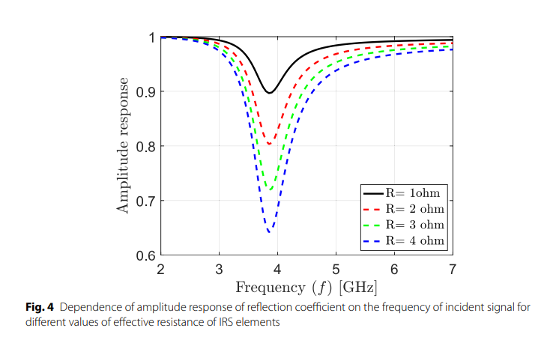

Recent Advances in Automatic Modulation Classification Technology: Methods, Results, and Prospects
The paper provides a comprehensive survey of Automatic Modulation Classification (AMC), a critical technology for intelligent wireless communication systems such as cognitive radio and dynamic spectrum access [1]. AMC faces significant challenges in practical environments due to unknown channel parameters, noise, multipath propagation, and diverse signal parameters like symbol rates [1], [2]. The authors categorize and analyze existing AMC methodologies—ranging from traditional likelihood-based approaches to modern deep learning techniques—to evaluate their performance, advantages, and limitations [1], [3]. Ultimately, the review aims to guide future research by identifying key development directions necessary to support emerging technologies such as 6G networks, drone communications, and the Internet of Things (IoT) [4], [5].
The methodology employs a systematic survey framework, classifying AMC approaches into three distinct categories. Likelihood-based (Lb) methods include Bayesian estimation techniques such as the Average Likelihood Ratio Test (ALRT), Generalized Likelihood Ratio Test (GLRT), and Hybrid Likelihood Ratio Test (HLRT) [3], [6], which compute likelihood functions based on probability density functions of signals and channel parameters [7]. Feature-based (Fb) methods rely on manual feature engineering, using spectral features, high-order cumulants, and cyclostationarity features [3], [8], with classifiers such as Support Vector Machines (SVM), Random Forests (RF), and Decision Trees (DT) [3], [9]. Deep Learning (DL) methods are extensively reviewed, covering end-to-end models that automatically extract features, including Convolutional Neural Networks (CNNs), Recurrent Neural Networks (RNNs) like LSTM, Graph Neural Networks (GNNs), Transformers, and hybrid architectures [3], [10-12]. The survey also analyzes signal representations such as I/Q temporal signals, constellation diagrams, and spectrograms, discussing how input formats affect performance [13-15]. Performance evaluation compares classification accuracy and inference efficiency using public datasets like RadioML 2018.01A and RadioML 2016.10A, as well as simulated datasets under varying SNRs [16], [17].
The findings highlight the dominance of deep learning methods, which generally outperform traditional approaches in complex environments by eliminating the need for manual feature engineering and exhibiting strong generalization capabilities [18], [19]. Hybrid models such as CNN-LSTM achieve superior accuracy by extracting features from multiple perspectives [20]. Traditional methods, while valuable, face limitations: Lb methods are theoretically optimal but computationally intensive and require precise estimation of channel parameters [19], [21], while Fb methods offer interpretability but struggle with generalization and are susceptible to noise [19], [22]. Performance benchmarks show that most state-of-the-art methods achieve classification accuracy above 85% when SNR exceeds 10 dB [17], [19], but performance drops sharply at low SNRs, often resembling random guessing [17]. Signal fusion—combining multiple representations such as I/Q data with constellation graphs—significantly enhances classification accuracy compared to single-domain inputs [23], [24].
The implications are profound for next-generation wireless networks. AMC is essential for 6G communication, particularly in high-mobility scenarios involving drones and autonomous vehicles, where systems must adaptively adjust modulation schemes to handle Doppler effects and rapid channel variations [4], [25], [26]. Accurate modulation identification supports Dynamic Spectrum Allocation (DSA), improving spectrum utilization and reducing congestion in dense urban environments [27]. AMC also enhances security by identifying non-cooperative interference and unauthorized signals, strengthening military and civilian networks against malicious intrusions [26], [27]. In IoT ecosystems, AMC facilitates management of massive device populations by automatically recognizing signal types for tracking and resource allocation [26].
The study concludes by identifying limitations and future research directions. Existing models often struggle to generalize to unseen scenarios or varying channel parameters such as frequency offsets and timing errors [25], [28], [29]. Deep learning models are computationally intensive, necessitating lightweight architectures and compression techniques like pruning for deployment on resource-constrained edge devices and FPGAs [29-31]. Current methods also face challenges in fine-grained classification, particularly distinguishing between high-order intra-class modulations such as 128QAM and 256QAM [29]. Finally, the authors suggest integrating expert knowledge with deep learning architectures to guide learning and improve interpretability, rather than relying solely on data-driven approaches [32], [33].
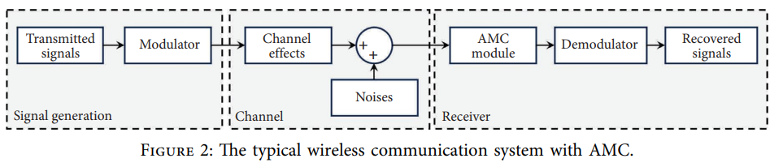

Performance Analysis of Active RIS-Aided Wireless Communication Systems over Nakagami-m Fading Channel
The paper addresses the limitations of passive Reconfigurable Intelligent Surfaces (RIS), particularly their inability to amplify signals, which leads to “multiplicative fading” and degrades system performance. To overcome this, the study analyzes active RIS aided wireless communication systems that integrate reflection amplifiers to enhance signal strength and mitigate double fading. The authors aim to derive accurate, analytically tractable closed form expressions for Outage Probability (OP) and Secrecy Outage Probability (SOP) under Nakagami m fading conditions. A key goal is to demonstrate that active RIS can achieve high reliability and security with significantly fewer reflecting elements than passive RIS, proving its economic viability and reduced hardware complexity.
The methodology combined theoretical modeling and simulation. The system model was a Single Input Single Output (SISO) setup with a source, destination, eavesdropper, and active RIS equipped with reflecting elements. Channels were modeled using Nakagami m fading, which captures a wide range of fading severities. To address mathematical intractability, the authors derived novel recursive integrals that simplify expressions involving the Gaussian Q function and exponential terms. The Central Limit Theorem (CLT) was applied to approximate cascaded channel gains as Gaussian random variables for large numbers of elements. For SOP analysis, moment matching was used to approximate the eavesdropper’s SNR as a Gamma distribution. Extensive Monte Carlo simulations validated the analytical expressions across integer, half integer, and non integer fading parameters.
The findings highlight several advances. An active RIS with 10 dB amplification reduced the required number of reflecting elements by nearly 90% compared to passive RIS while maintaining reliability (OP of 0.4). For example, 30 active elements matched the performance of 300 passive ones. Asymptotic analysis showed that active RIS systems achieve user SNRs about 40 dB higher than passive RIS systems, regardless of fading parameters. The recursive integrals provided tractable closed form solutions for OP and SOP across diverse fading conditions, overcoming prior limitations restricted to Rayleigh fading. Increasing amplification gain significantly decreased SOP, enhancing physical layer security against eavesdroppers.
The applications are highly relevant for next generation networks such as 5G, 6G, and IoT, where reliability and security are critical. Active RIS offers economic viability by achieving superior performance with fewer elements, reducing deployment costs and hardware complexity. The results have direct implications for physical layer security in vehicular networks, UAV systems, and cognitive radio, especially in environments with random obstacles and eavesdroppers. The asymptotic SNR analysis provides clear design metrics for integrating active RIS to overcome path loss in high frequency bands.
The study also identifies limitations and future research directions. The analysis was limited to Nakagami m fading; future work should extend to more general fading scenarios such as κ μ and η μ channels. The current focus on SISO systems could be expanded to MISO and MIMO configurations using the recursive approach. Advanced RIS architectures such as Beyond Diagonal RIS (BD RIS) and Symbiotic Radio systems are suggested for exploration. Finally, the assumption of perfect Channel State Information (CSI) should be relaxed in future studies to evaluate performance under imperfect CSI and phase shift errors, ensuring robustness in practical deployments.

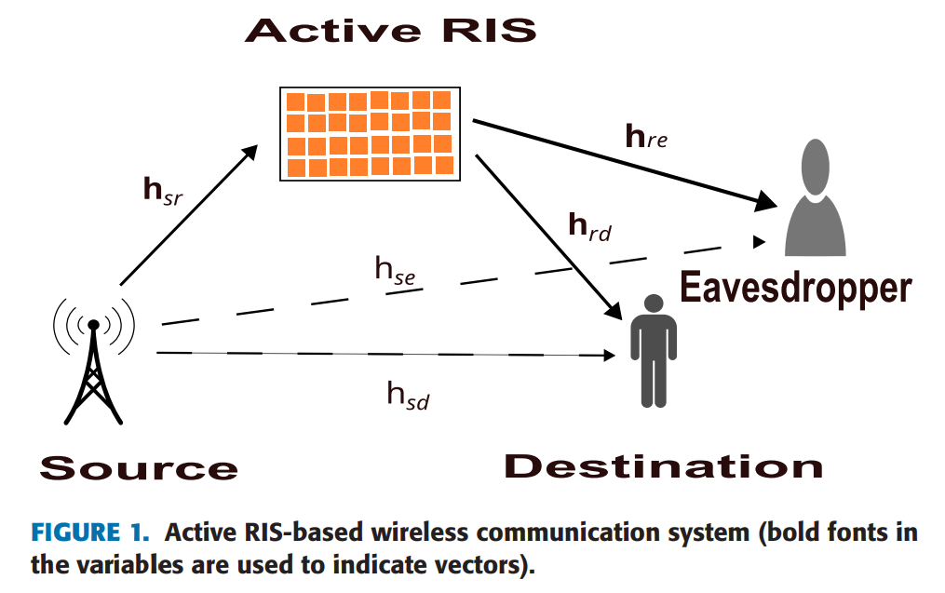

Comparative Analysis of Intelligent Reflecting Surfaces and AF/DF Relaying for Energy-Efficient Wireless Communication
The objective of this paper is to comparatively analyze intelligent reflecting surfaces (IRS) and conventional amplify-and-forward (AF) and decode-and-forward (DF) relaying schemes in the context of energy-efficient wireless communication systems. With the rapid growth of data-intensive applications in fifth-generation and beyond wireless networks, energy consumption has emerged as a major concern. While traditional relaying techniques improve coverage and reliability, their reliance on active power amplification and complex hardware significantly increases energy usage. IRS technology, on the other hand, offers a passive and reconfigurable solution that can manipulate electromagnetic wave propagation without requiring power-hungry amplifiers. The primary goal of the study is therefore to evaluate whether IRS-assisted communication can outperform AF and DF relays in terms of transmit power requirements, achievable data rate, and overall energy efficiency, and to determine the minimum number of IRS elements required to surpass conventional relay performance.
The methodology employed in this work is based on analytical modelling and Monte Carlo simulations under realistic wireless channel conditions. A system model is developed in which communication between a source and a destination occurs either directly or with assistance from an IRS, AF relay, or DF relay, all placed at the same location for fair comparison. Rayleigh fading channels are assumed, and analytical expressions are derived for achievable data rate, signal-to-noise ratio, transmit power, and energy efficiency for each transmission scheme. For IRS-assisted transmission, both random phase shift (RPS) and optimal phase shift (OPS) configurations are considered, with OPS designed to maximize constructive signal interference. Monte Carlo simulations averaged over thousands of independent channel realizations are used to validate the analytical results, with system parameters such as path loss, noise power, amplifier efficiency, and hardware power consumption selected to reflect practical urban deployment scenarios.
The results presented in the paper clearly demonstrate that IRS-assisted communication, particularly with optimal phase shift configuration, achieves superior energy efficiency and power savings compared to conventional AF and DF relaying. The analysis shows that as the number of IRS elements increases, the required transmit power decreases significantly due to enhanced constructive interference. Numerical results indicate that fewer IRS elements are needed to outperform AF and DF relays at higher data rate requirements, especially when optimal phase alignment is employed. For instance, at moderate to high achievable data rates, IRS with OPS consistently requires fewer reflecting elements than RPS to exceed relay performance. Energy efficiency analysis further reveals that IRS with OPS achieves the highest peak energy efficiency among all considered schemes, outperforming DF relays, which in turn perform better than AF relays due to reduced noise accumulation. These findings confirm that IRS technology can deliver higher data rates with lower power consumption under suitable channel conditions.
In conclusion, the paper establishes intelligent reflecting surfaces as a highly promising technology for energy-efficient wireless communication, capable of outperforming traditional AF and DF relaying schemes when properly configured. By enabling passive signal manipulation with minimal hardware power consumption, IRS offers a scalable and sustainable alternative for future wireless networks, particularly in high data rate and energy-constrained scenarios. However, the study also highlights several limitations, including the strong dependence of IRS performance on accurate channel state information, synchronization challenges among large numbers of IRS elements, and reduced effectiveness in highly dynamic or interference-dominated environments. Future research directions include extending the analysis to multi-user scenarios, incorporating machine learning-based channel estimation and phase optimization techniques, addressing hardware imperfections, and developing hybrid IRS-relay systems to enhance robustness in practical deployments.
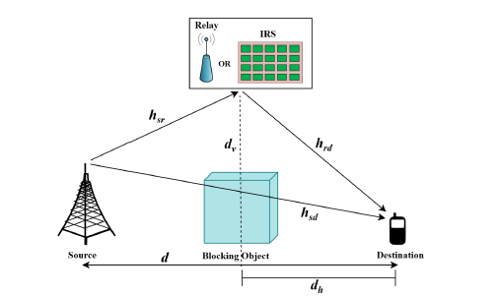

6G-Enabled Vehicle-to-Everything (V2X) Communications: Current Research Trends and Open Challenges
The paper addresses the problem of enabling ultra-reliable, low-latency, and intelligent Vehicle-to-Everything (V2X) communication under the stringent performance requirements of future 6G networks. This issue is critical because existing 5G-based V2X systems struggle to support autonomous driving, real-time traffic coordination, and cooperative perception due to limitations in latency, scalability, spectrum efficiency, and reliability. The primary objective of the study is to systematically analyse how 6G technologies—such as terahertz communication, AI-native networking, edge intelligence, and integrated sensing and communication—can overcome these limitations while identifying unresolved challenges.
The theoretical foundation of the work is based on next-generation wireless communication theory, vehicular networking models, and AI-driven network optimization. The paper surveys enabling technologies including ultra-massive MIMO, reconfigurable intelligent surfaces, AI-assisted mobility management, and semantic communication. Methodologically, the authors adopt a comprehensive survey approach, synthesizing results from recent academic literature, standardization efforts, and industrial research initiatives related to 6G V2X. Comparative analyses are used to contrast 5G and 6G V2X capabilities across latency, data rate, reliability, and intelligence dimensions.
The key findings indicate that 6G can fundamentally transform V2X communication by enabling sub-millisecond latency, centimetre-level positioning accuracy, predictive networking through AI, and seamless integration of communication and sensing. The study highlights that AI-driven resource allocation and edge computing significantly improve vehicular decision-making and traffic safety. However, it also identifies major challenges such as high propagation loss at terahertz frequencies, security vulnerabilities, interoperability issues, and regulatory constraints.
In terms of applications, the research is highly relevant to autonomous vehicles, cooperative driving, smart transportation systems, intelligent traffic management, and vehicle-assisted edge intelligence. The findings suggest that 6G-enabled V2X will play a foundational role in smart cities and intelligent transportation ecosystems. Nevertheless, limitations remain due to the lack of real-world 6G test beds, immature terahertz hardware, and unresolved security frameworks. Future research directions include robust AI-based security mechanisms, joint communication-sensing design, cross-layer optimization, and large-scale experimental validation.
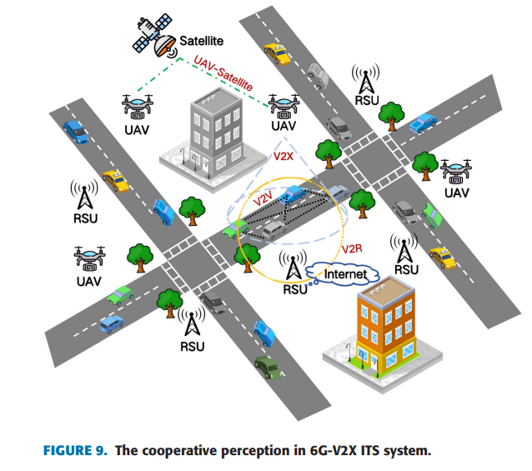

Artificial Intelligence for Speech Classification and Enhancement of Speech and Language Disorders: Techniques, Applications, and Future Directions
The objective of this paper is to systematically examine how artificial intelligence can be applied to the classification and enhancement of speech and language disorders, with particular emphasis on neurodegenerative and clinically significant conditions. Speech and language disorders arise from disruptions in respiratory, phonatory, articulatory, and cognitive mechanisms and can severely affect communication, quality of life, and social participation. Traditional clinical assessments conducted by speech-language pathologists are often subjective, time-consuming, and limited in scalability. In response to the increasing global demand for assistive technologies and objective diagnostic tools, the paper aims to synthesize existing research on machine learning and deep learning techniques used to classify sixteen distinct speech and language disorders. Additionally, the study seeks to highlight recent advances in AI-based speech enhancement methods that improve intelligibility and signal quality, thereby strengthening downstream diagnostic and assistive systems.
The methodology adopted in this work is a systematic literature review conducted according to a predefined protocol. Peer-reviewed journal articles published between 2007 and 2024 were collected from major academic databases, including Scopus, Web of Science, and PubMed. A comprehensive search strategy was designed using keywords related to speech and language disorders, artificial intelligence, machine learning, deep learning, feature extraction, and speech enhancement. The study selection process followed PRISMA guidelines, resulting in a final corpus of 231 relevant articles after removing duplicates and excluding non-relevant studies. The selected literature was analyzed thematically to examine the types of disorders addressed, the datasets and corpora used, the AI algorithms and feature extraction techniques employed, evaluation metrics adopted, and real-world applications. The review also integrates insights from speech enhancement research, analyzing deep learning-based preprocessing techniques that improve speech intelligibility prior to classification.
The results of the review indicate that artificial intelligence has demonstrated strong potential in accurately classifying speech and language disorders and supporting assistive communication technologies. Among the sixteen disorders reviewed, Parkinson’s disease, dysarthria, and voice disorders dominate existing research, accounting for the majority of published studies, while other high-prevalence conditions such as multiple sclerosis and Lewy body dementia remain underrepresented. Machine learning models such as support vector machines and random forests are commonly used for smaller datasets and simpler classification tasks, whereas deep learning architectures, including convolutional neural networks, recurrent neural networks, and transformer-based models, achieve higher accuracy in handling complex and multimodal speech data. Feature extraction methods based on acoustic, prosodic, and linguistic characteristics play a critical role in model performance, with multimodal feature fusion offering improved diagnostic accuracy. The review further highlights that AI-based speech enhancement techniques, such as multi-scale feature fusion networks, noise-aware variational autoencoders, and neuromorphic models, significantly improve speech intelligibility and robustness, particularly in noisy or low-resource environments, thereby enhancing the effectiveness of classification systems.
In conclusion, the paper establishes artificial intelligence as a powerful and enabling technology for the automated classification and enhancement of speech and language disorders. By integrating classification and enhancement approaches, AI-driven systems can support early diagnosis, continuous monitoring, personalized therapy, and assistive communication across clinical and real-world settings. However, the study also identifies key limitations, including the lack of longitudinal and cross-cultural datasets, limited clinical validation, challenges in model explainability, and constraints related to real-time deployment on low-power devices. Future research should focus on developing inclusive and standardized datasets, advancing multimodal and explainable AI models, jointly optimizing speech enhancement and classification pipelines, and validating systems in real-world clinical environments. Addressing these challenges will be essential for improving the accuracy, generalizability, and adoption of AI-based speech and language disorder assessment systems.
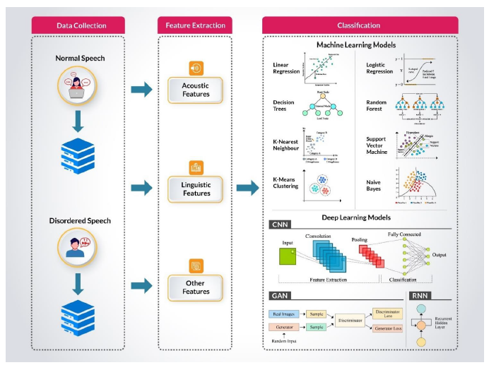

Beyond Amplification: How Artificial Intelligence Is Redefining Hearing
The objective of this paper is to examine how artificial intelligence is transforming hearing aid technology beyond conventional sound amplification, with the aim of improving speech understanding, personalization, and overall quality of life for individuals with hearing loss. Hearing loss is one of the most prevalent chronic health conditions worldwide and significantly affects communication, social interaction, and well-being. Despite widespread use of hearing aids, nearly half of users report dissatisfaction, largely due to generic fitting approaches that fail to account for individual listening preferences and real-world acoustic environments. The paper seeks to highlight how AI-driven hearing aids can overcome these limitations by enabling adaptive, user-centered, and intelligent hearing solutions that extend beyond amplification to include health monitoring, connectivity, and assistive functions.
The methodology of this study is based on a comprehensive narrative review of recent literature related to artificial intelligence applications in hearing aids and audiology. The authors synthesize findings from clinical studies, laboratory experiments, technological reports, and commercial implementations of AI-enabled hearing devices. The paper reviews key AI techniques, including machine learning, deep neural networks, reinforcement learning, and acoustic environmental classification, and explains how these methods are integrated into modern hearing aid architectures such as single-chip and dual-chip designs. The review also analyzes different personalization strategies, including offline and online training methods, paired comparison learning, smartphone-based applications, and cloud-assisted processing, as well as experimental studies evaluating speech intelligibility, listening effort, and user satisfaction.
The results discussed in the paper demonstrate that AI-enabled hearing aids significantly enhance speech clarity, adaptability, and user satisfaction compared to conventional devices. Machine learning and deep learning algorithms allow hearing aids to classify acoustic environments in real time and automatically adjust gain, directionality, noise reduction, and compression parameters. Personalized fitting approaches, including self-fitting over-the-counter hearing aids and user-driven preference learning, have been shown to provide comparable or even superior outcomes to clinician-fitted devices in mild to moderate hearing loss. Clinical studies reviewed in the paper report improvements in speech-in-noise performance, reduced listening effort, and increased perceived sound quality through features such as Edge Mode, SoundSense Learn, and neural speech enhancement. In addition, AI integration enables advanced functionalities such as remote fitting, Bluetooth LE Audio streaming, fall detection, health monitoring, tinnitus management, language translation, and voice-to-text transcription, thereby expanding the role of hearing aids into multifunctional assistive and health-monitoring devices.
In conclusion, the paper establishes that artificial intelligence is fundamentally redefining hearing aid technology by shifting it from static amplification devices to intelligent, adaptive, and personalized hearing systems. AI-driven hearing aids offer substantial benefits in speech understanding, user comfort, accessibility, and quality of life while reducing dependence on frequent clinical visits through remote and self-adjustment capabilities. However, the paper also highlights several limitations, including ethical concerns related to data privacy and bias, high device costs, increased system complexity, processing delays, and energy consumption constraints. Future research directions include developing faster and more energy-efficient AI algorithms, improving data security and fairness, expanding clinical validation, and enhancing usability for diverse user populations. Addressing these challenges will be essential to ensure equitable, safe, and widespread adoption of AI-powered hearing technologies. 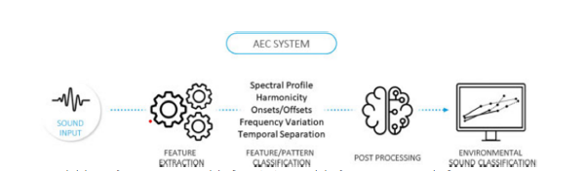

Secure THz Communication in 6G: A Two-Stage DRL Approach for IRS-Assisted NOMA
The paper focuses on improving security and energy efficiency in terahertz (THz) communication for future 6G networks. Wireless communication channels are inherently vulnerable to eavesdropping, making physical layer security an important challenge. At the same time, next-generation networks must operate with high energy efficiency. To address these issues, the authors propose a deep reinforcement learning (DRL)-based framework for an Intelligent Reflecting Surface (IRS)-assisted Non-Orthogonal Multiple Access (NOMA) system operating in the THz band. The goal is to optimize secrecy energy efficiency by jointly managing transmit power allocation and IRS phase shifts while maintaining secure communication even in the presence of multiple eavesdroppers.
The study introduces a two-stage learning strategy based on the Deep Deterministic Policy Gradient (DDPG) algorithm. In the first stage, the model focuses on maximizing the secrecy rate by dynamically adjusting transmission power and IRS reflection coefficients, ensuring that legitimate users receive stronger signals than potential eavesdroppers. In the second stage, the policy is refined to reduce overall energy consumption while maintaining the achieved security level. The system is modelled as a Markov Decision Process where the DRL agent learns optimal decisions based on channel conditions, user requirements, and system constraints. This approach also considers practical challenges such as imperfect channel state information and uncertain network environments.
Simulation results demonstrate that the proposed DRL-based framework significantly improves system performance compared to conventional optimization methods and other reinforcement learning algorithms. The DDPG model achieves faster convergence, better stability, and higher secrecy energy efficiency. The findings highlight the effectiveness of combining IRS technology, THz communication, and deep reinforcement learning to create secure and energy-efficient wireless systems. Overall, the study presents a scalable solution for secure, high-capacity, and energy-efficient communication in future 6G networks.
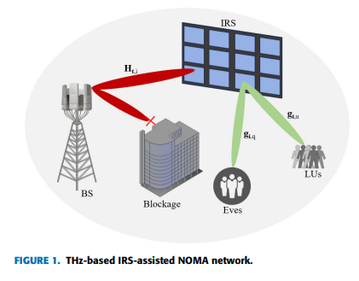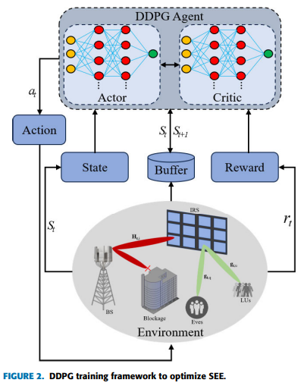

Dual Optimization With Convolutional Coding and AI-Based Noise Filtering to Enhance LoRa Resilience for IIoT
The objective of this paper is to enhance the reliability and robustness of LoRa communication systems deployed in Industrial Internet of Things (IIoT) environments, where severe noise, interference, and channel variability significantly degrade transmission quality. Although LoRa technology is well suited for Industry 4.0 applications due to its long-range, low-power, and cost-effective characteristics, its performance deteriorates in harsh industrial settings characterized by impulsive noise, multipath propagation, and obstacles. The paper aims to investigate two complementary optimization techniques to improve LoRa resilience for both “one-to-many” and “many-to-one” communication modes. The first objective is to evaluate the impact of convolutional coding with different coding rates on error correction performance, while the second objective is to overcome the resulting throughput loss by integrating an artificial intelligence–based noise filtering mechanism that preserves high data rates while maximizing signal robustness.
The methodology employed in this work is based on simulation-driven performance evaluation using a detailed LoRa communication architecture modeled in MATLAB. The authors incorporate convolutional coding with coding rates of 1/2 and 3/4 into the LoRa transmission chain, followed by interleaving, chirp spread spectrum modulation, and propagation through industrial channels modeled under both line-of-sight (LOS) and non-line-of-sight (NLOS) conditions. To further enhance performance, an adaptive artificial neural network–based filtering system is implemented at the receiver to predict and suppress channel noise. The study evaluates two communication modes, node-to-gateway (many-to-one) and gateway-to-node (one-to-many), using realistic IIoT parameters such as a carrier frequency of 868 MHz, bandwidth of 125 kHz, and spreading factors of 7 and 12. Performance is assessed using packet error rate (PER) as the primary metric, with statistical confidence intervals computed to ensure robustness and reliability of the simulation results.
The results presented in the paper demonstrate that convolutional coding significantly improves LoRa performance in noisy industrial environments, particularly under NLOS conditions. A coding rate of 1/2 provides strong error correction with signal-to-noise ratio gains ranging from 3 dB to 10 dB, and up to 9 dB in certain one-to-many configurations, though at the expense of reduced throughput. The coding rate of 3/4 preserves higher data rates but yields more modest gains of approximately 1–5 dB. When the 3/4 coding rate is combined with the proposed AI-based noise filtering system, the overall performance improves substantially, achieving SNR gains of 7–10 dB under LOS conditions and 12–17 dB under NLOS conditions. In some configurations, gains reach up to 21 dB, significantly outperforming conventional approaches such as Hamming coding combined with FIR or IIR filtering. These results confirm that the hybrid approach provides an optimal balance between throughput and robustness in challenging industrial environments.
In conclusion, the paper establishes that combining convolutional coding with artificial intelligence–based noise filtering offers a powerful and effective solution for enhancing LoRa communication reliability in IIoT applications. While the 1/2 coding rate ensures high robustness at the cost of reduced data rate, the hybrid scheme using a 3/4 coding rate with ANN-based filtering achieves superior resilience without sacrificing throughput. Despite these promising results, the study is limited to simulation-based evaluation and focuses primarily on specific industrial channel models. Future research directions include real-world experimental validation, exploration of more advanced deep learning architectures, optimization of computational complexity for embedded devices, and extension of the proposed approach to large-scale LoRaWAN deployments. These advancements will be essential for enabling reliable and scalable LoRa communications in next-generation industrial systems.
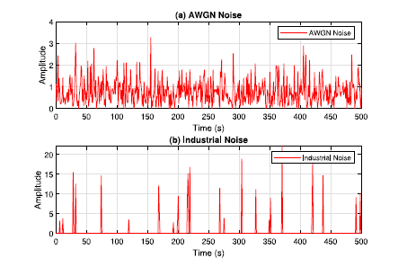

A Star Modulation Network for Wireless Image Semantic Transmission
The paper addresses the problem of inefficient wireless transmission of visual data using conventional bit-level communication techniques, which are highly sensitive to channel noise and bandwidth constraints. This issue is significant because emerging applications such as autonomous driving, remote surveillance, and intelligent sensing require semantic-level understanding rather than exact pixel reconstruction. The main objective of the study is to propose a novel semantic communication framework that directly transmits task-relevant image information using a star-structured modulation network.
The theoretical basis of the work lies in semantic communication theory and deep learning-based joint source–channel coding. Instead of separating source coding and channel coding, the proposed method integrates feature extraction, semantic representation, and modulation into a unified neural architecture. The methodology employs a deep neural network where a star-shaped modulation structure maps extracted image features into constellation points optimized for wireless transmission. The system is trained end-to-end under varying channel conditions, including additive white Gaussian noise and fading channels.
Key results demonstrate that the proposed star modulation network significantly outperforms traditional digital transmission schemes and conventional deep JSCC methods in terms of semantic accuracy and robustness to noise. The model achieves higher task performance at low signal-to-noise ratios while requiring less bandwidth. The findings confirm that semantic-level transmission is more resilient to channel impairments than pixel-accurate reconstruction.
The applications of this research extend to wireless image sensing, edge intelligence, UAV communication, and autonomous systems, where semantic fidelity is more important than raw data recovery. The work has strong implications for future 6G semantic communication systems. However, limitations include increased training complexity, dependency on task-specific datasets, and limited generalization across different vision tasks. Future research may explore lightweight models, adaptive semantic extraction, and real-time hardware implementation.
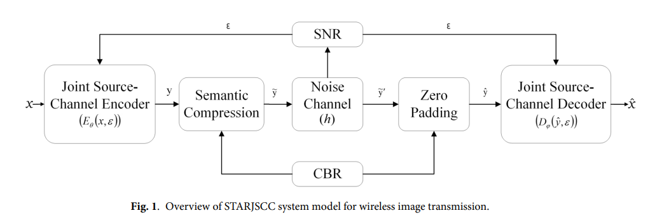

Simulation-Based Analysis of Noise Spectral Components Affecting Mobile Communication in Industrial Drones
The paper addresses the issue of intersystem electromagnetic interference (EMI) in industrial drones, where electromagnetic noise generated by onboard electronics degrades the receiver sensitivity of mobile communication systems such as LTE, which are essential for long range operations. Previous research often focused only on total noise power or idealized noise waveforms without distinguishing the effects of specific spectral components found in actual drone hardware. To overcome these limitations, the authors evaluate and compare the impacts of broadband white noise originating from power modules and clock driven harmonic continuous wave (CW) noise from control modules on communication performance. A further objective is to establish a simulation based analysis framework that enables assessment of EMI effects during the early design phase of compact electronic devices, ensuring reliable operation without extensive physical prototyping.
The methodology combines empirical measurement and numerical simulation. A commercial industrial drone measuring 29 cm × 29 cm was placed in an anechoic chamber to isolate internal noise sources. A standard dipole antenna for the 800 MHz band was mounted on the bottom of the drone to capture electromagnetic emissions, while a band reject filter blocked Wi-Fi signals. Two primary noise types were identified: random noise from the power module, modeled as white Gaussian noise, and clock driven harmonics from the control module, modeled as CW noise. Interference analysis was conducted using PathWave System Design, simulating an LTE downlink signal with a 10 MHz bandwidth, Quadrature Phase Shift Keying (QPSK) modulation, and 15 kHz subcarrier spacing, consistent with 3GPP specifications. Performance was evaluated using minimum receiver sensitivity, defined as the lowest signal power required to maintain 95% of maximum throughput. The modeled noise types were injected into the receiver model at varying power levels, and the simulation was validated by injecting actual recorded EM noise data from the drone.
The findings highlight the spectral dependence of EMI. Clock driven harmonic CW noise was shown to have a significantly stronger impact on receiver sensitivity than white Gaussian noise when the total in band power was equal. CW noise caused degradation in sensitivity starting at a lower power level (–104 dBm/10 MHz) compared to white noise. When noise power exceeded the receiver’s performance limit by more than 20 dB, CW noise resulted in up to 7 dB greater degradation in sensitivity than white Gaussian noise, since CW noise concentrates energy on specific subcarriers while white noise distributes it evenly across the band. Real world validation revealed that the actual recorded drone noise primarily behaved like broadband white noise, producing interference effects similar to the Gaussian model rather than the CW model in this specific drone configuration. Importantly, the simulation included control channels such as PDCCH in addition to data channels, providing a more realistic assessment of interference vulnerability.
The applications and implications of this research are significant for the design and deployment of industrial drones and mobile communication devices. The findings suggest that designers must consider the spectral shape of noise, not just total power, when developing shielding or filtering solutions. Narrowband noise from digital clocks requires different mitigation strategies than broadband power noise. The proposed simulation based framework offers a practical method for predicting communication performance and EMI issues during the design phase, which is critical for compact, lightweight drones where physical space for shielding is limited. By accurately modeling interference impacts on receiver sensitivity, manufacturers can better ensure stable long range connectivity for critical applications such as logistics, security, and disaster relief.
The study also identifies limitations and future research directions. The results regarding the dominance of white noise are specific to the particular industrial drone evaluated, and different drone types, antenna placements, or operating frequencies may exhibit stronger harmonic noise components. Interference impacts are highly dependent on communication signal structure, and future work should investigate how different noise types affect control versus data channels. While the study focused on the 800 MHz band, the findings regarding co channel interference are applicable to other bands, suggesting further investigation into different frequency ranges and communication schemes.

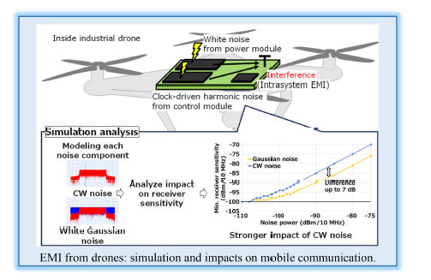

YAMNet‑based transfer learning for compact noise classification in urban and wireless systems

The paper addresses the limitations of traditional noise recognition methods in complex urban and wireless communication environments, focusing on the problems of poor adaptability and the heavy reliance on large labelled datasets associated with conventional models such as Gaussian Mixture Models (GMM) and standard Convolutional Neural Networks (CNNs). To overcome these challenges, the authors propose a novel framework called YAMNet Trans, which integrates transfer learning with acoustic and communication signal processing techniques. The goals of the study are to achieve high classification accuracy using minimal labelled data through small sample learning, enhance computational efficiency for resource constrained edge devices, and bridge the gap between environmental noise management and next generation communication systems such as 5G and IoT by validating the model on both acoustic and modulation datasets.
The methodology centers on a transfer learning approach that combines the pre trained YAMNet model with a Deep Convolutional Neural Network (DeepCNN). A dual path feature extraction strategy is employed: first, YAMNet (based on the MobileNet_v1 architecture) processes audio inputs to extract 1024 dimensional deep feature vectors from Mel spectrograms, with its convolutional layers frozen to preserve foundational knowledge; second, handcrafted features are extracted using Mel frequency cepstral coefficients (MFCC) and Short time Fourier transform (STFT) to capture domain specific acoustic characteristics. These features are weighted and fused with a coefficient of 0.5 before classification. The fused features are then fed into a DeepCNN with fully connected layers and a Softmax classifier, implemented in PyTorch on hardware equipped with an NVIDIA RTX 3070 GPU and an Intel i9 12900H processor. To address data scarcity and simulate non ideal channel conditions such as multipath effects and burst noise, augmentation techniques including noise injection, time shifting, and pitch transformation are applied. The datasets used include UrbanSound8K, ESC 50, Freesound, and self-collected data categorized into ten sound types such as rain, thunder, and engines, along with the RML2016.10a modulation dataset to validate applicability in wireless communications. Comparative analysis benchmarks YAMNet Trans against VGG 16, ResNet 50, AST (Audio Spectrogram Transformer), BEATs, and the baseline YAMNet model.
The key findings demonstrate the superiority of the transfer learning approach in data limited scenarios. The YAMNet Trans model achieved an average classification accuracy of 94.21% on environmental noise tasks, outperforming VGG 16 (70.11%), ResNet 50 (74.58%), and the baseline YAMNet (86.19%). It also achieved the lowest Equal Error Rate (EER) of 1.274%, indicating high reliability compared to other models such as VGG 16, which had an EER of 8.541%. In wireless communication tasks using the RML2016.10a dataset, the model reached a modulation recognition accuracy of 97% after transfer learning, surpassing VGG 16 (84%) and ResNet 50 (88%). With a lightweight design of only 5.2 million parameters, the model offered a better balance between precision and computational efficiency than larger transformer based models like BEATs and AST, which tended to overfit on small samples.
The applications and implications of this research are significant for Smart City infrastructure and next generation wireless networks. High accuracy in identifying specific noise sources such as construction and traffic supports “Quiet City” initiatives and automated regulatory compliance monitoring. In IoT and 5G/6G networks, effective classification of environmental noise can mitigate interference that causes channel attenuation and multipath effects in wireless transmission. The model’s low computational demand makes it suitable for real time anomaly detection on resource constrained edge devices within IoT networks. Furthermore, the success of transfer learning demonstrates that robust recognition systems can be deployed without the prohibitive cost of collecting massive labelled datasets, enabling rapid adaptation to customized application scenarios.
Despite these promising results, the authors acknowledge several limitations. The model depends heavily on pre training from YAMNet, limiting its flexibility when encountering entirely unknown noise types not represented in the original dataset. The study also focuses on predefined noise categories, which may not capture the full complexity of urban acoustic environments. Although lightweight, the computational demands of DeepCNNs may still pose challenges for extremely resource constrained devices. For future research, the authors propose integrating Reinforcement Learning to enable self-learning capabilities, allowing the model to autonomously detect and adapt to new noise sources. They also suggest expanding the range of classifiable noise categories and implementing real time update mechanisms to enhance robustness in dynamic environments.

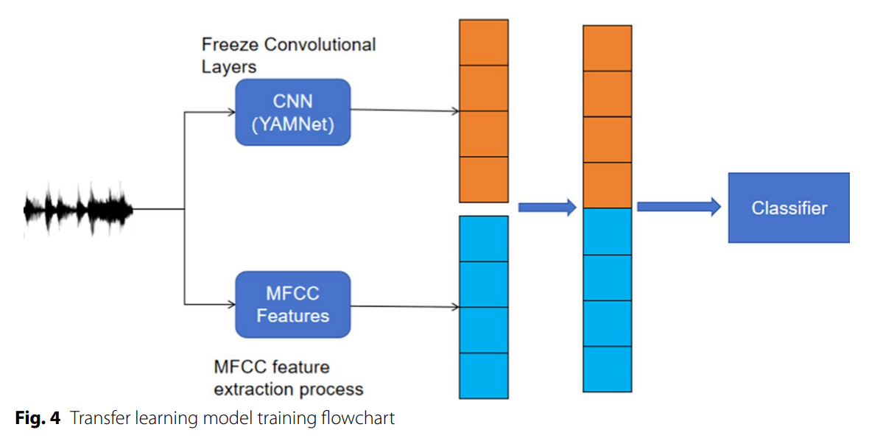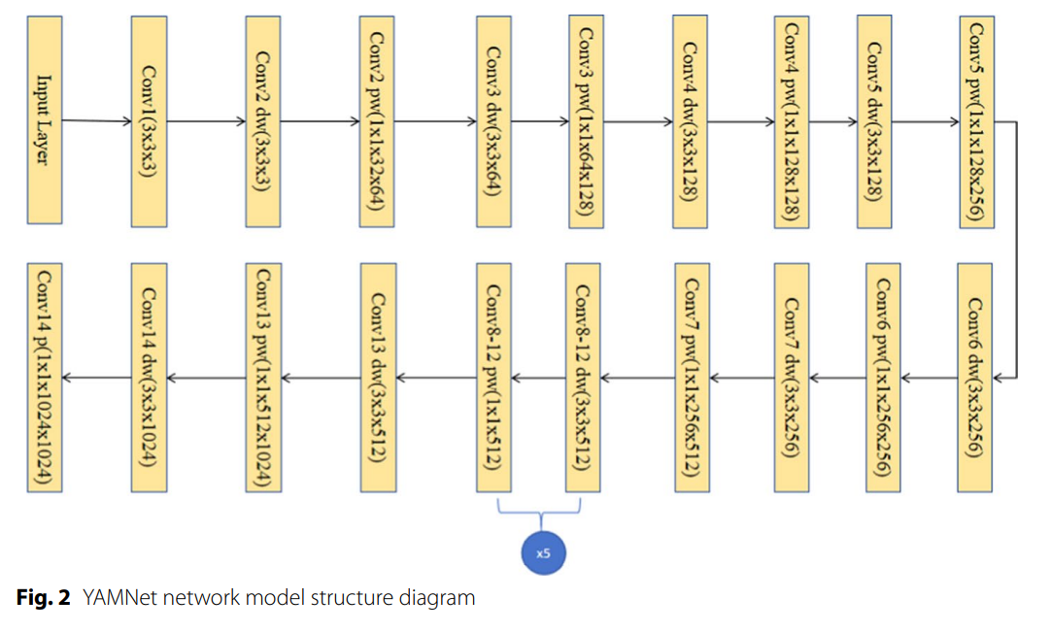

A KLJN-Based Thermal Noise Modulation Scheme With Enhanced Reliability for Low-Power IoT Communication
The paper focuses on improving secure and reliable communication for low-power Internet of Things (IoT) systems using thermal noise–based transmission. Traditional Kirchhoff’s Law Johnson Noise (KLJN) modulation schemes rely on symmetric resistor configurations to generate noise for secure data exchange. However, these systems often suffer from high latency and low data rates because they require a large number of noise samples to maintain reliable communication. To address this limitation, the authors propose a new asymmetric thermal noise modulation scheme called P-Ther-Mod, which aims to enhance reliability and reduce bit errors while maintaining the low-power advantages required for IoT communication environments.
The proposed methodology modifies the conventional KLJN architecture by introducing a four-resistor configuration instead of the traditional two-resistor setup. Each resistor combination corresponds to different bit patterns, creating more distinct noise variance levels that improve signal detection accuracy. The system analyzes thermal noise signals generated by resistors and evaluates their statistical properties to estimate transmitted bits. Analytical models are developed to calculate bit error probability (BEP) for both wired and wireless IoT communication channels, considering common channel conditions such as additive white Gaussian noise and Rayleigh fading. Simulation studies are also performed to validate the theoretical analysis and evaluate the system under realistic operating conditions.
Results demonstrate that the proposed P-Ther-Mod scheme significantly improves reliability compared to traditional KLJN approaches. The new design reduces the number of required noise samples by up to 35% while achieving similar or better error performance. For instance, the system can reach a bit error rate of 10−510^{-5}10−5 using fewer samples and achieve extremely low error levels of around 10−810^{-8}10−8 with higher sampling. Additionally, optimizing the detection threshold parameter improves system robustness and provides up to 7 dB signal-to-noise ratio savings, even in fading wireless environments.
Overall, the study demonstrates that using an asymmetric resistor configuration in thermal noise modulation can greatly enhance both communication reliability and efficiency in low-power IoT networks. By reducing sampling requirements and improving detection accuracy, the proposed approach enables higher bit rates while maintaining secure communication. This makes the technique particularly suitable for applications such as industrial sensor networks, wearable devices, and other IoT systems operating in noisy or interference-prone environments.

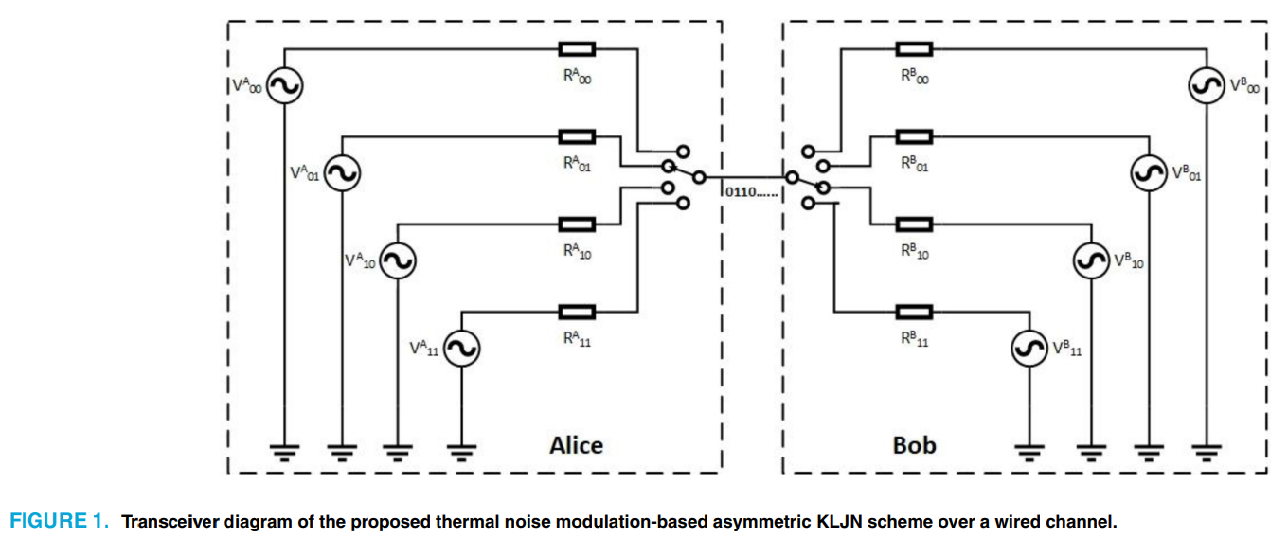

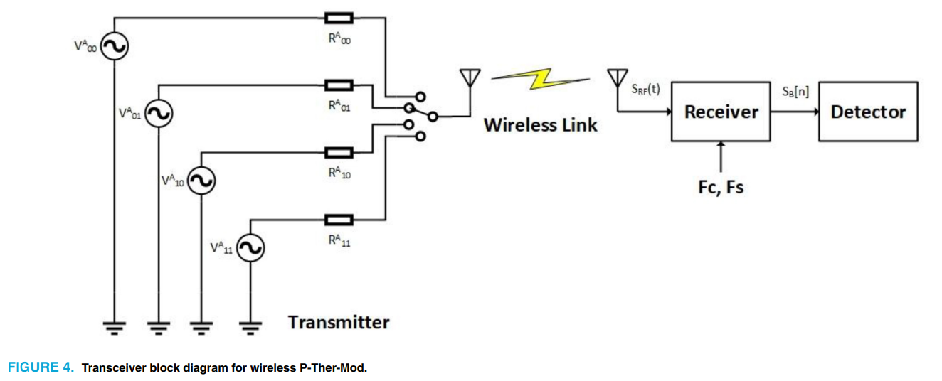

Enhancing Noise Reduction in Quadrature Amplitude Modulation Receivers Through Advanced Circuit Design
The objective of this paper is to address the critical challenge of noise degradation in high-speed wireless communication systems, particularly in Quadrature Amplitude Modulation (QAM) receivers, which are widely used to achieve high spectral efficiency in modern and future networks. As wireless systems evolve toward 6G and beyond, higher-order QAM schemes are increasingly adopted to support growing data traffic; however, these schemes are inherently more sensitive to noise, resulting in increased bit error rate, reduced signal-to-noise ratio (SNR), and limited coverage. Conventional noise mitigation approaches, including software-based signal processing, error correction coding, and hybrid solutions, often introduce computational complexity, latency, and spectral overhead. The primary objective of the paper is therefore to propose a novel, purely hardware-based noise reduction circuit that can significantly enhance SNR without relying on computational resources, thereby enabling reliable high-order QAM reception with minimal latency and complexity.
The methodology employed in this work is centered on the design and mathematical analysis of an innovative analog circuit placed between the front-end and demodulation stages of a QAM receiver. The proposed circuit exploits phase manipulation, DC component removal, and differential amplification to suppress noise while preserving the desired in-phase (I) and quadrature (Q) signal components. A detailed node-by-node mathematical analysis is presented to track the signal evolution across ten circuit nodes, demonstrating how intentional swapping of local oscillator signals causes the desired data signals to become out of phase while noise remains in phase. This enables effective noise cancellation at the operational amplifier through its high common-mode rejection ratio. The circuit is validated using MATLAB Simulink simulations under an Additive White Gaussian Noise channel, with received signal powers ranging from 40 nW to 10 aW and SNR values spanning positive and negative regimes, in accordance with 3GPP receiver sensitivity standards. Performance evaluation is primarily based on SNR enhancement and noise figure analysis.
The results presented in the paper demonstrate a substantial improvement in signal quality achieved by the proposed circuit. Simulation outcomes show that the circuit can enhance SNR by approximately 116 dB to 166 dB, even when the input signal is deeply buried below the noise floor. This unprecedented noise suppression leads to the introduction of a new concept termed the pseudo-negative noise figure, indicating effective noise cancellation beyond conventional receiver limitations. The results further confirm that the proposed circuit maintains signal integrity across a wide range of received signal powers and SNR conditions, outperforming traditional noise reduction techniques that rely on digital processing, coding, or filtering. The circuit achieves this enhancement without introducing additional latency, computational load, or spectral inefficiency, making it particularly suitable for high-order QAM systems.
In conclusion, the paper establishes that advanced analog circuit design can play a transformative role in enhancing noise resilience in QAM receivers for next-generation wireless communication systems. By achieving extreme noise reduction through purely hardware-based means, the proposed circuit enables improved power efficiency, extended coverage, and reliable high-order modulation without increasing transmission power or system complexity. However, the study also acknowledges limitations related to oscillator phase accuracy, operational amplifier noise, and practical hardware implementation constraints. Future research directions include experimental hardware prototyping, integration with advanced modulation and beamforming systems, and optimization for terahertz and 6G applications. Overall, the proposed approach represents a significant step toward low-latency, high-reliability wireless communication in noise-limited environments.

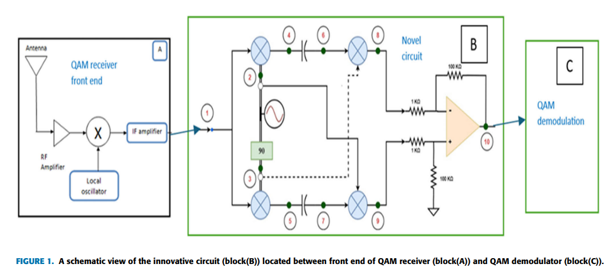

Noise Folding in Optoelectronic PLLs for Ultralow Phase Noise: Modelling and Suppression with Experimental Validation
The objective of this paper is to investigate and suppress the phenomenon of noise folding in optoelectronic phase-locked loops (OEPLLs), which limits the achievable ultralow phase noise performance of microwave frequency synthesizers. Although OEPLLs that lock a microwave tuneable oscillator to a mode-locked laser (MLL) offer significantly lower phase noise than conventional electronic PLLs, the electro-optical phase detector inherently performs under sampling of the RF signal. This under sampling causes broadband noise from multiple Nyquist zones to fold into the baseband, thereby degrading the phase noise floor of the system. The primary aim of the study is to develop a rigorous theoretical model of noise folding in OEPLLs, identify its dominant contributors, and propose practical suppression techniques to achieve near-quantum-limited phase noise suitable for high-performance communication, radar, and timing applications.
The methodology employed in this work combines analytical modelling, system-level design, and experimental validation. The author’s model the electro-optical phase detector based on a single-output Mach–Zehnder modulator (SO-MZM) as a subsampling system, mathematically describing spectrum replication and broadband noise folding using sampling theory. A detailed noise model is derived to quantify how broadband noise power accumulates in the baseband as a function of sampling frequency, modulator bandwidth, and folding factor. To suppress noise folding, a band pass filter is introduced before the MZM to limit the RF noise bandwidth. The OEPLL architecture consists of a low-jitter MLL, an SO-MZM-based balanced phase detector, a dielectric resonator oscillator (DRO), and optimized loop filtering. Additionally, a secondary PLL is implemented to lock the MLL to a quartz-based signal generator, improving close-in phase noise. Extensive experimental measurements are carried out at a 10-GHz carrier frequency to analyse the effects of sampling rate, harmonic content, pre-filtering, and modulation conditions on phase noise performance.
The results demonstrate that noise folding is a dominant mechanism that degrades mid-band phase noise in OEPLLs if not properly controlled. Experimental measurements show that increasing the MLL repetition rate from 250 MHz to 1 GHz significantly reduces the folding factor, resulting in a 5–8 dB improvement in mid-band phase noise. The introduction of RF band pass filtering before the MZM further suppresses folded noise, achieving an additional 10–15 dB improvement. With optimized filtering and modulation conditions, the OEPLL achieves phase noise levels below −155 dBc/Hz across offset frequencies from 50 kHz to 2 MHz, with a minimum noise floor of approximately −170 dBc/Hz at a 400-kHz offset. At very low offset frequencies, synchronizing the MLL to a quartz reference yields phase noise improvements of up to 60 dB at 100 MHz the integrated rms jitter is reduced to 22 fs, confirming ultralow timing instability.
In conclusion, the paper establishes that noise folding caused by under sampling in electro-optical phase detection is a critical limitation in OEPLLs and must be explicitly addressed to achieve ultralow phase noise. By developing a comprehensive noise folding model and demonstrating effective suppression through band pass filtering, sampling rate optimization, and careful modulator biasing, the study achieves state-of-the-art phase noise performance that surpasses conventional electronic synthesizers. While the experimental setup assumes ideal component stability and controlled laboratory conditions, the results clearly demonstrate practical feasibility. Future research directions include further integration of OEPLL components, reduction of system complexity, and extension of the approach to higher carrier frequencies and compact photonic integrated platforms for next-generation terahertz communication and sensing systems.
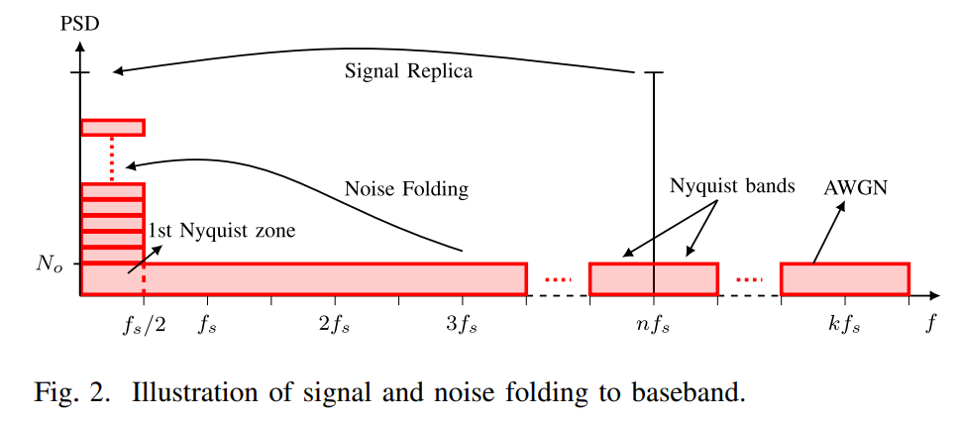

Noise Modulation over Wireless Energy Transfer: JEIH-NoiseMod
The objective of this paper is to propose a novel joint energy and information harvesting scheme for low-power Internet-of-Things (IoT) devices by exploiting the emerging noise modulation (NoiseMod) technique. As future IoT networks evolve toward 6G, powering massive numbers of energy-constrained devices while maintaining reliable communication has become a critical challenge. Conventional simultaneous wireless information and power transfer (SWIPT) approaches, such as time-switching and power-splitting, rely on deterministic modulation schemes that are not optimized for energy harvesting. The main objective of this study is to transform noise, traditionally considered undesirable, into a useful carrier of both energy and information by embedding data into the statistical mean of Gaussian noise samples, thereby enhancing energy harvesting efficiency while preserving reliable communication performance.
The methodology adopted in this work introduces a joint energy and information harvesting NoiseMod scheme, referred to as JEIH-NoiseMod, operating in a time-switching mode. At the transmitter, information bits are mapped into the mean value of real Gaussian noise samples while maintaining a fixed variance to satisfy the transmit power constraint. During each transmission interval, a portion of the samples is allocated to energy harvesting and the remaining samples to information harvesting. The received signal is modeled under Rician fading with free-space path loss, and a simple mean-based detector is employed at the receiver to decode the transmitted bits. For energy harvesting analysis, a nonlinear rectenna model based on a single-diode rectifier is used, where both second-order and fourth-order terms of the received signal contribute to the harvested DC power. Closed-form analytical expressions for the bit error probability are derived by averaging over the Rician fading distribution, and extensive simulations are performed to validate the theoretical results under various channel conditions, distances, and sampling configurations.
The results demonstrate that the proposed JEIH-NoiseMod scheme significantly outperforms conventional modulation techniques in terms of energy harvesting capability while maintaining reliable communication. Simulation results show that JEIH-NoiseMod achieves harvested power levels comparable to ideal real Gaussian signaling and consistently higher than traditional schemes such as BPSK, QAM, and PSK, particularly at short transmission distances. Bit error rate performance improves as the number of samples used for information detection increases, confirming the effectiveness of mean-based detection. The analytical and simulated BER curves closely match, validating the theoretical derivations. Additionally, the scheme exhibits robustness to Rician fading, path loss, and channel estimation errors, as the detection process relies on sample averaging rather than precise instantaneous channel estimates.
In conclusion, the paper establishes that noise modulation can be effectively leveraged for simultaneous wireless energy and information transfer in energy-constrained IoT systems. By embedding information in the mean of Gaussian noise samples, the proposed JEIH-NoiseMod scheme achieves a favorable trade-off between energy harvesting efficiency and communication reliability. Although the scheme inherently requires a higher sampling rate compared to conventional modulation techniques, its low-power nature and strong energy harvesting performance make it well suited for future ambient and battery-less IoT applications. Future research directions include extending the framework to multi-user scenarios, improving data rates by exploiting other statistical properties of noise, and developing adaptive schemes that dynamically balance energy and information harvesting under varying real-world conditions.
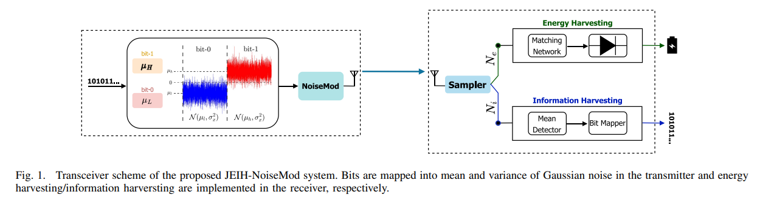

On–Off Digital Noise Modulation
The paper introduces and validates On-Off Digital Noise (OODN) modulation, a novel scheme designed to meet the stringent energy and connectivity requirements of future Internet of Things (IoT) networks [1], [2]. Existing noise-based communication techniques suffer from limitations: analog thermal noise modulation offers low data rates and short ranges, while the recently proposed digital “NoiseMod” framework exhibits higher error probabilities [3-5]. The authors aim to develop a solution that combines ultra-low-power consumption and low transceiver complexity with reliable performance, establishing OODN as a power-optimal reference for binary noise modulation [1], [6].
The methodology combined mathematical modeling and simulation. In OODN, the transmitter encodes bit ‘1’ as a sequence of digital complex AWGN with known variance, while bit ‘0’ is represented by silence [1], [6]. Closed-form expressions for Bit Error Probability (BEP) were derived in AWGN channels and extended to fading environments using the κ-μ distribution, which models both LoS and nLoS conditions [1], [7]. Gauss-Laguerre quadrature was used to approximate average BEP under fading [8]. The receiver design employed non-coherent detection: an energy detector computes the empirical variance of received samples and compares it against an optimal threshold, eliminating the need for phase or frequency synchronization [9-11]. Performance was benchmarked via Monte Carlo simulations in MATLAB, comparing OODN against BPSK, On-Off Keying (OOK), and NoiseMod [12]. Validation included practical 65 GHz mmWave indoor channel data [6], [13]. Analytical “SNR gaps” quantified the additional SNR required by other schemes to match OODN’s BEP [6], [14].
The findings establish OODN’s efficacy. It was shown to be the most power-efficient binary noise modulation reported to date [6]. Analytical results confirmed that OODN consistently achieves lower BEP than NoiseMod, BPSK, and OOK for practical sample sizes [15]. Significant SNR advantages were quantified: at a sample size N and SNR of –5 dB, OODN required 1.2 dB less power than NoiseMod and 9.6 dB less than BPSK to achieve the same error rate [16]. The scheme demonstrated robustness across Rayleigh, Rice, and Nakagami-m fading scenarios, with theoretical predictions closely matching simulations in both AWGN and mmWave channels [17], [18], [13]. BEP decreased monotonically as the number of noise samples per bit increased, reducing variance in the receiver’s decision variable [18], [19].
The applications are highly relevant for next-generation wireless networks. OODN’s non-coherent detection enables extremely simple receiver architectures without complex synchronization, ideal for massive deployments of low-cost, battery-operated IoT nodes [2], [9]. The noise-like waveforms make OODN suitable for covert or stealth communications where signals must appear indistinguishable from background noise [20], [21]. It is also well-suited for wideband low-rate telemetry applications where bandwidth is abundant but power and hardware resources are constrained [21].
The study acknowledges limitations and future directions. OODN achieves superior energy efficiency at the cost of spectral efficiency, which decreases as the number of samples per bit increases [21]. The Gaussian approximation for variance distribution showed slight deviations for very small sample sizes at high SNRs [13]. Future research could extend the framework to M-ary OODN, using one silence symbol and multiple variance-encoded symbols [22]. Integration with Time-Division Multiplexing or Noise-Domain Non-Orthogonal Multiple Access (ND-NOMA) could support multiple devices within the same bandwidth [22].
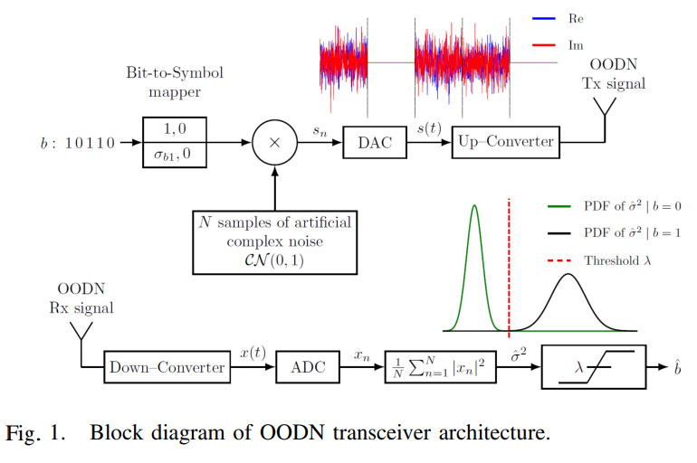

Pulsed HEMT LNA Operation for Qubit Readout

The paper addresses the challenges associated with scaling up superconducting quantum computers, focusing on the high thermal load and “backaction” interference caused by High-Electron Mobility Transistor (HEMT) Low-Noise Amplifiers (LNAs) used for qubit readout [1], [2]. As the number of qubits increases, the continuous power consumption of these amplifiers at the 4-K stage threatens the system’s thermal budget, while amplifier backaction can disturb qubit states [2]. To overcome these limitations, the study demonstrates the feasibility of a pulsed operation scheme (duty cycling) for cryogenic LNAs. The specific goals are to minimize amplifier “deadtime” (recovery time) so that the device can stabilize within the short windows required for qubit readout—on the order of tens to hundreds of nanoseconds—and to prove that this method reduces average power consumption without compromising noise or gain performance [3], [4].
The methodology involved characterizing a modified commercial LNA using a custom cryogenic measurement system. The Device under Test (DUT) was a commercial InP HEMT LNA (LNF-LNC4-8C), modified by removing a parallel resistor and reducing the gate bias low-pass filter capacitor from 100 nF to 1 nF to enable faster transient responses [5]. A cryogenic time-domain noise and gain measurement setup was developed, capable of 5-ns resolution and a noise standard deviation below 0.3 K [1], [6]. Operating at 10.6 K, the setup employed a “hot” and “cold” noise source method combined with a high-speed oscilloscope and an Arbitrary Waveform Generator (AWG) to capture transient responses [7], [8]. To overcome slow recovery times, the researchers implemented a real-time Genetic Algorithm (GA) that optimized the shape of the gate voltage waveform, creating a fast-recovery pulse with an initial high-voltage “kick” to minimize stabilization time [1], [9], [10]. Drain current transients were measured to calculate average power consumption, and S-parameters were analyzed to ensure unconditional stability of the modified device [11], [12].
The findings validate the viability of pulsed LNA operation. A standard square-wave pulse resulted in a recovery time of approximately 120 ns with a 130 ns initial delay, whereas the GA-optimized waveform reduced recovery time to 35 ns [13], [14], sufficient for demanding quantum error correction protocols [15]. Average power consumption was reduced proportionally to the duty cycle; for example, a 10% duty cycle lowered consumption to about 13.9% of the static DC baseline [12]. Distinct transient dynamics were observed: noise performance stabilized faster than gain in the time domain, while in the frequency domain noise recovery was slower at the band edges, whereas gain recovery was uniform across the bandwidth [15]. Importantly, the modified LNA maintained state-of-the-art noise performance (noise temperature below 2 K) under pulsed conditions, proving that pulsed operation does not degrade signal quality once the device stabilizes [14].
The applications are directly relevant to the hardware infrastructure of large-scale superconducting quantum computers [1]. By reducing heat dissipation at the 4-K stage, this approach enables higher density of readout lines, facilitating qubit scaling [2], [15]. Synchronizing LNA activation with readout pulses minimizes backaction, preserving qubit coherence and reducing error rates [3]. The achievement of a 35-ns recovery time makes the technology compatible with fast surface code error correction protocols requiring rapid readout and reset cycles [4], [13].
The study also identifies limitations and future research directions. Modifying the low-pass filter improved speed but increased gain fluctuation fivefold compared to the unmodified LNA, as the filter provided less suppression of supply variations [11]. The optimized waveform showed a slight gradual decrease in gain (0.45 dB) during steady state, attributed to imperfections in the power supply regulator, suggesting the need for more stable supplies [16]. The GA was used because analytical modeling was difficult due to component tolerances and parasitic elements; future work could explore analytical control theory methods if accurate large-signal models and precise component characterization are available [17], [18]. Dedicated circuit designs should also be developed to balance fast transient operation with robust supply regulation, mitigating observed gain fluctuations [11]

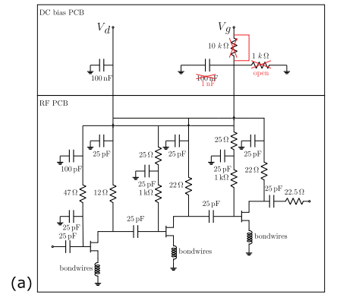
(a) Bias schematic of the HEMT LNA DUT before and after modification, illustrating the dc and RF PCBs.

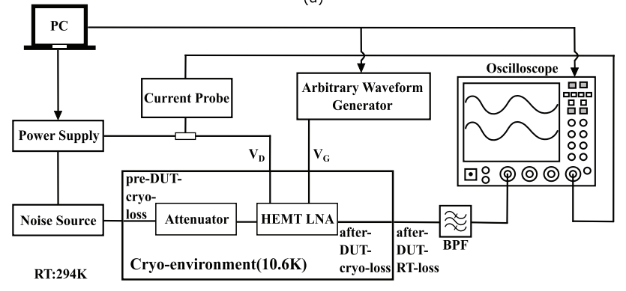

Development of Signal Processing and Machine Learning Methods for Spectrum Sensing Using Autocorrelation Features
The objective of this paper is to develop robust and low-complexity spectrum sensing techniques capable of detecting weak wireless signals in highly congested Fifth Generation New Radio Frequency Range 1 (5G NR FR1) bands. With the rapid growth of 5G networks, IoT devices, and data-intensive applications, spectrum congestion has become a critical challenge, necessitating efficient spectrum sharing and dynamic spectrum access. Conventional statistical signal-processing-based sensing methods, such as energy detection and eigenvalue-based detectors, suffer from uncertain detection thresholds and degraded performance under low signal-to-noise ratio (SNR) conditions. Although machine and deep learning-based sensing approaches provide threshold-independent detection, they often require large datasets and high computational resources. The paper therefore aims to bridge this gap by exploiting frequency-domain autocorrelation features to design two novel sensing methods that achieve reliable low-SNR detection while maintaining low computational complexity.
The methodology adopted in this work is based on hypothesis-testing-driven signal processing and lightweight machine learning frameworks. The received 5G FR1 signal is preprocessed through bandpass filtering, downconversion, and sampling, after which frequency-domain autocorrelation coefficients are computed using the Wiener–Khinchin theorem. In the Auto-Correlation Integral-based Sensing (ACIS) method, autocorrelation values across multiple lags are summed to form a decision statistic known as the autocorrelation integral, and an analytical detection threshold is derived based on Gaussian noise assumptions for a fixed false alarm probability. In parallel, the Logistic Regression Model-based Sensing (LRMS) approach treats autocorrelation coefficients as feature vectors and trains a logistic regression classifier using labelled datasets to discriminate between noise-only and signal-present hypotheses. Extensive simulations are conducted in a Python environment using synthetic 5G mid-band signals with additive Gaussian noise, and performance is evaluated by varying SNR, sample size, and dataset size, with probability of detection, probability of false alarm, and classification accuracy used as evaluation metrics.
The results presented in the paper demonstrate that both proposed methods significantly outperform many existing spectrum sensing techniques reported in the literature. ACIS achieves a detection probability exceeding 90% at an SNR of −18 dB using a correlation vector size of 512, with a computational complexity of O(N log N), making it suitable for real-time and resource-constrained implementations. The LRMS method exhibits superior performance, achieving over 90% classification accuracy for signals as weak as −30 dB when trained with sufficiently large datasets, while maintaining a low computational complexity of O(N). Simulation results further show that detection and classification performance improves with increasing sample size and dataset size, confirming the effectiveness of autocorrelation features in distinguishing weak signals from noise even under severe low-SNR conditions.
In conclusion, the paper establishes frequency-domain autocorrelation features as a powerful and efficient foundation for spectrum sensing in next-generation wireless networks. The ACIS method offers a simple, training-free signal-processing solution with strong low-SNR robustness, while the LRMS method provides a lightweight, threshold-independent machine learning alternative with superior detection capability under extreme noise conditions. However, ACIS is limited in adaptability under very low SNR scenarios, and LRMS requires large labelled datasets for optimal performance. Future research directions include extending the proposed techniques to wideband and cooperative spectrum sensing, implementing them on real-time hardware platforms, and exploring advanced learning models that retain low complexity while improving adaptability and generalization. These advancements can significantly contribute to efficient spectrum sharing in 5G and beyond wireless communication systems.

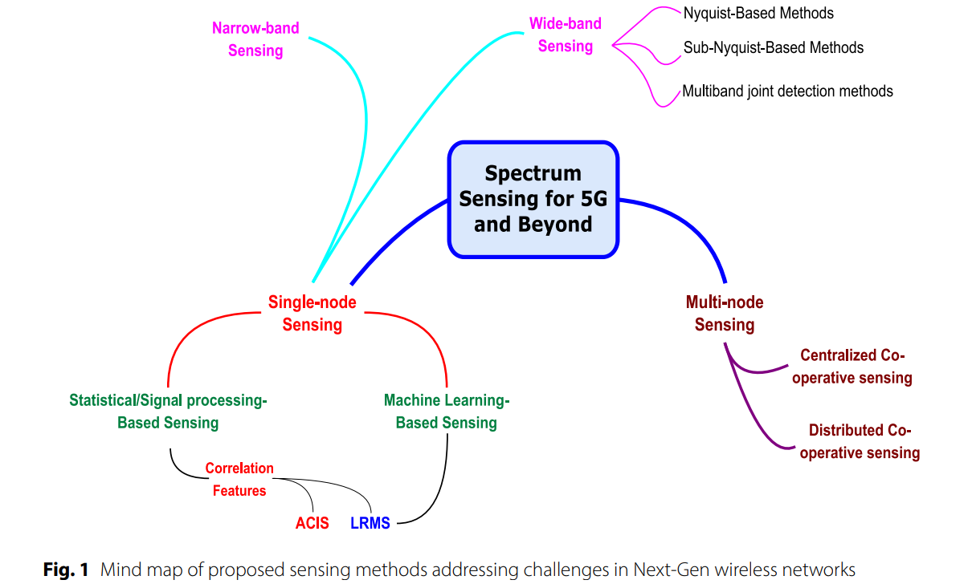

GLIM: Generalized Detection of Low-SNR Signals Using an Iterative Feedback Model
The objective of this paper is to address the problem of detecting unknown wireless signals operating at very low signal-to-noise ratios (SNRs), where conventional digital signal processing (DSP) techniques and supervised machine learning methods perform poorly. In many real-world applications such as opportunistic spectrum sharing, spectrum monitoring, long-range communications, and positioning, navigation, and timing (PNT) systems, signals may be intentionally hidden, unstructured, or entirely unknown to the detector. Existing DSP-based detectors suffer from severe performance degradation at low SNRs, while machine learning approaches typically require extensive offline training with labelled data and prior knowledge of signal structure. The primary objective of the study is therefore to develop a generalized, online detection framework capable of accurately identifying the presence of unknown signals under noise without requiring a priori signal knowledge, pre-training, or labelled datasets.
The methodology proposed in this paper is based on a novel iterative feedback architecture called GLIM, which combines traditional DSP-based detection with deep learning in an online pseudo-label learning framework. Initially, incoming signals are processed using energy detection and auto-correlation detectors to generate coarse estimates of signal presence. These estimates are used to create pseudo-labels for training a convolutional neural network (CNN) without access to true signal labels. The CNN is trained using a binary cross-entropy loss function with regularization and dropout to ensure stability under noisy labels. A key feature of GLIM is its closed-loop feedback mechanism, where model-generated predictions are iteratively fed back to refine future pseudo-labels, gradually improving detection accuracy at lower SNRs. The framework is evaluated using a wide variety of signal types, including BPSK, QPSK, DSSS, OFDM, and linear frequency-modulated (LFM) signals, under AWGN, Rayleigh, and Rician fading channels. Performance is assessed using probability of detection, false alarm rate, and Youden’s J-statistic across SNRs ranging from −30 dB to +20 dB.
The results demonstrate that GLIM significantly outperforms traditional DSP-based detectors in low-SNR environments and achieves detection performance within approximately 3 dB of fully supervised deep learning models trained with ideal labelled data. Experimental evaluations show that GLIM consistently detects unknown signals below −20 dB SNR, a regime where energy and auto-correlation detectors fail. The iterative feedback mechanism enables generalized learning across different waveform types, sequence lengths, and timing offsets, without overfitting to specific signal structures. Additionally, GLIM exhibits strong robustness to detector threshold selection, a property referred to as threshold selection forgiveness, which is quantitatively shown to be superior to DSP-based methods. The computational complexity of the framework scales linearly with signal length and training size, making it suitable for practical deployment.
In conclusion, the paper establishes GLIM as a powerful and practical solution for generalized detection of unknown low-SNR signals in realistic wireless environments. By integrating DSP-based estimation with iterative deep learning feedback, the framework eliminates the need for labelled training data and prior signal knowledge while maintaining near-optimal detection performance. However, the study is limited to simulation-based validation and assumes access to sufficient signal observations across varying SNRs for convergence. Future research directions include real-world experimental validation, optimization of feedback delay and stability mechanisms, extension to multi-signal and dense spectral environments, and integration with autonomous spectrum monitoring and cognitive radio systems. Overall, GLIM represents a significant advancement toward intelligent, adaptive, and label-free signal detection in next-generation wireless networks.
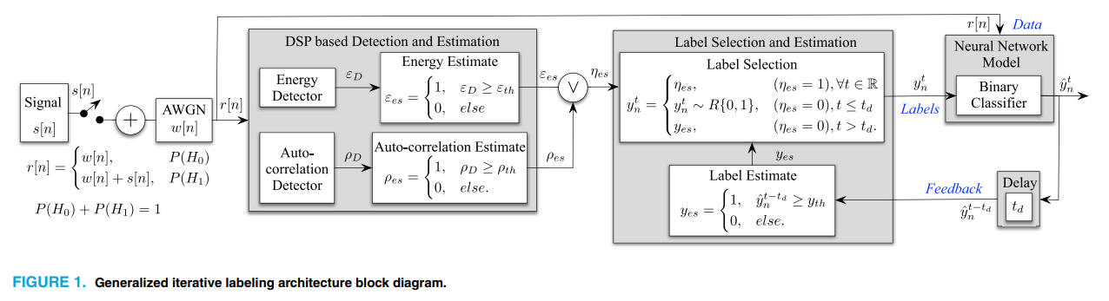

Neural Processing of Noise-Vocoded Speech Under Divided Attention: An fMRI–Machine Learning Study
The objective of this paper is to investigate how the human brain processes acoustically degraded speech when attentional resources are divided between concurrent tasks. In real-world listening environments, speech perception often occurs under degraded acoustic conditions while individuals simultaneously perform other cognitively demanding tasks. Although previous studies have examined degraded speech perception or attentional distraction separately, the combined effects of acoustic degradation and divided attention on neural processing remain poorly understood. The primary goal of this study is therefore to identify the neural networks that support noise-vocoded speech perception under divided attention and to determine how attentional resources are dynamically allocated across speech and visual tasks using a combination of functional magnetic resonance imaging (fMRI) and machine learning techniques.
The methodology employed in this study is based on a dual-task experimental paradigm combined with whole-brain fMRI and multivariate machine learning analysis. Twenty-five healthy adult participants listened to noise-vocoded sentences while simultaneously performing a visuomotor recognition task involving Gabor patch orientation discrimination. Speech degradation was manipulated using four-band (hard) and eight-band (easy) noise vocoding, while visual task difficulty was controlled by varying the angular discrepancy between target and non-target stimuli. fMRI data were acquired using a 3-Tesla scanner, and conventional general linear model (GLM) analyses were applied to identify brain regions sensitive to task difficulty. To capture distributed and nonlinear neural patterns beyond standard univariate analysis, an Extreme Gradient Boosting (XGBoost) machine learning classifier was trained on parcellated whole-brain activation maps to predict task conditions. Feature importance was assessed using Shapley Additive Explanations (SHAP) to identify brain regions contributing most strongly to classification performance.
The results reveal that processing degraded speech under divided attention recruits a distributed frontotemporal and cingulate network associated with effortful listening and attentional control. Behavioral findings show that increased difficulty in one task adversely affects performance in the other, indicating a trade-off in attentional resources. fMRI analyses demonstrate stronger blood-oxygen-level-dependent (BOLD) responses for harder speech conditions in bilateral insulae, paracingulate cortex, and superior frontal gyrus, regions previously associated with executive control and effortful auditory processing. Machine learning results further reveal both modality-general and modality-specific neural responses, with regions such as the insula, inferior frontal gyrus, and middle frontal gyrus contributing to both speech and visual task demands. The XGBoost classifier significantly outperformed chance-level prediction, demonstrating that distributed neural activation patterns encode information about task difficulty that is not fully captured by traditional GLM analysis.
In conclusion, this study demonstrates that the neural processing of acoustically degraded speech under divided attention relies on a bilateral operculo-frontal and cingulate network involved in attentional regulation, performance monitoring, and executive control. By integrating fMRI with machine learning, the paper provides new insights into how the brain dynamically allocates resources when facing simultaneous perceptual and cognitive challenges. However, the study is limited by its relatively small sample size and reliance on laboratory-controlled tasks that may not fully capture real-world listening scenarios. Future research should extend this approach to larger and more diverse populations, incorporate more ecologically valid listening environments, and explore real-time neural decoding methods to better understand adaptive listening strategies in everyday communication.

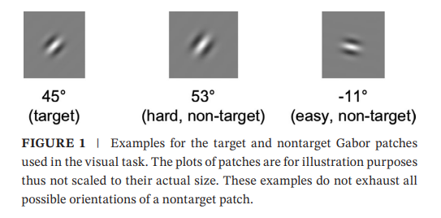
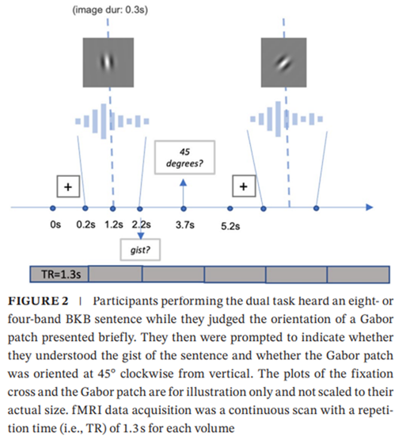

Machine Learning-Assisted Secure Random Communication System
The paper addresses the limitations of physical layer security (PLS) and existing random communication systems (RCSs) by proposing the first machine learning-assisted random communication system (ML-RCS) [1], [2]. Previous RCS models suffered from low data rates, while conventional systems lacked robust protection against eavesdropping [3]. The authors aim to demonstrate that integrating machine learning can bridge the data rate gap between conventional communication systems and unconventional noise-based systems, providing a baseline model and benchmark for secure 6G and nano-communication systems [2], [3].
The methodology involved designing a novel communication framework operating in an AWGN channel. The transmitter employed skewed alpha-stable noise shift keying, encoding binary bits into skewed alpha-stable noise carriers by shifting the distribution left or right [4], [5]. The legitimate receiver used a Decision Tree (DT) classifier, specifically a Fine Tree (FT), chosen for its low computational complexity and robustness against outliers [6], [7]. The DT was pretrained on a private dataset (-SNSD) containing combinations of signal parameters [4], [8]. Security relied on private keys, including pulse length and parameter sets known only to the transmitter and legitimate receiver [9], [10]. Performance was evaluated via Monte Carlo simulations, analyzing BER and confusion matrices under varying exponents, skewness differences, and pulse lengths [1], [11]. An illegitimate receiver (ILR) was modeled with a CART-based classifier but without access to the private dataset or keys [12].
The findings highlight several advances. The ML-RCS achieved a BER of ~0 at an MSNR of –12 dB, the minimum achievable compared to other RCSs [13]. Data rates improved drastically: binary digits were transmitted with a pulse length of only N samples, compared to prior systems requiring 57N, enabling ~57 times more bits [13]. Security was validated, as the illegitimate receiver achieved a False Negative Rate of 50.2% and a True Positive Rate below 50%, rendering it unable to decode information [1], [14]. Comparative analysis confirmed that the Fine Tree configuration outperformed Medium and Coarse Tree classifiers [7].
The applications are significant for next-generation networks. ML-RCS strengthens PLS in 5G and 6G systems, offering adaptive defense and built-in security for ultra-low latency communications [15], [16]. Its low computational complexity makes it suitable for IoT and edge computing environments, including industrial control and mobile healthcare [6], [17]. The use of alpha-stable noise masks communication presence, making it valuable for covert military and satellite operations [3], [18]. The method also functions as a user and device authentication model, ensuring confidentiality between transmitter and legitimate receiver [2], [4].
The study also identifies limitations and future directions. Current testing was limited to AWGN channels, requiring validation in dynamic environments such as Rayleigh–Rician fading [19]. The research focused solely on Decision Trees; future work should explore SVMs, KNNs, and Neural Networks for comparative effectiveness [19]. Key distribution was assumed to be predetermined; future research should develop secure distribution methods independent of pilots to prevent interception during synchronization [19].
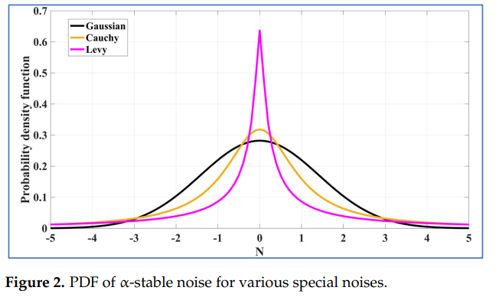

Embedded Hardware-Based Adaptive Filtering for Noise Reduction in Bio impedance Data
This paper focuses on reducing noise in bio impedance signals, which are widely used in medical monitoring and wearable healthcare devices. Bio impedance analysis is applied in several biomedical applications such as body composition measurement, respiratory monitoring, and cardiovascular diagnostics. However, signals obtained from portable or wearable measurement systems are often affected by noise caused by electrical interference, body movement, hardware limitations, and environmental factors. These disturbances can degrade signal quality and affect the accuracy of measurements. The main objective of the study is to develop an automated digital filtering technique capable of improving signal quality while remaining suitable for low-power embedded systems used in wearable devices.
The authors propose an adaptive filtering method based on an exponential moving average (EMA) filter with automatically tuned parameters. Unlike conventional filters that require manual configuration or prior knowledge of the signal characteristics, the proposed approach determines the optimal filtering coefficient by minimizing the difference between noisy input data and the smoothed output while maintaining signal smoothness. The method was evaluated using synthetic bio impedance datasets generated through the Cole impedance model as well as experimentally measured impedance signals. In addition, the filtering algorithm was implemented on a microcontroller-based platform to demonstrate its feasibility for real-time embedded applications.
The experimental results show that the proposed method significantly improves signal quality under various noise conditions. For simulated datasets with noise levels between 0.5% and 2%, the filter achieved improvements in signal-to-noise ratio of up to 8 dB. The algorithm automatically adjusted its smoothing parameter according to the noise level, applying stronger filtering when noise increased. Practical experiments also demonstrated improved accuracy in electrical circuit parameter estimation and effective noise reduction in physiological signals such as electromyography (EMG) and respiration bio impedance data.
The study demonstrates that the proposed filtering technique is computationally efficient and well suited for embedded hardware implementation. The microcontroller-based implementation achieved low power consumption and fast execution time, making it appropriate for wearable and portable healthcare systems. Future work may involve integrating the method with advanced signal processing or machine learning techniques to further enhance noise reduction performance in complex biomedical monitoring environments.
