### PROJECT REPORT

### on

# AMAZON SURVEY FORM

#### Submitted by

#### Group/Team No: G27-B/T18

**RITTIKA TYAGI, 2210990732,**

**RITVIK SACHDEVA, 2210990733,**

**RIYA, 2210990734,**

**RIYA KUNDRA, 2210990735**

**PRANAV MANGAL, 2210990995**

#### in partial fulfillment for the award of the degree of

## BACHELEOR OF ENGINEERING

***in***

COMPUTER SCIENCE & ENGINEERING



**CHITKARA UNIVERSITY**

**CHANDIGARH-PATIALA NATIONAL HIGHWAY**

**RAJPURA (PATIALA) PUNJAB-140401 (INDIA)**

##### May, 2023

###### TABLE OF CONTENTS

|  |  |  |
| --- | --- | --- |
| Serial no. | Section | Page no. |
| 1 | Introduction | 3 |
| 2 | Problem Statement | 4 |
| 3 | Technical Details | 5 |
| 4 | Key Features | 6 |
| 5 | Project Highlights | 7-13 |
| 6 | Bonus Feature | 14 |
| 7 | Conclusion | 15 |
| 8 | Reference Links Used | 16 |

###### Introduction

This report is on the topic, ‘**Survey Form’**, and with the collective efforts of the team 18 members, **Rittika Tyagi**, **Ritvik Sachdeva (Team Leader),** **Riya, Riya Kundra and Pranav Mangal**, the project was made.

The main objective of this project, on survey form made using HTML, CSS and JavaScript, is to collect accurate and useful data from respondents by creating a user-friendly interface that encourages participation and provides a clear understanding of the purpose and scope of the survey. The form should be designed in a way that ensures the questions are easy to understand, the response options are clear and concise, and the overall layout is visually appealing and engaging. The survey form should be programmed to validate responses and ensure data accuracy, while also being optimized for compatibility with a range of devices and browsers. Ultimately, the objective is to create a survey form that maximizes response rates, minimizes response errors, and provides meaningful insights into the topic at hand.

Lots of companies use survey forms as a means of collecting relevant data about their target audience.  In this project, we have to design a full-fledged survey form that includes relevant questions like name, age, email, address, contact number, and other questions, depending on the type of company or organization, we are shaping the form for. This project tests our webpage’s structuring skills.

Here, the company we have used to shape our survey form, accordingly, is “**Amazon**”.

###### Problem Statement

Design a user-friendly survey form for a company using HTML, CSS and JavaScript that will encourage participation, provide clear instructions, and be optimized for compatibility across multiple devices and browsers. The survey form should be designed to minimize response errors and validate responses to ensure data accuracy such that it improves the data collection process, gain valuable insights into the customer needs and preferences, and make informed decisions that will enable a company to grow and succeed in a highly competitive marketplace.

Also, this project, on survey form, should include relevant questions like name, age, email, address, contact number, and other questions, depending on the type of company, the form is shaped for.

###### Technical Details

A brief overview of all the technical details, including technologies and methods used in making the project is given as follows:

1. HTML: HTML (Hypertext Markup Language) is the standard markup language used to create web pages. It provides the structure and layout of the content on the web page, including headings, paragraphs, lists, and links.
2. CSS: CSS (Cascading Style Sheets) is a stylesheet language that describes the presentation of a web page. It allows developers to control the visual appearance of the content, including fonts, colors, layout, and other design elements.
3. Semantic HTML: Semantic HTML is a coding practice that involves using HTML tags to convey the meaning and structure of the content on the web page. This can help improve accessibility and search engine optimization (SEO), as well as make the code easier to read and maintain.
4. Responsive Design: Responsive design is an approach to web design that allows web pages to adapt to different screen sizes and devices. This can be achieved using CSS media queries, which adjust the layout and styling of the survey form based on the screen size.
5. Form Elements: HTML provides a number of form elements that can be used to create survey forms, such as input fields, checkboxes, radio buttons, and dropdown menus. These elements can be styled using CSS to match the design of the survey form.
6. Validation: HTML provides built-in validation for certain form elements, such as required fields and email inputs. This can be enhanced using CSS to provide visual feedback to users when they submit the form.
7. Usability: Usability is an important consideration when designing survey forms using HTML and CSS. This involves ensuring that the survey form is easy to use and understand, with clear instructions and labels for form elements. The survey form should also be visually appealing and engaging, with a consistent design and layout.
8. JavaScript: JavaScript can be used to add interactivity to the survey form. Event listeners can be added to capture form submission and perform actions like validating the inputs, displaying error messages, or sending the form data to a server for processing. JavaScript frameworks or libraries like jQuery can also be used to simplify form manipulation and enhance the user experience.

###### Key Features

The key features used in making the project are given below:

1. Form Elements: HTML provides a variety of form elements that can be used to create a survey form, such as input fields, checkboxes, radio buttons, and dropdown menus. These elements can be styled using CSS to match the design of the survey form.
2. Layout and Design: CSS can be used to control the layout and design of the survey form, including the use of grids, columns, and responsive design. This can help ensure that the survey form is visually appealing and easy to use across different devices and screen sizes.
3. Accessibility: Accessibility is an important consideration when designing a survey form, as it ensures that users with disabilities can access and complete the form. This involves using proper markup, providing descriptive labels for form elements, and following accessibility guidelines.
4. Feedback: The survey form should provide feedback to users when they submit the form, such as a confirmation message through another page within the site. This can help ensure that users know their responses have been received and can provide a sense of closure to the survey process.

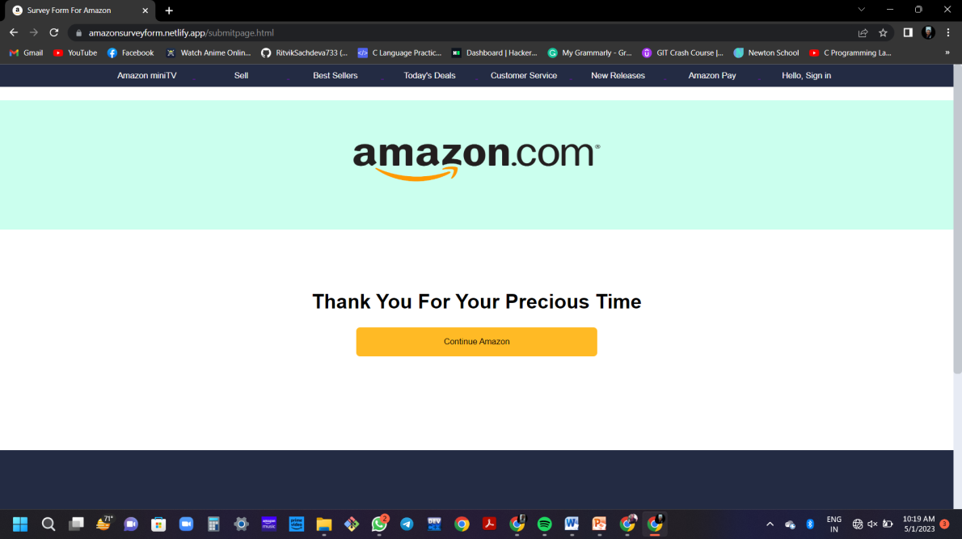

The above pic is the screenshot of the feedback page of our Survey Form that provides a sense of closure to the survey process

1. Usability: Usability is an important consideration when designing a survey form, as it ensures that the form is easy to use and understand. This involves providing clear instructions and labels for form elements, as well as ensuring that the survey form is visually appealing and engaging.
2. Conditional Fields: Display or hide certain fields based on user selections or responses. Use JavaScript to handle the logic for showing or hiding specific questions or sections of the form dynamically.

###### Project Highlights

1. Screenshot of running Survey Form.

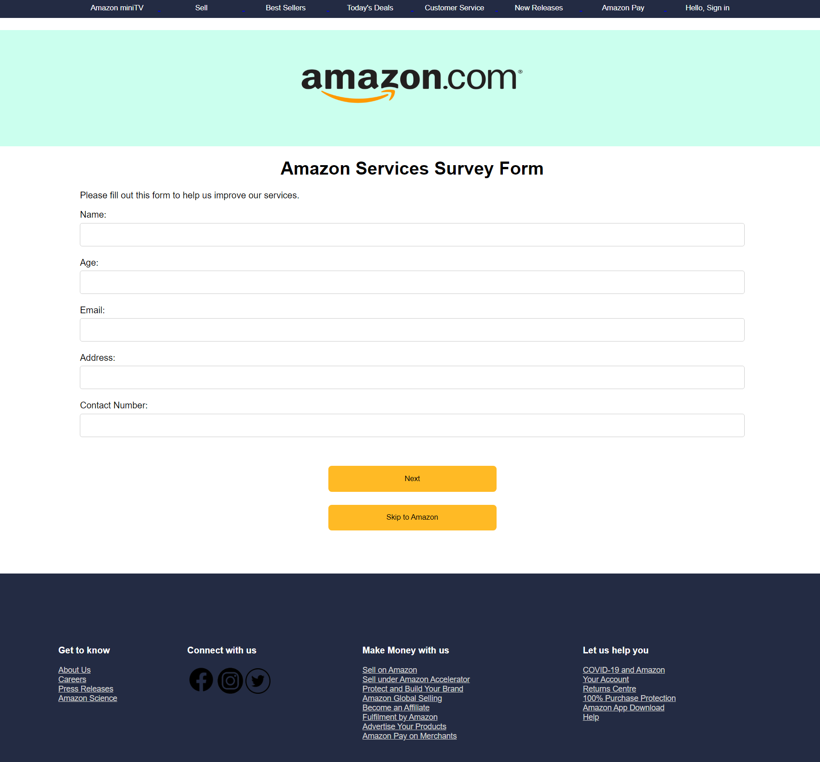

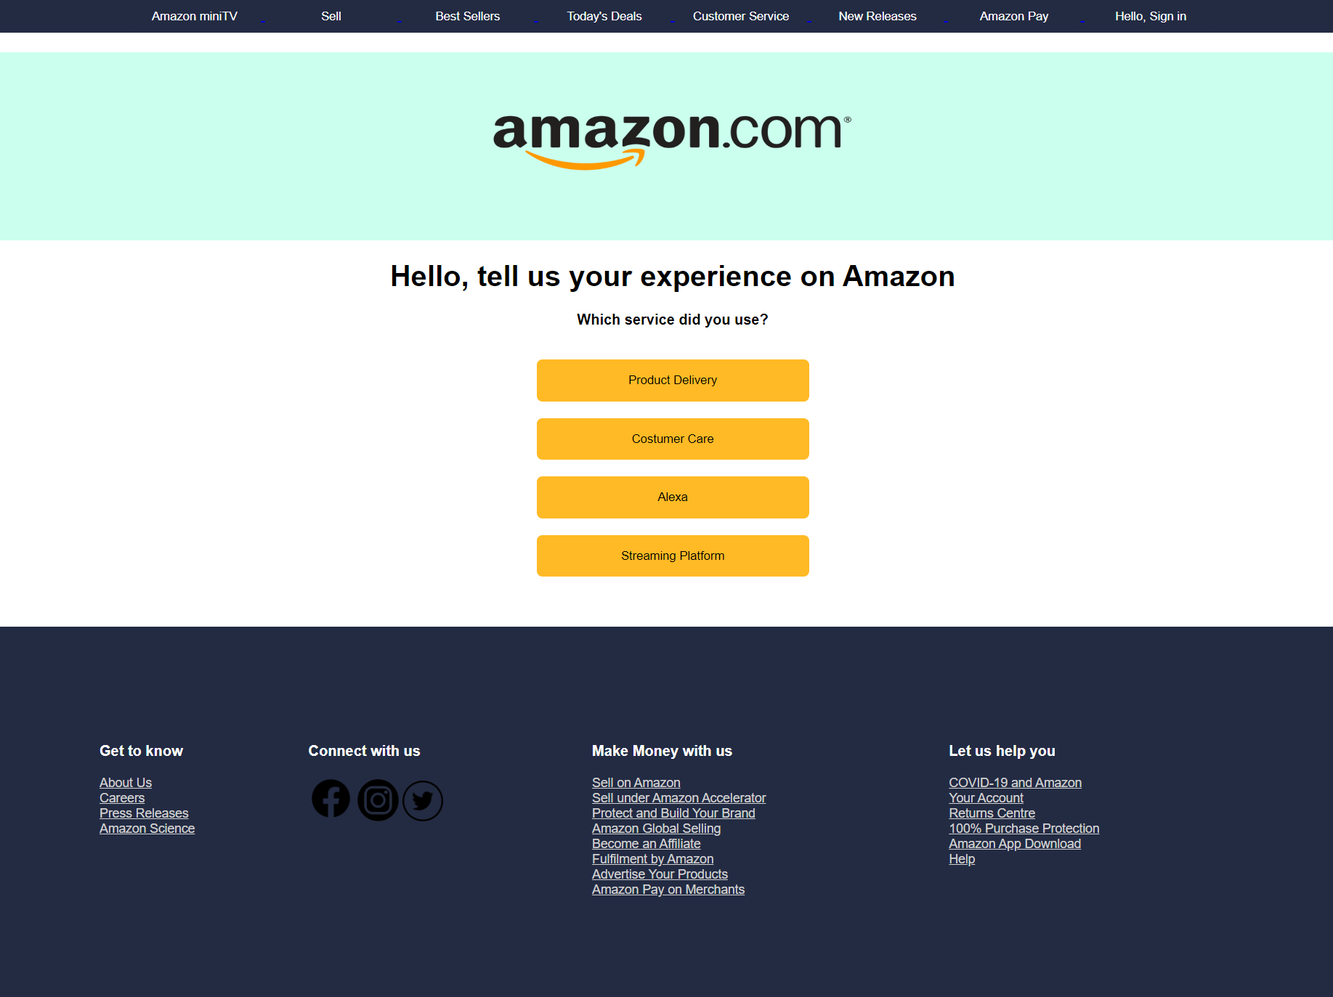

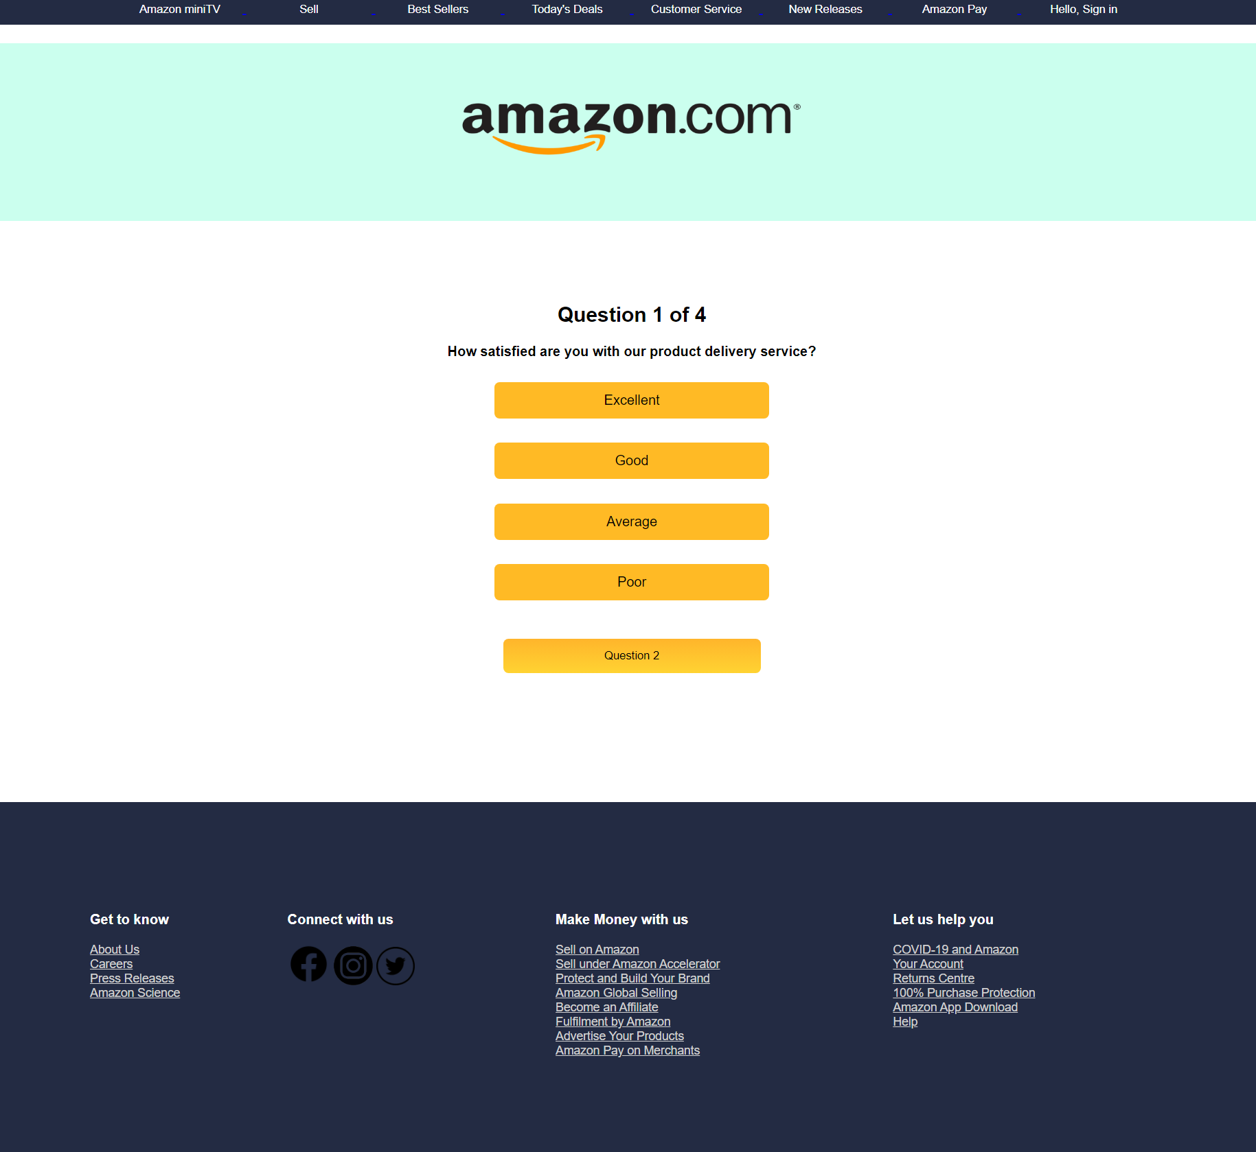

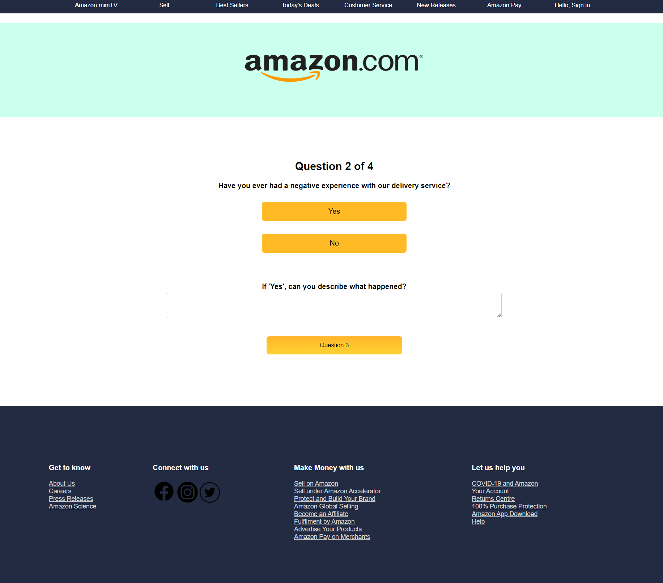

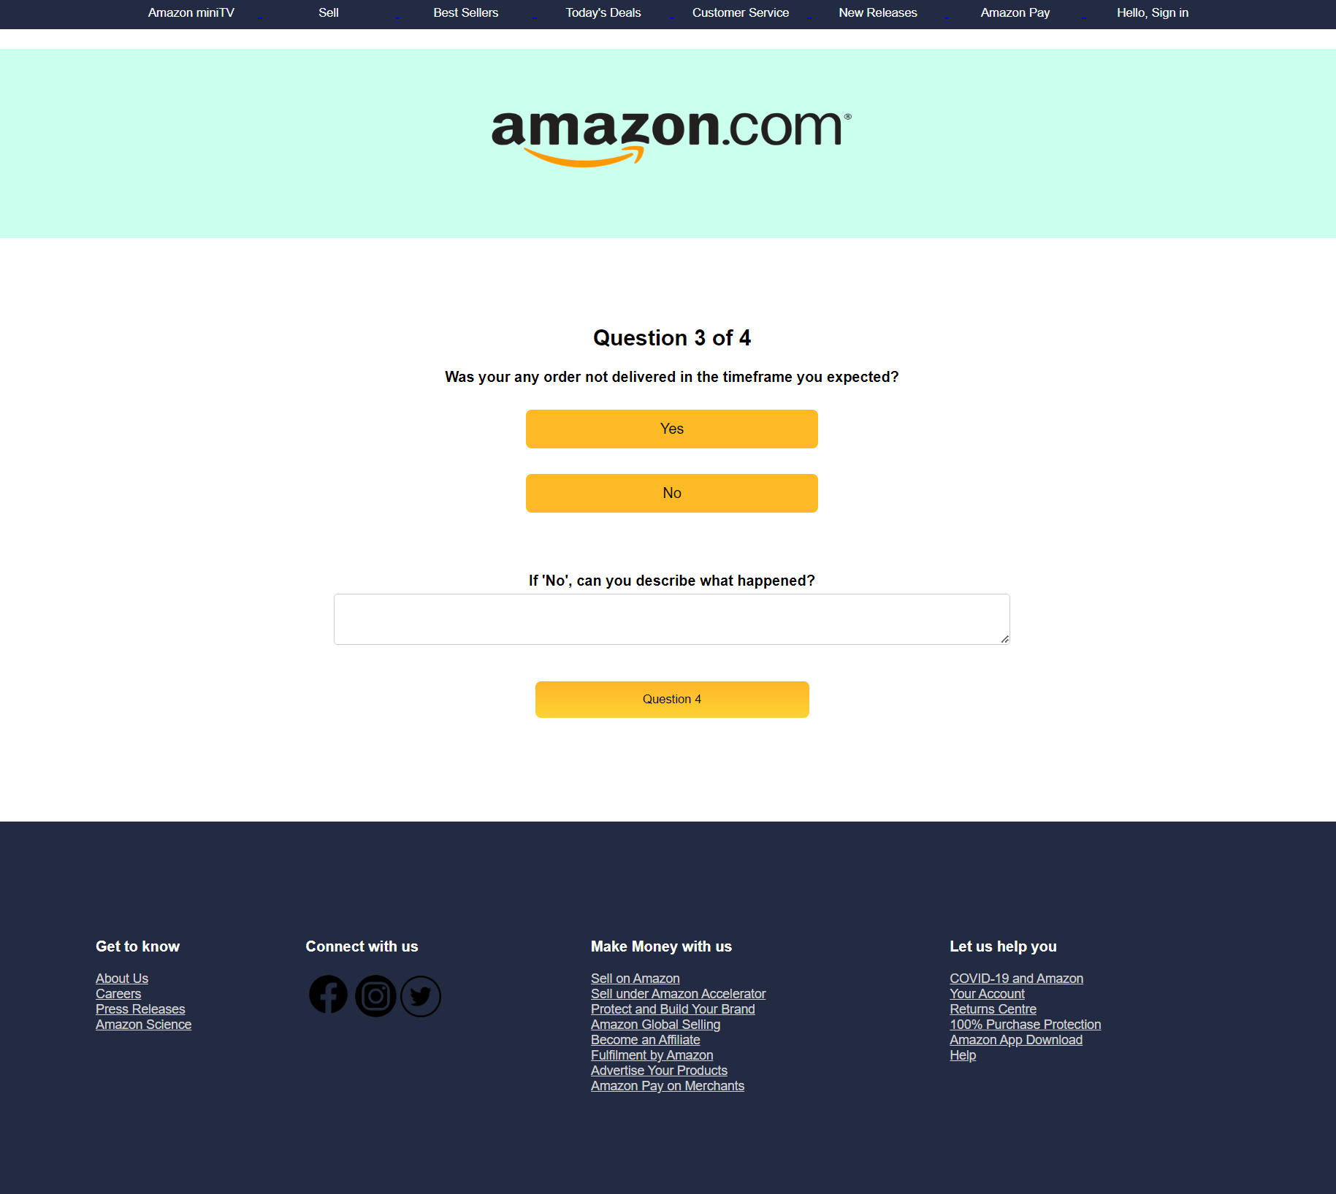

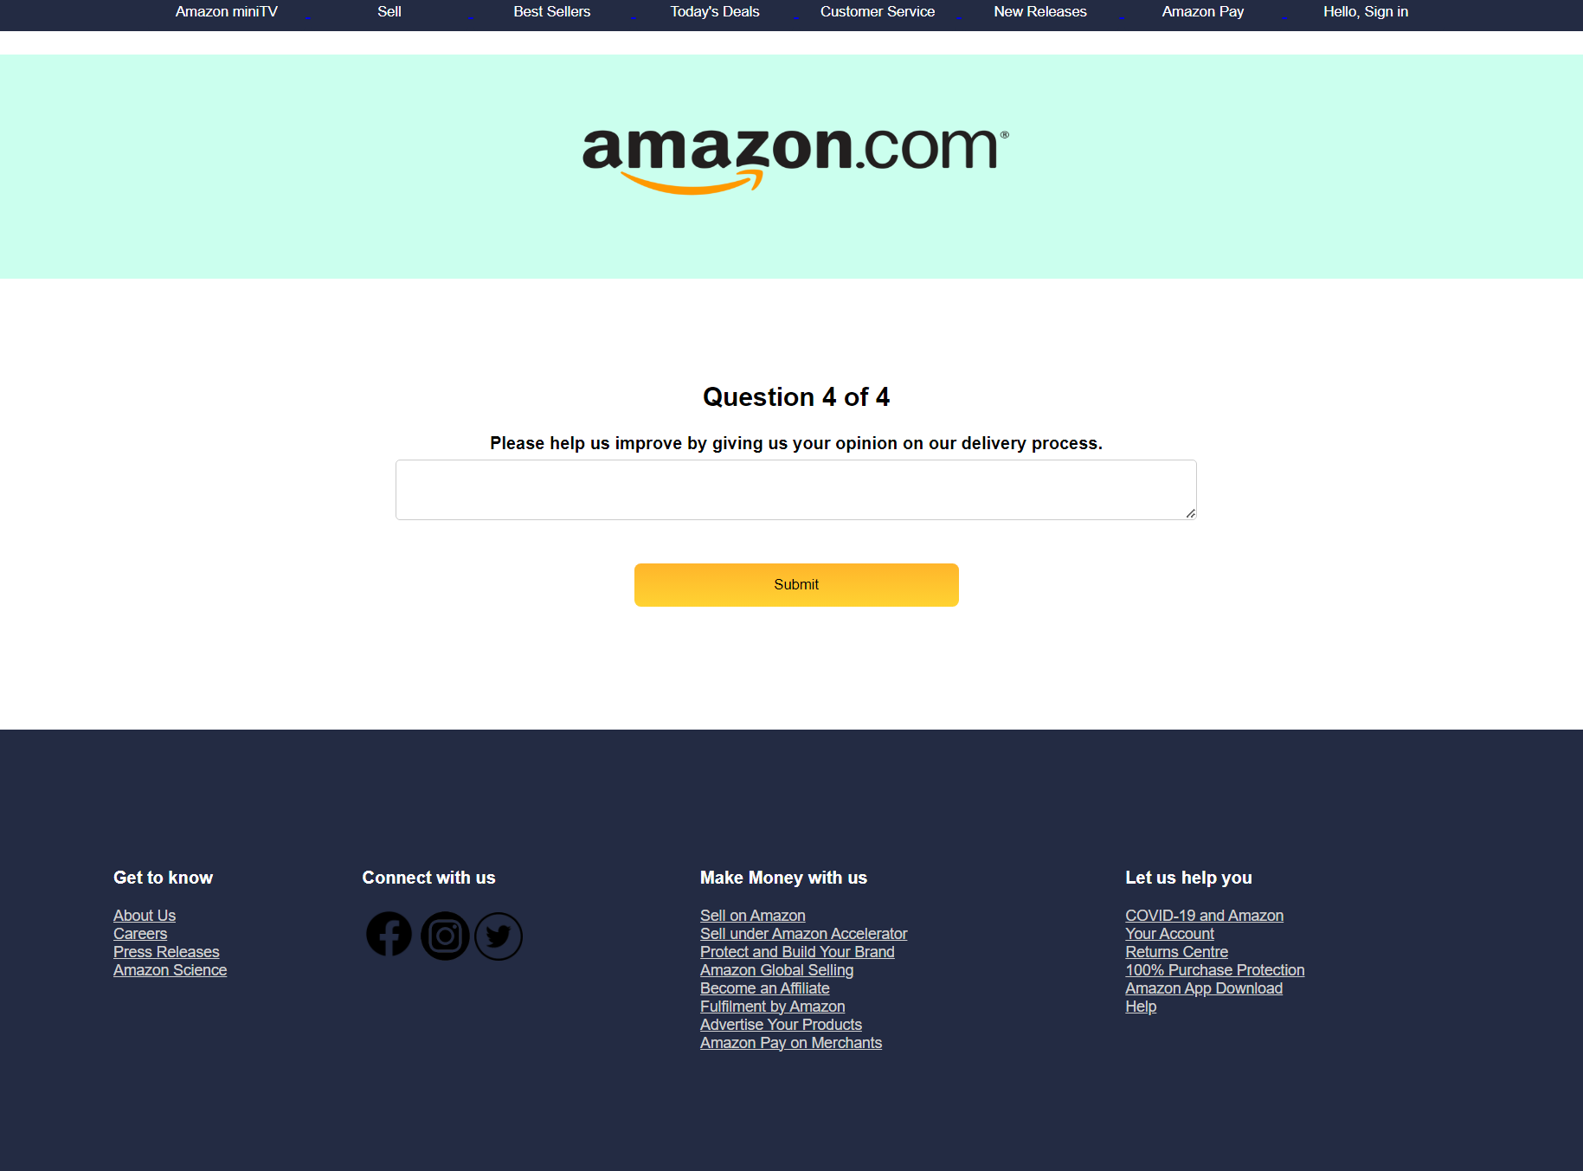

1. Screenshot of Feedback page for the Survey Form

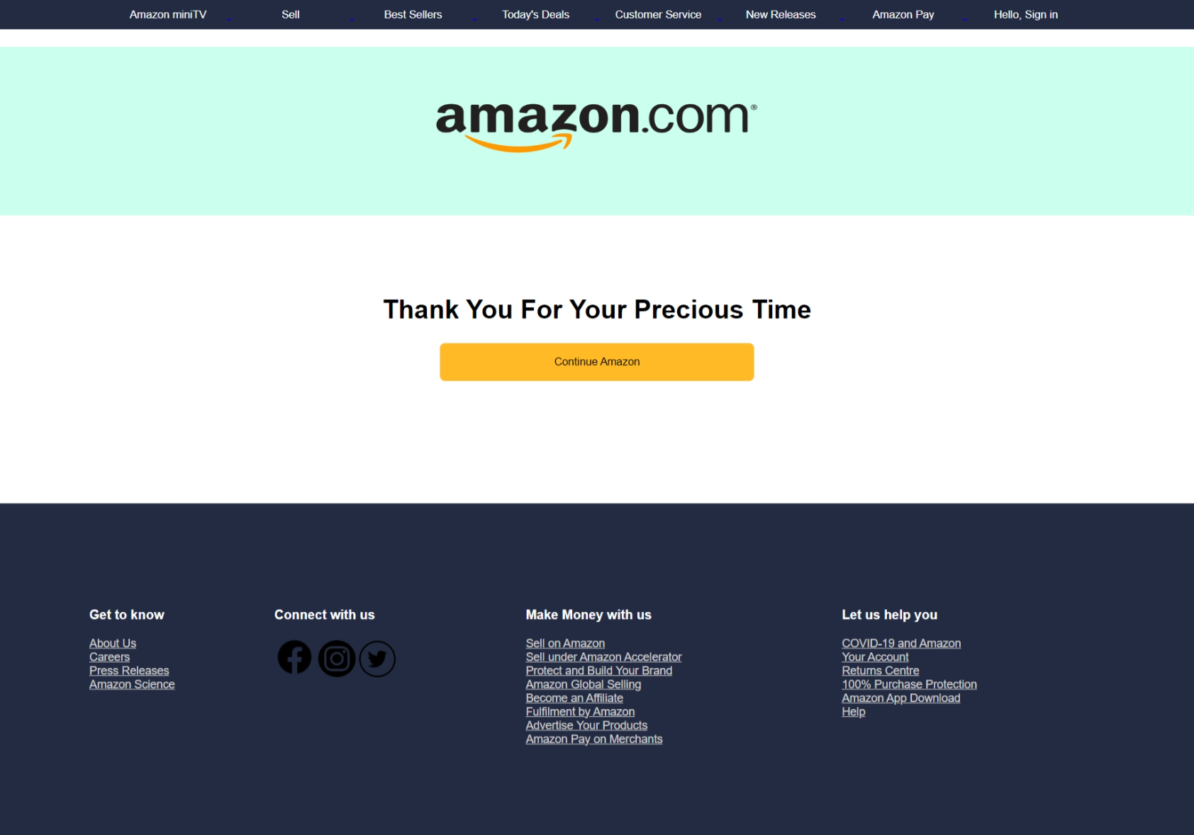

1. Code Link:

https://github.com/RitvikSachdeva733/FEE-Evaluation2.git

###### Bonus Features

1. The best feature of this form was found on asking the latest AI feature on internet these days, ChatGPT. It claims that the website our team made is a survey form that mimics the professional design of Amazon's website.

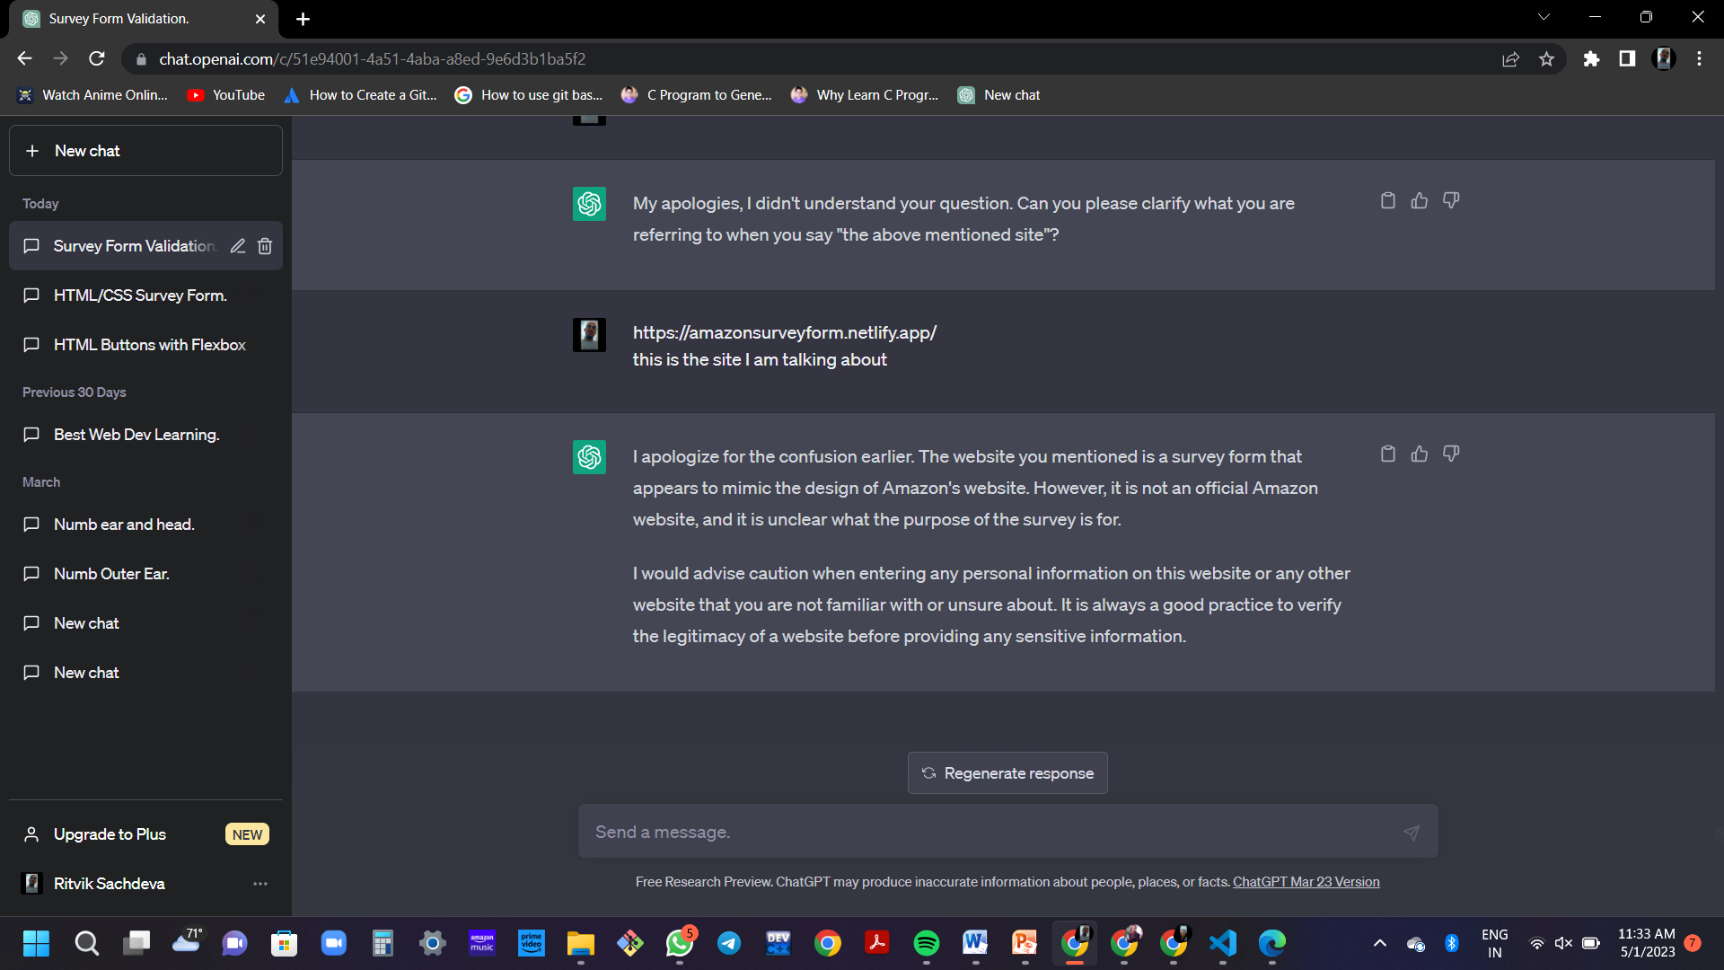

1. One good feature of the website survey form is that it includes a required field validation for all the form inputs. This helps ensure that the data collected is complete and accurate.
2. Additionally, the website design is simple and has a user-friendly interface, making it easy for the users to fill out the survey form.
3. The inclusion of the Amazon logo and branding also adds to the overall professional appearance of the website.
4. The website is optimized for mobile devices, which is an important feature, since a large number of users access the internet via mobile devices.

**Conclusion**

In conclusion, creating a survey form using HTML, CSS and JavaScript provides a wide range of key features that can help ensure the form is visually appealing, easy to use, and accessible to as many users as possible. By using HTML's form elements, CSS's layout and design capabilities, JavaScript, following best practices for validation, accessibility, feedback, usability, and compatibility, we have created a high-quality survey form that meets the needs of both the survey creator and respondents. Additionally, HTML, CSS and JavaScript are easy-to-learn and widely-used technologies that allowed us to create this survey form quickly and efficiently.

**Reference links**

* <https://www.w3schools.com/css/default.asp>

**Survey Form Project Link**

* <https://amazonservicessurveyform.netlify.app/>