**IP Bi-Weekly Progress**

**Week 1 and 2**

* Literature review of PPN related research papers
* Read ppn related research papers

**Week 3 and 4**

* Understood the previous codebase of Harman and Shriya of ppn network
* Replicated the results shared by Harman and Shriya

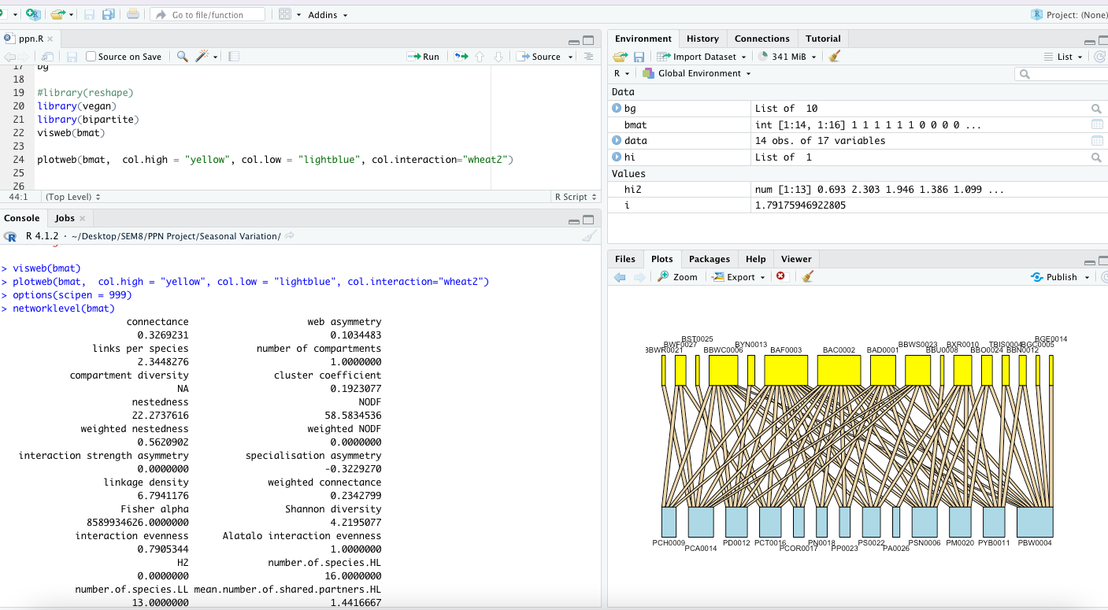

**Week 5 and 6**

* Identified butterflies and flowers from the given image dataset
* Wrote a python script for analysis of 2021 data

**Week 7**

* Midsem

**Week 8 and 9**

* Studied the bipartite library in R
* Found out more results in Python and R
* Tried to find out initial significances and conclusions from the results we had extracted for poster creation that was due next week in RIISE

**Week 10 and 11**

* Compiled all results, observations, significances, conclusions etc. into a poster to present in RIISE
* Performed network simulations in Python and R
* Studied papers related to network resilience

**Week 12 and 13**

* Found more properties
* Calculated above results for 2019 data
* Did comparative analysis between the properties of 2019 and 2021 data
* Found significances for all the calculated results

**Week 14**

* Created the final research paper draft

**Information about the files/links submitted:**

* bipartite.pdf : Documentation of the main R library used for network analysis.
* IP_Reasearch_paper.pdf : The research paper draft submission
* PPN_Results: File containing all the results and figures found by us
* RIISE_poster.pdf : The poster submitted in RIISE.
* The Codefiles folder contains 3 files that use 2019 and 2021 data.
* ppn. R : Network analysis and simulations done in R, mainly using bipartite library
* ppn_modules.R : Modularity analysis and simulations done in R
* PPN.ipynb: Network analysis and simulations done in Python, these are different from what was done in R