Independent Project

# *Investigating Plant-Pollinator Network In a Tropical Urban Ecosystem*

### Bhavik Agarwal (2018385)

### Ritvik Gupta (2018407)

**ABSTRACT**

Plant Pollinator Interactions are mutualistic in nature. Insect pollinators depend on nectar and pollen from plants for food while plants rely on the pollinators for reproduction via pollination. A plant-pollinator network (PPN) is a bipartite nested network composing many such plant-pollinator interactions. The interactions only exist between two distinct, non-overlapping sets i.e. the plants and the animals. For this study, we used the plant-bee network found in IIIT Delhi for the year 2019 and 2021 data separately. Our goal was to explore the consequences of random and targeted attacks (removal of hubs) on the network. We further analyzed the network by studying the change in network properties such as degree density, assortativity, nestedness, modularity etc. from the original network structure by removing plant nodes. We also performed simulations by adding and removing plant nodes from the network and analyzed the resulting network properties. Finally we studied the robustness and resilience of the PPN and found out which of the nodes affect it the most using simulations. All the analysis was done on 2019 and 2021 data and comparisons are drawn. We find that a small set of plant species are responsible for maintaining a large fraction of total bee species in the network. Our study will help in understanding the stability and resilience of this plant-pollinator network.

**INTRODUCTION**

Insect pollinators play a vital role in the sustainability of ecosystems by pollinating and regenerating flowering plants. However, insect pollinators are declining rapidly due to human-induced factors such as the use of pesticides and changes in land use. Our research investigates the interactions between plants and bees using a network analysis approach. Our findings can be used to design strategies for the conservation of the pollinator species and the plants they pollinate. Although a lot of studies have been done on analyzing plant-pollinator networks, very few studies have considered PPNs in urban tropical ecosystems, like (Stewart AB, Waitayachart P, 2020).

Underlying the functioning of biological systems is a complex network of interactions and exchange of energy, materials and information. Thus, analysis of the network structure of ecological systems has emerged as a fundamental approach to gain better insights into community function, and as a simple way of dealing with complex, many-species systems.

We have seen that network theory is applied to analyze complex ecological interactions mainly food webs (Martinez 1992; Williams and Martinez 2000; Montoya and Sole´ 2003; Pascual and Dunne 2006) and they can be used as a tool to determine the structure and function as required in the specific network. Many researchers lately have also started to study the plant pollinated networks using network theory (Jordano 1987; Memmott 1999; Bascompte et al. 2003; Jordano et al. 2003; Bascompte and Jordano 2007).

Basically these plant pollinated networks comprises two sets of nodes i.e. one of plants and one of animals. It is a type of a bipartite graph which means these sets of nodes have connections among each other's set but not in their set itself. We can say that there is a connection between a bee and a plant if the bee sits on a particular plant as the bee depends on the plant for food and also the plant depends on the nectar from the bee for reproduction via pollination. So many such types of connections are formed in these networks.

We found various properties like assortativity, nestedness, robustness, modularity etc. Different sets of methods were used to analyze these sets of properties like removing nodes one by one, adding nodes one by one, removing modules, identifying specialist and generalist species etc. Also comparative analysis was done on two different datasets i.e. 2019-20 and 2020-21. The results were expected to differ a bit as the 2019 network was more denser than 2020.

Previously some researchers have tried to find out similar findings using different approaches.

These networks are considered to have a structure more nested than expected by chance alone (Bascompte et al., 2003). It has been found that there has been an over-representation of shared mutualistic interactions between specialist (species with few interactions) and generalist (species with many interactions) when one tried to compare the observed networks against random networks where the interactions were shuffled randomly or arbitrarily mixed. Traditionally, this nested structure refers to the network topology (i.e., presence or absence of interactions). While quantitative measures of nestedness have been proposed (Almeida-Neto and Ulrich, 2011; Staniczenko et al., 2013), their application to observed networks is still limited for two main reasons: theoretically it has been shown that the topology and the interaction strength of mutualistic networks play a separate role in shaping species persistence (Saavedra et al., 2013; Rohr et al., 2014), and the frequency of interactions is not enough to parameterize interaction strengths (Schupp et al., 2017). These results have generated a rich research agenda on understanding the factors modulating the nested structure (topology) of mutualistic networks in general (Bascompte and Jordano, 2013).

We have also observed that when it comes to network stability it is not always the case that every species contributes the same amount to maintain community stability but only the species with particular topological attributes such as high connectivity are particularly very important in this case. For example, we have seen that when species with many connections to other species are lost then communities are heavily impacted compared to when species with few connections are lost.The loss of species with many connections to other species often impacts communities more strongly than the loss of species with few connections 3,4,5.

Similarly, losing species that contribute more to nestedness in mutualistic networks leads to stronger impacts on community integrity6, while losing peripheral species (those with few connections within and between modules) in modular networks exerts only weak effects at the community level6. Very few developments have been towards understanding the importance of inherent biological attributes related to functional traits such as the span of life, body size, form of life,invasiveness or phenology 7,8,9. Arguably, to make progress in our understanding of the functioning of ecological networks we need an integrated evaluation of both purely topological attributes, which depend strongly on local community structure, and species’ biological attributes.

We have also seen researchers studying the cascading effect which is when the extinction of a species leads to loss in interactions which can further lead to more species being lost. Models with ecological interaction networks constitute a useful tool to simulate coextinction cascades, with the ultimate goal of understanding community robustness to species loss and resilience 10,11,12,13. Topological coextinction models (TCMs) represented the first attempt to explore patterns of extinction in plant-pollinator networks 10.

We assume static network structure to be the main basis for these models but it has very important constraints. For instance, they assume that a species can only become extinct when all its interacting partners are lost; however, the primary loss of a pollinator species in real plant-pollinator networks may cause the coextinction of a plant, leading in turn to the coextinction of other pollinators that strongly depended on that plant, and even to the indirect coextinction of other plants which rely on those pollinators. TCMs ignore that species vary greatly in their degree of functional dependence on mutualistic partners. For instance, in plant-pollinator networks, the plant breeding system is a key determinant of its dependence on pollinators to produce seeds and may modulate plant vulnerability to pollinator loss14. This dependence varies from high in plants with obligated cross-pollination to low in plants with autonomous self-pollination16. When modeling species vulnerability to coextinction, consideration of such dependencies is very important.

In our work we have collected images of plants and bees from IIIT D Campus and then identified them. After identification we created our own adjacency matrix through which we created our graph after detecting the connections.

**MATERIALS AND METHODS**

We collected over 500 images of plant-bee interactions (30 plants and 26 bee species) to create a bipartite plant-bee network in a tropical urban ecosystem. This data was collected from IIIT Delhi campus(28.5459° N, 77.2732° E, 215 meters above the sea level).

The campus consists of a variety of plants and bee species due to a variety of conditions.

To find out which plants and bee pollinators are present in IIIT Delhi campus, regular monitoring was done and 2 image datasets were created in the year of 2019 and 2021 respectively. The images taken in the dataset consisted of a bee either sitting on a flower, or a bee attached to the stigma/anther of flowers.

By observing the connections in the image datasets, we created an adjacency matrix with plant species as rows and bee species as columns. We used a ‘1’ to indicate an interaction between the species and a ‘0’ to indicate no interaction.

**Network Analysis:**

We used Python modules - networkx and matplotlib to create a bipartite graph from the interactions in the adjacency matrix. We generated unique IDs for each plant and bee species and included a legend along with the graph mapping each of the IDs to the corresponding name of the plant/bee species name. For further analysis, we also used the Bipartite package in R.

Firstly, we performed targeted and random attacks on the plants in the PPN, as per given in Barabási et al, 2005 . The targeted attacks were performed based on descending order of degrees of the plant nodes.

Then we found out the following properties in the PPN:

Degree distribution: describes the frequency with which species with different numbers of links occur in any given network (Newman 2005).

Clustering Coefficient: measure of the degree to which nodes in a graph tend to cluster together.

Degree Density: the portion of the potential connections in a network that are actual connections.

Assortativity: If high degree nodes tend to attach to low degree nodes, the network is assortative else it is disassortative. In general biological networks tend to be disassortative.

Connectance: This value is a measurement used to determine the level of connectivity. It is the realized proportion of possible links (Dunne et al. 2002) i.e. sum of links divided by number of cells in the matrix.

Robustness: An index to represent what fraction of species we need to remove to eliminate half of all species in the web (via secondary/cascading extinctions). Higher value indicates greater ability to withstand changes or adverse conditions and maintain the network properties.

Modularity: indicates the presence of dense clusters of related nodes embedded within the network. In many systems, we can find a partition of nodes into specific communities or modules. Modularity occurs when certain groups of species within a network are much more highly connected to each other than they are with the rest of the network, with weak interactions connecting different modules.

Resilience: The network resilience is an information theoretic measure that describes the extent to which random node removal deteriorates network structure. We have used modified Shannon's entropy to calculate resilience.

Nestedness: It is calculated using the matrix temperature (T), a perfectly nested network(value 0) implies that the more specialist species interact with species that are proper subsets of those species interacting with the more generalist ones (Bascompte et al. 2003), while a perfectly non-nested network(value 100) is just the opposite.

Vulnerability: mean effective number of HL species per LL species

Next, we found out the different modules in the network, removed modules and checked for variation in network properties.

We also conducted simulations where we added plant nodes one after another into the network and observed the variation in the analyzed network properties.

**RESULTS**

**For 2021 Data:**

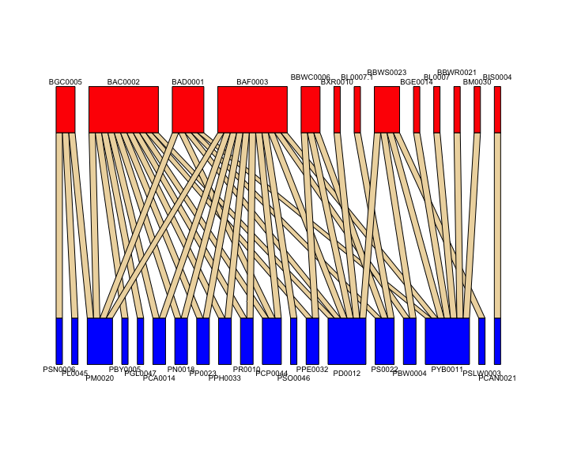

**Targeted and Random Attacks:**

After performing targeted attacks and random attacks on PPN, we find that the network disintegrates much faster in case of targeted attacks, while it disintegrates a lot slower in case of random attacks. It takes just 10% of targeted node deletion for the PPN to disintegrate completely, while it requires over 80% of random node deletions to disintegrate the whole network.

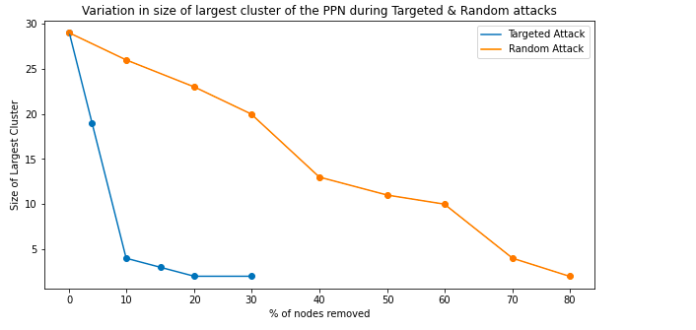

**All network properties:**

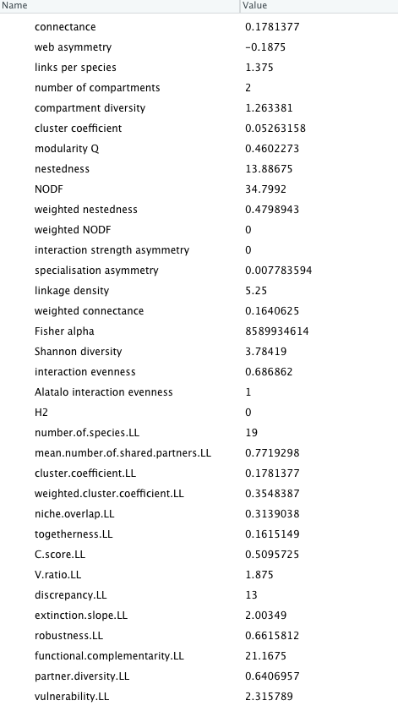

The assortativity coefficient of the network was found to be -0.47, which indicates that the network is disassortative. The nestedness was found to be 13.9 on a scale of 100. The connectance value is 0.17 . While robustness with respect to the plants is found to be 0.67. Vulnerability is found to be 3.4 .

**Removing every plant node and then checking the properties:**

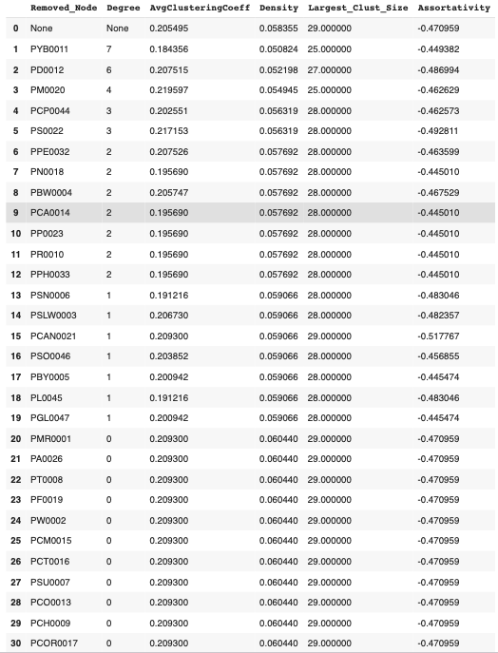

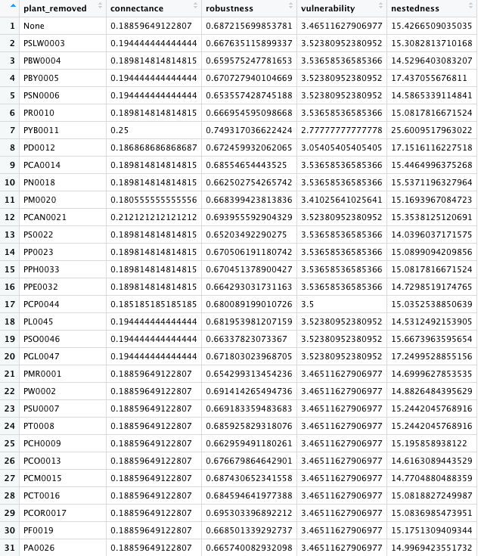

Firstly, we can see that PYB0011 is the node with the highest degree(i.e. 7). On removing this node, the degree density, largest cluster size and vulnerability becomes the minimum of all. While connectance robustness and nestedness become maximum when we remove this plant from the network as compared to removing any other node.

The highest change in assortativity is observed when node PCAN0021 is removed.

Also, removing PM0020(degree 1) reduces the largest cluster size to 25, the same as what was found after removing the hub node.

Overall PYB0011 is the node causing the most significant change in the properties of the network.

**Finding modules in the network:**

5 modules were found in the network as shown in the below figure.

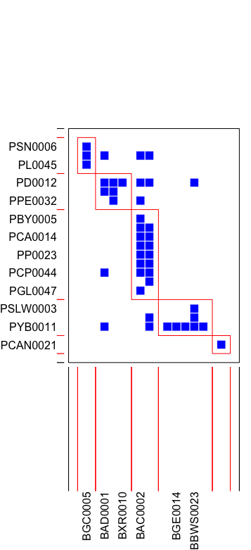

**Removing Modules one at a time:**

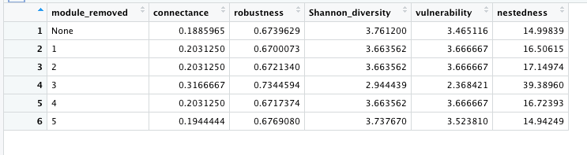

One removing modules one at a time we find that removal of module 3 causes the most significant change in properties, all the other modules don’t change the overall network properties as such.

**Adding nodes one at a time based on degree:**

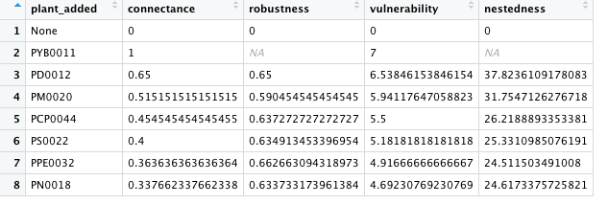

On adding ones one at a time by descending order of degree, it can be observed from the above table that on adding the first few nodes, the properties(other than robustness) calculated have high values which keep on decreasing with each new added node and then become almost stagnant when they’re close to the actual network value.

**Finding resilience of the network:**

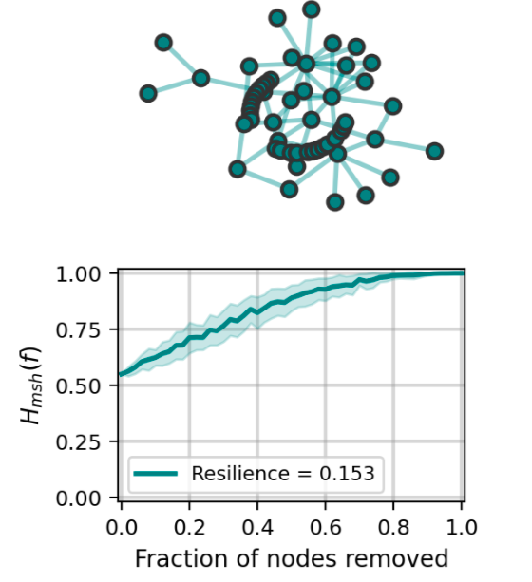

The resilience of this network is found to be 0.153, which is quite low.

**For 2019 Data:**

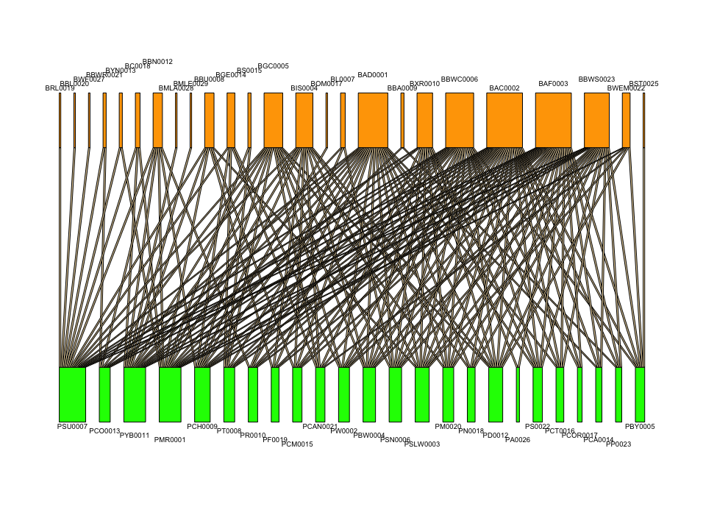

**Network Simulations:**

After performing targeted attacks and random attacks on PPN, we find that the network disintegrates faster in case of targeted attacks as compared to random attacks, but in this network the integrates at a lesser rate as compared to the 2021 PPN network. It takes 30% of targeted node deletion for the PPN to disintegrate completely, while it requires over 80% of random node deletions to disintegrate the whole network.

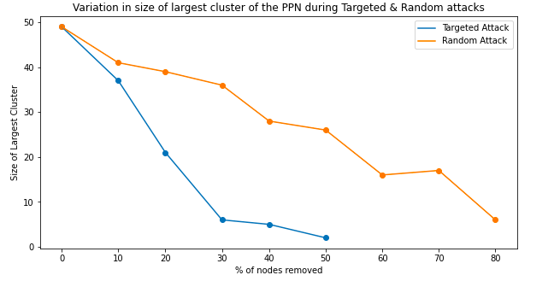

All network properties:

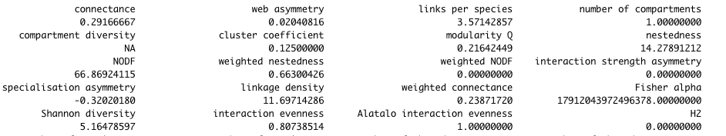

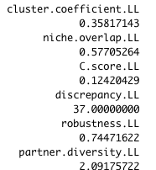 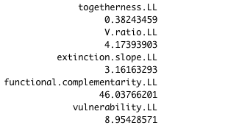

The assortativity coefficient of the network was found to be -0.43, which indicates that the network is disassortative. The nestedness was found to be 15.5 on a scale of 100. The connectance value is 0.29 . While robustness with respect to the plants is found to be 0.74. Vulnerability is found to be 8.9 . Largest cluster size is 49.

As compared to the 2021 network, it can be observed that all of the calculated network properties show a greater value in the 2019 network.

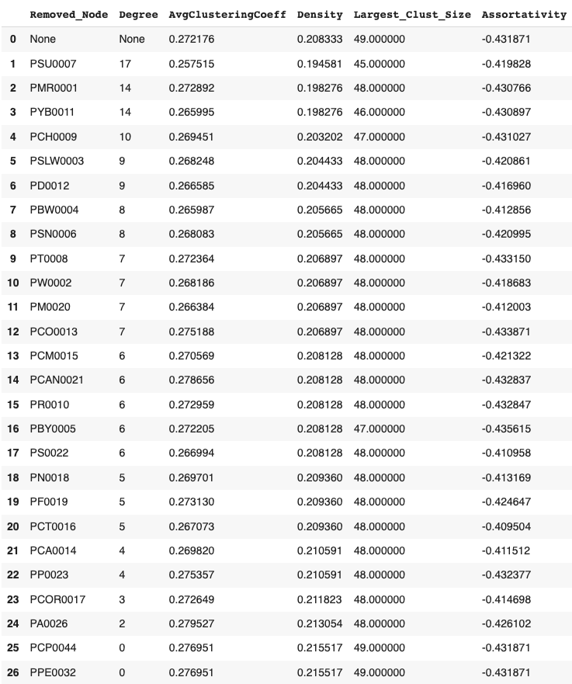

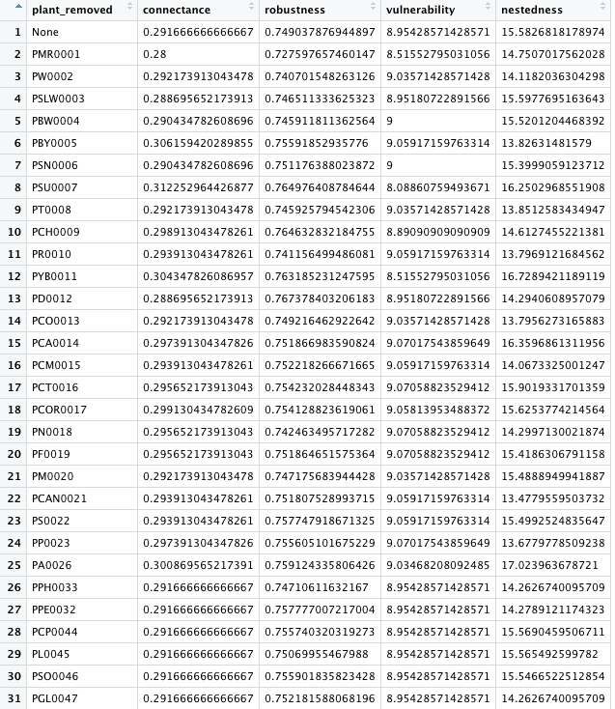

On removing nodes one at a time, we find that no node is able to make a significant difference in any network property, even on removing the hub nodes like PSU0007 and PMR0001 no significant change was observed. This indicates that the network is not dependent on a higher degree plant node to maintain its properties.

**Modularity of the network:**

6 modules were found in the network.

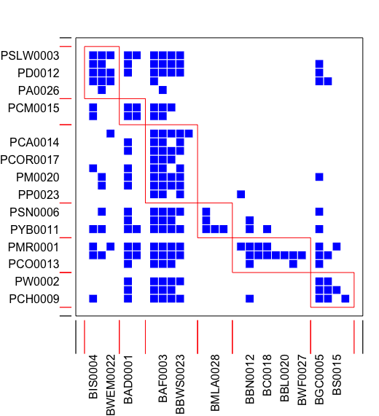

Modules removed one at a time:

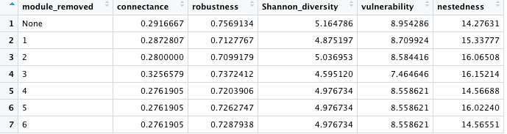

As observed during the node removal, removing modules one at a time does not change overall network properties much, the only noticeable difference was that when module 3 was removed, the vulnerability of the network fell from 8.95 to 7.46 .

Adding plant nodes one at a time:

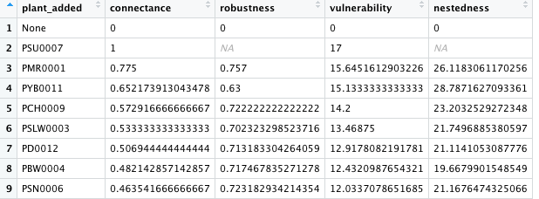

On adding plants one by one, the network properties still remain close to the actual value so there’s no significant change observed.

**Resilience of the network:**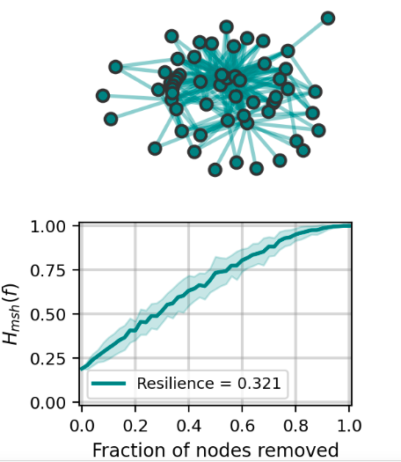

The network resilience is 0.321, which is a fairly high value.

**DISCUSSION**

In the case of 2021 data ,we can say that the PPN is highly vulnerable to targeted attacks, while it’s quite robust to random attacks as the network disintegrated on removing 10% nodes. The network won’t disintegrate easily unless we deliberately start removing the hub plants and bees.

Whereas in the case of 2019 data,we can say that the PPN is less vulnerable to targeted attacks when compared to 2021 data, as the network disintegrated on removing 30% nodes.

We also found 2019 data has more connectivity when compared to 2021 data so we can say that 2019 network is more densely connected. Vulnerability was found to be significantly higher in 2021 data as compared to 2019 data so we can conclude that there is a larger number of bee species per plant species in the 2019 network.

Rest of the discussion follows for both the years network as common.

The negative assortative coefficient explains that a new bee species when introduced in a network, would prefer interacting with a plant with lesser degree, rather than a plant already interacting with a large variety of bee types. This helps maintain the natural balance of the ecosystem. We can also say that nodes with the highest degree need not necessarily affect the network level properties the most. We plan to expand the network to include more species of plants and pollinators to create a more complex mutualistic network.

As our network is disassortative, if a high degree plant dies, it would most likely be connected to a low degree bees, and that bee will find it difficult to survive in the network as there will be no plant left.

The properties of assortativity are useful in the field of epidemiology, since they can help understand the spread of disease or cures. For instance, the removal of a portion of a network's vertices may correspond to curing, vaccinating, or quarantining individuals or cells. Since social networks demonstrate assortative mixing, diseases targeting high degree individuals are likely to spread to other high degree nodes. Alternatively, within the cellular network—which, as a biological network is likely disassortative—vaccination strategies that specifically target the high degree vertices may quickly destroy the epidemic network.

We have seen that if nestedness is high, even if specialist group of bees die, then also our plant pollinated by those bees could survive as it is being pollinated by generalist species.On the other hand, If it is low, if specialist group of bees die then chances of such plant to survive are very less due to it not being pollinated by generalists.

We can see in our table after removing or without removing the plant nodes,modules or adding nodes the nestedness is in the low range so we can say that in our network if certain specialist bees die then the plant pollinated by them has very less survival chances as it won't be pollinated by generalists.

Some other observations we see are If any plant is removed and if it shows high cascading effect, then the value to the extinct half network would be less so robustness would be low(0.1-0.2). But if it doesn’t show a cascading effect, then the power to extinct half of the nodes would be high, so robustness would be high. In general we have seen in our original network and also after removing plant nodes,modules and adding nodes the robustness is moderately high so we can say our network even without removing or adding anything doesn't show any cascading effects that easily. Robustness is the tolerance of a network to the removal of a species (Memmott et al., [2004](https://onlinelibrary.wiley.com/doi/full/10.1002/ece3.8055#ece38055-bib-0515)) and is a useful metric for network stability. A number of network metrics are associated with robustness. For example, modules in a network—groups of species that interact more with one another—can be the result of habitat heterogeneity, co-evolution or phylogenetic relatedness of the species, or species traits like phenology (Lewinsohn et al., [2006](https://onlinelibrary.wiley.com/doi/full/10.1002/ece3.8055#ece38055-bib-0026); Morente-López et al., [2018](https://onlinelibrary.wiley.com/doi/full/10.1002/ece3.8055#ece38055-bib-0033); Pimm & Lawton, [1980](https://onlinelibrary.wiley.com/doi/full/10.1002/ece3.8055#ece38055-bib-0036); Thompson, [2005](https://onlinelibrary.wiley.com/doi/full/10.1002/ece3.8055#ece38055-bib-0047)), and modularity is associated with the stability of networks (Thébault & Fontaine, [2010](https://onlinelibrary.wiley.com/doi/full/10.1002/ece3.8055#ece38055-bib-0046), Stouffer & Bascompte, [2011](https://onlinelibrary.wiley.com/doi/full/10.1002/ece3.8055#ece38055-bib-0522)). In seed dispersal networks for example, plant and animal trait values—body mass and seed mass—were associated with the modularity of individual species (Donatti et al., [2011](https://onlinelibrary.wiley.com/doi/full/10.1002/ece3.8055#ece38055-bib-0011), where species modularity describes whether species are peripheral or highly connected both within or among modules).

On comparing 2019 and 2021 data we found out that 2019 was a more densely connected network. Most of the network properties like degree density, nestedness, robustness, resilience etc. were found to be higher in the 2019 network. We also came to a conclusion that when nodes in the form of hub, modules etc. were removed in 2019 data not much change in properties was seen so we can say it is a stable network as compared to 2021 data in which the properties were getting affected on removing nodes again in the form of hubs,modules etc.

Through this study we were able to show the basic nature of plant-pollinator networks in urban tropical ecosystem. The analysis done in this study can be compared to analysis done in other studies(for different regions across the world) and further insights can be drawn which can help in developing a better understanding for ecological conservation and sustainability.

**REFERENCES**

[1] Albert, R., Jeong, H. & Barabasi, A.-L. Error and attack tolerance of complex networks. Nature 406, 378–382 (2000)

[2] R. Heleno, M. Devoto, and M. Pocock, “Connectance of species interaction networks and conservation value: Is it any good to be well connected?,” Ecological Indicators, vol. 14, pp. 7–10, Mar. 2012, doi: 10.1016/j.ecolind.2011.06.032.

[3] Sole, R. V. & Montoya, M. Complexity and fragility in ecological networks. Proc R Soc Lond, B, Biol Sci 268, 2039–2045 (2001).

[4] Dunne, J. A., Williams, R. J. & Martinez, N. D. Network structure and biodiversity loss in food webs: robustness increases with connectance. Ecol Lett 5, 558–567 (2002).

[5] Memmott, J., Waser, N. M. & Price, M. V. Tolerance of pollination networks to species extinctions. Proc R Soc Lond, B, Biol Sci 271, 2605–2611 (2004).

[6] Saavedra, S., Stouffer, D. B., Uzzi, B. & Bascompte, J. Strong contributors to network persistence are the most vulnerable to extinction. Nature 478, 233 (2011).

[7] Brose, U., Williams, R. J. & Martinez, N. D. Allometric scaling enhances stability in complex food webs. Ecol Lett 9, 1228–1236 (2006).

[8] Ramos-Jiliberto, R. et al. A network analysis of plant–pollinator interactions in temperate rain forests of chiloé island, chilé. Oecologia 160, 697 (2009).

[9] Valdovinos, F. S., Ramos-Jiliberto, R., Flores, J. D., Espinoza, C. & López, G. Structure and dynamics of pollination networks: the role of alien plants. Oikos 118, 1190–1200 (2009).

[10] Memmott, J., Waser, N. M. & Price, M. V. Tolerance of pollination networks to species extinctions. Proc. R. Soc. Lond. B Biol. Sci. 271, 2605–2611 (2004).  
[11] Pocock, M., Evans, D. M. & Memmott, J. The Robustness and Restoration of a Network of Ecological Networks. Science 335, 973–977 (2012). [12] Evans, D. M., Pocock, M. J. O. & Memmott, J. The robustness of a network of ecological networks to habitat loss. Ecol. Lett. 16, 844–852 (2013). [13] Gao, J., Barzel, B. & Barabási, A. L. Universal resilience patterns in complex networks. Nature 530, 307–312 (2016). [14] Astegiano, J., Massol, F., Morais Vidal, M., Cheptou, P. & Guimarães, P. R. J. The robustness of plant-pollinator assemblages: linking plant interaction patterns and sensitivity to pollinator loss. PloS one 10, e0117243 (2015). [15] Bond, W. J. Do mutualisms matter? Assessing the impact of pollinator and disperser disruption on plant extinction. Philos. Trans. R. Soc. B Biol. Sci. 344, 83–90 (1994). [16] Vázquez, D. P., Morris, W. F. & Jordano, P. Interaction frequency as a surrogate for the total effect of animal mutualists on plants. Ecol. Lett. 8, 1088–1094 (2005).

[17] Stewart AB, Waitayachart P (2020) Year-round temporal stability of a tropical, urban plant-pollinator network. PLoS ONE 15(4): e0230490. https://doi.org/10.1371/journal.pone.0230490