**Original Graph Properties**:

Here the Diameter and cluster size property is of the largest cluster in graph.

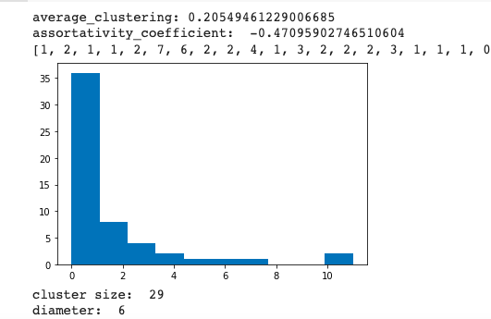

**After removing 5% nodes:**

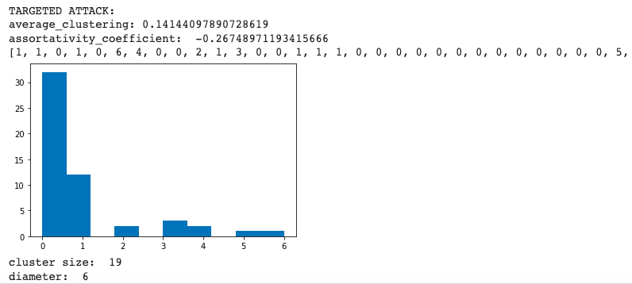

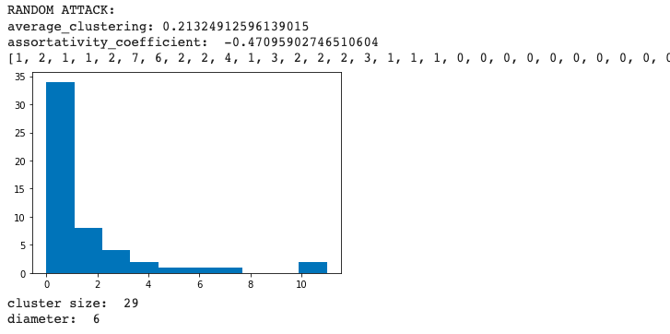

**After removing 10% nodes:**

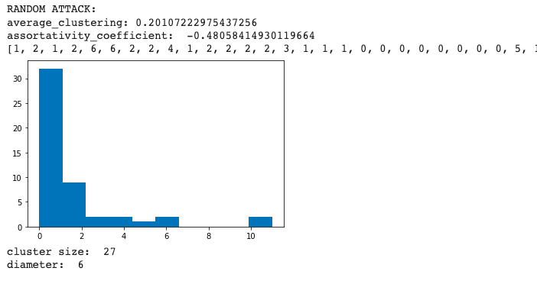

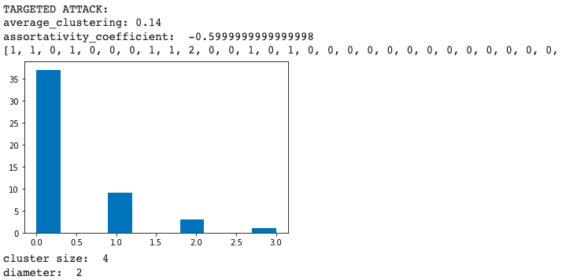

**After removing 20% nodes:**

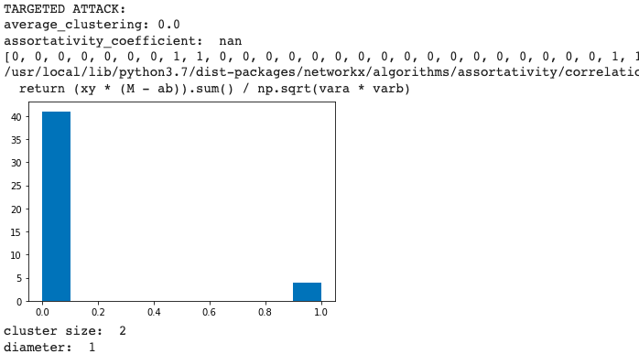

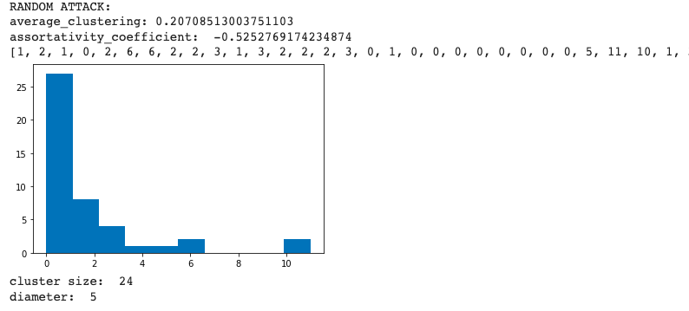

**Observation:**

After performing targeted attacks and random attacks, on 5% of the nodes of the network , on 10% of nodes and 20% of the nodes respectively, we find that the network disintegrates much faster in case of targeted attacks, and does not integrate in case of random attacks . The network most disintegrates on 5% targeted deletion, and completely disintegrates on just 10% node deletion, on the contrary random deletion requires over 80% node deletion to disintegrate.

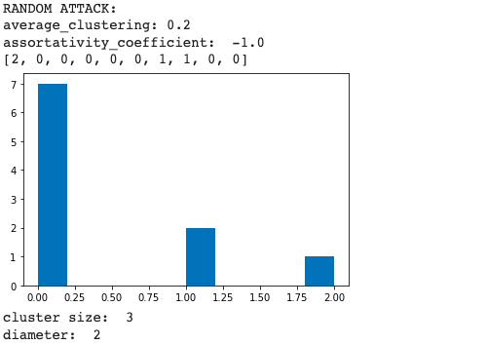

**What can we do ahead?**

We can remove only plant major hubs or bees major hubs separately and observe change in properties. We can try to increase the size of the graph with more connections and nodes as the change in properties would be more evident then.

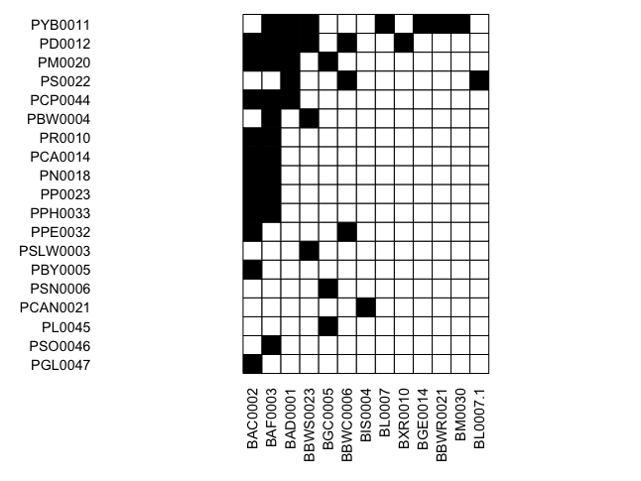

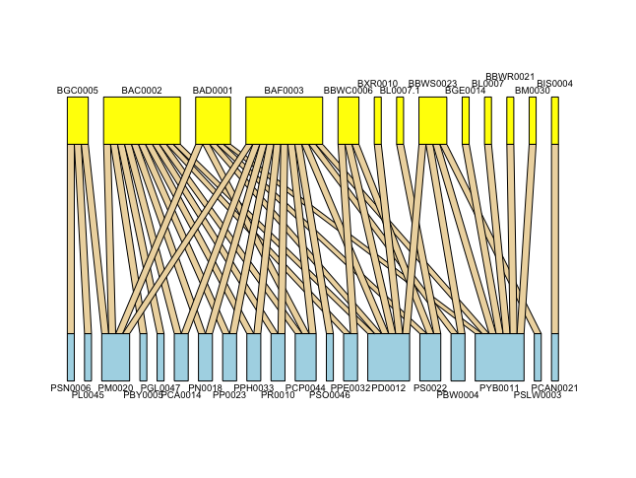

Results:

1. After performing targeted attacks and random attacks on PPN, we find that the network disintegrates much faster in case of targeted attacks, while it disintegrates a lot slower in case of random attacks. It takes just 5% of targeted node deletion for the PPN to disintegrate completely, while it requires over 80% of random node deletions to disintegrate the whole network.
2. We found the assortativity coefficient of the network to be -0.47, which indicated that the network is disassortative in nature, a property that’s observed in many of the other biological networks.
3. When we observed network properties by taking out every plant node one at a time, we find :

* The average clustering coefficient and degree density reduces the most when PYB0011 is removed, which as expected is also the plant node with highest degree.
* But many of the properties don’t follow trends where removing the highest degree node makes the highest impact. For instance, the size of the largest cluster is the least when we removed PM0020. Similarly the coefficient of assortativity increases the most when PPH0033 is removed, while it reduces the most when PS0022 is removed. These nodes are not the nodes with the highest degree yet they’re making more impact on the network properties than the hub node.

Significance:

1. We can say that the PPN is highly vulnerable to targeted extinctions, while it’s quite robust to random extinctions. The network won’t disintegrate easily unless we deliberately start removing the hub plants and bees.
2. The negative assortative coefficient explains that a new bee species when introduced in a network, would prefer interacting with a plant with lesser degree, rather than a plant already interacting with a large variety of bee types. This helps maintain the natural balance of the ecosystem.
3. We can also say that nodes with the highest degree need not necessarily affect the network level properties the most.

Clustering Coefficient: measure of the degree to which nodes in a graph tend to cluster together.

Degree Density: the portion of the potential connections in a network that are actual connections.

Assortativity: If high degree nodes tend to attach to low degree nodes, the network is assortative else it is disassortative.

Connectance: This value is a measurement used to determine the level of connectivity.

Robustness: The persistence of a certain characteristic.

or trait in the system under perturbations or conditions of uncertainty.

Higher value indicates greater ability to withstand changes or adverse conditions and maintain the network properties.

Shannon’s Entropy: The Shannon diversity index tells you how diverse the species in a given community are. It rises with the number of species and the evenness of their abundance.

The higher the index, the more diverse the species are in the habitat. If the index equals 0, only one species is present in the community.

Vulnerability: mean effective number of LL species per HL species,weighted by their marginal totals.

Network Properties:

[1] "connectance:"

> print(nw[["connectance"]])

[1] 0.1781377

> print(nw[["robustness.LL"]])

[1] 0.6535226

> print("extinction slope:")

[1] "extinction slope:"

> print(nw[["extinction.slope.LL"]])

[1] 1.947962

> print("Shannon diversity:")

[1] "Shannon diversity:"

> print(nw[["Shannon diversity"]])

[1] 3.78419

> print("vulnerability:")

[1] "vulnerability:"

> print(nw[["vulnerability.LL"]])

[1] 3.5

| PYB0011 | 0.22839506172839 connectance |
| --- | --- |

PYB001 0.737299487217752 Robustness

PYB001 2.97233354332835 Extinction slope

PYB001 2.837(lowest) Vulnerability

Extinction slope is proportional to Robustness.

PSU0007 lowest robustness

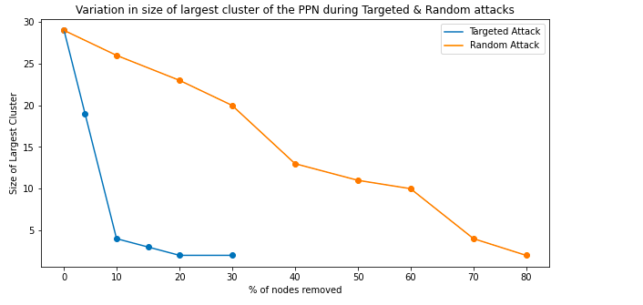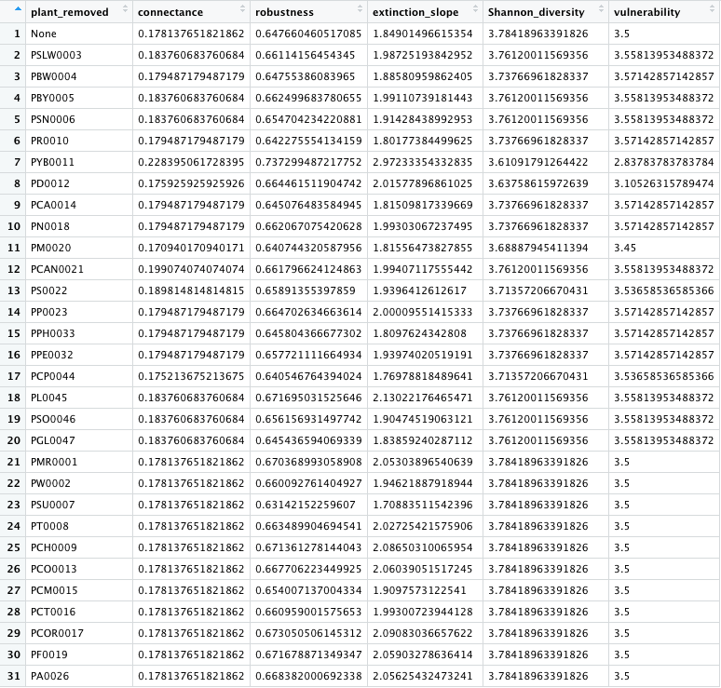

**Robustness**: How many species do you need to remove to eliminate half of all species in the web (via secondary extinctions).

**Modularity** indicates the presence of dense clusters of related nodes embedded within the network. In many systems, we can find a partition of nodes into specific communities or modules.

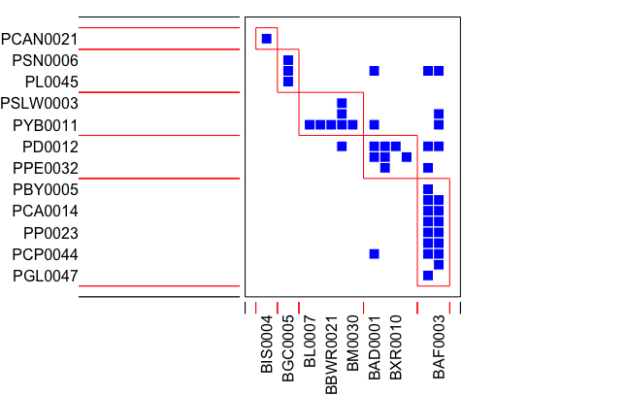

Modules in the network:

[[1]]

[[1]][[1]]

[[1]][[1]][[1]]

[1] "PSLW0003" "PBW0004" "PBY0005" "PSN0006" "PR0010" "PYB0011" "PD0012" "PCA0014"

[9] "PN0018" "PM0020" "PCAN0021" "PS0022" "PP0023" "PPH0033" "PPE0032" "PCP0044"

[17] "PL0045" "PSO0046" "PGL0047"

[[1]][[1]][[2]]

[1] "BAD0001" "BAC0002" "BAF0003" "BIS0004" "BGC0005" "BBWC0006" "BL0007" "BXR0010"

[9] "BGE0014" "BBWR0021" "BBWS0023" "BM0030" "BL0007.1"

[[2]]

[[2]][[1]]

[[2]][[1]][[1]]

[1] "PSN0006" "PM0020" "PL0045"

[[2]][[1]][[2]]

[1] "BGC0005"

[[2]][[2]]

[[2]][[2]][[1]]

[1] "PD0012" "PS0022" "PPE0032"

[[2]][[2]][[2]]

[1] "BAD0001" "BBWC0006" "BXR0010" "BL0007.1"

[[2]][[3]]

[[2]][[3]][[1]]

[1] "PCAN0021"

[[2]][[3]][[2]]

[1] "BIS0004"

[[2]][[4]]

[[2]][[4]][[1]]

[1] "PBY0005" "PR0010" "PCA0014" "PN0018" "PP0023" "PPH0033" "PCP0044" "PSO0046" "PGL0047"

[[2]][[4]][[2]]

[1] "BAC0002" "BAF0003"

[[2]][[5]]

[[2]][[5]][[1]]

[1] "PSLW0003" "PBW0004" "PYB0011"

[[2]][[5]][[2]]

[1] "BL0007" "BGE0014" "BBWR0021" "BBWS0023" "BM0030"

**Strength**: Strength is simply the number of interactions, a trivial measure of a species importance.

**Resilience**:

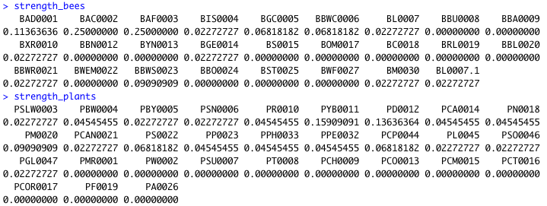

Plants with no interaction:

20 PCT0016

21 PCH0009

22 PT0008

23 PCOR0017

24 PSU0007

25 PMR0001

26 PA0026

27 PW0002

28 PCM0015

29 PF0019

30 PCO0013

Specialist Plant nodes in the network:

13 PSLW0003

14 PSN0006

15 PSO0046

16 PBY0005

17 PCAN0021

18 PGL0047

19 PL0045

Generalist plant species in the network:

1 PYB0011

2 PD0012

3 PM0020

4 PCP0044

5 PS0022

6 PBW0004

7 PP0023

8 PPE0032

9 PCA0014

10 PR0010

11 PN0018

12 PPH0033

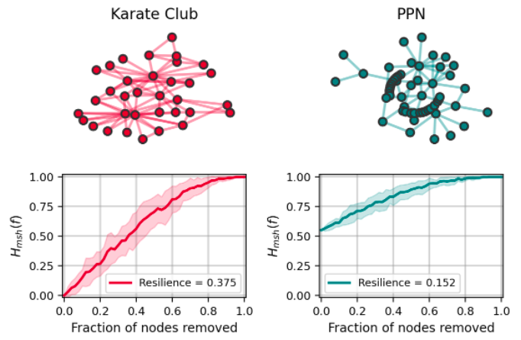

Further Work:

* Discard 0 degree plants, bees
* Create plant-plant unipartite network with number of bees being the links
* Remove modules and check properties
* Study the bee density changes
* Use 2019 data
* Add nodes

Doubts:

What does the number of species mean?

frame2webs input?

2019 analysis:

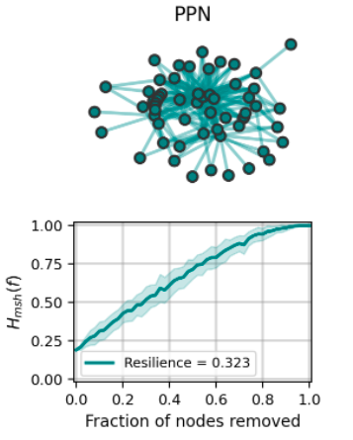

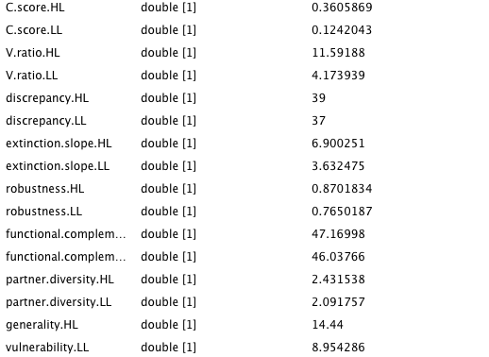

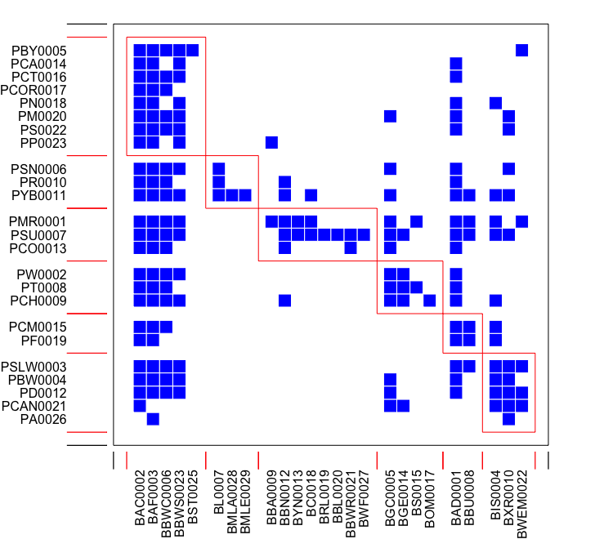

[[1]]

[[1]][[1]]

[[1]][[1]][[1]]

[1] "PMR0001" "PW0002" "PSLW0003" "PBW0004" "PBY0005" "PSN0006" "PSU0007"

[8] "PT0008" "PCH0009" "PR0010" "PYB0011" "PD0012" "PCO0013" "PCA0014"

[15] "PCM0015" "PCT0016" "PCOR0017" "PN0018" "PF0019" "PM0020" "PCAN0021"

[22] "PS0022" "PP0023" "PA0026"

[[1]][[1]][[2]]

[1] "BAD0001" "BAC0002" "BAF0003" "BIS0004" "BGC0005" "BBWC0006" "BL0007"

[8] "BMLA0028" "BMLE0029" "BBU0008" "BBA0009" "BXR0010" "BBN0012" "BYN0013"

[15] "BGE0014" "BS0015" "BOM0017" "BC0018" "BRL0019" "BBL0020" "BBWR0021"

[22] "BWEM0022" "BBWS0023" "BST0025" "BWF0027"

[[2]]

[[2]][[1]]

[[2]][[1]][[1]]

[1] "PBY0005" "PCA0014" "PCT0016" "PCOR0017" "PN0018" "PM0020" "PS0022"

[8] "PP0023"

[[2]][[1]][[2]]

[1] "BAC0002" "BAF0003" "BBWC0006" "BBWS0023" "BST0025"

[[2]][[2]]

[[2]][[2]][[1]]

[1] "PSN0006" "PR0010" "PYB0011"

[[2]][[2]][[2]]

[1] "BL0007" "BMLA0028" "BMLE0029"

[[2]][[3]]

[[2]][[3]][[1]]

[1] "PMR0001" "PSU0007" "PCO0013"

[[2]][[3]][[2]]

[1] "BBA0009" "BBN0012" "BYN0013" "BC0018" "BRL0019" "BBL0020" "BBWR0021"

[8] "BWF0027"

[[2]][[4]]

[[2]][[4]][[1]]

[1] "PW0002" "PT0008" "PCH0009"

[[2]][[4]][[2]]

[1] "BGC0005" "BGE0014" "BS0015" "BOM0017"

[[2]][[5]]

[[2]][[5]][[1]]

[1] "PCM0015" "PF0019"

[[2]][[5]][[2]]

[1] "BAD0001" "BBU0008"

[[2]][[6]]

[[2]][[6]][[1]]

[1] "PSLW0003" "PBW0004" "PD0012" "PCAN0021" "PA0026"

[[2]][[6]][[2]]

[1] "BIS0004" "BXR0010" "BWEM0022"

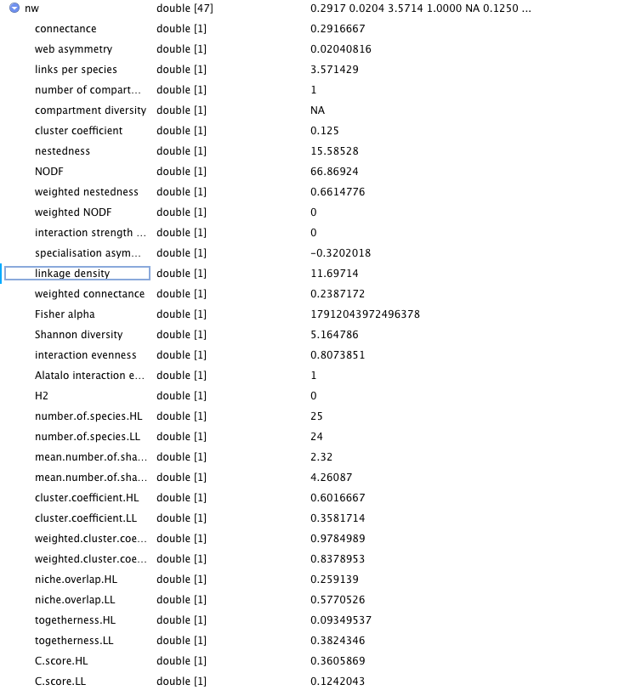

Assortativity:

As our network is disassortative, if high degree plant dies, it would most likely be connected to a low degree bees, and that bee will find it difficult to survive in the network as there will be no plant left.

The properties of assortativity are useful in the field of epidemiology, since they can help understand the spread of disease or cures. For instance, the removal of a portion of a network's vertices may correspond to curing, vaccinating, or quarantining individuals or cells. Since social networks demonstrate assortative mixing, diseases targeting high degree individuals are likely to spread to other high degree nodes. Alternatively, within the cellular network—which, as a biological network is likely disassortative—vaccination strategies that specifically target the high degree vertices may quickly destroy the epidemic network.

Nestedness:

If nestedness is high, even if specialist group of bees die, then also our plant could survive as it is being pollinated by generalist species.

If it is low, if specialist dies then chances

Robustness:

If any plant is removed and if it shows high cascading effect, then the value to the extinct half network would be less so robustness would be low(0.1-0.2). If it doesn’t show a cascading effect, then the power to extinct half of the nodes would be high, so robustness would be high.

Add Plant nodes one at a time based on degree:

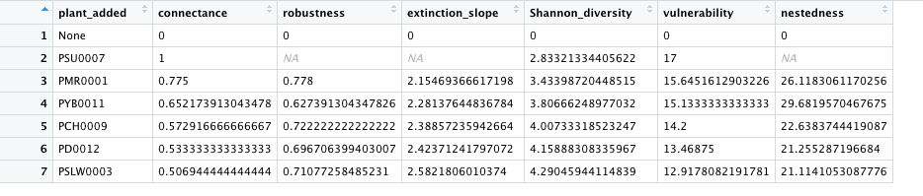

Removing the plant modules one at a time:

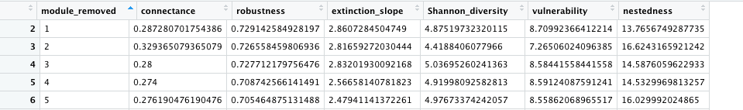

Modules of 2019 added in the paper:

[[1]]

[[1]][[1]]

[[1]][[1]][[1]]

[1] "PMR0001" "PW0002" "PSLW0003" "PBW0004" "PBY0005" "PSN0006" "PSU0007" "PT0008" "PCH0009" "PR0010" "PYB0011" "PD0012"

[13] "PCO0013" "PCA0014" "PCM0015" "PCT0016" "PCOR0017" "PN0018" "PF0019" "PM0020" "PCAN0021" "PS0022" "PP0023" "PA0026"

[[1]][[1]][[2]]

[1] "BAD0001" "BAC0002" "BAF0003" "BIS0004" "BGC0005" "BBWC0006" "BL0007" "BMLA0028" "BMLE0029" "BBU0008" "BBA0009" "BXR0010"

[13] "BBN0012" "BYN0013" "BGE0014" "BS0015" "BOM0017" "BC0018" "BRL0019" "BBL0020" "BBWR0021" "BWEM0022" "BBWS0023" "BST0025"

[25] "BWF0027"

[[2]]

[[2]][[1]]

[[2]][[1]][[1]]

[1] "PSLW0003" "PBW0004" "PD0012" "PCAN0021" "PA0026"

[[2]][[1]][[2]]

[1] "BIS0004" "BXR0010" "BWEM0022"

[[2]][[2]]

[[2]][[2]][[1]]

[1] "PCM0015" "PF0019"

[[2]][[2]][[2]]

[1] "BAD0001" "BBU0008"

[[2]][[3]]

[[2]][[3]][[1]]

[1] "PBY0005" "PCA0014" "PCT0016" "PCOR0017" "PN0018" "PM0020" "PS0022" "PP0023"

[[2]][[3]][[2]]

[1] "BAC0002" "BAF0003" "BBWC0006" "BBWS0023" "BST0025"

[[2]][[4]]

[[2]][[4]][[1]]

[1] "PSN0006" "PR0010" "PYB0011"

[[2]][[4]][[2]]

[1] "BL0007" "BMLA0028" "BMLE0029"

[[2]][[5]]

[[2]][[5]][[1]]

[1] "PMR0001" "PSU0007" "PCO0013"

[[2]][[5]][[2]]

[1] "BBA0009" "BBN0012" "BYN0013" "BC0018" "BRL0019" "BBL0020" "BBWR0021" "BWF0027"

[[2]][[6]]

[[2]][[6]][[1]]

[1] "PW0002" "PT0008" "PCH0009"

[[2]][[6]][[2]]

[1] "BGC0005" "BGE0014" "BS0015" "BOM0017"