**Evaluation - 2 :** Design a system for car stereo systems such that whenever the

increase button is pressed, a red background given by red LED

blinks the number of times the button is pressed.

**Circuit Diagram :**

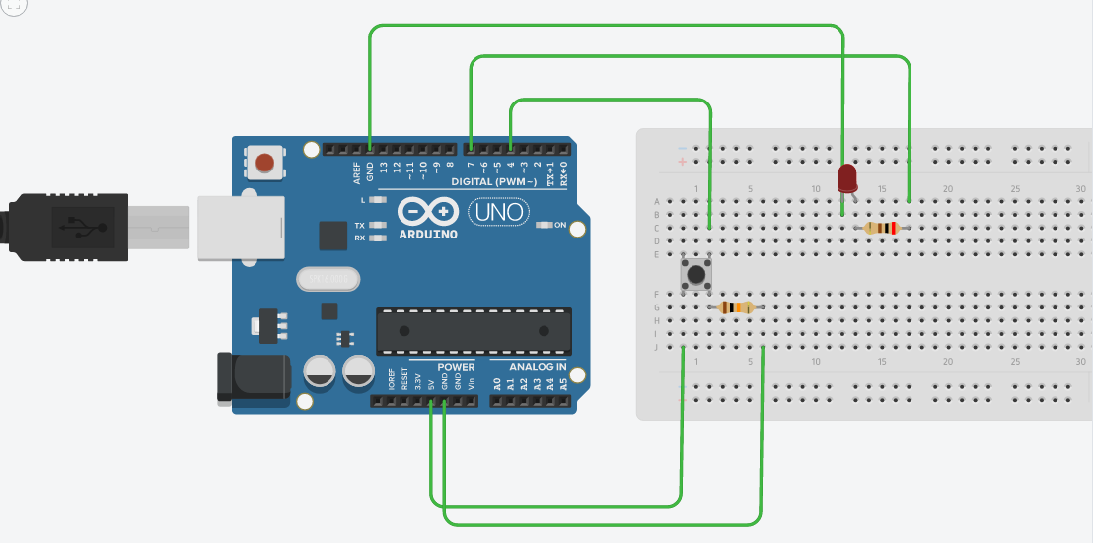

**Theory –**

**Concept Used :**

A circuit is made using Push Button, LED and two resistors (10kohm and 200ohm).

1. When the push button is open (unpressed) there is no connection between the two legs of the pushbutton, so the pin is connected to ground (through the pull down resistor) and we read a LOW. When the button is closed (pressed), it makes a connection between its two legs, connecting the pin to 5 volts, so that we read a HIGH.
2. The Background is red as mentioned in the TASK. Therefore the LED is set to HIGH as default.
3. The count tells us the number of time the button is being pressed and therefore LED blinks that number of times. Eg.- When first button is pressed, it blinks one time and second time it blinks two times and so on.

**Learning and Observations :**

* Making circuits using Breadboard.
* Using Pushbutton with the help of pull down resistor.
* Working of Arduino UNO.
* Coding to be done on Arduino.exe for stimulation of the experiment.

**Problems & Troubleshooting –**

No problems were occurred during the execution of the experiment.

**Precautions –**

1. The circuit made on breadboard can be wrong and damage the circuit.
2. Any Element used can be defective.
3. Resistance of high value should not be used resulting in no current for LED to glow.
4. The coding done for Arduino Board can be incorrect due to which stimulation can be failed.
5. Port Selection for Arduino can be incorrect due to which it wont upload on Arduino Board and resulting in failure of experiment.

**Learning Outcomes –**

1. Setting up circuit on a Breadboard.
2. Using Pushbutton to blink LED in a particular manner.
3. Working and coding of Arduino and its IDE.

**Result –**

Blinking of LED was verified after uploading the program.