Submitted by:

**Ritwick Bhaduri**

**WORD GUESS GAME**

**CONTENT**

**Page**

1. HEADER FILES - - - - - - 3
2. FUNCTIONS - - - - - - - 4
3. SOURCE CODE - - - - - - 5
4. OUTPUT SCREENS - - - - - 13
5. BIBLIOGRAPHY - - - - - - 18

**HEADER FILES**

1. iostream.h - for standard I/O operations
2. conio.h - for clrscr() amd getch() functions
3. stdio.h - for string I/O operations

**FUNCTIONS**

* printendls()
* table1()
* lines()
* table2()
* game()
* createarray()
* main()

**SOURCE CODE**

#include<iostream.h>

#include<stdio.h>

#include<conio.h>

*// character array used to build the table*

char arr[40];

*//integer arrays to store column numbers*

int pos1[20];

int pos2[20];

*//function for multiple “endl”s*

void printendls(int n=1)

{

for(int i=0; i<n; i++)

{

cout<<endl;

}

}

*//function for introduction lines*

void lines()

{

cout<<"Hello, I am Ritwick!";

printendls();

cout<<"Welcome to 'THE MIND READER'";

printendls(23);

cout<<"I am now going to read your mind!";

printendls(2);

cout<<"Please do the following steps:";

printendls(3);

cout<<"Now, Think of ANY Word!";

}

*//function for step1 consisting of table1*

void table1()

{

cout<<"Step 1:";

printendls(2);

cout<<"Tabel 1:";

printendls(2);

cout<<"-----------";

printendls();

*//loop to print column numbers of table1*

for(int i=0; i<5; i++)

{

cout<<i+1<<" ";

}

printendls();

cout<<"-----------";

*//loop to create and print table1*

for(i=0; i<30; i++)

{

if(i%5==0)

{

printendls();

}

cout<<arr[i]<<" ";

}

printendls();

cout<<"-----------";

}

*//function for step2 consisting of table2*

void table2(int no)

{

cout<<"Step 2:";

printendls(2);

cout<<"Tabel 2:";

printendls(2);

cout<<"-----------";

printendls();

*//loop to print column numbers of table2*

for(int i=0; i<6; i++)

{

cout<<i+1<<" ";

}

printendls();

cout<<"-----------";

*//loop to create and print table2*

for(i=0; i<no; i++)

{

printendls();

for(int j=pos1[i]; j<30; j= j + 5)

{

cout<<arr[j]<<" ";

}

}

printendls();

cout<<"-----------";

}

*//function for the main game*

void game()

{

int i, no, j, z;

char ch;

clrscr();

*//calling of introduction lines function*

lines();

printendls(2);

cout<<"Enter total number of letters in the word: ";

cin>>no;

*//loop to enter column number(s) from table1 of each letter of the word*

for(i=0; i<no; i++)

{

clrscr();

*//calling of table1 function*

table1();

printendls(2);

cout<<"Enter Letter "<<i+1<<"'s Coloumn number: ";

cin>>pos1[i];

pos1[i]=pos1[i]-1;

}

clrscr();

*//loop to enter column number(s) from table2 of each letter of the word*

for(i=0; i<no; i++)

{

clrscr();

*//calling of table2 function*

table2(no);

printendls(2);

cout<<"Enter Letter "<<i+1<<"'s Coloumn number: ";

cin>>pos2[i];

pos2[i]=pos2[i]-1;

}

clrscr();

cout<<"Gottcha! ";

printendls(2);

cout<<"You Thought Of The Word: ";

*//loop for printing the word assumed*

for(i=0; i<no; i++)

{

cout<<arr[pos2[i]*5+pos1[i]];

}

printendls(2);

cout<<"SURPRISED!";

printendls(7);

}

*//function to create array for alphabets*

void createarray()

{

char j='A';

*//loop to enter each alphabets into the array*

for(int i=0; i<26; i++)

{

arr[i]=j;

j++;

}

}

*//main function*

void main()

{

char ch;

createarray();

do

{

*//calling of game function*

game();

*//to repeat the program as per user's choice*

cout<<"Would you like to play again? (Y/N)...";

cin>>ch;

getch();

} while(ch!='n' && ch!='N');

clrscr();

//to end the game

cout<<"Enter ESC to end the game...";

while(getch()!=27);

}

**OUTPUT SCREENS**

1. First output welcome screen

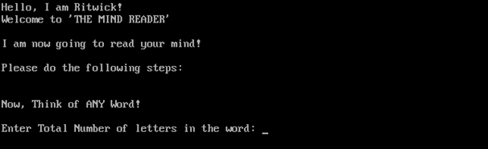

**2.** Suppose the user assumes the word as “**HELLO”**. Therefore the number of letters are **5**.

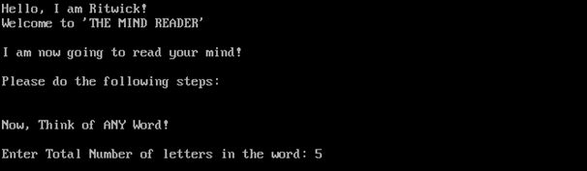

**3.** Second output on the screen.

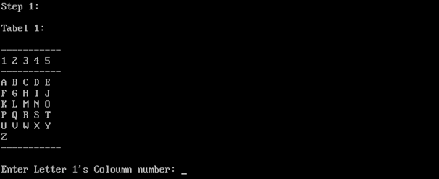

**4.** Number of the column to be entered by the user in Step1.

**(i)**

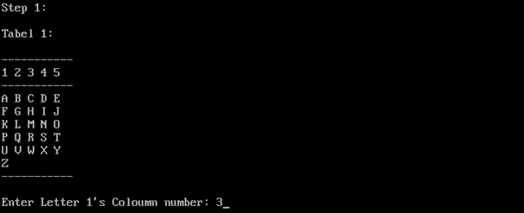

**(ii)**

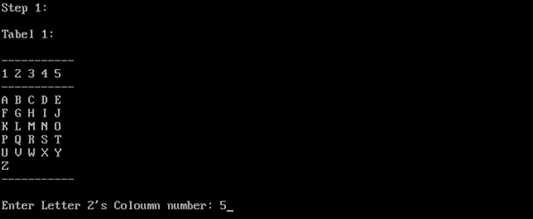

**(iii)**

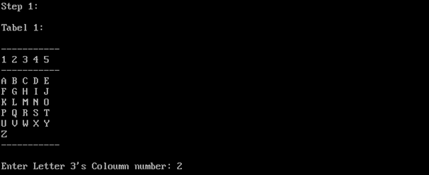

**(iv)**

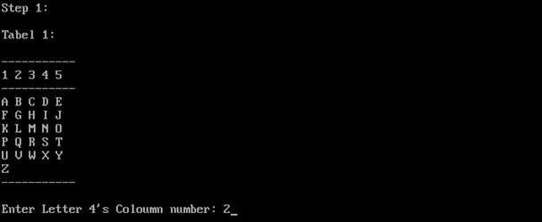

**(v)**

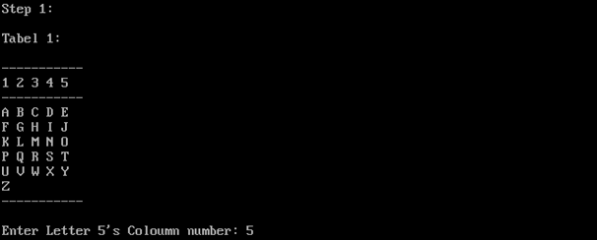

**5.** Number of the column to be entered by the user in Step2

(i)

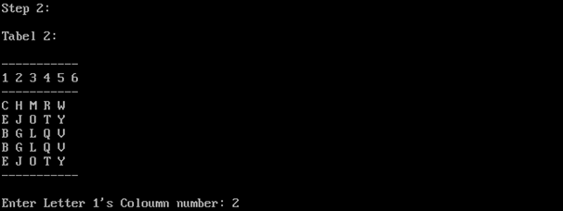

**(ii)**

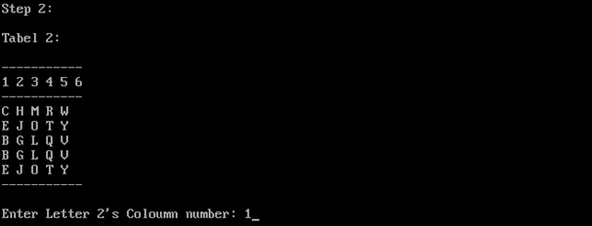

**(iii)**

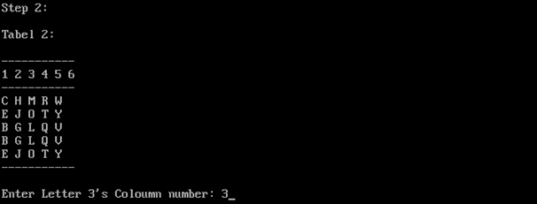

**(iv)**

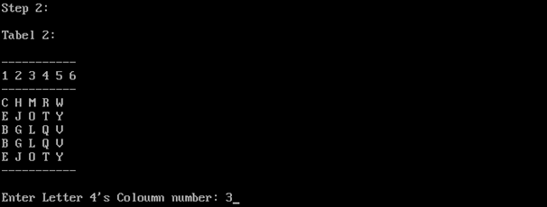

**(v)**

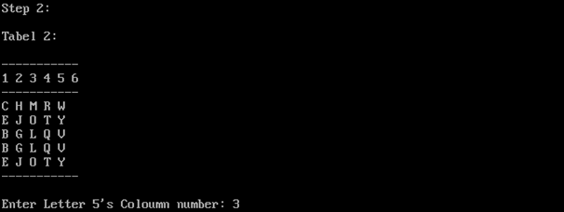

**6.** The word assumed by the user, is now guessed!!

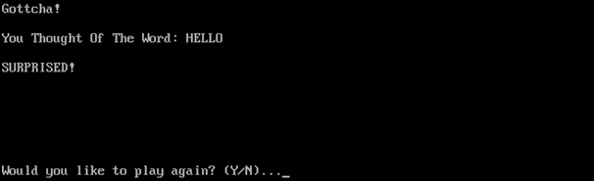

**7.** If the user wishes to play the game again, user press ‘y’ or ‘Y’, else, if the user wishes to end the game, user press ‘n’ or ‘N’.

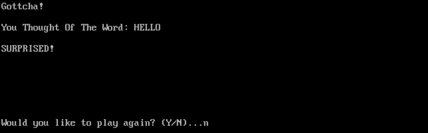

**8.** END of the game.



**BIBLIOGRAPHY**

* Computer Science for class XII by Sumita Arora
* TURBOC C++ Version 3.0 Borland Inc
* http://www.cplusplus.com/