ManoVarta: Multilingual Conversational Screening for Mental Health
Adaptive questioning, Aya extraction, hybrid safety, and a final self-hosted runtime
Ritwij and Yash

Abstract
ManoVarta is a multilingual, voice-capable conversational screening system that maps open-ended English, Hindi, and Hinglish dialogue to PHQ-9 and GAD-7 item evidence, item scores, and a separate safety state. The project only became reliable after we moved away from raw transcript scoring and toward an evidence-first pipeline with explicit safety fusion. The final live runtime achieves coverage 0.783, exact match 0.639, macro-F1 0.251, safety precision/recall 1.000/1.000, and zero parse failures, with 2.292 average user turns to a stable item score. The central empirical result is that Aya was the best extractor choice for multilingual evidence coverage, while the final deployed product paired that extraction logic with hybrid safety and a later self-hosted local runtime for deployment.

1. Introduction
Traditional mental-health screening relies on rigid questionnaires such as PHQ-9 and GAD-7. ManoVarta reframes screening as a guided conversation that still ends in structured outputs: item scores, supporting evidence, confidence state, unresolved items, and a separate safety label.
The early system taught a negative lesson before it taught a positive one: conversational fluency alone was not enough. Raw prompting sounded plausible but produced sparse or unstable questionnaire coverage. Progress came from adding structure one layer at a time: evidence extraction before scoring, separate safety fusion, confidence-based follow-up planning, language-aware lexicons, verifier passes for weak English anxiety items, and deployment validation.

2. Data, Task, and Metrics
The project targets English and Hindi as the primary required languages and treats Hinglish as a robustness condition. The processed repo assets include 84 core extractor-train examples, 48 dev, 48 test, a 140-example best extractor-train split, 126/80/84 safety train/dev/test items, and 120/96/144 follow-up train/dev/test items.
The evaluation tracks four axes: discourse effectiveness (coverage completeness, exact match, macro-F1, parse failures), safety accuracy (precision and recall), disclosure efficiency (turns to stable item scores), and latency. This design is important because exact match by itself was misleading early in the project: a system can abstain heavily and still look artificially good on exact match.

3. Model Selection and System Evolution
The initial heuristic system used lexicons, fixed routing, and shallow scoring rules. It was useful for bootstrapping the UI and schema, but its apparent exactness was misleading because the system simply covered too few items. A raw transcript-scoring check failed for a similar reason, so the project moved decisively toward evidence-first extraction.
A saved local Qwen2.5-1.5B LoRA probe over 3 examples reached coverage 0.429, exact match 0.667, and macro-F1 0.129. It was useful because it documented an early compact-model direction, but it also exposed brittleness: schema adherence was uneven and the Hindi case failed badly enough that the probe could not support extractor selection.
The first extractor result that was both multilingual and fully archived was Aya. Its offline held-out coverage reached 0.913, far beyond the heuristic baseline and the raw scoring check, which is why Aya became the main extractor path. A DAIC-WOZ auxiliary continuation run then improved some English-style extraction behavior but reduced safety recall too sharply to become the default model.
A later retrospective local Llama 3.1 8B quantized probe over the same 3-example slice reached coverage 0.893, exact match 0.640, and macro-F1 0.190. That probe was stronger than the saved Qwen probe on raw coverage, but it still underperformed the archived Aya extractor on macro-F1 and over-escalated safety on benign examples, so it did not overturn the earlier Aya selection.

4. Results
The heuristic baseline covered only 0.022 of items overall. The early raw Aya scoring check was even worse at 0.009 coverage. In both cases, the exact-match numbers looked healthier than the systems really were because most items were never touched.
The best offline Aya extractor raised coverage to 0.913, with exact match 0.562 and macro-F1 0.272. However, its safety precision and recall were both zero in the archived extractor evaluation, making it unsuitable as a deployed front-end.
The early hybrid runtime validation reached exact match 0.712, macro-F1 0.295, and perfect safety precision/recall, but coverage dropped to 0.538. The final live runtime recovered to coverage 0.783, exact match 0.639, and macro-F1 0.251, while preserving safety precision/recall 1.000/1.000 and zero parse failures.
The DAIC auxiliary continuation run reached coverage 0.897 and macro-F1 0.268, but safety recall dropped to 0.312. That is why DAIC-WOZ remained an auxiliary English-only resource rather than the default multilingual path.
The later retrospective Llama comparison helped as a sanity check rather than as a historical milestone. It showed that a stronger open model could produce broad coverage on a tiny probe slice, but still miss the operational target: its macro-F1 remained below Aya and its safety labels were too aggressive on benign examples.
Milestone | Coverage | Exact | Macro-F1 | Safety P/R
Heuristic seed runtime | 0.022 | 0.635 | 0.058 | 1.000 / 0.604
Early raw Aya scoring check | 0.009 | 0.400 | 0.006 | 0.667 / 0.038
Local Qwen2.5-1.5B probe (n=3) | 0.429 | 0.667 | 0.129 | 0.000 / 0.000
Retrospective Llama 3.1 8B probe (n=3) | 0.893 | 0.640 | 0.190 | 0.000 / 0.000
Aya extractor offline | 0.913 | 0.562 | 0.272 | 0.000 / 0.000
DAIC continuation v2run3 | 0.897 | 0.561 | 0.268 | 1.000 / 0.312
Hybrid runtime validation | 0.538 | 0.712 | 0.295 | 1.000 / 1.000
Final live runtime | 0.783 | 0.639 | 0.251 | 1.000 / 1.000

Figure 1. Metric trajectory across system milestones.
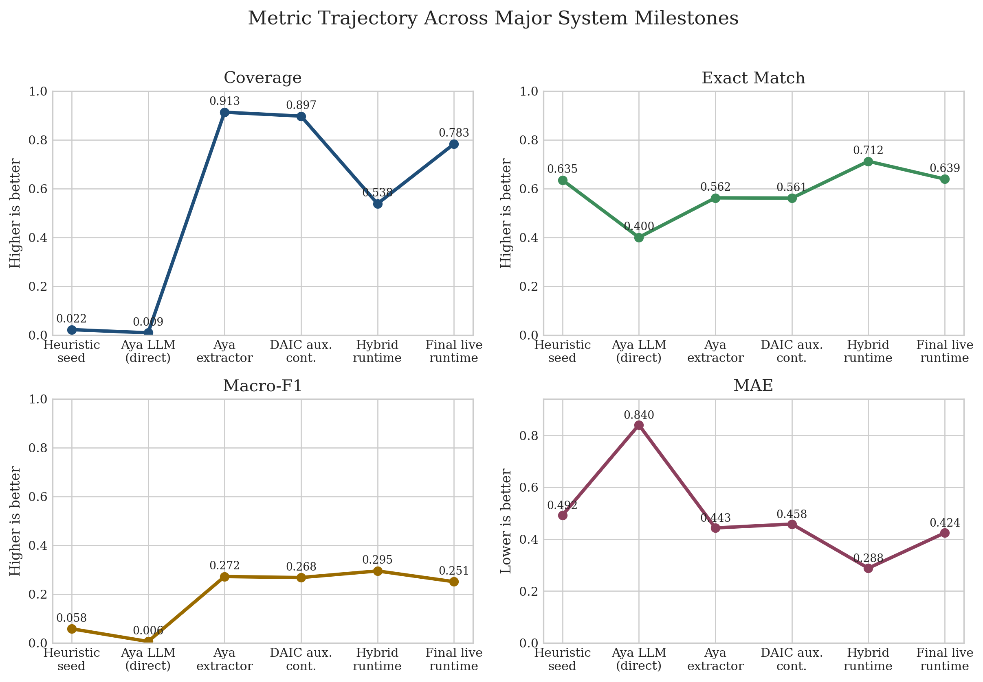

5. Language-Wise and Item-Wise Analysis
The final live language breakdown is balanced but still diagnostic. English finishes strongest after the late windowed-extraction and verifier pass, Hinglish remains broadly robust, and Hindi becomes the weakest final slice. This was not because the Hindi path failed entirely, but because a few sparse item types remained under-covered.
The most important late project repair was the English anxiety disambiguation pass. Weak English items such as GAD-2, GAD-3, and GAD-4 moved from being the primary bottleneck to full coverage/exactness in the final held-out evaluation. By contrast, the final heatmap shows Hindi still missing PHQ-1 and GAD-2 entirely and under-covering GAD-3, while Hinglish retains coverage but sometimes mis-calibrates severity for somatic items.
Language | Coverage | Exact | Macro-F1 | MAE
English | 0.844 | 0.667 | 0.239 | 0.370
Hindi | 0.719 | 0.609 | 0.242 | 0.435
Hinglish | 0.786 | 0.636 | 0.232 | 0.477

Figure 2. Final live runtime item coverage heatmap.
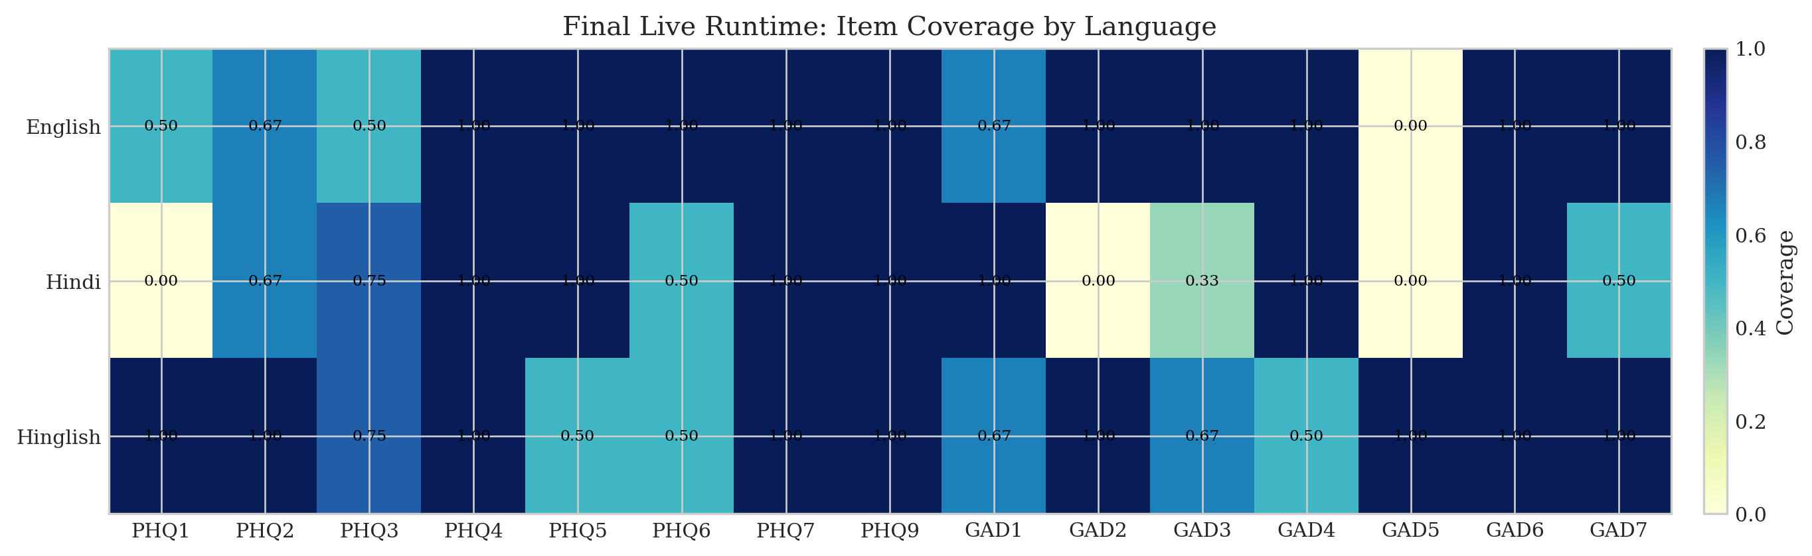

6. Productization: Safety, Voice, and Deployment
A major product milestone was moving from a browser-only demo feel to a deployed runtime with self-hosted local inference, hybrid safety, patient-profile onboarding, and backend speech routes. The final runtime reports provider=local, self-hosted inference enabled, hybrid safety enabled, and local safety checkpoint enabled.
Voice support also evolved materially. The final system includes browser speech as a fallback, but also backend cloud speech-to-text and text-to-speech. This makes the product meaningfully more robust than a pure browser-wrapper pipeline, even though it is still not a fully streaming duplex call experience.
Disclosure efficiency averaged 2.292 user turns per stable item trace. The final assignment bundle reports warm median screening-path latency of 32.73 ms and warm p95 of 32.89 ms for the deterministic local screening path.

7. Limitations
The project remains a screening-support system rather than a diagnostic or therapeutic system. The seed corpus is still small and partially synthetic, so the final metrics should be read as project validation rather than clinical validation.
The paper also reports one DAIC continuation row from a logged Colab experiment (v2run3) that was discussed during the project run but was not stored as a standalone repo JSON report. That row is included because it affected model-selection decisions, but it is explicitly labeled as a logged continuation run rather than a fully archived benchmark.
Gemma and Mistral appear in proposal-stage planning documents, but there is no reproducible final held-out result artifact for either in the repo. The report therefore excludes them from the main quantitative comparison.
The Qwen and Llama numbers reported here come from small multilingual probes rather than full held-out evaluations. They are included to document model selection honestly, not to inflate the benchmark table with incomparable results.

8. Conclusion
ManoVarta succeeded not because one model was magically better, but because the system was progressively made more structured and more honest. The final live runtime is not the numerically strongest raw extractor ever observed offline, but it is the strongest screening product built in the project: multilingual, voice-capable, self-hosted, safety-consistent, and grounded in PHQ-9/GAD-7 item evidence.

References
- Kroenke, Spitzer, and Williams (2001). The PHQ-9: Validity of a Brief Depression Severity Measure.
- Spitzer et al. (2006). A Brief Measure for Assessing Generalized Anxiety Disorder: The GAD-7.
- Dosovitsky et al. (2021). Psychometric Properties of a Chatbot Version of the PHQ-9.
- Abd-Alrazaq et al. (2020). Effectiveness and Safety of Using Chatbots to Improve Mental Health.
- Burdisso et al. (2024). DAIC-WOZ: On the Validity of Using the Therapist's Prompts in Automatic Depression Detection.
- Kakwani et al. (2020). IndicNLPSuite.
- Nayak and Joshi (2022). HingBERT.
- Zirikly et al. (2019). CLPsych 2019 Shared Task.
- Pichowicz et al. (2025). Performance of Mental Health Chatbot Agents in Detecting and Managing Suicidal Ideation.
- Cohere Aya Expanse documentation.
- Google Cloud Speech-to-Text and Text-to-Speech documentation.
- Google Cloud Run documentation.
- NIMH generalized anxiety and suicide warning-sign guidance.

