Single-Agent vs Multi-Agent LLM Systems
When to Use Each, at What Compute Cost, and What Makes One Design Outperform the Other
A review of established agent-design principles, supported by an original hands-on experiment.

Executive Summary
This report compares two ways of building an AI agent: a single agent that handles a task alone, and a multi-agent system where a coordinator routes work to specialised sub-agents. It answers the assigned question — since multi-agent systems spend more compute, is their advantage due to the structure or just the extra compute? Using established industry guidance and an original experiment, it finds neither design is universally better. A single agent is the right default; the multi-agent structure earns its higher cost only when tasks cross domains, tools grow, parallel work is needed, or the model is unreliable alone. The extra compute buys reliability and predictability, not accuracy for free.

1. How AI Agents Work
An AI agent uses a large language model (LLM) to reason, plan, and use tools to complete tasks. Its major components are the LLM (the brain that reasons and decides), tools (code functions for searching the web, reading pages, querying databases, or running code), and optionally memory (which preserves context across steps or sessions).
Agents differ from chatbots through the ReAct pattern (Reasoning + Acting): the agent reasons about the task, decides whether tools are needed, calls them, observes the results, and repeats until it can produce a grounded answer.

2. The Two Architectures

2.1 Single Agent
One LLM handles the entire task — it reasons, plans, and calls whatever tools it needs. Most systems should begin this way: the design is simple, cheap, low-latency, and sufficient for well-defined tasks.
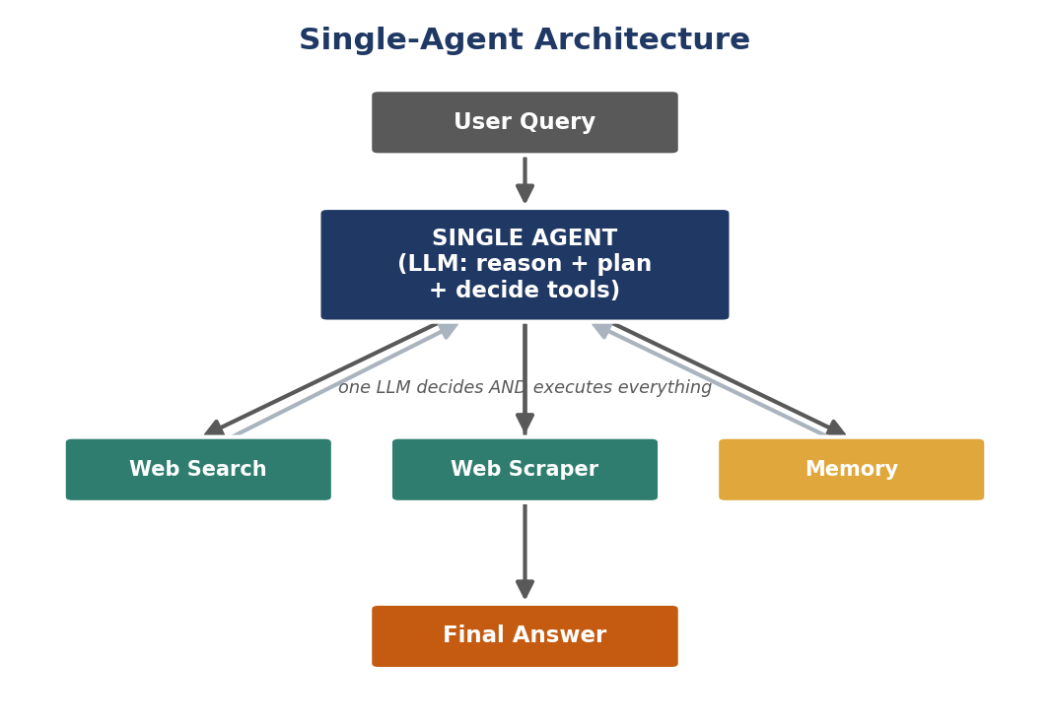
Figure 1. Single-agent architecture: one LLM both decides and executes.

2.2 Multi-Agent System
Specialised agents handle different parts of a task, coordinated by a central agent (an orchestrator, supervisor, or manager). Each specialist has its own role, tools, and context. Common patterns include Orchestrator → Coder → Tester → Reviewer for software work and Orchestrator → Retriever → Writer → Verifier for research.
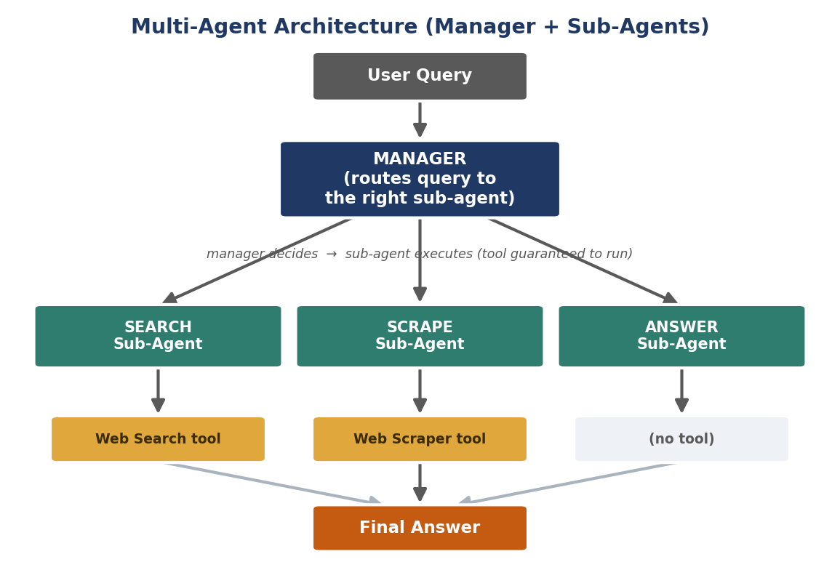
Figure 2. Multi-agent architecture: a manager routes the query to a specialised sub-agent, each owning its own tool.

3. When to Use Each (Established Guidance)
Industry practice treats this as a progression, not a binary switch. A single agent is the right starting point; the move to multi-agent is triggered by observable signals rather than ambition.

3.1 The Single-Agent Ceiling
A single agent degrades when three pressures appear, singly or together:
- Context-window overflow — as schemas, rules, and tool documentation accumulate, the agent starts forgetting instructions and misapplying rules. Failures are subtle and look reasonable, which makes them dangerous.
- Domain-expertise conflicts — one agent trying to embody several departments (e.g. sales speed vs compliance caution) has no stable way to resolve competing priorities, producing inconsistent decisions.
- Parallelism bottlenecks — a single agent works through multi-system tasks sequentially; at scale the queue backs up, whereas specialists can run in parallel.

3.2 The Decision Framework
Stay single-agent when | Go multi-agent when
Work stays within one domain | Work crosses domains regularly
Fewer than ~10 tools | Tool list exceeds ~10–15 tools
Context fits comfortably in one window | Context overflows / degrades
Domain rules don't conflict | Domain rules conflict
Sequential execution is fast enough | Parallel execution matters for throughput
Tight cost / low latency required | Governance isolation is needed

The usual trigger is domain conflict, not scale — the first time the agent violates a policy or routes a sensitive request wrongly, the boundary has been reached.

3.3 Easier to Debug
A multi-agent system has more parts, but it is easier to fix. When one big agent makes a mistake, it is hard to tell why, because it was handling everything at once. With separate specialists, you know exactly which agent failed and where to look.

3.4 Don't Split Too Much
More agents is not always better. If two agents use the same tools and data, they are duplicates that only add coordination overhead. Split only when each agent genuinely does something different.

4. The Research Question
Multi-agent systems are widely reported to outperform single agents, but they also spend more compute. So when they win, two explanations compete:
- The structure hypothesis: the design itself produces the improvement.
- The compute hypothesis: the improvement is just the effect of spending more compute.
Practitioner reports already hint at the answer: one documented lead-qualification system that moved from a single 15-tool agent to a three-agent pipeline (enrichment → scoring → routing) gained roughly 30% accuracy and easier debugging, but at about 40% higher token usage. The gain is real but paid for in compute. The experiment below tests the same tension directly on a small task.

5. Supporting Experiment
To see the tradeoff first-hand, a single agent and a multi-agent system were compared on the same web-research task, using the same model (Mistral via Ollama) and the same tools (web search + scraper), with tokens counted on every call. This is a small, single-task probe meant to illustrate the principles above — not to settle the question alone.

5.1 Result
Question: “Who won the most recent FIFA World Cup and in what year?”
Aspect | Single Agent | Multi-Agent
Tool actually executed? | No — printed as text | Yes — search ran
Answer produced | France, 2018 (wrong) | Argentina, 2022 (correct)
Compute cost (tokens) | 452 | 788 (~1.7×)

Both systems shared the same, independently verified working search tool. The single agent nevertheless failed to invoke it — the local model wrote the tool call out as text and answered from stale memory. The multi-agent design, by separating the routing decision from tool execution, guaranteed the tool ran and returned the correct answer, at about 1.7× the tokens.

5.2 What This Experiment Does and Doesn't Show
It does show the compute-for-reliability tradeoff clearly: the structured system was more reliable but more expensive. It does not prove multi-agent is inherently better — the single agent was handicapped by the local model's weak tool-calling, so this reflects a weak-model condition, not a like-for-like contest. A stronger model might have closed the gap.

6. Answering the Assigned Questions

6.1 Which System Is Best?
Neither is universally best. A single agent is the right default for well-defined, single-domain tasks with few tools. A multi-agent system becomes best once work crosses domains, tools grow past ~10–15, context overflows, rules conflict, or parallelism is needed. In the experiment's weak-model setting, the multi-agent design was best because it alone produced a correct answer.

6.2 Based on Compute Cost
Multi-agent consistently costs more, across both the literature (~40% higher tokens in the documented pipeline) and the experiment (~1.7×). Cost also varies by which specialist runs. Multi-agent is therefore never adopted to save compute; the extra compute is spent to buy reliability, specialisation, or parallel throughput.

6.3 Based on Structure
The structural advantage is real but conditional. Structure helps by giving each agent a bounded scope, its own tools, and clear governance — which improves reliability and, notably, predictability and debuggability (“which agent handles this?” replaces “why did the agent do that?”). In the experiment, structure's benefit took a specific form: separating decision from execution guaranteed the tool ran.

6.4 The Exact Thing That Makes It Better
There is no single universal mechanism; the structure helps in different ways depending on the problem: bounded context (each agent loads only its own domain), conflict resolution (a coordinator settles competing rules), parallelism, and easier debugging. In this experiment specifically, the mechanism was guaranteed tool execution — the structure took the model's unreliable tool-calling out of the critical path.

7. Conclusion
Start with a single agent; move to multi-agent only when a real wall appears — context overflow, domain conflict, parallelism, or an unreliable model. When it does, the structure improves reliability and predictability, but at a consistent compute premium (~1.4–1.7× more tokens in the evidence here). The extra compute buys dependability, not accuracy for free — so adopt the structure only when the task genuinely needs it.

7.1 Limitations and Next Steps
- The original experiment is a single-task probe on one local model; it supports, but does not by itself prove, the general conclusion.
- The single agent was disadvantaged by weak tool-calling; a single agent with forced tool execution, or a stronger model, would give a cleaner like-for-like comparison.
- A larger, automatically graded question set across several task types would strengthen the quantitative claims.

References
Olafenwa, A. (2026). Single Agent vs Multi-Agent: When to Build a Multi-Agent System. Agent components, the ReAct pattern, and single- vs multi-agent design.
Goldsborough, M. (NimbleBrain). Single Agent vs. Multi-Agent: When You Need More Than One. The single-agent ceiling, decision framework, complexity tradeoff, and over-splitting.
Practitioner report: lead-qualification system moving from a single 15-tool agent to a three-agent pipeline (~30% accuracy gain, ~40% higher token usage).
Original experiment by the author: Mistral (Ollama) with a LangChain single agent and a manager/sub-agent multi-agent system, with per-call token measurement.

