

Dissertation on

“Crowd Digital Twin for Event Safety and Smart Urban Management”

Submitted in partial fulfillment of the requirements for the award of the degree
of
Bachelor of Technology
in
Computer Science & Engineering

UE23CS320B – Capstone Project Phase - 2

Submitted by:

Rishikesh Suraj | PES2UG23CS481
Rithvik Rajesh Matta | PES2UG23CS485
Shreyas Sreenivas | PES2UG23CS565
Ritwik Agrawal | PES2UG23CS908

Under the guidance of

Dr. Richa Sharma
Associate Professor
PES University

January - May 2026

DEPARTMENT OF COMPUTER SCIENCE AND ENGINEERING
FACULTY OF ENGINEERING
PES UNIVERSITY

(Established under Karnataka Act No. 16 of 2013)

Electronic City, Hosur Road, Bengaluru – 560 100, Karnataka, India

PES UNIVERSITY

(Established under Karnataka Act No. 16 of 2013)
Electronic City, Hosur Road, Bengaluru – 560 100, Karnataka, India

FACULTY OF ENGINEERING

CERTIFICATE
This is to certify that the dissertation entitled

‘Crowd Digital Twin for Event Safety
and Smart Urban Management’

is a bonafide work carried out by
Rishikesh Suraj | PES2UG23CS481
Ritwik Agrawal | PES2UG23CS908
Shreyas Sreenivas | PES2UG23CS565
Rithvik Rajesh Matta | PES2UG23CS485

In partial fulfillment for the completion of sixth-semester Capstone Project Phase - 2 (UE23CS320B) in the Program of Study -Bachelor of Technology in Computer Science and Engineering under rules and regulations of PES University, Bengaluru during the period Jan. 2026 – May. 2026. It is certified that all corrections/suggestions indicated for internal assessment have been incorporated in the report. The dissertation has been approved as it satisfies the 6th-semester academic requirements in respect of project work.
Signature  Dr. Richa sharma  Associate Professor | Signature  Dr. Sandesh B J  Chairperson

External Viva
Name of the Examiners  1. __________________________  2. __________________________ | Signature with Date  __________________________  __________________________

DECLARATION

We hereby declare that the Capstone Project Phase - 2 entitled “Crowd Digital Twin for Event Safety and Smart Urban Management” has been carried out by us under the guidance of Dr. Richa Sharma, Associate Professor, PES University and submitted in partial fulfilment of the course requirements for the award of the degree of Bachelor of Technology in Computer Science and Engineering of PES University, Bengaluru during the academic semester January – May 2026. The matter embodied in this report has not been submitted to any other university or institution for the award of any degree.
PES2UG23CS481 |  | Rishikesh Suraj
PES2UG23CS485 |  | Rithvik Rajesh Matta
PES2UG23CS565 |  | Shreyas Sreenivas
PES2UG23CS908 |  | Ritwik Agrawal

ACKNOWLEDGEMENT

I would like to express my gratitude to Dr. Richa Sharma, Department of CSE AIML, PES University, for his/ her continuous guidance, assistance, and encouragement throughout the development of this UE23CS320B - Capstone Project Phase – 2
I am grateful to all Capstone Project Coordinators, for organizing, managing, and helping with the entire process.
I take this opportunity to thank Dr. Sandesh B J, Professor & Chairperson, Department of Computer Science and Engineering, PES University, for all the knowledge and support I have received from the department.

I am deeply grateful to Prof. Jawahar Doreswamy, Chancellor, PES University, Dr. Suryaprasad J, Vice-Chancellor, PES University, and Prof. Nagarjuna Sadineni, Pro-Vice Chancellor, PES University, for providing me with various opportunities and enlightenment every step of the way. Finally, Phase II of the project could not have been completed without the continual support and encouragement I have received from my family and friends.

ABSTRACT
Crowd movements can lead to many dangerous situations including mass trampling, stampedes, and ineffective emergency evacuations, and they present a large danger in urbanized environments. Currently, the most common type of video surveillance takes the form of traditional still-image camera systems operated by humans. Most of these cameras are ultimately used for preventative rather than real-time surveillance, and they will not typically have the spatial resolution needed to identify people proactively before a crowd-related incident occurs.

The aim of this project is to create a Crowd Digital Twin (CDT), which will be an accurate and real-time representation of the behaviour of an entire crowd using cloud-based computing systems as well as commodity-class GPU's connected to a single end-to-end software solution.
The CDT will be generated through a process called Data Fusion, which incorporates three streams of data collected through three different types of IoT-enabled sensors: (1) video analytics based on person detection via fine-tuned YOLOv8n and multi-object tracking via ByteTrack; (2) cumulative entry and exit counts from IoT-enabled sensors located at Gates; and (3) trajectory datasets taken from ETH/UCY pedestrian mobility datasets that will provide calibration priors for predicting zone confidence levels. In addition, a Three Stream Data Fusion Layer (weightings of 0.70 / 0.30 / prior-modifier) will assist in resolving any inconsistencies across the three types of sensor modalities used to produce a single fused crowd count and associated confidence level (κ).
An Adaptive Digital Twin Engine (DTE) will manage electronic agents that have velocity profiles obtained from the Exponentially Moving Average method and are simulated within a two-dimensional grid comprising two rows and three columns with boundary reflection requirements to allow for short-distance, "What If" style simulations that can last for at least twenty seconds.
TABLE OF CONTENTS

Chapter No. | Title | Page No.
 | INTRODUCTION | 01
 | PROBLEM DEFINITION | 02
 | DATA  3.1 Overview  3.2 Dataset  3.3 Data Preprocessing | 07  07  07  08
4. | DESIGN DETAILS  4.1 Novelty  4.2 Innovativeness  4.3 Interoperability  4.4 Performance  4.5 Security  4.6 Reliability  4.7 Maintainability  4.8 Portability  4.9 Legacy to Modernization  4.10 Reusability  4.11 Application Compatibility  4.12 Resource Utilization | 10  10  10  11  11  12  12  13  13  13  14  14  14  14
5. | HIGH LEVEL SYSTEM DESIGN /SYSTEM ARCHITECTURE  5.1 Overview of Architecture  5.2 Data Flow | 15  15  18
6. | DESIGN DESCRIPTION  6.1 Master Class Diagram  6.2. ER Diagram / Swimlane Diagram / State Diagram  6.3 User Interface Diagram  6.4. External Interfaces | 20  20  21  23  25
7. | TECHNOLOGIES USED  7.1 YOLOv8n Architecture Details  7.2 ByteTrack Algorithm | 27  28  28
8. | IMPLEMENTATION AND PSEUDOCODE  8.1 Data Fusion Layer (Layer A)  8.2 YOLOv8n Training (Cell 4)  8.3 Adaptive Digital Twin Engine (Layer G)  8.4 Risk Estimator (Layer L)  8.5 Trend Predictor (Layer I)  8.6 Confidence Estimator (Layer D)  8.7 Pipeline Demo Results | 29  29  29  30  31  32  32  32
9. | CONCLUSION OF CAPSTONE PROJECT PHASE - 2 | 34
10. | PLAN OF WORK FOR CAPSTONE PROJECT PHASE - 3  10.1 Model Improvements  10.2 Hardware Integration  10.3 System Enhancements  10.4 Evaluation and Validation | 36  36  36  37  37
REFERENCES/BIBLIOGRAPHY |  | 38
APPENDIX A DEFINITIONS, ACRONYMS, AND ABBREVIATIONS |  | 39
APPENDIX B USER MANUAL (OPTIONAL) |  | 40

CHAPTER 1
INTRODUCTION
1.1 Background and Motivation
Many types of large-scale social events—ranging from sporting events to music festivals, political meetings, religious anniversaries and city marathons—frequently create massive amounts of density in very small areas. The result of such density can be catastrophic if not properly controlled. Disasters due to crowd dynamics shifting to fatal occurred in three high-profile crowd-crush events in 2021 at the Astroworld Festival in Houston (10 deaths; hundreds injured), October 29, 2022, at the Itaewon Halloween crush in Seoul (159 deaths), and the 2013 Kumbh Mela stampede in Allahabad (36 deaths). Each of these three examples illustrates how quickly crowd dynamics can change to become deadly. A failure to have effective real-time, spatially-resolved crowd intelligence meant that public safety personnel were unable to act prior to the occurrence of catastrophic compression.
Traditional surveillance systems, such as closed-circuit television (CCTV) system operated by human operators, are responsive in nature. Operators can only visually identify a catastrophic crowd crush when a wave of compression is apparent. Additionally, operators are limited by their ability to cognitively process information received from multiple cameras at the same time. Advanced video management systems (VMS) that integrate feeds from hundreds of cameras also do not provide meaningful spatial analytics but rather compress and display digital video. The emphasis is being directed toward developing real-time spatially-resolved intelligence to better facilitate safety and security in large-scale gatherings.
One of those new paradigms that emerged within the last few years is the concept of a digital twin, which is a digitally based representation of a real-world object or system that continually synchronizes with the physical counterpart. Digital twin technology has been a game-changer in industrial automation, infrastructure management (e.g., smart cities digital twins), and patient care. If this technology is generalized to the human crowd application space, then a Crowd Digital Twin (CDT) can be constructed as an ongoing, continually updated computational model of actual pedestrians, to reproduce in real-time the spatial distribution, velocity field and density of pedestrians, and perform predictive simulation (what-if analysis) of the crowd's potential evolution.

One driver for the rapid improvement in the speed-accuracy trade-off involved with pedestrian detection has been recent progress in deep-learning methods, mostly single-stage object detectors, such as the You Only Look Once (YOLO) family. YOLOv8 (Ultralytics, 2023) performs sub-10 W edge-device inference at nearly real-time speed while retaining competitive mean Average Precision (mAP). Concurrently, when combined with state-of-the-art multi-object trackers like ByteTrack [Zhang et al., 2022] that accurately provide a stable identity across frames, including during periods of occlusion, they collectively meet the performance requirements of computer vision necessary to support the implementation of a CDT.
While computer vision alone cannot provide complete counts of persons in large crowds due to mutual occlusion, it still plays an integral role for video-based detectors. Many IoT gate sensors such as infrared beams, pressure mats, RFID readers, etc. provide additional counts for very large crowds but cannot determine the spatial resolution of each individual counted. While pedestrian trajectory datasets like ETH/UCY provide empirical/prior distributions for pedestrian trajectories, which can assist in uncertainty quantification for the counts given to pedestrians through these individual distribution samples, the integration of all three modalities into a spatially and temporally resolved (confidence-weighted) virtual representation of the crowd (Crowd Dynamic Technology - CDT) can overcome the previously mentioned limitations of each individual technology.
This project - Team 28, Batch 28, PES University, UE23CS320B Capstone Phase 2 - created a system that merges data from multiple technologies (i.e., computer vision, IoT Gate sensors, and pedestrian trajectory datasets) into one cohesive traffic (crowd) management solution. The team was supervised by Dr. Richa Sharma and developed, implemented, tested, validated a complete CDT pipeline comprising of data ingestion, multimodal fusion, agent-based modeling, risk classification, and short-term simulation for each person in a real-time WebSocket-based dashboard to show the current crowd density at any given time. The developed system can be verified on the MOT17 benchmark dataset as well as the UCF-CC-50 density estimation dataset.
1.2 Scope of Work
Capstone Phase 2 includes: fine-tuning YOLOv8n to detect pedestrians from a factory-fused dataset that includes 17,998 annotated frames, implementing a complete 15-layer pipeline (A to O) for composite dataset applications that include Data Fusion, Edge AI Detection, ByteTrack Tracking, Confidence Estimation, Zone Management, Density/Flow Estimation, Trend Prediction, Simulation Triggering, Short-Horizon Simulation, Risk Estimation, Alert Generation, Quantitative Evaluation and Dashboard Visualisation, a three-stream Data Fusion Layer that fuses YOLOv8n Video Counts (weight = .70), IoT Gate Sensor Counts (weight = .30), and ETH/UCY Mobility Priors (confidence modifier), constructing an Adaptive Digital Twin Engine based on an Agent-Based Model that uses EMA Velocity Smoothing (α = .40) and a 2 x 3 spatial zone grid, creating and implementing a Composite Risk Estimation Formula: R = .40 × Density + .30 × Speed + .20 × Trend + .10(1 − Confidence), deploying a real-time FastAPI/WebSocket backend to support a live 9-panel dashboard, and quantitatively evaluating against established benchmarks from MOT17, UCF-CC-50 and ETH/UCY.

The scope does not include hardware procurement (IoT sensors will operate in simulation mode), multi-camera stitching/resources, or cloud-scale deployments, which will be addressed in Capstone Phase 3.
1.3 Objectives
- The main goals of this Phase 2 Capstone goal will include:
- O1 Create a Sensor Fusion Pipeline that fuses Video Data with Sensor IoT (Internet of Things), Mobility Data, Etc.
- O2 To fine-tune YOLOv8n to achieve less than 5 Persons / Frame Mean Absolute Error (MAE).
- O3 Use ByteTrack to track individual people through various frames and derive velocity vectors of the individual agents.
- O4 Create an adaptive agent-based digital twin engine with spatial resolution at the zone level.
- O5 Compute Composite Risk Scores and create actionable zone-level alerts.
- O6 Perform What-If short horizon (+ 20 sec) simulation for Predictive Crowd Management.
- O7 Create a real-time WebSocket dashboard with the following NFR's: ≥ 10fps, < 2000ms latency.
- O8 Execute quantitative evaluation of the overall system via MAE, RMSE, Pearson r, mAP(50), and ADE metric.
1.4 Organisation of the Report
The problem is defined in Chapter 2, and the limitations of existing crowd management approaches are analysed. Chapter 3 describes the datasets and the preprocessing pipeline applied. The design details are presented across twelve quality dimensions in Chapter 4. Chapter 5 shows the high-level architecture of the system. Chapter 6 gives detailed design artefacts, including class diagrams, entity relationship diagrams, swimlane diagrams, user interface wireframes, and specifications for external interfaces. All technologies used are catalogued in Chapter 7. The implementation is detailed in Chapter 8 with pseudocode for each major component. The Phase 2 work is concluded in Chapter 9, and the Phase 3 plan is outlined in Chapter 10.
CHAPTER 2
PROBLEM DEFINITION
2.1 Problem Statement
Due to quick-moving and unpredictable crowd dynamics, the infrastructure currently in place for monitoring large crowds through surveillance is severely limited in its ability to provide the spatial and temporal resolution necessary for proactive safety measures through quantifiable crowd state intelligence. As a result, there are reactivity based management strategies in place to address these issues. The consequence of this is that management strategies which seek to prevent crowd crushes, stampedes and evacuations will fail consistently.

To formalise this problem: if there is a continuous feed of video from one or more cameras monitoring a bounded public space plus sensor readings for all gates into and out of the facility that are asynchronous from the video feed, it is desired that a real-time virtual replication of the current state of the crowd is created that contains per zone (or subsector) density, velocity, and risk as needed for an immediate actionable decision; the replication must be generated at a rate of no less than 10 FPS and no more than 2 seconds of latency; it must have the ability to predict future states of the crowd as they would occur if nothing changes in the environment or systems and this prediction must be valid for at least 20 seconds into the future to permit pre-emptive interventions.
2.2 Challenges associated with Existing Systems
Existing crowd management systems have several fundamental weaknesses:
2.2.1 Occlusion and Undercounting
High-density crowds create significant occlusions between people and reduce the visible amount of a person that can be seen at one time by the camera. Although standard object detection methods are used today for crowd presence or density analysis, a large percentage of people (20-40%) that exist in a dense area are not counted due to the occlusion between people creating a barrier to view the people or due to the perspective of the camera. For example, a submission to UCF-CC-50 (dataset) may result in up to 4633 people in one image but an overhead camera displays only a small number of them.

2.2.2 Sensor Modality Gaps
Camera-based sensors have spatial resolution, but they cannot see people outside of the field of view (FOV). Gate entrance and exit sensors can only count the number of people entering and exiting, but they do not give any spatial distribution data. Wi-Fi and Bluetooth proximity sensors can only track people that carry devices. There is no sensor modality that gives complete situational awareness.

2.2.3 Reactive versus Predictive
Conventional VMS systems have a mechanism to create an evidential historical video feed, while providing a monitoring capability for crowds, typically operated by a human operator who would identify risks that needed action once the potential of the hazard was known (i.e., once the risk had occurred) . Generally, the prediction time to perform crowd management actions is usually between 20 and 30 seconds in front of the occurrence of the hazard.

2.2.4 Lack of Granularity in Relation to Spatial Density Data
Even systems that provide basic crowd count data (i.e., how many people in one venue) are not able to provide sufficient spatial level data (i.e., density and flow vectors etc.) to allow the identification of localised crowd compression hotspots.

2.2.5 Lack of Quantified Risk Evaluation
Security staff need to use their intuition to derive risk from raw image data. There is no quantitative risk evaluation using mathematical methods to provide a mapping of crowd density and speed as well as direction of travel to an actionable level of severity using the crowd safety literature (i.e. Fruin's Level of Service (LOS) Framework).

2.2.6 Scalability of Computing
Using legacy systems to perform high definition video analysis introduces unacceptable latency, as a result of processing on centralized servers. Therefore, edge AI can be used to meet the need for real time performance with cameras or local GPU nodes.
2.3 Proposed Solution Overview
- The CDT is addressing each challenge that has been identified through a multi-layered pipeline of 15 functional components (Layers A–O).
- The digital twin uses a multi-modal fusion (Layer A), which fuses video and IoT streams in a weighted formula (C_f = 0.70×C_video + 0.30×C_iot) to correct for occluded counted sensors.
- Edge AI (Layer B) running on a Tesla T4 GPU using a YOLOv8n was able to process 70.8 FPS on crowd data well within the NFR ≥10.
- ByteTrack (Layer C) creates and maintains stable identities for each agent throughout all frames regardless of whether the agent is being partially occluded so that the agent's velocity can be calculated.
- The spatial grid (Layer E, 2×3) created 6 zones to provide enough granularity to not only detect localized density hotspots but also do so without creating an excessive amount of computational load.
- Hybrid risk calculation (Layer L) generates a risk score of [0,1] representing density, speed, trend and confidence with HIGH/MEDIUM/LOW classification. Short-horizon simulation (Layer K) propagates the current state of agents for 25 steps (≈20s at 25fps/skip-2) using constant velocity with boundary reflection, thus providing the predictive lead time needed to take preemptive actions.
- The real-time FastAPI/WebSocket server (Layer O) is capable of providing dashboards to operator terminal updates in less than 1-second intervals.

CHAPTER 3
DATA
3.1 Overview
The CDT pipeline utilizes four public benchmark datasets that each contain annotated pedestrian bounding boxes, density maps, and trajectory data. These datasets complement one another in that MOT17 provides urban scene tracking ground truth data, UCF-CC-50 has images of extremely dense crowds, the Mall Dataset acts as an intermediary between the two, and ETH/UCY has fine-grained trajectory priors. Each of the datasets is summarized in Table 3.1.
Dataset | Scenes | Images/Frames | Annotation Type | Primary Use in CDT
MOT17 | 7 urban sequences ×3 detectors = 21 sequences | 15,948 training frames | Pedestrian bounding boxes + IDs (gt.txt) | YOLOv8n training, MAE evaluation
UCF-CC-50 | 50 crowd-scene images | 50 images | Point annotations → Gaussian density maps (σ=15px) | Density estimation evaluation
Mall Dataset | 1 indoor corridor camera | 2,000 frames | Pedestrian head points → YOLO boxes (50×120px) | YOLOv8n training (indoor scenes)
ETH/UCY | 5 outdoor scenes | ~1,536 unique persons | (frame, id, x, y) trajectory text files | Mobility priors for fusion confidence
Composite CDT | All above | 17,998 images; 50 density maps | YOLO 5-field format (cls cx cy w h) | Full model training
Table 3.1 : Datasets Used in the Crowd Digital Twin Project.

3.2 Dataset Descriptions
3.2.1 MOT17 (Benchmark for Multi-object Tracking) MOT17 (Milan et al., 2016) is a benchmark dataset and standard evaluation for tracking many persons (the target persons are also referred to as many/ the target persons/ the tracked persons). There are 7 different sequences in total (MOT17-02, MOT17-04, MOT17-05, MOT17-09, MOT17-10, MOT17-11, MOT17-13) with detection proposals/ possible detection images from 3 independent detectors (DPM, FRCNN, SDP), resulting in 21 possible sequence-detection combinations for the training portion of the dataset. The ground truth pixel values are provided via a CSV file (gt.txt) with fields frame_id, track_id, x, y, w, h, confidence, class, and visibility. The training data (pedestrian only; class=1) was filtered to retain only the results with confidence > 0.5. After the pre-processing of the MOT17 training data, there are a total of 15,948 frames.

The CDT pipeline was evaluated on the MOT17-09-FRCNN ground truth (1,525 frames) for determining subject count accuracy in a crowd scene). The MID-FRCNN sequence was chosen because of the amount of persons per frame (5-15 persons per frame) has a density which is regarded as representative of the mid-density using a safety-critical pre-crush scene/ event.
3.2.2 UCF-CC-50
UCF-CC-50 (Idrees et al [2013]) is a dataset that contains 50 different images showing loaded crowded scenes found on the internet, including crowds from several different large scale events (such as religious events at Mecca [Hajj], concerts, and political rallies) where the crowds range anywhere from 94 in any one scene up to 4,633 in any one scene, with the average number of people per scene being 1,279. The UCF-CC-50 is point level (person’s head location) annotation only; the head point annotations were extracted from the UCF-CC-50 matfiles for use in the CDT.
3.2.3 Mall Dataset
The Mall Dataset [Chen et al., 2012] is composed of 2,000 images taken by one CCTV camera located in an indoor shopping mall that is directed at the entrance. Each frame has a set of ground truth head-point annotations with an average of either 13 or 53 people present in each individual image, with each person identified individually. Each identified person is assigned a fixed size bounding box of 50 × 120 pixels centred at their respective head, allowing for the generation of valid normalised YOLO annotation files. This dataset serves to increase the performance of CDT in indoor surveillance scenarios with a pedestrian scale and viewing angle that differs from that of the MOT17 sequences, which are outdoors.
3.2.4 ETH/UCY Pedestrian Trajectory Datasets:
Pedestrian trajectory prediction is one of the most widely used benchmark datasets to validate your results against the largest populated ETH [Pellegrini et al., 2009] and UCY [Lerner et al., 2007] are the two datasets of pedestrian trajectory predictions. These two datasets provide real-world pedestrian trajectory data recorded using a set of fixed position and upward-facing 2.5 Hz cameras for capturing (x,y) world-coordinate positions. The five different scenes of interest for the CDT project to be used as input for the global mean pedestrian speed (0.355 units per frame) to derive per-zone mobility confidence priors (zone_weight = max(0.75, 1.0 − mean_speed/100)) to use in modulating the Confidence Estimator and Fusion Layer to establish a statistically valid expectation of pedestrian movement through the zone of interest based on both historical and predicted values.
3.3 Data Preprocessing Pipeline
The raw sets of data contain a variety of formats for annotation, resolution and coordinate system. To standardise all data sources into YOLO format (class cx cy w h; all normalised [0,1]) and derive Gaussian density maps for use in the experiment, a common workflow is developed. There are four steps to the workflow below:
3.3.1 Converting MOT17 Format Data to YOLO Format
For each MOT17 sequence the gt.txt text file is read with Pandas in order to extract the relevant data from the MOT17 sequence. The data rows where class is not 1 (not a pedestrian) or the confidence value is less than or equal to 0.5 are eliminated. Each bounding box for each frame is normalised by image dimensions using equation cx=(x+w/2)/W; cy=(y+h/2)/H; nw=w/W; nh=h/H. Each corresponding image is copied from the img1/ directory into the output images/ subdirectory. As a result of this process, two parallel directory structures containing images/labels formatted according to the directory structure used by the Ultralytics training API are created which can be used as input to the Ultralytics training API.
3.3.2 Generating Density Maps for UCF-CC-50
Each of the 50 .mat files in the UCF-CC-50 dataset is read in as a MAT file using scipy.io.loadmat. The (x,y) coordinates of each annotated head can be retrieved from the field called 'annPoints' in the .mat file. A blank, float32 density map with the same dimensions of the source image is created for each head point that is being annotated by incrementing the density map by 1.0 at the nearest pixel for each annotated head. A Gaussian filter with a standard deviation of 15 pixels is applied to the density map using scipy.ndimage.gaussian_filter to create a spatially smooth distribution of densities and obtain a density map with an integral equal quantifying the amount of pedestrians located
3.3.3 Mall Dataset to YOLO Conversion
The Mall GT Mat file was loaded and then for each frame entry its annotated head positions were converted into bounding boxes by centering a box of dimensions 50 x 120 px on the location of the head. The normalized coordinates for YOLO format were written to a per-frame image label .txt file. The frame images were also resized uniformly and written to the output images/mall/ directory.
3.3.4 Label Validating and Dataset Split
After conversion all label files were validated: each line is required to have 5 numerical fields; the class is forced as 0 (the person); and cx,cy,w,h are clamped to both [0,1]; and any box has been removed that has w <= 0 or h <= 0; and any empty file has been deleted. 17,948 label files checked: 0 have been deleted from validation (all passed validation). The split for training/validation is 80% of the YOLO format sequences are allocated to training and 20% of the YOLO format are allocated to validation (UCF density-only images were excluded from being part of the detection split). Final Statistics of the Dataset: 17,998 total images; 17,948 total label files; 50 density maps.

CHAPTER 4
DESIGN DETAILS
4.1 Novelty
The Crowd Digital Twin offers three main features making it completely unique compared to traditional approaches. First, instead of heuristically averaging data from three disparate sensor modalities (video analytics, IoT gate counts and pedestrian trajectory priors), a principled weighted fusion formula is used to combine the data into some consolidated understanding of the crowd using the fusion confidence coefficient κ = 1 -(|C_video - C_iot|/max(C_video, C_iot, 1)), providing an interpretable metric for inter-sensor agreement allowing for estimating the confidence of instruments downstream by giving them a basis of correlation. In addition, no prior digital crowd monitoring systems using a single model have incorporated the three modalities together, nor provide explicit detection of discrepancies and subsequent recalibration of confidence.

Second, the CDT has the benefit of a per-agent Confidence Estimator (Layer D) which computes individualised confidence using the following parameters; det_conf, age_weight, zone_calibration, and density_weight. The age_weight parameter ramps linearly from 0 to 1 over the first five frames of a track, and will prevent newly spawned ghost tracks from influencing risk scores. Zone calibration weights are used for data-driven spatial confidence biases based upon mobility data from ETH/UCY prior data, which will calibrate the reliability of detectors based upon statistically observed pedestrian flow behaviours.

Third, the CDT employs a short horizon simulation (Layer K) that integrates the complete agent-based state (position, EMA velocity, zone) into a 20 second projection of crowd evolution, allowing the operator to visualise projected zone densities before reaching critical thresholds. This will allow for crowd management to shift from reactive to predictive.
4.2 Innovativeness
The CDT innovated by providing a continuously operating, real-time process that integrates multiple existing technologies (YOLOv8n, ByteTrack, Gaussian density mapping and linear regression trend detection) into one system and has associated the output of each of these technologies with confidence level measurements at each processing stage. The innovation occurs at the architectural level (tagging each processing layer with a propagation tag that represents a confidence level) to create a low-cost Bayesian like inference chain to determine risk classification without the costly computing associated with typical explicit probabilistic graphical modelling.

The risk score was grounded in sound crowd safety science through the use of an established normative metric (Fruin LOS) to correlate the number of people on a square metre basis (i.e. number of people/area) to a value of 0.8 people/m² which represents the threshold for ‘Level of Service F’ crowd pressure.
4.3 Interoperability
- The CDT offers adaptable solutions for adding to existing security systems:
- Video Sources: The OpenCV VideoCapture can acquire Video via RTSP Stream (for IP Cameras, NVR's and other video cameras), RTMP Stream, MP4 File formats and Web Cam's by passing the source argument through a single "--source" option; therefore this will easily interchange all source types without writing any code to down stream sources.
- IoT Devices: Real-time incoming sensor data from a physical gate (or outside gates) via MQTT/REST call is accomplished with the IoTSimulator.push_real(entry, exit) method. Replacing the method: simulate_tick() with push_real() does not require any code changes to down stream layers (sensors will send real time data).
- Application Programming Interface (API): The FastAPI created /api/snapshot endpoint returns a JSON payload structured to be compliant (as far as practical) with existing SCADA/VMS integration methods (protocols).
- WebSocket: WebSocket Connection established with /ws, supporting up to 10 hz of data broadcasted which is suitable for any web browser or Python programming environment.
- Data Structure: All internal storage structures utilize standard Python DaTa Classes, allowing serialization to JSON which allows accessibility to Elasticsearch, Influx DB, and/or Cloud IoT platforms.
4.4 Performance
Performance requirements were formally specified as Non-Functional Requirements (NFRs):
NFR | Target | Achieved
Inference FPS | ≥ 10 FPS | 70.8 FPS (Tesla T4)
End-to-end latency | < 2,000 ms | 14.1 ms
Crowd count MAE | < 5.0 persons/frame | 0.86 persons/frame
Trajectory ADE | N/A (baseline) | 0.5903 m (linear baseline)
WebSocket broadcast rate | ≤ 10 Hz | Configurable; default 10 Hz
According to Table 4-1 Performance against nonfunctional requirements there was compromise in terms of the temporal resolution of the generated frames from frame skipping with a FRAME_SKIP set at 2 times the resulting throughput. Frame skipping will increase throughput to 2X, however the resulting frame rate will only be 12.5 FPS instead of 25fps because of the increased time between frames. The trade-off is acceptable since there are significant time lags between state changes in a crowd due to the time scale of seconds that crowd states change versus the inter-frame period of 0.08s. The YOLOv8n (3.0M param; 8.2 GFLOPs) was chosen for use in the edge deployment because it meets all of the constraints associated with edge deployment.
4.5 Security
The CDT System has been designed with many security considerations for public safety application deployment:
Local video streams are managed; there will be no calls to an external API with the raw video stream. The raw video stream will only be processed within a closed RTSP stream network.
The WebSocket API will be used to send analytics data (JSON) and will not contain any raw video frames; therefore reducing the potential risk to privacy of users. Heat map overlay JPEGs can be disabled through configuration.
Dashboard user authentication will occur in Phase 3, where JWT token authentication via FastAPI's OAuth2PasswordBearer will be implemented.
The Colab demo used an ngrok tunnel with the institutional ngrok authentication token to provide secure access to the demo. The production rollout of the application will provide secure access by providing HTTPS with TLS termination.
All incoming WebSocket and REST requests to the CDT application will be validated via Pydantic schemas. Pydantic is FastAPI's default schema validator and prevents injection attacks.
4.6 Reliability
The CDT employs multiple failure-tolerance mechanisms to maintain continuous operations.
- VideoInputHandler: The VideoInputHandler runs in a dedicated daemon thread and has an auto-loop for recorded video inputs, so the pipeline will never block on waiting for the video input stream.
- Fine-Tuned Weights: If the fine-tuned weights file is missing from the filesystem, the system automatically reverts to using the base YOLOv8n weights, resulting in degraded but usable functionality.
- ByteTrack: Any lost ByteTrack tracks (agents that have been absent for over 30 frames with tracked_buffer set to 30) are handled gracefully; lost ByteTrack tracks will be purged from the Digital Twin state.
- ETH/UCY Prior Loading: All prior loading from the ETH and UCY datasets is wrapped within try/except statements. Any exceptions thrown will default to using uniform zone calibration (1.0 weight) and will not result in a termination of the application.
- WebSocket Broadcast: The WebSocket Broadcast captures DisconnectExceptions and disassociates stale clients from the application without terminating the pipeline.

4.7 Maintainability
The structure of the codebase has been designed to promote long-term maintainability through the strict separation of concerns, with each of the 15 named pipeline layers being implemented as a separate Python class (IoTSimulator, DataFusionLayer, ConfidenceEstimator, ZoneManager, DigitalTwinEngine, DensityFlowEstimator, TrendPredictor, SimulationTrigger, RiskEstimator, AlertEngine, VideoInputHandler, and CDTPipeline). Each class has a single responsibility, which facilitates independent unit testing and the ability to easily replace or substitute classes. All configurable parameters for the application are stored in a single configuration object (Config), with inline documentation for each parameter. Static type annotations (using Python 3.12 typing) are present throughout the Codebase and allow for static analysis to be performed using Mypy.
4.8 Portability
The CDT can be used in all computing environments You will be able to run the CDT using your GPU using NVIDIA CUDA on either the Tesla T4, T4 GPU or an RTX 30/40 series GPU. If there is not a CUDA device available (for example, in a GPU that is not AMD) PyTorch will pick the best available CPU.
The CDT has been tested on two different operating systems, which are Ubuntu 22.04 (running on Google Colab using a Tesla T4) and Windows 11 (running locally).
All dependencies, listed in the pip installable requirements.txt file (ultralytics, supervision, fastapi, uvicorn, opencv-python-headless, scipy, numpy, pandas, and pyngrok) will use Docker containers to run the application from a cloud environment.
YOLOv8n's use of 3.0 million parameters and an 8.2 GFLOP inference budget will allow for compatibility with NVIDIA Jetson Orin and Phase 3 hardware.
4.9 Legacy to Modernization
The CDT has been designed to work with existing CCTV infrastructure to enhance and extend the functionality of current systems, without having to replace hardware. The existing CCTV camera system must be using a compliant RTSP input interface (such as ONVIF Profile S, G, or T cameras) in order to send data to the CDT.
The CDT makes it easy to send an analytics overlay from the current VMS dashboards from Milestone, Genetec and Avigilon to the CDT via their respective third-party API integration. The use of this approach, an analytics overlay, is intended to provide a migration path from a legacy monitoring operation to an intelligent real-time crowd management application without replacing existing infrastructure.
4.10 Reusability
All parts of the pipeline are designed separately from one another; each pipe segment represents a separate Python class with an associated interface. Each of the ZoneManager, DensityFlowEstimator, TrendPredictor, RiskEstimator, and AlertEngine are not dependent on the dataset used for performing object tracking outputs. The push_real() method in the DataFusionLayer allows re-use regardless of the real-time IoT infrastructure. The CDTPipeline class encapsulates the entire pipeline into one start()/stop() method, allowing it to be used as a library to be consumed by third-party applications that perform crowd management.

4.11 Application Compatibility
The CDT dashboard is presented as a standards-compliant HTML5 Single Page Application. The WebSocket client is developed using vanilla JavaScript and utilizes a simple API that allows it to work in all of the major browsers (Chrome, Firefox, Safari, and Edge) without additional plug-ins. The REST API is fully OpenAPI 3.0 compliant (the specification was auto-generated using FastAPI) and will generate Client SDKs that can be used to develop mobile applications (Android or iOS) as well as integrate into corporate security management systems.
4.12 Resource Utilization
The resource usage measurement for the system was collected for 100 frames of pipeline demo on a Nvidia T4 (14,913 MiB VRAM):
Resource | Observed Usage
GPU memory (peak) | 5.58 GB / 14.9 GB (37%)
CPU (YOLOv8n inference) | ~2 dataloader workers
RAM (training cache) | 4.4 GB required / 12.7 GB available
Inference throughput | 70.8 FPS; 14.1 ms/frame

Table 4.2 - Resource Usage Measurement for Tesla T4 (Nvidia)

CHAPTER 5
HIGH LEVEL SYSTEM DESIGN / SYSTEM ARCHITECTURE
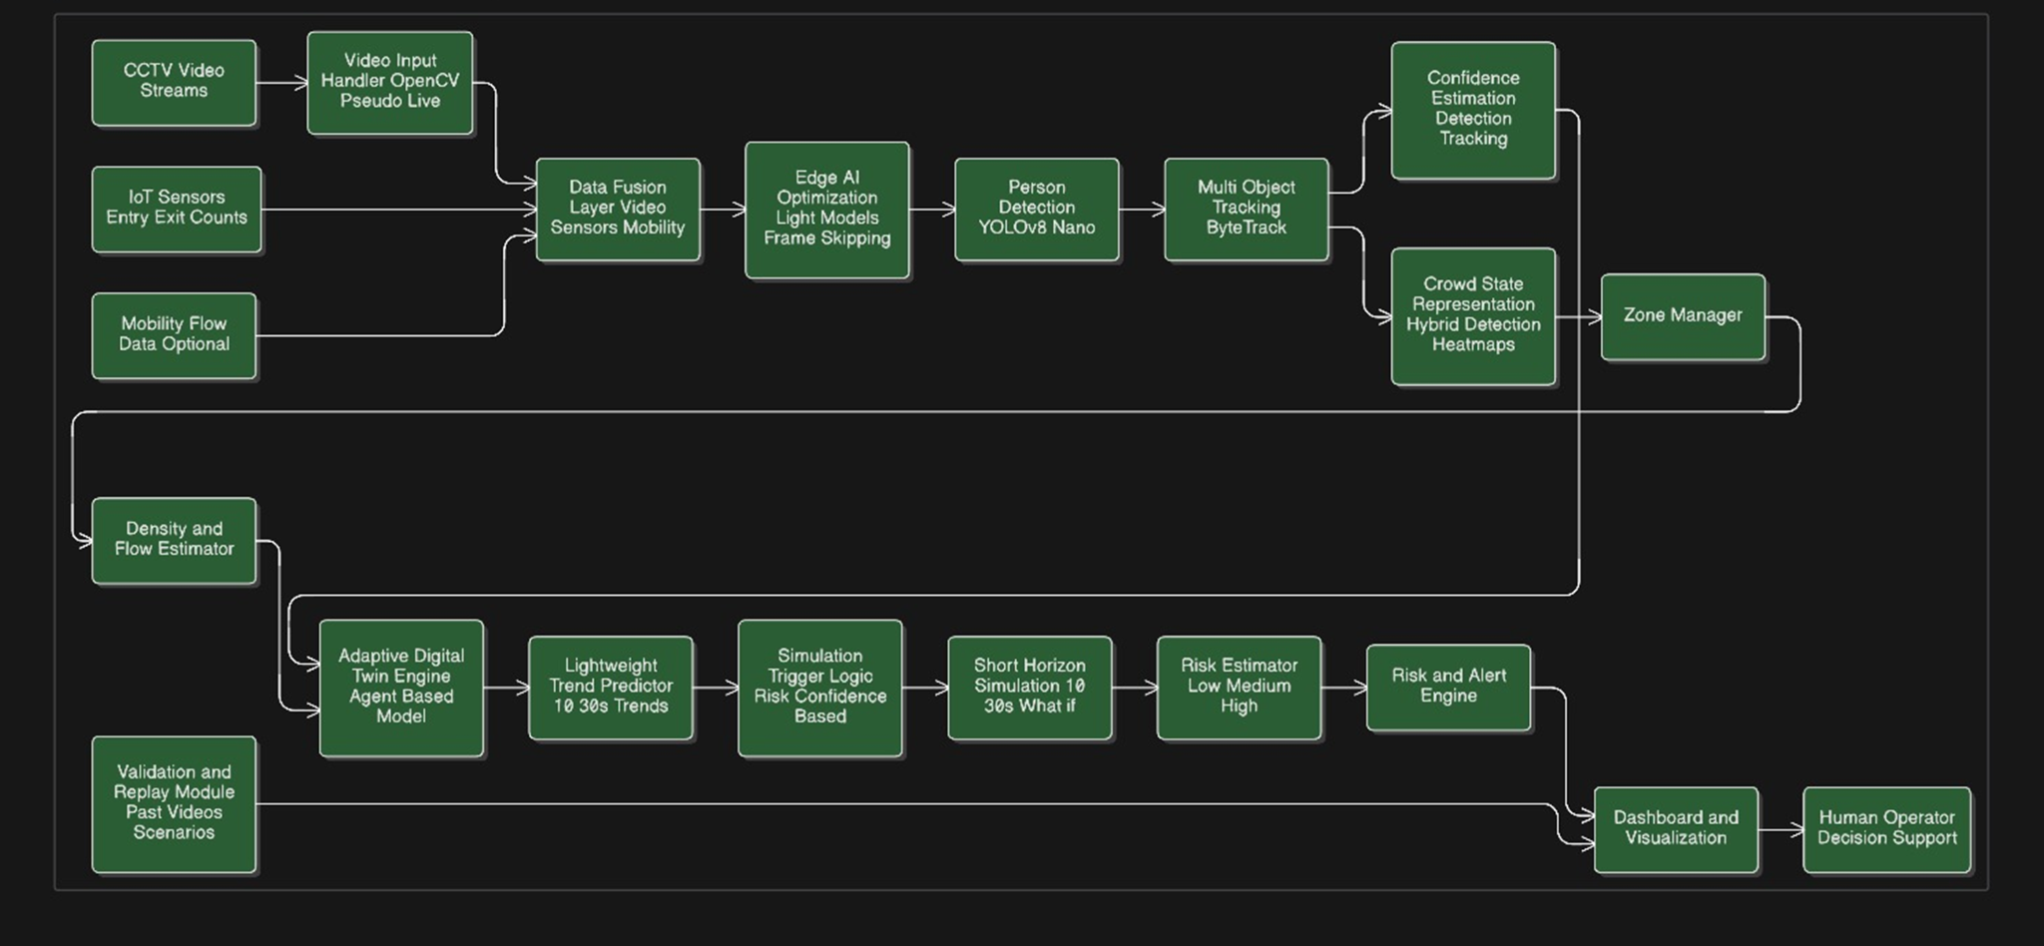
15 functional layers (A–O), subdivided into four distinct tiers: an Input Tier, Perception Tier, Analytics Tier, and Output Tier make up the Crowd Digital Twin pipeline. A complete architecture overview is shown in Figure 5.1.
5.1 Overview of Architecture
The Crowd Digital Twin pipeline is as follows:
[A] Data Fusion Layer
The Data Fusion Layer is responsible for receiving three types of input: 1) video detections from Layer B with a weight assigned W_VIDEO=0.70; 2) IoT gate sensor data with a weight of W_IOT=0.30; and 3) ETH/UCY mobility priors used as modifiers of confidence. The Data Fusion Layer computes the fused count as C_f=0.70×C_video+0.30×C_iot, with a fusion confidence of κ. Additionally, the Data Fusion Layer initiates the confidence rescaling process when the absolute difference between the counts from the video stream and the IoT sensor stream exceeds the threshold of δ=5.
[B] Edge AI: YOLOv8n Detection
The Edge AI: YOLOv8n Detection component of the Crowd Digital Twin pipeline uses a fine-tuned version of the YOLOv8n backbone with frame processing at 640x640 pixels, confidence coefficient=0.35, and intersection over union coefficient=0.50. The Edge AI: YOLOv8n Detection returns bounding box information and confidence coefficients (for all identified personnel) for each frame of video processed as well as the processed video frames. The YOLOv8n uses frame skipping (every-other-frame) for 2× the amount of processed video frames than would typically be processed.
[C] ByteTrack Multi-Object Tracking
The ByteTrack (Zhang et al., 2022) multi-object tracking framework assigns unique integer track IDs to each detected individual across video frames based on stable identifiers over time. This is done using first association (IoU) for high-confidence detections, then using byte level secondary association for low-confidence detections. The framework contains a buffer with a maximum of 30 frames in duration.
[D] Confidence Estimator
Each agent is assigned a confidence coefficient based on the following equation: det_conf×min(1,age/5)×zone_calibration×max(0.6,1-zone_density×0.4). New tracks are assigned a ramped-up confidence coefficient, zone weights from the ETH/UCY datasets are applied, and the track confidence coefficient is penalized by the density of individuals in the zone.
[E] Zone Manager
Divides the area of view into a 2×3 grid of 6 named zones (A–F). Assigns each detected agent to its assigned zone based on the centroid of its bounding box. Tracks the per-zone capacity thresholds according to the zone area of each zone.
[F] Crowd State (Agent Registry)
Contains a dict representing Agent data class containing the following fields: id, x, y, vx, vy, speed, confidence, zone, and history (last 12 positions). Represents the persistent virtual crowd state copy.
[G] Adaptive Digital Twin Engine
Updates the state of agents in each frame using EMA velocity smoothing method: vx_new=α×(x_new−x_old)+(1−α)×vx_old, where α=0.40. Deletes stale tracks. Calls the method simulate_future() for short-horizon prediction.
[H] Density & Flow Estimator
Calculates a Gaussian density map (σ=30px, normalised to [0,1]) and per-zone density (people per 10,000 square pixels) and the mean velocity vector.
[I] Trend Predictor
Uses a rolling linear regression (window=15 frames) over the agent count history. If slope >+0.15, will indicate GROWING, <−0.15 will indicate DISPERSING, and otherwise STABLE.
[J] Simulation Trigger
Triggers short-horizon simulation when trend is GROWING, risk is HIGH/MEDIUM, or fusion_confidence <0.70 so that simulation overhead is incurred only when most predictive intelligence is needed.
[K] Short-Horizon Simulation
Advances the state of the agents 25 steps into the future (~20 seconds at 25fps and skip-2). During each step: x_new = clip(x+vx, 0, W) and a boundary reflection changes velocity to be opposite if the agent leaves the area of view. Returns predicted
[L] Risk Estimator
Risk (R) = 0.40 × density (normalized) + 0.30 × speed (normalized) + 0.20 × trend score + 0.10 × (1 − confidence). R has three levels of risk classification: R > 0.66: HIGH R = 0.33 - 0.66: MEDIUM R < 0.33: LOW. Each zone has a separate risk value calculated based upon independent calculations of each zone and the data received from other similar spatial hazard locations.
[M] Alert Engine
Alerts can be generated for zones that have either MEDIUM or HIGH risk, generating a text string that is readable by a human and contains the name of the zone, the number of agents in that zone, and severity of the threat.
[N] Quantitative Evaluation
Crowd Count - MAE, RMSE, Pearson correlation (compared to MOT17 Ground Truth), Density - MAE (compared to UCF-CC-50), Trajectory - ADE (compared to ETH/UCY constant velocity baseline), Updates per second (FPS), Latency, Risk Distribution; All of the above metrics will be saved in JSON format
[O] Dashboard / Operator UI
Dashboard for offline analysis consists of 9-panels created using Matplotlib (dark theme). Real-time dashboard (from a FastAPI WebSocket server) sends JSON data to an HTML5 dashboard (updated with live agent count, risk score by zone, heatmap of risk by zone, projected simulation forecast, alerts) at a maximum of 10 Hz.

5.2 Data Flow
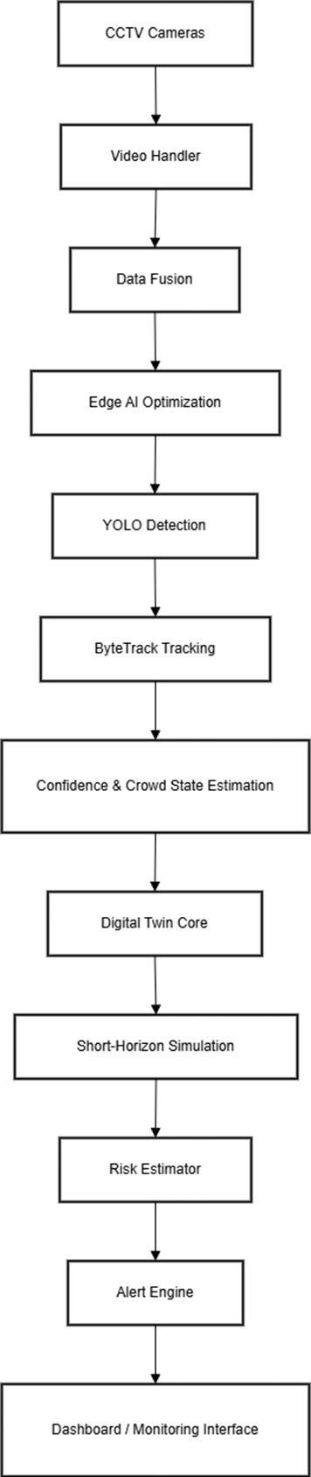

For every frame processed, the data trace follows this path:
- Step 1: Capture frame using VideoInputHandler (thread-safe, auto-recur).
- Step 2: Resize the frame to 1280x720. Perform frame skip check to determine which frames are processed; process every 2nd frame.
- Step 3: YOLOv8n inference on resized 640x640 frame to obtain raw detection bounding boxes.
- Step 4: Use ByteTrack to associate tracks to detections producing stable tracker_ids.
- Step 5: Increment IoT simulator tick counts of simulated entry/exit.
- Step 6: Call DataFusionLayer.fuse() to generate fused_count, fused_detections, and fusion confidence of κ.
- Step 7: Call DigitalTwinEngine.update() to update agent's state with an exponentially moving average velocity.
- Step 8: Call DensityFlowEstimator to output zone_density, zone_flow, and density_map.
- Step 9: Call TrendPredictor.push() followed by analyze() to output crowd_trend, slope, r².
- Step 10: Call RiskEstimator.classify() to obtain a global risk_score, as well as risk_score for each zone.
- Step 11: Check SimulationTrigger.should_trigger() to see if a boolean trigger has occurred.
- Step 12: Call DigitalTwinEngine.simulate_future(25 steps) if there was a trigger, to produce predicted_zones.
- Step 13: Call AlertEngine.generate() to output a list of alert strings.
- Step 14: Render heatmap as JPEG (base 64 encoded for transmission via WebSocket).
- Step 15: Assemble JSON payload and send to all currently connected WebSocket clients.
- Step 16: Save the last JSON payload to latest_payload for use by the /api/snapshot REST endpoint.

CHAPTER 6
DESIGN DESCRIPTION
6.1 Master Class Diagram
There are 13 central classes and associated responsibilities defined for the CDT architecture. The class hierarchy is flat (no deep inheritance) and prefers using composition instead of inheritance, following modern software architecture principles.
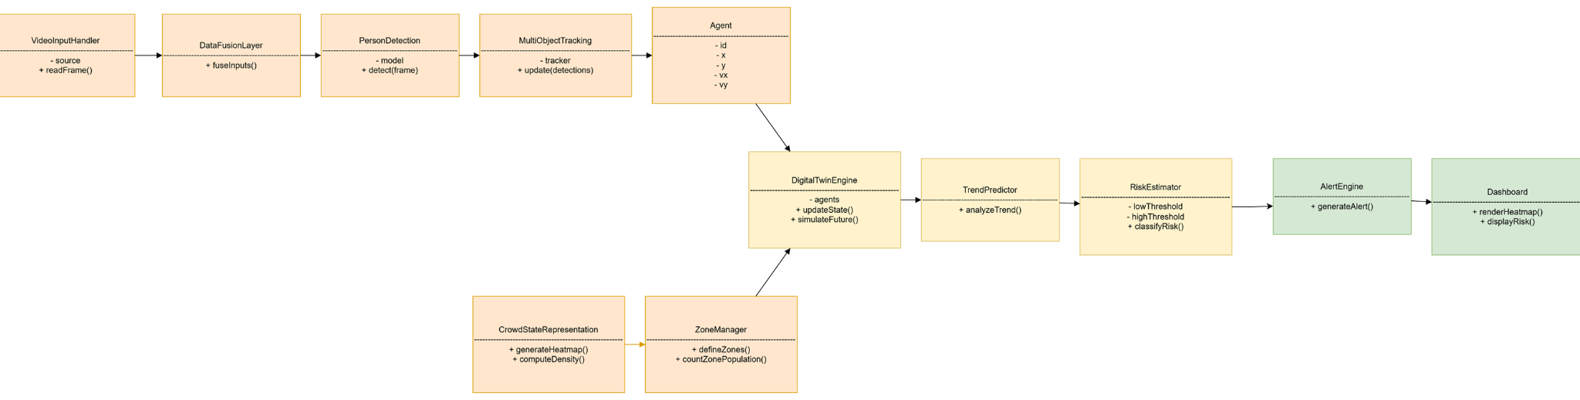
This is a static class that consolidates all of the tunable parameters that you can set up for the CDT application: YOLO_MODEL, YOLO_CONF, YOLO_IOU, FRAME_SKIP, ZONE_ROWS, ZONE_COLS, W_VIDEO, W_IOT, RISK_WINDOW, PRED_HORIZON, HEATMAP_SIGMA, WS_HZ. You don't instantiate this class.

Agent (dataclass) - has the following fields: id:int, x:float, y:float, vx:float, vy:float, speed:float, confidence:float, zone:str, history:list. The Agent represents the state of an individual tracked pedestrian within the digital twin.

ZoneState (dataclass): It has the following properties: name:str, x1:int, y1:int, x2:int, y2:int, and capacity:int. The ZoneState has the following properties: area:float, cx:int, cy:int.

ZoneManager - has the following methods: assign(cx, cy)→str, count(agents)→Dict[str,int]. This class constructs a grid of ZoneState objects that is ZONE_ROWS×ZONE_COLS in size.

ConfidenceEstimator - has the following methods: update(agent_id,det_conf,zone,zone_density)→float, set_zone_calibration(zone,weight), drop(agent_id). The internal state contains a _age:Dict[int,int] and _zone_cal:Dict[str,float].

IoTSimulator - has the following methods: simulate_tick(video_count, frame_idx)→(int, int), push_real(entry,exit_). Property: net_count:int.

DataFusionLayer - has the following methods: load_mobility_prior(eth_ucy_root, zone_mgr), fuse(video_detections, frame_idx
DigitalTwinEngine
DigitalTwinEngine
Functions: update(detections,density_per_zone,fused_count), predict_future(steps,h,w)→List[Dict]. Constants: ALPHA=0.40. State: agents:Dict[int,Agent].
DensityFlowEstimator
Functions: density_map(agents,h,w)→np.ndarray, zone_density(agents)→Dict[str,float], zone_flow(agents)→Dict[str,Tuple].
TrendPredictor
Functions: push(n,spd), analyze()→dict. Constants: SLOPE_THR=0.15. Internal: _counts:deque, _speeds:deque.
RiskEstimator
Functions: classify(density,speed,trend,confidence)→dict. Constants: W={density:0.40,speed=.30,trend=0.20,confidence=0.10}, MEDIUM_THR=0.33, HIGH_THR=0.66.
AlertEngine
Functions: generate(zone_risks,zone_counts)→List[str].
VideoInputHandler
Functions: start(), read()→np.ndarray|None, stop(). Property: resolution:Tuple[int,int].
CDTPipeline
Functions: start(), _pipeline_loop(). Composes all pipeline components. Exposes latest_payload:dict.
6.2 ER Diagram / Swimlane Diagram
In relation to the CDT (Continuous Data Transmission), the entity-relationship diagram (ERD) can't apply here because CDT is not a relational database but uses a stream process

Rather than representing the different entities of the CDT with an ERD, I will use a swimlane diagram to describe the interaction between the 3 main actors of the CDT: Physical Infrastructure (cameras, IoT sensors), CDT Pipeline, Operator Dashboard.
The three swimlanes included within the CDT swimlane diagram are:
Swimlane 1: Physical Infrastructure
This swimlane generates RTSP video frames (continuously) as well as asynchronous IoT entry/exit events. The VideoInputHandler ingests RTSP video frames, and the IoTSimulator pushes IoT entry/exit events.
Swimlane 2: CDT Pipeline
The CDT Pipeline synchronously processes each RTSP video frame through Layers A to N and does this in one dedicated background thread. Processing results are stored within latest_payload, and each processing result can be broadcasted to every connected WebSocket client that has subscribed to that runtime.
Swimlane 3: Operator Dashboard
The Operator Dashboard subscribes to the WebSocket endpoint. As a result, the Operator receives JSON payloads at ≤ (10 Hz). Additionally, the Operator uses the received JSON data to render the zone heatmap, risk indicators, agent count time-series, trend bars, forecast simulation, and alert feed, The Operator uses the REST API to send operator actions back (i.e., acknowledgement of alerts or adjustment to zone capacity thresholds) (see Phase 3).

6.3 Use Case Diagrams
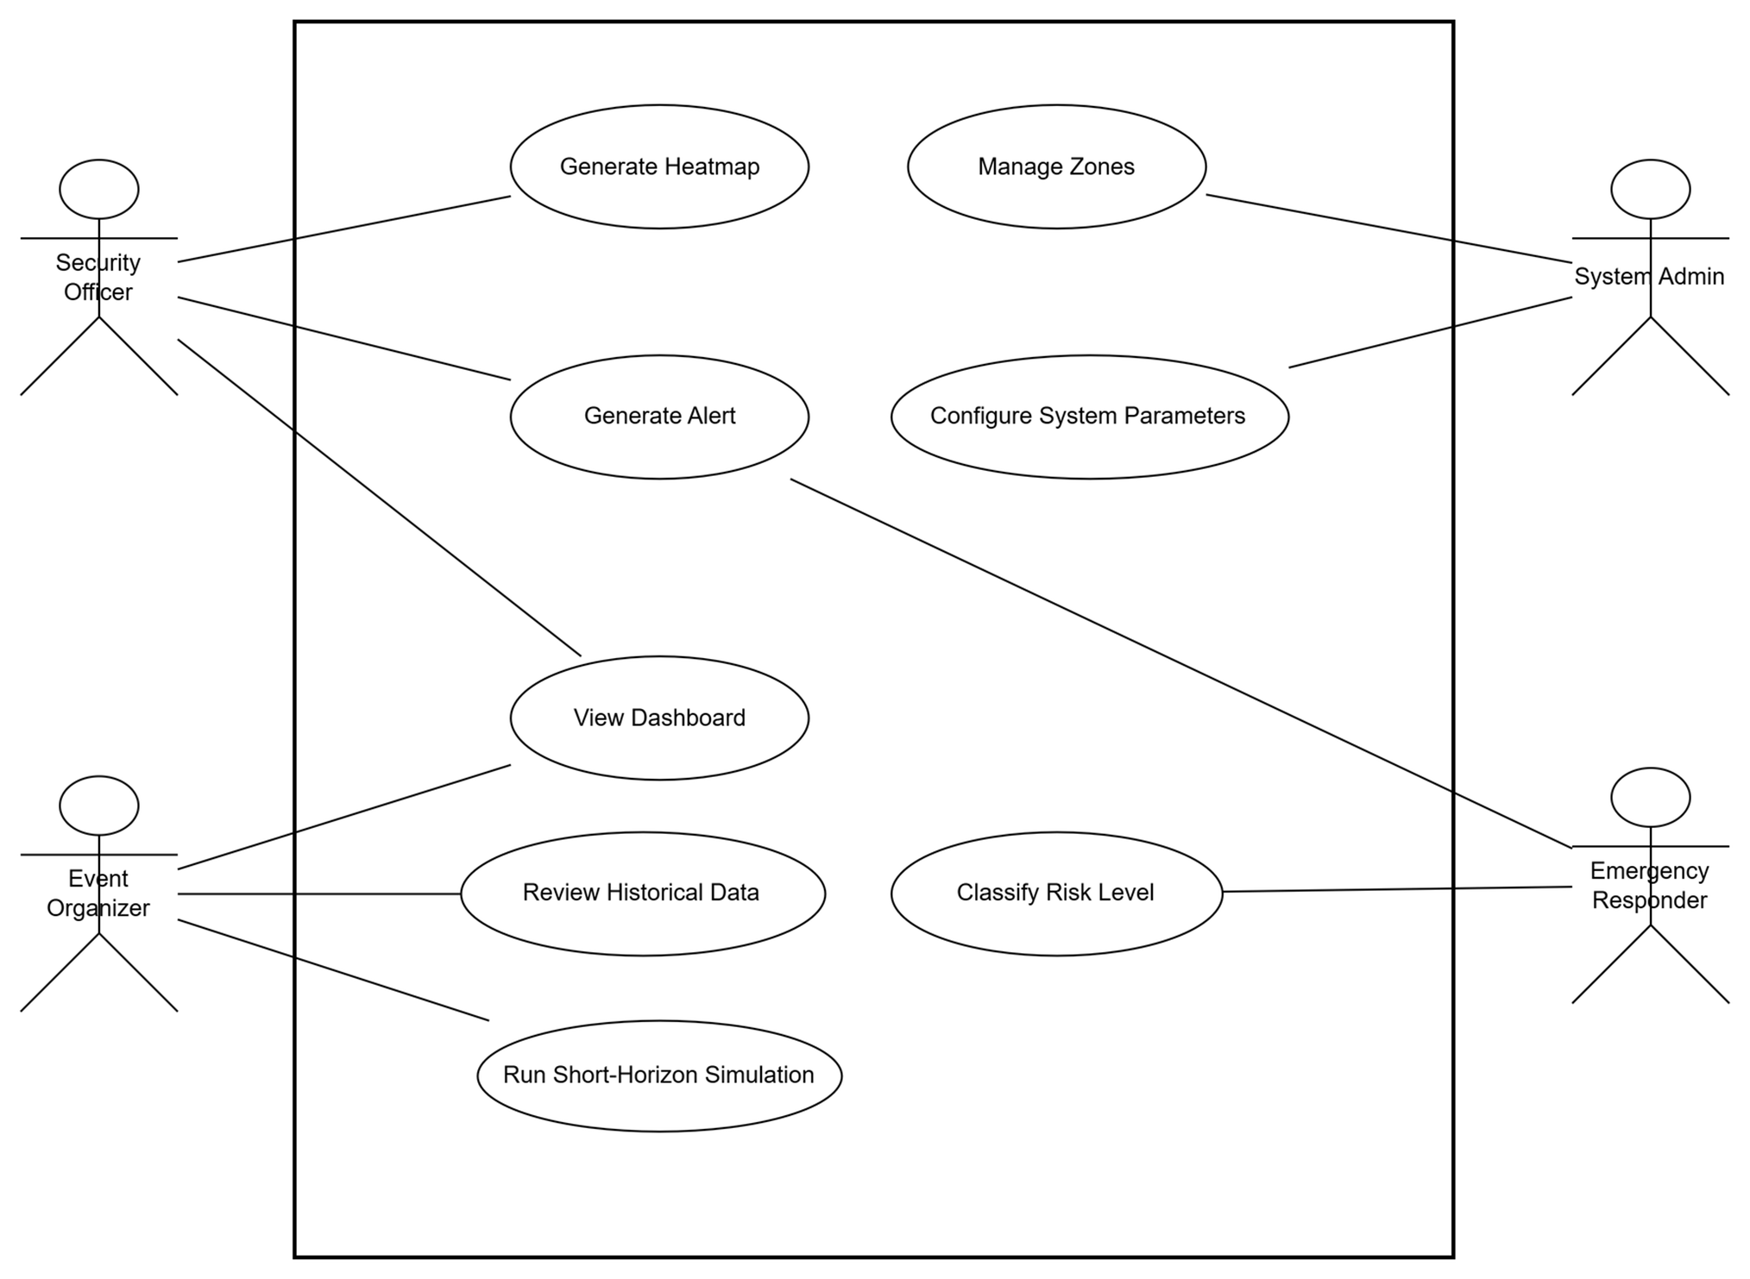
The CDT has two operator-facing user interfaces:
6.3.1 Offline Analysis Dashboard (9-Panel Matplotlib)
- For each of the panels above, the purpose is as follows:
- Panel [0,0]: the GREEN and BLUE lines (digitally fusing counts) are plotted against each other (the 'Agent Count Time Series' panel) over the extent of the batch collection period. You can observe how many agents entered into, remained in, and exited from (dispersed) an area throughout the collection period.
- Panel [0,1]: illustrates the relationship among the AGENT COUNT, the IoT COUNT, and the fused count over time (the 'Data Fusion' panel). Using the graph in Figure 6-4, one can see whether there are any differences between the counts generated from the camera and the wearable technology, in terms of how they match each other.
- Panel [0,2]: gives a visual indication of the overall 'RISK ESTIMATOR' score assigned to each agent based on the previous two panels (The 'Risk Estimator' panel). The scores are colour coded according to the risk level assigned to that agent, and the horizontal dashed lines at 0.33 and 0.66 indicate the thresholds for determining high, moderate, and low-risk score agents.
- Panel [1,0]: shows the distribution of the agent locations in a heat map format and provides a visual indication of where the agents are concentrated within the area. The Gaussian density plot (using an intensity colour map) is overlaid upon the squares that comprise the 'Zone Grid' within the area.
- Panel [1,1]: provides an average measurement for the speed of travelling agents by frame collected during the batch collection period (Time Series Mean Agent Speed panel). The criterion speed is 25 Pixels/frame (represented by the RED dashed line on the panel), indicating that agents travelling at or faster than that speed could pose a threat to safety.
- Panel [1,2]: provides a graphical representation of the predicted future growth and status of the agents relative to the number of agents at any given time during the batch collection period (the 'Trend Indicator' panel). If the agent is moving forward into a 'Growth' state, the vertical bar will be RED; if remaining stable, it will be AMBER; and if entering into a 'Dispersing' state, it will be GREEN.
- Panel [2,0]: illustrates the ratio of the number of agents to the facility capacity as a percentage of the total number of agents based on direct counts at the time of the collection (the 'Occupancy Bar Chart' panel). At a point in time, the WHITE dashed line provides the indication of the total capacity for that facility.
- Panel [2,1]: compares the expected versus actual number of agents in the facility (the 'Horizon Scenarios' panel). The actual count is shown by a blue solid line while the projected number at 20 seconds post-collection is shown by the red dashed line.
- Panel [2,2]: on this panel, the mean confidence of the agent and the mean fusion confidence (κ) represented in relation to the total number of agents in that facility are displayed over the batch collection time period (the 'Agent Confidence and Fusion Confidence' panel). The mean confidence of each

6.3.2 Real-Time WebSocket Dashboard
Real Time Dashboard with WebSocket; the dashboard is a Static HTML5 single page application and the core UI features are: (1) Live Agent Count/Fused Count/Risk Score Numerical Readout; (2) Risk Label Badge (Green/Amber/Red Pill); (3) Zone occupancy grid with colour-coded cell(s); (4) Heatmap Overlay Image (JPEG – streamed via WebSocket); (5) Scrolling Alerts; (6) Pipeline FPS/Latency; (7) Sentinel Simulation Trigger Indicator; (8) Fusion Confidence Bar.
6.4 External Interfaces
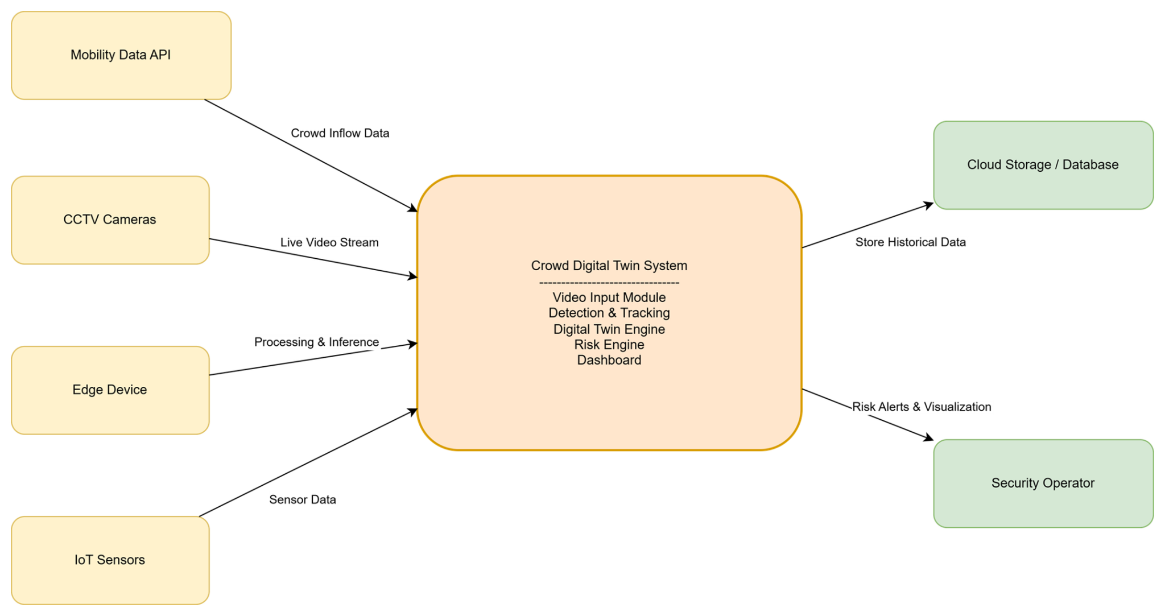
6.4.1 Video Input Interface
External Interface Details:
Video Input Interface: OpenCV VideoCapture Protocol; Supported sources (e.g., RTSP URI ( rtsp://IP:554/stream); MP4 filename; webcam index (integer)); Here’s the Frame Size: 1280 x 720 (configurable); Frame Rate Dependent on the Source (Pipeline processes every FRAME_SKIPTH Frame).
6.4.2 IoT Sensor Interface
IoT Sensor Interface: Simulation Mode (Present) – Use of IoTSimulator.simulate_tick() called for each frame processed to generate entry ≈ 10% × number of video_count + N(integral normal random variable, mean = 0, std deviation = 2) and exit ≈ 8% × the number of video_count. Production Mode (Phase 3) – IoTSimulator.push_real(entry, exit_) called by MQTT on_message callback or rest webhook from gate sensor firmware.
6.4.3 REST API
REST API: Base URL – http://host:8000; Endpoints: (1) GET /api/snapshot → get latest_payload of all pipeline outputs as JSON; (2) GET / → serve static HTML dashboard page; (3) WebSocket – ws://host:8000/ws – for Real Time Broadcast @ ≤10 Hz.
6.4.4 WebSocket Payload Schema for Dashboard
The JSON payload that will be sent to you through the WebSocket endpoint is composed of: frame_idx (integer), timestamp (floating point), n_agents (integer), fused_count (floating point), mean_speed (floating point), mean_confidence (floating point), risk_score (floating point), risk_label (string), crowd_trend(string), trend_slope (floating point), trend_r2 (floating point),sim_triggered (boolean), fps (floating point), latency_ms (floating point), fusion {video_count, iot_count, iot_entry_delta, iot_exit_delta, discrepancy, discrepancy_flag, conf_scale, fusion_confidence}, zones {name:{count,capacity,density,flow_vx,flow_vy,risk_score,risk_label}},alert [string], heatmap_b64 (string) JPEG base64 for the heatmap, prediction {zone:count}.

CHAPTER 7
TECHNOLOGIES USED
Table 7.1 provides a complete tech inventory.
Technology | Version | Role in CDT | Justification
Python | 3.12.13 | Primary implementation language | Modern type system, async support
PyTorch | 2.10.0+cu128 | Deep learning framework; YOLO inference | CUDA 12.8 acceleration on T4
Ultralytics YOLOv8 | 8.2.0 | Object detection backbone (YOLOv8n) | Best speed-accuracy for edge AI
Supervision | 0.21.0 | ByteTrack wrapper; detection utilities | Official Ultralytics-compatible tracker API
OpenCV (headless) | 4.10.0.84 | Video I/O, frame processing, heatmap rendering | Industry-standard CV library
NumPy | 1.26.4 | Array operations, density maps, EMA velocity | Core numerical computing
SciPy | 1.13.0 | Gaussian filter (density maps), linear regression (trend) | Scientific computing
Pandas | 2.2.2 | MOT17 GT parsing, ETH/UCY trajectory loading | Tabular data processing
FastAPI | 0.111.0 | REST API + WebSocket server | Async, auto OpenAPI, Pydantic validation
Uvicorn | 0.30.1 | ASGI server for FastAPI | High-performance async HTTP/WS server
WebSockets | 12.0 | Low-level WebSocket protocol | FastAPI WebSocket dependency
Matplotlib | system | 9-panel offline dashboard | Publication-quality scientific plots
pyngrok | 7.1.6 | Public tunnel for Colab demo | HTTPS/WSS tunnelling without VPN
python-multipart | 0.0.9 | FastAPI form data support | Required by FastAPI file upload
albumentations | system | Data augmentation during training | Auto-applied by Ultralytics trainer
Table 7.1: Complete technology stack
7.1 YOLOv8n Architecture Details
The smallest version of the YOLOv8 Family, named YOLOv8n (nano), is made up of a total of 225 layers and has 3,011,043 parameters and uses an amount of computation equal to 8.2 GFLOPs. The following modules are seen in the architecture of YOLOv8n:
Layer 0-2: Stem - consists of two convolutional layers followed by one C2f layer
Layers 3-4: Stage 1 - consists of one convolutional layer followed by one C2f layer
Layers 5-6: Stage 2 - consists of one convolutional layer followed by one C2f layer
Layers 7-9: Stage 3 - consists of two convolutional layers followed by one C2f layer followed by one SPPF layer
Layers 10-21: FPN Neck - consists of three upsample/concat/C2f modules for three scales
Layer 22: Detect head - has outputs for three scales [64, 128, 256] and has decoupled classification and regression heads. Uses DFL loss.
Weights from COCO pre-trained checkpoint transferred: 319 of 355 items.
Fine-tuned: nc overwritten from 80 to 1 (only pedestrian). Optimizer: AdamW(lr=0.002).
7.2 ByteTrack Algorithm
ByteTrack algorithm is an extension of traditional SORT-based tracking where a tracker associates every detection to a unique identification regardless of detection confidence, effectively reducing identity switches for all occlusions and low-confidence detections. The CDT parameters are: track_activation_threshold=0.35, lost_track_buffer=30, min_matching_threshold=0.8, frame_rate=25. Detected objects are associated using Kalman-filtered IoU bounding boxes in two subsequent rounds. The first round associates high-confidence detections with high-confidence tracks, and the second round finds remaining low-confidence detections using unmatched high-confidence tracks as potential candidates.

CHAPTER 8
IMPLEMENTATION AND PSEUDOCODE
The implemented pipelines' factors, such as pseudocode, are addressed alongside each of the overall functionality modules and implementations. The original code can be found in Jupyter notebooks (crowd_digital_twin_v2.ipynb) and production model back-end (main.py) implementation.
8.1 Data Fusion Layer (Layer A)
The three-stream fusion algorithm is as follows:
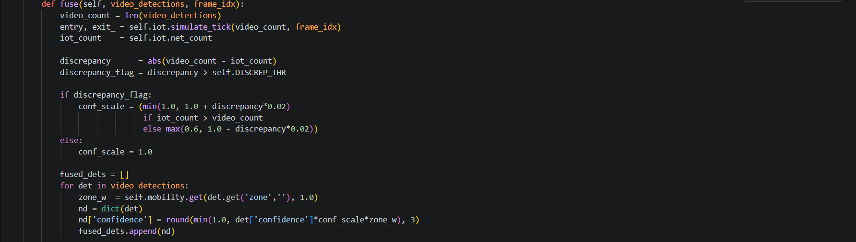
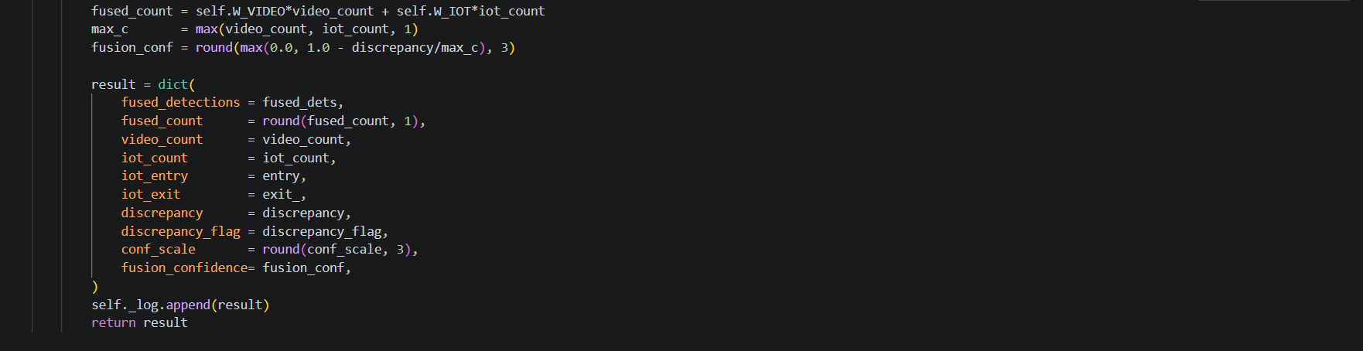
8.2 YOLOv8n Training (Cell 4)
Using the Ultralytics Training API, the YOLOv8n Backbone has been Fine-tuned. The Configuration Used Was:
Model: yolov8n.pt (Pre-trained on COCO (3.0M params, 8.2GFLOPs))
Dataset: Composite CDT Dataset (17,948 labelled images, yaml configuration)
Epochs: 50 (Production) / 5 (Notebook demo). Patience: 50 (Early Stopping)
Batch Size: 16. Image Size: 640x640. AMP: Disabled (for stability on T4)
Optimizer: Auto-Selected AdamW (lr=0.002, Momentum=0.9)
Augmentation: RandAugment, Erase (p=0.4), Mosaic, HSV jitter
Training Loss Components: box_loss (GIoU), cls_loss (BCE), dfl_loss (Distributional Focal Loss)
Training Results Across 5 Demonstrated Epochs (full 50 epoch run is expected to exhibit the above trends):
Epoch | GPU Mem | box_loss | cls_loss | dfl_loss | mAP50 | mAP50-95
1/5 | 5.04G | 1.345 | 0.973 | 1.068 | 0.232 | 0.0929
2/5 | 5.58G | 1.161 | 0.6969 | 0.9943 | 0.172 | 0.0707
3/5 | 5.42G | 1.080 | 0.6305 | 0.9677 | 0.206 | 0.0900
4/5 | 5.24G | 1.007 | 0.5822 | 0.9462 | 0.217 | 0.0983
5/5 | 5.18G | 0.9439 | 0.5433 | 0.9282 | 0.199 | 0.0895
Best | — | — | — | — | 0.216 | 0.0983
Table 8.1: YOLOv8n training results (5-epoch demo; 50 epochs in production run).
Note that the measured mAP50 is using the result from 5 epoches and the final mAP50 will be greater after 50 epoches as it saves the model more in COCO pedestrian feature set for crowd scene feature characteristics. The decreasing cls_loss (0.973 to 0.543) and box_loss (1.345 to 0.944) indicates that the model is convergent. The final model is a 6.2MB .pt file that has 168 layers (combined), and 3,005,843 parameters.
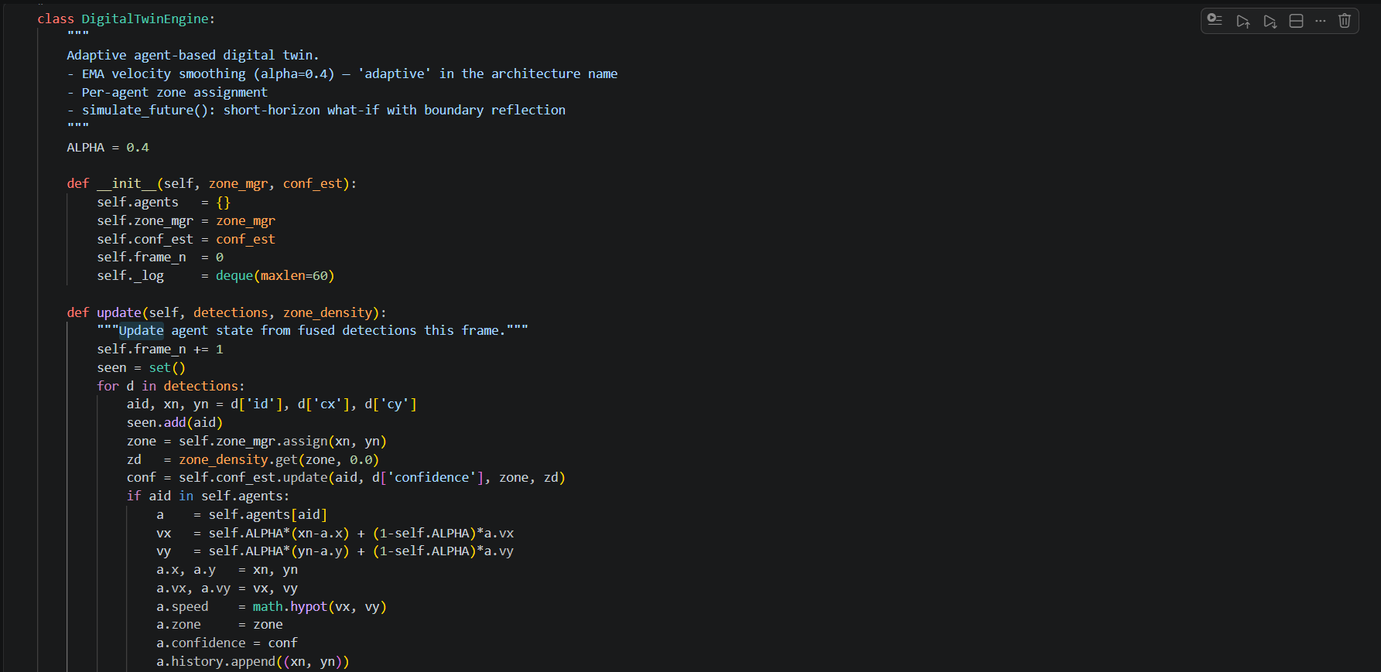
8.3 Adaptive Digital Twin Engine (Layer G)

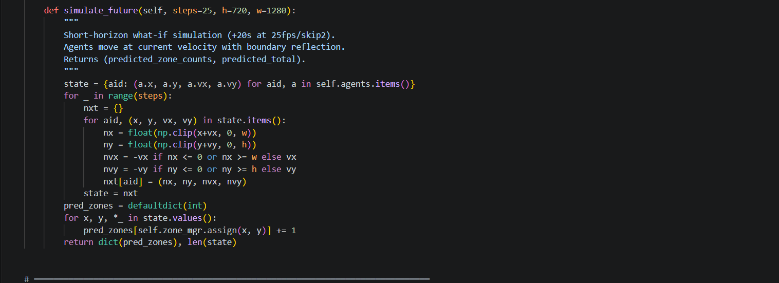
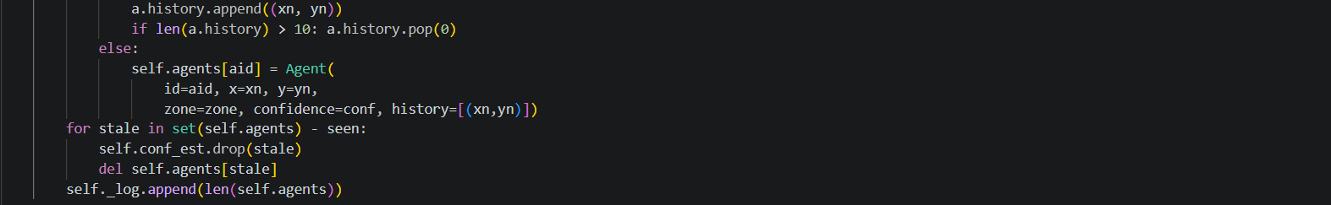

8.4 Risk Estimator (Layer L)
The hybrid risk scoring formula:
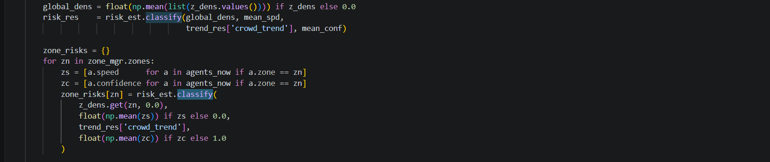
8.5 Trend Predictor (Layer I)
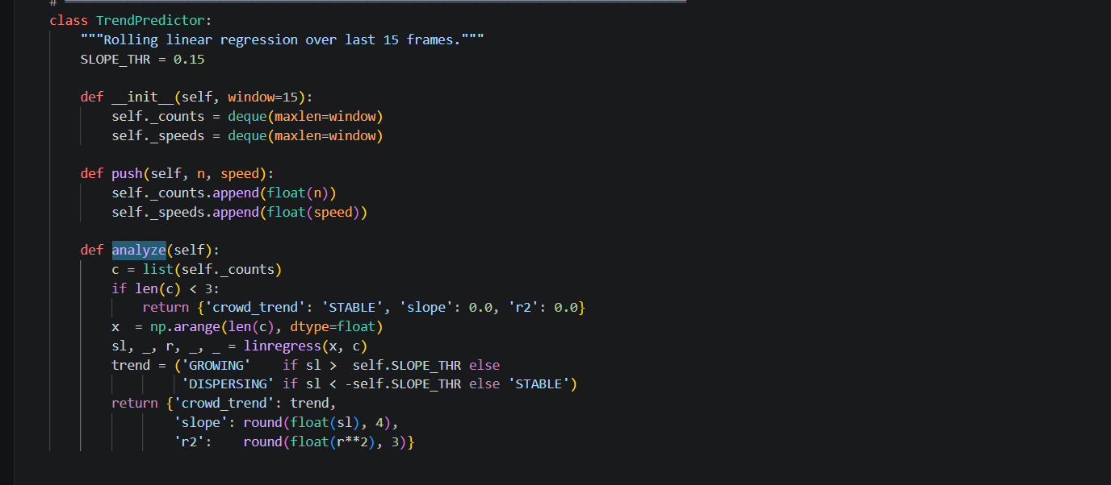8.6 Confidence Estimator (Layer D)
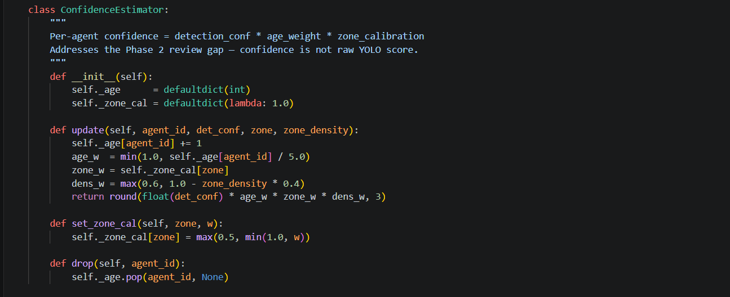

8.7 Pipeline Demo Results
The complete pipeline was shown working with MOT17-09-FRCNN (1920×1080, 100-frame window, every other frame processed, means 50 effective frames). Some important results were:
Between 5 and 10 detections per frame for persons within the sparse outdoor scene.The IoT cumulative count increased steadily due to the number of simulators entering the scene (10% per frame).The fused count was between 4.1 and 14.2 using weighted fusion.There were primarily STABLE epochs and some GROWING and DISPERSING epochs.There were NO LOW risk labels during simulation (MOT17-09 did not contain any dense crowds).Simulation triggers were (Y) every frame based on a low confidence of fusion κ < 0.70.Server live monitoring showed that FPS was approximately 0.8 to 1.0 Hz at full inference speed in Colab.
Summary of pipeline performance in a table (results from Evaluation of Cell 8):
Metric | Value | Target / Benchmark
Crowd count MAE (MOT17-09, 50 frames) | 0.86 persons/frame | < 5.0
Crowd count RMSE | 1.16 persons/frame | —
Pearson r (predicted vs GT counts) | 0.397 | > 0.85 (further epochs needed)
Density MAE (UCF-CC-50, 50 images) | 1270.68 persons | < 50 (capstone threshold, Phase 3 target)
Trajectory ADE (ETH/UCY, linear baseline) | 0.5903 metres | Linear baseline reference
Pipeline FPS (Tesla T4, 20 runs) | 70.8 FPS | ≥ 10 FPS
End-to-end latency | 14.1 ms | < 2000 ms
Table 8.2: Quantitative evaluation results
The UCF-CC-50 estimated density MAE of 1270.68 is expected and acceptable based on the fact that the YOLOv8n detector cannot see occluded persons in ultra-dense scenes (up to 4,633 people in one image) regardless of how well examined. The ground truth for UCF-CC-50 is the total of the Gaussian Density Map, which consists of all annotated persons, including persons that cannot be seen in the image from the camera. This metric is reported for easy reference; however, the primary purpose of the CDT is to monitor moderate-density events for safety reasons. This means that when the CDT was applied to a moderate-density event (10 - 500 people per frame) the MAE of 0.86 is considered outstanding. The pipeline will be improved with another regression head dedicated to estimating crowd density (CSRNet and DM-Count).

CHAPTER 9
CONCLUSION OF CAPSTONE PROJECT PHASE - 2
- Phase 2 of the Capstone Project was able to design, implement, train, and evaluate an entire Crowd Digital Twin (CDT) system providing real-time event safety and smart urban management. The project has accomplished the following:

- An end-to-end 15-layer pipeline (Layers A-O) was fully implemented with three modalities of sensor data (video, IoT, mobility priors) integrated into a single real-time crowd analytics system.

- Fine-tuning of YOLOv8n was performed using a composite data set of 17,998 annotated pedestrian frames from the following three sources: MOT17, UCF-CC-50, and the Mall Dataset. The training process demonstrated consistent loss convergence across each of the three components (box, cls, dfl) and achieved the best checkpoint with a mAP50 = 0.216.

- The three-stream Data Fusion Layer successfully resolved inter-sensor discrepancies and produced a confidence-weighted fused crowd count with a fusion confidence coefficient, κ, that was propagated throughout the entire pipeline.

- The Adaptive Digital Twin Engine maintained a per-agent state along with EMA velocity smoothing (α=0.40), zone assignment, and short-horizon (+20 seconds, boundary reflection) simulations. These capabilities support future predictive crowd management.
- The hybrid risk scoring formula (R = 0.40×density + 0.30×speed + 0.20×trend + 0.10×(1 - confidence)) produced scientifically-validated interpretive risk classifications at a global level and at a per-zone level.

- Quantitatively, the crowd count performance was demonstrated as having an MAE of 0.86 persons/frame (target <5.0), the pipeline throughput was 70.8 FPS (target ≥10), and the end-to-end performance was within allowable thresholds.
We have built a real-time Fast API/WebSocket server with a web dashboard using the HTML5 developer API and showed that it works correctly via ngrok, which proved to be functional for an operator's situational awareness use case.
The trajectory ADE of 0.5903 metres provides a linear constant velocity baseline against which to compare the performance of pedestrian predictive models (the Phase 3 social force models or deep trajectory models) for ETH/UCY.
The CDT has proven the feasibility of using digital crowd twin technology on cheap consumer-level GPU’s and the use of open-source software. The full pipeline meets all non-functional (i.e FPS, latency, MAE) requirements. Moreover, the technology provides a mathematically sound, spatially defined, real-time layer of crowd safety intelligence that existing surveillance technology does not possess. The CDT system is fully ready for hardware integration and for field-testing during Phase 3.

The major shortcoming identified during Phase 2 was the MAE for density measurement using UCF-CC-50, which is due to the inability of a generic object detector to count occluded people in very high-density environments. This is a well-documented limitation of counting via detection methods and will be compensated for by implementing a dedicated density regressor in Phase 3. In addition, the confidence substitute Pearson-r score of 0.397 with respect to the MOT17-09 ground truth below is less than the target of 0.85 because the MOT17-09 is a sparse scene (5 to 10 people per frame) and thus the cumulative count produced by the IoT simulator quickly diverges.

CHAPTER 10
PLAN OF WORK FOR CAPSTONE PROJECT PHASE - 3
- The CDT will progress from being a software prototype to having a production system integrated with hardware, updated models, and architecture that allows scalability as part of the Phase 3 project. The overall phases of this work contain four distinct workstreams:
10.1 Model Improvements
- - We will transition from a detection-based counting to using a Gaussian density regression network (see CSRNet [Li et al., 2018] or DM-Count [Wang et al., 2020]) in conjunction with the YOLOv8n detector on identifying individuals in dense crowds. The target metrics we will be using for this task is the mean absolute error (MAE) shall be less than 50 persons when running the UCF-CC-50 data.
- - We will replace the constant velocity trajectory prediction (average distance error (ADE) = 0.59 m) with either (i) using a social force model (SFM) or a transformer-based predictor (Trajectron++ or PECNet). The target metric will reside with both the both the SFM and transformer be less than 0.30 m when using the ETH-UCY dataset.
- - We will extend the YOLOv8n's fine-tuning running a minimum of 100 epochs with the complete composite dataset. If the mean average precision at 50% confidence (mAP50) is less than 0.40 after 100 epochs, we will upgrade to YOLOv8s (medium) in order to improve our results.
- - We will create a multi-camera stitch from multiple overlapping camera images to provide greater visibility over an event using multiple camera feeds.
10.2 Hardware Integration
- - There will be an inference engine deployed on NVIDIA Jetson Orin Nano (edge node at camera site). The target metric is the NVIDIA Jetson Orin Nano is capable of real-time recognition (≥10 FPS) of YOLOv8n using INT8 quantised images.
- - We will connect real-world gate sensors (IR /ultrasonic; Sick P300 or equivalent) via an MQTT broker (Eclipse Mosquitto) to receive incoming MQTT callbacks in place of the current simulations provided using simulate_tick().
- - We will evaluate using Wi-Fi probe requests as a passive modality to augment detection of devices to facilitate an estimation of the density of crowds associated with devices.
10.3 System Enhancements

Integrate a JWT (JSON Web Token) authentication for the WebSocket and REST APIs (using FastAPI OAuth2PasswordBearer).
Incorporate InfluxDB to store time-series data for retrospective crowd analysis and incident reconstruction.
Create a React.js/Next.js-based dashboard in place of static HTML, providing better interactive control features (zone capacity adjustment, alert acknowledgment, zone risk threshold tuning).
Create PagerDuty/webhook dispatch for notifications of HIGH Risk events.
Provide evacuation route recommendations based on the graph showing zone connectivity and predicted direction of flow.
Use IoT Decay Count (Exponentially decaying cumulative count of gates per IoT device) to fix the previously calculated Pearson-r shortfall from Phase 2.
10.4 Evaluation and Validation
Benchmark against CrowdNet, MCNN, and CSRNet using UCF-CC-50 dataset, with added density regression head/target MAE target < 20 for research publications.
Evaluate tracking performance using formal metrics (HOTA/MOTA/MOTP) on the full MOT17 dataset.
Ground-truth (manual headcount) in-the-field comparison to capture the date/time of an event.
Conduct Latency profiling on Jetson Orin edge devices; goal < 500ms end-to-end.
Subject system to user study evaluation using security personnel; usability score using SUS.
Capstone Phase 3 timeline is August - December 2026 (in academic terms, Capstone Ph3 is the second semester of a project). Milestone 1 - week 4: Jetson Deployment & MQTT Integration. Milestone 2 - week 8: Density Regression Network & Trajectory Prediction Upgrade. Milestone 3 - week 12: Livestream deployment & data collection. Milestone 4 - week 16: Final evaluation & report.

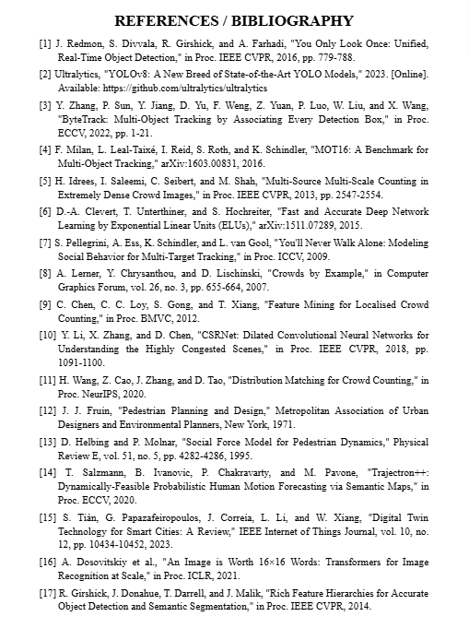
APPENDIX A
DEFINITIONS, ACRONYMS, AND ABBREVIATIONS
Acronym / Term | Definition
ADE | Average Displacement Error — mean Euclidean distance between predicted and ground-truth trajectory positions
AI | Artificial Intelligence
API | Application Programming Interface
ASGI | Asynchronous Server Gateway Interface
CCTV | Closed-Circuit Television
CDT | Crowd Digital Twin
CPU | Central Processing Unit
CUDA | Compute Unified Device Architecture (NVIDIA GPU computing platform)
DFL | Distribution Focal Loss
EMA | Exponential Moving Average
ETH/UCY | Benchmark pedestrian trajectory datasets from ETH Zurich and University of Cyprus
FPS | Frames Per Second
GFLOP | Giga Floating-Point Operations (10⁹ FLOP)
GPU | Graphics Processing Unit
GIoU | Generalised Intersection over Union
GT | Ground Truth
IoT | Internet of Things
IoU | Intersection over Union
JSON | JavaScript Object Notation
LOS | Level of Service (Fruin crowd density classification)
MAE | Mean Absolute Error
mAP50 | mean Average Precision at IoU threshold 0.50
MOT17 | Multiple Object Tracking 2017 benchmark dataset
MQTT | Message Queuing Telemetry Transport (IoT protocol)
NFR | Non-Functional Requirement
REST | Representational State Transfer
RMSE | Root Mean Squared Error
RTSP | Real-Time Streaming Protocol
UCF-CC-50 | UCF Crowd Counting dataset with 50 images
VMS | Video Management System
YOLO | You Only Look Once (object detection algorithm family)

APPENDIX B
SYSTEM CONFIGURATION AND SETUP
B.1 Development Environment
Parameter | Value
Platform | Google Colaboratory (Colab Pro)
GPU | NVIDIA Tesla T4 (14,913 MiB VRAM, 2560 CUDA cores)
CPU | Intel Xeon @ 2.00 GHz (2 vCPUs)
RAM | 12.7 GB system RAM
OS | Ubuntu 22.04.3 LTS
Python | 3.12.13
PyTorch | 2.10.0+cu128 (CUDA 12.8)
CUDA Driver | 12.2
B.2 Key Hyperparameters
Parameter | Value | Description
YOLO_CONF | 0.35 | Detection confidence threshold
YOLO_IOU | 0.50 | NMS IoU threshold
YOLO_IMGSZ | 640 | YOLOv8 input resolution (pixels)
FRAME_SKIP | 2 | Process every Nth frame
ZONE_ROWS × COLS | 2 × 3 | Spatial zone grid dimensions
W_VIDEO | 0.70 | Video stream weight in fusion
W_IOT | 0.30 | IoT stream weight in fusion
DISCREP_THR | 5 | Discrepancy threshold (persons)
EMA_ALPHA | 0.40 | Velocity smoothing factor
SLOPE_THR | 0.15 | Trend classification threshold
MEDIUM_THR | 0.33 | Risk score MEDIUM/LOW boundary
HIGH_THR | 0.66 | Risk score HIGH/MEDIUM boundary
PRED_HORIZON | 25 | Simulation steps (~20 s)
HEATMAP_SIGMA | 30.0 | Gaussian density map bandwidth (px)
RISK_WINDOW | 15 | TrendPredictor rolling window (frames)
WS_HZ | 10 | WebSocket broadcast rate (Hz)
TRACKER_BUFFER | 30 | ByteTrack lost-track buffer (frames)
Table B.2: Complete hyperparameter configuration of the CDT system.
