Maven is a project management tool

It does

1. Build generation
2. Dependency resolution
3. Documentation

POM (Project Object Management) – it is a xml file which contains all the configurations and build informations

In maven we have to specify what to do? It automatically gets how to do

Pom.xml

Every pom is inherited from a superpom which contains all the dependencies and it can also inherit from the previous project which ultimately inherite somethings from supermom

<properties> </properties> -key value pairs

Repositories, dependencies

Build –main

BUILD lifecycle has 7 phases. Each phases have some specific goals and we can also add our own goals in it

1. Validate phase- it sees the configurations . By default it contains some plugins mavin.checkstyle.plugin.
2. Compile phase – here our source code (java code) is converted into byte code in .class file
3. Test phase- here all the test cases we we write is run and success , failure is mentioned
4. Package phase- here everything is bundled into .jar file which is stored in target
5. Verify- this is used for static code analysis .It contains plugins like pmd analyser. It checks for unused variables and imports , empty cache block, no object uses, duplicate block. There are also certain plugins like checksum , signature also
6. Install- install the package in the local machine . “`/.m2/repository
7. Deploy- used to deploy in maven central(public repo) or private reps .   
   By default it is not present in the pom we have to add it in

Pom.xml

<project>

<distributionManagement>

<repository>

Id and url

</repository>

</distributionManagement>

</project>

Settings.xml

Add username , password

Maven is essentially a project management and comprehension tool and as such provides a way to help with managing:

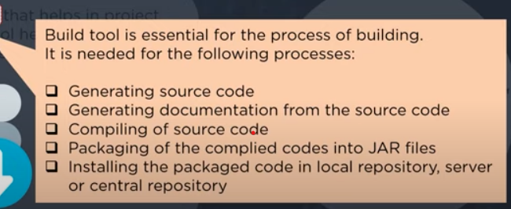

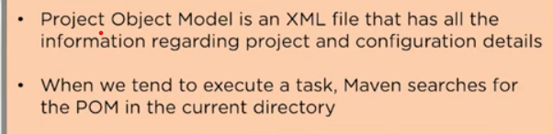

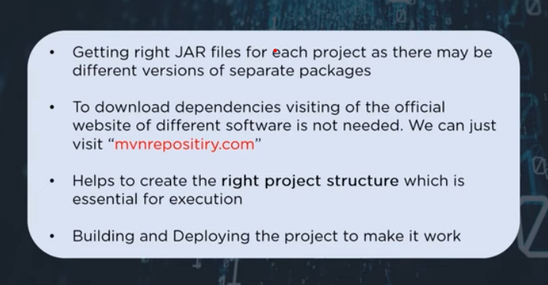

* Builds
* Documentation
* Reporting
* Dependencies
* SCMs
* Releases
* Distribution