CXMT IPO and Semiconductor Ecosystem Response:
An Event-Aligned Normalized Return Analysis
Cross-Market Event-Aligned Comparative Analysis
Date: August 8, 2026 | Report Type: Independent Quantitative Research Note
Analyst: Liu Ruize (Utah State University) | Status: Final Research Version 4 - Data through Aug. 7
Repository: github.com/Ritz-Liu/CXMT-Semiconductor-Analysis | Reproducibility: Python Workflow & Documented Data Pipeline
Keywords: CXMT; IPO; semiconductor ecosystem; normalized return; cross-market comparison; reproducibility | JEL: G14, G15, L63
Event Date | Research Window | Covered Securities | Core Measures
July 27, 2026 | June 8-August 7, 2026 | 7 companies / 3 markets | NCR and MA7

EXECUTIVE SUMMARY
Research objective. This final research version examines market responses surrounding the CXMT IPO and compares selected semiconductor-ecosystem participants using an event-aligned normalized return framework. The report uses daily closing prices and figure-specific baselines rather than estimating abnormal returns or conventional cumulative abnormal returns (CAR).
Final findings. With the research window frozen through August 7, 2026, the three figures show clear short-term differentiation. In Figure 1, AMEC ended 38.49% above its June-window baseline, compared with gains of 7.34% for NVIDIA and 3.91% for Apple. In Figure 2, CXMT was the only covered memory-sector name above the July 27 common baseline at the endpoint: CXMT gained 7.10%, while Micron, Samsung Electronics, and SK hynix ended 2.51%, 9.06%, and 21.70% below their respective event-date closes. CXMT closed at RMB 52.48 on August 7, with a complete MA7 of RMB 53.65.
Interpretation boundary. These patterns describe short-term price behavior during a limited observation period. They do not establish that the CXMT IPO caused peer movements, do not infer institutional trading behavior from prices alone, and do not constitute an investment recommendation.

1. Research Objective and Market Context
CXMT is treated as the focal listing event within a broader semiconductor ecosystem that includes upstream equipment, global memory peers, semiconductor-design/AI exposure, and downstream electronics demand. The analytical question is whether these different roles display visibly different short-term price responses around the same period, not whether every observed move can be attributed to the IPO itself.

1.1 Research Questions
- RQ1. How did selected semiconductor-ecosystem companies perform during the observation window surrounding the CXMT IPO?
- RQ2. How did CXMT and selected global memory peers differ after all four firms were aligned to the same July 27 event-date baseline?
- RQ3. How did CXMT's own closing price develop after listing, and what limited descriptive information is provided by a complete seven-trading-day moving average?

1.2 Research Contribution
The contribution is a transparent, reproducible record of an early listing window rather than a causal event study. The workflow links documented public market-data interfaces, frozen real-data CSV files, explicit figure-specific baselines, exchange-specific trading-date preservation, and reproducible Python calculations while keeping the distinction between NCR and conventional abnormal-return measures explicit.

1.3 Coverage Matrix
Company / Ticker | Ecosystem Role | Analytical Role | Figure
CXMT (688825.SH) | Memory semiconductor | Focal IPO company; memory-peer comparison and post-listing price development | 2 / 3
AMEC (688012.SH) | Upstream semiconductor equipment | Broader ecosystem comparison; equipment-side exposure | 1
SK hynix (000660.KS) | Memory semiconductor | Global memory peer | 2
Samsung Electronics (005930.KS) | Memory semiconductor | Global memory peer | 2
Micron Technology (MU) | Memory semiconductor | Global memory peer | 2
NVIDIA (NVDA) | Semiconductor design / AI ecosystem | AI-ecosystem comparison | 1
Apple (AAPL) | Downstream electronics demand | Demand-side electronics comparison | 1
Scope note. The sample is intentionally small and role-based rather than statistically exhaustive. The unit of analysis is a security-date daily closing-price observation; volume, intraday prices, firm fundamentals, and investor-level transactions are outside the dataset.

2. Semiconductor Ecosystem Framework
Figure 1 compares AMEC, Apple, and NVIDIA using Normalized Cumulative Return (NCR). Each series is normalized to its first valid closing price on or after June 8, 2026 within the predefined observation window. The vertical event marker identifies the CXMT IPO date but does not change the Figure 1 baseline rule.
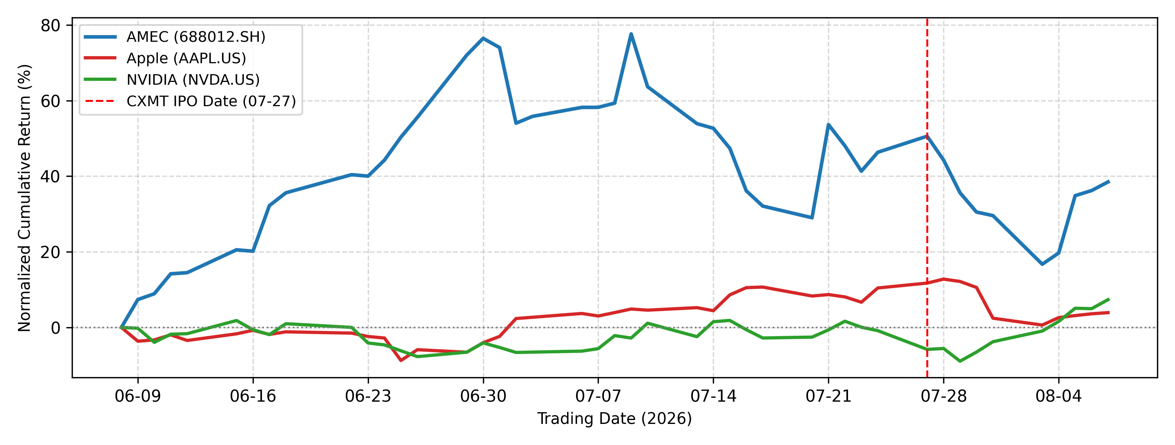
Figure 1. Semiconductor Ecosystem Normalized Return Comparison
Source: Tencent Finance interface (AMEC); Sina Finance with Yahoo Finance fallback (Apple and NVIDIA); author calculations in Python. Final data through August 7, 2026.
AMEC Endpoint NCR | NVIDIA Endpoint NCR | Apple Endpoint NCR
+38.49% | +7.34% | +3.91%

2.1 Auditable Endpoint Values
Company | Baseline Date | Baseline Close | Final Date | Final Close | Endpoint NCR
AMEC | Jun. 8 | RMB 265.47 | Aug. 7 | RMB 367.65 | +38.49%
NVIDIA | Jun. 8 | USD 208.64 | Aug. 7 | USD 223.96 | +7.34%
Apple | Jun. 8 | USD 301.54 | Aug. 7 | USD 313.33 | +3.91%

2.2 Observed Ecosystem Response
- AMEC: AMEC showed the strongest endpoint performance in the comparison. After reaching a much higher peak earlier in the window and falling sharply through August 3, it partially recovered and ended 38.49% above its June-window baseline.
- Apple: Apple remained above its starting baseline around the IPO period but retreated from its late-July high. It ended the window 3.91% above baseline, supporting a modest relative-performance description rather than a claim about memory-cost pass-through or margin protection.
- NVIDIA: NVIDIA moved below baseline in late June, recovered during July, and strengthened during the final observations. It ended 7.34% above baseline, ahead of Apple but well below AMEC's normalized gain. The series is an AI-ecosystem comparison, not evidence of a direct IPO transmission mechanism.
Overall, Figure 1 shows differentiated normalized performance across ecosystem roles. AMEC retained the largest cumulative gain, while NVIDIA's late-window rise placed it ahead of Apple at the endpoint. The comparison remains descriptive because the three securities were also exposed to distinct company-specific and market-wide information.

3. Event-Aligned Memory Sector Comparison
Figure 2 uses a common event baseline: July 27, 2026, the CXMT listing date, is defined as NCR = 0% for CXMT, Micron, Samsung Electronics, and SK hynix. This makes post-event movements directly comparable across the four memory-sector names while preserving the descriptive, non-causal interpretation of the study.
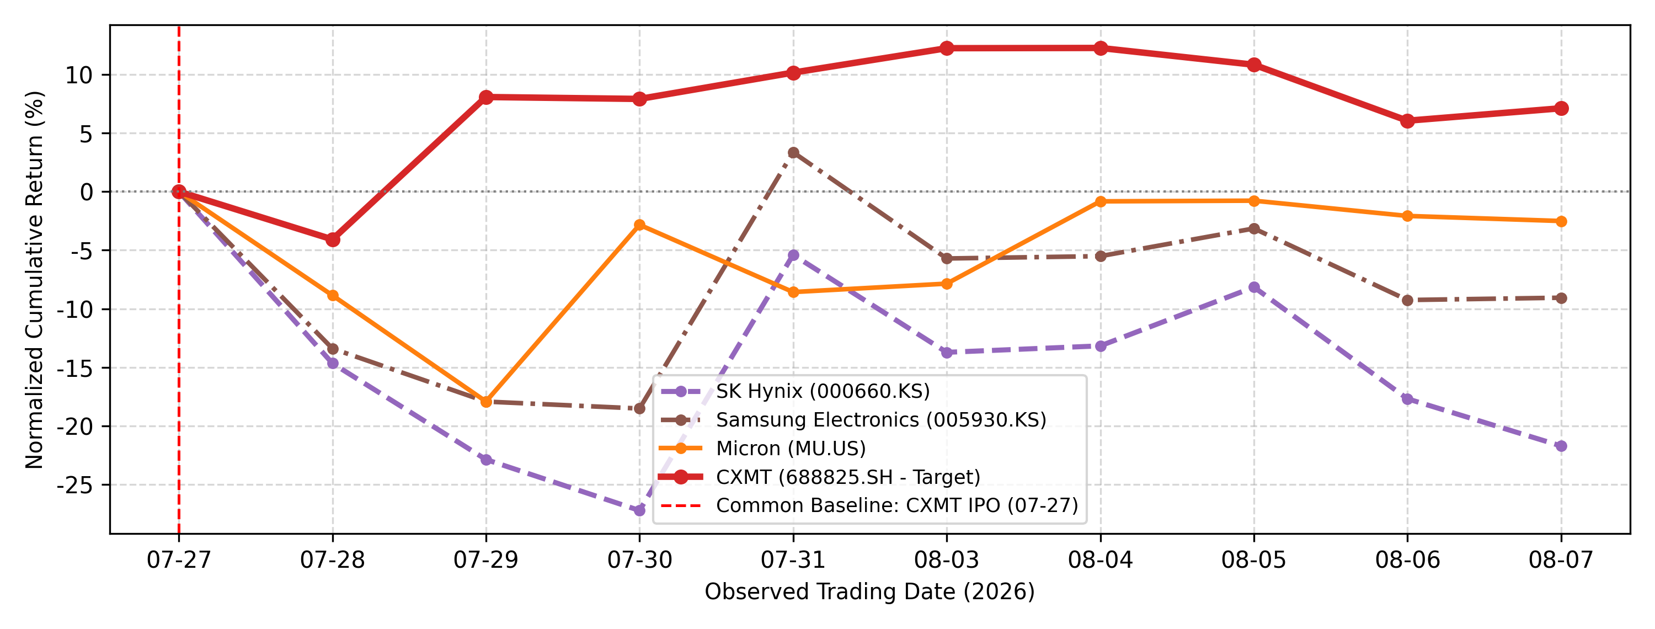
Figure 2. Event-Aligned Memory Sector Performance Comparison
Source: Tencent Finance interface (CXMT); Sina Finance with Yahoo Finance fallback (Micron); Naver Stock interface (Samsung Electronics and SK hynix); author calculations in Python. Common baseline: July 27, 2026 = 0%. Final data through August 7, 2026.
CXMT | Micron | Samsung Electronics | SK hynix
+7.10% | -2.51% | -9.06% | -21.70%

3.1 Auditable Endpoint Values
Company | July 27 Close | Currency | Final Date | Final Close | Endpoint NCR
CXMT | 49.00 | RMB | Aug. 7 | 52.48 | +7.10%
Micron | 900.20 | USD | Aug. 7 | 877.57 | -2.51%
Samsung Electronics | 254,000 | KRW | Aug. 7 | 231,000 | -9.06%
SK hynix | 1,816,000 | KRW | Aug. 7 | 1,422,000 | -21.70%

3.2 Short-Term Divergence After the IPO Date
- CXMT: After closing 4.08% below the listing-day baseline on July 28, CXMT moved above zero on July 29 and remained positive through the end of the window. Its August 7 NCR was +7.10%, the strongest endpoint result in the four-name comparison.
- Micron: Micron stayed below the common baseline throughout the displayed post-event observations. Its path included a rebound on July 30 and further recovery in early August, but it ended the window at -2.51%.
- Samsung Electronics: Samsung fell substantially during July 28-30 and briefly moved above the common baseline on July 31. It subsequently returned to negative territory and ended August 7 at -9.06%.
- SK hynix: SK hynix recorded the deepest negative movement in the group. Although it rebounded sharply on July 31 and again on August 5, it ended the window at -21.70%, the weakest endpoint among the covered peers.
The final ranking is CXMT, Micron, Samsung Electronics, and SK hynix. This divergence is consistent with different company-specific and market conditions during the same short window; it is not causal evidence that the CXMT IPO produced the peer-stock declines.

4. CXMT Post-IPO Price Development
Figure 3 reports CXMT daily closing prices directly in RMB. The listing-day close of RMB 49.00 on July 27 serves as the company-specific event anchor. The analysis uses closing prices only; therefore July 28 is described as a RMB 47.00 close rather than an intraday low or technical support level.
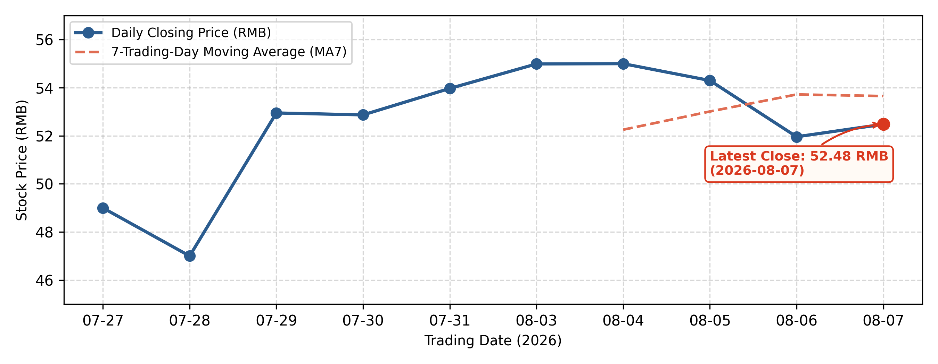
Figure 3. CXMT Post-IPO Closing Price and 7-Trading-Day Moving Average
Source: Tencent Finance interface (CXMT); author calculations in Python. Latest displayed close: RMB 52.48 on August 7, 2026; latest MA7: RMB 53.65.
Listing-Day Close | August 7 Close | Latest Complete MA7 | Close vs. MA7
RMB 49.00 | RMB 52.48 | RMB 53.65 | -2.19%

4.1 Observed Price Development
- Initial adjustment: CXMT closed at RMB 47.00 on July 28, down 4.08% from the RMB 49.00 listing-day close.
- Recovery and later pullback: The stock recovered to RMB 52.95 on July 29 and stayed above the listing-day close through August 7. It reached RMB 55.00 on August 4 before falling to RMB 51.96 on August 6 and recovering modestly on the final day.
- Final observation: CXMT closed at RMB 52.48 on August 7, 7.10% above the listing-day close but 4.58% below the August 4 close.
- MA7 treatment: The complete seven-observation rule produced four MA7 values: RMB 52.25 on August 4, RMB 53.01 on August 5, RMB 53.72 on August 6, and RMB 53.65 on August 7. The final close was 2.19% below the latest MA7. Given the very short series, these values are used only for descriptive smoothing and do not establish a trend or trading signal.
No 'golden cross,' institutional buying, technical-floor confirmation, or price-target conclusion is drawn from Figure 3.

4.2 Daily Closing Prices and Complete MA7 Values
Date | Close (RMB) | MA7 (RMB) | Date | Close (RMB) | MA7 (RMB)
Jul. 27 | 49.00 | - | Aug. 3 | 54.99 | -
Jul. 28 | 47.00 | - | Aug. 4 | 55.00 | 52.25
Jul. 29 | 52.95 | - | Aug. 5 | 54.30 | 53.01
Jul. 30 | 52.87 | - | Aug. 6 | 51.96 | 53.72
Jul. 31 | 53.97 | - | Aug. 7 | 52.48 | 53.65

5. Methodology and Data Pipeline

5.1 Event-Aligned Research Design
Event date: July 27, 2026 (CXMT listing date). Predefined research window: June 8 to August 7, 2026. Final Version 4 includes all valid observations in the frozen window through the August 7 close. Exchange-specific trading dates are preserved rather than forcing a synthetic common calendar.
Relative to conventional event-study methods described by MacKinlay (1997), this framework is descriptive. It does not estimate expected returns, market-model beta, abnormal returns, or conventional cumulative abnormal returns (CAR).

5.2 Normalized Cumulative Return (NCR)
NCR(i,t) = [P(i,t) / P(i,0) - 1] x 100%, where P(i,t) is the closing price of security i on date t and P(i,0) is the baseline closing price defined for the relevant figure.
Baseline rule. Figure 1 uses each security's first valid closing price on or after June 8, 2026. Figure 2 uses July 27, 2026 as one common 0% baseline for CXMT, Micron, Samsung Electronics, and SK hynix. Figure 3 reports CXMT closing prices directly and therefore does not use NCR.
Interpretation boundary. NCR is a descriptive normalized price-performance measure. It is not conventional CAR and should not be read as an estimate of abnormal return.

5.3 7-Trading-Day Moving Average (MA7)
MA7(t) = (1/7) x Sum[k=0...6] P(t-k). The implementation requires seven complete trading observations (rolling window = 7, min_periods = 7). MA7 is used only to smooth the closing-price series for descriptive visualization.

5.4 Data Sources and Processing
A-share data are retrieved through Tencent Finance interfaces; U.S. data use Sina Finance with Yahoo Finance as a fallback; Korean-market data use Naver Stock interfaces. The processing workflow is: retrieve -> validate/clean -> preserve exchange-specific trading dates -> apply figure-specific baseline rules -> calculate NCR or MA7 -> generate figures -> document outputs. Synthetic future observations and manual filling of unavailable market prices are not permitted.

6. Data Reliability and Research Limitations
- No artificial price generation, future-data generation, or manual filling of unavailable prices.
- Daily closing prices are used unless a separate OHLC source is explicitly documented.
- The sample is intentionally small and heterogeneous, and the observation window is short.
- Cross-market prices reflect simultaneous company, industry, macroeconomic, and market-structure factors; causal identification is outside the scope of this note.

7. Conclusion
Across the frozen window, the three comparisons point to short-term differentiation rather than a uniform semiconductor-sector response. AMEC retained the largest Figure 1 gain, NVIDIA finished ahead of Apple, and CXMT was the only covered memory-sector name above the common July 27 baseline at the August 7 endpoint. CXMT's final close remained above its listing-day close but below its latest complete MA7.
These findings answer the report's three research questions descriptively: ecosystem roles displayed different normalized paths, the four memory-sector names diverged after event-date alignment, and CXMT's short post-listing series produced only four complete MA7 observations. The evidence does not identify a causal IPO effect, abnormal return, sustained trend, or trading signal. The note's principal value is therefore its transparent early-window record and reproducible workflow.

8. Data Availability and Reproducibility
The project repository documents the Python workflow, frozen real-data CSV files, data-source mapping, research methodology, variable definitions, and visualization process. The August 7 data freeze completes the predefined research window without changing the locked methodology definitions.
Repository: https://github.com/Ritz-Liu/CXMT-Semiconductor-Analysis
Replication package: Zenodo archival and DOI assignment will follow publication of the final frozen repository version.

References and Source Documentation
MacKinlay, A. C. (1997). Event studies in economics and finance. Journal of Economic Literature, 35(1), 13-39.
Market-data sources and integrity rules: data_sources.md.
Industry and company-role documentation: industry_reports.md.
Research design and model definitions: research_methodology.md and mathematical_models.md.
Variable definitions and figure-specific coverage: variables_definition.md.
Replication materials: frozen real-data CSV files, Python chart-generation script, and final figure files in the project repository.

AI-Assisted Editing Disclosure
Generative AI tools, including OpenAI ChatGPT, were used to assist with language editing, document organization, consistency checking, and refinement of explanatory text. All methodological choices, data-processing procedures, quantitative calculations, interpretations, and conclusions were independently reviewed and determined by the author, who assumes full responsibility for the content of this research.

