**ABESEC Ghaziabad**



**Department of Computer Science & Engineering**

**SYNOPSIS REPORT**

**(Session 2022-23)**

|  |  |  |  |  |
| --- | --- | --- | --- | --- |
| **Project Title:** | | | | |
| **Project Type**(application, product, research, review etc.) | |  | | |
|  | **Name** | **Roll Number** | **Section** | **Signature** |
| **Group member (1)** | **Ritika Rastogi** | **1900320100127** | **CSE-B** |  |
| **Group member (2)** | **Riya Gupta** | **1900320100129** | **CSEB** |  |
| **Group member (3)** |  |  |  |  |
| **Project Guide** | **Rhea Srivastava** | **Remarks:** | | |
| **Signature** |  |
| **Date of submission** |  |

* 1. **Problem Introduction**

1.1.1. Motivation

In many of organizations especially the small ones, that can’t afford the cost of expensive software to manage their employees they still do it manually on paper. The organizations have bundles of registers to track their attendance and keep their details etc. It makes it very difficult if they have to search for any information for any particular day or search about any particular employee etc. Moreover, in this type of system, the proxy could also be easily done, which would create difficulty for the organizations to manage the employees moreover searching for anything related to them was also a very tedious task. Therefore, I wanted to develop an application system that could easily run on their computers just with a few installations. This would also be cheap and help automate the system

1.1.2. Project Objective

The main objective of the project is to create an employee management system. The functionalities of the system include storing the details of each employee, adding new employees and removing the employees who leave the organization. This system will also keep a record of the daily attendance of the employees and also keep a record of their leaves. Moreover, this application will help to maintain transparency in the organization as the HR(admin),team-lead will be able to assign daily tasks through the portal and hence, the progress of the project can be both tracked by the team -lead and the operations team.

1.1.3. Scope of the Project

The project's primary goal is to develop a workforce administration system. The Software application provides 4 views namely-

1. HR

2. Employee

3. Team Lead

4. Fresher

The system's capabilities include keeping each employee's information, adding new hires, and eliminating those who leave the company. This system will also keep track of the employees' daily attendance as well as their absences. Moreover, along with these functionalities, the system will make it easy for the project teams and leads to interact with each other and would also make the working on the project and its progress very transparent.

Thus, this application would not only make the administration of employees easy but would also increase the performance rate of the employees as they would be offered bonuses and coupons for their good performance, which could be redeemed easily by the employees through the dashboard. We have made use of Vroom's expectancy theory here which states that people tend to put in greater effort when they believe that their efforts would increase their performance which in turn would help them gain rewards and recognition. Thus, it can be clearly stated that rewarding the employees for their good performance would increase their productivity and would also motivate their peer employees and increase and develop a healthy work environment.

* 1. **Related Previous Work**

The problem of manually maintaining the records was identified and the need of a computerized system was recognized.

|  |  |  |  |  |  |
| --- | --- | --- | --- | --- | --- |
| **Name** | **Author** | **Publishing Year** | **Published in** | **Techniques Used** | **Advantages & Limitations** |
| **Employee Management System** | Rishabh Bajpai | December-2020 | International Journal for Modern Trends in Science and Technology, 6(12): 225-234, 2020 | 1.Cloud based data storage  2. Firebase handles security and provides free support for email authentication  3. Compatible with both android and iOS | **Advantages**  1. On time salary calculation in just a click, help strengthen the employer - employee relationship.  2. It is cheaper and easy to use.  3. It gives errorless calculations  4. Prevent any kind of malpractice by employees  **Limitations**  1. Since, labour might not be having smartphones and many of them would not be knowing usage of android system, it was a great task to make a system such that it can be used widely else it will not be useful.  2. It is also difficult for this system to be used properly by companies because any type of mistake cannot be solved later. |

|  |  |  |  |  |  |
| --- | --- | --- | --- | --- | --- |
| **Name** | **Author** | **Publishing Year** | **Published in** | **Techniques Used** | **Advantages & Limitations** |
| **Employee Management System** | Mr.Pratik Udayshankar Singh, Mr. Hemant Singh Fartyal, Mr. Khan Abdul Ahad Zubair, Prof. Akshata Laddha | May-2019 | International Research Journal of Engineering & Technology | 1. The application is actually a suite of applications developed using PHP  2. This software project has been developed using the powerful coding tools of HTML, CSS and PHP at Front End and Microsoft SQL Server at Back End | **Advantages**  1. Transparency to all the user of system.  2. Less paper use and removal of redundancy.  3. Less prone to errors.  **Limitations**  1. Has 2 views only i.e., HR and employee however there are other staff members who might want to have access to multiple functionalities.  2. Restricted to limited members of the organization. |
| **Employee Management System** | Madya Ansari, Maviya Shaikh, Ansari Abdul Basit, Jigna Waghela | February-2018 | International Journal of Scientific & Engineering Research Volume 9, Issue 2 | 1. At front end ‘HTML’ and ‘CSS’ is used.  2. At the backend ‘php’,is used and scripting languages are used such as ‘JavaScript ‘and ‘AJAX’  3. For database ,MySQL has been used.. | **Advantages**  1. Time saving due to digital management in software very less manual intervention.  2. Secure data storage.  3. Proper management of employee resources will lead to profit enhancement.  **Limitations**  1. Has only 4 modules that records data of the employee in the database, one for, workdays, salary and provident fund calculation.  2. Employee view has very less functionalities mostly view only. |
| **Administration in Employee Management System** | 1-Mohammed Eshteiwi Ahmouda Shafter  2- 2-Prof (Dr.) A.K.SINGH | January-2020 | **Journal of Emerging Technologies and Innovative Research,** **Volume 7, Issue 1** | 1. The application has been developed using C  language.  2. File handling is used to store and retrieve data | **Advantages**  1. It is a user-friendly system.  2. It records various details of the employees.  3. Each of the employees can update their own details but are authenticated based on  administrator authorization.  **Limitations**  1. The areas of concern are – system reliability and the storage of data along with the operations needed to be performed. |

**1.3 Software and Hardware requirements**

We have used Django in this project. The minimum requirements to run Django are :

* 4GB RAM,
* Intel Core-i3
* Windows 7 or above.

For the front end we have used bootstrap to make the UI more attractive. Bootstrap is the widely used CSS framework.

1.)Django-It is a high-level python framework used to create websites that use python. It has many ready-to-use features like user login and authentication system and database connection and it supports various databases also. The database that we have used in this project is the default database that is being used by Django that is db.sqlite3.Django also helps in the re-usability of various components and features like template inheritance etc. Django follows MVT architecture that is Model, View and Template.

I)Model-The data that we want to display on the frontend of the website or the data that we want to store in the database is done with the help of models.

ii)View-It is responsible for handling the requests from the user. It renders and associated content on receiving request from the user.

iii)Template-It is an HTML file that contains the layout of the webpage to be rendered.

Some of the features of Django that make it so popular are:-

➢ High Security

➢ Rapid Development

➢ High Scalability

➢ SEO optimized

➢ Thoroughly tested

Django has one project and within which different modules are built which provide functionalities to the Project. The different apps have to include in the settings.py file of the project.

2.)HTML,CSS and JavaScript-HTML are used to provide structure to the website.CSS is used for styling the website and JavaScript is used to provide interactivity to the website. In this application, we have used two CSS frameworks:-

I.)Bootstrap-It is one of the most extensively used HTML, CSS and JavaScript frameworks. It is an open-source framework and is free to use. It follows a mobile-first approach. It helps to make the website fully responsive and has various built-in classes which could easily manipulate the styling of the web-page.

**1.4 Proposed Method**

We will be using Python and Django frameworks to make this project. In this, there would be different portals for admin, managers, and employees and they would be granted different permissions and functionalities. For eg:-The admin can add or remove employees while the employees are granted no such functionalities.

**1.5 Deliverables**

The output of the project will be an employee management system dashboard that will keep a record of all the employees and also keep a record of the leaves of the employees. It would also help the managers to approve or reject leave requests via the application. Below are a few screenshots of the project.

1. The login screen of the system

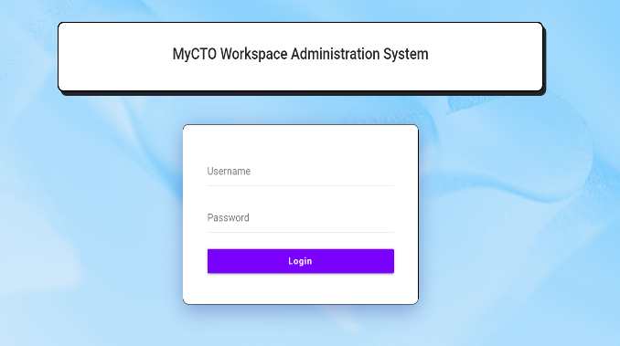

1. The HR Dashboard of the system

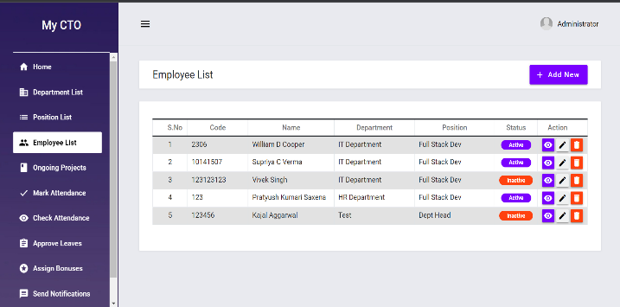

3.)The HR can access the employees view like below:-

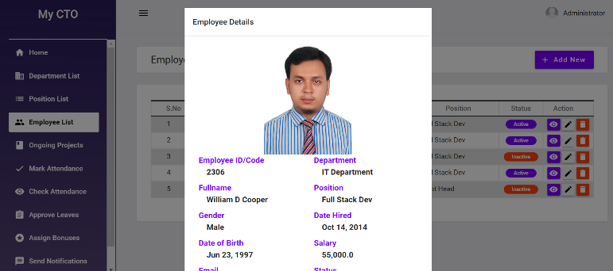

**1.6 Stakeholders**

The stakeholders of the project are the organizations, the employees, team-lead and the fresher.

**1.8 References**

1. Bajpayi, Rishabh. (2020). Employee Management System. International Journal for Modern Trends in Science and Technology. 6. 225-234. 10.46501/IJMTST061242**.**
2. Singh, P., Fartyal, H., Zubair, K. A. A., & Laddha, A. (2019). Employee Management System. International Research Journal of Engineering and Technology (IRJET), 6.
3. Punia, R., Panwar, S., Kamra, R., & Gupta, R. (2020). Voice Based Employee Management System Using AWS and Alexa. International Journal of Innovative Research in Computer Science & Technology (IJIRCST), ISSN, 2347-5552.
4. "Administration in Employee Management System", International Journal of Emerging Technologies and Innovative Research (www.jetir.org | UGC and issn Approved), ISSN:2349-5162, Vol.7, Issue 1, page no. pp125-132, January-2020, Available at:http://www.jetir.org/papers/JETIR2001022.pdf