**OPEN-SOURCE WORKFORCE ADMINISTRATION SYSTEM USING DJANGO**

Ritika Rastogi

Department of Computer Science and Engineering, ABES Engineering College, Ghaziabad.

ritika.19b101173@abes.ac.in

Riya Gupta

Department of Computer Science and Engineering, ABES Engineering College, Ghaziabad.

[riya.19b101031@abes.ac.in](mailto:riya.19b101031@abes.ac.in)

Ayushi Agarwal

Assistant Professor, Department of Computer Science and Engineering, ABES Engineering College, Ghaziabad.

ayushi.agarwal@abes.ac.in

**ABSTRACT**

The paper focuses on Workforce management using Django Framework. This open-source software application has a wide-spread use especially in small scale organizations who can’t afford expensive software. Every organisation, public or commercial, uses an information system to keep information about their employees. However, it has been discovered that many small-scale enterprises in India still utilise paper and pen to preserve records. Even though there are many sophisticated technology systems that can perform this function, they are all too expensive for these low-level industries to afford. This essay addresses developing a method to handle their challenges at a lower cost. Our Workforce Administration System has 4 views namely HR, Employee, Team Lead and Fresher based on the different categories of users of this software application. There are several functionalities in these 4 views that makes this framework not only employee friendly but also helps builds a bond between the company and the staff by ensuring smooth interaction between the two.

**KEYWORDS**

Open-Source, Analytics, Secure, User-friendly interface, CRUD Operations, Cost Efficient, Interactive Dashboard

**1. INTRODUCTION**

Employees are an organization's most important resource for growth and seamless operation. The documentation that was previously completed to manage personnel was really onerous and demanded a lot of time in addition to extra labor. Conflicts might also result from it. For instance, manual searching would be necessary and take a lot of time if the information of any employee was required. The information was not secure in this type of system, and the registers' information could be simply altered. As a result, a system was required to automate everything, including the monitoring of attendance, the tracking of existing projects inside the companies, and the methodical training of new hires. There are several systems on the market that can assist in carrying out these tasks, but they are highly expensive and occasionally need to be handled by skilled experts. However, we're going to open-source this programme so that it may readily operate on any machine with a few installations. Additionally, using it wouldn't require a lot of technical knowledge.

Different portals would be included in the system that would be created for human resources, employees, trainees, and team leads. The human resource site, for example, would offer the ability to view employees, change their information, and add new hires, among other options. Examine staff attendance, the status of the organization's ongoing projects, and other things. Similar to this, the team lead, trainee, and staff would each have unique features available in their respective portals. The organization would benefit from this application's contribution to efficient operation. Additionally, this programme would be much more secure than the currently available software in the market. We require a thorough system study before we can design this system. It calls for a thorough understanding of how the sector operates. We need to properly comprehend databases and construct them so that they can meet all of the system's requirements. Users should have access to a suitable GUI when using the software. The whole system has mainly 4 types of users- HR, Employee, Team Lead and Freshers. We have assigned functionalities accordingly in each view. Some primary features of HR(Admin) view are: Viewing the Employees List, and their details, and executing other CRUD operations on them. The Employee view includes: Review of personal information and making any necessary changes, marking their attendance, Requesting leave etc. Similarly, the Fresher's view has features such as: Viewing their information and making any necessary changes, marking their participation in training, Submitting a request for leave, and downloading reference materials and study guides. And lastly, the team lead view which provides functionalities such as: View team details, assign daily tasks to each team member, or uploading any necessary documents or plan for the current project.

This system hence will not only allow the users to perform basic tasks but also help the organization to have better co-ordination with the employees and achieve positive results. Not only does it solve the issue of better management of the employees but will also help the managers and owners of the small-scale industries to have a multi-functional dashboard to manage their business efficiently and at a minimal cost.

**1.2 MOTIVATION**

The management of employees is still done manually on paper in many firms, especially small ones that cannot afford the cost of sophisticated software. To keep track of attendees, record contact information, etc., the organizations have a variety of registers. If they need to look up information for a specific day, an employee, etc., it becomes exceedingly challenging. Furthermore, this kind of system made it simple to make proxies, which made it difficult for businesses to manage their workforces and made it time-consuming to look for information on them. As a result, we sought to create an application system that could quickly and simply function on their machines after a few installations. This would also be affordable and assist in automating the system.

**1.3 SCOPE**

The project's primary goal is to develop a workforce administration system. The Software application provides 4 views namely-

1. HR

2. Employee

3. Team Lead

4. Fresher

The system's capabilities include keeping each employee's information, adding new hires, and eliminating those who leave the company. This system will also keep track of the employees' daily attendance as well as their absences. Moreover, along with these functionalities, the system will make it easy for the project teams and leads to interact with each other and would also make the working on the project and its progress very transparent.

Thus, this application would not only make the administration of employees easy but would also increase the performance rate of the employees as they would be offered bonuses and coupons for their good performance, which could be redeemed easily by the employees through the dashboard. We have made use of Vroom's expectancy theory here which states that people tend to put in greater effort when they believe that their efforts would increase their performance which in turn would help them gain rewards and recognition. Thus, it can be clearly stated that rewarding the employees for their good performance would increase their productivity and would also motivate their peer employees and increase and develop a healthy work environment.

**2. LITERATURE REVIEW**

**Table 1**

|  |  |  |  |  |  |
| --- | --- | --- | --- | --- | --- |
| **Name** | **Author** | **Publishing Year** | **Published in** | **Techniques Used** | **Advantages & Limitations** |
| **Employee Management System** | Rishabh Bajpai | December-2020 | International Journal for Modern Trends in Science and Technology, 6(12): 225-234, 2020 | 1.Cloud based data storage  2. Firebase handles security and provides free support for email authentication  3. Compatible with both android and iOS | **Advantages**  1. On time salary calculation in just a click, help strengthen the employer - employee relationship.  2. It is cheaper and easy to use.  3. It gives errorless calculations  4. Prevent any kind of malpractice by employees  **Limitations**  1. Since, labour might not be having smartphones and many of them would not be knowing usage of android system, it was a great task to make a system such that it can be used widely else it will not be useful.  2. It is also difficult for this system to be used properly by companies because any type of mistake cannot be solved later. |
| **Employee Management System** | Mr.Pratik Udayshankar Singh, Mr. Hemant Singh Fartyal, Mr. Khan Abdul Ahad Zubair, Prof. Akshata Laddha | May-2019 | International Research Journal of Engineering & Technology | 1. The application is actually a suite of applications developed using PHP  2. This software project has been developed using the powerful coding tools of HTML, CSS and PHP at Front End and Microsoft SQL Server at Back End | **Advantages**  1. Transparency to all the user of system.  2. Less paper use and removal of redundancy.  3. Less prone to errors.  **Limitations**  1. Has 2 views only i.e., HR and employee however there are other staff members who might want to have access to multiple functionalities.  2. Restricted to limited members of the organization. |

|  |  |  |  |  |  |
| --- | --- | --- | --- | --- | --- |
| **Name** | **Author** | **Publishing Year** | **Published in** | **Techniques Used** | **Advantages & Limitations** |
| **Employee Management System** | Madya Ansari, Maviya Shaikh, Ansari Abdul Basit, Jigna Waghela | February-2018 | International Journal of Scientific & Engineering Research Volume 9, Issue 2 | 1. At front end ‘HTML’ and ‘CSS’ is used.  2. At the backend ‘php’,is used and scripting languages are used such as ‘JavaScript ‘and ‘AJAX’  3. For database ,MySQL has been used.. | **Advantages**  1. Time saving due to digital management in software very less manual intervention.  2. Secure data storage.  3. Proper management of employee resources will lead to profit enhancement.  **Limitations**  1. Has only 4 modules that records data of the employee in the database, one for, workdays, salary and provident fund calculation.  2. Employee view has very less functionalities mostly view only. |
| **Administration in Employee Management System** | 1-Mohammed Eshteiwi Ahmouda Shafter  2- Prof (Dr.) A.K.SINGH | January-2020 | **Journal of Emerging Technologies and Innovative Research,** **Volume 7, Issue 1** | 1. The application has been developed using C  language.  2. File handling is used to store and retrieve data | **Advantages**  1. It is a user-friendly system.  2. It records various details of the employees.  3. Each of the employees can update their own details but are authenticated based on  administrator authorization.  **Limitations**  1. The areas of concern are – system reliability and the storage of data along with the operations needed to be performed. |

While the above literature review of previous works provide valuable information regarding the existing Employee Management Systems, there are certain aspects that we have analysed for improvement and incorporated in our proposed Workforce Administration System using Django.

Firstly, we have tried to make this system user friendly by making it's UI simple enough so that it can be used even if the user is not highly skilled on using technologies.

Secondly, we have made our system more diverse by increasing the number of views to 4 that provides more functional capabilities to different types of users that includes HR, Employee, Team Lead and Fresher.

Lastly, since we have used Django in building our system, it makes our system more reliable and secure.

**3. METHODOLOGY**

To create this project, we have used Django, a high-level python web framework. For hr, team-lead, and employees, there would be various portals with varying rights and functionalities. For instance: While employees are not given these functionalities, the hr can add or

delete employees. In this project, Django was used. Django requires a minimum of:

-4GB RAM

-an Intel Core i3

-Windows 7 or later

The architecture of the system mainly consists of the following parts:-

1.)Frontend-This is the interface with which the users will interact. This is being made simple, attractive and user-friendly so that the users could easily interact with the various services provided.

2.)Backend-The backend of any application is basically what goes on behind the scenes. It consists of APIs, servers, operating systems, databases and more all of which come together to ensure that correct information is served to the user as quickly as possible. It is the backbone of the website and is responsible for fetching the information which is to be displayed on the front end. It responds to the requests made by the user and serves them with the required information.

3.)Database-It is an organized collection of structured data. It is responsible for storing

the information entered by the user and for storing the data which is displayed on the front-end of the application after being fetched from here.

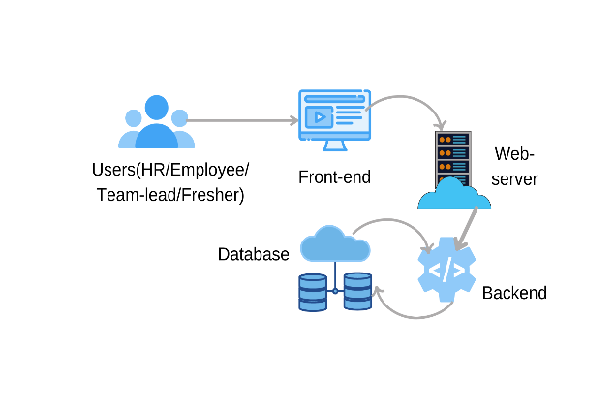

Fig 1 Architecture of the system

The various technologies used for implementing the application are discussed below:-

1.)Django-It is a high-level python framework used to create websites that use python. It has many ready-to-use features like user login and authentication system and database connection and it supports various databases also. The database that we have used in this project is the default database that is being used by Django that is db.sqlite3.Django also helps in the re-usability of various components and features like template inheritance etc. Django follows MVT architecture that is Model, View and Template.

I)Model-The data that we want to display on the frontend of the website or the data that we want to store in the database is done with the help of models.

ii)View-It is responsible for handling the requests from the user. It renders and associated content on receiving request from the user.

iii)Template-It is an HTML file that contains the layout of the webpage to be rendered.

Some of the features of Django that make it so popular are:-

➢ High Security

➢ Rapid Development

➢ High Scalability

➢ SEO optimized

➢ Thoroughly tested

Django has one project and within which different modules are built which provide functionalities to the Project. The different apps have to include in the settings.py file of the project.

2.)HTML,CSS and JavaScript-HTML are used to provide structure to the website.CSS is used for styling the website and JavaScript is used to provide interactivity to the website. In this application, we have used two CSS frameworks:-

I.)Bootstrap-It is one of the most extensively used HTML, CSS and JavaScript frameworks. It is an open-source framework and is free to use. It follows a mobile-first approach. It helps to make the website fully responsive and has various built-in classes which could easily manipulate the styling of the web-page.

ii.)Materialize CSS-It is a UI component library developed and designed by Google. The main goal of building this was to allow for a unified user experience across all they products developed by them across all the platforms. We have used along with bootstrap to make the dashboards more interactive and to follow the dashboard convention.

This system offers four views with different functionalities as discussed below:-

1. HR VIEW

(i)View the Employees List, and their details, and execute CRUD actions on them.

(ii)View the Organization's different departments.

(iii)Take a look at the projects the company is working on and keep track of their progress.

(iv)Verify any employee's attendance record.

(v)Distribute discounts and bonuses to various staff.

(vi)Send out crucial notifications.

(vii)Examine employee feedback.

(viii)Approve leaves

(ix)View issues and questions and address them.

(x)View fresh applications on the job portal of the organization and decide whether to accept or reject them.

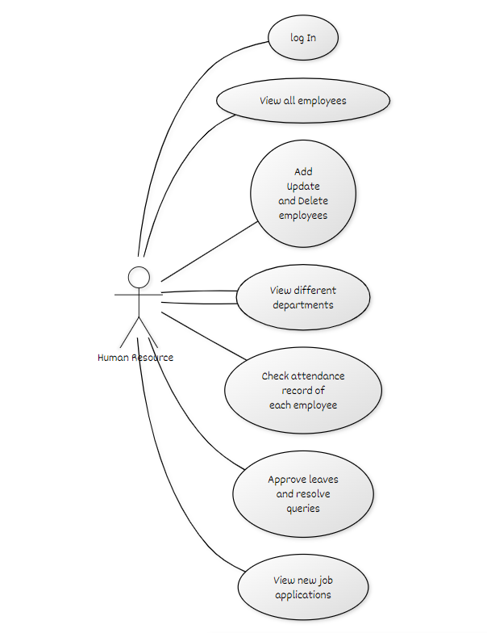

Fig 2 Use Case Diagram for HR View

2. EMPLOYEE VIEW

(i)Review their information and make any necessary changes.

(ii)Mark their attendance.

(iii)Request leave.

(iv)Verify the day's assignment.

(v)View discounts and rewards and redeem them.

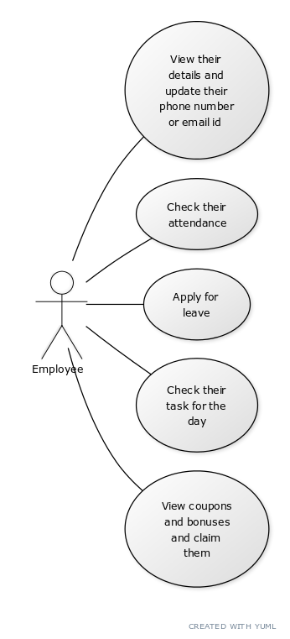

Fig 3 Use Case Diagram for Employee

3. TEAM LEAD VIEW

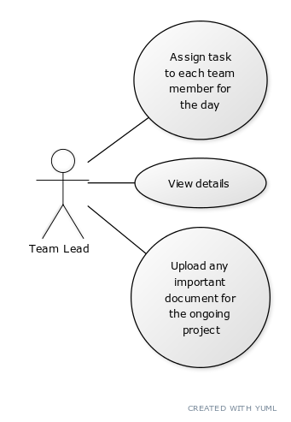

Fig 4 Use Case Diagram for team lead

(i)View information

(ii)Assign daily tasks to each team member.

(iii)Any necessary documents for the current project could be uploaded.

4. FRESHER'S VIEW

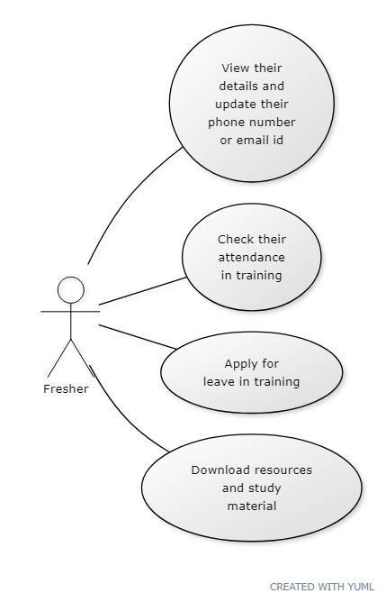

Fig 5 Use Case Diagram for freshers

(i)View their information and make any necessary changes.

(ii)Verify their participation in training.

(iii)Submit a request for training leave.

(iv)Download reference materials and study guides.

**4. RESULTS & DISCUSSIONS**

1.On successful installation of the software, the user can login using the credentials to access the portal.

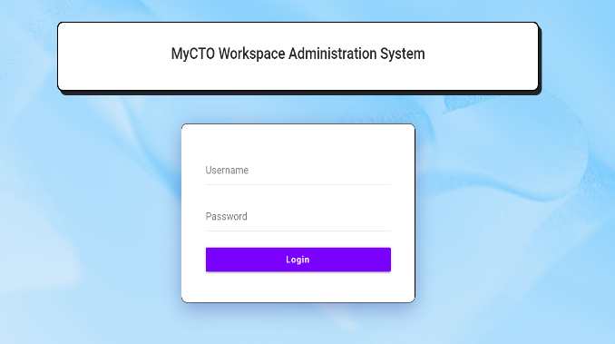

Fig 6 Login View of the System

2. When the HR of the company logins, he is directed to the following page where he can take several actions as discussed under the functionalities of HR view.

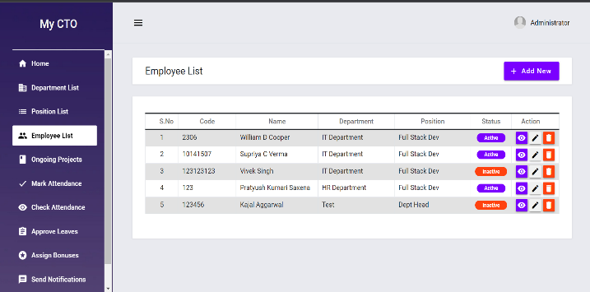

Fig 7 HR Dashboard

3. Below is the screenshot of the portal’s detailed employee view. It will help the system admin or HR to see all the details of the employee like his employee code, department, position, his personal details etc. The HR also has the option to edit these details or remove any employee.

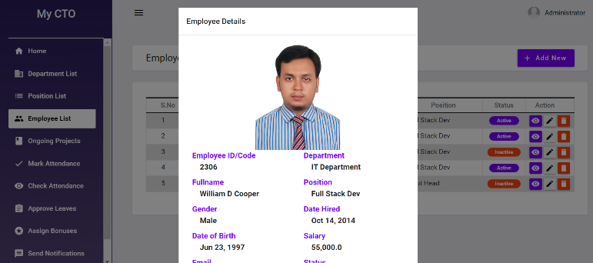

Fig 8 HR accessing the details of an employee

4.Every functionality in the dashboard has a different purpose. For instance, the ongoing projects functionality in the HR Dashboard will help the organization to see all the ongoing projects, their progress, project lead and the details of the team members.

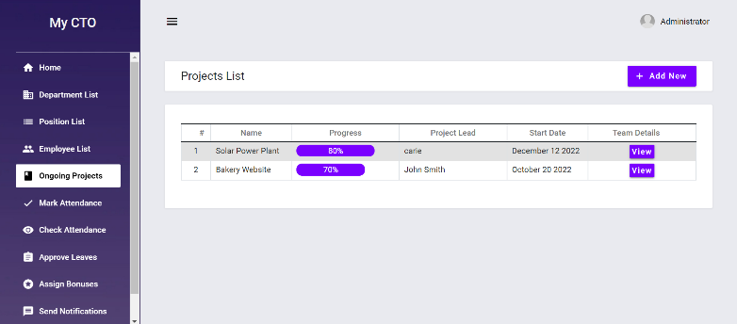Fig 9 Ongoing Project Functionality of the HR Dashboard

Test Cases: -Some of the test cases that we have tested the system for are:-

**Test Case 1:-** We have tried to test if we are able to login using the wrong credentials.

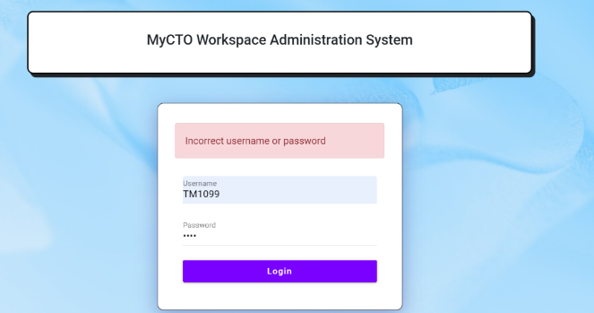

Fig 10 Trying to login into the system using wrong credentials

The test case has passed, we will not be able to login using the wrong credentials. Thus, the system is secure and the person who has the right credentials can only login and perform various operations.

**Test Case 2:-** Now, we are trying to see if we are able to delete the details of any employee from the system.

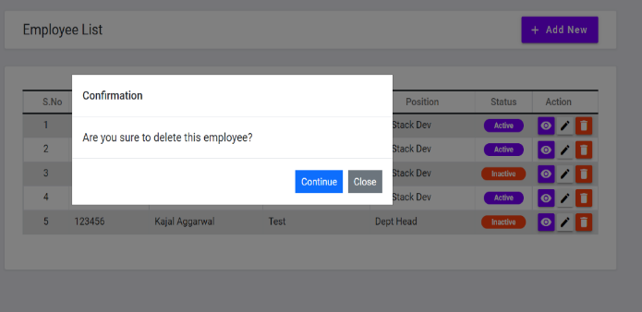

Fig 11 Testing if we are able to delete an employee properly

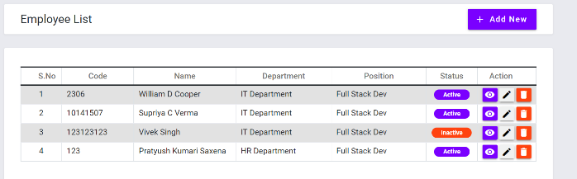

Fig 12 Thus we have deleted an employee successfully

**Test Case 3:-** Now we are testing if we are able to add a new Department.

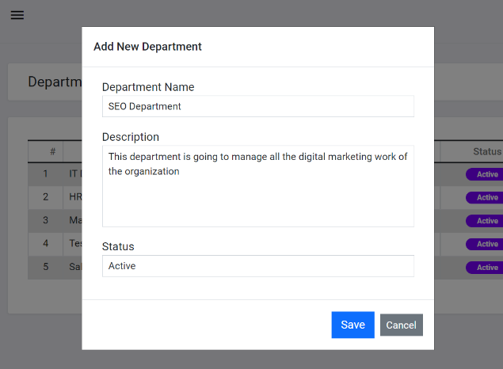

Fig 13 Testing if we are able to add a new department properly in HR Dashboard

This test was a success, we are able to add a new department successfully.

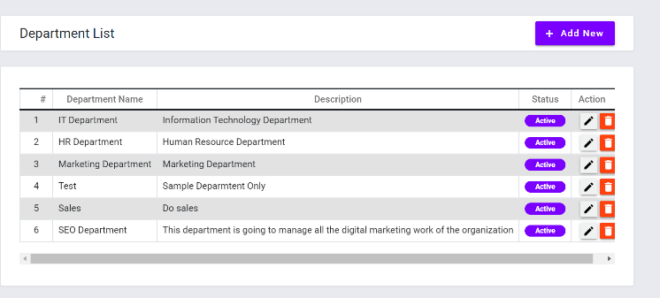

Fig 14 Thus we are able to add a new department successfully

**CONCLUSION**

Thus, we have created a system that will help organizations to manage their workforce efficiently. Thus, reducing the problems faced by the organizations earlier. This system will also ensure transparency in the organization and bridge the communication gap between the employees and the employers as they will be able to directly write their queries through the portal. This system in comparison to the other system will make use of analytics which would make it easier to analyze data and make important decisions based on them.

**REFERENCES**

1. Bajpayi, Rishabh. (2020). Employee Management System. International Journal for Modern Trends in Science and Technology. 6. 225-234. 10.46501/IJMTST061242**.**
2. Singh, P., Fartyal, H., Zubair, K. A. A., & Laddha, A. (2019). Employee Management System. International Research Journal of Engineering and Technology (IRJET), 6.
3. Punia, R., Panwar, S., Kamra, R., & Gupta, R. (2020). Voice Based Employee Management System Using AWS and Alexa. International Journal of Innovative Research in Computer Science & Technology (IJIRCST), ISSN, 2347-5552.
4. "Administration in Employee Management System", International Journal of Emerging Technologies and Innovative Research (www.jetir.org | UGC and issn Approved), ISSN:2349-5162, Vol.7, Issue 1, page no. pp125-132, January-2020, Available at:http://www.jetir.org/papers/JETIR2001022.pdf

|  |
| --- |
|  |
|  |  |