**Experiment 1**

**Aim:** To create a basic webpage using HTML and CSS.

**Theory:**

**HTML (HyperText Markup Language):**

HTML is the core language used for creating and structuring web content. It defines the elements on a webpage using various tags and attributes. HTML tags help browsers interpret and display content in the appropriate format.

* **Elements**: HTML documents are made up of elements, which include tags like <div>, <p>, <h1>, <a>, <img>, and more.
* **Attributes**: Elements often have attributes that provide additional information, such as id, class, src, and href. For example, <img src="image.jpg" alt="description">.
* **Structure**: HTML uses a hierarchical structure with a root element <html>, which contains two primary sections: <head> (contains meta information, links to stylesheets) and <body> (contains the visible content like text, images, and links).
* **Document Structure**: Basic structure of an HTML document is as follows:

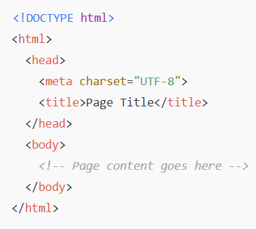

HTML focuses on the semantic meaning of content. For example:

* <h1> to <h6> for headings
* <p> for paragraphs
* <a> for links
* <ul> and <ol> for unordered and ordered lists, respectively.

**CSS (Cascading Style Sheets):**

CSS is used to control the presentation of HTML elements. It specifies how the content should be styled and arranged on the page.

* **Selectors**: CSS uses selectors to target HTML elements. Common selectors include element selectors (h1, p), class selectors (.class-name), and ID selectors (#id-name).
* **Properties and Values**: CSS defines the appearance of elements through properties and values. For example, colour: blue; changes the text colour to blue, and background-colour: yellow; sets the background colour.
* **Box Model**: Every HTML element is treated as a box, consisting of:
  + content: The actual content of the box (text, images, etc.)
  + padding: The space between the content and the border
  + border: A line around the box
  + margin: The space outside the border, creating space between elements
* **Layout Techniques**: CSS includes various techniques for layout, such as:
  + **Flexbox**: Used for creating flexible and responsive layouts. It provides control over alignment, distribution, and positioning of elements.
  + **Grid**: A powerful layout system that allows developers to create complex, two-dimensional layouts with rows and columns.
* **Responsive Design**: CSS supports responsive web design, making websites adaptable to different screen sizes using **media queries**. These allow styles to change based on the device or viewport size.
* **Animations and Transitions**: CSS also allows for adding animations and transitions to create smooth effects on elements (e.g., changing colours, moving elements).

**Files:**

**1.HTML:**

<!DOCTYPE html>

<html lang="en">

<head>

<meta charset="UTF-8" />

<meta name="viewport" content="width=device-width, initial-scale=1.0" />

<title>OptiVision - Spectacles Store</title>

<link rel="stylesheet" href="styles.css" />

</head>

<body>

<header>

<div class="logo">OptiVision</div>

<nav>

<ul>

<li><a href="#">Home</a></li>

<li><a href="#">Shop</a></li>

<li><a href="#">About</a></li>

<li><a href="#">Contact</a></li>

</ul>

</nav>

</header>

<section class="hero">

<div class="hero-content">

<h1>Find Your Perfect Pair of Spectacles</h1>

<p>

Browse our exclusive collection of stylish and functional eyewear.

</p>

<button>Shop Now</button>

</div>

</section>

<section class="product-section">

<h2>Featured Products</h2>

<div class="product-container">

<div class="product-card">

<img src="spectacle1.jpg" alt="Spectacle 1" />

<h3>Classic Round Glasses</h3>

<p>₹1099.00</p>

<button>Add to Cart</button>

</div>

<div class="product-card">

<img src="spectacle2.jpg" alt="Spectacle 2" />

<h3>Modern Square Frame</h3>

<p>₹3500.00</p>

<button>Add to Cart</button>

</div>

<div class="product-card">

<img src="spectacle3.jpg" alt="Spectacle 3" />

<h3>Retro Sunglasses</h3>

<p>₹7950.00</p>

<button>Add to Cart</button>

</div>

</div>

</section>

<footer>

<p>&copy; 2025 OptiVision. All Rights Reserved.</p>

</footer>

</body>

</html>

**2.CSS**

/* Reset styles */

* {

  margin: 0;

  padding: 0;

  box-sizing: border-box;

}

body {

  font-family: "Arial", sans-serif;

  background-color: #f5f5f5;

  color: #333;

  line-height: 1.6;

  display: flex;

  flex-direction: column;

  align-items: center;

  justify-content: center;

  min-height: 100vh;

  text-align: center;

}

header {

  display: flex;

  justify-content: space-between;

  align-items: center;

  padding: 20px 50px;

  width: 100%;

  background-color: #333;

  color: white;

}

header .logo {

  font-size: 2.5rem;

  font-weight: bold;

  color: #ff6a00;

}

header nav ul {

  display: flex;

  list-style-type: none;

}

header nav ul li {

  margin: 0 15px;

}

header nav ul li a {

  color: white;

  text-decoration: none;

  font-size: 1.1rem;

  font-weight: bold;

  text-transform: uppercase;

  transition: all 0.3s ease;

}

header nav ul li a:hover {

  color: #ff6a00;

}

/* Hero Section */

.hero {

  background: linear-gradient(135deg, #ff6a00, #ffcc00);

  color: white;

  padding: 100px 50px;

  width: 100%;

}

.hero h1 {

  font-size: 3rem;

  margin-bottom: 20px;

}

.hero p {

  font-size: 1.2rem;

  margin-bottom: 30px;

}

.hero button {

  background-color: #ff6a00;

  color: white;

  border: none;

  padding: 15px 30px;

  font-size: 1.2rem;

  cursor: pointer;

  border-radius: 50px;

  transition: background-color 0.3s;

}

.hero button:hover {

  background-color: #ffcc00;

}

/* Product Section */

.product-section {

  padding: 50px;

  background-color: #fff;

  width: 100%;

  text-align: center;

}

.product-section h2 {

  font-size: 2.5rem;

  margin-bottom: 50px;

}

.product-container {

  display: flex;

  justify-content: center;

  gap: 30px;

  flex-wrap: wrap;

}

.product-card {

  background-color: #fff;

  border: 1px solid #ddd;

  width: 250px;

  border-radius: 15px;

  padding: 20px;

  box-shadow: 0 5px 15px rgba(0, 0, 0, 0.1);

  text-align: center;

  transition: transform 0.3s ease;

}

.product-card:hover {

  transform: translateY(-10px);

  box-shadow: 0 10px 25px rgba(0, 0, 0, 0.15);

}

.product-card img {

  width: 100%;

  height: 250px;

  object-fit: contain; /* Ensures the whole image is visible */

  border-radius: 10px;

}

.product-card h3 {

  font-size: 1.5rem;

  margin: 15px 0;

}

.product-card p {

  font-size: 1.2rem;

  margin-bottom: 20px;

}

.product-card button {

  background-color: #ff6a00;

  color: white;

  border: none;

  padding: 10px 20px;

  font-size: 1.1rem;

  cursor: pointer;

  border-radius: 50px;

  transition: background-color 0.3s;

}

.product-card button:hover {

  background-color: #ffcc00;

}

/* Footer */

footer {

  background-color: #333;

  color: white;

  padding: 20px 0;

  text-align: center;

  width: 100%;

}

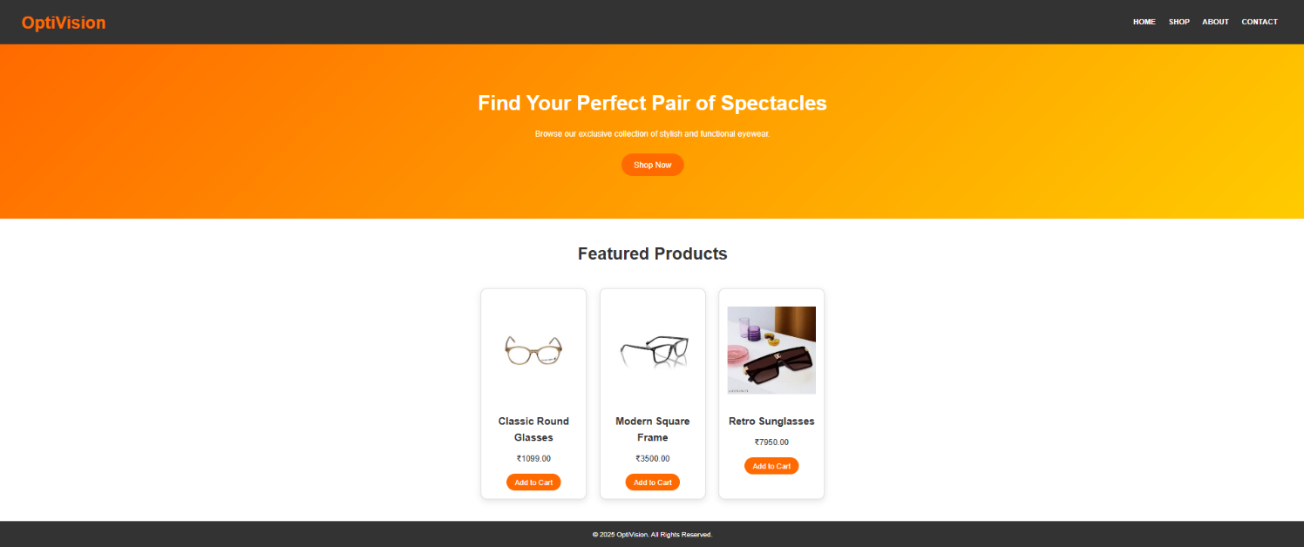**OUTPUT:**