1. Aim:-Implementation of BGP using AS_path attribute.

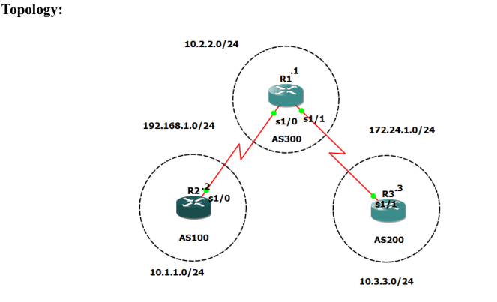

Steps/Commands:

Step1: Configuration

R2# conf t

int s1/0

ip add 192.168.1.2 255.255.255.0

no sh

R1# conf t

int s1/0

ip add 192.168.1.1 255.255.255.0

no sh

int s1/1

ip add 172.24.1.1 255.255.255.0

no sh

R3# conf t

int s1/1

ip add 172.24.1.3 255.255.255.0

no sh

Step2: Loopback

R2# int lo0

ip add 10.1.1.1 255.255.255.0

R1# int lo0

ip add 10.2.2.2 255.255.255.0

R3# int lo0

ip add 10.3.3.3 255.255.255.0

Step3: Configure as-bgp

R2# router bgp 100

neighbor 192.168.1.1 remote-as 300

network 10.1.1.0 mask 255.255.255.0

R1# router bgp 300

neighbor 192.168.1.2 remote-as 100

neighbor 172.24.1.3 remote-as 200

network 10.2.2.0 mask 255.255.255.0

R3# router bgp 200

neighbor 172.24.1.1 remote-as 300

network 10.3.3.0 mask 255.255.255.0

ON ALL ROUTERS:

do sh ip route

Step4: ping routers

R1#do ping 10.3.3.3 source lo0

R3#do ping 10.2.2.2 source lo0

Output:

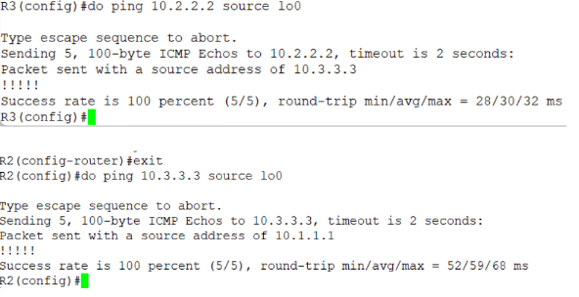

1. Aim: Configuring IBGP and EBGP sessions.

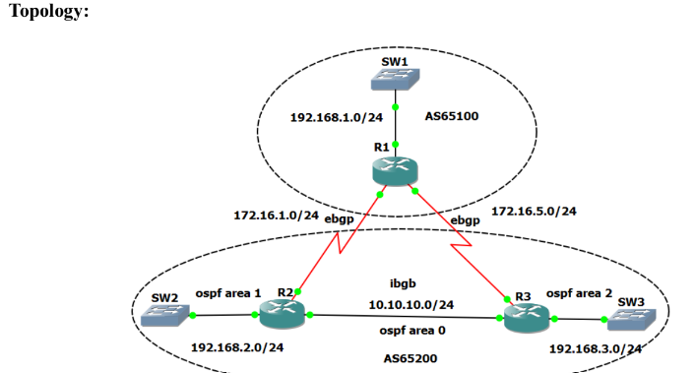

Steps/Commands:

Step 1: Drag and drop R1, R2 and R3; take 3 Ethernet switch and perform configurations on given routers.

R1# conf t

int f0/1

ip add 192.168.1.1 255.255.255.0

no sh

int s1/0

ip add 172.16.1.1 255.255.255.0

no sh

int s1/1

ip add 172.16.5.1 255.255.255.0

no sh

R2# conf t

int f0/0

ip add 10.10.10.2 255.255.255.0

no sh

int f0/1

ip add 192.168.2.2 255.255.255.0

no sh

int s1/0

ip add 172.16.1.2 255.255.255.0

no sh

R3# conf t

int f0/0

ip add 10.10.10.3 255.255.255.0

no sh

int f0/1

ip add 192.168.3.3 255.255.255.0

no sh

int s1/1

ip add 172.16.5.3 255.255.255.0

no sh

ON ALL ROUTERS:

do sh ip int br | include up

Step 2: Configure IRP(Interior Routing Protocol [using OSPF]) in autonomous system 65200(AS65200)

R2(config)

router ospf 1

network 10.10.10.0 0.0.0.255 area 0

network 192.168.2.0 0.0.0.255 area 1

R3#(config)

router ospf 1

network 10.10.10.0 0.0.0.255 area 0

network 192.168.3.0 0.0.0.255 area 2

ON BOTH ROUTERS:

R3>(config)

do ping 192.168.2.2

R2>(config)

do ping 192.168.3.3

Step 3: IBGP and EBGP configurations

R1>(config)

router bgp 65100

network 192.168.1.0

network 172.16.1.0 mask 255.255.255.0

network 172.16.5.0 mask 255.255.255.0

neighbor 172.16.1.2 remote-as 65200

neighbor 172.16.5.3 remote-as 65200

R2>(config)

router bgp 65200

network 172.16.1.0 mask 255.255.255.0

redistribute ospf 1

neighbor 172.16.1.1 remote-as 65100

neighbor 10.10.10.3 remote-as 65200

R3>(config)

router bgp 65200

network 172.16.5.0 mask 255.255.255.0

redistribute ospf 1

neighbor 172.16.5.1 remote-as 65100

neighbor 10.10.10.2 remote-as 65200

Step 4: Final output:

(ON ALL ROUTERS)

(config) do sh ip route

(DO THIS ONLY WHEN EXAMINER ASKS)

R1> (config)

do ping 192.168.2.2

do ping 192.168.3.3

Output:

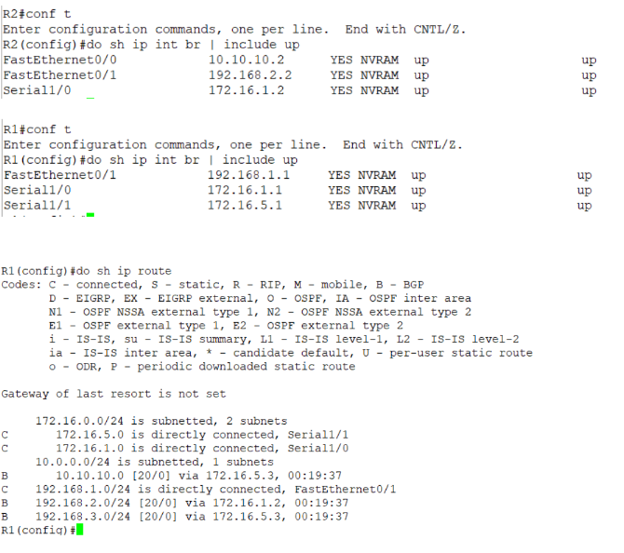

1. Aim: Secure management plane.

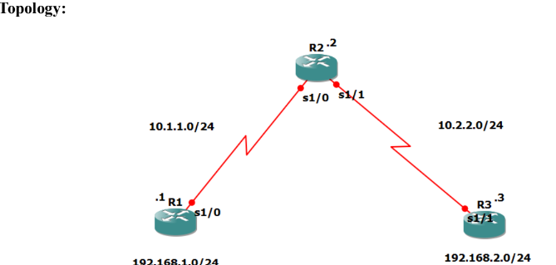

Steps/Commands:

Step 1: Configure routers.

R1> conf t

int s1/0

ip add 10.1.1.1 255.255.255.0

no sh

int lo1

ip add 192.168.1.1 255.255.255.0

R2> conf t

int s1/0

ip add 10.1.1.2 255.255.255.0

no sh

int s1/1

ip add 10.2.2.2 255.255.255.0

no sh

R3> conf t

int s1/1

ip add 10.2.2.3 255.255.255.0

no sh

int lo1

ip add 192.168.2.1 255.255.255.0

Step2: Configure Routing:

R1> ip route 0.0.0.0 0.0.0.0 10.1.1.2

R2> ip route 192.168.1.0 255.255.255.0 10.1.1.1

ip route 192.168.2.0 255.255.255.0 10.2.2.3

R3> ip route 0.0.0.0 0.0.0.0 10.2.2.2

R1> do ping 192.168.2.1

R3> do ping 192.168.1.1

(START ONLY WHEN 100% SUCCESS ON PING)

Step3: Secure management access

R1> (config)

hostname r1

security password min-length 10

enable secret class12345

line console 0

password ciscoconpass

exec-timeout 5 0

login

logging synchronous

exit

line vty 0 4

password ciscovtypass

exec-timeout 5 0

login

exit

line aux 0

no exec

end

do wr

conf t

service password-encryption

banner motd $Unauthorized access not allowed$

exit

R3> (config)

hostname r3

security password min-length 10

enable secret class12345

line console 0

password ciscoconpass

exec-timeout 5 0

login

logging synchronous

exit

line vty 0 4

password ciscovtypass

exec-timeout 5 0

login

exit

line aux 0

no exec

end

do wr

conf t

(config)

service password-encryption

banner motd $Unauthorized access not allowed$

exit

r2> telnet 10.1.1.1

Output:-

