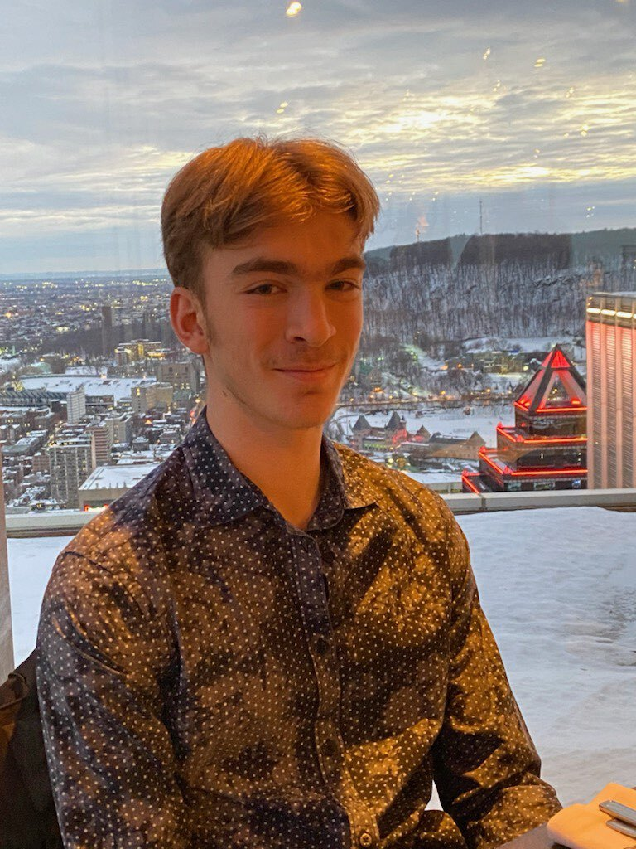 Lucas Audet - Portfolio

# Profession:

Student aiming for a career in software engineering

# About Me

I am a student completing my DEC in computer science and mathematics. I have a strong interest in technology and computing. I aim to continue my development by enrolling in a Bachelor's degree in software engineering at E.T.S.

# Skills

- Strong analytical and problem-solving abilities

- Web design and development

- Java programming skills

- Requirements gathering and functional specification

- Team coordination and leadership

- Communication and collaboration

- Python development and automation

# Experience

- Cook at McDonald's: Quick food preparation, hygiene standards compliance, efficiency during peak hours, adaptability, and teamwork.

- Dock attendant at Saint-Mathieux-De-Rioux: Efficient management of port operations, assistance to users, maintenance of space, and enforcement of local regulations.

- Clerk at Éditions Vaudreuil: Precise preparation of warehouse orders, inventory management, and space optimization.

- Cook at Première Moisson: Introduction to team coordination, culinary preparation, and maintenance of quality standards.

# Education

- CEGEP: Cégep Gérald Godin 2021-2024

- High School: Collège Notre-Dame 2016-2021

- Elementary School: Virginie-Roy 2009-2016

# Programming Languages & Projects

- Website Designer: Created a professional CV site, implemented attractive designs, and optimized for better online visibility.

- Java Skills: Proficient in Java and used JavaFX and Scene Builder interfaces for developing interactive applications.

- Exploring Python: Developed a functional Discord bot to execute essential tasks, implementing programming and automation skills.

# Contact Details

Email: Lucasriv43@gmail.com  
Cell: 514-451-6262 (texto)

Home: 514-453-6262