RIVA MALIK20I-1208

ZARAH AMER 20I-2201

Visualization Report

April 20, 2021

# **Figure 1**

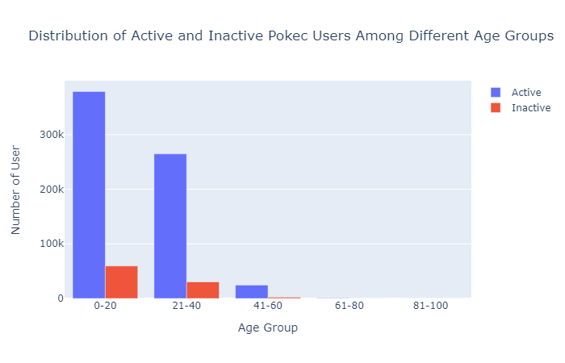

Figure 1 shows the distribution of active and inactive users in different age groups. Apart from that it also reveals which age group has the most number of users registered on *Pokec*. User activity is calculated from login information. The Figure 1 shows that every age group has more active users as compared to inactive users this indicates that *Pokec* indeed is a widely used social networking as claimed by the company. *Pokec* is most popular among people of age 0-20 years old. If we look closely the distribution of active and inactive users in age group 41-60 shows the most difference. This indicates that older people tend to be more active on the platform.

Figure 1 is included because it provides the foremost insights related to any social networking platforms. It provides the number of users, the age group of users, the activeness of user which in turn gives the popularity of platform ( if the platform is popular only then users visit it frequently and excessively ) all in one glance.

# **Figure 2**

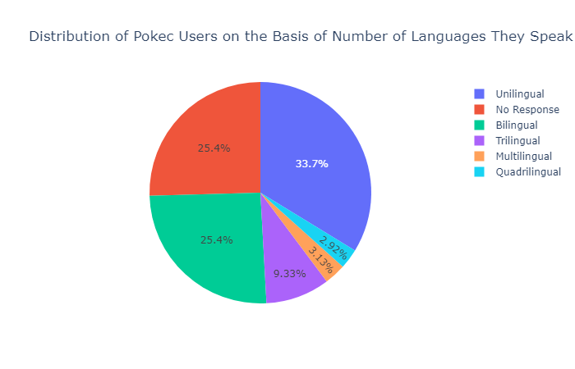

Figure 2 shows how the users of *Pokec* are distributed according to the number of languages they speak. Majority of the users speak only one language. The second highest portion of users speak two languages. Only a small portion of users can speak more than 4 languages.

Figure 2 is included because this data can be used for advertisement targeting. Showing people the ad which they can understand and relate to is highly important from marketing perspective. As most of the people are unilingual and bilingual the Ad companies can use this data to target their audience.

# **Figure 3**

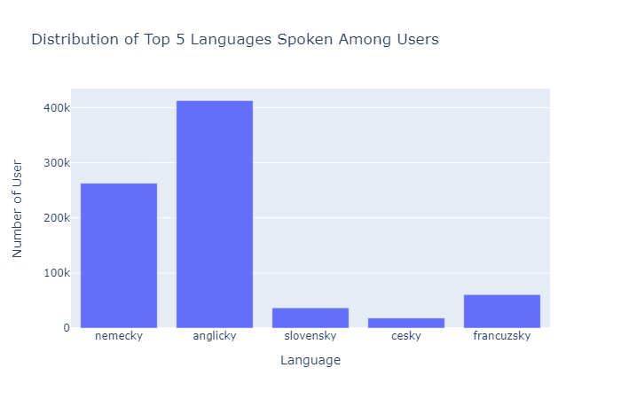

Figure 3 shows the top five languages spoken by *Pokec* users. “Nemecky” which translate to German is the most widely spoken language after that English and after that their native language Slovak is spoken.

Figure 3 is included because it is a representation of demographic location of Slovakia. The countries which are close to it have their influence on the people of this region as well. Apart from that people from other countries may be user of this platform.